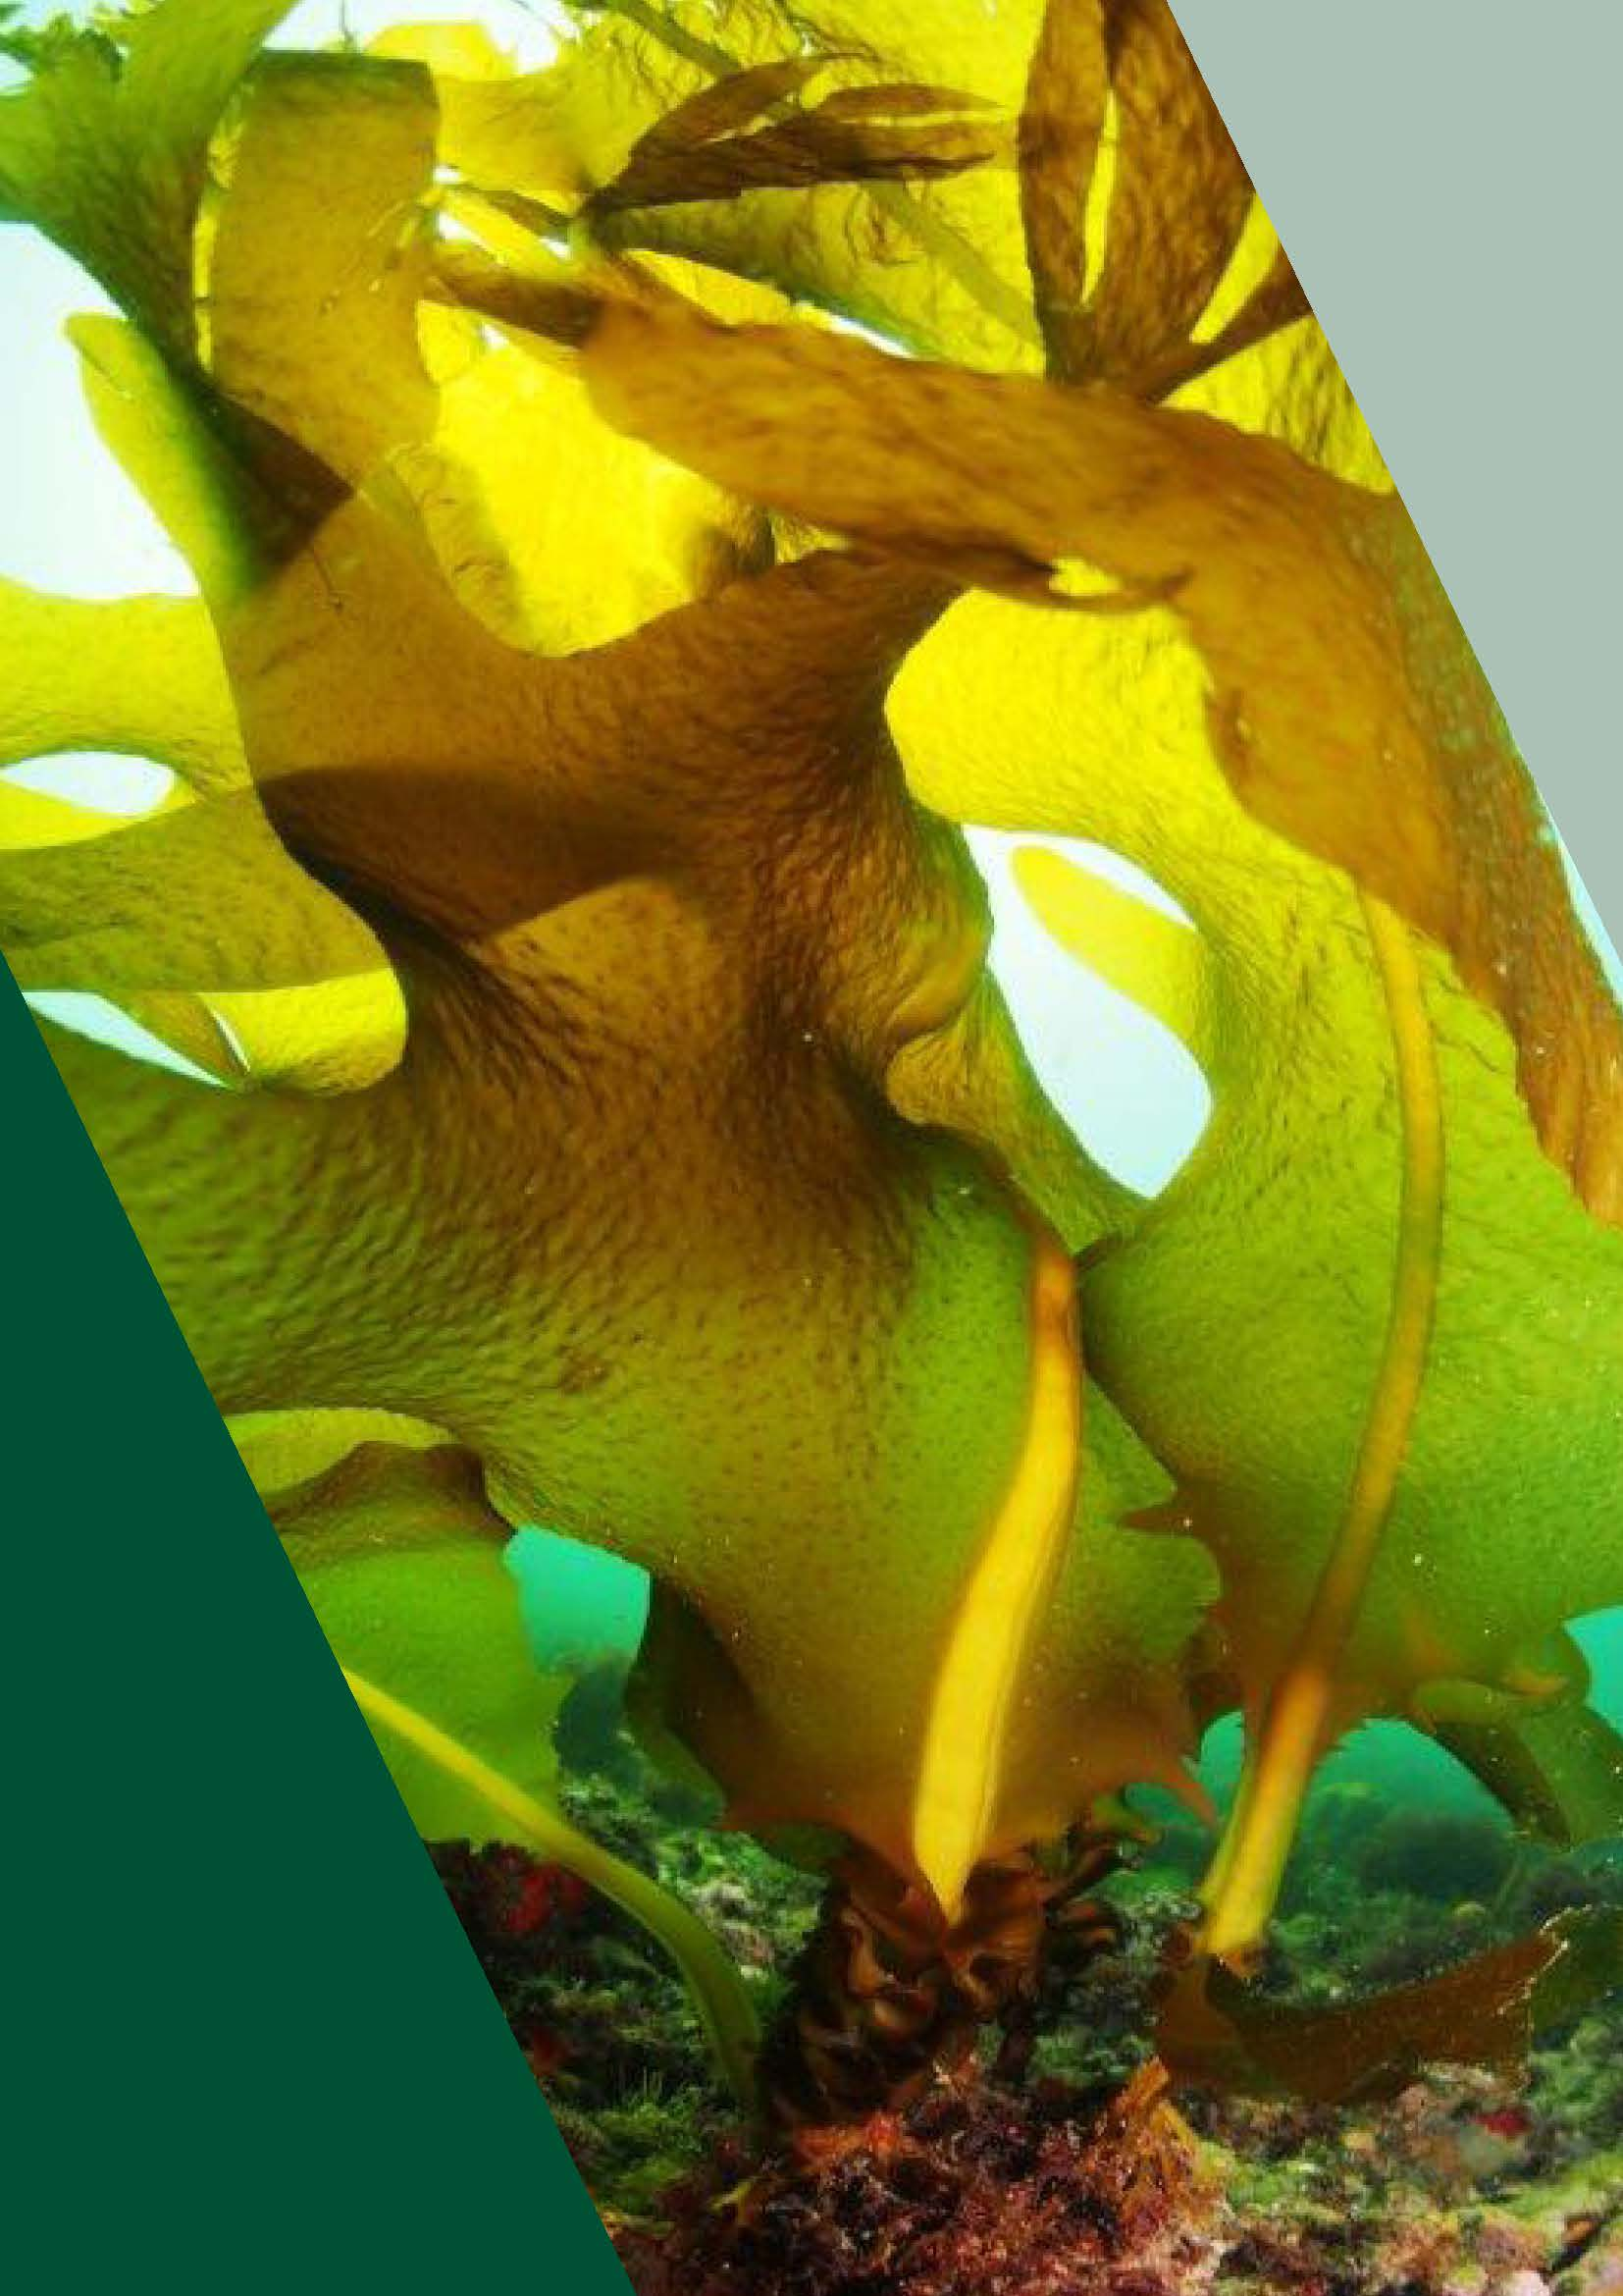
Invasive Marine Pests Module Consultation
Consultation Summary Report - 2022
Document title | Introduction

Traditional Owners acknowledgement
We proudly acknowledge Victoria’s First Nations peoples and their ongoing strength in practising the world’s oldest living culture. We acknowledge the Traditional Owners of the lands and waters on which we live and work and pay our respect to their Elders past and present. Victoria’s Aboriginal communities continue to strengthen and grow with the ongoing practice of language, lore, and cultural knowledge. We recognise the contribution of Aboriginal people and communities to Victorian life. Traditional owners managed Victoria’s land and water for tens of thousands of years. We acknowledge their history and their living cultural traditions.

Introduction
Agriculture Victoria, in collaboration with other agencies, has developed a draft Invasive Marine Pests Module under the Victorian Government’s Invasive Plants and Animals Policy Framework (IPAPF). The IPAPF represents the Victorian Government’s approach to managing existing and potential invasive species across the whole of Victoria.
The development of the marine pests module will fill an existing gap in Victoria’s invasive species module framework. It sets out the Victorian Government’s intention to guide and inform the development of regional and other place specific strategies and plans for the prevention, eradication and containment of marine pests and associated asset protection.
Public consultation was undertaken to improve our understanding of stakeholder views on marine pest management and inform the finalisation of the module.
The draft Invasive Marine Pests Module was open for public consultation from 11 November until 8 December 2021 through the Engage Victoria website. Engage Victoria is the Victorian Government's online consultation platform that provides a digital way for the public to participate and to have a say in the development of government policies and programs.

What did we ask?
We asked for people’s views and ideas on the management of invasive marine species within Victoria. We asked:
- Do you think the Invasive Marine Pests draft module appropriately addresses your needs?
- Do you think the Invasive Marine Pests draft module clearly communicates the issues and factors relating to managing invasive marine pests in Victoria?
- Do you think the future priorities outlined within the Invasive Marine Pests draft module will help to improve the Victoria’s natural environments, built environment, cultural and amenity environment?
- What do you like about the Invasive Marine Pests draft module?
- How do you think the Invasive Marine Pests draft module could be improved?

What did we hear?
Overall, there was general support for the Invasive Marine Pests draft module. Contributors felt that the draft module was a good starting point in the management of invasive marine pests in Victoria and supported the future priorities and strategies. Contributors also felt the case studies in the draft module helped convey the impacts of invasive marine species and the problems in managing them.

Do you think the invasive marine pests draft module appropriately addresses your needs?
Contributors were divided on whether the marine pest module addresses management needs appropriately. Overall, contributors thought the module was a good starting point for management, but more could be done.

We heard that:
- The module could recognise the involvement of marine scientists and institutions with marine expertise in research to address knowledge gaps. This will be essential to ensure the success of the Invasive Marine Pest module and associated frameworks.
- The module could further recognise and detail the valuable nature of the marine environment to Victorian society.

We will:
- Include a case study acknowledging the importance of the expertise held by institutions in managing marine pest incursions
- More clearly recognise the valuable nature of the marine environment.
- Emphasise that the module is intended to guide / inform the development of regional and other place specific strategies and plans

Do you think the Invasive Marine Pests draft module clearly communicates the issues and factors relating to managing invasive marine pests in Victoria?
The majority of contributors acknowledged that the Invasive Marine Pests draft module clearly communicated the issues and factors relating to managing invasive marine pests in Victoria but raised a few issues that they would like the module to address.

We heard that:
- Contributors supported the development and implementation of an active surveillance program at high-risk ports and marinas in Victoria and welcomed the inclusion of research priorities relating to the use of molecular techniques.
- The draft module could include more information on the involvement of local groups or local experts on the issue of invasive marine pest management.
- The ‘Victoria’s Biosecurity goals’ section in the draft module could be strengthened by highlighting the importance of ‘early detection’ (in Prevention goal) as it is an important part in monitoring and surveillance programs.

We will:
- Highlight the importance of involving local groups and/or experts in invasive marine pest management.
- Strengthen reference to ‘early detection’ in ‘Victoria’s Biosecurity goals’ section of the draft module.

Do you think the future priorities outlined within the Invasive Marine Pests draft module will help to improve the Victoria’s natural environments, built environment, cultural and amenity environment?
The vast majority of contributors supported the future priorities outlined within the Invasive Marine Pests draft module.

We heard that:
- Contributors were generally supportive of the future priorities put forward and believe they will address some of the significant gaps in invasive marine pest management.
- Many commended the draft module on including priorities that addressed aspects of management of invasive species such as preventing spread, eradication, containment, and biofouling and ballast water management.
- The review of roles and responsibilities and the expansion of fundamental initiatives to detect and manage marine pests (greater surveillance, risk assessments and response planning and implementation) was well received.
- The ‘Future priorities’ section in the draft module could include priorities associated with education and public awareness of invasive species, early detection surveys in high priority areas and high-risk areas.
- The Research priorities in the module could include priorities associated with cultural values and partnership with Traditional Owners
- The module could also include population modelling as a surveillance and monitoring tool in addition to eDNA and Remote Operated Vehicles.

We will:
- Highlight the importance of giving consideration to cultural values, establishing partnerships with Traditional Owners, undertaking education and public awareness and conducting early detection surveys in high priority areas and high-risk areas.
- Recognise the role of population modelling as a surveillance tool.

What do you like about the Invasive Marine Pests draft module?

We heard that:
- The Invasive Marine Pests module frames the issues surrounding invasive marine plants and animals with useful background and case-studies.
- Contributors acknowledged that the future priorities and strategies around monitoring and surveys and the focus on improving capabilities set a clear intention.
- Contributors commended the draft module as it covers many important topics such as the spread and impacts of introduced marine species. They also commended the use of case studies to illuminate the problems of ballast water, biofouling management and prevention, biosecurity, emerging challenges, eradication strategies, emergency management arrangements, and containment.
- Contributors also commended the Future Priorities identified in the draft module, especially the development of a marine pest response plan.
- Contributors welcomed the inclusion of research priorities relating to the use of molecular techniques and assessment of impacts from environmental, social, and economic perspectives.
- The draft module was well received as it recognised the social and economic impact invasive marine pests can have on Victoria’s marine environment.

How do you think the Invasive Marine Pests draft module could be improved?

We heard that:
- The asset-based protection priorities in the ‘Future priorities’ section can include the mapping of high value conservation areas across the state, with early detection and management prioritised for these areas. Marine national parks and sanctuaries should be considered, in addition to areas outside of formal protected areas.
- The module can recognise Museums Victoria online collections data from marine surveys in Victoria waters (including all major Port Phillip Bay environmental surveys) and the role Museums Victoria can have in diagnostic capability and training.
- The draft module could further recognise engagement opportunities with facilities that can provide accurate taxonomic identifications of marine fauna which are supported by verifiable specimens and tissue bank depositions.
- List of stakeholders in Appendix A of the draft module should be amended to include Museums Victoria and Visit Victoria.
- The draft module can recognise roles/responsibilities for managing established pests versus new incursions and include definitions. If it cannot be included, this should be identified as a gap that needs to be addressed.
- The draft module could better promote biofouling management on vessels to stop the spread and respread of nuisance species.

We will:
- Recognise the role of online databases and online identification tools, taxonomic training workshops and collaboration in early detection and response to marine incursions.
- Continue to recognise asset-based protection as a priority and include a focus on high-value conservation areas.
- Update Appendix A with additional stakeholders.
- Enhance the information on the roles and responsibilities and management of established pests and new incursions.
- Include more information in the draft module on biofouling management on vessels

Next steps
Agriculture Victoria thanks all those who have contributed their ideas and feedback in this engagement, and we look forward to showing you the finalised Invasive Marine Pests Module.
Once finalised, the Invasive Marine Pests module will be published on the Agriculture Victoria website (https://agriculture.vic.gov.au/biosecurity/protecting-victoria/legislation-policy-and-permits/invasive-plants-and-animals-policy-framework).

