Join the Great Biosecurity Quest
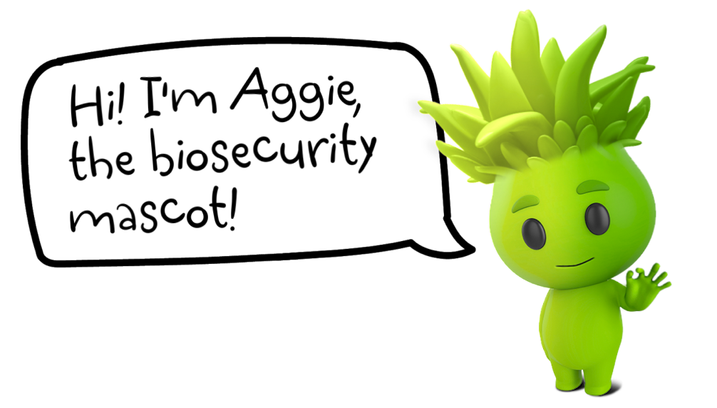

This year, Aggie is asking Victorians to join the Quest and be on the lookout for stink bugs, including the invasive brown marmorated stink bug!

What is Biosecurity?
Biosecurity is all about protecting what we value most by preventing and managing harm caused by pests and diseases.
If we all work together to protect our biosecurity, we can continue to spend time in the great outdoors, enjoy clean and safe food and protect the agricultural industries that provide so much for us all.

Play your part – Join the Great Biosecurity Quest!
The responsibility falls to all of us to protect Victoria’s biosecurity, and a strong biosecurity system requires industry, community and government working together. Early detection and reporting of outbreaks is critical to minimise the impacts of biosecurity emergencies.
One way you can play your part is by joining the Great Biosecurity Quest and be on the lookout for stink bugs, including the invasive brown marmorated stink bug! You can use this toolkit to help you to identify different stink bugs you might find.
Another great tool you can use when looking for stink bugs and other species is the iNaturalist app. You can Join our Great Biosecurity Quest project on iNaturalist where you can become a citizen scientist by submitting photos of stink bugs and any other interesting critters you find, and bug experts at iNaturalist will help to identify them! These observations will also contribute to data that scientists can use to identify biosecurity pests and learn more about our natural environment.

How to report a pest
If you have found an unusual plant, pest or disease that you think we should know about, you should visit agriculture.vic.gov.au/reportaplantpest to make a report.
The type of information you will need to provide may include:
- What you think the pest might be
- Where and how you found it
- The type of plant you found the pest or disease on
- Photos of the pest or symptoms of the disease
If you believe you have identified a pest, and if it is safe to do so, please secure it.

Brown marmorated stink bug
Victoria is lucky to be free from many of the world’s most damaging plant pests, including the brown marmorated stink bug. Exotic pests like the brown marmorated stink bug can damage our natural environment, destroy our food production and agriculture industries, and some could change our way of life. Outbreaks of plant pests and diseases are increasing due to climate change, and more people and goods coming into the state.

Brown marmorated stink bug
Halyomorpha halys
The brown marmorated stink bug (Halyomorpha halys) is an exotic plant pest that is a high priority for Australia.

What does it look like?
Image 1: Brown marmorated stink bug (Halyomorpha halys), adult – dorsal view.
(© CSIRO)
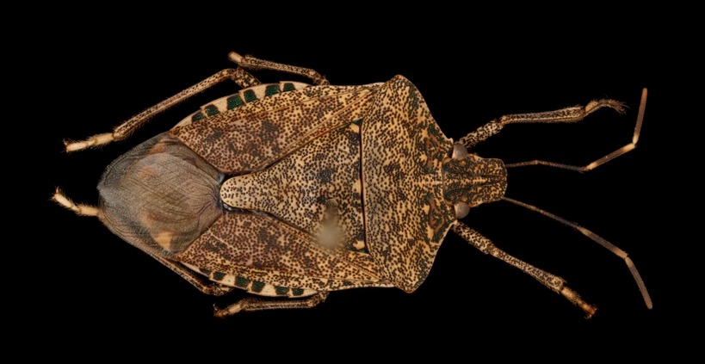

Adults:
- 12 to 17 millimetres long
- Brown shield-shaped body
- Pale, white bands on the antennae
- Distinctive black and white banding along body
Image 2: Brown marmorated stink bug (Halyomorpha halys), early instar nymphs and eggs. (© Gary Bernon, USDA APHIS, Bugwood.org)
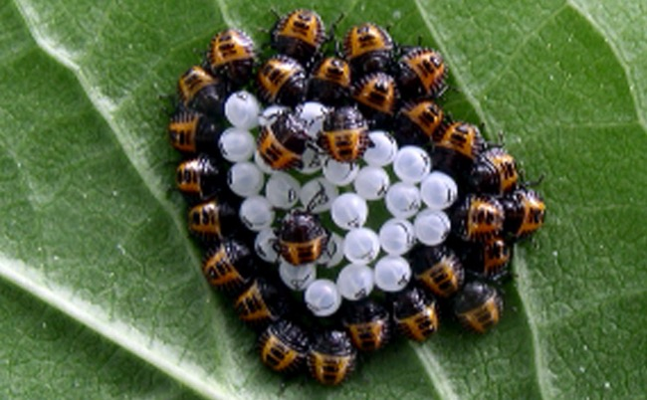

Juveniles (nymphs):
- Newly hatched – dark head and shoulders, red and orange abdomen with dark stripes
- Older – darker, begin to show banding pattern on the legs and antennae
- Juveniles cannot fly
Image 3: Brown marmorated stink bug (Halyomorpha halys), eggs.
(© Susan Ellis, Bugwood.org)
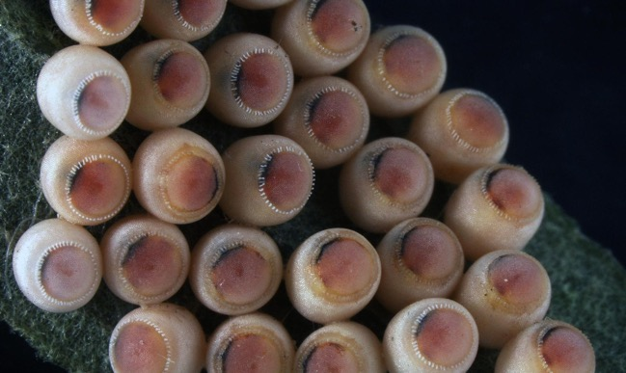

Eggs:
- White to light green colour
- Barrel shaped
- Laid in clusters of 25–30 on underside of leaves

Why is it a pest?
The brown marmorated stink bug, also known as BMSB, is a sneaky hitchhiker that tries to pass our borders by hiding inside imported shipping containers, machinery, goods and packaging – especially between September and April.
It is known to feed on and damage over 300 types of fruit, ornamental trees and vegetable crops, including apples and pears, peaches, cherries, berries, grapes, grains, sweetcorn, tomatoes, tree nuts and truffles.
Brown marmorated stink bug poses no risk to human health. It is a nuisance pest because it can enter homes, vehicles, machinery and sheds to seek shelter during cooler months – often in very large numbers.
They are not easy to treat with insecticides and produce a very unpleasant odour when disturbed or squashed, making them hard to remove.

How do I report it?
If you think you have found brown marmorated stink bugs, report this immediately to Agriculture Victoria by calling the Exotic Plant Pest Hotline on 1800 084 88, visiting agriculture.vic.gov.au/reportaplantpest or using the QR code below:
It’s important to make a report as soon as possible. Make sure to take clear photos of the pests and damage to include in your report if you can. Information on how to take a quality photo for identification can be found on our reporting page.

Other bugs you might find
Not all stink bugs are invasive pests. There are different stink bugs, and bugs that look very similar to stink bugs, that can be found in Victoria and other parts of Australia. Some of these bugs are listed below and can help you to identify stink bugs in the Great Biosecurity Quest! Remember, if you think you have found a brown marmorated stink bug or other exotic pest, make sure you report it immediately.

What could it be confused with?
Name and habitat of bug | Photo of Bug
Acacia shield stink bug (Alcaeus varicornis)  Present in Australia:  VIC, ACT, NSW, NT, QLD, SA, WA  Photo credit:  Jean and Fred Hort, Flickr (CC BY2.0) | 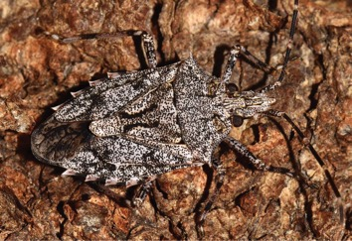
Golden brown shield bug (Anchises parvulus)  Present in Australia:  VIC, ACT, NSW, NT, QLD, SA, WA  Photo credit:  Graham wise from Brisbane Australia (CC BY 2.0) Wikimedia Common) | 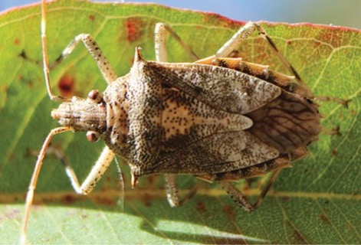

Name and habitat of bug | Photo of Bug
Brown long-headed shield bug (Austromalaya reticulata)  Present in Australia:  NSW, QLD, NT WA (Papua New Guinea)  Photo credit:  Gary ALA.org.au (CC BY NC 4.0) | 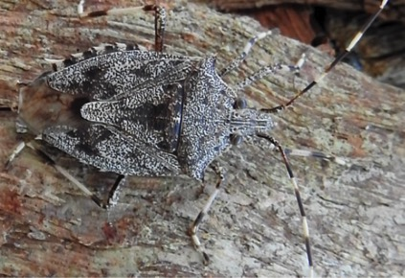
Zebra shield bug (Bathrus variegatus)  Present in Australia: NSW, QLD  Photo credit: © CSIRO | 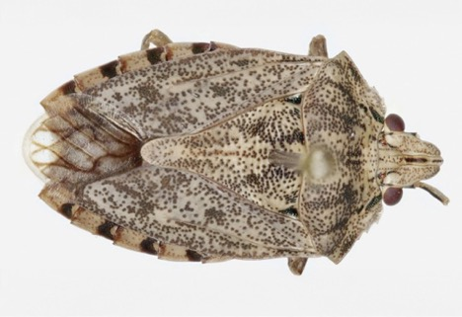
Small brown stink bug  (Caystrus pallidolimbatus)  Present in Australia:  QLD, NT (Papua New Guinea, Vanuatu)  Photo credit:  (Brisbane Insects.com) | 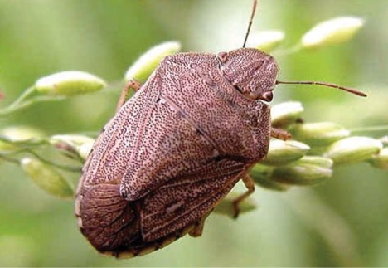
Glossy shield bug  (Cermatulus nasalis)  Present in Australia:  VIC, ACT, NSW, NT, QLD, SA, WA,  (New Zealand)  Photo credit: © CSIRO | 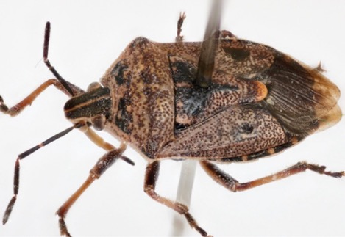
Brown shield bug  (Dictyotus caenosus)  Present in Australia:  VIC, ACT, NSW, NT, QLD, SA, WA,  (New Zealand, New Caledonia)  Photo credit: © CSIRO | 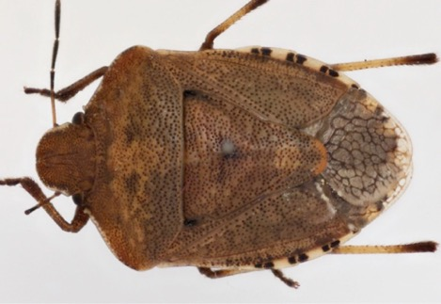
Gum tree shield bug  (Omyta centrolineata)  Present in Australia:  VIC, NSW, QLD, SA, TAS  Photo credit: © CSIRO | 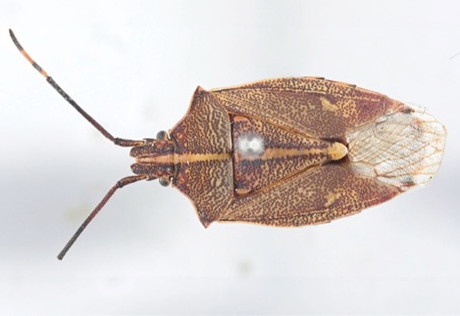
Brown stink bug  (Oncocoris apicalis)  Present in Australia:  VIC, ACT, NSW, NT, QLD, SA, WA  Photo credit: © CSIRO | 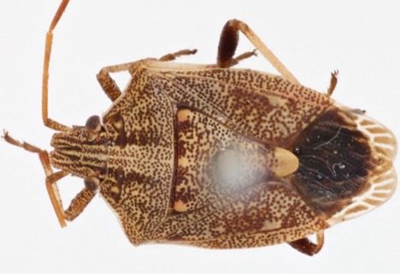
No common name  (Oncocoris geniculatus)  Present in Australia:  VIC, ACT, NSW, QLD, SA, TAS  Photo credit:  Carol Page iNaturalist.org (CC BY NC 4.0) | 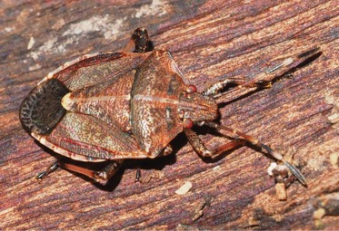
Gum tree shield bug (Poecilometis strigatus)  Present in Australia:  VIC, ACT, NSW, QLD, SA  Photo credit: © CSIRO | 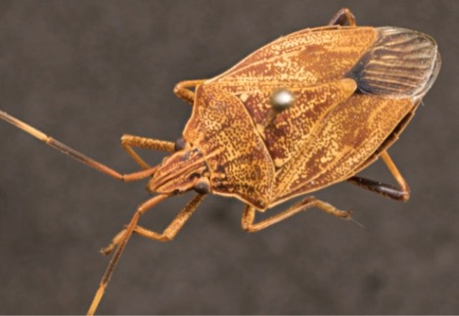
Gum tree shield bug  (Theseus modestus)  Present in Australia:  VIC, ACT, NSW, NT, QLD, SA, WA  Photo credit: © CSIRO | 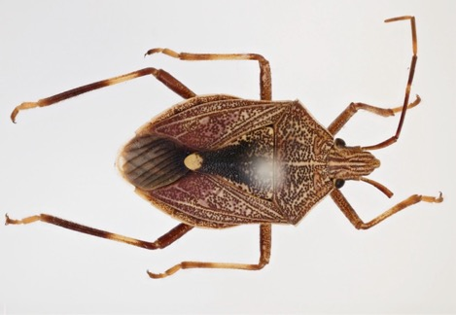

Disclaimer:
This publication may be of assistance to you but the State of Victoria and its employees do not guarantee that the publication is without flaw of any kind or is wholly appropriate for your particular purposes and therefore disclaims all liability for any error, loss or other consequence which may arise from you relying on any information in this publication.
Information is correct as of December 2023.
agriculture.vic.gov.au/biosecurity
End of document.

