Wildlife and Small Institutions Animal Ethics Committee
Project Amendment Request Form (V July 2023)
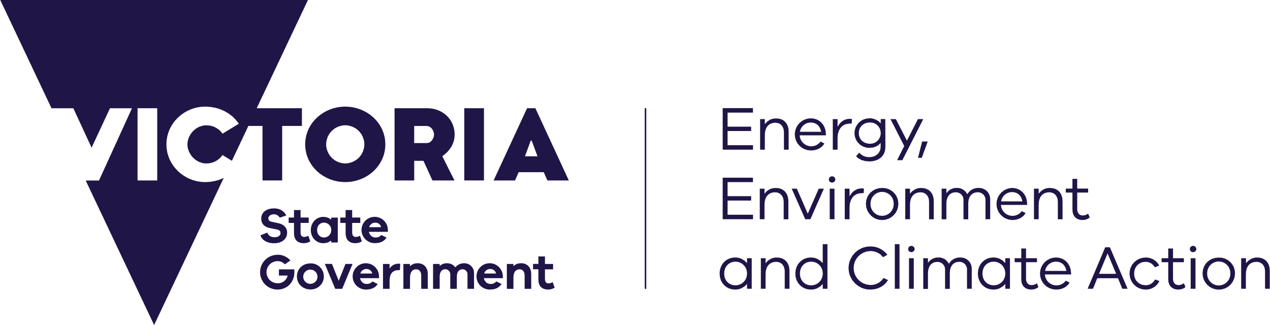
deeca.vic.gov.au

Information for applicants
This form is to be lodged for amendments to the procedures involving animals or changes in the experimental design.
Please be advised that applicants must:
- Complete all sections of this form.
- Give a clear concise rationale for the amendment.
- Forward the completed form to wsi.aec@ecodev.vic.gov.au
- Forward to the WSIAEC via wsi.aec@ecodev.vic.gov.au an electronic copy of the Approved Project with the requested changes highlighted using track changes.
- Be aware that if the requested amendment is considered by the WSIAEC to be not in line with the original aims of the project, the applicant will be required to lodge a new ethics application.
- Be aware that delays may occur if the above instructions are not followed (e.g. request not signed, not clearly written or submitted after the relevant WSIAEC submission dates WSIAEC website)
- A minor amendment may be reviewed, at the discretion of the Executive Officer and the Chair, by an Executive of the WSIAEC out of session, examples of a minor amendment are minor changes to protocol or procedures with no or less animal welfare impact, minor changes to number or strain of animal with no impact to animal welfare.
- All other amendments must be reviewed at a quorate WSIAEC meeting. If any of the amendments requested on this form are considered not of a minor nature all amendments will be considered by the full WSIAEC meeting. If any minor amendments required are of an urgent nature or you believe there are animal welfare improvements as a result of this amendment you must notify by email (wsi.aec@ecodev.vic.gov.au) of the urgent nature of this request.
- If there are a significant number of applications to modify a project over time the WSIAEC may decide that it is too difficult to understand the impact of the research or teaching activities on the animal(s) and will require a resubmission of a new application, and the application to modify the project will be denied.
You are reminded that the amendment cannot occur or be implemented without formal written approval from WSIAEC.

Privacy Statement
The DEECA is committed to protecting personal information provided by you in accordance with the principles of the Victorian privacy laws.
The information you provide will be used for the purposes of the function of the Wildlife and Small Institutions Animal Ethics Committee (WSIAEC) which is administered according to the Prevention of Cruelty to Animals Act 1986 (POCTA) and regulations 2008 and the terms of reference of the WSIAEC.
The information you provide will be made available to members of the WSIAEC, The Minister for Agriculture and DEECA employees administering the POCTA Act and may be disclosed to another government organisation for the purpose of administering or enforcing the Catchment and Land Protection Act 1994, Wildlife Act 1975, POCTA Act or other relevant state, territory or commonwealth legislation.
If all requested information including correspondence and related documents is not received the WSIAEC will be unable to adequately assess or review your application or approved project. This may result in your application not being considered by the WSIAEC or suspension of approval of a project.
You may access the information you have provided to DEECA by contacting DEECA’s WSIAEC Executive Officer, 475 Mickleham Road, Attwood, Victoria 3049.

Submission
Send your completed form and supporting documentation to wsi.aec@ecodev.vic.gov.au

Application form

Project Number, Project Title and Applicant

Type of Amendment Request – Select one or more of the following options:
Add investigator or co–investigators
Indicate how many co-investigators there are before the below are added:
List the names of the co-investigators and their qualifications plus provide qualifications for any trainers listed.

Remove investigator or co–investigators
Indicate how many co-investigators remain once these are removed:
List the names of the co-investigators who are being removed.

Extension
Indicate the duration of the extension period being requested.

Change of protocol
Indicate the amended protocol

Other
Provide detail of the amendment request

Amendment Rationale
Give clear concise rationale for the amendment/s

Has a prior amendment been approved by WSIAEC for this project?
Yes No
- If yes, provide a summary of all previously approved amendments and the date of approval.
Type | Detail | Date approved
Investigator / Extension/Protocol / Other
Investigator / Extension/Protocol / Other

Applicant declaration
By submitting this amendment request I hereby declare that:
- the above information is true and correct and
- I have attached to this application, the applicable declarations and/or marked up project application as relevant.
Chief Investigator Name:
Chief Investigator Signature:
Date:

