Information for food outlets
Food waste containing meat or other animal by-products must not be fed to pigs. It may contain animal viruses such as those that cause foot-and-mouth disease and African swine fever.
These viruses are not always destroyed by chilling, freezing, curing or cooking.
Australia is currently free of foot-and-mouth disease and African swine fever, but if introduced these diseases could have a significant impact on Australia’s livestock industries. Such diseases could enter Australia through imported meat products.
Pork remains safe to eat. African swine fever does not pose any risks to human health or food safety.
Banning the feeding of prohibited food waste to pigs (known as ‘swill feeding’) helps to protect Australia from these diseases.

There are significant penalties for feeding prohibited food waste or supply it to a piggery.
THE PENALTY FOR FEEDING PROHIBITED FOOD WASTE OR SUPPLYING IT TO A PIGGERY IS $23,077 FOR AN INDIVIDUAL AND $69,231 FOR A BODY CORPORATE.
It is illegal to feed prohibited food waste to pigs or to supply it to a piggery.
If you are caught storing or collecting for the purposes of feeding, or supplying, feeding or directing a person to feed this food waste to pigs, you will be prosecuted and face large fines.

Illegal activities include:
• feeding or directing a person to feed prohibited food waste to pigs
• supplying prohibited food waste to feed pigs
• collecting prohibited food waste from food premises to feed pigs
• storing prohibited pig feed on a premise where pigs are kept.

Foods that must not be fed to pigs
Feeding meat, meat by-products, imported dairy products (excluding those imported legally for stock feed), and any food that has been in contact with meat is banned. Examples include:
• pizza bun rolls, meat pies
• bacon and cheese rolls, salad rolls containing meat
• vegetables, rice, pasta and bread that has been in contact with meat (including on the same plate).
• Caesar salad (because it contains bacon pieces)
• steak, hamburgers, sausages, butcher’s shop waste
• imported dairy products such as butter and cheese.

Responsible disposal of food waste
Businesses that prepare and sell food (e.g. restaurants, bakeries, hotels, fast food outlets, hospitals) have a responsibility to dispose of food waste appropriately. Swill should be placed in an appropriate bin for collection by the council or commercial waste service for disposal in landfill or composting at an appropriate recycling facility.

Report the supply or feeding of prohibited food waste
If you know or suspect food waste is being supplied to pig owners, or pigs can access or are being fed prohibited food waste, you should confidentially report this activity to Agriculture Victoria as soon as possible on 136 186 to help protect Australia’s disease-free status.
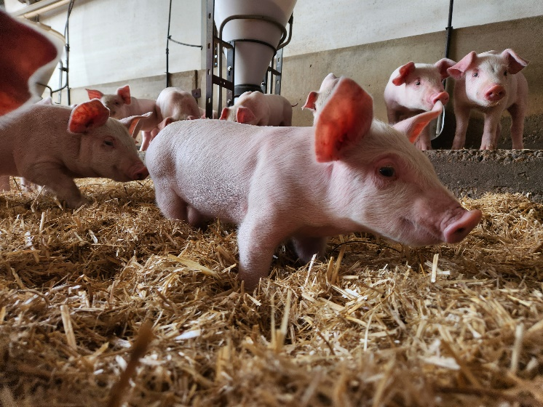

For more information visit agriculture.vic.gov.au/africanswinefever or call 136 186.
Produced with the assistance of the South Australian Government.

