|  |
| --- |
| Agriculture Victoria |
| Sheep and Goat Compensation Fund |
| 2021-24 Outcomes Summary |

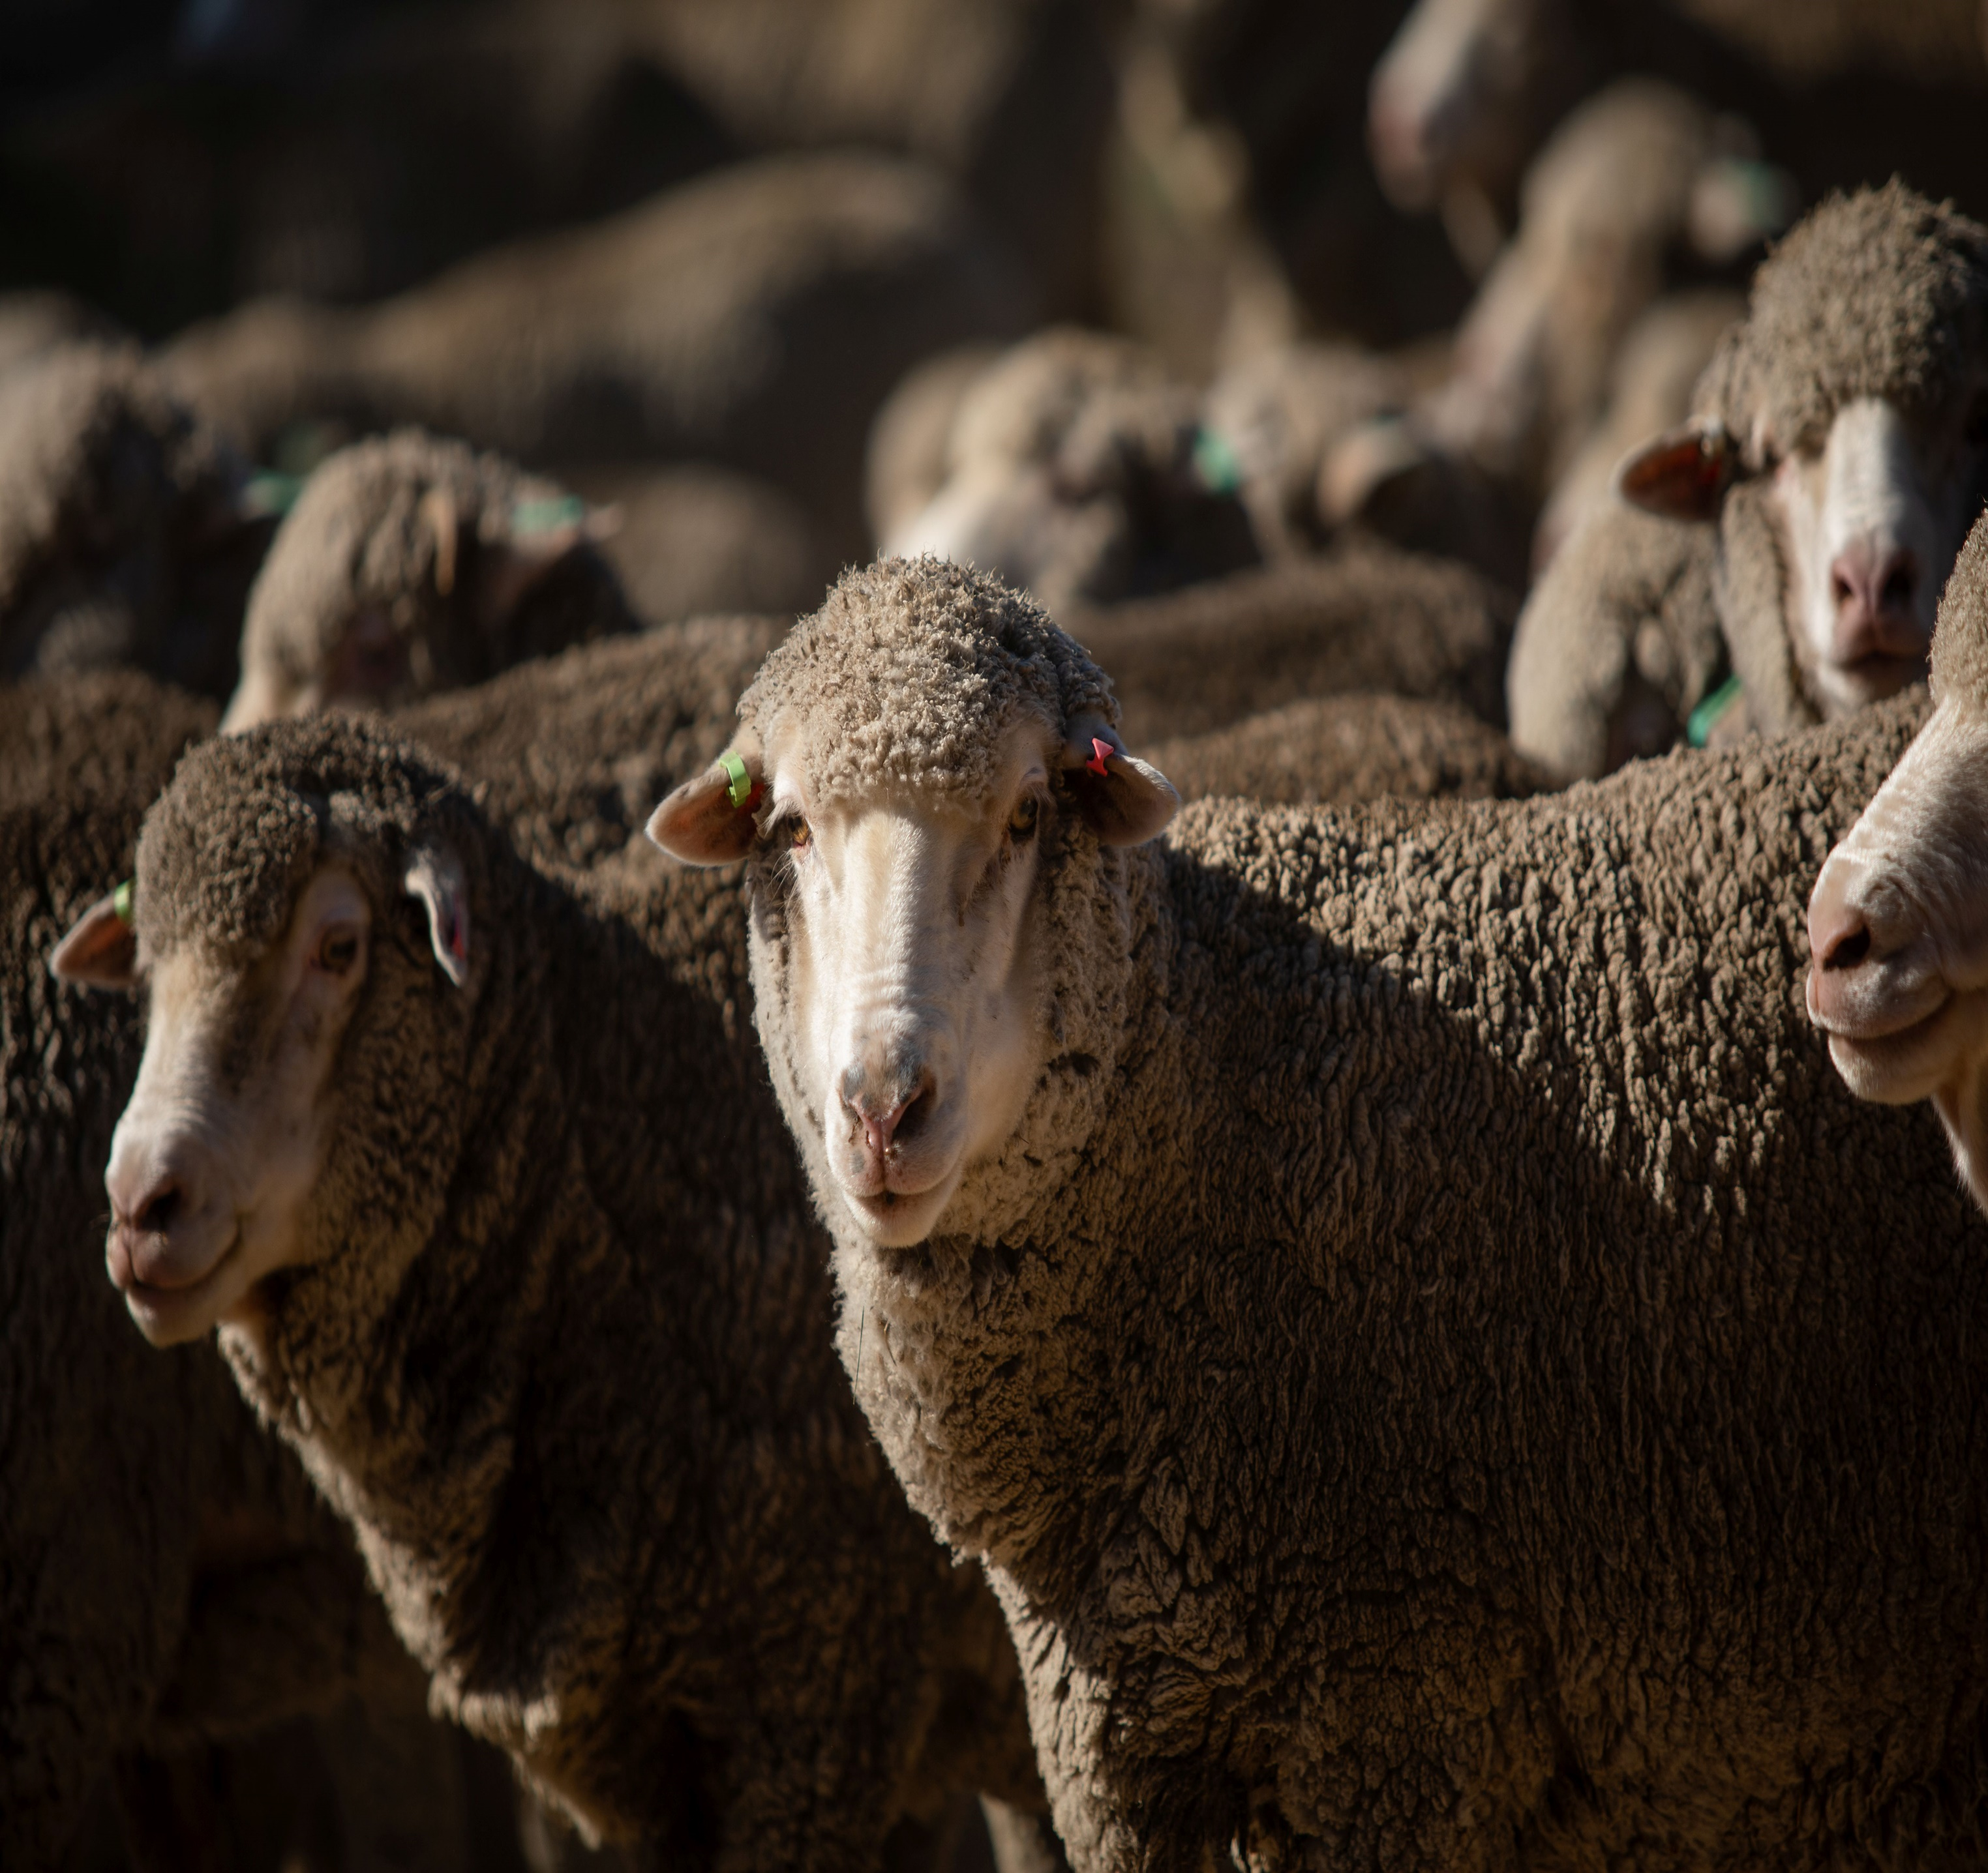

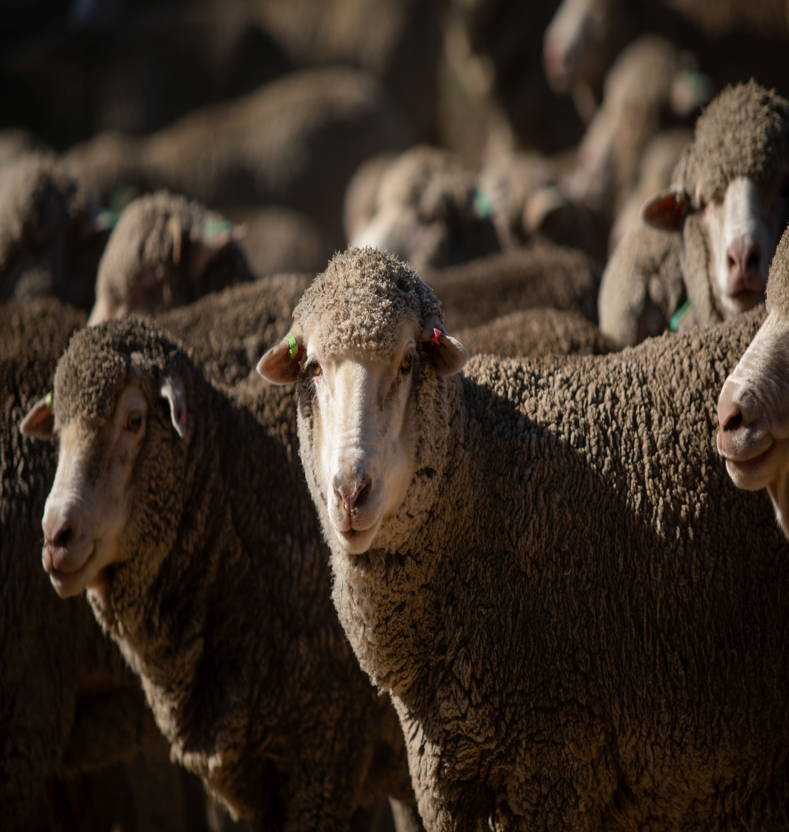

**Further information regarding the Livestock Biosecurity Funds may be obtained from:**

Monica Bird  
Agriculture Victoria  
475 Mickleham Road, Attwood, Victoria Australia

[LivestockBiosecurityFund@agriculture.vic.gov.au](mailto:LivestockBiosecurityFund@agriculture.vic.gov.au)

Authorised and published by the Victorian Government, Department of Energy, Environment and Climate Action (DEECA) 2024. © The State of Victoria Department of Energy, Environment and Climate Action 2024.

This publication is copyright. No part may be reproduced by any process except in accordance with the provisions of the *Copyright Act 1968*.

For more information contact the Agriculture Victoria Customer Service Centre on 136 186.

**Disclaimer**

This publication may be of assistance to you, but the State of Victoria and its employees do not guarantee that the publication is without flaw of any kind or is wholly appropriate for your particular purposes and therefore disclaims all liability for any error, loss or other consequence which may arise from you relying on any information in this publication.

**Accessibility**

If you would like to receive this publication in an accessible format, such as large print or audio, please telephone 136 186.

Deaf, hearing impaired or speech impaired? Call us via the National Relay Service on 133 677 or visit www. relayservice.com.au

This document is also available on the [Agriculture Victoria](https://agriculture.vic.gov.au/support-and-resources/funds-grants-programs/sheep-and-goat-compensation-fund) website.

# Sheep and Goat Compensation Advisory Committee

The Sheep and Goat Compensation Advisory Committee (SGCAC) provides recommendations to the Minister for Agriculture for expenditure from the Sheep and Goat Compensation Fund (SCGF), through the annual Livestock Biosecurity Funds Grant Program. Successful projects and programs prevent, monitor, and control diseases, thereby enhancing animal health, biosecurity and market access for the benefit of Victorian sheep and goat industries.

The Minister for Agriculture appoints the SGCAC chairperson and members on the basis of their skills and experience in the prescribed areas under the *Livestock Disease Control Act 1994* (the Act).

The SGCAC met 8 times in the 2023-2024 financial year, supported by Agriculture Victoria as secretariat.

# Activities of the Committee

Key activities since July 2023 include:

* The assessment of 2024 Livestock Biosecurity Funds grant program and contributing to the continuous improvement of the annual grant rounds
* Finalisation of a SGCAC Strategic Communications and Engagement Strategy that is being rolled out over the next 3 grant rounds
* Reviewed the strategic focus for the 2024 Livestock Biosecurity Funds grant program
* Contributed to the new member’s selection process and improved induction and handover to new membership
* Oversight of the SGCF and milestones for successful projects

## Livestock Biosecurity Funds Grant Program

Since the last report, the SGCF has been a part of the following Livestock Biosecurity Funds Grant Program rounds. See background below for more detail.

The SGCAC assessed every application received against the selection criteria set out in the Guidelines. In finalising their recommendation and supporting justification to the Minister, the SGCAC considered their individual assessments, the available balance of their fund and a report from an independent assessment panel to determine the successful projects. An independent Probity Advisor oversaw the conflict-of-interest declarations and recommended the appropriate treatment of each.

### 2021 Livestock Biosecurity Funds Grant Program

The 2021 Livestock Biosecurity Funds Grant Program was open from 17 September to   
26 November 2021.

The SGCAC assessed all applications in early 2022 and recommended 6 projects, totalling $618,247.97 to the Minister for Agriculture for approval:

* Validated molecular assays for Johne’s Disease in goats
* Truck wash and effluent disposal review (Phase 1)
* Livestock AMR Practices - Industry Review and Survey
* Risks and Records (Sheep and Goat)
* Validation of In-field detection of Sheep lice
* Autogenous Vaccine Development - Sheep

### 2022 targeted Livestock Biosecurity Funds Grant Program round

In June 2022, SGCAC agreed to participate in a joint targeted funding round, together with the cattle and swine livestock advisory committees.

The 3 committees identified a gap in emergency preparedness in the projects funded by the Livestock Biosecurity Funds given the outbreaks of Lumpy Skin Disease and Foot and Mouth Disease in Indonesia in 2022.

Invitations were sought from Agriculture Victoria, with 2 successful projects recommended by the SGCAC and approved by the Minister for Agriculture, totalling $75,000 (SGCF contribution $24,000):

* Strategic holding facilities for use during a livestock standstill
* On farm disposal tool

### 2022 Livestock Biosecurity Funds Grant Program

The 2022 Livestock Biosecurity Funds Grant Program was open from 27 October to   
23 December 2022.

The SGCAC assessed all applications in early 2023 and recommended 8 projects, totalling $365,000, to the Minister for Agriculture for approval:

* Control and prevention of anthrax
* Optimal outcomes for Victoria during a FMD incursion
* Victorian Significant Disease Investigation (SDI) Program
* Community pig control and surveillance
* Electronic National Livestock Identification System (NLIS) (Sheep) tag subsidy
* Rapid On-Farm Test for Barber’s Pole Worm
* Sheep and goat reconciliation with animals transacted in Victoria
* StockSense Livestock

### 2024 Livestock Biosecurity Funds Grant Program

The 2024 Livestock Biosecurity Funds Grant Program was open from 4 March 2023 to   
15 April 2024, including a webinar to launch the round, presented by all 4 committees.

The SGCAC assessed all applications in mid-2024 and recommended 13 projects, totalling $2,262,792, to the Minister for Agriculture for approval:

* A modular program for the onfarm integration of developing veterinarian
* Animal Disease Investigation (ADI) Course
* Electronic National Livestock Identification System (NLIS) (Sheep) tag tender
* Enhancing veterinary surveillance capability in Victoria
* Infected Premises - Livestock Producers Awareness Course
* Managing animal mortalities in emergencies - Training Course
* Private veterinary practitioner up-skill, online project
* Producer Led Extension (StockSense Livestock)
* Rapid multiplexed immunoassay for priority internal parasites of sheep
* Risks of potential EAD transmission between feral pigs and farmed livestock
* Stage 2 - Truck wash review - Addressing biosecurity risks
* Testing and optimising rapid appraisal outbreaks in Victorian sheep & goats
* Victoria's Footrot Footprint- monitoring, awareness and education program

## Improvements to the governance and operation of the committee

### Improved communications and engagement

The SGCAC developed a Communications and Engagement Strategy that outlines the tools, channels and activities to ensure the grant round attracts quality applications, and the benefits of the SGCF projects are shared with industry. The SGCAC Communications and Engagement Strategy will be implemented over the next 3 rounds and reviewed every 3 years.

As part of the rollout of the SGCAC Communications and Engagement Strategy, the inaugural webinar to launch the 2024 grant round was held on 4 March 2024. The   
4 chairpersons presented an overview of the 2024 Livestock Biosecurity Funds Grant Program and its strategic focus, eligibility, requirements and how to apply and held a Q&A session. The recording is available on the [Program Website](https://agriculture.vic.gov.au/support-and-resources/funds-grants-programs/livestock-biosecurity-funds).

### Strategic focus for annual rounds

The SGCAC reviewed the strategic direction for the SGCF in late 2023 and identified 5 key themes:

* Preparedness for response – Prevention and building response capability, capacity and planning
* Traceability – enhance system integrity and effectiveness
* Early detection – improved surveillance and monitoring
* Education – awareness and training for industry to better manage biosecurity risks
* Research – particularly technologies for testing and treatment (eg vaccines)

In addition, the SGCAC identified 4 targeted areas for 2024:

* Livestock veterinary capability to respond to an EAD outbreak
* Antimicrobial stewardship.
* Data management and animal health feedback.
* Livestock treatment and potential residues.

This strategic focus formed the selection criteria for the 2024 grant round and was incorporated in the Guidelines.

### Member selection changes and improved committee inductions and handover

From October 2022, changes were made to the *Livestock Disease Control Act 1994*, to allow for a maximum of 9 members appointed by the Minister for Agriculture based on skills and experience.

The Minister for Agriculture makes an appointment after considering a candidate’s experience in one or more of the following areas:

* the sheep and goat and allied industries
* biosecurity or market access
* quality assurance and food safety
* finance, legal practice, or business management
* agricultural, animal or veterinary science
* public policy
* any other area the Minister considers relevant to the functions of the Committee

The livestock advisory committees were consulted on the legislative changes and in the development of the selection process in 2022 and 2023.

The SGCAC also worked with the Secretariat to develop the additional criteria for the selection of SGCAC members and an improved induction package for the new SGCAC membership.

## Appointment of a new committee

The previous membership, appointed by the Minister for Agriculture from prescribed nominating bodies expired in 2024. Following a 3-year term and a short-term extension, an Expression of Interest process for SGCAC membership was open from 10 May to   
11 April 2024

A Selection Panel, chaired by Agriculture Victoria and including industry representation, assessed all applications against the selection matrix. The Selection Panel conducted interviews and probity checks and recommended the preferred candidates to the Minister for Agriculture.

The Minister for Agriculture appointed the below members for a 3-year term, from   
12 August 2024.

* Ms Kaylene Baird (chairperson)
* Mr Peter Baldwin (member)
* Ms Georgina Gubbins (member)
* Ms Celia Scott (member)
* Mr Mark Inglis
* Ms Liz Mann
* Mr Thomas Gooden

# LBF grant program projects

Milestone management of the successful projects is overseen by the Department of Energy, Environment and Climate Action (DEECA), in consultation with the SGCAC.

A summary of project activity since 1 July 2020 to 31 August 2024 is below.

## Summary of active SGCF projects

| Project (Recipient) | Project Timeline | Total allocated from SGCF | Achievements to  31 August 2024 |
| --- | --- | --- | --- |
| 24.24 A modular program for the onfarm integration of developing veterinarian  (Herd Health)  To enhance the skills of Victoria’s emerging livestock veterinarians through a modular development program focused on on-farm management, biosecurity, disease investigation, and emergency response. | Oct 2024 – May 2026 | $70,911.00 | Proposed curriculum has been prepared |
| 24.07 Animal Disease Investigation (ADI) Course (Biosecurity Victoria)  A two-day course run by Agriculture Victoria Veterinary Officers and AgriBio pathologists annually in four different regional locations across Victoria delivering training in disease investigation, field epidemiology, biosecurity, and advanced necropsy techniques for Victorian livestock veterinary practitioners | Aug 2024 – Jun 2027 | $54,528 | Grant agreement executed August 2024 |
| 24.11 Electronic National Livestock Identification System (NLIS) (Sheep) tag tender (Biosecurity Victoria)  Coordinate preparation of tender related material both pre, during and after. Allowing Agriculture Victoria with continued industry support to provide attractively priced electronic NLIS ear tags to Victoria’s 50,000 active cattle producers | Jan 2025 - Feb 2026 | $62,500 | Grant agreement executed September 2024 |
| 24.13 Enhancing veterinary surveillance capability in Victoria (Biosecurity Victoria, DEECA)  To evaluate and strengthen the capability of private veterinary practitioners to deliver effective surveillance for livestock diseases in Victoria. | Dec 2024 – Jun 2027 | $84,330 | Grant agreement executed September 2024 |
| 24.28 Infected Premises - Livestock Producers Awareness Course  (P2r2 Consulting Pty Ltd)  To inform livestock producers as to what happens on an Infected Premises after an emergency animal disease has been diagnosed. | Oct 2024 –  Dec 2025 | $41,060 | Grant agreement executed September 2024 |
| 24.31 Managing animal mortalities in emergencies - Training Course  (P2r2 Consulting Pty Ltd)  Development of training materials, in consultation with Agriculture Victoria, on how to manage animal mortalities in emergency situations that are appropriate for livestock producers and staff involved in an emergency animal disease or natural disaster response | Aug 2024 – Nov 2026 | $78,675 | Successful completion of an extensive stakeholder consultation program and subsequent development of training course and materials. Also participated in a Veterinary Capability Workshop with other project participants to explore opportunities for synergies between other successful projects. |
| 24.18 Stage 2 - Truck wash review - Addressing biosecurity risks  (Biosecurity Victoria, DEECA)  Aims to build on the previously funded RMCG study/report in addressing the gap in Victoria's truck wash network in Melbourne's outer west. | TBC | $100,000 | Milestone negotiations underway. |
| 24.15 Private veterinary practitioner up-skill, online project (Biosecurity Victoria, DEECA)  Aims to increase the capability and confidence of private veterinary practitioners (PVP’s) to identify and respond appropriately to the suspicion of significant diseases (SD’s) in cattle, sheep, goats and pigs | Dec 2024 – Dec 2026 | $50,000 | Grant agreement executed September 2024 |
| 24.37 Producer Led Extension (Stock Sense Livestock)  (Victorian Farmers Federation)  Aims to increase producer awareness and adoption of practices that improve on-farm biosecurity and animal health in Victoria with a particular focus on peri urban landholders who have been identified as the highest biosecurity risk | Feb 2025 –  Dec 2025 | $395,000 | Grant agreement executed October 2024. |
| 24.20 Rapid multiplexed immunoassay for priority internal parasites of sheep (CSIRO)  Aims to improve the diagnosis of intestinal parasites through the development of a quantitative and differential ELISA-based coproantigen test that can be built into a lateral flow device with further investment. The test can be performed by an unskilled operator, multiplexed for species differential, is highly correlated with worm burden (especially for Teladorsagia) and can detect infestations earlier. | TBC | $699,788.00 | Grant agreement negotiations underway |
| 24.03 Risks of potential EAD transmission between feral pigs and farmed livestock  (Arthur Rylah Institute)  To quantify the potential risk of EAD transmission between farmed livestock (cattle, sheep and pigs) and feral pigs by quantifying areas in Victoria where feral pigs could pose a significant reservoir for EADs. Including identification of cost-effective strategies for managing feral pigs in the event of an EAD outbreak to eliminate the potential for disease transmission | Apr 2025 – Nov 2025 | $100,000 | Grant agreement executed in August 2024 |
| 24.33 Testing and optimising rapid appraisal for outbreaks in Victorian sheep and goats  (University of Melbourne)  To enhance preparedness for responding to emergency animal disease outbreaks and seek to minimise the negative impacts on the Victorian sheep and goat industry from potentially devastating outbreaks. | Mar 2025 – Oct 2026 | $120,000 | Grant agreement executed September 2024 |
| 24.25 Victoria's Footrot Footprint- monitoring, awareness and education program  (J.T. Agri-Source Pty Ltd)  This project aims to increase awareness amongst producers to better identify and treat Dichelobacter Nodosus (footrot) on farms. | Aug 2024 – Jul 2027 | $398,000 | Grant agreement executed in August 2024 |
| 22.13 Control and prevention of anthrax  (Biosecurity Victoria, DEECA)  To support anthrax vaccination of sheep and goats on affected and high-risk properties. | Jul 2023 – Oct 2026 | $75,000 | Progress reports have been delayed due to emergency animal disease response. |
| 22.12 Significant Disease Investigation (SDI) (Biosecurity Victoria, DEECA)  To enhance the capacity for early detection and control of diseases in livestock that could impact human health, animal health, farm productivity and market access and trade. | Jul 2023 - Oct 2026 | $360,000 | Communication and engagement plan submitted  There were 375 total sheep and goat disease investigations (323 sheep and 52 goat investigations) undertaken and reported to Agriculture Victoria between 1 July 2023 and 30 June 2024. |
| 20.10 eNVD Uptake - Whole Supply Chain  (Agrinous)  To eliminate inefficiencies in manual handling of paper NVD's and to ensure product integrity and enhanced biosecurity. | Oct 2020 – TBC | $66,046 | Progress delayed due to COVID impacts.  eNVD integration is complete.  Awaiting confirmation if project can continue given progress in this space since application in 2020. |
| 20.19 Point of Care (POC) testing for worm control  (Federation University)  The development of a diagnostic test (POC test) for producers to easily identify worm-resistant sheep for selective breeding. | Jan 2021 – Jun 2025 | $90,542 | A prototype lateral flow device has been developed to test for antibody against gastrointestinal nematodes (worms) in the saliva of sheep |
| 22.14 Stock Sense Livestock  (Victorian Farmers Federation)  Providing livestock producers with an information source including events, accessing information online and asking industry related questions, with the purpose of improving animal welfare. | Jan 2024 – Dec 2024 | $365,000 | Communications, activities and project plans for 2024 have been completed.  In 2024, there were 180 registrations for the Farming Essentials (Peri Urban) Webinar series with an average of 40 online participants.  2 sheep and goat workshops held in Bendigo and Dollar respectively, with a total 48 attendees across the 2 events.  242 registrations and 97 online participants for the Goat Essentials webinar series held on 16 & 17 July 2024. |
| 21.05 Livestock AMR Practices - Industry Review and Survey (Biosecurity Victoria, DEECA)  To increase awareness and support the implementation of best practice antimicrobial stewardship (AMS) and monitoring programs at a producer, veterinary prescriber and industry level.  It will ensure that process guidance given on AMS practices is aligned with State and national AMR Strategy objectives | Jul 2022 – TBC 2024 | $192,720 | The University of Melbourne Asia Pacific Centre for Animal Health (APCAH) has entered an agreement with the Department of Energy, Environment and Climate Action to conduct a review of Antimicrobial Stewardship (AMS) practices of veterinarians servicing the sheep and goat industries in Victoria.  Project completion delayed due to emergency animal disease response. |
| 21.14 Risks and Records (Agriculture Sector Development and Services, DEECA)  Extension program to develop livestock managers understanding, skills and confidence to implement traceability and biosecurity systems that underpin and protect Victoria’s livestock industry. | Jul 2022 – Jun 2025 | $103,500 | A total of 75 sheep and goat producers (67 sheep and 8 goat) attended a total of 12 workshops between June 2022 and July 2023, in addition to 77 cattle producers, averaging 12 cattle, sheep and goat producers per workshop. |
| 21.19 Validation of In-field detection of Sheep lice  (La Trobe University)  To develop a rapid, highly sensitive field-based, early identification technology to detect sheep lice (Bovicola ovis), potentially resulting in a significant saving in the sheep industry. | Oct 2022 – Nov 2024 | $58,080 | Project delayed due to resourcing.  Sheep fleece, including tailings were provided by farmers from various locations in South Australia and Victoria, Australia.  All samples were swabbed and evaluated to determine suitability for in-field processing |
| 21.03 Autogenous Vaccine Development (Biosecurity Victoria)  To eliminate the sole reliance of antibiotic treatment of a prioritised sheep disease. The research and development of an effective autogenous vaccine will enable sheep to develop immune protection against the endemic disease, reduce antibiotic treatments and improve overall animal health outcomes. | Jul 2022 – Sep 2025 | $154,396 | Completed project plan, scientific literature review, and detailed manufacturing plan.  Application for the APVMA permit in progress. |
| 22.11 NLIS Sheep and Goat Tag Subsidy  (Biosecurity Victoria, DEECA)  Subsidies for producers when purchasing NLIS tags for sheep and goats in Victoria | Jul 2024 – Mar 2026 | $2,925,000 | Continued assistance of Victorian sheep and goat producers with the identification of sheep and goats using NLIS system tags |
| 22.19 Community pig control and surveillance  (Biosecurity Victoria, DEECA)  Pilot program working with producers on private and private/public interface to control feral pigs and assist in monitoring genetics and presence or proof of absence of disease. | Dec 2023 – Sep 2026 | $118,909 | Group locations have been identified with one in East Gippsland and one in Hume. Engagement underway. |
| 22.08 Rapid On-Farm Test of Barber's Pole Worm  (Federation University)  Production of a fast, accurate and cost-effective test for farmers to implement appropriate management of Barber’s Pole and to detect early infections in sheep and goats before production loss and stock loss occurs. | Aug 2023 – Nov 2025 | $96,860 | A test has been developed that can rapidly detect Barbers Pole DNA in either faeces or a faecal float (a common test for parasitic worms). The test involves isolating DNA from a faecal float sample or directly from faeces, adding that sample to a solution of pink dye and heating the sample to 65 degrees for 30 min. If there is DNA from Barber’s Pole in the sample, then the colour will change to yellow. In its current format it can detect infections with greater than 250 epg. |
| 22.09 Sheep and goat duty reconciliation with animals transacted in Victoria (Biosecurity Victoria, DEECA)  To employ a person for a 12-month period to investigate discrepancies in duties paid by Sheep and Goat producers and what was received. The position will also raise awareness of how duty related income is utilised. | Jul 2023 – Oct 2025 | $160,000 | Recruitment delayed due to emergency animal disease response. Project led due to commence in December 2024. |

## Summary of SGCF projects closed - July 2021 to June 2024

| Project (Recipient) | Project Completed | Total SGCF contribution | Outcomes |
| --- | --- | --- | --- |
| 20.08 Control and prevention of anthrax (Biosecurity Victoria, DEECA)  To support anthrax vaccination of sheep and goats on affected and high-risk properties | August 2023 | $66,067 | This project has supported Victoria’s capacity for the prevention, early detection and rapid control of anthrax disease in sheep and goats. Between 1 July 2020 and 30 June 2023, the project facilitated the preventive vaccination of 18,612 sheep and 9 goats. |
| 20.21 Producer-Led Biosecurity Extension Program  (VFF)  To increase producer adoption of practices that improve on-farm biosecurity and animal health in Victoria | December 2023 | $621,448 | Stock Sense directly engaged over 300 producers in 2022, including through 17 regionally based face to-face workshops. Other producers have been engaged through webinars, a dedicated website, fact sheets, newsletters, industry talks and Stock Sense attending industry events and field days. Stock  Sense’s total reach in 2022 comprised nearly 100,000 people at various field days and over  100,000 people through print, social and radio mediums.  For both the Cattle and Sheep & Goat compensation funds, in 2023 a total of 20 Stock Sense events were held: 5 cattle, 5 sheep & goat, 5 peri urban, 2 supply chain training, 3 webinars and 5 field days were attended.  10 network groups were also formed, one for each Catchment Management area in Victoria. |
| 20.03 Animal Disease Investigation Course (Biosecurity Victoria, DEECA)  To deliver training in investigation, field, epidemiology, biosecurity and advanced necropsy techniques for Victorian veterinary practitioners | July 2023 | $26,966 | Over the three years of the project a total of 106 private veterinarians and 27 animal health staff were trained in disease investigation. These attendees were from across Victoria and some from South Australia that conduct livestock work in Victoria |
| 20.23 Significant Disease Investigation (SDI) (Biosecurity Victoria, DEECA)  To enhance the capacity for early detection and control of diseases in livestock that could impact human health, animal health, farm productivity and market access and trade. | August 2023 | $263,025 | There were 541 total sheep and goat disease investigations (489 sheep and 52 goat investigations) reported to Agriculture Victoria between 1 July 2022 and 30 June 2023.  Of these there were 202 investigations undertaken as part of the Significant Disease Investigation (SDI) program (198 sheep and 4 goat SDI investigations) |
| 21.18 Validated molecular assays for Johne’s Disease in goats  (Agriculture Victoria Research, DEECA)  To provide the sheep and goat industry with a rapid validated diagnostic test for Johne’s Disease to facilitate interstate movement of goats and overseas exports. | August 2023 | $40,118 | This project compared the HTJ-PCR with faecal culture using 216 goat samples that were collected from two monitored negative goat properties in Victoria and two infected properties in Victoria and New South Wales (NSW).  This evaluation resulted in a highly specific test with a suggested sensitivity that is similar to culture. However, there are several features that differ between faecal culture and faecal HTJ-PCR that affect their ability to accurately detect Map and are fundamental to understanding why both tests may derive different but true results. |
| 22.05 Strategic holding facilities for use during a livestock standstill  (Biosecurity Victoria, DEECA)  To provide saleyard staff at strategic holding sites the capability and a targeted training package to manage stock receival and biosecurity during a livestock standstill. | September 2023 | $16,000 | The ‘Strategic holding facilities for use during a livestock standstill’ project has been successfully completed by Agriculture Victoria staff to support our emergency preparedness efforts in the event of a foot-and-mouth disease outbreak. During the project, suitable locations able to receive livestock across the state of Victoria were cross analysed with livestock transport data to identify 11 active saleyards as ideal holding site facilities. Specific training was delivered to each of the holding site facilities, with ongoing plans to develop operational planning and capability of these facilities into the future |
| 22.02 On Farm Disposal Tool (Biosecurity Victoria, DEECA)  To develop a self-assessment tool to assist farmers in identifying suitable on farm disposal options as part of biosecurity planning. | September 2023 | $8,000 | AgVic and the Environment Protection Authority have co-developed a tool to help farmers plan for and respond to an emergency animal disease outbreak where large numbers of carcasses need to be buried and can be done so on farm. This tool can be used by farmers to update their biosecurity plans about if, where and how carcasses can be buried on their properties if necessary. |
| 21.16 Truck wash and effluent disposal review (Phase 1) (Biosecurity Victoria, DEECA)  To enhance biosecurity measures in the Victorian livestock industry by reviewing the existing state-wide network of publicly accessible truck wash and effluent dump facilities. | January 2024 | $69,434 | The [report](https://agriculture.vic.gov.au/biosecurity/animal-diseases/truck-wash-and-effluent-disposal-facilities-review) addresses:  1. Relevant trends and prospects in livestock industries  2. Demand and need for truck washing services and gaps in existing network of facilities  3. Need for additional facilities: number, their location(s) and infrastructure requirements  4. Relevant Environment Protection Authority (EPA) guidelines and regulations on effluent management  5. Indicative current costs of constructing and operating a new facility  6. Likely steps needed to improve truck washing in the event of a disease outbreak (noting the difficulty in prescribing specific or effective requirements for the wide range of possible individual disease outbreaks)  7. A financial analysis of the capacity of a well-located new truck wash facility to be a profitable investment and self-supporting (or a commercial operation)  8. Next steps in further exploring viable options to improve the truck wash network in Victoria. |
| 21.08 NLIS Sheep and Goat Tag Subsidy  (Biosecurity Victoria, DEECA)  Subsidies for producers when purchasing NLIS tags for sheep and goats in Victoria | December 2022 | $1,523,257 | For tags purchases from January 2022 to December 2022  Continued delivery of subsidies for producers when purchasing NLIS tags for sheep and goats in Victoria |
| 22.07 NLIS Sheep and Goat Tag Subsidy (Biosecurity Victoria, DEECA, DEECA)  Subsidies for producers when purchasing NLIS tags for sheep and goats in Victoria | August 2024 | $2,688,186 | For tags purchases from January 2023 to June 2024  Continued assistance of Victorian sheep and goat producers with the identification of sheep and goats using NLIS system tags |
| 22.10 Optimal outcomes for Victoria during a FMD incursion  (Biosecurity Victoria, DEECA)  Risk Management planning for a possible FMD incursion. Assessment of vaccinate-to-die versus vaccinate-to-live policies. | NA | $0 | Project withdrawn given alternate funding sourced.  $75,000 approved reallocated to SGCF. |
| 20.25 Sheep Notes (Agriculture Sector Development and Services, DEECA)  Continuation of the SheepNotes newsletter, distributed to over 18,000 sheep farmers in both hard copy and e-versions, twice yearly. This will include a review of the distribution method over a two-year period and look to transition to a digital path. | February 2024 | $115,060.43 | A 16-page hard copy SheepNotes were produced and distributed to approximately 17,000 producers with PICS, agents, vets and advisers in Spring and Autum across 2021 to 2023.  A corresponding e-newsletter was sent to approximately 700 subscribers, with a 51% average open rate. Articles were also hosted on the Ag Vic site website |
| 17.01 Validation of a field test for the Identification of anthrax in Victorian Sheep (Biosecurity Victoria, DEECA)  To determine the true accuracy of the Immunochromatographic test (ICT) kit for the identification of anthrax in sheep. | June 2024 | $219,744.89 | The team achieved the intended outcome of concluding that the anthrax ICT kit is a reliable test for field investigations of anthrax in sheep, to promote rapid detection of anthrax and allow appropriate controls to be implemented to prevent further cases, protect public health and minimise trade and export issues associated with anthrax outbreaks. |

# Background

## Sheep and Goat Compensation Fund

Victoria's Sheep and Goat Compensation Fund (SGCF) is established under the Act and is funded from livestock duties paid on the sale of sheep and goats or their carcasses in Victoria.

The SCGF receives 35 cents ($0.35) for each sheep or goat, or each carcass, sold from January 2023.

The Act sets out how the money in the SGCF may be used. This is generally for projects and programs that benefit the Victorian sheep and goat industries, compensation for specified endemic diseases and administration of the SGCF.

All expenditure from the funds require approval from the Minister for Agriculture, after considering the advice from the SGCAC.

## Livestock Biosecurity Funds Grant Program

The Livestock Biosecurity Funds Grant Program is administered by the Department of Energy, Environment and Climate Action, with funding from the respective fund:

* Cattle Compensation Fund
* Sheep and Goat Compensation Fund
* Swine Compensation Fund
* Honey Bee Compensation and Industry Development Fund.

The Livestock Biosecurity Funds Grant Program aims to fund projects and programs that prevent, monitor, and control diseases, thereby enhancing animal health, biosecurity and market access for the benefit of Victorian cattle, sheep, goat, swine and honey bee industries.

Livestock Biosecurity Funds Grant Program funds are used for projects producing outcomes, consistent with the Act, which demonstrates the following principles:

* Innovative solutions and emerging technologies for unsolved livestock biosecurity issues, needs or gaps.
* Collaboration where possible across value chains.
* Quantifiable benefits to the whole of the livestock industries, which are measured and evaluated with evidence and data.

Each of the funds has a statement of strategic intent, outlining areas for investment and outcomes within the purpose and objectives of the Act. These are included in the Guidelines each year.

For more information on the Program, see [agriculture.vic.gov.au/support-and-resources/funds-grants-programs/livestock-biosecurity-funds](https://agriculture.vic.gov.au/support-and-resources/funds-grants-programs/livestock-biosecurity-funds).

# Current membership

* **Kaylene Baird** (chairperson) is a dedicated professional who seamlessly balances her roles as a critical care registered nurse and a commercial farmer. Alongside her husband Bill, she manages Weeroona Boers, a modest Boer goat and cattle farm in Victoria’s Western District. Kaylene’s passion for agriculture is matched by her commitment to healthcare, and rural communities, where she serves as a critical care nurse in Ballarat.

Kaylene is a long-standing member of the Royal Australian Nursing Corps Reserve, currently posted to the Royal Victoria Regiment (Infantry).

* **Peter Baldwin** (member) is one of Australia’s finest Property Auctioneers Peter has enjoyed a phenomenal career in the Property and Livestock industry Australia wide having auctioned over 38,000 properties with an aggregate value of over $15 Billion.​Peter Holds a Bachelor of Business majoring in Valuation, is a Class 1 Licensed Stock & Station Agent, Real Estate Agent in NSW, registered valuer, Licensed Estate Agent, General Auctioneer, Chattel Auctioneer, Queensland and Licensed Estate Agent Victoria.​
* **Georgina Gubbins** (member) is a progressive red meat producer farming in Southwest Victoria. Georgina has a Masters of Agribusiness from the University of Melbourne, a Fellow of the Australian Institute of Company Directors (FAICD), and a past Livestock Councillor for the Victorian Farmers Federation. Georgina was awarded an Order of Australia Medal for services to agriculture and the community in January 2024.
* **Celia Scott** (member) is a farmer in South West Victoria, running self-replacing composite sheep and seedstock cattle enterprises. This is Celia’s second sitting on the SGCAC and in recent years has been a VFF livestock councillor for the Glenelg region and sat on the Sheep Producers Australia Policy Council.
* **Mark Inglis** (member) is experience in animal husbandry and animal production working on and managing a broad range of livestock orientated properties including cattle properties in Western Australia’s Kimberley, sheep properties both wool and meat in Victoria and establishing a 900-sow outdoor free range pig breeding operation. Mark spent 7 years working for MLA/MSA with producers, stock agents, saleyards, feedlots and livestock buyers to gain a greater understanding of the pathways into both the cattle and sheep MSA programs.​
* **Liz Mann** (member) owns and operates a Poll Dorset Stud in Northern Victoria. Liz is actively involved in the Poll Dorset Association being secretary of the Goulburn Valley Region, Secretary of the Vic State, and also a Federal Board Member.​ Liz has a Bachelor of Agricultural Science (Honours), Graduate Diploma in Agricultural Management & Extension, and Diploma from the Australian Institute of Company Directors.
* **Thomas Gooden** (member) has 16 years of experience in the livestock industry, with a decade spent at Growth Farms Australia, leading to his current role as Group Agricultural Manager for Burgess Rural. Thomas has managed large-scale grazing operations in prime lamb, wool, and beef enterprises across New South Wales and Victoria.

# Previous membership

* Michael Craig (Chairperson) Sheep industry nominee
* Celia Scott (member) Sheep industry nominee
* Scott Young (member) Sheep industry nominee
* Kate Dorahy (member) Sheep industry nominee
* Kaylene Baird (member) Goat industry nominee
* Peter Baldwin (member) Livestock agents’ nominee
* Noel Kelson (member) Meat processing nominee
* Georgina Gubbins (member) Department nominee