Victorian Wine Strategy 2025-2030
Table of Contents
Ministers' foreword 2
Wine Victoria Chair's foreword 4
Executive Summary 5
Our Vision – Victorian wine: enjoyed locally, acclaimed globally. 6
Our 4 priorities 9
Introduction 16
1. Domestic and international trade 28
2. Innovation and Sustainability 37
3. Visitor Experience 44
4. People and Community 48
Publication information 53

Ministers' foreword
Victoria boasts 21 unique wine regions producing some of Australia’s most celebrated wines that are enjoyed around the world. The Victorian wine industry is not only a critical part of our agricultural sector but also an important player in Victoria’s visitor economy and thriving food and drink scene. This strategy is not just about wine, but about the individuals and communities who shape Victoria’s dynamic and diverse wine industry. From the grape growers and winemakers to the visitors who come from near and far to experience our exceptional wines – this strategy is for you.
The wine industry contributes $9.5 billion to the Victorian economy each year and supports over 10,000 direct jobs in the sector, as well as 13,767 flow-on jobs. With over 400 cellar doors, Victoria offers a unique opportunity for visitors to engage directly with winemakers, fostering a deeper connection to the people and passion behind every bottle. Victoria currently exports wine to around 60 countries and continues to seek out opportunities to increase exports and ensure Victoria’s acclaimed wines are enjoyed across the globe.
We know the industry is facing many challenges including supply and demand imbalance, international trade disruptions, climate change, and biosecurity risks. This strategy outlines a roadmap for how government will partner with industry to overcome these obstacles and embrace opportunities through innovation and collaboration. By working together, we are optimistic our united wine industry will grow more vibrant and prosperous, ensuring that Victorian wine continues to be enjoyed locally and acclaimed globally.
We are confident that this strategy will not only enhance the profitability and sustainability of our wine industry but will also support economic growth across regional Victoria. The Victorian Government has a long history of partnership with the wine industry, and we proudly developed this strategy in collaboration with Wine Victoria and other industry leaders. Together, we can elevate Victoria’s wine industry to new heights and strengthen the industry into the future.
The Hon. Ros Spence
Minister for Agriculture
The Hon. Danny Pearson
Minister for Economic Growth and Jobs
The Hon. Steve Dimopoulos
Minister for Tourism, Sport and Major Events

Wine Victoria Chair's foreword
The Victorian wine industry is a vibrant, resilient and deeply interconnected community of growers, makers, marketers and storytellers. This strategy reflects the collective ambition of our sector – to adapt to changing conditions, embrace innovation and continue producing world-class wines that proudly represent Victoria’s terroir and talent.
Developed in close partnership with the Victorian Government and through extensive consultation with our members, this strategy captures the authentic voice of industry. It acknowledges the significant challenges we face – from climate variability and global market shifts to evolving consumer preferences – and sets out key priorities to tackle them head-on.
Our 21 diverse wine regions are home to exceptional producers, unique landscapes, and a proud heritage. They are also places of opportunity – where wine intersects with tourism, culture and community. This strategy not only highlights the value in which our sector contributes but demonstrates the critical impact it has on our regional and rural communities both now and into the future.
On behalf of Wine Victoria, I thank the many individuals, organisations and regional associations who contributed to shaping this plan. Your insights, experience and optimism form the foundations upon which this strategy was built.
We look forward to continuing with that collaborative spirit to ensure our greater wine community is not only future-ready, but empowered, enabled and – most importantly – celebrated both at home and abroad. And loudly!
Collectively, let us be the change we want to see.
Dan Sims
Chair – Wine Victoria

Executive Summary
Victoria has the most diverse and dynamic wine industry in Australia, with 21 unique wine regions producing high‑quality, acclaimed wines. Victoria has over 400 cellar doors – more than any other state – creating opportunities for visitors and locals meet winemakers and to sample their wines.
Victoria’s wine industry has an impressive economic footprint, contributing $9.5 billion to the economy, and with 10,049 direct jobs in the sector and 13,767 flow-on jobs. Delivering this strategy will increase the profitability and sustainability of the wine industry and support the resilience and growth of regional economies. This will be achieved by increasing domestic and export sales, productivity gains through innovation and improved sustainability, increased tourism, and building workforce skills and capability. The delivery of this strategy will drive jobs and economic growth across Victoria.
While the future of the wine industry is under threat from significant challenges including international trade disruptions, declining consumption, climate change and biosecurity risks, we remain optimistic. This strategy details key actions to address these challenges and seize new opportunities. The strategy outlines how our united wine industry can collaborate and innovate to secure a vibrant future.

Our Vision – Victorian wine: enjoyed locally, acclaimed globally.
By 2030, the Victorian wine industry will:
- be recognised domestically and globally as the home of Australia’s most acclaimed wine regions, wine producers and wine-tourism experiences
- demonstrate leadership in innovation and sustainability, with the resilience to adapt to consumer trends, economic cycles and environmental challenges
- champion workforce diversity and collaboration, offering a range of attractive employment, career and investment opportunities
drive sales and economic growth especially in regional communities, boosting jobs and local economies.

The opportunities and challenges
Victorian wineries have a proud history of producing outstanding wines, with a wide diversity of styles and varietals reflecting the terroir of Victoria’s regions.
Over the last 5 years, our industry has experienced economic and environmental challenges. As a resilient sector, we are uniquely placed to respond to these challenges, and we remain optimistic about the future.
Our strengths include our diverse wine regions and styles, reputation for quality and value, celebrated producers, world-class venues and cellar doors, sustainable practices and skilled and passionate people. Victorian wineries are contributing to and benefiting from shifts in consumer preferences, particularly for lighter wine styles and varietals. This strategy leverages these strengths to ensure the industry’s future.
Increasing consumer demand is essential for boosting domestic and international sales of Victorian wines. There is significant opportunity for Victorians to enjoy more Victorian wines and strong potential to increase exports. Improving cellar door experiences can drive local and interstate sales and are a key component of regional tourism.
Innovation and new technologies are critical to meeting industry challenges, bringing benefits across viticulture, winemaking, packaging, distribution, and sales and marketing. Adopting sustainable practices will increase productivity, tackle climate and biosecurity risks, and meet consumer preference and trade requirements.
The wine industry is a key player in regional Victoria, providing jobs and driving economic growth from wine production, visitor experiences and broader supply chains. Creating authentic wines means attracting, developing and retaining skilled people, as well as working closely with local communities. This includes looking for opportunities to build relationships with First Peoples in Victoria, recognising our shared interests inherent in terroir and Country.
Our industry is resilient, and together we can recover from the significant disruptions of the last decade. This strategy sets out our priorities and actions for success.

Our 4 priorities for success
This strategy focuses on the actions that will have the greatest impact on industry prosperity and economic growth, with the following priorities:
- Domestic and International Trade
Grow domestic market share and exports to ensure financial sustainability
- Innovation and Sustainability
Accelerate innovation to tackle issues including productivity, adaptation to consumer demands, sustainability and climate change
- Visitor Experience
Partner with the visitor economy to enhance the quality and diversity of the visitor experience and drive sales
- People and Community
Attract, develop and retain skilled people to build a capable and diverse workforce, partner with First Peoples and maintain social licence

Our 4 priorities
Our 8 goals and 18 actions to achieve our vision

Domestic and International Trade
Goal: Make Victorian wines the #1 choice for wine drinkers in Victoria
1.1 Grow the Drink Victorian program for the benefit of all Victorian wine regions
1.2 Identify and activate more opportunities for the Victorian Government to promote and serve Victorian wines
Goal: Increase international market share of Victorian wine in priority global markets
1.3 Facilitate wine export market entry and the export capability of Victorian wineries
1.4 Promote Victorian wine in priority international markets and grow exports
Goal: Capitalise on successes and build recognition for Victoria’s wines
1.5 Celebrate Victoria’s great wines through our premier wine shows

Innovation AND Sustainability
Goal: Safeguard the future through innovation and sustainability
2.1 Create a new Innovation and Technical Lead role that focuses on sustainability and innovation to build industry resilience
2.2 Investigate establishing a co‑investment fund that supports industry to adopt innovation and improve sustainability
2.3 Encourage more Victorian wine businesses to achieve Sustainable Winegrowing Australia certification
2.4 Improve biosecurity education, practices and prevention for wine businesses across Victoria
Goal: Drive industry forward with quality data
2.5 Collect and share better data and insights with Victorian wine businesses, and provide environmental and financial benchmarking tools

Visitor Experience
Goal: Create better Victorian wine experiences to drive wine sales and improve profitability
3.1 Pursue funding opportunities to improve and diversify visitor experiences
3.2 Establish a partnership between Wine Victoria and statewide visitor economy organisations to collaborate on opportunities
3.3 Build collaborative partnerships between regional wine associations and regional visitor economy bodies
3.4 Promote Victoria’s exceptional wine destinations and seasonal wine events

People AND Community
Goal: Attract, develop and retain talent
4.1 Develop our people through the career lifecycle, connecting them with industry leadership and scholarship opportunities
4.2 Support opportunities to partner with Traditional Owners and First Peoples businesses throughout the wine supply chain
4.3 Support Australian Grape and Wine to advocate for visa and workforce issues that align with Victoria’s needs
Goal: Maintain the Victorian wine industry’s social licence and community acceptance
4.4 Continue to support national advocacy on health and social impacts, responsible practice and wine taxation

Key enabling actions
- Gain industry support for and implement a sustainable funding model for Wine Victoria
- Explore options for collaborative investment in strategy delivery
- Establish strategy oversight and reporting mechanisms

Figure 1: Victoria’s 21 wine regions
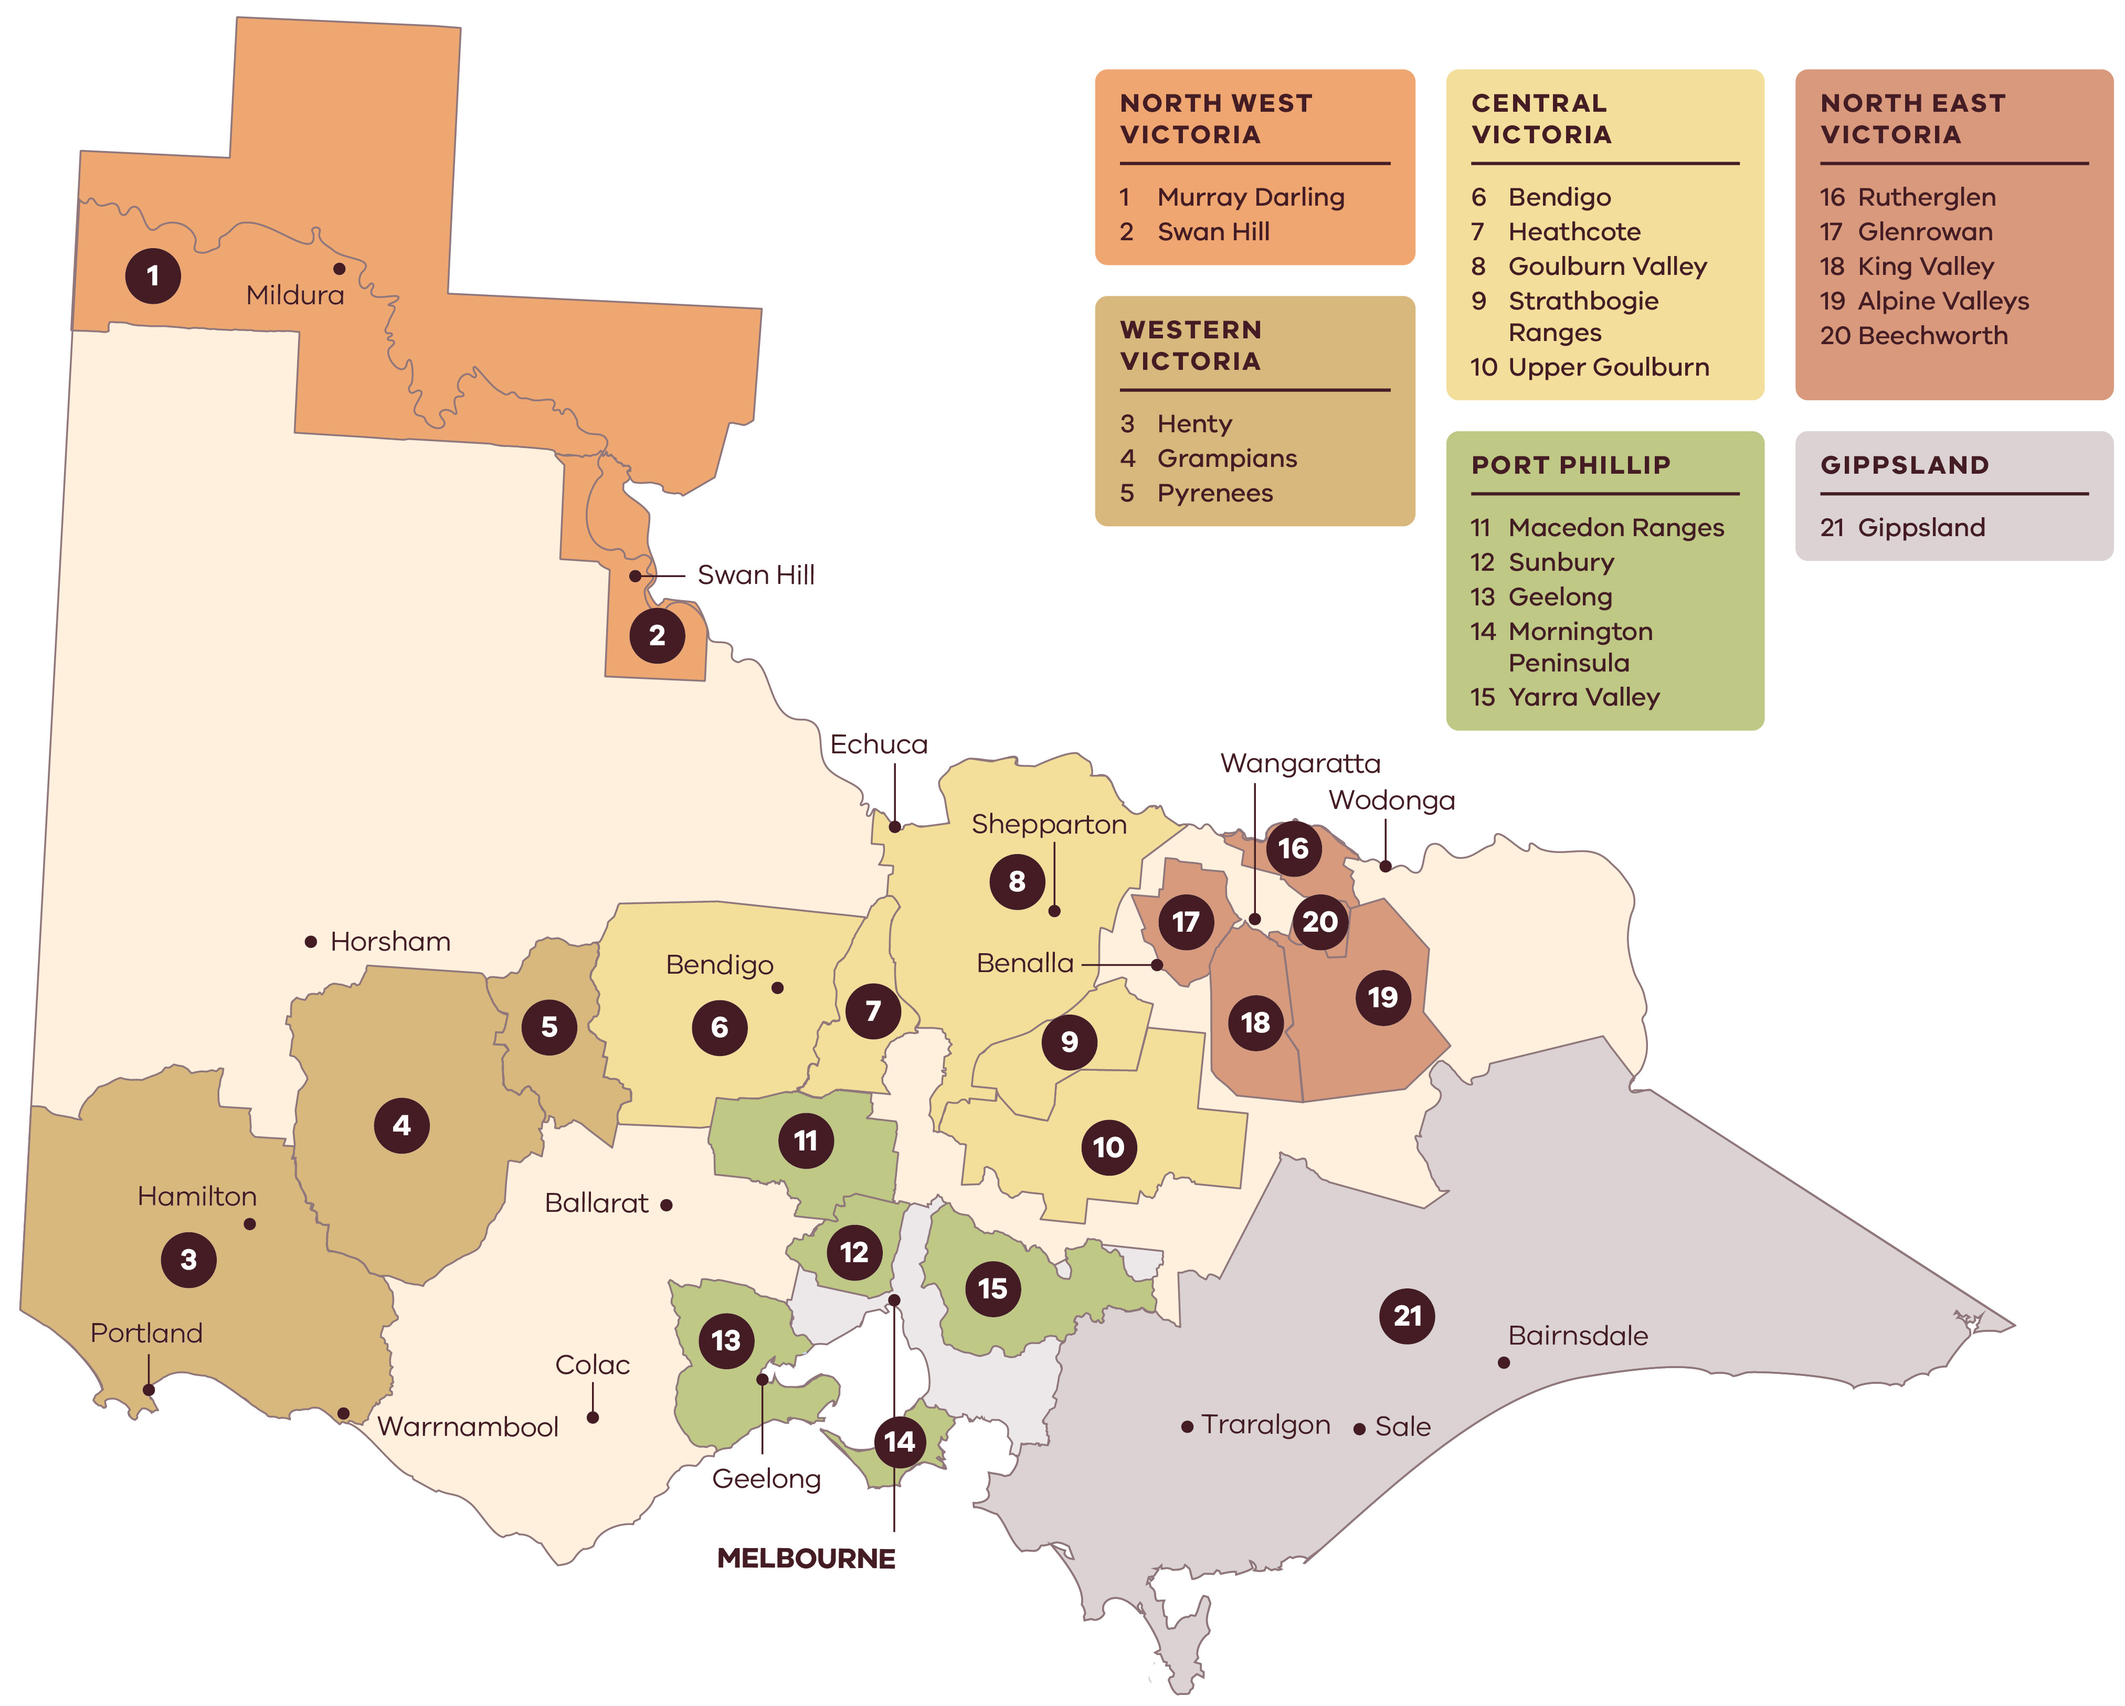

Figure 2: Industry challenges and strengths
Domestic and international trade | Innovation and sustainability | Visitor experience | People and community
CHALLENGES
- Declining wine consumption and changing consumer preferences driven by cost-of-living pressures and demographic shifts  - Intensifying global competition and trade uncertainties  - Global oversupply of red wine  - Low domestic consumption of Victorian wines | - Increasing frequency of floods, droughts and bushfires  - Decreasing suitability of some growing regions for existing varietals  - Increasing costs of production including water, energy and viticultural inputs  - Increase in biosecurity threats  - High upfront costs and risks for innovation  - Lack of robust data across the industry | - Limited coordination between wine and tourism bodies  - High upfront investment costs for upgrading cellar doors  - Transport and accommodation limitations in certain regions | - Labour and skills shortages in some areas  - Limited career development opportunities in small and often isolated wineries  - Migration pathways are not meeting industry skills and labour needs
STRENGTHS
- Wide range of varietals and styles to appeal to all tastes  - Renowned for wines of exceptional depth and complexity  - Home to some of Australia's oldest vines | - Diversity of climates and terroirs across 21 wine regions  - Culture of innovation and collaboration  - Strong uptake of sustainable practices and AgTech  - Higher growing season rainfall than SA or NSW; low reliance on irrigation outside of North-West Victorian regions  - Proven innovation and extension model in the Murray Valley | - Many wine regions easily accessible from Melbourne  - More cellar doors than any other state  - World-class wine festivals and events, and strong food and drink culture | - An important contributor to regional economies and communities  - Skilled and passionate people  - First Peoples’ and Traditional Owners’ deep connection to Country and culture

Key industry statistics
- $9.5 BILLION in total economic contribution per year
(Source: Wine Victoria, Economic Scorecard, 2024)
- 10,049 direct jobs and 13,767 flow‑on jobs
(Source: Victorian Food and Fibre Export Performance report, 2023-24)
- $152 MILLION in exports, 7% of Australia’s total wine exports by value
(Source: Agriculture Victoria, Victorian Wine Industry – Fast Facts, 2024. agriculture.vic.gov.au/about/agriculture-in-victoria/victorias-agriculture-and-food-industries)
- 700 wineries and 770 grape growers
- 32% of Australia’s wineries are in Victoria
- 21 unique wine regions, more than any other stated
- 22,151 ha of vineyards
(Source: Wine Australia, Australian wine sector at a glance, 2023-24. agriculture.vic.gov.au/about/agriculture-in-victoria/victorias-agriculture-and-food-industries)
- 15– 20% of Australia’s total grape crush
(Source: Wine Australia, National Vintage Report, July 2025. https://www.wineaustralia.com/market-insights/national-vintage-report)
- 277,701 tonnes crushed (2025-26)
(Source: Wine Australia, National Vintage Report, July 2025. https://www.wineaustralia.com/market-insights/national-vintage-report)
- AROUND 60% of all Victorian wineries have a cellar door
(Source: Agriculture Victoria, Victorian Wine Industry – Fast Facts, 2024. agriculture.vic.gov.au/about/agriculture-in-victoria/victorias-agriculture-and-food-industries)
- 17 MILLION visitor nights include wineries
(Source: Tourism Research Australia, 2024)
- $2.7 BILLION spent by winery visitors
(Source: Tourism Research Australia, 2024)

Introduction
This strategy encompasses the whole wine industry from the grape to the glass – from the vineyard and winery to packaging and logistics, marketing and sales, and retail and hospitality. The wine industry is also entwined with the tourism industry from the cellar door to the vibrant bars and restaurants in Melbourne.
Wine production in Victoria is often considered as 2 categories:
Table 1: Categories of wine production in Victoria
Commercial wine
Predominantly from the Murray Valley and Swan Hill regions, this wine is usually produced by large, commercial export-driven businesses with a focus on scale and value. Businesses are typically price-takers in a globally competitive environment. | 70–80% of Victorian production  <$10US per bottle

Premium wine
Predominantly produced by smaller wine businesses in cool or temperate regions with a focus on fine wine and wine tourism. Businesses seek to extract a premium based on brand, region, sales channel and visitor experiences. | 20–30% of Victorian production  >$10US per bottle
The Victorian wine industry is facing a range of economic and trade challenges. There is a persistent global gap between supply and demand for wine (Figure 3). Australian wine consumption has fallen since 2010, driven by cost-of-living pressures, demographic changes, competition from other alcoholic drinks and health concerns.
Figure 3: Wine consumption is declining, and there is a persistent gap between global wine production and consumption.
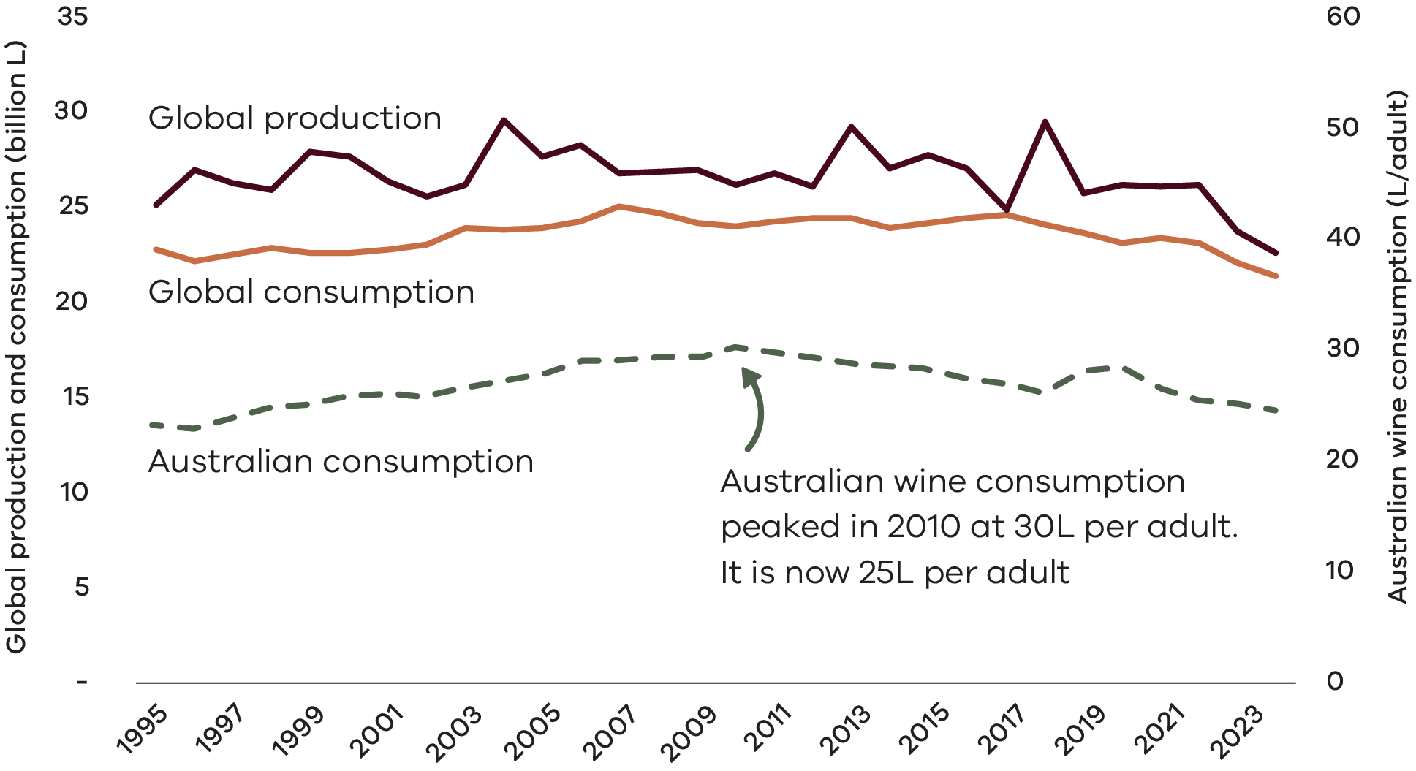
Source: International Organisation of Vine and Wine (OIV), Statistics, accessed 5 May 2025. www.oiv.int/what-we-do/statistics
Dataset 1: Data used to create the graph shown in Figure 3
Year | Consumption  (billion L) | Production  (billion L) | Australian wine consumption (L/adult)
1995 | 23 | 25 | 23
1996 | 22 | 27 | 23
1997 | 23 | 26 | 24
1998 | 23 | 26 | 25
1999 | 23 | 28 | 25
2000 | 23 | 28 | 26
2001 | 23 | 26 | 26
2002 | 23 | 26 | 26
2003 | 24 | 26 | 27
2004 | 24 | 30 | 27
2005 | 24 | 28 | 28
2006 | 24 | 28 | 29
2007 | 25 | 27 | 29
2008 | 25 | 27 | 29
2009 | 24 | 27 | 29
2010 | 24 | 26 | 30
2011 | 24 | 27 | 30
2012 | 24 | 26 | 29
2013 | 24 | 29 | 29
2014 | 24 | 27 | 29
2015 | 24 | 28 | 28
2016 | 24 | 27 | 27
2017 | 25 | 25 | 27
2018 | 24 | 29 | 26
2019 | 24 | 26 | 28
2020 | 23 | 26 | 29
2021 | 23 | 26 | 27
2022 | 23 | 26 | 26
2023 | 22 | 24 | 25
2024 | 21 | 23 | 25
As a result of these supply and demand trends Australia currently has a large oversupply of red wine (Figure 4), which primarily affects large commercial operators, although can have flow-on impacts on smaller operators.
Figure 4: Declining red wine demand has resulted in a much higher stock-to-sales ratio for red wine compared to white wine in Australia
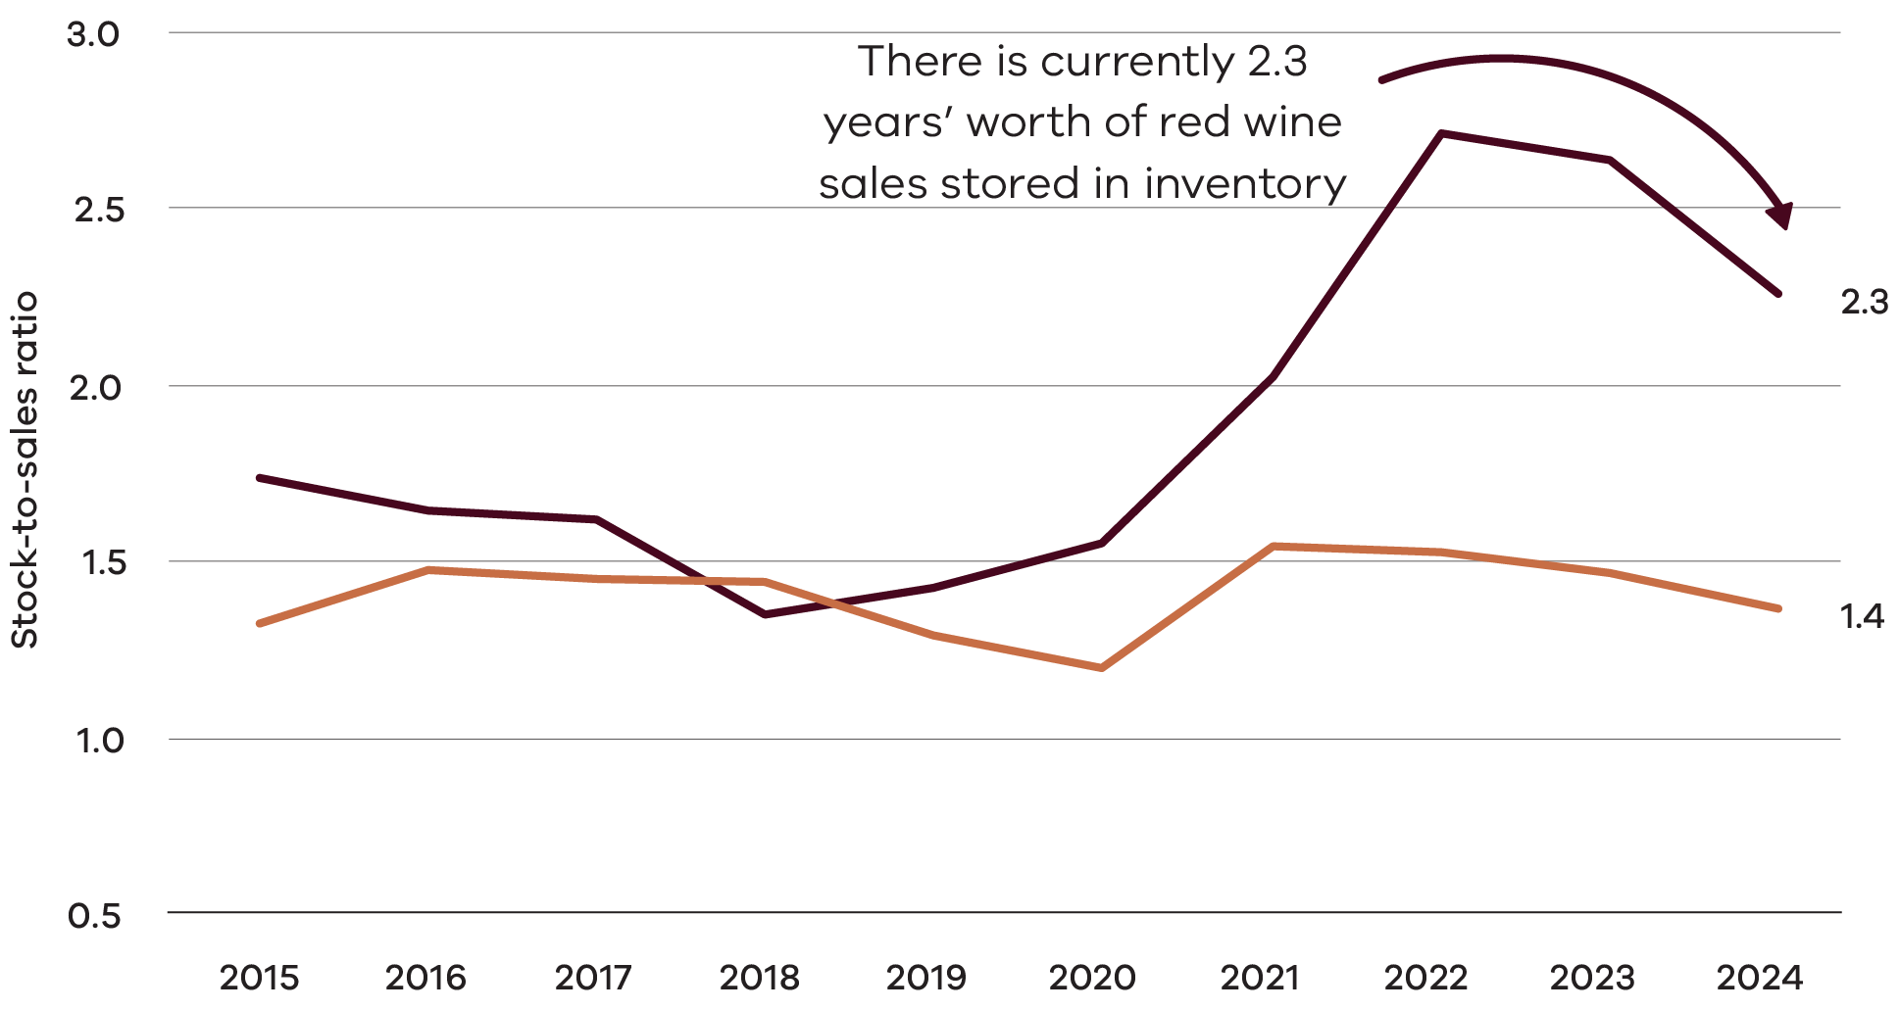
Source: Wine Australia, Australian wine production, sales, and inventory report 2023–24, December 2024. www.wineaustralia.com/market-insights/australian-wine-production-sales-and-inventory
Dataset 2: Data used to create the graph shown in Figure 4
Year | Stock-to-sales ratio: White wine | Stock-to-sales ratio: Red wine
2015 | 1.3 | 1.7
2016 | 1.5 | 1.6
2017 | 1.4 | 1.6
2018 | 1.4 | 1.3
2019 | 1.3 | 1.4
2020 | 1.2 | 1.6
2021 | 1.5 | 2.0
2022 | 1.5 | 2.7
2023 | 1.5 | 2.6
2024 | 1.4 | 2.3
These pressures are felt by both winemakers and grape growers, reflected in the below-production-cost price of red grapes from warm inland regions (Figure 5).
Figure 5: Average winegrape purchase price of cool/temperate wine is higher than warm inland prices, and inland red wine prices are lower than production costs
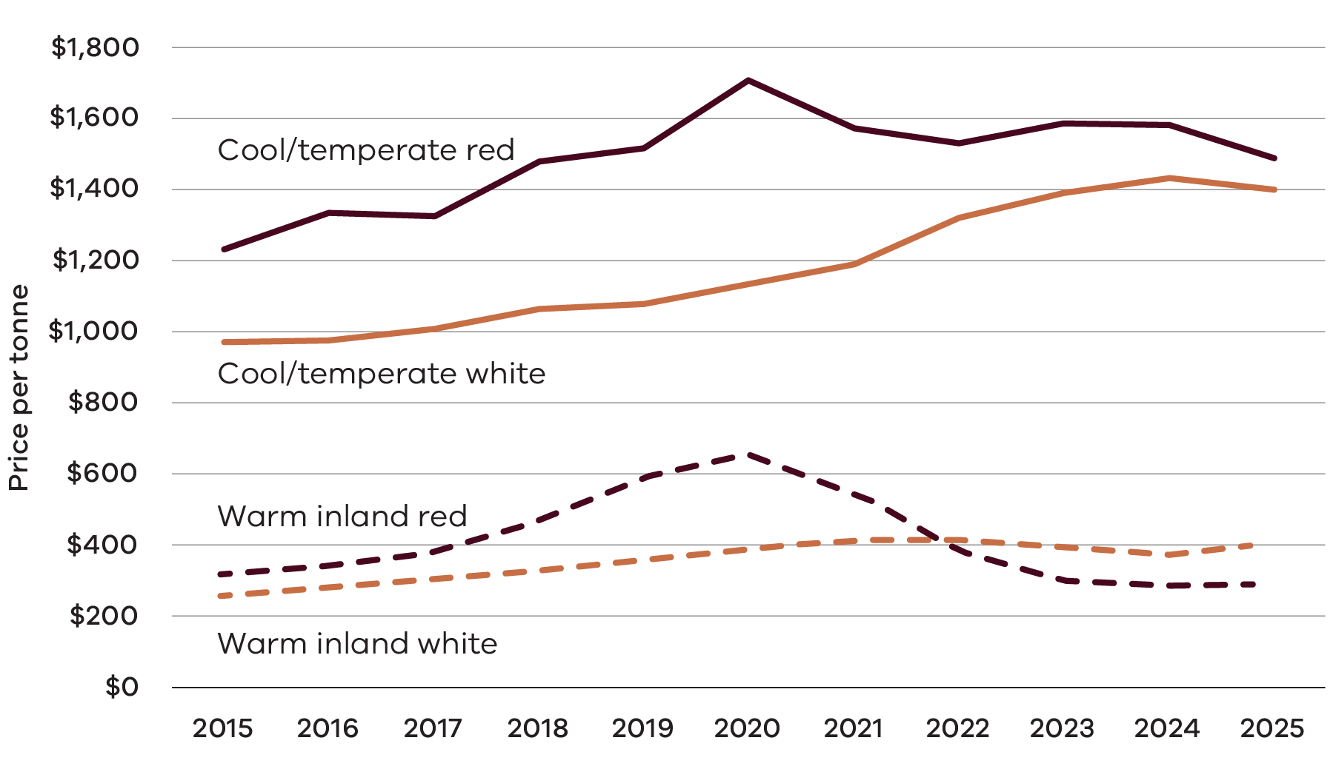
Source: Wine Australia, Vintage Report 2024. www.wineaustralia.com/market-insights/national-vintage-report
Dataset 3: Data used to create the graph shown in Figure 5
 | Price per tonne ($)
Year | Warm inland red | Warm inland white | Cool/temperate red | Cool/temperate white
2015 | $322 | $263 | $1,237 | $974
2016 | $343 | $288 | $1,337 | $980
2017 | $382 | $311 | $1,330 | $1,011
2018 | $470 | $332 | $1,483 | $1,069
2019 | $591 | $361 | $1,518 | $1,082
2020 | $659 | $397 | $1,708 | $1,135
2021 | $546 | $417 | $1,572 | $1,192
2022 | $384 | $419 | $1,532 | $1,324
2023 | $304 | $399 | $1,587 | $1,391
2024 | $290 | $379 | $1,583 | $1,436
2025 | $293 | $400 | $1,489 | $1,404
In contrast to export-focused commercial wines, cool and temperate regions in Victoria feature mostly smaller businesses with different drivers. These businesses typically:
- are more vertically integrated between vineyard, winery, brand and cellar door
- have sales channels focused towards direct‑to‑consumer sales and supplying smaller bottle shops and restaurants
- combine a wine business with a tourism business
rely more heavily on the wine equalisation tax rebate for financial sustainability.
In addition to the economic challenges, the industry also faces environmental and social issues. Environmental issues include severe weather, climate change, biosecurity risks, energy costs, and water availability. A shortage of skilled workers is a problem across the industry including in viticulture, wine making, and staffing cellar doors and restaurants. This can be compounded by lack of accommodation and visa conditions. Our industry also needs to maintain our social licence through promoting responsible consumption.
Despite a global decline in wine consumption, demand for categories such as lighter whites, sparkling wine and rosé is growing. Victorians are starting to drink more local wine. Exports are beginning to rebound, driven by the re-opening of China’s market. And visitor numbers are up across the state. Our wine industry must adapt to these trends through developing a strong understanding of domestic and export consumer preferences.

What we heard
In 2024 and 2025 over 220 people provided feedback through forums, interviews, submissions and workshops. Through this strong engagement we heard some consistent key messages:
- Strong support for the Drink Victorian program to increase local sales of Victorian wines.
- Continued focus and support for exports, recognising their importance for the whole industry.
- Ensure the strategy helps all growers and winemakers from both warm inland and cool/temperate wine regions.
- Innovation is critical to improve efficiency, reduce costs and adapt to climate change, and additional extension services are needed to drive this innovation.
- A strong appetite for government to co-invest with industry to support and de-risk innovation across the supply chain.
- Ongoing sustainability is important, including Sustainable Winegrowing Australia certification.
- Rigorous biosecurity measures are critical to limit impacts of pests and diseases.
- Closer collaboration with visitor economy organisations to drive visitation and sales and build on Victoria’s existing wine-tourism strengths.
- More effort to attract and retain talent and address workforce shortages.
- There are emerging opportunities to partner with First Peoples and Traditional Owners across the supply chain such as in land management, tourism, and marketing.
- Wine Victoria needs more resources and a stable funding model to implement the strategy and better serve the industry.

Partnering with First Peoples
First Peoples and Traditional Owners were engaged through interviews and a roundtable facilitated by Wariga Molla, an Aboriginal-owned consultancy. The engagement explored opportunities and barriers to participation in the wine industry. Mechanisms to identify and progress practical initiatives of interest and benefit to First Peoples were canvassed. Opportunities identified included tourism ventures, land management, viticulture, marketing and hospitality. Partnership will require a commitment to genuine and respectful engagement, cultural competency, and listening to First Peoples’ perspectives.
This strategy recognises the ongoing connection of First Peoples to the Countries on which Victoria’s acclaimed wines are made. The Victorian wine industry will build relationships with First Peoples in Victoria with respect and for mutual advantage, recognising the shared interests and unique opportunities inherent in terroir and Country.

Impact of the strategy
Our wine industry is an important driver of economic growth, contributing $9.5 billion to the Victorian economy annually and supporting over 23,000 jobs. By 2030 it is estimated that it will generate more than 4,500 new jobs, additional domestic sales of $113 million and exports will increase by $84 million.
Table 2: Estimated impact of the strategy on segments of the industry by 2030
Industry segment | Estimated impact of the strategy by 2030,,
Grape growers | Enhanced extension and adoption services, connected to the national innovation and extension network. Benefits include:  - 20 regional workshops on viticulture, innovation and sustainability  - Support to double the number of SWA-certified businesses  - Improved data including financial benchmarking data.
Winemakers, retail and hospitality | Victorian sales growth of $113 million from $770 million increasing to $883 million by 2030:  - on-premises sales growth of $70 million from $235 million up to $305 million by 2030  - off-premises and other sales growth of $43 million from $535 million up to $578 million by 2030.
Export businesses | Increased value of Victorian wine exports and strengthening Victorian’s share of Australia’s wine export market.
Wine industry | Jobs growth from 23,816 up to 28,446 by 2030, an increase of 4,630 jobs:  - direct jobs growth of 1,654 jobs  - flow-on jobs growth of 2,677 jobs.
Note: estimates are uncertain and depend on broader economic factors and full implementation of the strategy.

Strategic context
This strategy builds on the success of the previous Victorian Wine Industry Development Strategy 2017-2021. The Wine Growth Fund grant program supported wine businesses to deliver projects aligned to priorities under the previous strategy and had strong engagement from industry. The previous strategy provided a strong platform for government investment; the Wine to the World export program and the Growing Victorian Wine into the Future viticulture program were both supported by industry. Evaluation of the previous strategy highlighted the ongoing limitations of Wine Victoria’s funding model – addressing this is a key enabling action in this current strategy.
Wine Australia’s and Australian Grape and Wine’s One Grape & Wine Sector Plan outlines the sector’s response to ongoing challenges to improve profitability and resilience. There are many complimentary actions between the strategies including:
- Improving domestic and export market share
- Building extension and adoption services to increase sustainability and innovation
- Collecting and sharing better data to help decision making
- Supporting career growth, and attracting and retaining skilled workers
- Collaborative advocacy on social licence, taxation, and workforce issues
Focusing on sustainability and adaptation to climate change, including support for Sustainable Winegrowing Australia.
Agribusiness is a priority sector in Victoria’s Economic Growth Statement and in the Victorian Industry Policy, and delivering this strategy will build prosperity and a strong regional Victoria. This strategy has strong links with other Victorian strategies including Victoria’s Agriculture Strategy, Victoria’s Climate Change Strategy, Experience Victoria 2033, and Victoria’s Biosecurity Strategy. A full list of linked strategies can be found in the Public Consultation Report at https://engage.vic.gov.au/victorian-wine-strategy.

Enabling actions
This strategy will be delivered in collaboration with grape growers, winemakers, regional wine associations, national peak bodies, research institutions, First Peoples and the Victorian Government. Our 3 enabling actions are crucial to the successful delivery of the strategy.

A. Gain industry support and implement a new funding model for Wine Victoria
Wine Victoria currently lacks the resources to delivery this strategy. It relies on voluntary membership fees for core funding and has fewer resources than wine industry peak bodies in other states. Funding is often tied to grants, which don’t provide sustainable, ongoing funding. There is clear industry support for strengthening Wine Victoria to deliver this strategy.
A sustainable funding model is needed for Wine Victoria to ensure it has the people and resources needed to drive this strategy and deliver key services to the industry. Wine Victoria will develop a range of funding options, discuss with the industry and implement the chosen option.

B. Explore options to provide collaborative investment for this strategy
The Victorian Government is a key partner of the wine industry and the strategy identifies areas where industry and government may seek to co-invest. Many actions identified in the strategy could be accelerated by matching business investment with government investments. This could build on the successful Wine Growth Fund model (2016–2019), which provided matched investment from the Victorian Government to wine businesses for projects aligned to the priorities of the previous Victorian Wine Industry Development Strategy 2017-2021. Programs could address specific needs for domestic and export growth, innovation, sustainability, biosecurity and visitor economy priorities.

C. Establish strategy oversight and reporting arrangements
Key principles for effective governance and management of this strategy are:
- committed leadership – key leaders to champion the strategy
- collaboration – a leadership role for Wine Victoria in partnership with regional wine associations, the Victorian Government, visitor economy bodies and First Peoples
- open communication – public and transparent updates on progress
- clear accountability – allocate responsibility and track progress
resourcing – industry and government will contribute their respective expertise and seek avenues for co-investment.
The strategy provides a clear direction for the Victorian wine industry and regional wine associations can develop their own actions and plans aligned with the strategy. Wine Victoria and the Victorian Government will share strategy progress and updates with industry every year.

1. Domestic and international trade
Goal: Make Victorian wines the #1 choice for wine drinkers in Victoria
Actions | Deliverables and targets | Lead
1.1 Grow the Drink Victorian program for the benefit of all Victorian wine regions | Review and evolve the Drink Victorian program  Target: Increase proportion of Victorian to non-Victorian on-premises sales from 27% to 35% over the life of the strategy | Wine Victoria
1.2 Identify and activate more opportunities for  the Victorian Government to promote and serve Victorian wines | Collect data on government procurement of Victorian wine  Identify opportunities to supply Victorian wine for Victorian Government events  Engage with international media at festivals and events  Target: Increase Victorian Government procurement of Victorian wine by 2030 | Agriculture Victoria  Wine Victoria  Visit Victoria
Goal: Increase international market share of Victorian wine in priority global markets
Actions | Deliverables and targets | Lead
1.3 Facilitate wine export market entry and the export capability of Victorian wineries. | - Develop a proposal for a Victorian export facilitation program to enable export-ready wineries to enter and expand in priority markets including options for industry and government funding.  - Target: High satisfaction rating in annual participants survey  - Target: Increase in total export value year-on-year in priority markets | Wine Victoria and Global Victoria
1.4 Promote Victorian wine in priority international markets and grow exports | - Develop options for a continued Victorian export development and promotion program for wineries aspiring to export or at an early stage of their exporter journey to build capability and define their brand story. The program should have distinctive storytelling that positions Victoria as the leading Australian state for high-quality, great value wines. Consider options for industry and government funding.  - Target: High satisfaction rating in annual participants survey  - Target: Increase in total export value and year-on-year in priority markets | Wine Victoria and Global Victoria
Goal: Capitalise on successes and build recognition for Victoria’s wines
Actions | Deliverables and targets | Lead
1.5 Celebrate Victoria’s great wines through our premier wine shows | - Celebrate and promote Victoria’s key wine shows  - Celebrate the successes of Victoria’s very best wines and include recognition in key promotional initiatives | Regional wine associations

Challenges and opportunities
Trade uncertainties and the global wine oversupply impacts on both domestic and export markets and are serious challenges to the future of the Victorian wine industry.

Domestic consumption
Only 27% of the wines available in Victorian venues are Victorian wines. Although this increased by 5% from 2023 to 2024, this is low compared to other states (see Figure 6). Higher sales will be driven by increasing the awareness of retailers, hospitality, and consumers through the Drink Victorian program.
Figure 6: Percentage share of locally produced wine on wine lists by state
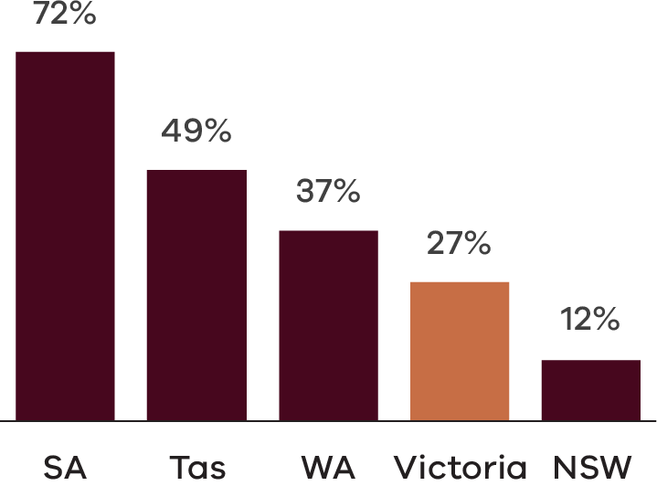
Source: Wine Business Solutions, Wine On-Premise, 2024
Dataset 4: Data used to create the graph shown in Figure 6
State | Percentage
South Australia | 72%
Tasmania | 49%
Western Australia | 37%
Victoria | 27%
New South Wales | 12%
The Drink Victorian program began in 2021 to encourage Victorians to drink local beverages including wine, beer, spirits, cider and non-alcoholic drinks. The program is led by the Victorian Drinks Alliance, a collaboration between Wine Victoria, Cider Australia, the Independent Brewers Association, the Australian Distillers Association and Spirits Victoria. The program has been funded by the Victorian Government and delivered by Food + Drink Victoria. Drink Victorian works directly with venues to increase their awareness and purchases. Activities include events to taste and promote Victorian drinks, regional winery visits by buyers and sommeliers, and a comprehensive marketing, communication and education strategy.
The wine industry is enthusiastic about the Drink Victorian program and strongly supports its growth. The program could evolve to include more activities in regional centres to showcase Victoria’s diverse wine regions. The program could promote strategy priorities such as sustainability and innovation. A co-investment model could expand Drink Victorian and build a greater market share for Victorian wines in Victoria. This investment would boost the visibility, appreciation and profitability of Victorian wineries and aligns with the goals of Victoria’s Economic Growth Statement and Victorian Industry Policy to create jobs and economic growth in regional Victoria and the agribusiness sector.
The Drink Victorian program will be complemented by efforts to increase Victorian Government promotion and procurement of Victorian wine. More local wine at government events and venues will showcase the best Victorian wine to local, interstate and international visitors.

CASE STUDY: Drink Victorian trade tasting – Driving local consumption of Victorian wine
The Drink Victorian trade tasting is an annual industry event at Marvel Stadium showcasing the quality and diversity of Victoria’s beverage sector. The event strengthens connections between producers and the hospitality sector. The event attracts hundreds of hospitality buyers and professionals who meet over 250 local producers, including winemakers, brewers, distillers, and cider makers. The event has grown each year and by promoting local products and fostering industry relationships, the tasting helps drive local consumption of Victorian wines.

Exports
Since 2019, Victoria’s wine exports have declined dramatically–particularly for red wine (Figures 7 and 8). This has been driven by pandemic-related supply chain disruptions and ongoing trade disruptions, notably China’s import duties from November 2020 to March 2024. Declining exports significantly impact on growers and winemakers in warm inland regions, such as the Murray Darling and Swan Hill regions in Victoria. While prices for cool/temperate grapes and white wine grapes continued to increase, prices for warm inland red wine grapes fell to 10-year lows in 2024. The sustained excess of supply of grapes and wine over demand is a structural issue that poses a profitability challenge for the Victorian wine industry.
Figure 7: Victoria exports more red wine, but exports have been significantly affected by trade disruptions
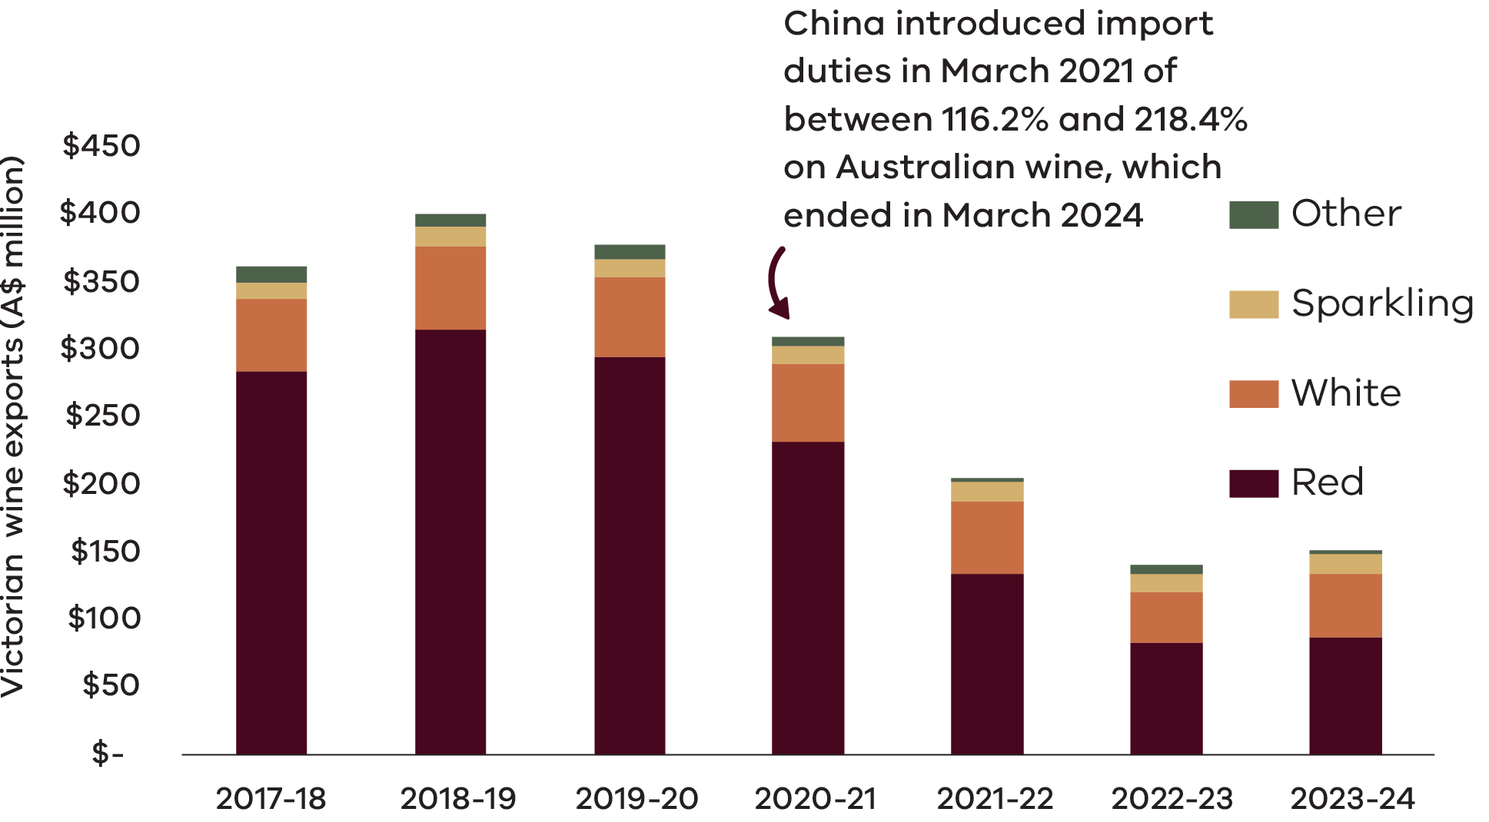
Source: DJSIR, Victorian Food and Fibre Export Report 2023-24. Data is for wine made in Victoria. https://global.vic.gov.au/__data/assets/pdf_file/0006/2383386/Food-Fibre-Export_Data.pdf
Dataset 5: Data used to create the graph shown in Figure 7
 | Export value (A$ millions)
Wine product | 2017-18 | 2018-19 | 2019-20 | 2020-21 | 2021-22 | 2022-23 | 2023-24
Other | $12 | $10 | $11 | $7 | $3 | $6 | $3
Sparkling | $12 | $15 | $14 | $13 | $15 | $13 | $15
White | $53 | $62 | $58 | $57 | $53 | $37 | $47
Red | $285 | $315 | $296 | $233 | $135 | $84 | $87
Total | $362 | $402 | $379 | $310 | $206 | $140 | $152
Figure 8: Victoria’s wine exports are slowly recovering from trade disruptions, particularly with China.
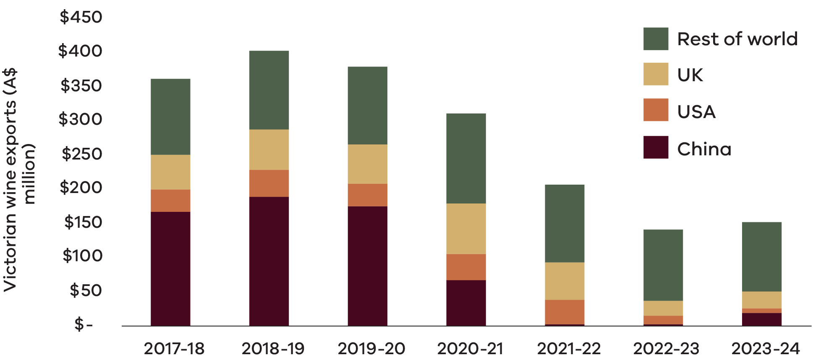
Source: DJSIR, Victorian Food and Fibre Export Report 2023-24. Data is for wine made in Victoria. https://global.vic.gov.au/__data/assets/pdf_file/0006/2383386/Food-Fibre-Export_Data.pdf
Dataset 6: Data used to create the graph shown in Figure 8
 | Export value (A$ millions)
Year | Rest of world | UK | USA | China
2017-18 | $112 | $50 | $33 | $167
2018-19 | $115 | $59 | $39 | $188
2019-20 | $113 | $57 | $33 | $175
2020-21 | $132 | $74 | $38 | $66
2021-22 | $114 | $54 | $36 | $3
2022-23 | $104 | $23 | $11 | $3
2023-24 | $102 | $24 | $7 | $19
To increase the value of Victorian wine exports and national export share, the Victorian Government will work with businesses to support export opportunities. In 2023, the Victorian Government extended the Victorian Wine to the World Program by 2 years (valued at $5 million) to develop this strategy and continue to support new and established Victorian wine exporters to enter and expand in priority markets through targeted international trade activities. Global Victoria and Wine Victoria led the program which focused on the United States, United Kingdom and Europe, South East Asia, North Asia and Greater China. Since 2022, the Wine to the World program has supported more than 170 wineries and facilitated over 40 international trade activities, delivering more than $4.5 million in realised sales. The program has also enhanced global brand exposure for Victorian wine through targeted education and promotion efforts. In addition, over 40 wineries have participated in dedicated market entry initiatives designed to help secure new distribution partners.

Celebrate Victoria’s great wines through our premier wine shows
The depth, breadth and diversity of Victoria’s wine offering has been honed through generations of grape growing and winemaking and has been shaped by the industry’s preparedness to take risks, learn and improve. Our excellence has been shaped by Victoria’s generational wineries, regional wine associations and the sector’s commitment to Australian and international wine shows. Victoria is home to renowned wine shows including the Melbourne Royal Wine Awards, Australian Alternative Varieties Wine Show and the Victorian Wine Show. We will celebrate and promote Victoria’s excellent wines across Australia and support Victorian wine shows across the state.
The Melbourne Royal Wine Awards, one of Australia’s most prestigious wine competitions, celebrates excellence in winemaking with over 2,500 entries from more than 400 wineries nationwide each year. The Jimmy Watson trophy is recognised as one of the most prestigious wine awards in Australia. The event showcases the latest trends in viticulture and offers a benchmark for quality and innovation in Australian wine.
Celebrating innovation and diversity in the glass, the Australian Alternative Varieties Wine Show in Mildura champions the bold, the rare, and the unconventional bringing together winemakers and wine lovers who dare to explore beyond the mainstream. The show is a vibrant showcase of Australia’s evolving wine identity, where passionate producers gather to honour the art of alternative varietals through spirited competition, education, and community.
The Victorian Wine Show has been celebrating the excellence and diversity of Victorian wine since 1981–from elegant cool climate whites to bold reds and fortified wines from its warmer regions. The show benchmarks the best wines from across Victoria and nurtures the next generation of wine industry professionals through recognition, education, and community support. The Victorian Wine Show also awards the Premier’s Trophy, which gathers the best‑of‑show wines from Victoria’s regional wine shows to discover the best of the best.

2. Innovation and Sustainability
Goal: Safeguard the future through innovation and sustainability
Actions | Deliverables and targets | Lead
2.1 Create a new Innovation and Technical Lead role that focuses on sustainability and innovation to build industry resilience | Establish a new extension, adoption and coordination role in Wine Victoria by 2025  Collaborate with Murray Valley Winegrowers and Agriculture Victoria to deliver extension services  Target: High satisfaction with Innovation and Technical Lead’s activities | Wine Victoria
2.2 Investigate establishing a co-investment fund that supports industry to adopt innovation and improve sustainability | Investigate establishing a co-investment fund by 2026  Target: Increased industry investment in innovation and sustainability | Wine Victoria
2.3 Encourage more Victorian wine businesses to achieve Sustainable Winegrowing Australia certification | Address current barriers, build a value proposition for certification, and provide expert support and advice  Target: Double the number of SWA certified members in Victoria to 372 | Wine Victoria
2.4 Improve biosecurity education, practices and prevention for wine businesses across Victoria | Continued industry engagement on biosecurity risks  Adoption of new and cost-effective technologies to improve early detection  Develop a contemporary and aligned national phylloxera policy inclusive of an updated National Phylloxera Management Protocol  Target: Maintenance of existing phylloxera management zones and increased awareness of biosecurity management | Wine Victoria  Agriculture Victoria
Goal: Drive industry forward with quality data
Actions | Deliverables and targets | Lead
2.5 Collect and share better data and insights with Victorian wine businesses, and provide environmental and financial benchmarking tools | Database designed, scoped, developed and in place by 2026  Deliver a financial benchmarking project by 2026 and communicate findings with industry  Target: High satisfaction and impact on wine businesses | Wine Victoria

Challenges and opportunities

Innovation
The Victorian wine industry must continue to embrace innovation to increase productivity, profitability, and resilience. Technologies are rapidly changing and interacting in new and unexpected ways. Innovation includes new technology and practices across winemaking and grape growing, sales and marketing, efficiency and sustainability, and packaging and logistics (outlined in Figure 9).
Figure 9: Innovation opportunities for the wine industry
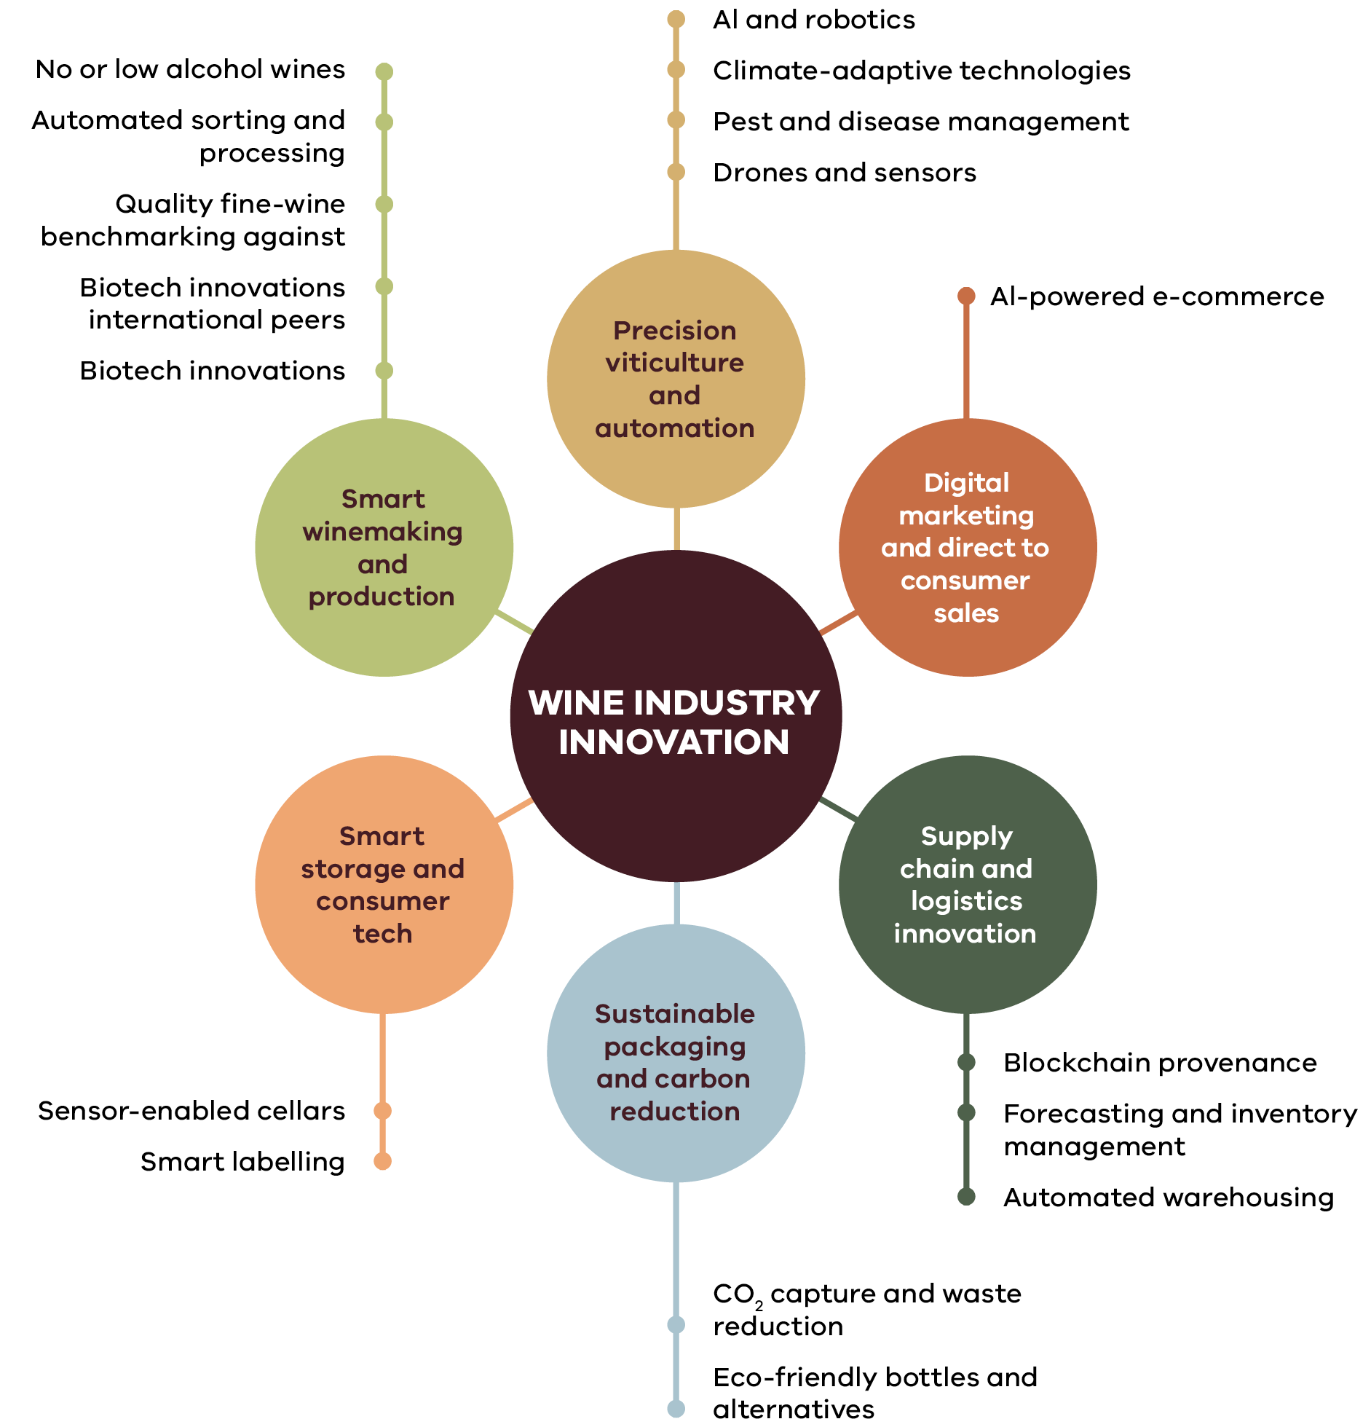
This strategy will address common barriers to innovation that can discourage growers, winemakers and other businesses from adopting new technologies and practices. These barriers include:
- limited extension and adoption services (outside of North West Victoria)
- high upfront costs for trialling and adopting new technology and practices
- lack of practical expertise to interpret research and development
- lack of technical expertise to embed new technology
risk-aversion to new practices and technologies, particularly if new or untested.
This strategy will focus on supporting the translation of innovation into practice. A new Technical and Innovation Lead role in Wine Victoria will deliver adoption and extension services to help businesses identify and adopt the best innovations to suit their needs. This role will collaborate closely with the Murray Valley Winegrowers’ development officers, Agriculture Victoria, and other national wine industry extension services. The role will draw on research, which is largely managed by Wine Australia at a national level and funded by investment from industry and the Australian Government.
To overcome financial barriers to innovation, the Victorian Government and industry will work towards co-investment funds to de-risk and encourage adoption of innovative solutions. The Victorian Government’s Wine Growth Fund offered a successful model of co-investment by the Victorian Government and private business to help achieve the objectives of the previous Victorian Wine Industry Development Strategy 2017–2021.

Sustainability and climate change
Climate change is already reshaping wine production, altering vineyard suitability and shifting grape ripening to earlier in the season. Over the past 40 years, harvests have advanced by 2–3 weeks, affecting grape composition, wine quality and style. Climate change also increases incidence of heatwaves, drought, fires and salinity. Smoke taint from bushfires can have significant impact on grape quality. New approaches to mitigate the impact of extreme events on grapevine physiology and grape and wine quality have become an integral part of vineyard management in Australia. To remain profitable and resilient, Victoria’s wine industry must continue to adopt new strategies to adapt to climate change. Wine Victoria will support cross-sector sustainability and climate change adaptation, including projects and trials.
Sustainable Winegrowing Australia (SWA) is the recognised certification program for Australian grape growers and winemakers with certified businesses displaying the SWA trust mark. Of 293 SWA members in Victoria, 63% (186) are now certified. Certification demonstrates the business is tackling carbon emissions, improving water efficiency, managing waste and recycling, conserving biodiversity and enhancing soil fertility.
Large wine producers often require SWA certification from their growers to meet retailer and export market requirements. Maintaining access to some export markets depends on continued progress on sustainable practices through certification. Smaller grape and wine producers, especially those experiencing financial challenges, need more support and a stronger value proposition to achieve SWA certification. Wine Victoria will focus on growing SWA membership and certification for Victorian wine businesses by addressing barriers, building a value proposition for certification and providing expert support and advice. To manage climate change and sustainability, Agriculture Victoria, Murray Valley Winegrowers and Wine Victoria will continue to work with the industry on awareness, capability development and strategies including through the Farm Business Resilience Program, Carbon Farming Outreach Program, and Horticulture Industry Networks.

Biosecurity
Biosecurity is managed through a national, coordinated system involving local, state and national organisations including Agriculture Victoria, Wine Victoria, Plant Health Australia, Vine Health Australia, Australian Grape and Wine, and the Department of Agriculture, Fisheries and Forestry. The wine industry faces significant biosecurity risks that could impact its sustainability and productivity. Major threats include exotic pathogens (managed by the Commonwealth Government) such as xylella and controlled pests like phylloxera–the primary biosecurity concern for Victorian wine grape growers. Pests and diseases can be transmitted through the movement of soil, vine material, clothing, footwear, machinery, equipment, vehicles and cargo, and can have devastating consequences for businesses. Biosecurity risks require ongoing management and intervention with innovative surveillance technologies, development of resistant grapevine varieties and rigorous quarantine protocols.
To manage biosecurity, Agriculture Victoria and Wine Victoria will continue to work with the industry on research, education, monitoring and surveillance, containment and response strategies including maintaining quarantine zones. Regional associations may consider becoming a Phylloxera Exclusion Zone through monitoring and surveillance, following the example of the Mornington Peninsula reclassification in 2022. Our efforts will help producers protect their vineyards from invasive species and pathogens, ensuring sustainable production and market access for the wine industry.

Data and insights
There is an opportunity to provide more accurate, reliable and timely data about the Victorian wine industry. This includes data on the number and size of vineyards and winemakers, planted areas of grape varieties, sales channels and financial profitability. Wine businesses may need help to better understand their current financial performance and risks to their financial sustainability.
Good data is essential to making good decisions for farmers, winemakers, investors, businesses and government. Wine Victoria will undertake a financial benchmarking project to provide growers and winemakers with data for sound financial management and decision-making and will share insights across the industry to inform business and investment decisions. Wine Victoria will collect and communicate better data on the Victorian wine industry to build on its existing Economic scorecard data, complemented with data from Wine Australia.

Case Study: Innovation – Brown Brothers, North East Victoria
​Founded in 1885 in Milawa, Brown Brothers has long been a leader in technical innovation. From the early 1900s, the company embraced experimentation, introducing grape varieties like Mondeuse and Graciano. A collaboration with CSIRO led to the development of varieties such as Tarrango and Cienna, specifically suited to Australia’s diverse climates.
In 1989 Brown Brothers opened an innovation winemaking space, known as the Kindergarten Winery – a hub for small-batch experiments enabling the trial of new techniques without disrupting main production. This approach paved the way for wines that became top‑selling varieties including Moscato and Prosecco.
Brown Brothers’ new bottling facility–the HIVE (harvesting, innovation, value and efficiency)–opened in 2022. The HIVE produces 40,000 bottles daily while incorporating renewable energy, advanced insulation, and waste minimisation technologies.

3. Visitor Experience
Goal: Create better Victorian wine experiences to drive wine sales and improve profitability
Actions | Deliverables and targets | Lead
3.1 Pursue funding opportunities to improve and diversify visitor experiences | - Explore state and national funding opportunities to improve wine visitor experiences  - Target: At least 6 regional wine associations and Visitor Economy Partnerships have initiatives funded by 2028 | Wine Victoria  DJSIR
3.2 Establish a partnership between Wine Victoria and statewide visitor economy organisations to collaborate on opportunities | - Partnership established by 2026  - Identify and deliver joint initiatives from 2027  - Target: Increased visitor trips to wineries by 2030  - Target: Increase in total visitor expenditure from visitor trips that included wineries by 2030. | Wine Victoria  Visit Victoria  DJSIR
3.3 Build collaborative partnerships between regional wine associations and regional visitor economy bodies | - Regional wine associations and Visitor Economy Partnerships collaborate to develop initiatives  - Target: At least 8 regional wine associations in collaboration with Visitor Economy Partnerships have developed initiatives by 2027 | Regional wine associations  Visitor Economy Partnerships
3.4 Promote Victoria’s exceptional wine destinations and seasonal wine events | - Promote Victoria’s wine stories, regions and events in key promotional initiatives | Regional wine Associations  Global Victoria  Visit Victoria

Challenges and opportunities
Victoria has more cellar doors than any other state, with around 60% of Victorian wineries providing opportunities to visit and taste exceptional wines. Food and drink is a key part of the visitor economy and is often woven throughout the visitor experience. Visitors can enjoy wine at the winery, local restaurants and cafes, wine stores, events, tours and dedicated tastings. The wine industry is a key driver of tourism through wine events and festivals, roadshows, trade visits, hospitality and accommodation.
Increasing the flow of visitors to wineries is an effective way to lift their profitability, especially for smaller wineries. Cellar door visits lead to more direct-to-consumer sales at higher margins. Visits provide an opportunity to convert a memorable experience into ongoing sales and provides the winery with valuable feedback from consumers.
Barriers to improving visitor experiences in wine regions include transport limitations, a lack of accommodation, limited dining and tasting options, language barriers, workforce constraints and poorly coordinated cellar door opening hours. Tackling these challenges is best led at a regional level drawing on local knowledge and experience.
Increasing unique and high-quality wine experiences and weaving them into overall tourism offerings will showcase each region’s wine and food as expressions of their heritage and character and attract more visitors. To achieve this requires better collaboration between the wine industry and visitor economy organisations. While there is a long history of working together, this strategy provides an opportunity to renew and deepen collaboration. Partnerships will occur at both statewide and regional levels:
- Statewide – Wine Victoria will collaborate with DJSIR (Tourism and Events, Strategy and Reform), Visit Victoria, the Victoria Tourism Industry Council and national organisations such as Tourism Australia and Austrade
- Regional – Regional wine associations can collaborate with Visitor Economy Partnerships, local governments, First Peoples organisations and other regional stakeholders.
Wine Victoria and the Victorian Government will support regional organisations as they collaborate on visitor economy initiatives. Collaboration can focus on:
- pursuing funding opportunities to invest in tourism initiatives such as cellar door upgrades
- better leveraging major events, festivals and wine shows in Melbourne and regional Victoria to showcase Victorian wine and promote wine tourism
- supporting the development of implementation plans and linking these to local government and Visitor Economy Partnership plans
- integrating wine experiences into marketing programs and activities
using the Five Pillars wine marketing program and materials for international visitors
The Victorian Government and industry will continue to support the shared vision to generate greater individual and collective wealth for First Peoples across Victoria, a commitment in the Yuma Yirramboi Strategy (Invest in Tomorrow). It’s important to invest in long-term sustainability, jobs, and career pathways in tourism and agriculture, and to recognise First Peoples businesses are intrinsically linked to values rooted in Caring for Country.

Case Study: Collaborating on regional tourism – Tourism North East
Tourism North East (TNE) is the peak tourism organisation for Victoria’s High Country. Incorporating five wine regions – Alpine Valleys, Beechworth, Glenrowan, King Valley and Rutherglen – the region is renowned for its diverse and exceptional food and drink. Wineries, cellar doors, and wine events play crucial roles in attracting visitors and providing opportunities to explore and enjoy the region.
TNE invests in market research on products and audiences to better understand visitor needs – this information is communicated to all wine businesses in the region. Wineries and wine associations collaborate with TNE to develop destination, product, and experience marketing campaigns while celebrating the uniqueness of each wine region. TNE supports marketing and promotion of regional wine events such as Dark Side of Wine in Rutherglen and La Dolce Vita in the King Valley. They also work with the wine industry to create new consumer experiences through exploring funding opportunities and one-on-one consultations.

4. People and Community
Goal: Attract, develop and retain talent
Actions | Deliverables and targets | Lead
4.1 Develop our people through the career lifecycle, connecting them with industry leadership and scholarship opportunities | - Regular Victorian participation in Rootlings, Next Crop, Future Leaders, wine mentoring program and Australian Institute of Company Directors bursary  - Target: 80% of participants report positive outcomes for their development and careers (participants survey) | Wine Victoria
4.2 Support opportunities to partner with Traditional Owners and First Peoples businesses throughout the wine supply chain | - Support opportunities for participation of First Peoples enterprises in the Victorian wine industry  - Explore opportunities for collaboration in Caring for Country and visitor economy initiatives  - Explore opportunities to promote and purchase from First Peoples-owned and led businesses to generate economic opportunities for Traditional Owners, a commitment in the Yuma Yirramboi Strategy. | Wine Victoria  Agriculture Victoria  DJSIR
4.3 Support Australian Grape and Wine to advocate for visa and workforce issues that align with Victoria’s needs | - Visa conditions amended to be more responsive to Victorian wine industry needs. | Wine Victoria
Goal: Attract, develop and retain talent
Actions | Deliverables and targets | Lead
4.4 Continue to support national advocacy on health and social impacts, responsible practice and wine taxation | - High satisfaction on annual member survey | Wine Victoria

Challenges and opportunities
Skilled and passionate people are building fulfilling careers in our wine industry. But our industry still faces challenges attracting and retaining workers across viticulture, winemaking, marketing, sales, hospitality and management. Contributing factors include:
- difficulties in attracting and retaining workers in regional and remote areas
- limited career development in small and often isolated wineries
- barriers associated with visa processes including time and costs to the business
- a lack of affordable and available accommodation in regional areas
- These workforce issues are complex and require action at national, state and local levels from a range of organisations.

People
Wine Victoria will partner to deliver a range of programs supporting the development of people in the wine industry across their careers including:
- Rootlings: a national network for under-35s providing networking and education
- Next Crop: a leadership and management program for mid-career professionals
- Future Leaders: a professional and personal development program for emerging industry leaders
- Wine Industry Mentoring Program: providing mentors for industry professionals
Wine Victoria Bursary Company Directors Course: to build industry governance skills.
Next Crop is a training program funded by Wine Australia and regional partners that helps build leadership, business and management skills. Wine Victoria successfully ran the program in 2022 and will offer it again in 2025.
The benefits of these career development programs flow beyond the participants, inspiring and driving change across the industry. Wine Victoria will support post-program activities to ensure sustained benefits.

Case Study: Nurturing the next generation of industry leaders through Next Crop and Future Leaders programs
Steven Paul, General Manager of Oakdene Wines in Geelong, strengthened his leadership skills through the Next Crop and Future Leaders programs.
The Next Crop program provided Steve, along with other emerging leaders, with 6 months of leadership training, networking opportunities and industry insights. This experience enhanced his strategic thinking and industry connections. Building on this foundation, Steven was selected for Wine Australia’s Future Leaders program, joining a cohort of 15 industry innovators. The five month program enhanced his skills and vision to drive meaningful change at Oakdene and within the broader wine sector.
“Both the Next Crop and Future Leaders programs have been an amazing period of personal and professional growth for me, and provided the tools to look towards the future with an extremely positive outlook for the Australian wine industry. I’m extremely proud to be among the alumni, a fantastic bunch of talented wine individuals I can honestly call lifelong friends, so willing to share their insight and ideas to take the wine industry forward.” – Steven Paul, Oakdene Wines

First Peoples
Our industry can build relationships with First Peoples, opening the way for greater participation and initiatives that offer mutually beneficial opportunities. Wine businesses can partner with First Peoples throughout the supply chain, for example in Caring for Country and land management, or developing visitor experiences. There are opportunities for greater participation of First Peoples enterprises in the wine sector, such as in branding and marketing. There is an opportunity to share First Peoples’ Culture and Country through winery tourism experiences while boosting economic growth.
It is critical to recognise the inherent right of First Peoples to self-determination, enabling First Peoples to control their cultural, social and economic futures. The principles of self-determination underpin this strategy’s approach to ensuring that First Peoples communities are active partners in shaping their involvement in the wine industry. Wine Victoria is committed to collaborating with First Peoples to identify and progress emerging opportunities.

Visas
Current visa requirements limit access to seasonal workforce. National bodies such as Australian Grape and Wine have long advocated on visa-related issues, including addressing seasonal labour shortages and reforming Working Holiday visas. Wine Victoria will support advocacy by Australian Grape and Wine to the Australian Government to address Victoria’s challenges and needs.

Community
The wine industry acknowledges the importance of responsible consumption of wine, as well as wine’s cultural, social and economic significance, particularly for regional communities. Wine Victoria will support national advocacy to ensure any legal, regulatory, or taxation changes support the industry, particularly smaller wine businesses and their regional communities. Wine Victoria will continue to support the industry with advice on economic, health and social issues.

Case Study: Bidja wines – a First Nations wine company
The Ngiyampaa word “Bidja”, meaning friend, the brand embodies the spirit of coming together. This holds personal significance for winemaker Craig Cromelin, whose grandmother was from the Ngiyampaa tribe. Her heritage and connection to language and culture are woven into the very essence of Bidja, making it a true representation of tradition and kinship.
Craig, a co-founder of Murrin Bridge Wines–Australia’s first First Nations-owned and operated vineyard–brings his craftsmanship as both a winemaker and a storyteller. Bidja focus on wines from the cooler regions of Victoria, in partnership with Buller Wines of Rutherglen (a 100-year-old wine company), with great resources and production facilities. Craig’s approach to winemaking is rooted in respect for the land, tradition, and storytelling. He believes that great wine starts in the vineyard, with a deep connection to Country and an understanding of how the environment shapes each bottle.

Publication information

Acknowledgements
We acknowledge and respect Victorian Traditional Owners as the original custodians of Victoria’s land and waters, their unique ability to care for Country and deep spiritual connection to it.
We honour Elders past and present whose knowledge and wisdom has ensured the continuation of culture and traditional practices.
DEECA is committed to genuinely partnering with Victorian Traditional Owners and Victoria’s Aboriginal community to progress their aspirations.

Copyright
© The State of Victoria Department of Energy, Environment and Climate Action, September 2025.

Creative Commons
This work is licensed under a Creative Commons Attribution 4.0 International licence, visit the Creative Commons website (http://creativecommons.org/licenses/by/4.0/).
You are free to re-use the work under that licence, on the condition that you credit the State of Victoria as author. The licence does not apply to any images, photographs or branding, including the Victorian Coat of Arms, and the Victorian Government and Department logos.
ISBN 978-1-76176-251-2 (pdf/online/MS word)

Disclaimer
This publication may be of assistance to you but the State of Victoria and its employees do not guarantee that the publication is without flaw of any kind or is wholly appropriate for your particular purposes and therefore disclaims all liability for any error, loss or other consequence which may arise from you relying on any information in this publication.

Accessibility
To receive this document in an alternative format, phone the Customer Service Centre on 136 186, email customer.service@delwp.vic.gov.au, or contact National Relay Service on 133 677. Available at DEECA website (www.deeca.vic.gov.au).
End of document.

Wine Victoria, Victoria Wine Industry Snapshot, 2024
Wine Australia, National Vintage Report, July 2025. https://www.wineaustralia.com/market-insights/national-vintage-report
Wine Australia, Australian Wine Production, Sales and Inventory Report, 2023-24. https://www.wineaustralia.com/news/media-releases/australian-wine-sector-sees-signs-of-adjustment,-but-red-stocks-remain-high
Wine Victoria, Victoria Wine Industry Snapshot, 2024.
Wine Victoria, Economic contribution of the Victorian Wine Industry, 2024
Estimates by atticusnow/Langley & Co, 2025
Agriculture Victoria. Wine Industry Fast Facts: June 2024, 2024. https://www.wineaustralia.com/news/media-releases/australian-wine-sector-sees-signs-of-adjustment,-but-red-stocks-remain-high
Sapere, Mid-term evaluation of the Victorian Wine Industry Development Strategy 2017-2021, 2019
Wine Business Solutions, Wine on-premises, 2024
Wine Australia, Market Bulletin 308, March 2024. https://www.wineaustralia.com/news/market-bulletin/issue-308
Wine Australia, National Vintage Report, July 2025. https://www.wineaustralia.com/news/market-bulletin/issue-308
van Leeuwen et al, Climate change impacts and adaptations of wine production, Nature Reviews Earth & Environment, 2024. https://doi.org/10.1038/s43017-024-00521-5
DCCEEW, Australia State of the Environment Report, 2021. https://soe.dcceew.gov.au/
Wine Australia, Environment and climate, accessed 15 May 2025. https://www.wineaustralia.com/growing-making/environment-and-climate
Wine Australia, ESG Investment Plan, May 2023. https://www.wineaustralia.com/getmedia/c0097f58-7b92-4763-88ef-57ee499c85b7/Wine-Aust-ESG-Investment-Plan.pdf
These targets are measured using Tourism Research Australia Domestic Tourism Statistics data, which began collection in 2025.
Agriculture Victoria, Victorian Wine Industry – Fast Facts, 2024. https://agriculture.vic.gov.au/about/agriculture-in-victoria/victorias-agriculture-and-food-industries
Wine Australia, Direct to Consumer Report, 2024. https://www.wineaustralia.com/getmedia/ce018469-db4d-4294-9f2c-579d2f61898d/MI_DTC_Report_2024.pdf

