Tomato Potato Psyllid Identification

Tomato Potato Psyllid (TPP) has been detected in Victoria.

Be alert for the pest and the symptoms in plants.
The tomato potato psyllid (Bactericera cockerelli) is a tiny sap-sucking insect with key host plants from the Solanaceae and Convolvulaceae families. This includes fresh fruit and vegetables such as tomatoes, potatoes and capsicum.
TPP can also be transported on other species of plants even though it does not feed on them. These ‘carrier’ plants are also regulated when moving interstate.
The psyllid can be identified at three stages of development:

Egg
Psyllid eggs are less than 0.5 mm long and are white when first laid, then turn yellow to orange after a few hours. Eggs can often be found on the lower leaf surface of along the leaf stalk as shown in Figure 1 and Figure 2.
Figure 1: TPP eggs laid along leaf edge (Credit: Ashley De Vries)
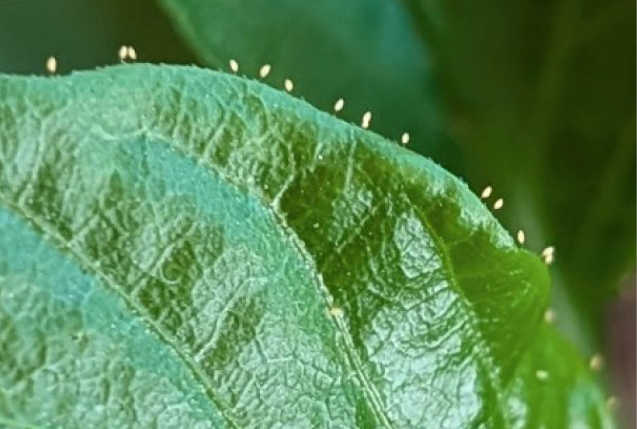
Figure 2: TPP adult and eggs showing egg stalks from side of leaf
(Credit: New Zealand Plant and Food)
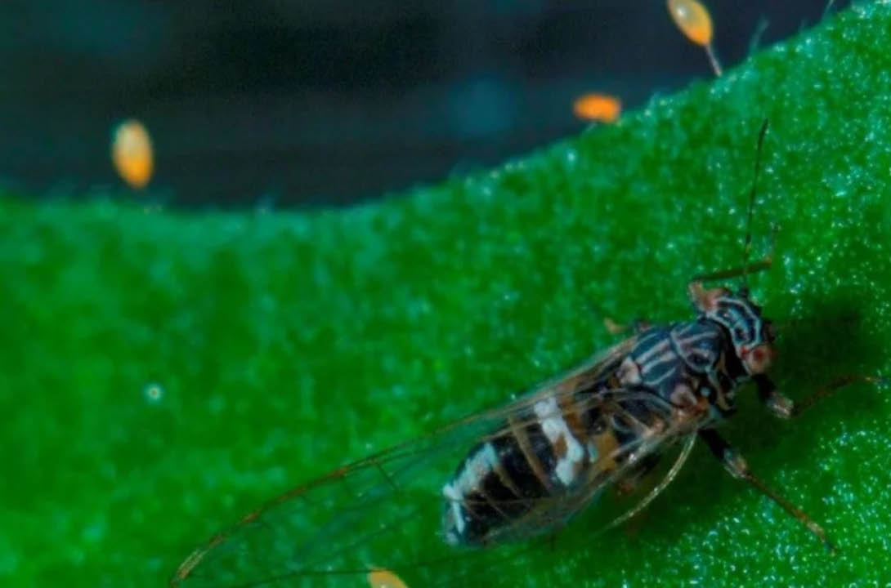

Nymph (Juvenile)
Nymphs moult 5 times, getting progressively larger each time, up to 2 mm long. Nymphs have flattened oval, pale yellow to green or orange scale-like bodies and red eyes (Figure 3 and Figure 4). More mature nymphs have wing buds and are fringed with hairs. Nymphs can usually be found on the underside of leaves.
Figure 3: TPP adults and juveniles on the underside of a leaf
(Credit: Department of Primary Industries and Regional Development, Western Australia)
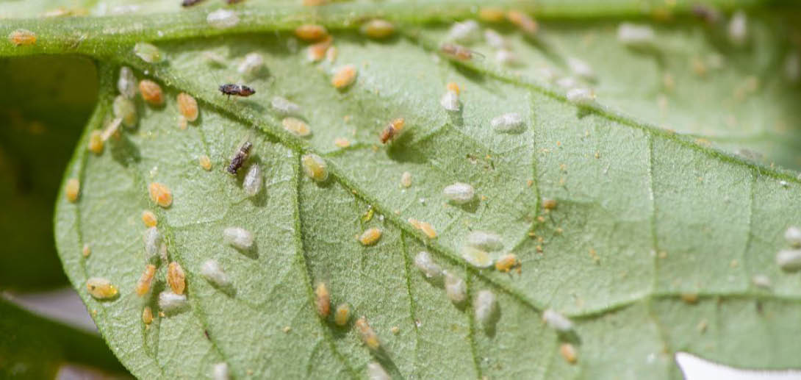
Figure 4: Close up of TPP nymphs (Credit: Joseph Munyaneza USDA)
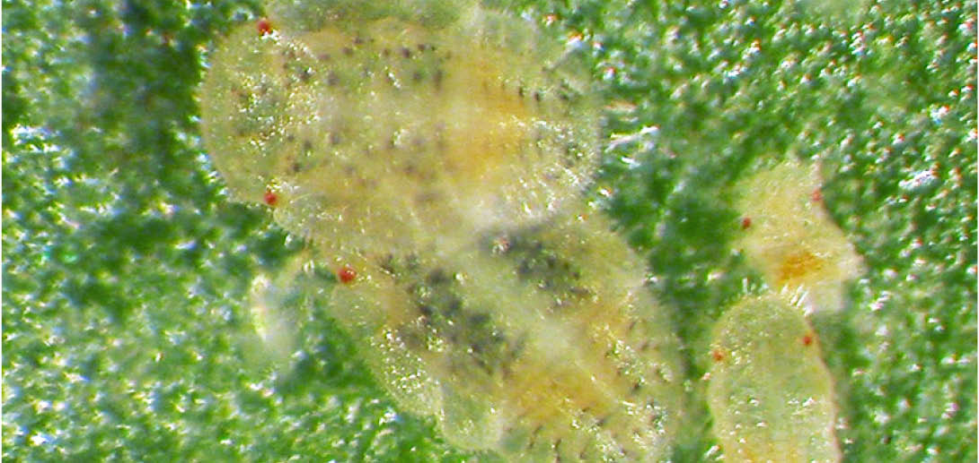

Adult
Adults resemble small, winged cicadas and are about 3 mm long (Figures 2 to 6). When new moulted their body is yellow but turns brown soon after. White or yellowish markings are apparent on the thorax and a broad white band occurs on the abdomen. Their wings are transparent and held vertically over their body. In crops insects may be seen jumping or flying when disturbed.
Figure 5: TPP size relative to 5 cent piece
(Credit: Department of Primary Industries and Regional Development, Western Australia)
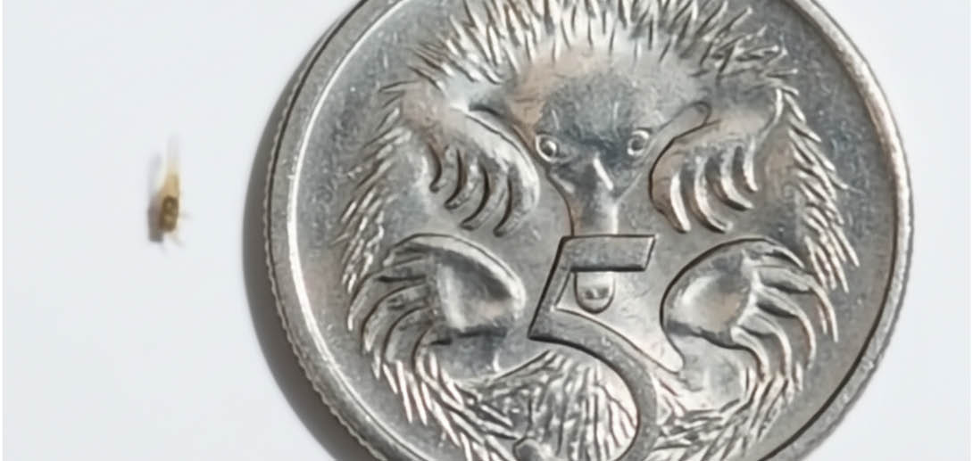
Figure 6: TPP adult and eggs on leaf. White substance is honeydew (sugar-like granules) excreted by TPP (Credit: Joseph Munyaneza, USDA)
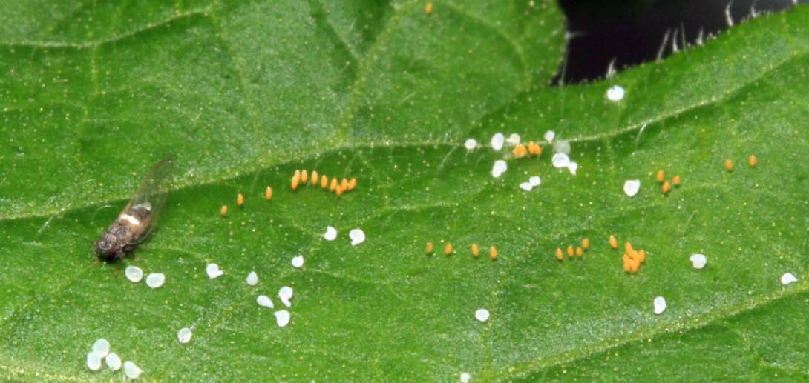

Signs of TPP in crops
When TPP is present in a crop plants may wilt severely when heavily infested and leaves may show yellowing along the edges and upward curling. Growth may be stunted, with shortened stem internodes and stem death.
White, sugar-like granules excreted by psyllids can coat leaves and stems, leading to the development of sooty mould (Figure 7).
Figure 7: Honeydew (sugar-like granules) excreted by TPP
(Credit: Department of Primary Industries and Regional Development, Western Australia)
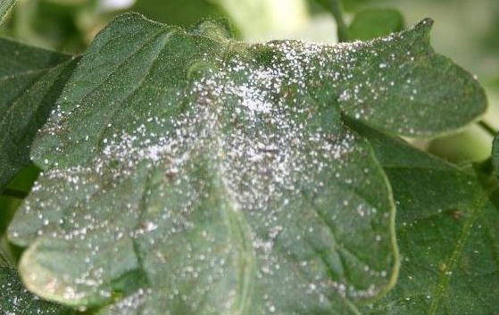

Tomato potato psyllid may be mistaken for other common psyllids and aphids found in Victoria
Figure 8: Lilly pilly psyllid (Trioza eugeniae) multiple life stages
(Credit: Whitney Cranshaw, Colorado State University, bugwood.org)
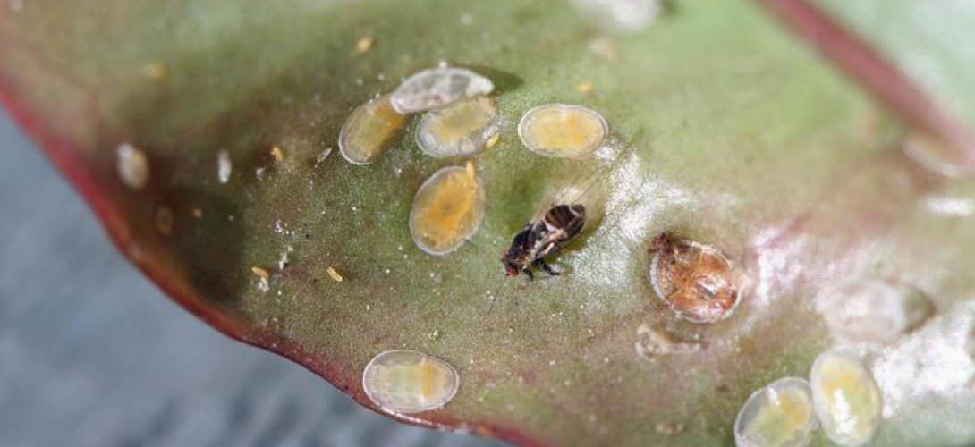
Figure 9: Adult Gum tree psyllid (Ctenarytaina eucalypti)
(Credit: Jesse Rorabaugh, iNaturalist)
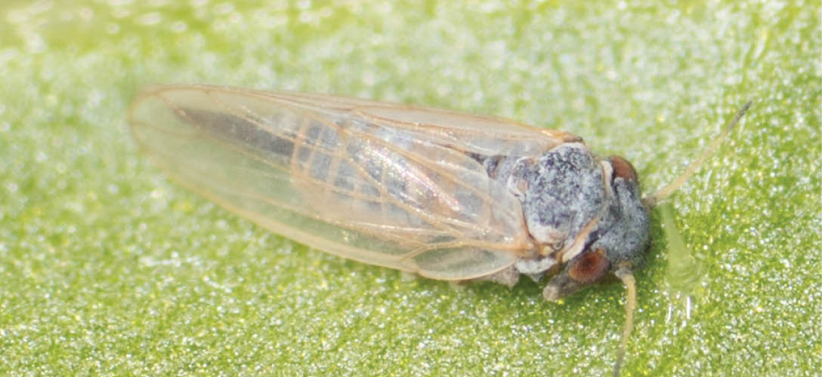
Figure 10: Cotton aphid (Aphis gossypii) multiple life stages
(Credit: Whitney Cranshaw, Colorado State University, bugwood.org)
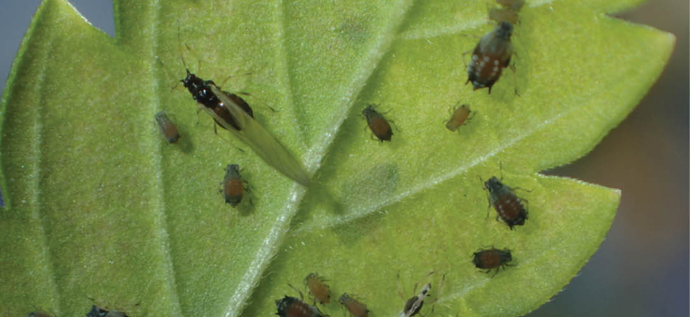
Figure 11: Australian solanum psyllid (Acizzia solanicola)
(Credit: N A Martin, Plant and Food Research New Zealand)
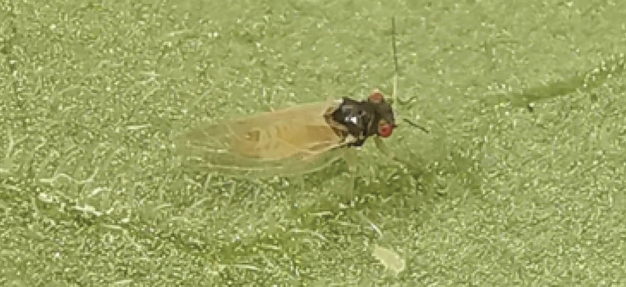

What should you do?
If you suspect TPP please report with photos.
Report online at agriculture.vic.gov.au/reportaplantpest OR Call 1800 084 881

Need help taking pest photos?
Visit: agriculture.vic.gov.au/takeaphoto

For more information
More information about TPP can be found on the Agriculture Victoria website.
Scan the QR code to visit:


Publication information

Acknowledgements
We acknowledge and respect Victorian Traditional Owners as the original custodians of Victoria’s land and waters, their unique ability to care for Country and deep spiritual connection to it.
We honour Elders past and present whose knowledge and wisdom has ensured the continuation of culture and traditional practices.
DEECA is committed to genuinely partnering with Victorian Traditional Owners and Victoria’s Aboriginal community to progress their aspirations.

Copyright
© The State of Victoria Department of Energy, Environment and Climate Action, 2025.

Creative Commons
This work is licensed under a Creative Commons Attribution 4.0 International licence, visit the Creative Commons website (http://creativecommons.org/licenses/by/4.0/).
You are free to re-use the work under that licence, on the condition that you credit the State of Victoria as author. The licence does not apply to any images, photographs or branding, including the Victorian Coat of Arms, and the Victorian Government and Department logos.

Disclaimer
This publication may be of assistance to you but the State of Victoria and its employees do not guarantee that the publication is without flaw of any kind or is wholly appropriate for your particular purposes and therefore disclaims all liability for any error, loss or other consequence which may arise from you relying on any information in this publication.

Accessibility
To receive this document in an alternative format, phone the Customer Service Centre on 136 186, email customer.service@delwp.vic.gov.au, or contact National Relay Service on 133 677. Available at DEECA website (www.deeca.vic.gov.au).
End of document.

