Significant Disease Investigation Guide Cattle & Sheep

Biosecurity
You play a key role in the state’s animal disease surveillance system. By reporting and investigating significant disease events you will help protect the livelihood of producers and the health of people, companion animals, livestock, and native animals. This guide aims to help you decide when to initiate a significant disease investigation (SDI) and outlines the process you need to follow. Disease information relating to cattle and sheep has been arranged by syndrome for ease of use in the field.
A companion edition of this guide has been produced for equine and pig diseases. You can obtain a copy by contacting cvo.victoria@agriculture.vic.gov.au or by visiting the SDI website page agriculture.vic.gov.au/SDI

Disclaimer
This publication may be of assistance to you but the State of Victoria and its employees do not guarantee that the publication is without flaw of any kind or is wholly appropriate for your particular purposes and therefore disclaims all liability for any error, loss or other consequence which may arise from you relying on any information in this publication.
This guide was produced with the help of the Department of Agriculture and Water Resources, the Government of Western Australia, the Northern Territory Government and the Queensland Government. Thanks to Agriculture Victoria staff who also provided pictures.

The Victorian Significant Disease Investigation Program
The Victorian Significant Disease Investigation (SDI) Program aims to boost Victoria’s capacity for the early detection of emergency animal diseases in livestock and wildlife by increasing the participation of veterinary practitioners and subsidising the cost of investigating significant disease events. Subsidies are available for the initial field investigation, including clinical evaluation and necropsy, laboratory testing and follow-up investigation of significant disease events in livestock and wildlife. Eligible vets are those in private practice, zoos or wildlife parks. Subsidy details can be found on the Agriculture Victoria Significant Disease Investigation Program website page.
To be considered a significant disease event and be eligible for the subsidies one
or more of the following criteria must be met:
• An unusual or atypical manifestation of disease, including high morbidity, mortality and/or rate of spread; or
• An initial investigation fails to establish a diagnosis, including when
veterinary treatment does not produce an expected response; or
• There are findings suggesting a possible effect on trade, public health, biodiversity or the viability of the farm, industry or region, excluding events where there is a genuine suspicion of an emergency animal disease.
• Where there is a genuine suspicion of an exotic or emergency animal disease, the department will lead the disease investigation and cover the cost of the investigation.
If you suspect an exotic or emergency animal disease, call the EAD Hotline 1800 675 888.

Genuine suspicion of an EAD?
Immediately notify an Agriculture Victoria Animal Health or Veterinary Officer or contact the Emergency Animal Disease Hotline if you suspect an exotic or emergency animal disease (EAD) or see the following with no apparent plausible explanation:
• sheep and cattle that have ulcers, erosions or blisters around the feet, muzzle, udder or mouth;
• sheep and cattle that are lame and drooling or salivating excessively;
• unusual nervous system signs in more than one animal;
• rapid spread of disease through a herd or flock;
• a disease event where multiple species are affected;
• a disease with sudden high mortality in any species.

In the case of a sudden unexplained death in cattle or sheep, test for anthrax.
Anthrax testing should be carried out on all sudden, unexplained deaths of cattle, sheep and other susceptible livestock. Field testing of cattle and sheep carcases can be carried out using a penside immunochromatographic test (ICT). Agriculture Victoria Animal Health and Welfare staff can provide training on the use of these test kits and can provide kits at no cost. ICT results are available in 15 minutes. Do not commence a necropsy examination until anthrax has been ruled out. Wear appropriate PPE if you suspect anthrax or any zoonotic disease.

Suspicion of zoonotic disease?
It is important to remember that some diseases have the potential to infect humans as well as animals.
• When investigating a disease outbreak, consider possible zoonotic diseases that could be responsible and take relevant precautions.
• Ensure all people in contact with the animals also take appropriate safety precautions.

Zoonotic disease differentials for syndromes seen in cattle:
Syndrome | Disease | Modes of transmission | Precautions at the property
Gastointestinal | Colibacillosis | Ingestion of faecal  contaminated material,  food and water | Wear PPE for examination of animals.  Avoid ingestion of faecal material and  faecal contaminated food and water.
 | Salmonellosis | Ingestion of faecal  contaminated material,  food and water | Wear PPE for examination of animals.  Avoid ingestion of faecal material and  faecal contaminated food and water.
 | Campylobacteriosis | Ingestion of faecal  contaminated material,  food and water | Wear PPE for examination of animals.  Avoid ingestion of faecal material and  faecal contaminated food and water.
Neurological | Bovine spongiform  encephalopathy | Ingestion of material from  infected animal | Remove suspect animals from food  chain. Wear PPE for necropsy, caution  with handling nervous tissue.
 | Rabies | In saliva via bites/scratches | Extreme care. If bitten, euthanase and  test animal - wear PPE for necropsy,  caution with handling nervous tissue.  Seek post exposure treatment.
 | Listeriosis | Direct contact with infected  animal tissue | Wear PPE for examination of animals.
Reproductive | Bovine brucellosis | Direct contact / ingestion of  animal products | Wear PPE for examination of animals.  Avoid ingestion of contaminated  material.
 | Leptospirosis | Urine, reproductive fluids | Avoid splashing or inhaling body fluids,  wear PPE.
 | Listeriosis | Direct contact with infected  placenta/foetus, ingestion  of infected animal products | Wear PPE for examination of animals.  Avoid ingestion of contaminated  material.
 | Q Fever | Inhalation of aerosols  from infected animals  particularly placenta and  fluids, and contaminated  dust. Direct contact  through open wounds. | Wear appropriate PPE  (particularly if not immune).
Respiratory signs | Bovine tuberculosis | Direct transmission by  ingestion, inhalation and  instillation | Remove suspect animals from food  chain. Wear PPE for necropsy.
Skin lesions | Ringworm | Direct contact with infected  skin | Wear gloves to examine animals. Wash  hands and equipment.
 | Pseudocowpox | Direct contact with infected  cattle | Wear gloves to examine animals. Wash  hands and equipment.
Sudden death | Anthrax | Direct contact with infected fluid and tissues | Wear PPE for examination of animals,  avoid contamination from discharges  and avoid opening carcass.
Neurological | Scrapie | Ingestion of neural tissue  from an infected animal. | Remove from food chain. Do render  as blood and bone meal. Wear PPE for  examination of animals.
 | Listeriosis | Ingestion of infected brain | Remove from food chain. Wear PPE for  the examination of animals.
 | Hydatids | People – ingestion of  tapeworm eggs (infected  dog licking face) | Personal hygiene about farm dogs
Reproductive (abortion) | Consider all cases  potentially due to a  zoonotic agent | Ingestion, inhalation, across  mucous membranes.  Mosquito bites (Rift Valley  Fever) | Wear PPE including P2 masks and  goggles
Reproductive (mastitis and orchitis) | Brucella melitensis | Ingestion, inhalation, across  mucous membranes | Wear PPE including P2 masks and  goggles. Consume only pasteurised  sheep and milk products.
Respiratory | Tuberculosis (exotic) | Ingestion, inhalation, across  mucous membranes | Remove from food chain. Wear PPE for  examination of animals.
Skin lesions | Dermatophilosis | Skin contact with wet,  contaminated fleeces | Wear PPE for the examination of animals
 | Orf (scabby mouth) | Skin contact | Wear PPE for the examination of animals
Sudden death | Anthrax | Direct contact with infected fluids and tissues | Wear PPE for the examination of animals, avoid contamination from discharges and avoid opening carcass.

What should be collected in the field?

To complete the Record of Disease Event form (RODE) and laboratory submission form you will need to gather

these details.
• Species. Is more than one species affected?
• Number of deaths, number sick, number at risk, number examined.
• Age, condition score, sex.
• History and predisposing factors.
- When did the outbreak begin?
- What is the recovery time?
- What vaccinations and treatments have the
animals had?
- Recent livestock introductions?
Consider possible sources of introduction/spread. Grazing/feeding history, pasture/feed type
and weed species (if suspect plant toxicity).

Timeline
• Sequence dates of disease cases and note clusters.
– Find the first case – what happened before it?
– Note other events that happened on the property within the timeline.
– What’s different when cases don’t occur?

Details of the location
• Take GPS coordinates if possible.
• Address and PIC.
• Physical factors.
– Infrastructure
– Geography
– Soil
– Vegetation
– Water sources
• Photos of layout and significant features.
• Spatial mud map of where cases occurred.
– Identify clusters of cases.
– Overlay geography and infrastructure.

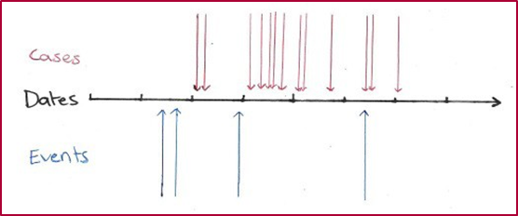

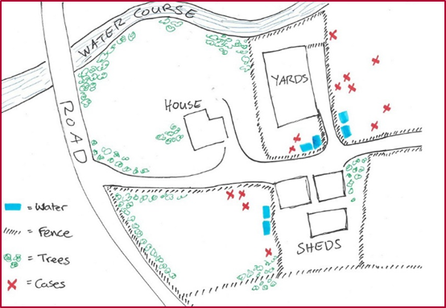s

Good blood collection
Careful handling of blood samples gives the best chance for thorough investigation and accurate diagnosis.
• Make sure you select the correct sample tube for the required tests
• Fill blood tubes
• Avoid haemolysis:
– remove needle before transferring blood from a syringe to a tube
– leave clot tubes standing upright to clot
– mix anticoagulant tubes gently
– allow tubes to cool in esky before placing on an ice block, don’t freeze
– don’t allow tubes to overheat
Tube type | Description | Tests
Serum separation and clot activator  Allows the clot to form so serum can be analysed. | Gold and red tops | Serology, Antibody and antigen tests, Clinical biochemistry
EDTA  Contains anticoagulant | Purple tops | Haematology, Haemoparasite Virus isolation, Polymerase chain reaction (PCR)
Lithium heparin  Contains anticoagulant | Green tops | Clinical biochemistry
Please collect two of the following blood samples from each of 10 animals (five affected, five clinically normal) – 2 x clotted bloods and 2 x EDTA bloods.

Good tissue sample collection
Careful collection of tissue gives the best chance for thorough investigation and accurate diagnosis
Ensure samples are representative of lesions
• sample the interface with normal tissue
• areas of different colour or consistency
• consider multiple sections for large lesions
Take fresh and fixed tissue samples
Fixed tissue
• use 10 times the volume of 10% buffered formalin as tissue
• can be drained before transportation (allow at least 24 hours for tissues to fix) -add a few millilitres of formalin to moisten tissue and seal well
Fresh tissue
• place in individual sterile containers and chill in esky/fridge.

Organ | Sample Size | Don’t forget
Liver and spleen | 10mm cube (fresh), 20mm long x 8mm wide (fixed), 50mm cube (fresh liver and kidney for toxicology) | Multiple samples of normal tissue and pathology
Kidney | 10mm cube (fresh), 20mm long x 8mm wide (fixed), 50mm cube (fresh liver and kidney for toxicology) | Cortex, medulla, pelvis and stones
Heart | 10mm cube (fresh), 20mm long x 8mm wide (fixed), 50mm cube (fresh liver and kidney for toxicology) | Left and right ventricles, atrium, septum, valves
Lung | 10mm cube (fresh), 20mm long x 8mm wide (fixed), 50mm cube (fresh liver and kidney for toxicology) | Cranio-ventral and dorso-caudal areas
Lymph nodes | Whole lymph node (half fresh and half fixed) | Label container to identify which lymph node.

Additional sample collection guide for syndromes seen in cattle

 | Blood Clotted | Blood EDTA | Blood Smear | Faeces & Urine | Priority tissue samples | Other samples
Ill thrift | Yes | Yes | Yes | Yes | Liver, kidney, heart, lung, spleen,  GIT, lymph nodes | Any lesions
Neurological | Yes | Yes | Yes |  | Brain, spinal cord, liver, kidney,  heart, skeletal muscle | Rumen and intestinal contents,  cerebrospinal fluid, aqueous  humour, any lesions.  Fresh kidney (50g) if suspect  lead poisoning
Oral lesions | Yes | Yes | Yes |  | Vesicular fluid, epithelium from  vesicles, oral, nasal, vesicular and  tonsillar swabs in VTM or saline | Spleen, liver, lung, GIT, lymph  nodes, any lesions.
Reproductive | Yes | Yes |  |  | Aborted / stillborn foetus and  placenta,  Pericardial and intrathoracic  fluid from foetus
Respiratory signs | Yes | Yes | Yes |  | Lung, trachea, bronchial lymph  nodes, pleural fluid, any lesions | Oral and nasal swabs in VTM  (Viral and Transport Media)  Bacto swab of lesions in TM  (Transport Media)
Skin lesions | Yes | Yes | yes |  | Skin lesion, skin scrapings,  pustular lesion swab in VTM,  external parasites (70% alcohol) | Liver, kidney, any lesions
Sudden death  (perform anthrax  ICT prior to opening  carcass. Do NOT  perform necropsy  if the anthrax ICT is  positive) | Yes | Yes | Yes | Yes | Brain, liver, kidney, heart, skeletal  muscle, lymph nodes, any lesions | Fluid from body cavities, bone  marrow, aqueous humour, any  suspect toxins.

Additional sample collection guide for syndromes seen in sheep
 | Blood clotted | Blood EDTA | Blood smear | Faeces & Urine | Priority tissue samples | Other samples
Ill thrift | Yes | Yes | Yes | Yes | Liver, kidney, heart, lung, spleen,  GIT, lymph nodes | Any lesions
Neurological | Yes | Yes | Yes |  | Brain, spinal cord, liver, kidney,  heart, skeletal muscle | Rumen and intestinal contents,  cerebrospinal fluid, aqueous  humour, any lesions.  Fresh kidney (50g) if suspect  lead poisoning
Oral lesions | Yes | Yes | Yes |  | Vesicular fluid, epithelium from  vesicles, oral, nasal, vesicular and  tonsillar swabs in VTM or saline | Spleen, liver, lung, GIT, lymph  nodes, any lesions
Reproductive | Yes | Yes |  |  | Aborted / stillborn foetus and placenta,  vaginal mucous or cervical mucous  from cow, preputial wash from bull  Pericardial and intrathoracic fluid  from foetus.
Respiratory signs | Yes | Yes | Yes |  | Lung, trachea, bronchial lymph  nodes, pleural fluid, any lesions | Oral and nasal swabs in VTM  Bacto swab of lesions in TM
Skin lesions | Yes | Yes | Yes |  | Skin lesion, skin scrapings,  pustular lesion swab in VTM,  external parasites (70% alcohol) | Liver, kidney and any lesions
Sudden death (perform ICT prior to opening carcass. Do NOT perform necropsy if the ICT is positive) | Yes | Yes | Yes | Yes | Brain, liver, kidney, heart, skeletal  muscle, lymph nodes, any lesions | Fluid from body cavities, bone  marrow, aqueous humour, any  suspect toxins

Differential diagnosis for syndromes seen in cattle (not a complete list of diseases)
 | Exotic | Endemic | Lab will undertake
Ill thrift | • Surra  • Haemorrhagic septicaemia  • Jembrana  • Tick fever (babesiosis and  anaplasmosis) (exotic to Victoria) | • Bovine Viral Diarrhea Virus (BVDV-1) /  Mucosal Disease  • Johne’s disease  • Intestinal worms and Coccidiosis  • Liver Fluke  • Theileriosis  • Acute Bovine Liver Disease  • Blue Green Algae  • Trace mineral deficiency  • Chronic plant toxicity | Surra – CATT, ELISA, PCR
Gastrointestinal | • Rinderpest | • Mucosal disease (BVDV)  • Bovine Malignant Catarrh  • Salmonellosis  • Yersiniosis  • Johne’s disease  • Intestinal worms and  Coccidiosis
Neurological | • Bovine Spongiform Encephalopathy  • Rabies  • Heartwater | • Botulism  • Bovine Herpesvirus (BHV- 5)  • Toxicity - Chemical / plant  • Polioencephalomalacia  • Metabolic – Grass Tetany, Ketosis,  Hypocalcaemia  • Neoplasm | BSE - Histology
Oral lesions | • Foot and Mouth Disease  • Vesicular stomatitis  • Bluetongue  • Jembrana | • Mucosal disease (BVDV-1)  • Bovine Malignant Catarrh  • Bovine papular stomatitis  • Actinobacillosis and actinomycoses  • Non-infectious causes such as trauma | FMD – ELISA & PCR  VS – VNT, virus isolation  (referral)
Reproductive | • Bovine brucellosis  • Bovine Viral Diarrhoea Virus (BVDV-2)  • Infectious pustular vulvovaginitis  • Bovine Herpesvirus, exotic serotype  • Rift Valley fever | • Vibriosis  • Trichomoniasis  • Bovine Viral Diarrhoea Virus (BVDV-1)  • Leptospirosis  • Arboviruses – Akabane, Bovine Ephemeral Fever | Brucellosis – RBT, CFT, PCR,  Culture
Respiratory signs | • Contagious Bovine  Pleuropneumonia  • Bovine tuberculosis  • Bluetongue  • Bovine Herpesvirus, exotic  serotypes  • Meliodosis | • Bovine Respiratory Disease  • Infectious Bovine Rhinotracheitis (BHV-1.2b)  • Pneumonia  • Bovine Ephemeral Fever  • Lung worm | CBPP – Histology, PCR,  Culture  TB – Histology, PCR, Culture
Skin lesions | • Lumpy skin disease  • Bluetongue  • Aujeszky’s  • Surra  • Screw Worm Fly  • Haemorrhagic septicaemia  • Irritation from cattle tick or buffalo fly | • Acute Bovine Liver Disease  • Bovine Herpes Virus (BHV-2)  • Bovine papillomavirus (Warts)  • Photosensitisation  • Ringworm  • Mange (Chorioptes bovis or Demodex bovis)  • Enzootic Bovine Leucosis | LSD – Histology, EM  microscope
Sudden death | • Haemorrhagic Septicaemia  • Rinderpest  • Foot and Mouth Disease (young  calves)  • Tick fever (babesiosis and  anaplasmosis)  • Bluetongue | • Anthrax  • Toxicity – Chemical / plant  • Clostridial diseases – Enterotoxaemia,  Tetanus, Black Leg, Black disease  • Mucosal disease (BVDV)  • Theileriosis  • Acute Bovine Liver Disease  • Bovine Malignant Catarrh  • Botulism  • Metabolic diseases  • Blue Green Algae poisoning  • Lightning strike | HS – PCR, Culture

Differential diagnosis for syndromes seen in sheep (not a complete list of diseases)
 | Exotic | Endemic | Lab will undertake
Ill thrift | • Maedi-Visna  • Scrapie  • Bluetongue (BTV)  • Foot and Mouth disease | • Johne’s disease  • Intestinal Worms and Coccidiosis  • Liver Fluke  • Blue Green Algae  • Trace mineral deficiency  • Chronic plant toxicity  • Malnutrtiion  • Worms (Haemonchus or scour worms)  • Paratuberculosis  • Toxicities (eg pyrrolizidine alkaloidosis) | BTV serology and  Polymerase Chain Reaction  (PCR). FMD on cattle.  Histology for scrapie and  Maedi-Visna
Gastrointestinal | • Peste des Petits Ruminants (PPR)  • Rift Valley Fever  • Bluetongue Virus  • Lamb dysentary | • Johne’s disease  • Toxicity (Plant / Chemical)  • Scour worms  • Salmonellosis  • Yersiniosis  • Coccidiosis | Virology for PPR, Rift Valley  Fever and Bluetongue Virus.
Neurological | • Scrapie  • Maedi-Visna | • Toxicity – Chemical / plant  • Polioencephalomalacia  • Metabolic  • Listeriosis  • Staggers diseases  • Toxicological syndromes  • Pregnancy toxaemia | Histology for Maedi-Visna  and Scrapie
Oral lesions | • Foot and Mouth disease  • Bluetongue Virus  • Peste des Petits Ruminants (PPR)  • Rift Valley Fever (RVF) | • Traumatic lesions (eg grass seeds)  • Renal failure | Virology for FMD, Bluetongue  Virus, Peste des Petits  Ruminants (PPR) and Rift  Valley Fever (RVF).
Reproductive | • Brucella melitensis  • Rift Valley Fever  • Bluetongue Virus  • Foot and Mouth disease | • Brucella ovis (rams)  • Abortive agents (Camplyobacter, Listeria,  Toxoplasma, etc)  • Malnutrition | Bacterial culture for Brucella.  virology for Rift Valley Fever,  Bluetonge Virus and FMD.
Skin and fleece lesions | • Scrapie  • Sheep Pox  • Sheep Scab | • Photosensitisation  • Lice  • Flystrike  • Scabby mouth  • Photosensitisation | Histology, Virology, Parasitology  for these.
Sudden death | • Peste des Petits Ruminants  • Rift Valley Fever  • Bluetongue Virus  • Foot and Mouth disease (lambs) | • Anthrax  • Clostridial diseases – Enterotoxaemia,  Tetanus, Black Leg, Black disease  • Metabolic diseases  • Blue Green Algae  • Pulpy kidney  • Tetanus  • Other Clostridial diseases  • Salmonellosis  • Hypocalcaemia | Virology for Peste des Petits  Ruminants, Rift Valley Fever,  Bluetongue Virus, FMD.
Lameness | • Foot and Mouth disease  • Bluetongue Virus | • Footrot  • Benign footrot  • Foot abscess | Virology for FMD and  Bluetongue Virus
- There are subsidies available for TSE testing. Contact Agriculture Victoria.

Handling samples in the field
• Ensure samples are taken prior to giving treatments (where possible).
• Ensure enough samples are collected to represent the whole herd.
• Collect fresh and fixed samples first, then gut samples.
• Label samples as soon as you take them.
• Ensure labelling is clear and indelible. Record Property Identification
Code (PIC), animal identification, date and vet on label.
• Tissue samples should be prepared as both fresh and fixed.
• Use plenty of 10% formalin to fix tissues.
• Fix for 24 hours then formalin can be drained off for transport. Add a few
mL of formalin to the container, or wrap tissue in paper towel moistened
with formalin, and place in leak proof container.
• Clean any surface contamination from tubes and containers.
• Place tubes/vials into zip-lock bags to keep them clean and contained
together.
• Keep fresh samples cool while in the field with ice bricks.
• Don’t leave samples standing in the sun while working.
• Use an esky and ice bricks to store samples in transit.

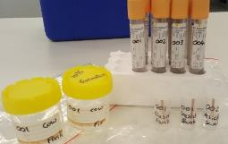

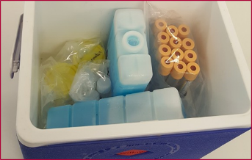

Ill thrift

Clinical signs
• Depressed animals.
• Weight loss or failure to gain weight.
• Emaciation.
• Sudden losses in production.
• Weakness.
• Lethargy.
• Cattle: oedema in lower parts of body.
• Cattle: swollen lymph nodes.
• Cattle: death.
• Tail in mob.
• Diarrhoea (possibly).
• Bottle jaw.
• Sheep: Fleece break.

Samples to collect
• Acute and convalescent blood samples for serology –collect in clot tubes and EDTA.
• Blood smears.
• Tissue samples of any lesions found.
• Tissue samples from dead animals – lymph nodes,
liver, kidneys, heart, lung, spleen, GIT.
• Faeces.
• Urine.

Remember to ask
• How long have the animals been affected?
• What proportion of animals are affected?
• Are other species affected, what are they?
• Have any animals been introduced to the property?
• Have any animals been removed from the property?
• Have you had a problem with biting or blood-sucking insects?
• Drenching history.
• Any supplementary feeding?
• Any history of Johne’s disease and is the flock/herd vaccinated?

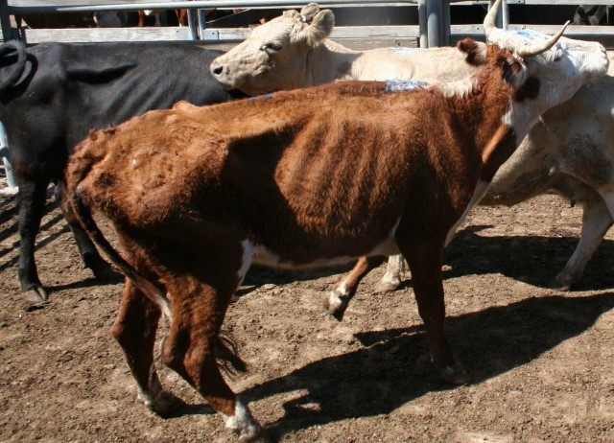

Neurological signs

Clinical signs
• Behavioural changes.
• Unusual vocalisation.
• Unusual posture and gait.
• Puritis and self-trauma.
• Sheep: fleece derangement.
• Sheep: Fall over when moved.
• Weakness.
• Ataxia.
• Paralysis.
• Blindness.

Samples to collect
• Acute and convalescent blood samples for serology – collect in clot tubes and EDTA.
• Blood smears.
• Tissue samples of any lesions found.
• Tissue samples from dead animals
– liver, kidneys, brain, spinal cord, heart, spleen.
• Aqueous humour.
• Smears of brain, vascular tissue and spleen.
• Fluid from body cavities.
• Rumen and intestinal contents.
• Faeces.
• Urine.
• Transmissable Spongiform Encephalopathies (sheep scrapie, cattle BSE) specific samples, up to two animals.

Remember to ask
• How long have the animals been affected?
• What proportion of animals are affected?
• Are other species affected, what are they?
• Have any animals been introduced to the property?
• Have any animals been removed from the property?
• Has there been any recent rainfall?
• Have animals had access to a rubbish dump?
• Has any new equipment or feed been brought onto the property?
• Sheep: What have they been grazing?

Oral lesions and vesicular diseases

Clinical signs
• Unwillingness to eat.
• Excess salivation.
• Depressed animals.
• Fever.
• Vesicles/erosions/ulcerations in the mouth.
• Check if animals also present with:
– lameness
– reluctance to move
– similar lesions on the feet or the teats.

Samples to collect
• Vesicular fluid – from unruptured vesicles collect via a syringe or a swab and place in plain sterile tube.
• Nasal, oral and tonsillar swabs.
• Place swabs in 0.5ml of phosphate buffered saline or viral transport media.
• Epithelium from unruptured vesicles.
• Epithelial tags from freshly ruptured vesicles: 1–2 cm.
• Oropharyngeal fluid, collected with a probang, if this is available.
• Acute and convalescent blood samples for serology – collect in clot tubes and EDTA.
• Tissue samples from dead animals – lymph nodes, spleen.

Remember to ask
• How long have the animals been affected?
• What proportion of animals are affected?
• Are other species affected, what are they?
• Have any animals been introduced to the property?
• Have any animals been removed from the property?
• Has any new equipment or feed been brought onto the property?
• Have there been visitors to the property recently?
• Has anyone who has contact with the animals been overseas recently?
• What have they been grazing?

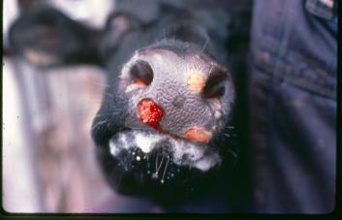

Reproductive signs

Clinical signs
• Low pregnancy/scanning rate.
• Low calving/lambing rate, low marking or weaning rates.
• Protracted lambing/calving.
• Abortion.
• Stillborn calves/lambs.
• Weak calves/lambs.
• Retained placentas.

Samples to collect
• Blood samples from live animals for serology – collect in clot tubes and EDTA.
• Swabs from placenta or foetus.
• Pericardial and thoracic fluid from aborted/stillborn foetuses.
• Swab of uterine discharge – place swabs in 0.5ml of phosphate buffered saline or viral transport media.
• Whole placenta or foetus chilled.
• Tissue samples from foetus– liver, kidneys, lung, brain, heart.
• Sheep: foetal abomasum.

Remember to ask
• Do you pregnancy test your herd/flock?
• What are your pregnancy testing, calving/lambing results?
• Have you noticed any aborted foetuses in the paddocks or yards?
• Have you noticed any deformed calves/lambs?
• Do you vaccinate for reproductive diseases?
• Sheep: Do you vaccinate for abortion in ewes?
• Sheep: When did you mate these ewes?
• Do you run heifers and cows and maiden ewes/ewes separately?
• Have you introduced new bulls/rams to the property and how have they been managed?
• Do you have significant problems with wild dogs?
• Sheep: Have you tested your rams for Brucella ovis, or are they all from accredited studs?
• Sheep: What has ewe nutritional status been like at mating and throughout pregnancy?

Respiratory signs

Clinical signs
• Coughing.
• Rapid respiration.
• Nasal discharge
– mucopurulent
– frothy
– bloody.
• Tail in mob.
• Respiratory distress.
• Conjunctivitis.
• Sudden death.

Samples to collect
• Nasal, oral and tonsillar swabs.
• Swabs from lesions.
• Acute and convalescent blood samples for serology.
• Collect in clot tubes and EDTA.
• Tissue samples of any lesions found.
• Tissue samples from dead animals – lymph nodes,
liver, kidneys, pleural fluid, spleen.

Remember to ask
• How long have the animals been affected?
• What proportion of animals are affected?
• Are other species affected, what are they?
• Have any animals been introduced to the property?
• Have any animals been removed from the property?
• Have the animals been transported recently?
• Are there any wild/feral animals which could contact stock?
• Sheep: Have the animals been lot or confinement fed?
• Sheep: Have they been droved, yarded, transported or shorn recently?

Skin lesions

Clinical signs
• Depressed animals.
• Maggots in wounds or openings such as eyes.
• Cutaneous nodules – may become necrotic.
• Enlarged lymph nodes.
• Sheep: odour of flystrike.
• Oedema in limbs and ventral parts of body.
• Scratching, biting, rubbing and itching.
• Loss of hair/wool.
• Sheep: fleece derangement.
• Scabs.

Samples to collect
• Acute and convalescent blood samples for serology
– collect in clot tubes and EDTA.
• Nasal, oral and tonsillar swabs.
• Place swabs in 0.5ml of phosphate buffered saline or viral transport media.
• Skin scrapings at site of lesions and adjacent tissue.
• Crusts, scabs and swabs from lesions.
• Any external parasites found (in 70% alcohol).
• Fresh and fixed tissue samples from
dead animals - lymph nodes, kidney, liver, spleen.

Remember to ask
• How long have the animals been affected?
• What proportion of animals are affected?
• Are other species affected, what are they?
• Have any animals been introduced to the property?
• Have any animals been removed from the property?
• Has any new equipment been in contact with the animals?
• Do you have problems with biting insects?
• Sheep: What fly control measures do you use?
• Sheep: Do you have a problem with straying sheep?
• Sheep: Have you bought sheep in the past 12 months?

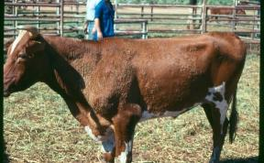

Sudden death

Clinical signs
• Single or multiple animals found dead.
• Death not preceded by obvious signs of disease.
• Animals dying in rapid succession.

Samples to collect
• Perform anthrax ICT before conducting necropsy.
• Blood samples from live affected and normal
animals for serology, collect in clot tubes and EDTA.
• Swabs from any lesions found.
• Swab of any bloody discharge from any orifice.
• Tissue samples of any lesions found.
• Tissue samples from dead animals – lymph nodes,
liver, kidneys, lung, brain, bone marrow, spleen.
• Fluid from body cavities.
• Faeces.
• Urine.

Remember to ask
• What have weather conditions been like lately?
• How long have the animals been dying?
• What proportion of animals have died?
• Are other species affected, what are they?
• Have any animals been introduced to the property?
Have any animals been removed from the property?
• Has any new equipment or feed been brought on to the property?
• Has anyone travelled overseas recently? To where?
• Any property or locality history of anthrax?
In the case of a sudden unexplained death in cattle or sheep, test for anthrax.
Anthrax testing should be carried out on all sudden, unexplained deaths of cattle, sheep and other anthrax susceptible livestock. Field testing of cattle and sheep carcases can be carried out using a penside immunochromatographic test (ICT). Agriculture Victoria Animal Health and Welfare staff can provide training on the use of the test kits and can provide kits at no cost. ICT results are available in 15 minutes.

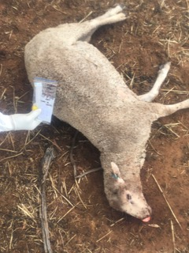

Gastrointestinal disease

Clinical signs
• Scouring, diarrhoea, dags.
• Weight loss.
• Depression.
• Production loss.
• Deaths.

Samples to collect
• Faecal samples: individual from sick, and bulk (10+) from stock.
• Blood samples from live affected and normal animals in EDTA and clot tubes.
• Tissue samples (fresh and fixed) from any lesions seen at necropsy.
• Tissue samples (fresh and fixed) from along the GI tract: rumen, abomasum, proximal duodenum,
jejunum, ileum, caecum, colon.
• Gut contents.
• Fluid from body cavities.

Remember to ask
• Drenching history?
• How long have the stock been on the property?
• What proportion of the stock are affected (just this mob, or others)?
• Are any other species affected?
• What are they grazing or being fed?

Lameness in sheep

Clinical signs
• Lameness.
• Weight loss.
• Tail in mob.

Samples to collect
• Examine feet.
• Swabs from lesions in interdigital space or underrun hoof.
• Scabs if present.
• Blood samples from normal and affected animals in EDTA and clotted tubes.

Remember to ask
• Do you footbathe the stock?
• Have you bought in stock in the past 12 months?
• Do you have a problem with straying stock?
• Have your sheep had footrot before?
• Have you attempted to eradicate footrot in the past?
• Have you noticed increased insect activity after heavy
rain?
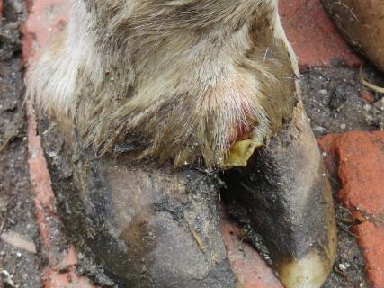

Practising good biosecurity

Vehicles, clothing, footwear and equipment can all spread disease between properties
• Take cleaning equipment in your vehicle.
• If possible, leave your vehicle outside the property.
• Include a bucket, brush, disinfectant and bin bags. Common disinfectants such as chlorine based and Virkon are effective against most infectious agents.
• Put clean overalls on over your clothes before entry.
– clean disposable or dedicated overalls.
– clean gumboots.
• Wear disposable gloves to collect samples.
• Establish clean and dirty zones at the entrance to the property.
• Equipment, clothing and footwear that have been in contact with the dirty zone, must be cleaned or placed in bags when exiting the dirty zone.
• Always clean before disinfecting. Mud and dirt can prevent disinfectants from being effective.
• Pay particular attention to footwear, hands and fingernails as well as equipment used on animals.
• Collect all waste and disposable equipment in a plastic bin bag.
• Remove overalls as you depart the property and place in a plastic bag.
• All mud and dirt should be cleaned from your boots, including the soles.
• Once cleaned the boots should be disinfected.
• Clean vehicle on exit from the property, paying particular attention to wheel arches and tyres.

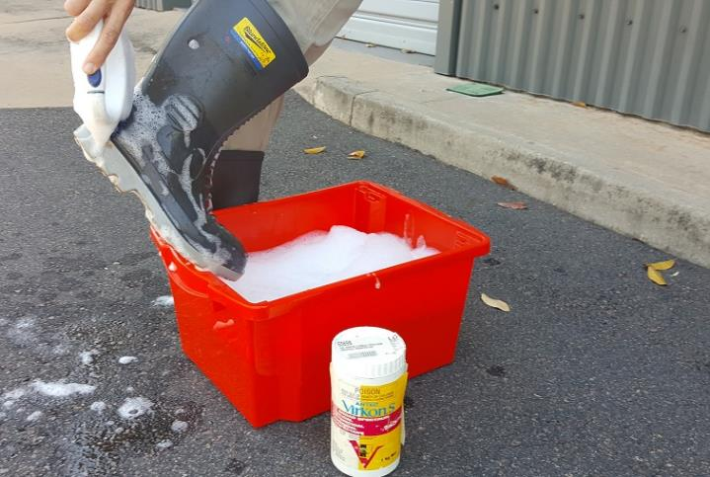

If you suspect a notifiable disease call the EAD Hotline for advice before leaving the
property. Do not allow animals to be moved off the property. Leave disposable equipment
securely on the property for later disposal post investigation.

Packaging samples for transport
• Refrigerate samples as soon as you return from the property.
• Do NOT freeze samples.
• List all samples taken on the submission form.
• Samples must be sent to the Veterinary Diagnostic Services AgriBio laboratory as soon as practical.
• Place all sample containers in zip-lock bags for transport.
• Place bags of samples in a rigid container (esky/cool box).
• Use absorbent material to line container in case of leaks.
• Pack all samples with ice blocks in the transport container.
• Do not pack with wet ice.
• Place laboratory submission form in a separate zip lock bag within the transport container.
• Seal the container with tape.
• If sending via courier, place the consignment note on top of the container.
• If samples are travelling by air, packing must comply with the dangerous goods regulations for
– UN3373, Biological substances, Category B.

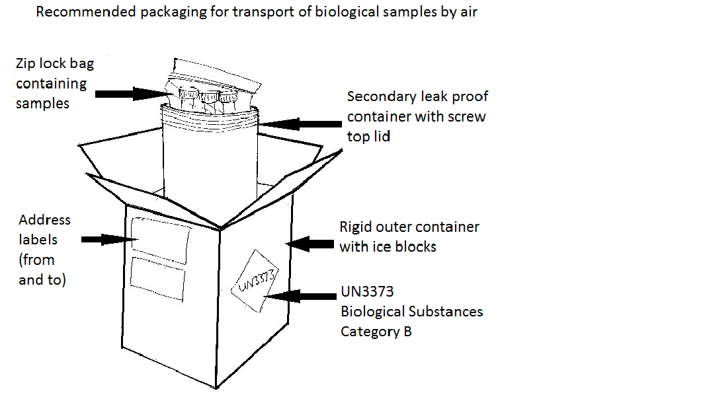
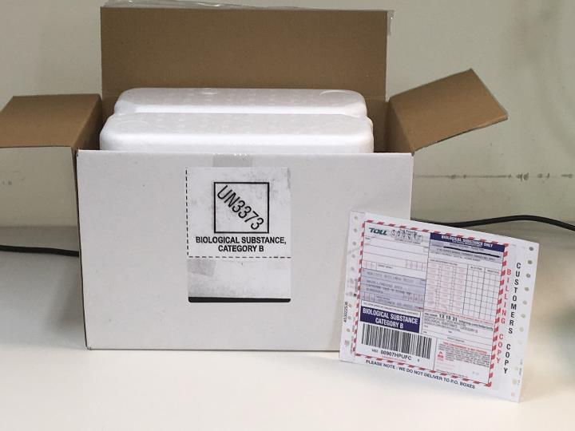

Submitting samples and reports.
Veterinary Diagnostic Services
AgriBio Specimen reception
Main Loading Dock
5 Ring Rd
Latrobe University
Bundoora 3083

Phone: (03) 9032 7515
Fax: (03) 9032 7604
Email: vet.diagnostics@agriculture.vic.gov.au

Further information
For further information contact your local Agriculture Victoria veterinarian or refer to the Agriculture Victoria website www.agriculture.vic.gov.au
During business hours contact 136 186 and ask to speak to your local Agriculture Victoria veterinarian to report a significant disease investigation or a suspect emergency animal disease, or refer to the Agriculture Victoria website agriculture.vic.gov.au/sdi
And remember, if you suspect an emergency animal disease, please call the Emergency Animal Disease hotline, or use the Notify Now app immediately!


Information correct 2026. Please check the Agriculture Victoria website for your current SDI contact.

