Demonstration Summary

Pasture cropping to fill the winter feed gap - Enhanced Producer Demonstration Site

The Glenelg BestWool/BestLamb (BWBL) group was keen to experiment with pasture cropping to improve degraded phalaris pastures and increase feed production. Demonstration sites were established to evaluate the benefits of
integrating cropping into pasture, measuring grain yields and pasture improvements.

Encouraged by the results, the group set up a second demonstration to measure the production gains from grazing the crop/pasture in winter and filling the winter feed gap.

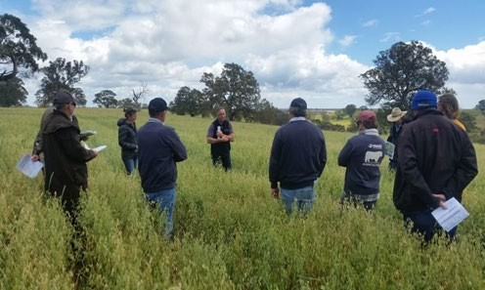
Figure 1. Glenelg BWBL group inspecting pasture/crop.

What is pasture cropping?

Pasture cropping involves sowing winter crops into summer-active perennial pastures to improve year-round production.

In south-west Victoria, however, the predominantly winter rainfall and winter-active pastures mean autumn-sown cereals compete with pasture growth.

The Glenelg BWBL group’s idea was to adapt the concept by allowing phalaris to run to head, providing regenerative benefits and removing annual weeds and increasing fertility at sowing. While the pasture rested, the oat crop could develop and be harvested or grazed as required.
Key points

Pasture cropping led to slight increases in phalaris ground cover in the following year.

Crops provided good quality feed and high growth rates in winter.

Winter grazing increased the profit margin of the pasture/crop.

Phalaris also uses soil moisture, which the group felt might reduce the impact of waterlogging on the crop.

Producer demonstrations

Demonstration 1: Establishing pasture/crop

Over three years, the Glenelg BWBL group
hosted 14 sites where Quoll oats were sown into
sub-optimal phalaris pasture.

Crop establishment

Paddocks were spray-topped in the spring preceding sowing and were again sprayed in May to knock out all weeds and suppress phalaris. Quoll oats were sown later in May at 100kg/ha with 100kg/ha MAP. Post-emergent herbicides were used in July to remove onion grass and broadleaf weeds.

The total cost of chemical, seed, fertiliser, contractors and harvest was approximately
$300/ha for each site.

The number of phalaris plants and percentage of perennial ground cover were measured prior to sowing and after the crop phase. Crop yields were also calculated.

This demonstration was funded by Agriculture Victoria and the Glenelg Hopkins Catchment Management Authority and run by Agriculture Victoria.
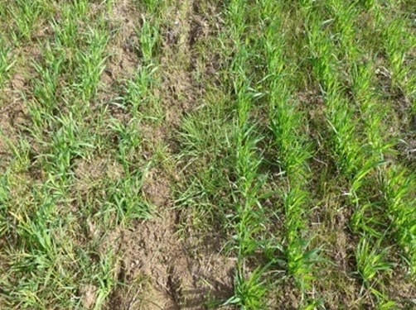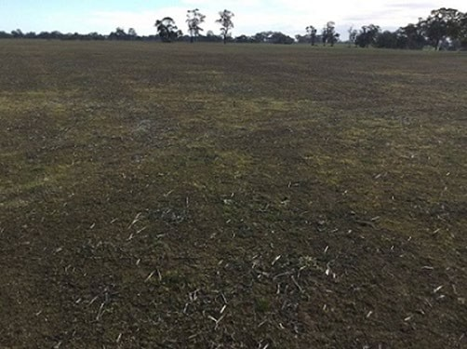

Figure 2. Pasture in May Year 1, immediately prior to sowing.
Figure 3. Crop establishment in June.

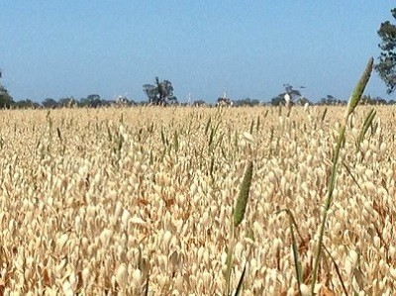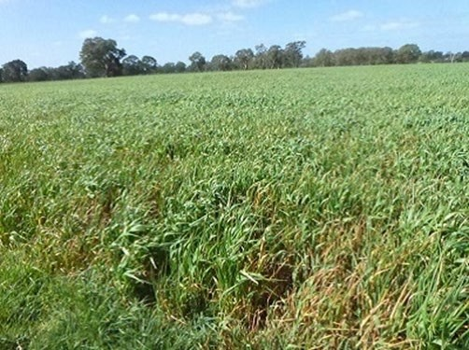

Figure 4. Crop in July at the time of post-emergent spray. Figure 5. Crop in November with phalaris heads poking through.

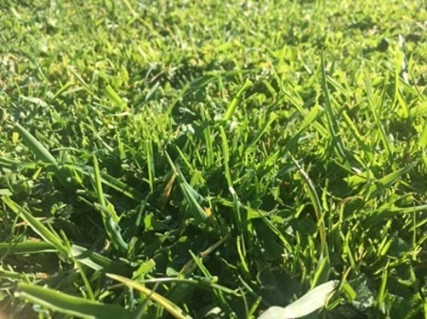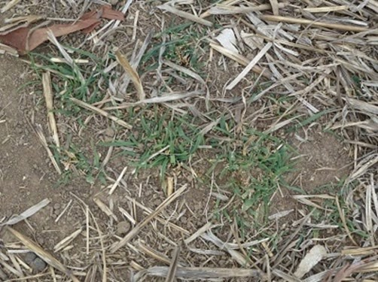

Figure 6. Site in March Year 2, phalaris growing back after grazing stubble.
Figure 7. Same site in June, two years after cropping.
Demonstration 2: Grazing the crop/pasture

Encouraged by results from the Grain and Graze project (Falkiner et al. 2013), the group set up additional demonstration sites in 2015 and 2016. These sites were established following the same method as the first demonstration (above), however areas of the crop/pasture were grazed over winter to measure livestock production benefits (compared to grazing pasture) and any crop yield reductions caused by grazing.

The crop/pasture was grazed for 21 days in winter with ewe weaners and yearling bulls. Livestock growth rates were measured and compared to animals from the same mob grazing pasture at the same stocking rate. Feed quality and crop and pasture growth rates were also measured.
This demonstration was run with Agriculture Victoria and co-funded by Meat & Livestock Australia (MLA).

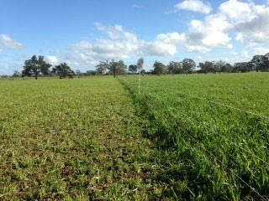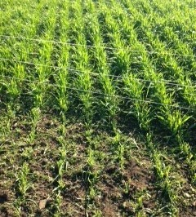

Winter feed
Figure 8. Grazed and ungrazed crop/pasture.
The crop/pasture sites outperformed the pasture-only sites in feed quality and growth in the middle of winter. Metabolisable energy (ME), digestibility and crude protein levels of the crop/pasture were higher than in pasture- only sites (Table 1), though protein levels were more than adequate in both paddock treatments.

Table 1: Feed quality and production for 2015 and 2016 (assessed in July before grazing).

 | Year | FOO at grazing  (kgDM/ha) | Growth rate  (kg DM/ha/day) | Digestibility  (DDM%) | Metabolisable energy  (MJ ME/kg DM) | Crude protein  (%)*
Crop/pasture | 2015 | Not measured | Not measured | 90–92 | 13.8–14.3 | 29.2–29.5
Pasture | 2015 |  |  | 78 | 11.7 | 23.5
Crop/pasture | 2016 | 680–1020 | 47–60 | 78–82 | 11.7–12.5 | 18.8–26.7
Pasture | 2016 | 550–850 | 12 | 70–77 | 10.4–11.7 | 17.8–25.5

Livestock production

The high feed quality and winter growth of the crop/pasture led to higher weight gains for both ewe weaners (Figure
9) and yearling bulls (Figure 10) than on the pasture only. (A portion of this difference may be due to additional gut fill in the crop-grazed animals).

2016 Lamb growth rate g/day/hd for 21 days
Crop/ pasture Pasture

414 414
2016 Bull growth rate g/day/hd for 21 days

Crop/ pasture Pasture

2270
420

 |  | 155 |  |  |  | 121

Site 1 Site 2

Figure 9: Daily growth rates of ewe weaners on crop/pasture and pasture only.

Crop/ pasture Pasture

Figure 10: Daily growth rates of yearling 3
bulls on crop/pasture and pasture only.
Crop yields

Crop yields from all demonstration sites ranged from 2–5.5t/ha, with the lower yields occurring during the very dry seasons of Year 1 and Year
2.

Grazing the crop led to minor reductions in grain yield (0–0.8t/ha) in the first year, however yields were between 1.1–1.42t/ha lower in grazed
sites in the second year of grazing. This was caused by a combination of waterlogging (which affects the grazed areas more due to the smaller leaf area) and a miscalculation in grazing time.
In 2016, livestock grazed the crop beyond the recommended growth stage 30 and into early growth stage 31, which will damage the embryo ear and reduce yields (Figure 11).

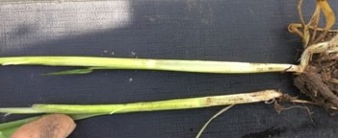

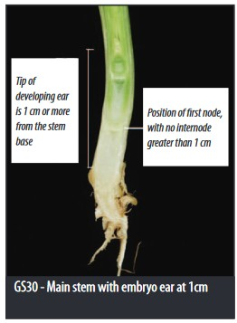Figure 11: Crop after grazing (above) and growth stage 30 (right). Source: GRDC Cereal Growth Stages Guide

Pasture changes

Pasture improvements from cropping into pasture were difficult to quantify and value, however the group indicated they were considerable. Cleaner pastures were observed (though not measured) and a slight increase in phalaris ground cover (around 10%) was measured as a result of plants becoming reproductive and shooting from the crown, fertiliser application and weed removal.
Did it pay?

All sites were more profitable with winter grazing, despite any grain yield reductions it caused.

There was a large variability in gross margin between sites and years (ranging from -$79/ha to +$194/ha), largely caused by the extremes in rainfall (2014 and 2015 were the two driest consecutive years on record, followed by the wettest year on record in 2016) and variation in grain and livestock prices.

This includes a considerable cost for destocking the paddock for most of the growing season to allow crop growth. It also includes the benefit of stubble grazing; however, it does not include a value for cleaner pastures and slightly increased phalaris ground cover, which was difficult to quantify.

All things considered, cropping into an existing pasture with winter grazing stacked up as a good option for group members and participants in the demonstration.

Take-home messages

• Pasture cropping was useful for cleaning pastures and slightly increased phalaris ground cover.
• The system offered flexibility as the crop can be winter grazed, harvested, cut for hay or silage, or spring/summer grazed, and the pasture is available the following year.
• Pastures with low phalaris counts may not produce sufficient benefits from pasture cropping and should be considered for renovation instead.
• Quoll oats oversown in pasture provided good quality feed and high growth rates in winter.
• Livestock weight gains were higher on crop/pasture than on pasture only over winter.
• Oats should not be grazed beyond growth stage 30 or yield reductions will occur.
• Grazing the crop/pasture with stock that could capitalise on the feed in winter increased the profit margin.
• The system was considered best suited to the following scenario:
o low–moderate fertility and well-drained paddock
o reasonable phalaris base
o pasture cleaning required for annual
weeds or onion grass
o strong oat price
o good seasonal outlook
o winter feed shortfall/availability of
livestock to utilise winter feed.

References

Falkiner S., Watson D., & Nicholson C. (2013). Pasture cropping chapter, Workshop notes, Grain & Graze Program.

Nicholson C., Frischke A., & Barrett-Lennard P. (2016). Grazing cropped land – A summary of the latest information on grazing winter crops from the Grain & Graze Program. GRDC.

For further information contact:

Bindi Hunter
Agriculture Victoria
E: bindi.hunter@agriculture.vic.gov.au

Tim Leeming
E: pconsult@bigpond.com

Disclaimer

Any recommendations, suggestions or opinions contained in this publication do not necessarily represent the policy or views of Meat & Livestock Australia (MLA). No person should act on the basis of the contents of this publication without first obtaining specific, independent professional advice. MLA takes no responsibility, in any way whatsoever, to any person in respect to the document, including any errors or omissions therein, arising through negligence or otherwise however caused.

© Meat & Livestock Australia 2019 ABN 39 081 678 364

This work is copyright. Apart from any use permitted under the Copyright Act 1968, all rights are expressly reserved. Requests for further authorisation should be directed to
the Corporate Communications Manager, PO Box 1961,
North Sydney, NSW 2059 or info@mla.com.au. Published in March 2020.

