Demonstration Summary

Autumn saving of pastures – Enhanced Producer Demonstration Site

The practice of ‘autumn saving’ involves deferring grazing after the autumn break until feed on offer (FOO) is sufficient to maintain enough feed until spring, when pasture growth increases dramatically.

The Glenthompson–Dunkeld
BestWool/BestLamb (BWBL) group took part in a
three-year demonstration to examine the practice of autumn saving and its impact on farm profitability.

Background

The Glenthompson–Dunkeld BWBL group embarked on the three-year Enhanced Producer Demonstration Site (EPDS) project between 2016 and 2018, with Agriculture Victoria and co- funded by Meat and Livestock Australia (MLA), to help weigh up the costs and benefits of autumn saving.

Creating a feed wedge after the autumn break requires increased levels of supplementary feeding while stock are kept in either containment or sacrifice paddocks. This can come at a significant expense, as six weeks’ supplementary feed for ewes can cost around
$6–12/head, depending on the level of supplementation and fodder costs.

The demonstration

The same method was used across the three years on different properties. Immediately post- scanning, a mob of twin-bearing ewes was randomly and equally split into a deferred mob (implementing autumn saving) and a set stocked mob. They were each allocated a portion of farm with similar area, terrain, soils, pasture species and soil fertility.

Key points

• Autumn saving gives more certainty to
producers to provide adequate nutrition to early and mid-winter lambing ewes.
• Autumn saving is a cost-effective method for producing extra feed. To be profitable, stocking rates need to be adequate to use the additional feed.

• The deferred mob was kept in containment and fed a grain/hay ration meeting their energy, protein and fibre requirements until FOO was adequate to meet the target for
twin-bearing ewes at lambing (approximately
1400kg DM/ha). At that point, the ewes were released into paddocks and were set stocked over lambing.
• The set stocked mob grazed according to the producers’ usual management style and
were split across the treatment paddocks
just prior to lambing.
• FOO and feed quality were measured monthly and ewe condition was measured at regular intervals.
• The demonstration measured and compared lambing percentage, lamb weight and ewe condition score and calculated profit margins for the two treatments each year.

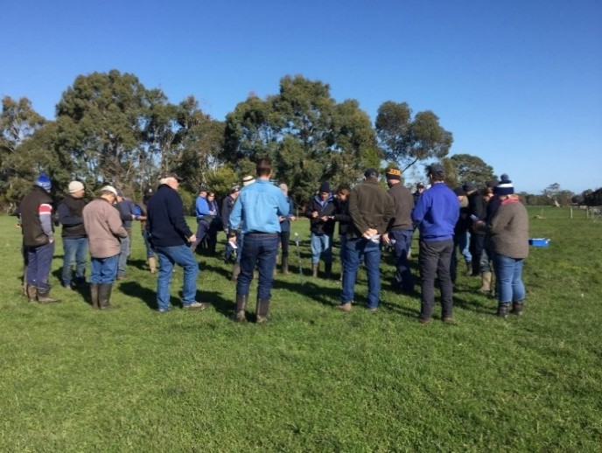Figure 1: Producers assessing feed on offer (FOO).
Demonstration outcomes

Feeding in containment

The deferred mob spent an average of 33 days in containment to enable adequate FOO accumulation to meet the target 1400kg DM/ha. The cost of feeding sheep in containment averaged $5.17/ewe over the three years.

In 2017 and 2018 the FOO at lambing exceeded targets. As a result, the ewes could have been removed from containment earlier, which would have reduced the average days in containment and average cost of feeding.

Extra pasture grown

The extra FOO grown prior to lambing averaged 850kg DM/ha, equating to an extra 27.7t DM each year over the deferred paddocks. FOO across treatments followed a similar trend at each property. The larger leaf area in the deferred paddocks led to rapid pasture growth, which continued at a higher rate when sheep were released (Figure 2). The largest difference in FOO occurred in early lambing.

The extra pasture cost $48/t, calculated using the costs of feeding ewes in containment. The value of this pasture compares favourably to using urea to grow extra grass, which was estimated at $100/t DM – approximately twice the cost of containment feeding.

FOO levels in the deferred paddocks exceeded the 1400kg DM/ha target in Year 2 and more so in Year 3. A reduction in crude protein was measured where pasture became rank. This may have impacted on lamb growth rates in 2018, which were lower in the deferred mob.

2200

Feed on offer (kg DM/ha)
2000
1800
1600
1400
1200
1000
800
600
400
200
0
 | Apr | May | June | July | Aug | Sept
Deferred | 426 | 1220 | 1856 | 1994 | 1708 | 1438
Set stocked | 389 | 808 | 1076 | 1147 | 1186 | 1310

Average FOO across Year 1, Year 2, Year 3

Figure 2: Average feed on offer (FOO) over the three years of demonstration.

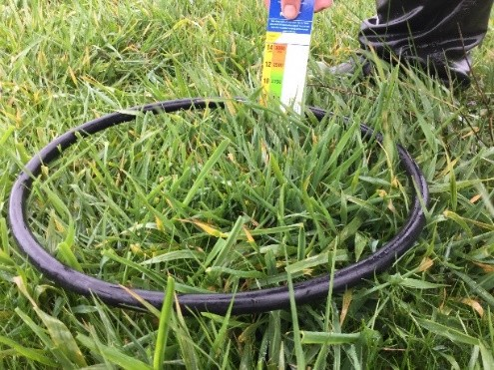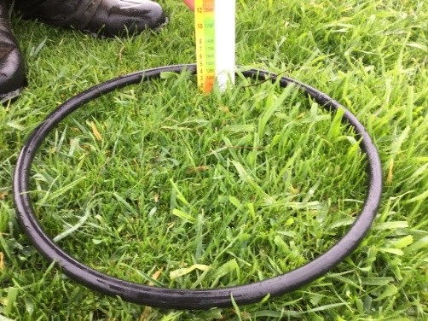
Figure 3: Year 1 deferred pasture at Figure 4: Year 1 set stocked pasture at point of lambing: FOO = 1425kg DM/ha point of lambing: FOO = 960kg DM/ha.

Livestock production

Ewes lost condition in containment each year while, at the same time, the set stocked mob was gaining condition in the paddock. This was reversed when the deferred mob was released from containment as they rapidly gained condition, while the set stocked ewes lost condition prior to lambing (Figure 5). This contributed to the heavier lamb weights in the deferred mob in Year 1 and Year 2. Merino ewes were used in Year 3 and the fluctuations in condition score between the deferred and set stocked mobs were less pronounced.

4.00
3.80
3.60
Condition score (CS)
3.40
3.20
3.00
2.80
2.60
2.40
2.20
2.00
Condition scores across all years

Apr May Jun Jul Aug Sept Oct

2016 Set stocked | 2016 Deferred | 2017 Set stocked
2017 Deferred | 2018 Set stocked | 2018 Deferred

Figure 5: Ewe condition score for the deferred and set stocked mobs each year. Note Merinos were used in
2018.

Animal performance varied considerably over the three years and was negatively impacted by management issues, such as condition score prior to entering containment, transitioning into containment and feeding in wet conditions (which led to poor feed utilisation).

Across the three years, lambing percentage ranged from +7% to -14% in the deferred mob compared to the set stocked mob. Lamb weight in September ranged from 2.1kg heavier to 1.8kg lighter in the deferred mob and lamb production per ewe ranged from +5.5kg to -4kg per ewe in the deferred mob compared to the set stocked mob.

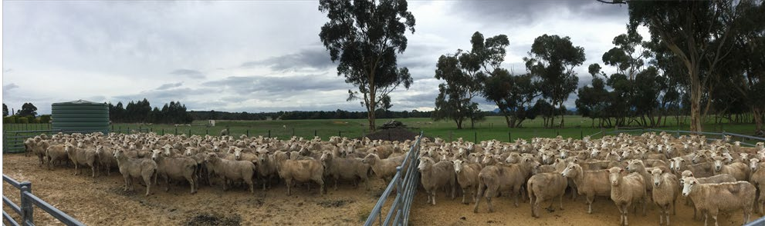
Figure 6: Ewes in the set stocked mob (left – condition score 3.57) and deferred mob (right – condition score 2.94) in
May of Year 2.

Profit margin

Profit varied according to feed costs, lamb prices and animal performance each year. The difference in income between the treatments ranged from $8.99/ewe higher in the deferred mob (Year 1) to $18.54 higher in the set stocked mob (Year 3).

The value of containment can be seen by the ability to run extra stock through winter, which then allows for increased utilisation of feed through spring. The containment feeding accumulated on average an additional 850kg DM/ha of pasture FOO.

In comparison, paddocks that are set stocked in south-west Victoria encounter approximately
100 days (May 20 until the end of August) when pasture growth is not able to meet demand of twin-bearing ewes at high stocking rates. An additional 850kg DM/ha could be used to run (conservatively) an additional two ewes per hectare through the winter period. This is based on 60% feed utilisation over winter and ewes requiring 2.5kg DM of feed per day throughout the 100-day winter period.

Conclusion

Overall, the demonstration showed that autumn saving is a cost-effective method to grow additional pasture for lambing ewes in winter; more economical than urea. However, the demonstration also highlighted several potential pitfalls in the system that can severely impact the profitability of autumn saving.

Large variation in animal performance and subsequent profit per ewe was more of a reflection on management practices than on the autumn saving concept and provided useful insights for managing ewes in containment.

Tips and observations on autumn saving

The following tips were developed from the demonstration results and those producers who successfully use autumn saving as part of their farm management:

• Autumn saving can ensure feed on offer requirements are met prior to lambing.
• Appropriate feed transitioning is essential, both into containment and from containment onto green pastures, particularly near the point of lambing.
• Feeding in containment and preventing condition loss in ewes can be challenging after the autumn break. Ensuring they consume all feed supplied is difficult due to soiling in a muddy, winter environment.
• Feeding on the ground in wet conditions will lead to poor utilisation and adversely affect livestock. One producer estimated only 40% utilisation when containment feeding on the ground after the autumn break.
• To accurately predict FOO at lambing, feed budgeting and regular pasture monitoring are essential. If ewes enter the paddock too early, target FOO will not be achieved, impacting on animal health. However, if deferment is too long, containment costs will be higher than necessary and pastures may be under-utilised, causing wastage and subsequent reductions in quality. The demonstration showed that under- utilised pasture causes a big loss in farm profit, especially when you have spent additional money to grow it, as is the case with autumn saving.
• It is important to have ewes in an appropriate condition score profile before they are contained (>CS3.0). It is
difficult to maintain or increase condition in containment, in fact ewes lost condition in containment each year of
the demonstration.
• When set up well, feeding in containment can help to ensure animal nutritional requirements are met.
• More information about stock containment guidelines, including siting and livestock water requirements, can be found at: http://agriculture.vic.gov.au/agriculture/ emergencies/recovery/livestock-after-
an-emergency/stock-containment-areas
For further information contact:

Dr Andrew Whale Livestock Logic a.whale@livestocklogic.com.au

Bindi Hunter Agriculture Victoria bindi.hunter@agriculture.vic.gov.au

Disclaimer

Any recommendations, suggestions or opinions contained in this publication do not necessarily represent the policy or views of Meat & Livestock Australia (MLA). No person
should act on the basis of the contents of this publication without first obtaining specific, independent professional advice. MLA takes no responsibility, in any way whatsoever, to any person in respect to the document, including any errors or omissions therein, arising through negligence or otherwise however caused.

© Meat & Livestock Australia 2019 ABN 39 081 678 364

This work is copyright. Apart from any use permitted under the Copyright Act 1968, all rights are expressly reserved. Requests for further authorisation should be directed to the Corporate Communications Manager, PO Box 1961, North Sydney, NSW 2059 or info@mla.com.au.

Published in March 2020.

