Strong, Innovative, Sustainable:

A New Strategy for Agriculture in Victoria
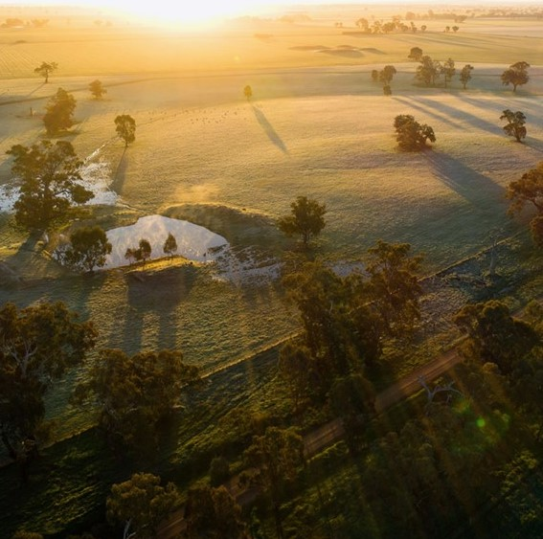
Minister’s foreword 1
Aboriginal acknowledgement 2
A new strategy for Victorian agriculture in a world of change 2
Our vision: A Victorian agriculture sector that is strong, innovative and sustainable 2
Recover 6
What’s next 7
Grow 7
Modernise 9
Protect 11
Promote 14
Case study 15
Our vision 16
Next steps 17
Appendix A 17

Minister’s foreword

Agriculture is experiencing constant change.
How we farm, what we grow and who buys our food and fibre is being rapidly transformed. The landscapes of our farms, and the climate that sustains them, are changing. At the same time, the social fabric of agriculture, farmers, rural communities and consumers is shifting.
This change presents challenges.
It creates opportunities.
In Victoria we are determined to face these challenges and respond to them. We will also seek out the opportunities. We will use our capacity for innovation, collaboration and action to shape our desired future for agriculture.
We know that, for many, 2020 has been a tough year; a tragic year. Indeed, the challenges of 2020 have demonstrated that we cannot solely rely on our traditional ways of doing things. We need new approaches to help protect and grow our agriculture sector in the face of global change and increasing unpredictability for all members of our society and our broader economy. This Strategy sets out how we will work with industry to do that. This document will give the sector certainty and support it to flourish and grow.
The priorities identified in this Strategy will require a collaborative effort. That’s why we will continue to work with industry to deliver them – just as we have done through the coronavirus (COVID-19) pandemic – but now with an eye to the long-term future and possibilities for the sector.
Successful farm businesses are an essential part of a thriving Victoria. The Victorian Government is taking action to ensure they continue to be successful in years to come.
Jaclyn Symes
Minister for Agriculture

Aboriginal acknowledgement
We proudly acknowledge Victoria’s First Nations peoples and their ongoing strength in practising the world’s oldest living culture. We acknowledge the Traditional Owners of the lands and waters on which we live and work, and pay our respect to their Elders past and present. Victoria’s Aboriginal communities continue to strengthen and grow with the ongoing practice of language, lore and cultural knowledge. We recognise the contribution of Aboriginal people and communities to Victorian life. Traditional owners managed Victoria’s land and water for tens of thousands of years. We acknowledge their history and their living cultural traditions.

A new strategy for Victorian agriculture in a world of change
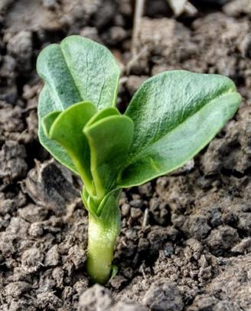
Change is part of agriculture. Drought, bushfires, floods and global economic variability mean that agriculture has always needed to be ready, adaptive, innovative and responsive.
Recent shocks have come in addition to long-term drivers of change that have been transforming the sector over time: climate change, demographic shifts, technological advancement, growing resource scarcity (including water demands) and changing community expectations. These will all continue to evolve and, in some cases, rapidly accelerate. But with targeted investment and coordinated action, Victoria can respond to this change, maintain the enviable position and reputation it holds around the world, and continue to grow.
The coronavirus (COVID-19) pandemic and its impact on economies around the world highlights the urgent need for a strategic vision for Victoria’s agriculture sector. The need for strong economic recovery has never been clearer. Victorian agriculture, with its exceptionally solid foundations, comes from a position of strength and is well-placed to lead this recovery if we get the settings right now. By building on these foundations, we can create jobs and accelerate economic growth in the immediate term, putting the state in a strong position for the future.
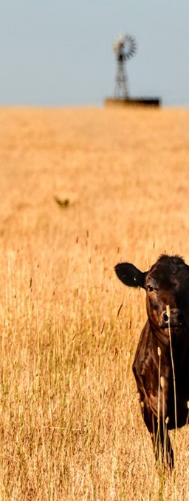

Victorian agriculture is a cornerstone of our economy
Victoria’s farmers, agribusinesses and surrounding communities are an integral part of our way of life.
They feed us, clothe us and export our products to the world. Agriculture creates essential jobs
in our regions and supports the productive management of our landscapes.
Victorian agriculture is already a significant contributor to our economy and communities. The Victorian Government wants to build on this to position the sector as an engine of growth in our recovering economy.
- $15.9 B Gross value of agriculture production in 2018-19
- 81,000 Jobs in agricultural production (August 2020)
- 11.5 M ha of productively used land, spanning 50% of Victoria’s land area
- 28%Of total national food and fibre exports in 2019-20.
Agriculture is particularly important for regional Victoria, supporting jobs in other industries (for example, tourism and hospitality), and supporting thriving regional towns. Many of our regional communities rely on agriculture for their economic prosperity.

Dependence of Victorian towns on agriculture, food processing and other significant and distinguishing regional industries
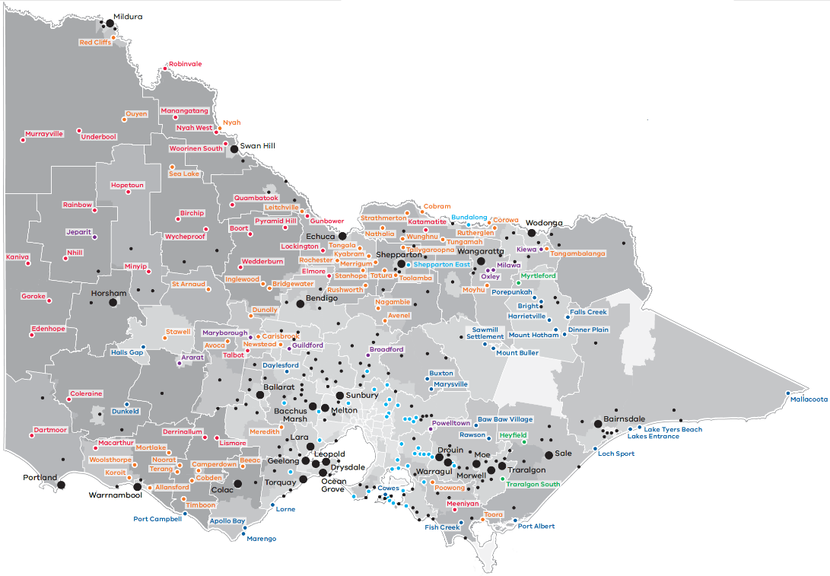
Cities and Towns
- Regional Cities: Victorian regional cities include: Mildura, Swan Hill, Echuca, Shepparton, Wangaratta, Wodonga, Horsham, Bendigo, Ballarat, Bacchus Marsh, Melton, Sunbury, Drouin, Warragul, Moe, Morwell, Traralgon, Sale, Bairnsdale, Portland, Warrnambool, Colac, Geelong, Torquay, Lara, Leopold, Drysdale and Ocean Grove.
- Other towns and locations include: Allansford, Apollo Bay, Ararat, Avenel, Avoca, Baw Baw Village, Beeac, Birchip, Boort, Bridgewater, Bright, Broadford, Bundalong, Buxton, Camperdown, Carlsbrook, Cobden, Cobram, Coleraine, Corowa, Cowes, Dartmoor, Daylesford, Derrinallum, Dinner Plain, Dunkeld, Dunolly, Edenhope, Elmore, Falls Creek, Fish Creek Port Albert, Goroke, Guildford, Gunbower, Halls Gap, Harrietville, Heyfield, Hopetoun, Inglewood, Jeparit, Kaniva, Katamatite, Kiewa, Koroit, Kyabram, Lake Tyres Beach, Lakes Entrance, Leitchville, Lismore, Loch Sport, Lockington, Lorne, Macarthur, Mallacoota, Manangatang, Marengo, Maryborough, Marysville, Meeniyan, Meredith, Merrigum, Milawa, Minyip, Mortlake, Mount Buller, Mount Hotham, Moyhu, Murrayville, Myrtleford, Nagambie, Nathalia, Newstead, Nhill, Noorat, Nyah, Nyah West, Ouyen, Oxley, Poowong, Porepunkah, Port Campbell, Powelltown, Pyramid Hill, Quambatook, Rainbow, Rawson, Red Cliffs, Robinvale, Rochester, Rushworth, Rutherglen, Sawmill Settlement, Sea Lake, Shepparton East, St. Arnaud, Stanhope, Stawell, Strathmerton, Talbot, Tallygaroopna, Tangambalanga, Tatura, Terang, Timboon, Tongala, Toolamba, Toora, Traralgon South, Tungamah, Underbool, Woolsthorpe, Woorinen South, Wunghnu, Wycheproof.
Towns with Significant Regional Industries
- Tourism – Halls Gap, Dunkeld, Daylesford, Port Campbell, Apollo Bay, Marengo, Lorne, Cowes, Fish Creek Port Albert, Loch Sport, Lakes Entrance, Lake Tyres Beach, Mallacoota, Rawson, Baw Baw Village, Marysville, Buxton, Sawmill Settlement, Mount Buller, Mount Hotham, Harrietville, Bright, Dinner Plain, Falls Creek, Porepunkah.
- Agriculture – Murrayville, Underbool, Robinvale, Manangatang, Nyah West, Woorinen South, Hopetoun, Rainbow, Nhill, Minyip, Kaniva, Goroke, Edenhope, Dartmoor, Coleraine, Macarthur, Derrinallum, Lismore, Talbot, Wycheproof, Boort, Pyramid Hill, Lockington, Elmore, Quambatook, Birchip, Gunbower, Katamatite, Meeniyan.
- Agriculture plus food manufacturing – Red Cliffs, Ouyen, Sea Lake, Nyah, Leitchville, St. Arnaud, Stawell, Inglewood, Avoca, Newstead, Carlsbrook, Dunolly, Bridgewater, Rochester, Tongala, Kyabram, Merrigum, Stanhope, Rushworth, Tatura, Nagambie, Avenel, Toolamba, Nathalia, Strathmerton, Cobram, Wunghnu, Tallygaroopna, Tungamah, Rutherglen, Corowa, Tangambalanga, Moyhu, Meredith, Beeac, Camperdown, Cobden, Timboon, Allansford, Terang, Noorat, Mortlake, Woolsthorpe, Koroit, Poowong, Toora.
- Forestry plus wood products manufacturing – Myrtleford, Heyfield, Traralgon South.
- Mixed manufacturing – Jeparit, Ararat, Maryborough, Guildford, Broadford, Oxley, Milawa, Kiewa, Powelltown.
- Construction – Bundalong, Shepparton East. There are also unnamed towns and localities inside and outside the Melbourne metropolitan area, including the Shires of Surf Coast, Greater Geelong, Hepburn, Mitchell, Baw Baw, Bass Coast and South Gippsland.
Percentage of employed workforce in agriculture, forestry and fishing
Categories include:
- 30.1% to 46.0%
- 20.1% to 30.0%
- 10.1% to 20.0%
- 1.1% to 10.0%
- 0.1% to 1.0%
- very low, data unreliable.
Commentary:
- The majority of the non-metro areas in the west of Victoria are shown in the 20.1% and 46% category. The area around Stawell is shown in the very low, data unreliable category.
- Non-metro areas in the east of Victoria are a little more mixed, but the majority are also shown in the 20.1% and 46% category. Areas around Bright, Mount Buller and Morwell are shown in the 0.1% to 1% category. There are also areas west of Mount Buller, west of Dinner Plain and south-west of Fish Creek shown in the very low, data unreliable category.
- The majority of the Melbourne metropolitan areas are shown in the 0.1% to 1% category. Some areas in the Mornington Peninsula and to the west of Melbourne are shown in the 10.1% to 20.0% category.
Notes
‘Significant’, means 15 per cent or more employed workforce. ‘Distinguishing’ means the size of the industry varies widely among regional towns. ‘Regional cities’ are those with a population of 10,000 or more.
Sources
ABS 2016, Census of Population and Housing; Analysis Socio-Economic Policy, Agriculture Victoria.
Disclaimer
Data is less accurate at high resolution. It is the user responsibility to check the accuracy, currency and relevance of the data.

Our vision: A Victorian agriculture sector that is strong, innovative and sustainable
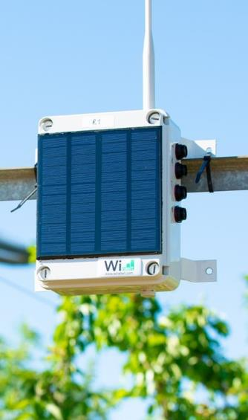
To help the agriculture sector thrive, the Victorian Government is committed to providing certainty where it can, and support where it is needed. We are committed to working with industry, communities and trading partners to ensure that the Victorian agriculture sector is strong, innovative and sustainable for many years to come.
This Strategy will help us achieve our vision by providing a way forward for the coming decade and identifying clear areas of focus and investment by government.
Through this Strategy, the Victorian Government seeks to build on the sector’s strengths, enable it to respond flexibly to emerging challenges and capture new opportunities so that agriculture can flourish.
But this is not something we can do alone. We need to partner with the sector to achieve real change through collective action. This Strategy is the start of a conversation with our industry partners about how we deliver outcomes together.
The Victorian Government is backing agriculture in this state and has an ambitious vision for its future.

In 2030, Victorian agriculture will be:
- An engine of growth for the Victorian economy: attracting investment, supporting jobs and helping communities thrive
- Creative, resilient and responsive to challenges and opportunities, capitalising on technological advancement and new ways of doing things
- A front runner in low-emission food and fibre production
- Australia’s agriculture exports centre, providing high-quality, sought after agriculture produce to diverse markets around the world
- Home to diverse and innovative careers, attracting the best and brightest to our farms and regions.

We are making commitments under five themes to achieve our vision for the coming decade.
Our themes | Our commitments
Recover  Recover from the impacts of drought, bushfires and the coronavirus (COVID-19) pandemic and become an engine of growth for the rest of the economy. | - Support farmers with information and tools to build resilience.  - Strengthen local supply chains and support opportunities for local manufacturing.
Grow  Grow the value and output of agriculture through increased exports, investment, greater diversification and new products. | - Support Victorian producers to be more profitable, exporting more products to more markets, more often.  - Maximise the growth potential of key emerging industries.  - Create the right conditions and opportunities for investment here in Victoria.
Modernise  Modernise Victorian agriculture through innovation, investment and future skills. | - Increase the adoption of new, effective and fit for purpose technology.  - Grow a thriving and globally competitive AgTech industry in Victoria.  - Enhance the commercialisation of research.  - Deliver the agriculture skills of the future.
Protect  Protect and enhance the future of agriculture by ensuring it is well-placed to respond to climate change, pests, weeds, disease and increased resource scarcity. | - Position Victoria as a leader in low-emission agriculture.  - Ensure Victorian agriculture is well-placed to manage climate risk and continues to be productive and profitable under a changed climate.  - Deliver best practice regulatory systems to manage risk and respond to new challenges.
Promote  Promote and build confidence in the sector to international markets and the community. | - Promote Victorian agriculture’s commitment to quality and high performance.  - Position agriculture as a career of choice and build its reputation for workplace excellence.

Our vision for agriculture in 2030 will deliver tangible benefits all along the supply chain – from farms, to manufacturing, to the people who buy our produce in Victoria and around the world.
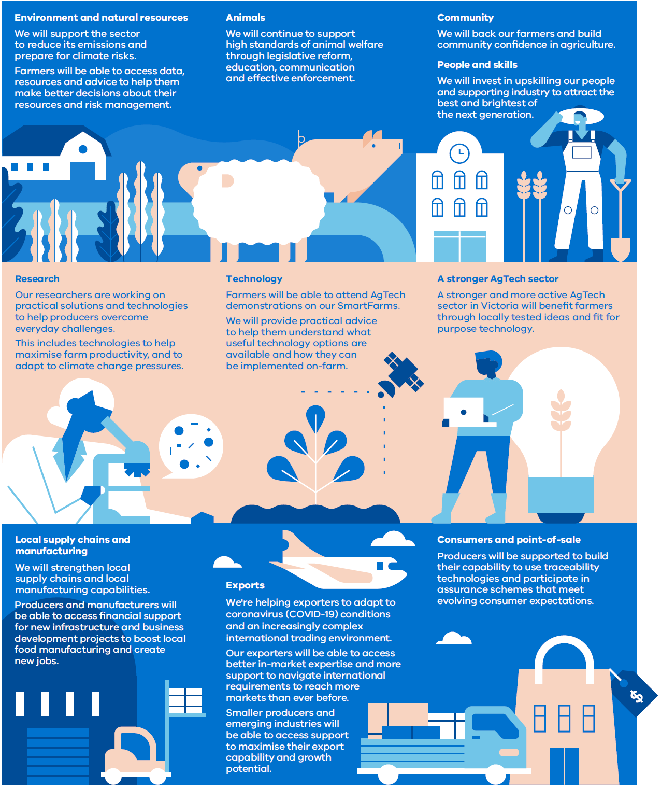
Environment and natural resources: We will support the sector to reduce its emissions and prepare for climate risks. Farmers will be able to access data, resources and advice to help them make better decisions about their resources and risk management.
Animals: We will continue to support high standards of animal welfare through legislative reform, education, communication and effective enforcement.
Community: We will back our farmers and build community confidence in agriculture.
People and skills: We will invest in upskilling our people and supporting industry to attract the best and brightest of the next generation.
Research: Our researchers are working on practical solutions and technologies to help producers overcome everyday challenges. This includes technologies to help maximise farm productivity, and to adapt to climate change pressures.
Technology: Farmers will be able to attend AgTech demonstrations on our SmartFarms. We will provide practical advice to help them understand what useful technology options are available and how they can be implemented on-farm.
A stronger AgTech sector: A stronger and more active AgTech sector in Victoria will benefit farmers through locally tested ideas and fit for purpose technology.
Local supply chains and manufacturing: We will strengthen local supply chains and local manufacturing capabilities. Producers and manufacturers will be able to access financial support for new infrastructure and business development projects to boost local food manufacturing and create new jobs.
Exports: We're helping exporters to adapt to coronavirus (COVID-19) conditions and an increasingly complex international trading environment. Our exporters will be able to access better in-market expertise and more support to navigate international requirements to reach more markets than ever before. Smaller producers and emerging industries will be able to access support to maximise their export capability and growth potential.
Consumers and point-of-sale: Producers will be supported to build their capability to use traceability technologies and participate in assurance schemes that meet evolving consumer expectations.

Recover

We will recover from the impacts of drought, bushfires and the coronavirus (COVID-19) pandemic and become an engine of growth for the rest of the economy.
The coronavirus (COVID-19) pandemic has had a significant impact on Victorian agriculture. Our export markets have been
challenged by contracting demand and disrupted supply chains. Reduced domestic demand from the hospitality sector has also affected our farmers. Production restrictions – necessary to contain and manage the spread of the virus in Victoria – have also had an impact.
In 2019-20, the Victorian Agriculture, Forestry and Fishing sector saw a decline in value add of $550 million (from $8.52 billion in 2018-19 (ABS)), largely attributable to COVID-19 impacts. Victorian agriculture is expected to continue to feel the impacts of COVID-19 into 2020-21, but may be less impacted than other key sectors.
For some businesses, the impact of coronavirus (COVID-19) comes in addition to the impact of bushfires and drought, particularly in East and Central Gippsland and Northern Victoria from the Millewa in the west to the Upper Murray in the east. Over the 2019-20 fire season, 1.5 million hectares of land was burnt, and 458 homes damaged or destroyed.
Around 22 per cent of agricultural land in the affected areas was burnt, with $40 million in damage to agriculture buildings. Approximately 10,000 head of livestock were lost and 6,350 kilometres of fencing was destroyed. The economic impact on farms through loss of assets and production has been significant.
Despite these impacts, our producers have repeatedly demonstrated their strength, resilience and capacity to adapt. We’ve seen that Victorians value the food and fibre we produce right here and come out strongly to support it.
Victorian agriculture has an enormous capacity to rebound, recover and grow, and it can be even more resilient than it has in the past by preparing for future shocks. The coronavirus pandemic has highlighted the importance of having diverse markets, strong supply chains and the ability to quickly take up new, local opportunities from changed market conditions. As we recover, we need to partner with businesses through the whole supply chain and invest in future resilience. Agriculture can bounce back and drive Victoria’s economic recovery – delivering jobs, and ensuring our state prospers and grows.
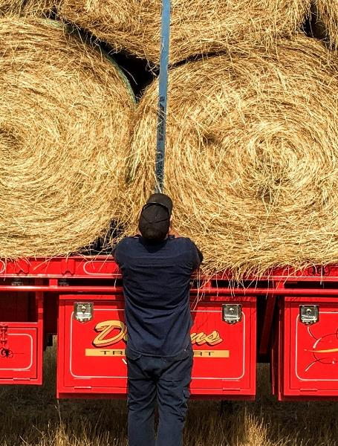

What we are already doing
Supporting Victorian agriculture and food production during the coronavirus pandemic. The $50 million Agriculture Workforce Plan has provided agriculture and critical food supply chain businesses with financial support to adapt their operations and attract and maintain a secure workforce through worker relocation, transport, induction and retraining. Funding has also supported critical job creation activities on projects with agriculture benefits in regional Victoria, and helped businesses transition to online marketplaces and take advantage of new e-commerce opportunities. A seasonal workforce program was announced in September 2020 for further activities to support farm businesses to access a safe seasonal workforce through spring and summer.
Engaging and sharing information with industry through the coronavirus pandemic. Agriculture Victoria’s COVID-19 Stakeholder Reference Group is a valuable forum for engagement with peak industry organisations through the pandemic. New relationships and information channels have been established and will continue to guide response and recovery.
Responding to drought and dry seasonal conditions. The Victorian Government has provided over
$81 million in targeted support for Victorian farmers and rural communities affected by drought and dry seasonal conditions from 2018 to 2020. This includes household financial relief, on-farm infrastructure grants, technical farm management assistance, employment support and mental health initiatives.
Working with regional communities to recover from 2019-20 bushfires. Support for agriculture continues to be a significant priority for the Victorian Government following the devastating bushfires over the summer of 2019-20. In the midst of the disaster, we supported the urgent distribution of fodder for farmers in need, coordinated agriculture relief operations in fire-affected areas, and provided animal welfare assessments and support. Primary producers have also been able to access a range of advisory and financial assistance to rebuild or replace destroyed on-farm infrastructure, salvage smoke affected crops, care for livestock and help get their businesses back up and running. Bushfire Recovery Victoria continues to lead recovery efforts, working closely with the government, community, agribusiness and the banking sectors on activities to support the recovery and resilience of fire-affected agribusinesses to compounding disaster shocks. Bushfire Recovery Victoria is also coordinating the delivery of the Local Economic Recovery program ($68.6 million). The program is jointly funded by the Commonwealth and Victorian Governments and will boost industry and jobs across bushfire-affected regions, and support economic stimulus projects.

What’s next

Support farmers with information and tools to build resilience.
Preparedness and good business planning are effective approaches to driving recovery and building resilience to future shocks particularly given increasingly variable farming conditions, for example due to climate change or global trade relations. The Victorian Government will continue to work closely with farmers to deliver services and information that builds farm business resilience and supports further growth of the sector. This will include a strong skills focus on business planning, decision‑making, financial literacy and sustainable farming practices. Service delivery models and communication approaches will continue to evolve to meet the needs of farm businesses.

Strengthen local supply chains and support opportunities for local manufacturing.
There are significant economic recovery and job creation opportunities which can be realised by investing in our agri‑food supply chain, where it makes sense to do so. The Victorian Government has committed $15 million to the new Food to Market grant program to provide financial support for new infrastructure and business development projects to support jobs, deliver productivity improvements and capitalise on new opportunities across the supply chain. This investment aims to increase value, which is added here in Victoria, from producers to processors and beyond. The improvements and opportunities generated by this investment will help fast-track economic recovery in regional Victoria and will result in more resilient supply chains over the long‑term.

Grow

We will grow the value and output of agriculture through increased exports, investment, greater diversification and new products.
All Victorians benefit from a strong and growing agriculture sector, and the jobs that it supports. It puts food on our plates and is the heartbeat of our regional communities.
Victorian agriculture has unparalleled ability to grow the food and fibre products that the world wants. To continue to have a strong, growing agriculture sector that generates jobs and supports thriving communities, we need export market success. It’s the best opportunity available to increase profitability over the long-term. This means continuing to export to existing markets and looking to diversify into new markets where appropriate.
We will continue to support Victorian agriculture exporters to be agile in an increasingly complex international trading environment, and help our exporters maintain stable and long-term trading relationships with our international trading partners.
As we move towards 2030, Victorian agriculture needs to continue to grow and adapt to the challenges and opportunities it faces while ensuring Victoria is the leading food and fibre exporter in Australia. Victorian food and fibre exports already account for 28 per cent of the national total and over half of the value of the total goods exported from the state. We produce far more food than we consume.
A flourishing agriculture sector and a stable business environment also present significant opportunities to attract investment. This will be an important component of the Victorian Government’s economic recovery and growth agenda.
New and emerging industries, such as alternative proteins and native foods, present significant growth opportunities for Victoria’s agriculture sector alongside our more traditional commodities. Leveraging Victoria’s culture for innovation can position us as a world leader in new products and budding industries. As well as export potential, new products also present opportunities for agritourism, increasing flow‑on economic benefits to our regional communities.
Agriculture is a vibrant, diverse sector with multiple opportunities to innovate. Seizing these opportunities will help us to stay ahead of the curve and help agriculture grow, attract investment, and benefit all Victorians.

What we are already doing
Helping producers and industry capture and maximise export market opportunities. The Growing Food and Fibre Markets program focuses on strengthening supply-side activities. Through this program, the Victorian Government is helping producers and industry better capture export market opportunities, strengthening biosecurity and food safety capability, broadening traceability across supply chains, expanding Victoria’s agri-food trade footprint and building on its reputation as an exporter of premium quality food and fibre. The program also helps producers keep ahead of the game with market access technology that shows Victorian products meet current and future international market requirements.
Pivoting trade programs to support Victorian businesses to export during the pandemic. The Victorian Government is adapting its trade programs to provide additional virtual and online services to Victorian businesses, regardless of location and industry, to support them to enter and grow in export markets. These initiatives include the Export Skills Program, Access Program and Virtual Trade Missions. These trade programs are not just for agriculture – they provide broad skills development in preparing businesses to export, specific intelligence on exporting to key international markets, and connections to potential in-market partners.
Partnerships to support Victoria’s native foods and botanicals industry. The Victorian Government has partnered with Victorian Traditional Owners to support the development of an authentic native foods and botanicals industry which can take advantage of strong interest and new markets. The Djakitjuk Djanga program is providing grants to Aboriginal businesses to help overcome key resource related barriers to commercial production of native foods and botanicals.
Supporting small-scale and craft businesses that are uniquely Victorian. Strong Victorian Government investment in artisanal agriculture has supported small and micro businesses to undertake a range of projects to build business capability. The Small-Scale and Craft Grants Program has targeted businesses looking to scale-up operations, diversify product lines and expand outreach.

What’s next

Support Victorian producers to be more profitable, exporting more products to more markets, more often.
Despite the impacts of coronavirus (COVID-19) and a disrupted global economy, we are determined to meet and exceed our already ambitious target for the value of Victoria’s food and fibre exports to reach $20 billion by 2030. Even with the increasingly volatile trading environment and fierce international competition, we know we can reach this target by investing in the sector to support it to grow, adapt, diversify and capitalise on its competitive advantages.
To support Victoria’s agriculture sector in international markets, the Victorian Government has committed $5 million
to the Pathways to Export program which will provide dedicated agriculture export resources to support our agriculture exporters to maximise their export potential and realise new export market opportunities.
This includes boosting our in-market expertise and leveraging the Victorian Government Trade and Investment network to provide proactive market access support and drive trade to a variety of international markets to reach our export targets.
As well as increasing the volume and value of agricultural exports in a sustainable and secure way, we will also help the sector diversify into new markets and product lines, providing our farmers and manufacturers with as many opportunities as possible. Advocating strongly on behalf of Victoria’s export interests will continue to be a priority, including working proactively with the Commonwealth Government to ensure negotiated market access arrangements
are appropriate and fair.

Maximise the growth potential of key emerging industries.
There is a clear role for the Victorian Government to ensure new and emerging industries have the right conditions to flourish and expand. These industries present significant future growth opportunities for value-added production.
In Victoria, we’ve demonstrated our capability in growing new industries. The successful Medicinal Cannabis Industry Development Plan took advantage of the emerging medicinal cannabis market to increase state productivity and create jobs along the supply chain. We can now apply lessons from this to support industry expansion for the growing alternative proteins industry and the native foods and botanicals sector.
Building on our strong market intelligence, industry development experience, research expertise and existing partnerships will ensure growth potential is realised. Keeping on top of changing consumer demands globally – particularly as markets evolve post-coronavirus (COVID-19) – will ensure we can quickly identify new areas of competitive advantage and support Victorian businesses to thrive.

Create the right conditions and opportunities for investment here in Victoria.
We want to make sure that we are putting the right settings in place to encourage sector investment and growth. Increasing investment in agriculture is essential for farms to improve their productivity and grow which will help make our exports even more competitive and increase our share of the global marketplace. We will achieve this by putting clear investment goals
in place. We will also support industry to promote itself as an attractive investment opportunity by leveraging our domestic
and international networks. The Victorian Government’s $2 billion Breakthrough Victoria Fund will drive investment in
priority sectors including agri-food to create jobs and accelerate growth.
It is also important that we provide the right conditions for businesses to invest in their capability and expand their operations. This means a modern and transparent regulatory environment, better and open data resources to support robust decision-making, and strong guidance on sector priorities.

Case study

Building on Victorian success stories
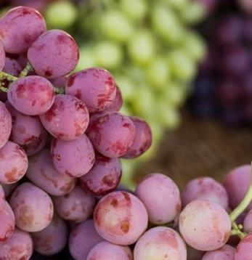
Since gaining market access in 2014, Victorian grape growers and exporters have experienced significant growth in sales to Japan and South Korea, despite the most difficult economic conditions in decades. From 16 containers to Japan and one to South Korea in 2014, grape sales to these countries have grown to $50.4 million and $14.8 million respectively.
This growth is testament to several initiatives and partnerships undertaken over the past five years. We will build on similar success stories, using Victorian Government expertise and various trade promotion tools, from missions to marketing materials.

Modernise

We will modernise Victorian agriculture through innovation, investment and future skills.
Victoria has one of the most modern and productive agricultural systems in the world. To maintain our competitive advantage, we need to continually innovate and invest in technology, science and skills. New technologies have the potential to drive significant productivity gains. Eighty per cent of improvements in Australia’s broadacre cropping productivity since 1977-78 have come from technology, and full implementation of digital agriculture could lift agricultural production by another 25 per cent.
Farmers and businesses who access new skills, technologies and approaches will deliver higher quality products to consumers with less environmental impact, and greater profitability. This includes using AgTech further down the supply chain, for example, to support traceability systems for exports.
Modern, sustainable farming comes in all shapes, and we will support all farmers – big and small, old and new – to adopt the new technologies and practices that will help them achieve their goals.
Victoria also has all the right ingredients to be home to a thriving and globally competitive AgTech sector. Our compact geography, diverse industries and climate zones, and growing number of digitally mature farmers set a strong foundation for success. Investing now and getting the settings right will have direct economic benefits to the state. It will also deliver flow-on benefits to our farmers through more targeted and locally tested products and ideas.

What is AgTech?
On-farm, AgTech can help producers make better informed decisions to improve farm performance. This includes technology that can:
- Sense – real-time monitoring of on-farm production factors
- Analyse – turn large amounts of data into manageable information and insights to make decisions
- Automate – use data and analytics to automate processes.
- Farmers can use these technologies to obtain insights that assist with decision making and improve business profitability, resilience and sustainability.
The Victorian Government invests heavily in agriculture research and innovation to benefit Victorian farmers, with world-class capability in genomics and cellular sciences; microbial sciences; pests; weeds and diseases; plant production sciences; animal production sciences; and agriculture resources sciences. Victoria’s private sector and universities also play an important role in agricultural research and innovation.
All these elements are critical for Victorian agriculture to be profitable and sustainable. But modernising is not just about research, innovation and technology. The agriculture workforce of the future will look different – and will need to be underpinned by new and diverse skills. That means existing farmers will need new skills to help them innovate, and new entrants to agriculture need to be equipped and ready to deal with the challenges and opportunities
of farming in the future.
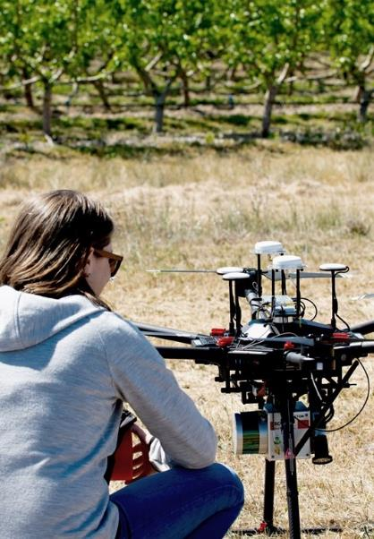

What we are already doing
Trialling on-farm Internet of Things technology and removing barriers to AgTech uptake.
The Victorian Government is committed to ensuring that Victoria’s farmers are at the forefront of digital agriculture to increase the efficiency, sustainability and productivity of the agriculture sector into the future. Key to this commitment is the On-Farm Internet of Things Trial ($12 million) to support Victorian farmers to adopt digital technologies.
Supporting digital connectivity across the state.
The Victorian Government is using a place-based approach to work with regional communities to deliver digital improvement projects. Prior to the 2020-21 State Budget, this included addressing mobile black spots by extending mobile coverage through the installation of 243 mobile towers to improve mobile services, piloting and delivering high speed business grade broadband in regional areas and establishing public Wi-Fi networks in CBD areas to expand public Wi-Fi coverage in regional areas.
The Victorian Government will build on these developments with the 2020-21 State Budget delivering the $626 million Victoria’s Digital Future Now initiative to radically improve mobile coverage and broadband access in regional areas, while supporting businesses and creating new jobs. This includes $250 million for the Gigabit State program to deliver business grade broadband in suburbs and regional towns, $300 million for new mobile base stations to eradicate mobile black spots
in populated areas of regional Victoria and improve mobile coverage, and $64 million for a Digital Skills and Jobs Program to enable unemployed Victorians to undertake digital skills training or internships.

What’s next

Increase the adoption of new, effective and fit for purpose technology.
To grow on-farm adoption of technology and innovative production methods, we need to ensure that research and development has strong connections with industry and practical applications. The Victorian Government has committed $15 million to establish an AgTech Regional Innovation Network, using our existing SmartFarms, to help translate cutting-edge research into useful on-farm applications. The network will be made up of agriculture service specialists actively engaging with the sector and researchers to understand on-farm priorities and connect proven and emerging technologies. Producers will also be able to access information and guidance on what technology solutions might be right for them and their business.
De-risking adoption of new technology on-farm is also a key aim of the Victorian Government. This will help farmers invest
in the digital technology they need to make their work easier and more profitable. More than $10 million will help facilitate
on-farm investment in new technology through a new grant scheme and actions to further improve the digital literacy of Victorian farmers and agribusinesses.

Grow a thriving and globally competitive AgTech industry in Victoria.
A key priority of the Victorian Government is to significantly grow our AgTech sector to achieve success at scale.
The Victorian Government will invest $2 million to facilitate greater interaction between researchers, start-ups, and farmers at the stage where ideas are formulated. This initiative will deliver dedicated support to assist early stage AgTech start-ups to take their concept to a minimum viable product and will complement broader government initiatives such as the Victorian Start-up Capital Fund, which aims to boost Victoria’s venture capital sector, stimulate jobs and boost innovation. Supporting start-ups to deliver new concepts will have flow-on benefits not just in agriculture, but in the broader economy.
Opportunities to target international investment to complement and strengthen our own local industry will also be an important area of focus for the Victorian Government.

Enhance the commercialisation of research.
Our agriculture research is already world-class, but we need to make the most of commercialisation opportunities to deliver market-ready solutions that benefit the sector. This includes making sure we have the right settings to optimise the commercialisation potential of our research. We will explore new opportunities to ensure we can continue to set the pace and lead agriculture research and innovation – delivering better outcomes for government, industry and the Victorian community.

Deliver the agriculture skills of the future.
Victoria’s growing food and fibre sector needs people with the right skills to be entrepreneurial, innovative and resilient in the face of change. This will create an increased demand for high-quality agriculture tertiary education. To meet the skills demands of the future, the Victorian Government will invest $50 million in the Agriculture Colleges Modernisation Fund
to support upgrades to teaching spaces and accommodation offerings at the state’s agriculture training and skills institutions, ensuring they have state-of-the-art research, learning and accommodation facilities.

Case studies

Using dendrometers to understand plant growth (horticulture)
Dendrometers are helping fruit growers in Victoria’s Goulburn Valley get better quality fruit to market. Used to measure the expansion and contraction of fruit or plants, they can help growers monitor different stages of growth and understand when a plant is in stress and needs more water.
When a dendrometer is used on the stem or trunk of a plant, it can help a grower decide how much irrigation water needs to be scheduled, minimising waste and production costs. When used on fruit, it can provide information on the impact of water stress and nutrients, which in turn can help growers decide when to apply nutrients to get the best crop of fruit.

Using technology to better manage irrigation water (dairy)
Dairy farmers in East Gippsland are turning to technology to help them better manage their annual allocation of irrigation water. Critical for growing quality pasture for their cows to produce milk, irrigation water must be carefully managed. Waking up several times a night to check irrigation bays to ensure pastures get the water they need to grow is time consuming and can mean pastures don’t get the amount of water they need.
Automated irrigation technology is making it easier for farmers to manage their irrigation system and importantly, improve both efficiency and productivity. The technology can be scheduled to irrigate pasture at any time of the day or night without needing to release the water manually. Automating the system in this way allows farmers to control their irrigation even when they’re away from the farm.

Protect.

We will protect and enhance the future of the sector by ensuring it is well-placed to respond to climate change, pests, weeds, disease, and increased resource scarcity.
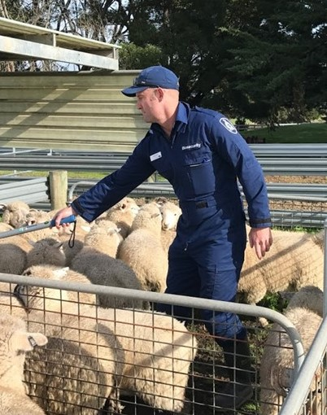
Protecting our sector and improving its resilience to external threats such as climate change, pests, disease, natural disasters and resource scarcity is critical to maintain its productivity and longevity.
To respond to these risks, agriculture needs to be agile and resilient, and actively plan and prepare for a range of future scenarios. Farmers and agribusinesses who do this well will be more profitable and sustainable over the long‑term. Responding to these risks also presents us with enormous opportunities to showcase Victorian innovation and tenacity.
Climate change is a significant challenge facing Victorian agriculture. Average temperatures and the frequency of extremely hot days are increasing, while rainfall is both decreasing and changing the pattern of how and when it falls. This can influence the cost and availability of important inputs. The sector needs support to prepare for changing conditions while reducing its own environmental footprint.
- Average annual temperatures increase 2.4ºC by 2050 under a high emissions scenario
- Agriculture is Victoria’s 4th largest source of emissions accounting for 15% of total emissions
- Victorian cropping productivity lowered by 7.7% on average since 2001 due to climate change
Over the past 20 years, Australia has responded to significant biosecurity incursions, including avian influenza, citrus canker and equine influenza and has invested significantly in preparing for biosecurity incursions such as foot and mouth disease and African swine fever. These incursions can have a significant economic impact. Managing biosecurity risks is increasingly challenging, as international and interstate migration, climate change, tourism and increased movement of goods all increase the risk of incursion. Government, industry and the community need to work together to prepare for, and respond to, current and future biosecurity risks.
Water will continue to be a critical resource that needs to be managed effectively and used efficiently. The health and profitability of our farms, businesses and communities all rely on access to safe, reliable and affordable water.

What we are already doing
Implementing a comprehensive, state-wide approach to reduce greenhouse gas emissions. Victoria has the strongest climate change legislation in the country, with a target of net zero emissions economy-wide by 2050. This leadership is critical to drive practical action on climate change and send strong market signals. Victoria’s comprehensive climate change framework outlines a process for developing and committing to emissions reduction proposals across all sectors of the economy, including agriculture.
Strengthening our biosecurity system. In 2019, the Victorian Government made an historic investment in our biosecurity system. It delivered ongoing capacity to avoid systemic weaknesses in critical biosecurity services – and it invested in strengthening our approach by building capability, improving voluntary compliance and developing a new biosecurity legislative framework to support more effective and responsive management of pests and diseases, based on a common understanding of shared responsibility and best practice regulation. This will ensure Victoria has a resilient and responsive approach to managing biosecurity risks that can be sustained into the future.
Engaging the best experts to inform our climate change response. The Victorian Government has established the Victorian Agriculture and Climate Change Council to provide independent, strategic advice to the Minister for Agriculture on how the agriculture sector can respond to the impacts of climate change. This includes working with industry to support action already being taken and maximise opportunities for the sector as we transition to a net zero emissions economy and climate resilient community.
Delivering a strong research agenda to support new approaches to climate change. Agriculture Victoria is partnering with industry bodies and associations to deliver cutting-edge research and innovation programs for climate change adaptation and mitigation, such as Dairy Feedbase and DairyBio. These programs apply the latest technology and bioscience to significantly improve on-farm profitability through genetic and genomic innovation in pastures and dairy cattle, future-proofing the feed base and enhancing animal performance. Agriculture Victoria is also conducting research and innovation activities to boost adaptation and profitability within the grains and horticulture industries.
Practical tools and information for farmers. Agriculture Victoria works closely with farmers across rural and regional Victoria to provide tools and information. Regular climate webinars, newsletters and videos enable the sector to better understand seasonal climatic variations and long-term trends. Practical advice helps farmers reduce their carbon emissions and adopt sequestration activities, increasing farm profitability and health as a result.
Investing in water infrastructure. Numerous water infrastructure projects are underway to secure the future for Victoria’s high-value agriculture and horticulture, while also protecting the environment. This includes the $2 billion Connections Project –the largest irrigation modernisation project in Australia. The project is generating water savings by creating a world leading delivery system that boosts irrigator productivity, helps communities thrive and fosters healthy waterways and wetlands. Other projects include the East Grampians Water Supply Project, which will supply water to agricultural areas surrounding Ararat and some sections of the Pyrenees and Northern Grampians shires, and both the South West Loddon Rural Water Supply and the Mitiamo and District Reticulated Water Supply Projects which will continue the extension of the water grid and improve water security to rural communities. The Victorian Government is supporting irrigators to get the most out of their water and plan for the future and improving the security and efficiency of water supplies as part of a $59 million Water Wise Rural Communities initiative.
This initiative includes extension support and information to help irrigators introduce best practice water management, make informed decisions and improve resilience and adaptability to climate change impacts.
Building on Victoria’s strong food safety culture. Existing regulatory and assurance systems underpin high standards for Victorian food and fibre products. These systems are critical to our sector’s reputation for safe, quality produce. They are also important for meeting trade expectations, and supporting our global reputation for high-quality food. Victorian food regulators are using risk-based approaches to drive innovation in food safety systems, while ensuring public safety. This includes the Dairy RegTech project, which is Dairy Food Safety Victoria’s transformational approach to regulation using digital platforms.
Socio-economic criteria for additional water recovery. We have put in place socio-economic criteria to protect communities from potential negative impacts of Basin Plan water recovery. The criteria were informed by socio-economic analysis and Basin-wide community engagement. This will address the cumulative and region-wide impacts that water recovery projects may have on water prices, regional communities and economies and the future viability of irrigation districts. The criteria also address the social, environmental and cultural impacts of projects.

What’s next

Position Victoria as a leader in low-emission agriculture.
Responding to climate change and reducing emissions in agriculture will require coordinated action across governments, industry and the community, and the Victorian Government is committed to delivering strong and lasting action.
The Victorian Government’s climate change strategy and agriculture sector emission reduction pledge will commit us to a pathway to support the agriculture sector in reducing its emissions. While the development of new technologies to reduce emissions is at an early stage, Victoria is well placed to build on existing activities already underway, tailoring new approaches to the needs of Victorian farmers and with a clear pathway to commercialisation. This includes making the most of opportunities in land restoration and carbon sequestration, which will both deliver jobs and long-term income streams for farmers, improving productivity and assisting in achieving net zero emissions.
Our world-class researchers and industry partnerships are already working on practical solutions that will help ensure Victorian agriculture remains productive in a changing climate. The future holds great potential for innovative approaches and first movers, and the Victorian Government will work with farmers to ensure they have the practical advice they need to act early.
The Victorian Government will also ensure our farmers are well-placed to take up other advanced and proven technologies, such as renewable energy and waste management systems, to reduce emissions, energy costs and improve farm resilience.
We will double our investment in the successful Agriculture Energy Investment Plan, providing an additional $30 million to continue supporting farmers to improve on‑farm energy generation and efficiency.

Ensure Victorian agriculture is well-placed to manage climate risk and continues to be productive and profitable under a changed climate.
The Victorian Government is preparing for the long-term risks of climate change for key sectors across the state. We will develop a Climate Change Adaptation Action Plan for primary production in 2021, to ensure our farmers, and the agriculture sector more broadly, are in the best position possible to meet future challenges.
We will also continue to work closely with farmers to provide them with better data, trusted resources and technical advice to support good decision-making and informed risk management. This engagement is especially critical under a changing climate, where science, models and technology need to be understood and translated into practical on-farm action. New and innovative financial products are emerging as another important tool to help farmers manage risk.

Deliver best practice regulatory systems to manage risk and respond to new challenges.
Managing effective and trusted biosecurity and food safety systems is a critical role of the Victorian Government, and one
which is fundamental to the prosperity for all Victorians. The Victorian Government will make sure that our biosecurity and food safety systems are agile and flexible to respond to evolving challenges, and we will strengthen both industry and government capability to meet the outcomes sought.
The Victorian Government will deliver a single consolidated Biosecurity Act for Victoria to provide modern, flexible regulation that can be applied and adapted according to the nature of the biosecurity risk. This streamlined and simplified approach will ensure that the regulatory framework is evidence-based, risk-based and proportionate, and that it provides the best possible support to our world-class biosecurity system. We will continue our close collaboration with the sector to provide opportunities for industry and communities to take on a bigger role in managing biosecurity risk, as well as supporting local, national and international initiatives that benefit Victoria.
A more efficient, responsive and digitally enabled food safety system will better promote confidence in Victoria’s agriculture sector. We will review the food safety system and its regulatory settings to ensure it manages evolving risks and provides certainty to consumers and markets. We will embrace technology improvements to realise gains in real time data and analytics, reduced cost of compliance and faster response times. Building on the success of Dairy RegTech,
we will look at opportunities for smarter, more advanced systems to underpin a strong and modern regulatory approach to food safety.

Promote

We will promote and build confidence in our agriculture sector to international markets and the community.
The coronavirus (COVID-19) pandemic showed us how much Victorians value farmers and access to our fresh and locally grown food. Evolving community and consumer expectations have already led to significant changes in agriculture, and we know they will drive further change.
Our vibrant and internationally recognised agriculture sector will grow stronger as it continues to reflect and engage with its communities. A strong social licence to operate will allow Victorian farmers to pursue their work with local support and promote their products to worldwide consumers. Research demonstrates that Victorians are generally positive about Victorian farmers and believe they are doing a good job, but there are opportunities for farmers to better tell their
stories and connect people to the farms and businesses that produce their food.
Internationally, Victoria’s reputation for supplying safe, pest-free, premium produce can be even stronger. Victorian farmers produce food sustainably and maintain high standards of food safety, quality and biosecurity integrity – and we will continue to showcase it to the world.
Maintaining consumer confidence in the sector’s animal welfare practices is becoming an increasing priority, particularly as community expectations are evolving. The way animals are treated also impacts our national and international reputation
as a humane and responsible producer of food and fibre, with flow-on implications for market access and consumer confidence.
There are also opportunities to improve community perceptions of agriculture as a career to help the sector attract and retain the labour and skills that it needs to thrive.

What we are already doing
A strong commitment to ensuring better animal welfare outcomes. The Victorian Government is implementing the state’s first-ever Animal Welfare Action Plan, which was released in 2018 following collaboration with industry and the community. It sets four priority areas to support improved animal welfare, including a new animal welfare act that will recognise the sentience of animals for the first time in Victoria. This new legislation will drive behavioural change and compliance so that Victoria continues to be well‑respected globally for its animal welfare practices.
Building capability in traceability and integrity systems. Victoria has led the nation with significant investment and pioneering approaches to livestock identification systems. The Victorian Government is also undertaking in-depth supply chain analysis to understand where enhancements to traceability and product integrity will be beneficial, supported by targeted collaborative research. This will improve industry’s ability to trace produce across supply chains, enhance safer food production and demonstrate premium quality attributes in increasingly competitive international markets.
Investing in Smarter, Safer Farms. Agriculture Victoria is working closely with industry to deliver the four-year, $20 million Smarter, Safer Farms program to improve sector safety and skills. Through this program, we are building digital and financial literacy, improving farm planning and supporting safe conditions on farms. A safe and healthy sector means more resilient communities in rural and regional Victoria, and an even more attractive place to work.
Building rewarding careers through the Victorian Government Young Farmers Program. The Victorian Government is supporting young farmers through targeted scholarships, leadership and mentoring opportunities, business bootcamps and workshops, and online networks. The Program provides young farmers a way to connect and learn together, responding to the need for greater connectedness between young farmers.
Supporting networking and leadership through the Victorian Rural Women’s Network. The Victorian Government is working to improve economic participation for rural women by driving digital connection and networking opportunities. The Network delivers leadership and mentoring programs, events, workshops and forums that help women connect to information, grants and resources. This aims to improve workforce participation, grow job opportunities, and put more women in leadership and decision-making roles in regional Victoria.

What’s next

Promote Victorian agriculture’s commitment to quality and high performance.
Existing regulatory and private assurance systems help maintain high standards for Victorian food and fibre products. These systems are critical to our sector’s reputation for safe and quality produce. They can also act as a device to attract the premium prices needed for the sector to adapt to meet evolving community standards, such as environmental sustainability outcomes. The Victorian Government will work with industry to explore opportunities for new, voluntary assurance systems that meet changing community values and reward high performance. This work will consider alignment between regulatory requirements and voluntary assurance programs to create efficiencies. We will also continue to work with the sector to grow its traceability capability to support greater transparency around the integrity, provenance and quality of our food and fibre products.
Community support is essential for our sector’s growth and success. We want to ensure community and public trust in agriculture is high. The Victorian Government will continue to work with industry to strengthen its relationship with the broader public and promote its achievements in upholding community standards. We will also continue to work with the Victorian Farmers Federation to deliver a community engagement campaign to build community understanding of agriculture. The campaign will be timed to deliver as the sector emerges from immediate responses to the coronavirus (COVID-19) pandemic.
Investing in research and development into farm practices and genetic trait selection that improve animal welfare and health while maintaining or improving productivity will help us ensure standards are underpinned by the best scientific evidence. Our new animal welfare legislation, and clear guidance and support for industry, will continue to achieve significant improvements to animal welfare outcomes in the sector and deliver on community expectations.

Position agriculture as a career of choice and build its reputation for workplace excellence.
To attract the best and brightest to agriculture, we need to improve how we promote the diverse and fulfilling opportunities that are possible with a career in agriculture. The Victorian Government has started this conversation with the community, raising awareness of employment opportunities in Victorian agriculture for local jobseekers through the seasonal worker marketing campaign. We will work with the sector to build on these initiatives and showcase rewarding career pathways for those wanting to commit to agriculture over the long-term.
The Victorian Government has also been working closely with industry to improve agriculture skills and safety through the Smarter, Safer Farms program. We will build on existing work with new, targeted safety initiatives that recognise farms are both homes and workplaces. An investment of $3 million will support a new farm safety rebate scheme and $1.5 million will support a family farm safety campaign to help protect family members, workers and visitors from workplace hazards.

Case study

Investing in tracing technology in the citrus industry
We are actively investing to improve the quality of our export produce and increase Victoria’s reputation as an exporter of premium quality produce to consumers globally.
The 2020 Citrus Traceability Pilot traces premium fruit from Mildura orchards through to international retail markets. Delivered as a partnership between Agriculture Victoria and Citrus Australia, this pilot used ‘digital fingerprint’ labelling and blockchain technology to scan fruit at over 50 retail and wholesale locations by overseas consumers, allowing them to verify that the fruit is a genuine Victorian product and to view the journey from “tree to table”.

Our vision
A Victorian agriculture sector that is strong, innovative and sustainable
Future state: In 2030, Victorian agriculture will be:
- An engine of growth for the Victorian economy: attracting investment, supporting jobs and helping communities thrive
- Creative, resilient and responsive to challenges and opportunities, capitalising on technological advancement and new ways of doing things
- A front runner in low-emission food and fibre production
- Australia’s agriculture exports centre, providing high-quality, sought after agriculture produce to diverse markets around the world
- Home to diverse and innovative careers, attracting the best and brightest to our farms and regions.

Our Themes
Recover from the impacts of drought, bushfires and the coronavirus (COVID-19) pandemic and become an engine of growth for the rest of the economy.
Grow the value and output of agriculture through increased exports, investment, greater diversification and new products.
Modernise Victorian agriculture through innovation, investment and future skills.
Protect and enhance the future of agriculture by ensuring it is well-placed to respond to climate change, pests, weeds, disease and increased resource scarcity.
Promote and build confidence in our agriculture sector to international markets and the community.
Our Commitments:
- Support farmers with information and tools to build resilience.
- Strengthen local supply chains and support opportunities for local manufacturing.
- Support Victorian producers to be more profitable, exporting more products to more markets, more often.
- Maximise the growth potential of key emerging industries.
- Create the right conditions and opportunities for investment here in Victoria.
- Increase the adoption of new, effective and fit for purpose technology.
- Grow a thriving and globally competitive AgTech industry in Victoria.
- Enhance the commercialisation of research.
- Deliver the agriculture skills of the future.
- Position Victoria as a leader in low-emission agriculture.
- Ensure Victorian agriculture is well-placed to manage climate risk and continues to be productive and profitable under a changed climate.
- Deliver best practice regulatory systems to manage risk and respond to new challenges.
- Promote Victorian agriculture’s commitment to quality and high performance.
- Position agriculture as a career of choice and build its reputation for workplace excellence.

Enablers:
- Partnering with the sector
- Working with local communities

Next steps
This Strategy represents the Victorian Government’s ambitious vision for a thriving agriculture sector, backed by significant new investment. But it is only part of the story. We now want to continue a conversation with our industry partners and regional communities about how this vision can come to life.
Together, we will position Victorian agriculture as the engine for Victoria’s economic recovery: strong, sustainable and innovative for the future.
Visit agriculture.vic.gov.au/strategy to find out more and be a part of the conversation.
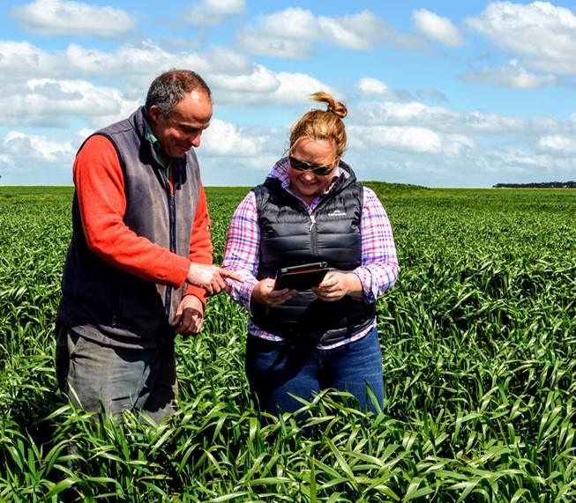

Appendix A

Building on Victoria’s successful agriculture industries
$14.5 B total food and fibre exports in 2019-20
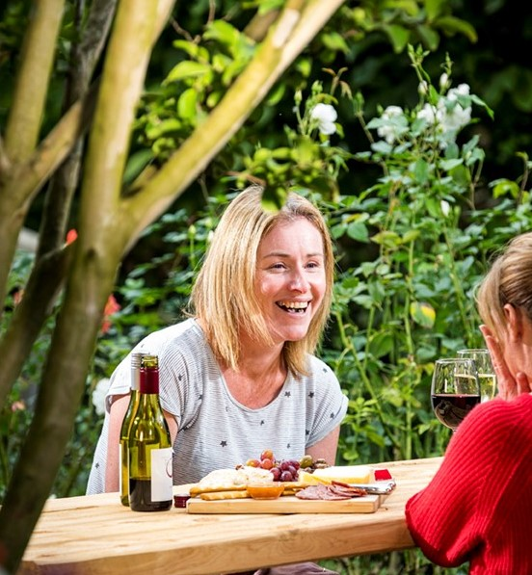

Meat

Beef, sheep meat, chicken, pork and goat
- $4.7 b total exports (2019-20)
- 1.1 m tonnes Meat and livestock produced (2018-19)
- $5.2 b meat and livestock produced (2018-19)
- 25% value of Australian meat exports (2019-20) > 40% of Australian lamb production (2018)
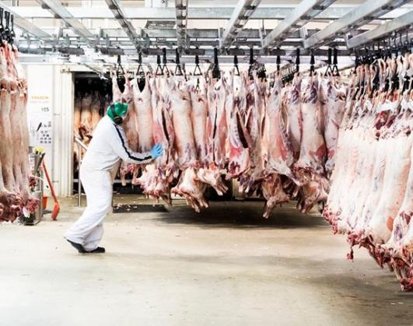

Horticulture

Fruit, nuts, oils, vegetables, coffee, tea, herbs and spices
- $1.61 b total exports (2019-20)
- 1.5 m tonnes Produced (2018-19)
- $2.95 b Produced (2018-19)
- 32% Of Australia’s production in value terms (2015-16)
- 50% Of Australian horticulture exports (2019-20)
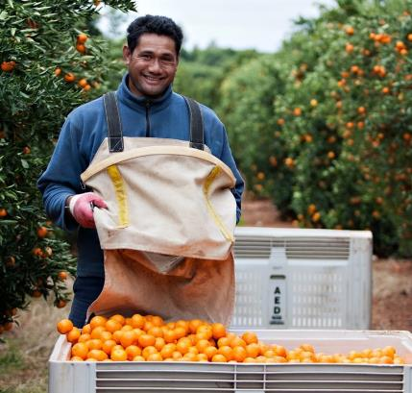

Grains

Cereals, pulses, processed grain and oilseeds
- $1.1 B total exports (2019-20)
- 4.7 M tonnes Produced (2018-19)
- $2.7 B produced (2018-19)
- 5,848 farms (2018-19)
- 13% of Australian grains produced (2018)
- 3.0 M hectares of grain farming (average 2011-12 to 2015-16)
- 10,350 jobs (2019-20)
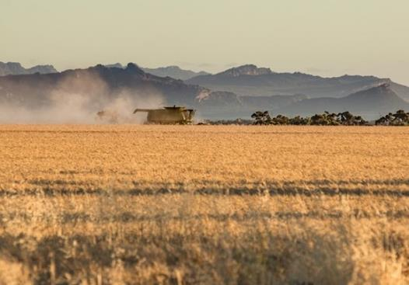

Wool
- $1.35 B total exports (2019-20)
- $1.4 B produced (2018-19)
- 29% of Australia’s wool (2019-20)
- 2nd largest producing state in Australia (2019-20)
- 52% of Australia’s wool exports (2019-20)
- # 1 Wool exporting state in Australia (2019-20)
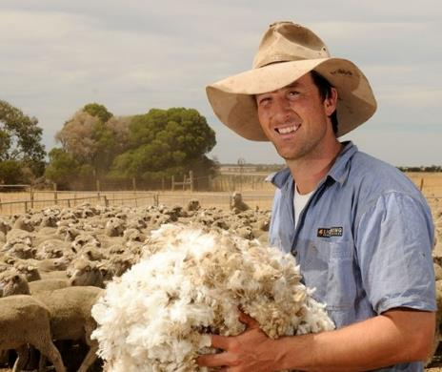

Dairy

Milk, cream, cheese, whey, butters, fats, oils, yoghurt, fermented milk and milk extracts
- $2.1 B total exports (2019-20)
- $2.7 B produced (2018-19)
- #1 dairy producing state (2018)
- $7.7 B gross value of food processing (2015-16)
- 3,685 farms (2018-19)
- 18,100 jobs (2019-20)
- 62% of Australia’s milk (2018)
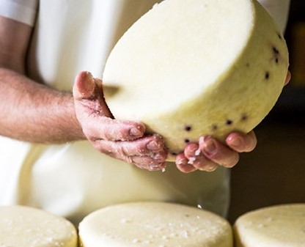

Wine
- $380 M Total exports (2019-20)
- 23,088 Hectares Of wine grapes (2016)
- 12,995 Direct jobs (including tourism) (2017)
- $7.6 B Direct economic contribution (2015)
- 1,132 Grape growers (2017)
- 747 Wineries (2017)
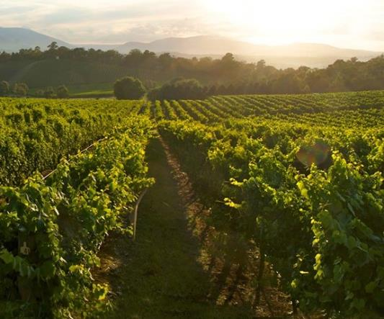

Craft and Specialised
Small-scale, craft and premium agribusinesses – closely linked to Victoria’s agritourism appeal and reputation as a producer of high-quality, niche offerings.
Agritourism has an important role in creating a more direct connection between the primary producer of food and drink and the end consumer.
It is estimated that there are 3,320 producers in the artisanal sector in Victoria, that combined make an annual contribution to the Victorian economy of between $209 - $350 m.
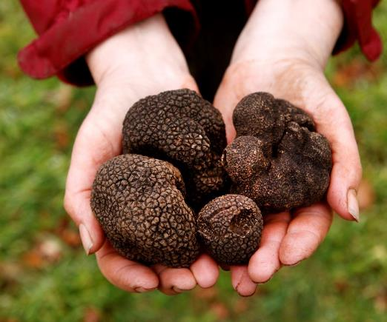

Emerging industries

Alternative proteins
- $4.1 B Expected national domestic consumption by 2030
- $2.5 B Expected exports nationally by 2030

Medicinal cannabis
- $365 m Estimated economic contribution to gross state product by 2028
- 30-50% Of all Australian demand for medicinal cannabis by 2028

Native foods
- $75-$125 m Value-added bush food products nationally (2017)
- 15 of ~ 6,000 Edible native plant species are commercially produced nationally (2017)

Published by Department of Jobs, Precincts and Regions, 1 Spring Street Melbourne, Victoria 3000.
Telephone (03) 9651 9999
December 2020
© Copyright State Government of Victoria 2020
This publication is copyright. No part may be reproduced by any process except in accordance with provisions of the Copyright Act 1968.
Authorised by the Victorian Government, Melbourne.
Designed by DJPR Design Studio
ISBN 978-1-76090-409-8
Disclaimer: This publication may be of assistance to you, but the State of Victoria and its employees do not guarantee that the publication is without flaw of any kind or is wholly appropriate for your particular purposes and therefore disclaims all liability for any error, loss or other consequence which may arise from you relying on any information in this publication. While every effort has been made to ensure the currency, accuracy or completeness of the content we endeavour to keep the content relevant and up to date and reserve the right to make changes as required. The Victorian Government, authors and presenters do not accept any liability to any person for the information (or the use of the information) which is provided or referred to in the report.

