Victoria’s Biosecurity System

Statewide Survey

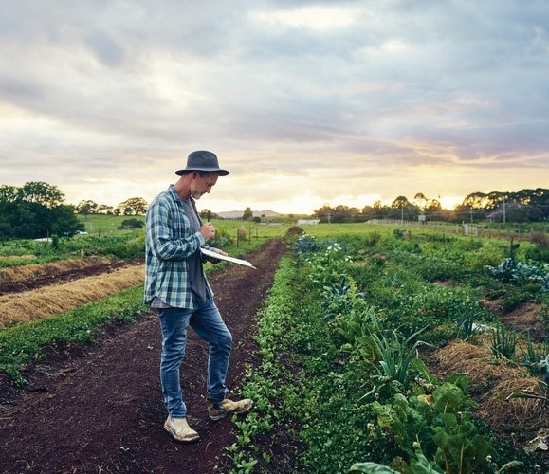

Prepared by Wallis Social Research | April 2021

Level 2, 273 Camberwell Road Camberwell VIC 3124  
+61 3 9621 1066 | wallis@wallisgroup.com.au | www.wallis.social





**Accreditations**

Wallis Social Research achieved accreditation to the International Standard ISO20252 in September 2007. The Company is committed to maintaining administrative and operational procedures which comply with these accreditation requirements and to improving its performance in all aspects of the service it delivers to its customers.

In 2020 Wallis sought and attained certification to ISO 27001. This is the highest standard for information and data security. Wallis made the strategic decision to become certified to ISO 27001 because we recognise the absolute necessity for our clients to be assured that their data is secure. Wallis is one of the first research companies in Australia to achieve certification to this standard.

Wallis is an active participant in the market research industry, with senior staff making significant contributions to the Research Society (TRS) and the Association of Market and Social Research Organisations (AMSRO). As such we actively pursue the ethical objectives of the industry.

In addition to having attained the highest Industry accreditation, Wallis also participates in the Australian Achiever Awards, which recognises the customer service excellence of Australian companies. The Company has been awarded a high commendation every year since the inception of these awards in 1999.

Wallis is an acknowledged leader in data protection and privacy. Our system is regularly subjected to external penetration testing and we are a Privacy Awareness Week supporter – committed to sharing our knowledge with others.

Contents

1 Research objectives and Methodological overview 1

1.1 Background and research objectives 1

1.1.1 Methodology 2

1.2 Categorisation 3

2 Awareness of biosecurity 6

2.1 Familiarity with, and attitudes towards biosecurity 6

2.2 Engagement with biosecurity 12

3 Biosecurity incidents and planning 16

3.1 Perceived likelihood of an outbreak and impacts 16

3.2 Detecting and reporting an outbreak 18

3.4 Factors that influence biosecurity resources 22

4 Decision Making and Communications 24

4.1 Importance of hearing information about biosecurity 24

4.2 Sources of information 25

4.3 Channels of communication 26

4.4 Most important types of information 28

5 Shared Responsibility and partnerships 29

5.1 Perceptions of the biosecurity system’s effectiveness 29

5.2 Ability to deliver role in biosecurity 30

5.3 Responsibility for biosecurity 32

5.4 Working in partnership 33

6 Our collective challenges 36

6.1 Resourcing of the system 36

6.2 Effort to improve the system 38

6.3 A vision for the future 40

Tables

Table 1 Reporting categorisation matrix 4

Table 2 What is the biggest biosecurity threat for your business right now? 11

Table 3 Perceived likely impacts from a biosecurity incident in Victoria 18

Table 4 Perceived ability of various groups to deliver their role in the biosecurity system 31

Figures

Figure 1 Familiarity with biosecurity systems (NET well informed) 7

Figure 2 How informed do you feel about specific biosecurity threats to… (farms % NET well informed) 8

Figure 3 What is the biggest biosecurity threat for your business right now? 9

Figure 4 Importance of biosecurity in protecting… (% net important) 12

Figure 5 Engagement with biosecurity 13

Figure 6 How much effort do you, personally make to keep informed about biosecurity threats? 14

Figure 7 Importance of day-to-day actions contributing to support Victoria’s biosecurity 15

Figure 8 In the next five years, how unlikely or likely is a biosecurity incident that would severely affect… 16

Figure 9 Percentage of respondents very likely to detect and report an outbreak 19

Figure 10 Which organisation or individual would you report the outbreak to? (Farms) 20

Figure 11 Does your organisation have a biosecurity plan? 21

Figure 12 Factors influencing the amount of time/money devoted to biosecurity (farms, net ‘strongly influence’) 23

Figure 13 Importance of hearing information about biosecurity, by groups 24

Figure 14 Sources of biosecurity information (farms) 25

Figure 15 Top seven channels of communication (farms) 27

Figure 16 The most important types of biosecurity information (farms) 28

Figure 17 How poorly or well is Victoria’s biosecurity system functioning? 29

Figure 18 Perceived responsibility for biosecurity in Victoria (farms) 32

Figure 19 To what extent do you feel that everyone [involved in the biosecurity system] is working together? 33

Figure 20 Awareness of any partnerships to encourage better biosecurity 34

Figure 21 Perceived performance of partnerships 35

Figure 22 Perception of how well resourced Victoria’s biosecurity system is 36

Figure 23 In the next five years, should more effort go into Victoria’s biosecurity compared to now? 39

# 

# Key findings

This report presents the findings from a statewide survey into attitudes towards, and perceptions of biosecurity among Victorian farms, related businesses and other stakeholders. The survey was conducted by Wallis Social Research, on behalf of Agriculture Victoria as part of its Strengthening Victoria’s Biosecurity Systems Program, which is a four-year transformation program with aims to strengthen Victoria’s biosecurity system. The aim of the survey was to develop new insights from industry, community and government on:

* biosecurity knowledge
* preferred information sources
* identification of influencing factors.

The following key findings emerged from the survey.

Biosecurity issues are perceived as relevant and immediate for most actors in the system

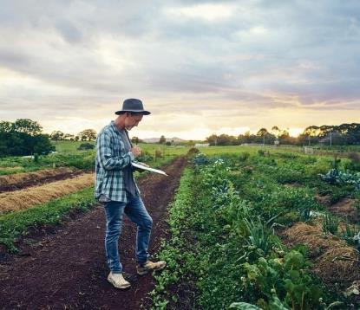

Both farms and related businesses rate the relevance of biosecurity issues to themselves as greater than four out of five on average. The ratings are even higher among stakeholders including interest groups and government stakeholders. Importantly, farms also perceive that they have agency in the biosecurity system. Some 80 per cent of farms feel their day-to-day actions are important in contributing to Victoria’s biosecurity.

Altruistic and environmental values figure prominently as biosecurity motivators for farms

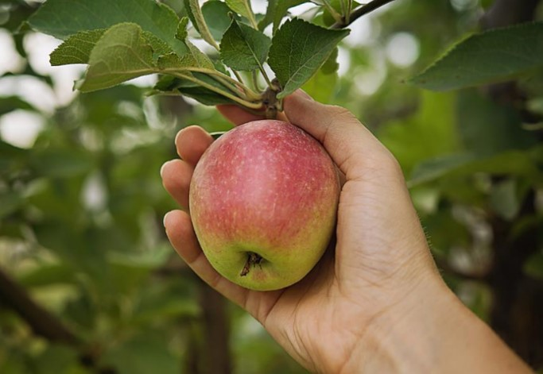

Among farms, ‘doing the right thing’ and ‘protecting environmental values’ are rated as strong influencing factors on the resources expended on biosecurity more frequently than ‘protecting business productivity’.

Biosecurity is already widely viewed as a shared responsibility

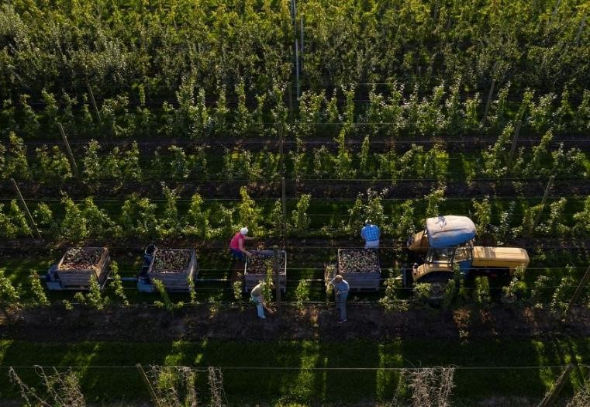

While the Victorian and Commonwealth Governments are given the highest ratings in terms of who is responsible for biosecurity, industry bodies, individual businesses and the broader community are rated almost as highly. This reflects an underlying understanding that responsibility for biosecurity cannot be laid at the feet of any single group.

While the need for shared responsibility is recognised, there are concerns with the way the system is currently working

A photograph of a famer wearing a watermelon coloured shirt and wearing a hat who is a man is looking at his phone. Landscape with cattle is in the background. This image was supplied by the Department of Jobs, Precincts and Regions.

Only moderate ratings are provided in terms of ‘everyone working together’, with farms and related businesses providing an average score of just three out of five on this measure. Other stakeholders including interest groups and government rate this aspect even less positively.

When assessing the overall working of the biosecurity system, fewer than half of farms feel the system is functioning well, with around one in five feeling that it is functioning poorly. Among various interest groups, there are notable levels of respondents (around four in ten) who feel the system is performing poorly.

There also appears to be some level of disconnect between the perceptions of government and other groups, with the percentage of government respondents identifying the system as functioning ‘well’ much higher than the other groups.

Nevertheless, there is discernible aspiration for a better biosecurity system. Four in five farms and related businesses say there should be greater effort applied to the system, while among interest groups this sentiment is almost universal.

Across all groups, there is strong demand for information regarding biosecurity

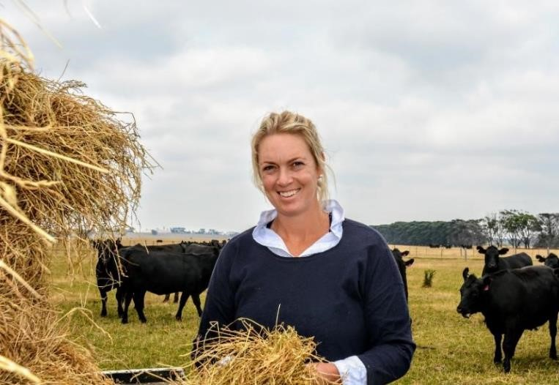

Farms place high importance on information from peak bodies as well as State and Federal Governments. However, there is less reliance placed on government-supplied information relative to the information from peak bodies. There is, therefore, scope for Agriculture Victoria to further leverage existing channels with peak bodies, and to promote further reliance on its own channels.

Agriculture Victoria’s stakeholders within the biosecurity system hold diverse views

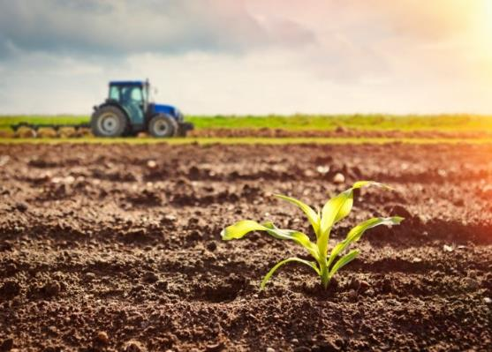

The survey collected views across two broad populations: a random selection of farms and related businesses, and interest group members with some existing connection to the system. Across almost all measures, the attitudes held are markedly different. Understanding the broad differences between these populations will be an important consideration for Agriculture Victoria.

# Research objectives and Methodological overview

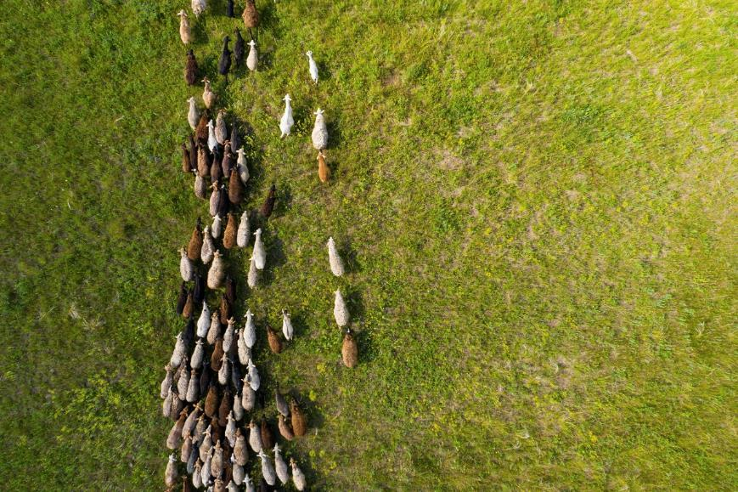

## Background and research objectives

The Strengthening Victoria’s Biosecurity System Program is a four-year transformation program which aims to strengthen Victoria’s biosecurity system, based on a common understanding of shared responsibility and best practice regulation. The program seeks to partner with industry and community and other government jurisdictions to prepare for the future and improve how Agriculture Victoria delivers biosecurity services.

The program consists of four projects:

**Strategy and engagement** – engaging industry, community and government stakeholders to support a common understanding of shared responsibility and the role of a biosecurity agency.

**Legislative reform** – developing a contemporary legislative framework for biosecurity in Victoria embedding the concept of shared responsibility and enable effective, flexible regulation.

**Regulatory practice** – modernising regulatory practice to generate stronger monitoring and intelligence approaches, increase compliance in priority areas and build capability within Agriculture Victoria and across the biosecurity system.

**Biosecurity business systems** – building capability in people and systems to enable efficient and effective delivery of biosecurity regulatory services.

#### Purpose of the statewide survey

The statewide survey supports the first project noted above. Its purpose is to develop new insights from industry, community groups and government on their biosecurity knowledge, preferred information sources, and to identify factors that influence biosecurity decisions.

These insights will allow the department to better understand the actors in the sector, so that progress can be made in fostering collaboration and shared ownership. As one stakeholder mentioned:

“We need to understand everyone’s perspective so we can work together.”

The insights from the survey will also be used to inform the development of a deliberative workshop bringing together experts from industry, community and government. In turn, these deliberative workshops will support how we meet future biosecurity challenges.

### Methodology

#### Scoping review

A scoping review was undertaken prior to commencing the survey. The purpose of the scoping review was to provide a summary of the program in a document that allowed Wallis and the department to agree on key aspects of the broad survey program. In addition, the scoping review served to provide a document that the department could use to inform its stakeholders regarding the project context, the lines of enquiry that would be explored and who would be engaged. Furthermore, the scoping review identified areas of enquiry that would be out of scope.

The scoping review had four sections:

1. Lines of Enquiry: Identify potential lines of questioning after a review of project documentation and a wide range of sources.
2. Populations: Identify and describe the populations of interest.
3. Sampling: Review the issues arising from the differing approaches required to reach the Populations.
4. Bringing it Together: Understand the likely data outputs from the statewide survey.

The scoping review used an abridged version of the Arksey and O’Malley framework to synthesise evidence by mapping the available information from a diverse range of sources. These sources included market research reports, questionnaires, a white paper, and reviews.

#### Survey sample

The survey had two broad sources of sample.

* Representative sample (respondents were contacted directly).
* Interest group sample (respondents were contacted via a link sent to organisations).

The representative sample was sourced from two databases. The first was from Illion which is a commercial supplier of business contacts. Illion provided 4,819 records consisting of farms and related businesses. The other source was CEDRIC, a database maintained by Agriculture Victoria, which also consists primarily of farms and related businesses. There were 1,470 records sourced from CEDRIC that were invited to the survey. Given that these records were drawn from a known population, and that these databases have relatively large coverage of the population, results can be considered to be representative of the population of Victorian farms and related businesses.

The interest group sample was sourced through various organisations that were sent an open link (customised for their organisation) for distribution to their networks. This is known as a convenience sample. Given that we have no information on what percentage of the population of these groups might have been reached in this way, or even what percentage responded, these results should be considered as indicative. We cannot assign any known levels of statistical confidence to these findings. To denote this uncertainty, figures in the report which reference findings from these cohorts are shaded light green.

#### Response

In total, 1,472 completed survey responses were received. There were 714 responses received from records soured from Illion (response rate of 15 per cent). From CEDRIC sourced records, there were 408 completed surveys (response rate of 28 per cent). Finally, there were 350 responses received from interest group sample sources. Due to the nature of the interest group sample, it is not possible to calculate a response rate.

#### Multi-modal survey

A multi-mode approach was used for the representative sample. Survey invitees were sent a survey pack that included a primary approach letter (PAL) and a hardcopy survey. Respondents had the option of completing the hardcopy survey and returning it to Wallis via the rely-paid envelope. Alternatively, respondents could scan the QR code on the PAL (or type in a short URL) and complete the survey online. If survey invitees did not initially complete the survey, Wallis followed up with a primary approach email and email reminders. In addition, there was follow-up from Wallis telephone interviewers, with whom interviewers could complete the survey over the telephone at the time or make an appointment to do so in the near future. Telephone interviewers also had the capability to send respondents an email or SMS if the respondents preferred to complete the survey online but could not readily find their survey invitation.

For interest group sample invitees, the survey needed to be completed online as Wallis did not have their contact details.

## Categorisation

This report uses six key groups for analysis. The groups are created based on their initial sample source and self-identification within the survey. This process is outlined below.

Survey respondents were initially categorised by Wallis in collaboration with Agriculture Victoria based on their sample source. Representative sample respondents were classified as farms or otherwise related businesses. Interest group sample respondents were initially categorised as interest groups, small holdings/lifestyle farmers, or government, depending on the organisation associated with the link that had been sent to each organisation.

However, respondents were given the opportunity to categorise themselves within the survey. For example, a respondent might enter the survey via a link from an organisation classified as an interest group. Within the survey, the respondent could then categorise themselves as a farm, related business, small holdings/lifestyle farmer, or even a government respondent.

If an interest group sample invitee categorised themselves as a farm, they were considered to be an ‘affiliated farmer’ and were grouped as such for this report. As these affiliated farmers came to the survey via an interest group, they could not necessarily be considered representative of the population of farmers. Indeed, results of the survey consistently demonstrated that affiliated farmers were on average much more aware of, engaged with, and concerned about biosecurity compared to the representative sample of farms. If affiliated farmers had been pooled with the representative sample of farms, then this would have skewed the survey results of farms to appear more engaged with biosecurity than is likely true of the farm population.

In Table 1, a matrix is provided to illustrate how the interplay between initial group and self-categorised group resulted in the final reporting groups that are used in the remainder of the report.

Table 1 Reporting categorisation matrix

Survey categorisation (based on respondent re-categorisation)

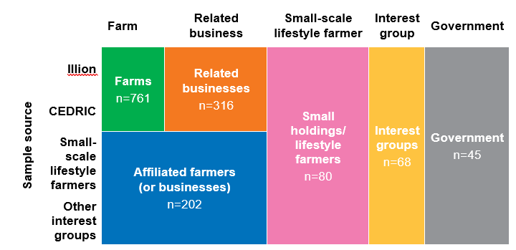

Data from the table is as follows:

* **761** respondents were categorised as **Farm** andcame from Illion and CEDRIC sample sources.
* **316** respondents were categorised as **Related business** andcame from Illion and CEDRIC sample sources.
* **202** respondents were categorised as **Affiliated farmers (or businesses)** andcame from small-scale lifestyle farmers, and other interest groups sample sources.
* **80** respondents were categorised as **Small holdings / lifestyle farmers** andcame from Illion, CEDRIC, small-scale lifestyle farmers, and other interest groups sample sources.
* **68** respondents were categorised as **Interest groups** andcame from CEDRIC and other interest groups sample sources.
* **45** respondents were categorised as **Government** andcamefrom CEDRIC, small-scale lifestyle farmers, and other interest groups sample sources.

The following list provides further details on the composition of each of these groups:

|  |  |
| --- | --- |
| Farms icon | **Farms (n=761):** Agricultural operations across a variety of sectors, including livestock, grain growing, horticulture and viticulture and aquaculture. |
| Related businesses icon | **Related businesses (n=316):** Businesses in related industries such as transport, wholesale, retail, vets and agronomists. |
| Affiliated farmers or businesses icon | **Affiliated farmers or businesses (n=202):** self-identified farms and related businesses that were sourced through opt-in survey links sent by organisations. |
| Small holding or lifestyle farmers icon | **Small holding or lifestyle farmers (n=80):** those who self-identified with this description. |
| Interest groups icon | **Interest groups (n=68):** self-identified members of various groups, including Landcare. |
| Government icon | **Government (n=45):** self-identified respondents from government across Commonwealth, State and Local levels. |

# Awareness of biosecurity

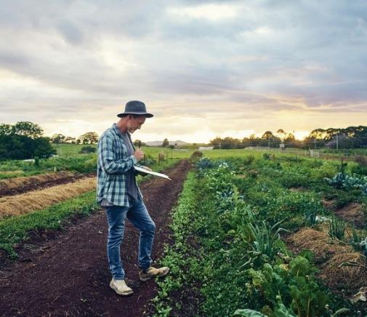

Biosecurity is a large and potentially complex topic. It is also a concept that is likely to mean a lot of different things to different groups of stakeholders. Therefore, to ‘anchor’ the survey questions, a definition of biosecurity was included early in the questionnaire. The definition is shown below.

“In this survey, when we say biosecurity, we mean the management of risks to the economy, the environment and the community, of pests and diseases entering, emerging, establishing or spreading. The national biosecurity system relies on the actions of, and partnerships between, Australian and State Governments, Local Governments, industries, environmental bodies, land managers and the broader public.”

This section explores two key issues regarding the way the different stakeholder groups perceive the biosecurity system. Specifically:

* it explores respondents’ self-assessed familiarity with the biosecurity system, and their attitudes towards biosecurity
* it also explores how engaged respondents are with biosecurity, in terms of how relevant they perceive it to be, how much effort they devote to the system, and whether they perceive their individual contribution is important.

## Familiarity with, and attitudes towards biosecurity

Fewer than half of farms (40 per cent) feel they are well informed about Australia’s national biosecurity system. Compared to all other groups, farms are the least likely to consider themselves informed. For other groups this percentage is above 50 per cent. Interestingly, farms are no more likely than other groups to consider themselves poorly informed. Rather, farms are much more likely to consider themselves neither well informed nor poorly informed. For example, farms (42 per cent) are more than twice as likely as small holdings/lifestyle farmers (18 per cent) to consider themselves neither well informed nor poorly informed.

The pattern is similar when the question concerns Victoria’s biosecurity system; most groups are slightly less likely to consider themselves to be informed about Victoria’s biosecurity system compared to the national biosecurity system. The exception is for Government respondents; they are more likely to consider themselves informed about Victoria’s biosecurity system than the national biosecurity system. This may reflect the fact that around two thirds of these respondents were drawn from the Victorian Government.

Figure 1 Familiarity with biosecurity systems (NET well informed)

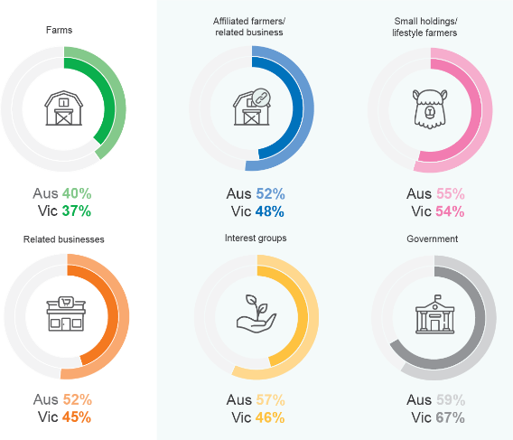

Q3 / Q4. How informed and/or familiar would you say you are about and/or with Australia’s and/or Victoria’s national biosecurity system?

Base sizes (n=): farms 761; related businesses 316; affiliated farmers/businesses 202; small holdings/lifestyle farmers 80; interest groups 68; government 45.

Further data provided in Figure 1 above is as follows:

* 40 per cent of the farms respondents say that they are informed about Australia's national biosecurity system and 37 per cent say that they are informed about Victoria's biosecurity system
* 52 per cent of the affiliated farmers and related business respondents say that they are informed about Australia's national biosecurity system and 48 per cent say that they are informed about Victoria's biosecurity system
* 55 per cent of the small holdings and lifestyle farmer respondents, say that they are informed about Australia's national biosecurity system and 54 per cent say that they are informed about Victoria's biosecurity system
* 52 per cent of the related businesses respondents say that they are informed about Australia's national biosecurity system and 45 per cent say that they are informed about Victoria's biosecurity system
* 57 per cent of the interest group respondents, say that they are informed about Australia's national biosecurity system and 46 per cent say that they are informed about Victoria's biosecurity system
* 59 per cent of the government respondents say that they are informed about Australia's national biosecurity system and 67 per cent say that they are informed about Victoria's biosecurity system.

#### How well-informed farms feel they are

Farms feel more informed about biosecurity threats that are likely to directly affect them. Around six in ten farms (59 per cent) feel well informed about biosecurity threats to their business sector, while 55 per cent feel well informed about threats to their business itself. A smaller percentage of farms feel less well informed about biosecurity threats that are less directly Related to their business, with less than half feeling they are well informed about biosecurity threats to their region, community or the state (44 per cent, 42 per cent and 40 per cent, respectively).

Figure 2 How informed do you feel about specific biosecurity threats to… (farms % NET well informed)

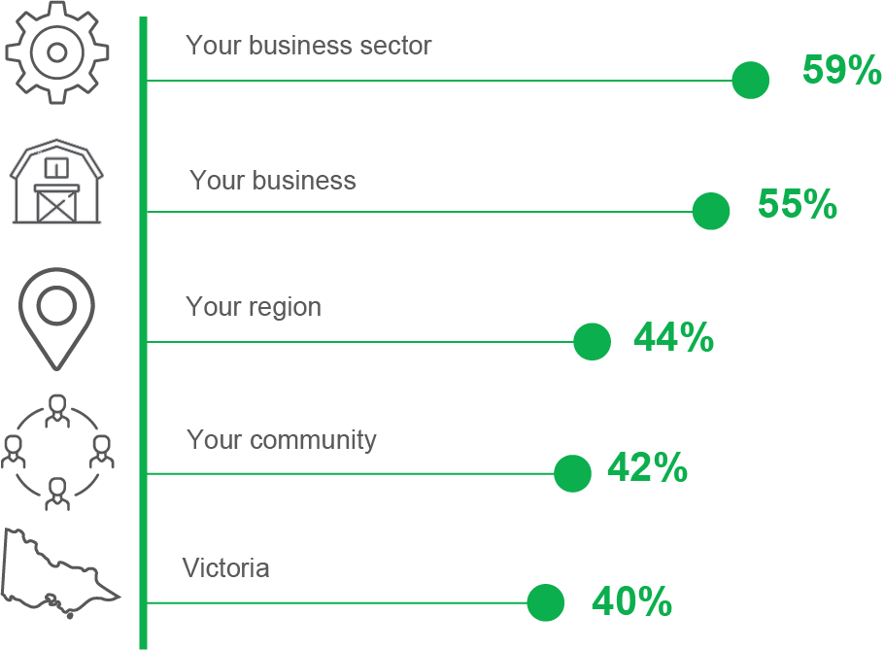

Q6. How informed do you feel you are about specific biosecurity threats to…

Base sizes (n=): farms 752.

#### Perception of biosecurity threats

Figure 3 below shows the biosecurity threats that farms and related businesses perceive as their biggest biosecurity threat right now. Around 30 per cent of both these groups indicate diseases or viruses, which is the most commonly identified threat. New incursions, weeds and insects are the next most commonly identified threats.

Figure 3 What is the biggest biosecurity threat for your business right now?

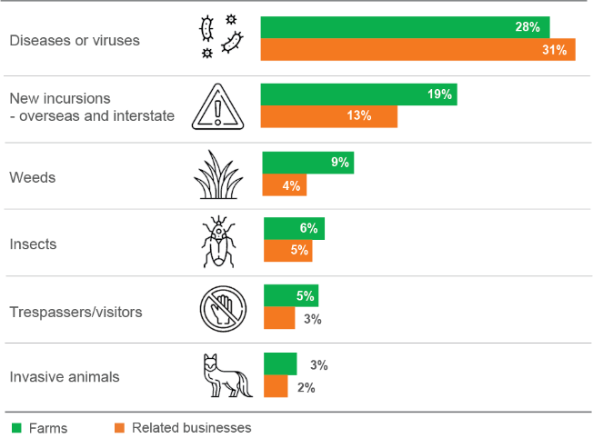

Q7. What is the biggest biosecurity threat for your business sector right now?

Base sizes (n=): farms 752; related businesses 301.

Further data provided in Figure 3 above shows the biggest biosecurity threats indicated to be as follows:

* 28 per cent of farms and 31 per cent of related businesses indicated diseases or viruses
* 19 per cent of farms and 13 per cent of related businesses indicated new incursions from overseas or interstate
* 9 per cent of farms and 4 per cent of related businesses indicated weeds
* 6 per cent of farms and 5 per cent of related businesses indicated insects
* 5 per cent of farms and 3 per cent of related businesses indicated trespassers or visitors
* 3 per cent of farms and 2 per cent of related businesses indicated invasive animals.

#### Perceptions of the biggest threat right now also varies by farm sector.

|  |  |
| --- | --- |
| diseases or viruses icon | **Dairy farms** (57 per cent) and horticulture and viticulture respondents (40 per cent) are more likely to identify diseases or viruses as the biggest threat. (compared with 35 per cent of farms overall). |
| weeds icon | **Grain growers** (21 per cent) and beef cattle farms (17 per cent) are more likely to identify weeds as the biggest threat (compared with 11 per cent of farms overall) |
| insects icon | **Horticulture and viticulture operations** (18 per cent), grain growing and other crop growing (both 15 per cent) are more likely to identify insects as the biggest threat (compared with seven per cent of farms overall) |

As shown in Table 2 below, weeds are perceived to be the biggest biosecurity threat right now for a larger percentage of affiliated farmers and businesses, interest groups, and small holdings/lifestyle farmers than for farms and related businesses. A higher percentage of government respondents perceive insects (30 per cent) and new incursions (23 per cent) to be the biggest biosecurity threat right now.

Table 2 What is the biggest biosecurity threat for your business right now?

|  | **Farms** | **Related businesses** | **Affiliated farmers/ businesses** | **Small holdings/ lifestyle farmers** | **Interest groups** | **Government** |
| --- | --- | --- | --- | --- | --- | --- |
| Diseases or viruses | 28% | 31% | 18% | 13% | 17% | 9% |
| New incursions - overseas & interstate | 19% | 13% | 16% | 9% | 12% | 23% |
| Weeds | 9% | 4% | 30% | 25% | 24% | 2% |
| Insects | 6% | 5% | 8% | 4% | 8% | 30% |
| Trespassers or visitors | 5% | 3% | 4% | 3% | 2% | 2% |
| Invasive animals | 3% | 2% | 9% | 5% | 15% | 7% |

Q7. What is the biggest biosecurity threat for your business sector right now?

Base sizes (n=): farms 752; related businesses 301; affiliated farmers/businesses 201; small holdings/lifestyle farmers 77; interest groups 66; government 43.

#### Importance of biosecurity in protecting the essential things

A large percentage of farms (87 per cent or greater) consider biosecurity to be important in protecting food production (93 per cent), the economy (92 per cent), export markets (91 per cent), the natural environment (87 %), and our way of life (87 per cent). The importance of biosecurity in protecting our cultural heritage is the lowest rated aspect but was still rated quite highly (83 per cent).

Figure 4 Importance of biosecurity in protecting… (% net important)

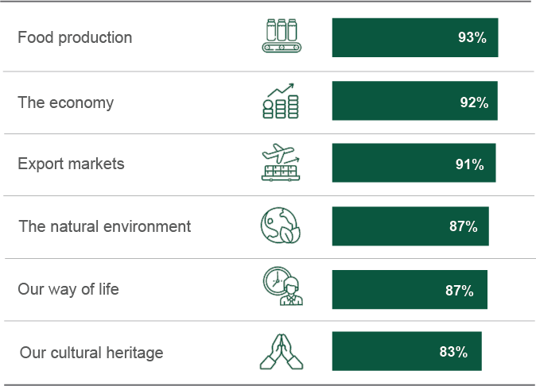

Q13. For each of the following items, on a scale from 1 to 5 where 1 is very unimportant and 5 is very important, how important do you feel biosecurity's role is in protecting…

Base sizes (n=): farms 752.

## Engagement with biosecurity

Respondents were asked to rate how relevant they felt biosecurity issues were for them, using a five-point scale where 1 meant ‘not at all relevant’ and 5 meant ‘highly relevant’. While all groups have mean scores above 4, farms (rating 4.3), related businesses (rating 4.2) and small holdings and lifestyle farmers (rating 4.3) are less likely to feel that biosecurity issues are relevant to them compared to affiliated farmers/businesses (rating 4.8). Interest groups (rating 4.5) and government (rating 4.6) both had average ratings highly than the majority of farm groups.

Only 55 per cent of farm and 52 per cent of related businesses gave a rating of five compared to 82 per cent of affiliated farmers/businesses and 76 per cent of government respondents.

Figure 5 Engagement with biosecurity

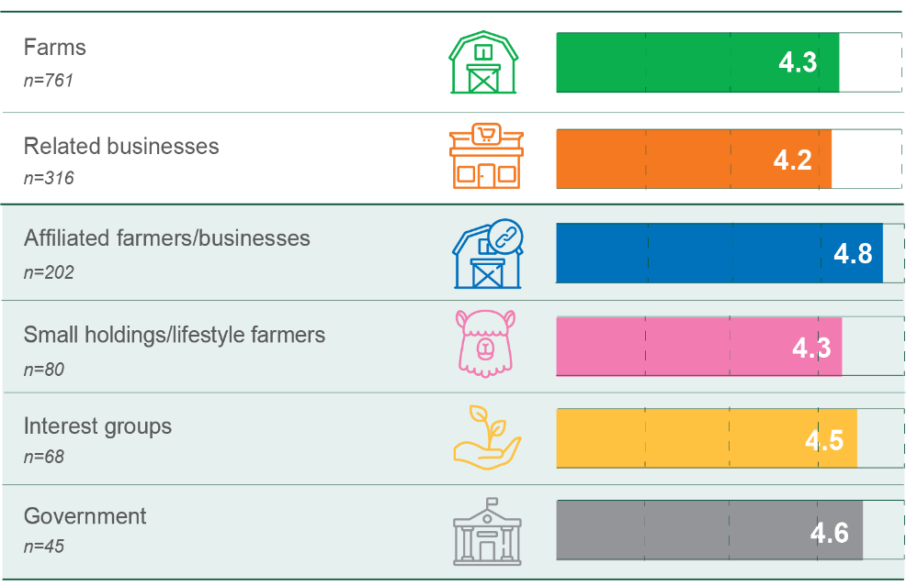

Q5. On a scale of 1 to 5, where 1 means ‘Not at all relevant’ and 5 means ‘highly relevant’, how relevant do you feel biosecurity issues are for you?

Base sizes (n=): farms 761; related businesses 316; affiliated farmers/businesses 202; small holdings/lifestyle farmers 80; interest groups 68; government 45.

#### Effort to keep informed about biosecurity

As shown in Figure 6 below, nearly 80 per cent of farms and a little over 70 per cent of related businesses say they make at least a moderate effort to keep informed about biosecurity threats. Government respondents and affiliated farmers/related businesses are more likely than other groups to say they make a lot of effort to keep informed about biosecurity threats (about twice the percentage of the other groups).

Figure 6 How much effort do you, personally make to keep informed about biosecurity threats?

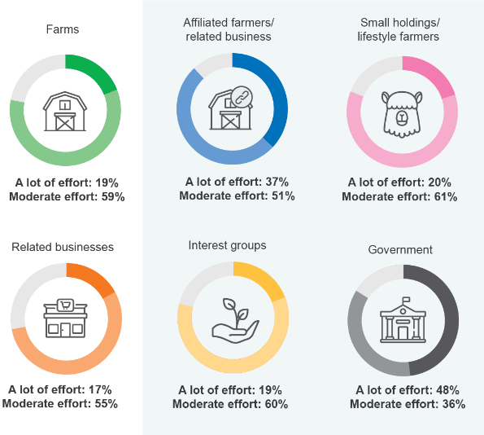

Q19. How much effort do you, personally, make to keep informed about biosecurity threats?

Base sizes (n=): farms 752; related businesses 301; affiliated farmers/businesses 201; small holdings/lifestyle farmers 77; interest groups 66; government 43.

The full data included in Figure 6 above shows the following:

* 19 per cent of farms make a lot of effort and 59 per cent make a moderate effort
* 37 per cent of affiliated farmers or businesses make a lot of effort and 51 per cent make a moderate effort
* 20 per cent of small holdings and lifestyle farmers make a lot of effort and 61 per cent make a moderate effort
* 17 per cent of related businesses make a lot of effort and 55 per cent make a moderate effort
* 19 per cent of interest groups make a lot of effort and 60 per cent make a moderate effort
* 48 per cent of government respondents make a lot of effort and 36 per cent make a moderate effort.

#### Importance of day-to-day actions contributing to support Victoria’s biosecurity

As shown in Figure 7, 80 per cent of farms and 75 per cent of related businesses feel that their own contribution is important or very important to support Victoria’s biosecurity. The percentage was only 65 per cent for small holdings/lifestyle farmers. Other analysis shows that related businesses and small holdings/lifestyle farmers are also less likely than other groups to feel their contribution is very important.

Figure 7 Importance of day-to-day actions contributing to support Victoria’s biosecurity

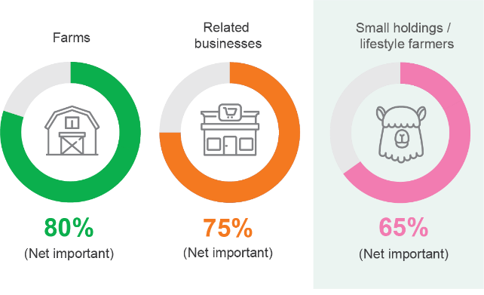

Q33. Please think now about the day-to-day actions you and your business and/or your organisation/and your department) could take to support Victoria’s biosecurity. How important do you feel your contribution is?

Base sizes (n=): farms 752; related businesses 301; small holdings/lifestyle farmers 77.

Q33 – Importance of day-to-day actions contributing to Victoria’s biosecurity (n=719,75)

# Biosecurity incidents and planning



## Perceived likelihood of an outbreak and impacts

Respondents were asked how unlikely or likely is a biosecurity incident that would severely affect Victoria in the next five years, using a five-point scale where 1 meant ‘highly unlikely’ and 5 meant ‘highly likely’. As shown in Figure 8, compared to other groups, farms and related businesses are less likely to say that a biosecurity incident would severely affect Victoria in the next five years. This finding is consistent with the finding in Section 2.2 that farm and related businesses feel that biosecurity issues are less relevant for them compared with other groups. Generally, respondents feel that there is a greater likelihood of a biosecurity incident severely affecting Victoria than one severely affecting their own business.

Figure 8 In the next five years, how unlikely or likely is a biosecurity incident that would severely affect…

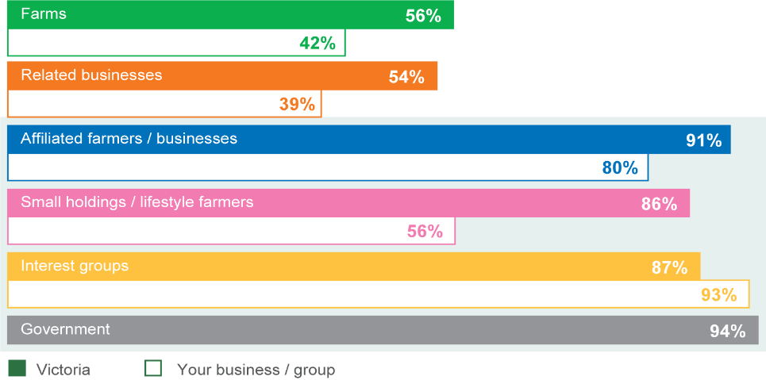

Q11. In the next five years, how unlikely or likely is a biosecurity incident that would severely affect…

(Victoria/Your business [or group])

Base sizes (n=): farms 752; related businesses 301; affiliated farmers/businesses 201; small holdings/lifestyle farmers 77; interest groups 66; government 43.

Full data provided in Figure 8 above includes:

* 56 per cent of farms thought that it was likely an outbreak would affect Victoria while 42 per cent thought it likely that an outbreak would affect their business
* 54 per cent of related businesses thought that it was likely an outbreak would affect Victoria while 39 per cent thought it likely that an outbreak would affect their business
* 91 per cent of affiliated farmers or businesses thought that it was likely an outbreak would affect Victoria while 80 per cent thought it likely that an outbreak would affect their business
* 86 per cent of small holdings and lifestyle farmers thought that it was likely an outbreak would affect Victoria while 56 per cent thought it likely that an outbreak would affect their business
* 87 per cent of interest groups thought that it was likely an outbreak would affect Victoria while 93 per cent thought it likely that an outbreak would affect their business or group
* 94 per cent of government respondents thought that it was likely an outbreak would affect Victoria.

Respondents were then asked how their business or organisation would likely be impacted if a biosecurity incident was to occur in Victoria. Table 3 below summarises the findings for this question. The groups are listed across the top of the table and the likely impacts are listed on the left side. The likely impacts are shown in order of the percentage of respondents who indicated each impact. Farms (86 per cent), related businesses (77 per cent) and affiliated farmers/businesses (73 per cent) are the most likely groups to say that their business would be impacted by a reduction in revenue. Together with small holdings/lifestyle farmers, these groups are also the most likely to say that their businesses would be impacted by an increase in costs.

Table 3 Perceived likely impacts from a biosecurity incident in Victoria

|  | **Farms** | **Related businesses** | **Affiliated farmers / businesses** | **Small holdings / lifestyle farmers** | **Interest groups** |
| --- | --- | --- | --- | --- | --- |
| Reduction in revenue | **86%** | **77%** | **73%** | **43%** | **36%** |
| Increase in costs | **82%** | **71%** | **81%** | **70%** | **52%** |
| Loss of productive capability | **78%** | **57%** | **74%** | **60%** | **45%** |
| Reduction in sales to Australian markets | **70%** | **47%** | **57%** | **34%** | **22%** |
| Reduction in sales to overseas markets | **60%** | **37%** | **46%** | **8%** | **14%** |
| Impact on reputation | **56%** | **42%** | **58%** | **42%** | **31%** |
| Impact on lifestyle | **48%** | **40%** | **52%** | **62%** | **50%** |

Q12 If a biosecurity incident was to occur in Victoria, how is your business/organisation likely to be impacted. Base sizes (n=): farms 752; related businesses 301; affiliated farmers/businesses 201; small holdings/lifestyle farmers 77; interest groups 66.

Other analysis indicates that there are differences by type of farm.

* Dairy cattle farms (73 per cent) and farms with a mix of livestock of grain (74 per cent) are more likely to say that they would be impacted by a loss of overseas markets compared to horticulture and viticulture operations (40 per cent), as well as other livestock and aquaculture operations (46 per cent).
* Dairy cattle farms are the most likely to say that they would be impacted by ‘impact on reputation’ (67 per cent, compared to 56 per cent for farms in total).

## Detecting and reporting an outbreak

Figure 9 below maps the percentage of each group that reports responses to two questions. The horizontal axis is the percentage of respondents who are ‘very likely’ to have procedures in place to promptly identify a situation where an unusual pest, disease or invasive plant/animal species found its way onto their farm (or starts to spread). The vertical axis is the percentage of respondents who would be ‘very likely’ to report an outbreak. Government respondents are the outliers; they are the most likely to both identify and report an incident. Related businesses are the least likely to have procedures in place. Nevertheless, approximately two in three (64 per cent) feel they would be ‘very likely’ to report an outbreak.

Figure 9 Percentage of respondents very likely to detect and report an outbreak

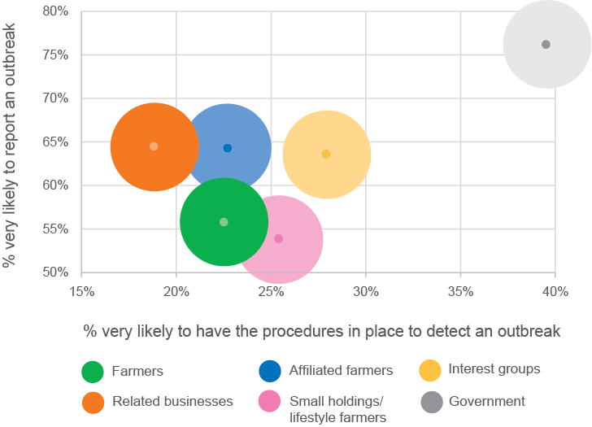

Q9. For the next few questions, please consider a hypothetical situation where an unusual pest, disease or invasive plant or animal species found its way onto your business/farm/starts to spread.

Base sizes (n=): farms 752; related businesses 301; affiliated farmers /businesses 201; small holdings/lifestyle farmers 77; interest groups 66; government 43.

Full data included in Figure 9 above provides the following details:

* 56 per cent of farmers are very likely to report an outbreak and 23 per cent are very likely to have procedures in place to detect an outbreak
* 64 per cent of affiliated farmers or businesses are very likely to report an outbreak and 23 per cent are very likely to have procedures in place to detect an outbreak
* 54 per cent of small holdings and lifestyle farmers are very likely to report an outbreak and 25 per cent are very likely to have procedures in place to detect an outbreak
* 65 per cent of related businesses are very likely to report an outbreak and 19 per cent are very likely to have procedures in place to detect an outbreak
* 64 per cent of interest groups are very likely to report an outbreak and 28 per cent are very likely to have procedures in place to detect an outbreak
* 76 per cent of government respondents are very likely to report an outbreak and 40 per cent are very likely to have procedures in place to detect an outbreak.

As shown in Figure 10, most farms mentioned Agriculture Victoria (or its predecessor, the Department of Primary Industries) or the Department of Agriculture. Veterinarians are the most frequently identified non-government avenues for reporting (16 per cent). Further analysis shows that this response is more common among farms with livestock, including dairy farms (31 per cent), sheep and beef farms (29 per cent) and beef (only) farms (25 per cent).

Figure 10 Which organisation or individual would you report the outbreak to? (Farms)

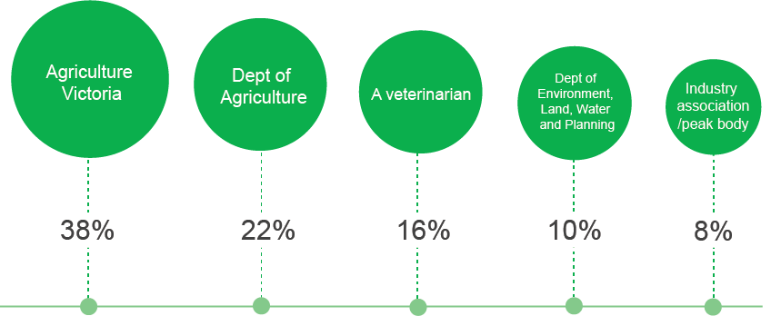

Q10. Which organisation or individual would you report the outbreak to?

Base sizes (n=): farms 656.

Full data included in Figure 10 above provides the following rankings from highest percentage to lowest:

* Agriculture Victoria at 38 per cent
* Department of Agriculture at 22 per cent
* a veterinarian at 16 per cent
* he Department of Environment, Land, Water and Planning at 10 per cent
* an industry association or peak body at 8 per cent.

Biosecurity plan

As shown in Figure 11 below, six in ten farms (61 per cent) say that they have a biosecurity plan compared with just over four in ten (43 per cent) related businesses.

Of those farms and related businesses with a plan, about two thirds (63 per cent and 68 per cent respectively) say that safety and / or risk management is the main reason for having a plan[1]. About one third (36 per cent and 30 per cent respectively) say that legislative/regulatory requirements are the main reason. Caring for the environment is the main reason for much smaller percentages (4 per cent and 5 per cent respectively).

Figure 11 Does your organisation have a biosecurity plan?

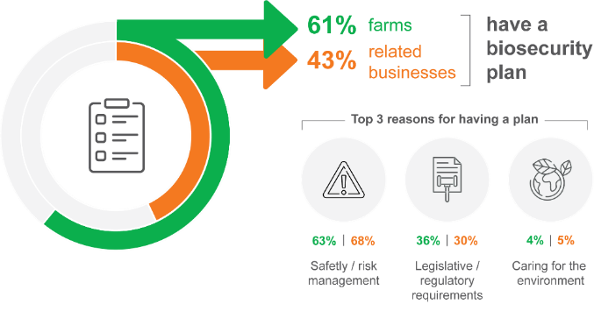

Q20. Does your business/organisation have a biosecurity plan?

Base sizes (n=): farms 752; related businesses 301.

Q21. What is the main reason for adopting a biosecurity plan?

Base sizes (n=): farms 410; related businesses 128.

Further analysis shows that of those farms without a biosecurity plan, about one in three (32 per cent) say they have a less formal system for dealing with biosecurity. One in ten farms (12 per cent) say they do not see the value of a plan, and a similar percentage (14 per cent) say it is too complex or time consuming to implement a plan. The quotations below provide a sample of the reasons given for not having a biosecurity plan.

“Too busy and not confident in what I am trying to create – don’t see how I [as] the business is going to benefit, the cost-benefit of creating it.”

“I'm really small, so I've seen no need. That said, I am really interested and a little knowledgeable.”

“Relatively small enterprise with key people well informed and active in the viticulture industry. Should be able to respond rapidly and effectively.

“Lack of information to formulate a plan. If we had a biosecurity template, we'd fill it out, otherwise we wouldn't know how to write it up. We would ask: is it relevant to our business?”

“Haven't sat down and written one. A framework or template I could download would be helpful. We have got some biosecurity measures in place just not in a formal plan.”

## Factors that influence biosecurity resources

As shown in Figure 12 below, over eight in ten farms (83 per cent) say that doing the right thing is a factor that strongly influences the amount of time/money devoted to biosecurity. ‘Protecting environmental values’ and keeping the community safe (both 75 per cent) are also factors that strongly influence the amount of time/money devoted to biosecurity.

Figure 12 Factors influencing the amount of time/money devoted to biosecurity (farms, net ‘strongly influence’)

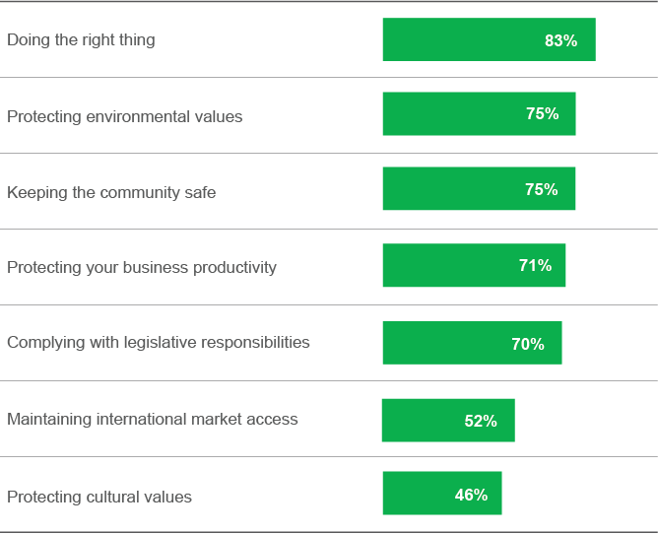

Q27. Please think now about the time and money your business devotes to biosecurity.

For each of the following factors, how weakly or strongly do they influence the amount of time and money you/your business devotes to biosecurity? Base sizes (n=): farms 752.

Full data provided in Figure 12 indicates that farms say the following are strong influences:

* 83 per cent say doing the right thing
* 75 per cent say protecting environmental values
* 75 per cent say keeping the community safe
* 71 per cent say protecting your business productivity
* 70 per cent say complying with legislative responsibilities
* 52 per cent say maintaining international market access
* 46 per cent say protecting cultural values.

# Decision Making and Communications



## Importance of hearing information about biosecurity

As shown in Figure 13, more than four in five respondents (80 per cent or more) in all groups say it is important or very important to hear information about biosecurity. However, farms (51 per cent) and related businesses (49 per cent) are the least likely to say it is very important to hear information about biosecurity

Figure 13 Importance of hearing information about biosecurity, by groups

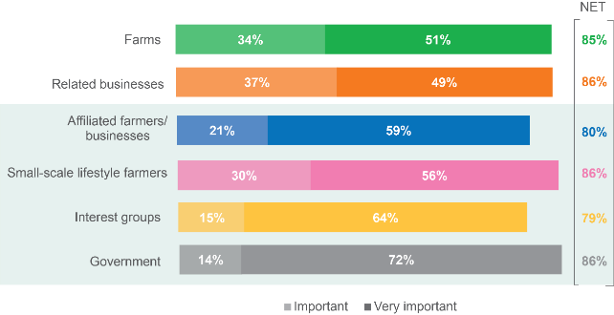

Q14. How important is it for you to hear information about biosecurity?

Base sizes (n=): farms 752; related businesses 301; affiliated farmers /businesses 201; small holdings/lifestyle farmers 77; interest groups 66; government 43.

Full data provided in Figure 13 above shows how different respondent groups viewed the importance of hearing information about biosecurity. Data includes:

* 34 per cent of farms said it is important while 51 per cent said it is very important, totaling 85 per cent
* 37 per cent of related businesses said it is important while 49 per cent said it is very important, totaling 86 per cent
* 21 per cent of affiliated farmers or businesses said it is important while 59 per cent said it is very important, totaling 80 per cent
* 30 per cent of small holdings and lifestyle farmers said it is important while 56 per cent said it is very important, totaling 86 per cent
* 15 per cent of interest groups said it is important while 64 per cent said it is very important, totaling 79 per cent
* 14 per cent of government respondents said it is important while 72 per cent said it is very important, totaling 86 per cent.

## Sources of information

Respondents were asked how important various sources of biosecurity information were for them, using a five point scale where 1 meant very unimportant and 5 meant very important. The respondents were also asked, for each source of information, how much they rely on them to inform their decisions about biosecurity. As shown in Figure 14, industry associations/peak bodies are the information source that the highest percentage of farms think is important. It is also the source farms are most likely to rely on a lot. An equivalent percentage of farms consider the State Government important as a source of information, but notably fewer farms rely on the State Government a lot compared to the percentage that rely on industry associations/peak bodies.

Figure 14 Sources of biosecurity information (farms)

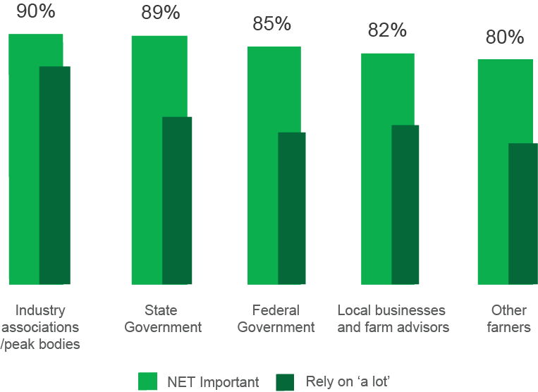

Q15. On the scale again, how important are the following sources of biosecurity information for you?

Q16. And for each of those sources of information, how much do you rely on them to inform your decisions about biosecurity?

Base sizes (n=): farms 616.

Full data provided in Figure 14 above shows that farms say following sources of biosecurity information are important to them:

* 90 per cent say that Industry associations and peak bodies are important while 70 per cent rely on Industry associations and peak bodies a lot as an information source
* 89 per cent say that the State Government is important while 58 per cent rely on State Government a lot as an information source
* 85 per cent say that the Federal Government is important while 52 per cent rely on the Federal Government a lot as an information source
* 82 per cent say that Local businesses and farm advisers are important while 55 per cent rely on Local businesses and farm advisers a lot as an information source
* 80 per cent say that other farmers are important while 48 per cent rely on other farmers a lot as an information source.

## Channels of communication

As shown in Figure 15, farms (70 per cent) say that email is the most effective way for government to communicate biosecurity information. Other analysis shows that related businesses also say that email is the most effective way to communicate biosecurity information. Less than a quarter (24 per cent) of farm say that social media is an effective way to communicate.

Figure 15 Top seven channels of communication (farms)

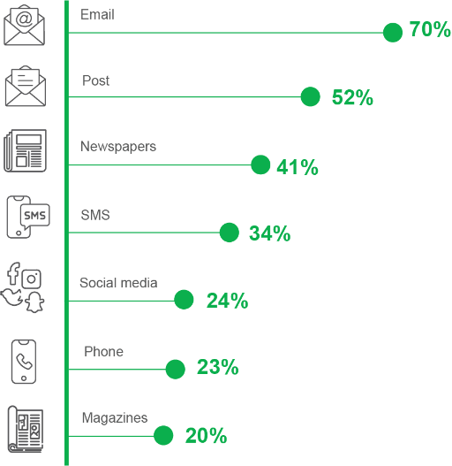

Q17. What are the most effective ways for the government to communicate biosecurity information to you?

Base sizes (n=): farms 630.

Full data provided in Figure 15 above lists the top seven channels of communication that farms rely on to get biosecurity information communication, including:

* 70 per cent rely on email
* 52 per cent rely on post
* 41 per cent rely on newspapers
* 34 per cent rely on SMS
* 24 per cent rely on social media
* 23 per cent rely on phone
* 20 per cent rely on magazines.

## Most important types of information

As shown in Figure 16, nine in ten farms (89 per cent) say that warnings and alerts are among the most important type of biosecurity information to receive. Eight in ten farms (81 per cent) say that how to identify pests and disease symptoms is among the most important type of information. This is followed by advice on how to identify and reduce risks (75 per cent). Information about changes to regulations is important for 72 per cent of farms. Further analysis shows that this information is more important for livestock farms, particularly sheep and beef farms (95 per cent).

Figure 16 The most important types of biosecurity information (farms)

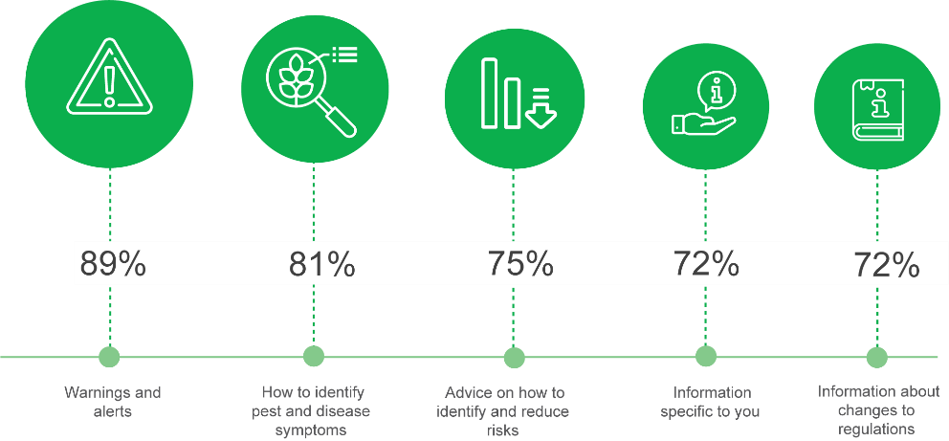

Q18. Which are the most important types of biosecurity information you need to receive?

Base sizes (n=): farms 667.

Data also included in Figure 16 above:

* 72 per cent of farms indicated that ‘information specific to you’ was important.

# Shared Responsibility and partnerships

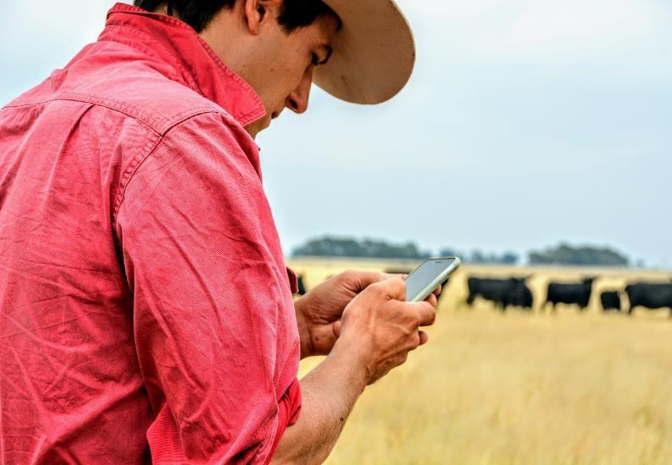

## Perceptions of the biosecurity system’s effectiveness

Respondents were asked how poorly or well Victoria’s biosecurity system is functioning. Figure 17 shows that less than half of farm (44 per cent) think the system is functioning well while 19 per cent think it is functioning poorly. Over half of related businesses (55 per cent) say the system is functioning well. In contrast, four in ten affiliated farmers (42 per cent) say the biosecurity system is functioning poorly. About a third of small holdings/ lifestyle farmers (39 per cent) and interest groups (31 per cent) also say that the system is functioning poorly.

Figure 17 How poorly or well is Victoria’s biosecurity system functioning?

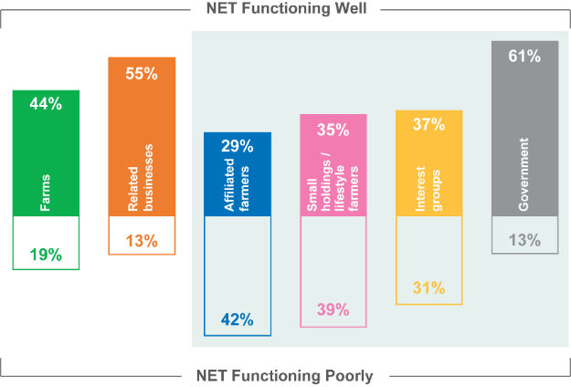

Q23 In your view, how poorly or well is Victoria's biosecurity system functioning?

Base sizes (n=): farms 752; related businesses 301; affiliated farmers/businesses 201; small holdings/lifestyle farmers 77; interest groups 66; government 43.

Full data provided in Figure 17 shows that:

* 44 per cent of farms said Victoria's biosecurity system is functioning well while 19 per cent said it is functioning poorly
* 55 per cent of related businesses said Victoria's biosecurity system is functioning well while 13 per cent said it is functioning poorly
* 29 per cent of affiliated farmers or businesses said Victoria's biosecurity system is functioning well while 42 per cent said it is functioning poorly
* 35 per cent of small holdings and lifestyle farmers said Victoria's biosecurity system is functioning well while 39 per cent said it is functioning poorly
* 37 per cent interest groups of said Victoria's biosecurity system is functioning well while 31 per cent said it is functioning poorly
* 61 per cent government of said Victoria's biosecurity system is functioning well while 13 per cent said it is functioning poorly.

## Ability to deliver role in biosecurity

Respondents were asked the extent to which they agreed or disagreed that various organisations were appropriately skilled in delivering their role in the biosecurity system. Table 4 below summarises the findings for this question. The groups are listed across the top of the table and the organisations are listed on the left side.

As shown in Table 4, most groups agree that industry bodies and farm advisors are appropriately skilled to deliver their role in the biosecurity system; the exception is small holdings/lifestyle farmers, from whom only a minority agree that industry bodies are appropriately skilled. Most groups also agree that Federal and State Governments are appropriately skilled. At the other end of the scale, a lower percentage of respondents in all groups agree that local communities, lifestyle farms, upstream and downstream industries, and Local Government are appropriately skilled in delivering their role in the biosecurity system.

The fact that, compared to respondents from other groups, small holdings/lifestyle farmers tend to be less likely to agree that industry bodies and Federal and State Governments are appropriately skilled could reflect the situation that small holdings/lifestyle farmers have less contact with such bodies. There might be a need for industry bodies as well as Federal and State Governments to engage more with small holdings/lifestyle farmers if they want to improve the level of confidence that small holdings/lifestyle farmers have in them.

As can also be seen in Table 4, groups of respondents, compared to other groups, tend to be more likely to agree that their own group is appropriately skilled to deliver their role in the biosecurity system. For example, 60 per cent of farms agree that farms are appropriately skilled, but all other groups have somewhat lower levels of agreement (ranging from 40 per cent to 55 per cent) that farms are appropriately skilled. As another example, while 29 per cent of small holdings/lifestyle farmers agreed that small holdings/lifestyle farms are appropriately skilled to deliver their role in the biosecurity system, only 10 per cent to 19 per cent of respondents from other groups agreed that small holdings/lifestyle farms are appropriately skilled. These differentials could reflect a natural self-serving bias, but they also could reflect that each group knows more about their own category and the relevant skills they have compared to what other groups know about them.

Table 4 Perceived ability of various groups to deliver their role in the biosecurity system

| **NET Agree** | **Farms** | **Related businesses** | **Affiliated farmers or businesses** | **Small holdings or lifestyle farmers** | **Interest groups** | **Govern-ment** |
| --- | --- | --- | --- | --- | --- | --- |
| n= | 700 | 280 | 201 | 72 | 65 | 43 |
| Industry bodies | **78%** | **72%** | **65%** | **43%** | **59%** | **80%** |
| Farm advisors | **76%** | **61%** | **55%** | **54%** | **66%** | **58%** |
| Federal Government | **66%** | **68%** | **57%** | **38%** | **61%** | **71%** |
| State Government | **63%** | **71%** | **56%** | **50%** | **61%** | **81%** |
| Farmers | **60%** | **52%** | **48%** | **48%** | **40%** | **55%** |
| Upstream suppliers and industries | **48%** | **42%** | **30%** | **23%** | **26%** | **39%** |
| Downstream companies  and industries | **39%** | **34%** | **31%** | **21%** | **18%** | **19%** |
| Local Government | **37%** | **36%** | **24%** | **38%** | **41%** | **37%** |
| Local communities | **24%** | **19%** | **20%** | **30%** | **26%** | **17%** |
| Small holding or lifestyle farms | **13%** | **12%** | **11%** | **29%** | **19%** | **10%** |

Q24 To what extent do you agree or disagree that the following groups are appropriately skilled in delivering their role in the biosecurity system …

Base sizes (n=): farms 700; related businesses 280; affiliated farmers/businesses 201; small holdings/lifestyle farmers 72; interest groups 65; government 43.

## Responsibility for biosecurity

When farms were asked to rate different entities in terms of their responsibility for biosecurity in Victoria, the Victorian Government was rated the highest (4.6 out of 5) in terms of being the most responsible for biosecurity. As well as State and Federal Governments, industry bodies and individual businesses are all rated as greater than four out of five in terms of responsibility for Victoria’s biosecurity.

Figure 18 Perceived responsibility for biosecurity in Victoria (farms)

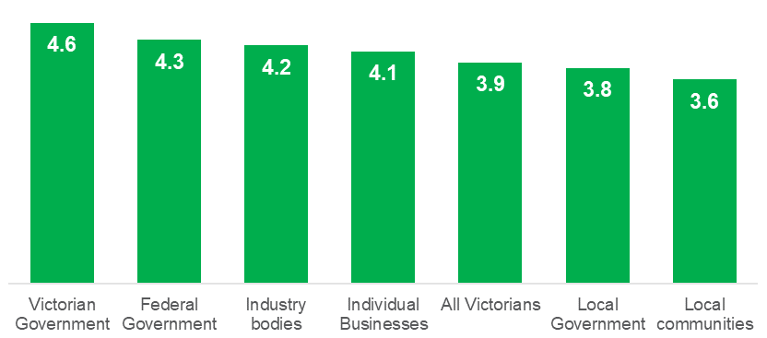

Q28. On a scale from 1 to 5, where 1 means ‘not at all’ and 5 means ‘to a great extent’, to what extent do the following groups have responsibility for Victoria’s biosecurity? Base sizes (n=): farms 752.

Full data provided in Figure 18 above indicates the following:

* the Victorian Government was rated 4.6 out of 5
* the Federal Government was rated 4.3 out of 5
* industry bodies were rated 4.2 out of 5
* individual businesses rated 4.1 out of 5
* all Victorians were rated 3.9 out of 5
* Local Government was rated 3.8 out of 5
* local communities were rated 3.6 out of 5.

## Working in partnership

Respondents were asked to what extent they felt that individual businesses, organisations and people involved in the biosecurity system are working together. As shown in Figure 19, all groups have a mean rating of three or less on a five-point scale. However, farms (3.0) and related businesses (3.0) have mean ratings that are higher than all the respondents in the interest group sample (affiliated farmers/businesses (2.4), small holdings/lifestyle farmers (2.4), interest groups (2.5) and governments (2.7).

Figure 19 To what extent do you feel that everyone [involved in the biosecurity system] is working together?

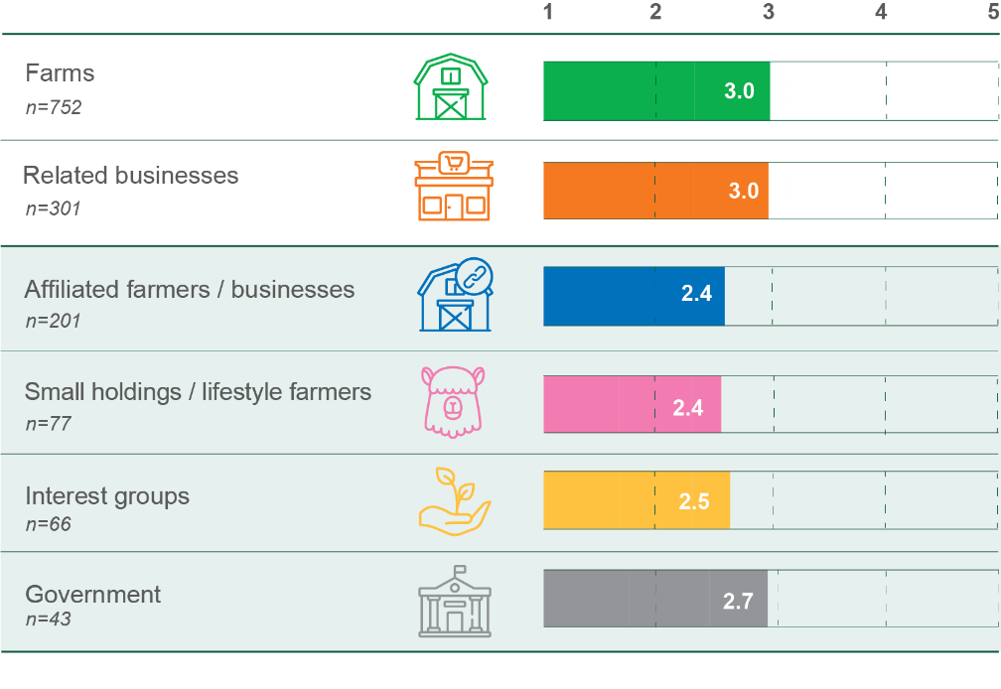

Q29a. Thinking now about all the individual businesses, organisations and people involved in the biosecurity system. Using the same scale as before, to what extent do you feel that everyone is working together?

Base sizes (n=): farms 752; related businesses 301; affiliated farmers/businesses 201; small holdings/lifestyle farmers 77; interest groups 66; government 43.

Respondents were then asked whether they were aware of any partnerships between government, individual businesses, industry or the community to encourage better biosecurity. Additional analysis shows that 84 per cent of government respondents say that they are aware of partnerships. However, as shown in Figure 20, only 41 per cent of farms and 35 per cent of related businesses say that they are aware of partnerships. A quarter of these farms (23 per cent) say that a partnership involving industry association/peak body comes to mind. Similarly, a quarter of related businesses (24 per cent) say that a partnership involving government comes to mind.

Figure 20 Awareness of any partnerships to encourage better biosecurity

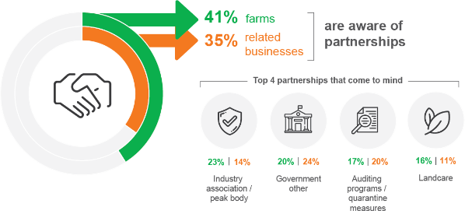

Q30. Are you aware of any partnerships between government, individual businesses, industry or the community to encourage better biosecurity? Base sizes (n=): farms 752; related businesses 301

Q31. Please tell me list the partnerships that immediately come to mind.

Base: those aware of partnerships @Q30. Base sizes (n=): farms 218; related businesses 80.

Further information describing Figure 20 shows that:

* 14 per cent of related businesses say that a partnership involving industry association or peak body comes to mind
* 20 per cent of farms say that a partnership involving government comes to mind
* 17 per cent of farms say that a partnership involving auditing programs or quarantine measures comes to mind
* 20 per cent of related businesses say that a partnership involving auditing programs or quarantine measures comes to mind
* 16 per cent of farms say that a partnership involving Landcare comes to mind
* 11 per cent of related businesses say that a partnership involving Landcare comes to mind

As shown in Figure 21, nearly three-quarters of farms (73 per cent) and related businesses (73 per cent) say that they feel the partnerships are performing well or very well. Only 6 per cent of farms feel the partnerships are performing poorly or very poorly. A lower percentage of affiliated farmers (67 per cent) feel that partnerships are performing well or very well, while 8 per cent feel the partnerships are performing poorly or very poorly.

Figure 21 Perceived performance of partnerships

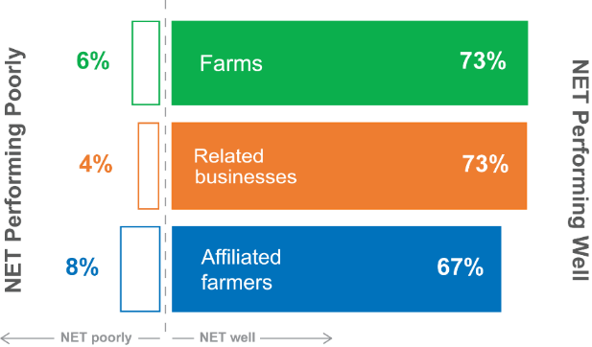

Q32. In your view, how poorly or well do you feel these partnerships are performing? Base: those aware of partnerships @Q30. Base sizes (n=): farms 218; related businesses 80; affiliated farmers/businesses 106.

# Our collective challenges

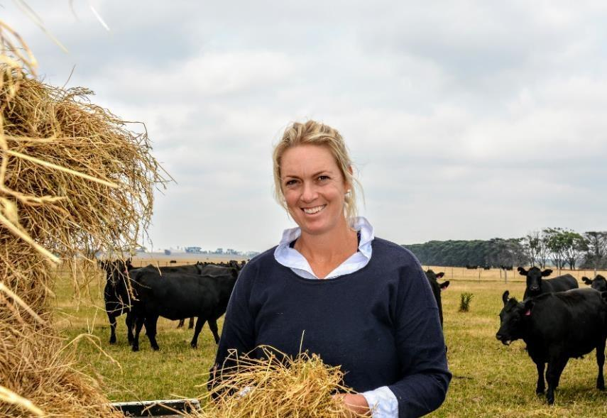

## Resourcing of the system

Respondents were asked how poorly or well-resourced Victoria’s biosecurity system is. Across all groups, less than three in ten respondents say that the system is well-resourced. Among farms and related businesses the percentages who say the system is well-resourced are 27 per cent and 29 per cent, respectively, while a slightly higher percentage among each group say that the system is poorly resourced (35 per cent and 34 per cent respectively). Respondents from the interest group samples are less likely to say the system is well-resourced and more likely to rate the resourcing of the system as ‘poor’.

Figure 22 Perception of how well resourced Victoria’s biosecurity system is

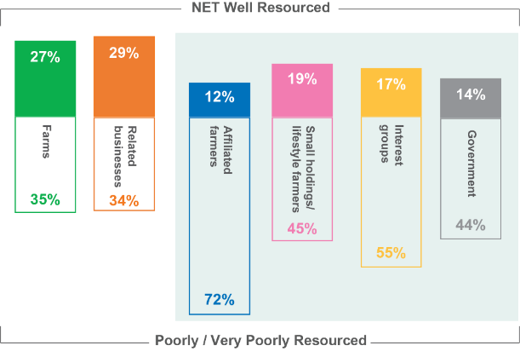

Q25. In your view, how poorly or well-resourced is Victoria’s biosecurity system?

Base sizes (n=): farms 752; related businesses 301; affiliated farmers/businesses 201; small holdings/lifestyle farmers 77; interest groups 66; government 43.

Full data provided in Figure 22 shows the different respondent groups views on how well or poorly resourced Victoria’s biosecurity system is, including:

* 27 per cent of farmers say it is well resourced and 35 per cent say it is poorly resourced
* 29 per cent of affiliated farmers or businesses say it is well resourced and 34 per cent say it is poorly resourced
* 12 per cent of small holdings and lifestyle farmers say it is well resourced and 72 per cent say it is poorly resourced
* 19 per cent of related businesses say it is well resourced and 45 per cent say it is poorly resourced
* 17 per cent of interest groups say it is well resourced and 55 per cent say it is poorly resourced
* 14 per cent of government say it is well resourced and 44 per cent say it is poorly resourced.

Among farms who hold the view that the Victorian biosecurity system is poorly resourced, the aspects of the system that are most frequently identified as in need of improvement are:

#### Better communication, information or education (21%)

“Communication with industry groups to ensure the system is functioning correctly. Demonstrate that they are across the issues”.

“Communication: government sponsored regular workshops should be held annually for farmers, councils, environmental groups and industry to bring awareness and better communication between the groups.”

“Communication directly with farmers not secondary personnel.”

#### More or better staffing (19%)

“Agriculture Victoria needs to have extension staff to support landholder and local communities.”

“Employ more field staff.”

“Frontline workers are either non-existent, under resourced or overburdened.”

“Experienced advisers that have firsthand knowledge of the subject, not fresh out of university.”

#### More monitoring, enforcement or penalties for breaches (13%)

“We have rules but no one to enforce them. Something as simple as footrot in sheep has layers of rules but no staff to actually check stock at saleyards let alone deal with the properties that have it.”

“More inspections and enforcement in relation to properties that are infested with existing and new species of weeds.”

#### More funding and resources generally (12%)

“A better funded Agriculture Department, less outsourcing of diagnostics. More funding for extension officer.”

“Biosecurity issues on government owned land is not adequately funded or addressed which makes it challenging to get private landholders to manage even declared pest plants and animals. New landowners/small hobby farm owners need investment/support with managing land and livestock including for biosecurity issues.”

Additional analysis shows that among affiliated farmers/related businesses, 21 per cent of respondents who hold the view that resourcing is poor identified weed/pest/animal/land management as a part of the system that needed to be improved. This is in contrast to 12 per cent of farms.

## Effort to improve the system

The majority of respondents across all groups say that more effort should go into Victoria’s biosecurity in the next five years, compared to now. Around four in five farms (79 per cent) and related businesses (80 per cent) say there should be ‘more’ or ‘much more’ effort compared to now, with even higher percentages among affiliated farmers/related businesses (97 per cent), small holding/lifestyle farmers (86 per cent), interest groups (92 per cent), and government (98 per cent) groups.

Figure 23 In the next five years, should more effort go into Victoria’s biosecurity compared to now?

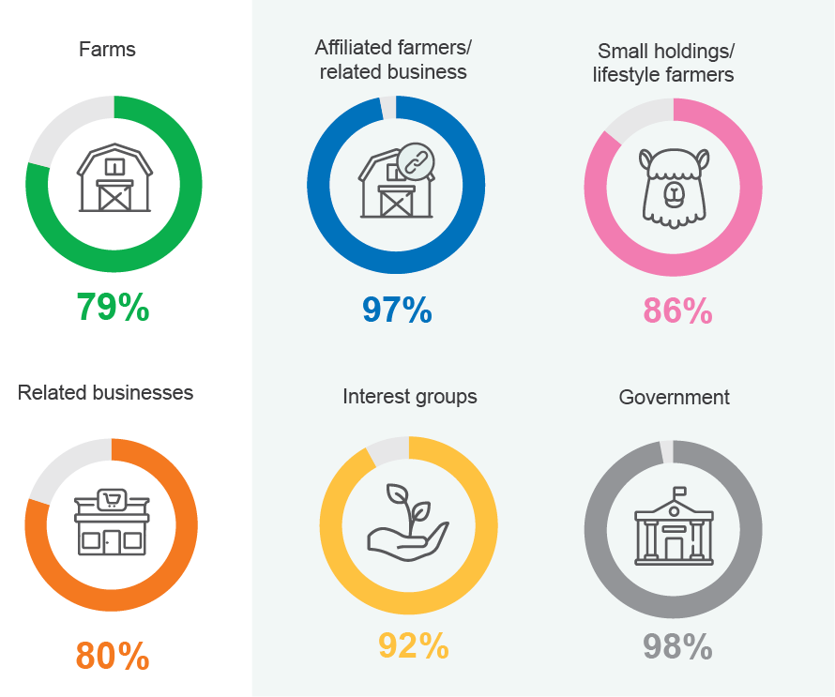

Q34. In the next five years, how much effort should go into Victoria’s biosecurity compared to now?

Percentage (%) displayed = ‘more’ + ‘much more’ effort. Base sizes (n=): farms 752; related businesses 301; affiliated farmers/businesses 201; small holdings/lifestyle farmers 77; interest groups 66; government 43.

Additional analysis shows that farms employing 20 or more staff (71 per cent) were less likely to say more effort should go into Victoria’s biosecurity.

While most respondents agree that more effort was required over the next five years, many suggested how the system could be improved now. These suggested improvements tend to centre on:

* greater enforcement at the Commonwealth level or better regulation at the State level (38 per cent of farms who felt that more effort was required)
* better, or more communication, information or consultation (35 per cent of farms who felt that more effort was required)
* more collaboration (16 per cent of farms who felt that more effort was required).

## A vision for the future

Respondents were asked what signs (apart from an absence of incidents or outbreaks) might tell us that Victoria’s biosecurity system is operating successfully in the next 10 years. The most common theme to emerge was greater education and deeper consultation between the system participants (37 per cent of farms), followed by fast or effective responses to threats (28 per cent of farms), and successful economic outcomes for the agricultural sector, including improved market access (20 per cent of farms). One in ten farms (9 per cent) mentioned that a healthy natural environment would be evidence of a successful Victorian biosecurity system.

#### Greater education and deeper consultation

“A well-educated and vigilant community.”

“Broader knowledge by farmers and community members, open discussion and understanding best practice.”

#### Fast and effective responses to threats

“Swift action on incidents.”

“There is a quick positive response to any biosecurity threat.”

#### Successful economic or export outcomes

“New export markets opening and more product friendly protocols to improve product in market and trade.”

“Victoria reputation of providing safe, quality produce is strong and is a marketing strength that benefits producers.”

#### A healthy natural environment

“More regular appearance of native species, flora and fauna and a lot less reliance on chemicals.”

“Healthy agricultural sector. Good environmental outcomes. Less degradation of natural habitat.”

1. Note: responses to this question consisted of open-ended text, and some respondents provided multiple main reasons.