Invasive Marine Pests
Module 2 under the Invasive Plants and Animals Policy Framework
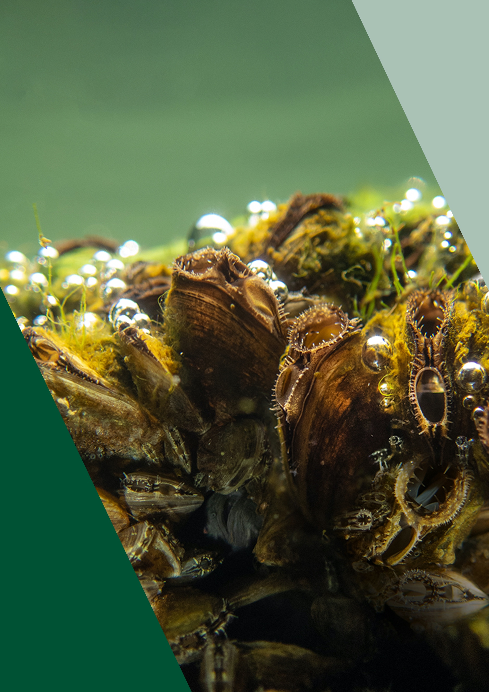

If you would like to receive this information/ publication in an accessible format (such as large print or audio) please call the Customer Service Centre on 136 186, TTY 1800 122 969, or email customer.service@ecodev.vic.gov.au.

Published by Agriculture Victoria, 2023.
© The State of Victoria 2023.
This publication is copyright. No part may be reproduced by any process except in accordance with the provisions of the Copyright Act 1968.
Authorised by Agriculture Victoria, 1 Spring Street, Melbourne 3000.
ISBN: 978-1-76090-434-0 (pdf/online/MS word)

Disclaimer
This publication may be of assistance to you but the State of Victoria and its employees do not guarantee that the publication is without flaw of any kind or is wholly appropriate for your particular purposes and therefore disclaims all liability for any error, loss or other consequence which may arise from you relying on any information in this publication.

Cover page: Black-striped mussel (Mytilopsis sallei). Image supplied by the then Department of Agriculture, Water and the Environment (DAWE).

Contents

Contents 2
Traditional Owners acknowledgement 3
1. Scope 4
2. Future priorities 5
3. Background and rationale 8
4. Victoria’s policy approaches 13
5. Strategies 32
6. Roles and responsibilities 37
7. Glossary 43
8. References 45
9. Appendices 46

Traditional Owners acknowledgement
We proudly acknowledge Victoria’s First Nations peoples and their ongoing strength in practising the world’s oldest living culture. We acknowledge the Traditional Owners of the lands and waters on which we live and work and pay our respect to their Elders past and present. Victoria’s Aboriginal communities continue to strengthen and grow with the ongoing practice of language, lore, and cultural knowledge.
We recognise the contribution of Aboriginal people and communities to Victorian life. Traditional owners managed Victoria’s land and water for tens of thousands of years. We acknowledge their history and their living cultural traditions.
1. Scope
This module is intended to guide and inform the development of regional and other place specific strategies and plans for the management of invasive marine pests.
The scope of this module of the Invasive Plants and Animals Policy Framework¹ (IPAPF) encompasses exotic invasive marine plants, marine algae, marine invertebrate animals and marine fish. It excludes non-fish marine vertebrate animals such as mammals (e.g. whales and seals) as these animals are protected in Australian waters under the Environment Protection and Biodiversity Conservation Act 1999. Reptiles (e.g. sea snakes), amphibians and birds are included in Weeds and Vertebrate Pests – Module 1 within the IPAPF and covered under the provisions of the Catchment and Land Protection Act 1994. This module also excludes diseases and pathogens of marine plants and animals, as separate legislative arrangements apply to these threats.
The management of marine species, that are native to other parts of Australia and are introduced into Victorian waters as a result of human mediated translocation, may be managed within the principles of this module. The management of naturally occurring range extensions of species into Victorian waters as a result of climate change, however, raises a complex policy question. It is unlikely that such instances would warrant a biosecurity response, they would therefore be more appropriately managed as a marine conservation issue.
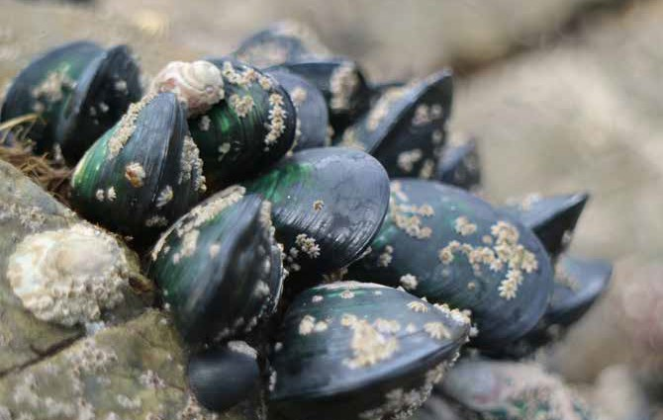
New Zealand green-lipped mussel (Perna canaliculus). Not known to be established in Victoria. Image supplied by DAWE.
2. Future priorities
This module of the IPAPF identifies opportunities to progress a strategic biosecurity approach for marine pests. The potential future priorities identified in this document are intended to guide action and investment by government. Actions will be prioritised over time, as resources are available and in consultation with stakeholders. Priorities currently being addressed are provided in italics.

PREPAREDNESS AND PREVENTION
- Review current roles and responsibilities related to marine pest preparedness, prevention, surveillance, monitoring and emergency response within Victoria to address any gaps and to reflect national cooperative arrangements. Establish formal agreements.
- Develop a marine pest biosecurity response plan that will include an emergency response framework for marine pest incursions.
- Using best practice methodology, progressively undertake risk assessments covering exotic marine pests to target preventive strategies and prioritise eradication and containment programs.
- Develop and undertake a surveillance program for exotic marine pests at high-risk and high priority sites as well as at targeted sites including at key ports and marinas.
- Integrate reporting and information management systems for the marine environment with those used in other areas of biosecurity to support incursion responses.

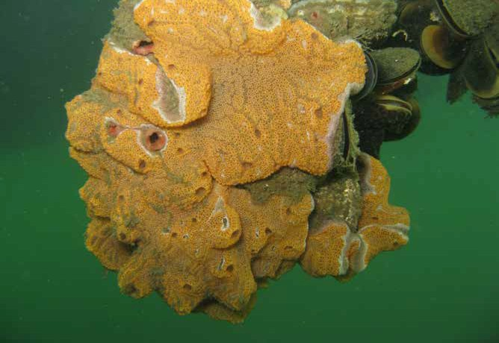
Compound ascidian (sea squirt). Some species are highly invasive and can dominate large areas of the seabed and subtidal zones with severe impact on the shellfish industry. Image supplied by DAWE

Compound ascidian (sea squirt). Some species are highly invasive and can dominate large areas of the seabed and subtidal zones with severe impact on the shellfish industry.

ERADICATION
- Conduct delimiting surveys of new exotic marine pest incursions to Victoria.
- Evaluate the case for eradication of incursions based on consideration of feasibility and environmental, social and economic benefits and costs. Develop and implement eradication plans as required.
- Review and regularly report on the progress of current eradication programs and develop alternative approaches if eradication is no longer justifiable.
- Engage with national processes for determining cost-sharing arrangements for eradication, in accordance with the National Environmental Biosecurity Response Agreement.

CONTAINMENT
- Conduct delimiting surveys of species already established in Port Philip or elsewhere within the state.
- Investigate the feasibility of containment programs to reduce the risks of transporting marine pests from infested areas to other Victorian locations and the establishment of new source populations
- Implement appropriate containment measures where practical and cost-effective.

ASSET-BASED PROTECTION
- Desktop exercise, database search and targeted surveys to better understand current marine pest distributions in Victoria to inform planning (including risk assessment) and management.
- Identify risks to and determine the susceptibility of marine environmental asset areas to marine pests and investigate options to reduce these risks.
- Identify opportunities to reduce the impacts of marine pests in areas where they have already established.
- Identify and map out high value conservation areas across the state where early detection and management are prioritised.

STAKEHOLDER ENGAGEMENT
- Develop and implement an engagement and communication strategy with enhanced messages about biosecurity measures that stakeholders can act on.
- Progress formal arrangements between government and stakeholders to enhance response capability and understanding of marine pests, as required for specific threats.
- Engage with stakeholders to encourage participation in passive surveillance, early detection and reporting for marine pests that are new to Victoria or spreading to new locations, based on surveillance planning.
- Develop and implement engagement strategies with Traditional Owners to enhance response capability, surveillance planning and biosecurity measures.

MONITORING, EVALUATION, REPORTING AND IMPROVEMENT
- Develop and implement a monitoring, evaluation, reporting and improvement (MERI) framework for marine pests, integrated with other areas of biosecurity.
- Address data gaps including collecting data on distributions of marine pest species and management activities undertaken in Victoria to inform subsequent management.

RESEARCH AND DEVELOPMENT
- Identify research priorities around:
- the pathways of invasion of marine pests
- the impacts on economic, social and environmental values
- new technology and techniques for their detection and management
- social attitudes
- effective engagement approaches for stakeholders

POLICY AND LEGISLATION
- Review Victorian legislative and administrative agencies in relation to marine biosecurity.
- Strengthen legislative frameworks to address gaps and provide a uniform approach to the management of marine biosecurity risks.
- Continue to work with other jurisdictions through sectoral committees to advance national cooperation in marine pest management.
- Investigate options for cost recovery from industry and other stakeholders for marine pest management.

BUILDING CAPABILITY AND CAPACITY
- Participate in national and international scenario exercises and training to further understand Victoria’s roles and responsibilities in national marine pest emergencies.
- Develop and implement Victorian-based scenario exercises and training to enhance Victoria’s capacity to manage incursions.

3. Background and rationale
Victoria’s marine environment encompasses approximately 10,500 square kilometres, including approximately 3,500 square kilometres of bay, inlet and estuarine environments.
Habitat types in Victoria include intertidal rocky shores, subtidal rocky reefs, seagrass beds, mangroves and saltmarsh, open water and pelagic environments and soft substrates such as sandy seabeds, sand flats and mudflats.
Each of these different habitats support distinct communities, some of which are highly significant at a state, national or even international level.
Victorian coastal saltmarsh along with mangroves and seagrass also (collectively known as blue carbon ecosystems) play a key role in carbon sequestration. Burial rates of organic carbon in blue carbon ecosystems are exceptionally high and can be 30-50 times higher than rates in the soils of terrestrial forests. This is in part because blue carbon ecosystems can trap particles and suspend sediments out of the water column. Undisturbed, these sediments accrete over time. This allows blue carbon ecosystems to continually capture carbon.¹⁶
A significant proportion of our marine species, particularly macroalgal flora, are not found anywhere else.² The unique nature of Victoria’s marine ecosystems and the high degree of endemism provides significant potential for invader impacts when introductions occur. The introduction of exotic organisms into Victorian marine waters has been listed as a Potentially Threatening Process under Victoria’s Flora and Fauna Guarantee Act 1988 (FFG Act) in formal recognition of the threat that marine pests pose to marine biodiversity and the integrity of Victoria’s marine ecosystems.³
Victoria’s marine environments also provide significant economic and social benefits to the state. Over the five years to 2018, commercial fishery production in Victoria has ranged between 3,800 and 5,000 tonnes per year. The annual economic value of the commercial sector is estimated to have been $60 million, on average, over the five years to 2018.⁴
Recreational fishing activities in Victoria are highly valued from a social and economic point of view. In 2018/19, 1,113,506 Victorian residents (juniors and adults) participated in recreational fishing across Victoria.⁵ Recreational fishing in Victoria in 2018/19, generated a combined direct and indirect economic output of $3.49 billion.⁵ More broadly, healthy marine environments can generate millions of dollars per year from tourism and recreation.
While there is a small number of locations in Victoria outside of Port Phillip which have emerging or established populations of marine pests, most of the state’s waters are currently pest free. A major challenge will be limiting the spread of marine pests from key ports or locations where they are established, particularly Port Phillip, to secondary ports and other parts of the coast by understanding and addressing invasion pathways.
Victoria’s marine environments also have immense cultural, social, and spiritual meaning of Sea Country to Indigenous Victorians, as demonstrated in historical and contemporary accounts of Indigenous dreaming stories.
Victoria’s marine environments have immense cultural, social, and spiritual meaning of Sea Country to Traditional Owners, as demonstrated in historical and contemporary accounts of Dreaming stories. Traditional Owners continue to utilise and harvest the resources of their Country. They maintain regular camping sites along the coast in which they pass knowledge of the coastal and marine environment between generations. This interaction with the coast has always been a crucial source of physical and spiritual sustenance and vital to Traditional Owners’ identity as coastal people. The coast contains many sacred and valuable sites for Traditional Owners, many of which are described on the Victorian Aboriginal Heritage Register.
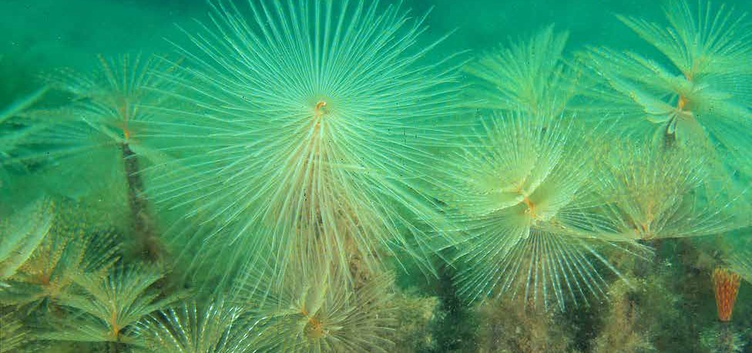
European fan worms (Sabella spallanzanii). Established in parts of Victoria.
Image supplied by CSIRO Marine and Atmospheric Research.

Spread of marine pests
Port Phillip is a hotspot for the introduction of marine animals and plants due to its long history of international shipping providing a means for pests to arrive. Most marine pests found in Victoria are believed to be initially introduced via one of two methods.
- Ships’ ballast has been implicated in the spread of many marine pests worldwide and is the subject of an international convention intended to minimise further introductions.
- The other most common human-associated vector of marine pests is biofouling.

Other vectors of marine pest introduction and dispersal of established species include:
- natural dispersal via currents
- in bilge water or wells of vessels
- in sediment or sludge transported in dredge equipment
- in connection with commercial and recreational fishing (on floats, as live fish consignments or fishing bait)
- transport or escape of exotic species associated with aquaculture industries
- unintended or deliberate release of aquarium specimens
- dispersal over large distances via marine debris i.e. flotsam and jetsam
- deliberate introductions for a specific purpose (e.g. aquaculture).

Movement of domestic commercial and recreational vessels within Victoria can also spread and respread marine pests to new areas. Once introduced, eradicating marine pests can be challenging and once established, it is extremely difficult to control and to prevent the further spread of a species.

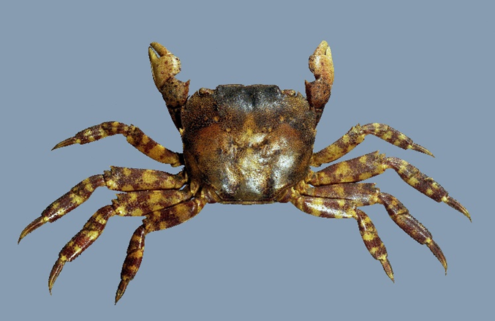
Asian shore crab (Hemigrapsus sanguineus). Recently found as a new pest in Port Phillip Bay. Image supplied by Agriculture Victoria.

Impacts of marine pests
The impacts of many of the marine pests known to be present in Victoria are poorly understood and local impacts are yet to be quantified.^{6,7}
Once introduced, marine pests reproduce quickly, often producing large numbers of offspring that can rapidly spread to new areas. They compete with native species by preying upon them, and outcompete them for space, light, food, or by overgrowing them. They can also introduce diseases and parasites to our native species.
Direct economic impacts of marine pests may include predation on and competition with commercial shellfish species while indirect impacts may occur because of costs associated with marine pests mitigation work. The outbreak of black striped mussel in Darwin in 1998 provides a good example of the level of investment required to eradicate a marine pest. The total cost of the successful eradication program was $2.2 million.⁸
Other economic impacts include management costs for fishing and aquaculture businesses affected by marine pests. In shellfish aquaculture the key impact is the direct fouling of stock causing physical damage, mechanical interference, biological competition and environmental modification, while infrastructure is also impacted. In contrast, the key impact in finfish aquaculture is the fouling of infrastructure, which restricts water exchange, increases disease risk and causes deformation of cages and structures.⁹
Biofouling can increase the costs of passage for shipowners as it increases drag on vessel hulls and thus increases fuel costs. The shipping industry and ports also experience additional costs associated with pest management and prevention of spread, including costs associated with biofouling removal and prevention and costs of ballast water management.
The effects of marine pests on social values and human health of marine pests are less immediately obvious, but potentially very serious. For example, blooms of an introduced dinoflagellate that produces a toxin causing paralytic shellfish poisoning, are now annual events in southern Tasmanian waters, particularly in autumn and spring.¹⁰ Other social impacts include interference with recreational activities, such as diving and recreational boating, via restrictions on vessel movements and use of sites infested with invasive species; and decreased aesthetic value where infestations or their effects are severe.

Emerging challenges
Globalisation, the expansion of overseas travel and international shipping trade have increased Victoria’s exposure to biosecurity risks and increased the rate of new incursions. Given that the primary vectors of marine pests are functions of shipping itself, the increased volume of movement of people and goods around the world and the diversity of countries involved has led to an increase in the risk of accidental introductions particularly in the absence of local predators.
Victoria may be at a heightened risk of accidental introduction of marine pests through the Port of Melbourne; Australasia’s largest port for containerised, automotive and general cargo. Other vessel types are increasingly visiting locations both within and outside of Port Phillip, adding to potential vectors for pest spread to these locations. Many of these utilise smaller local ports or known sheltered locations such as Refuge Cove in Wilsons Promontory National Park increasing the potential for pests to be introduced to these areas.
Opportunities for illegal trade and deliberate introduction of marine pests through the aquarium trade are also increasing through improved access to travel and technological advances (e.g. trade via the internet).
Climate change has the potential to affect the distribution, breeding, growth, abundance and population structure of marine pests as well as significantly impacting the resilience and viability of existing marine ecosystems. Victoria’s marine environment, particularly East Gippsland as a national climate change hotspot, is likely to become more suitable for some marine pest species – increasing the potential of their establishment or spread – and less suitable for others.
As the population of Victoria increases, the demand on marine environments will continue to grow as the number of visits to the coast and the demand for coastal infrastructure and facilities will grow. In June 2019, there were 195,682 registered recreational vessels in Victoria, an increase of 5.7 per cent since 2017-18.¹¹ Increased vessel movement within Victorian waters and the high mobility of trailered recreational vessels across the state may aid and facilitate the introduction of new marine pests or spread of existing species.

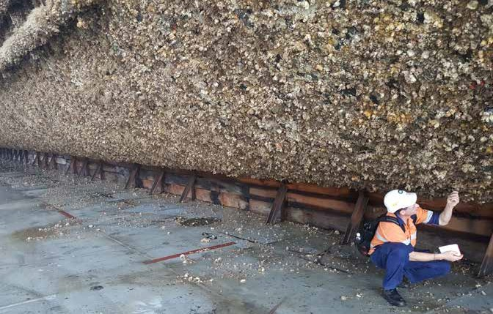
Heavy biofouling on a commercial ship. Image supplied by DAWE.

4. Victoria’s policy approaches
Victoria’s biosecurity goals can broadly be prioritised as:
- Prevention: using early-detection tools to prevent high-risk species from being introduced to Victoria
- Eradication: maintaining a high level of preparedness and vigilance to maximise the opportunity for eradication of any new incursions
- Containment: restricting, as far as possible, the further spread of high-risk species that cannot be eradicated
- Asset-based protections: taking an ongoing protective approach that excludes or reduces numbers of marine pests where they are affecting specific highly-valued assets.

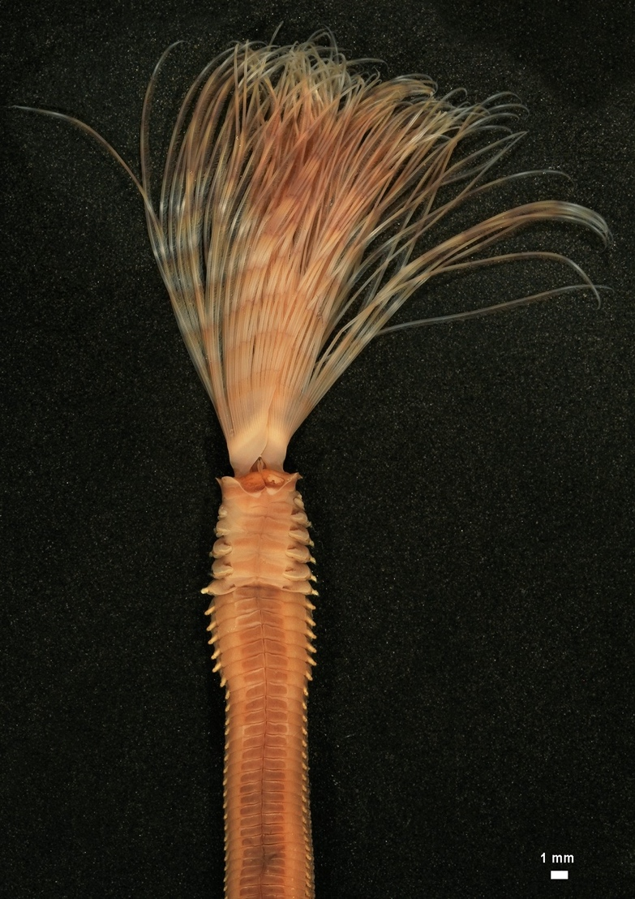
Detail of European fan worm (Sabella spallanzanii). Established in parts of Victoria. Image supplied by DAWE.

Prevention and preparedness
Preventing the introduction and establishment of exotic marine species is the most cost- effective approach to managing the threats posed by marine pests. Once established, marine pests are difficult to control and cannot be eradicated and significant resources can be consumed in managing their impacts on assets or preventing their further spread. Strategic containment programs may reduce the spread of the established species to new areas. Within an affected area, an asset-based protection approach can be used to help to protect and restore highly valued assets.
Preparedness encompasses all the activities and resources necessary to ensure that new incursions can be managed successfully.
Preparedness includes tasks such as coordinating activities between Victorian agencies and other jurisdictions, developing response plans, and ensuring that appropriate reporting and information management systems are in place. Sharing of marine pest information and training of agency staff, local port and marina managers and community volunteers in pest identification, survey techniques, and where feasible control options, all contribute to greater preparedness to respond to new incursions.
Marine industries also play a significant role in preventing marine pests from entering and spreading in Victorian waters. It is important that industry groups are involved in the development of prevention plans and preparedness strategies from the early stages.

REGULATION
Victoria uses a risk-management approach to reduce invasive species threats. This biosecurity system is achieved by a combination of legislation, economic incentives, quality assurance, and stakeholder engagement and education. A mix of these tools is appropriate because they vary in their effectiveness in achieving any particular goal.

MONITORING AND SURVEILLANCE
Early awareness provides the greatest opportunity to assess the risk of spread from existing populations and for mounting an effective response to prevent establishment of pests in new areas. In the case of new incursions, early awareness is vital in preventing the establishment of new marine pests in Victoria.
A systematic, widespread monitoring program across commercial and local ports and marinas within Victoria is the most effective way of ensuring early detection of new exotic marine species.
In 2021, a collaborative marine surveillance program was established in the Port of Melbourne to target surveillance effort and provide an early warning of marine pest incursions into Victoria’s unique marine environment. This project is the first of its kind to be implemented in Victoria and incorporates a combination of surveillance tools to target marine pest life cycle stages from larvae to settled juveniles and adults. The highly successful program within the Port of Melbourne has now been replicated across all of Victoria’s commercial ports.
In the same year, the then Department of Jobs, Precincts and Regions undertook a comprehensive survey within 15 of Victoria’s local ports to determine the distribution of marine pests already considered established in parts of the state. Using a range of surveillance tools including divers, remote operated vehicles, crab traps, beach walks and sediment grabs, the study has provided important baseline data that will assist in reducing the spread of these species to other parts of the state.
Parks Victoria monitors marine protected areas for many biodiversity-related values and threats, including marine pests. In addition, Parks Victoria encourages community participation in marine pest monitoring and supports a number of community monitoring programs, including Sea Search programs. These programs provide valuable intelligence on the presence of marine pests and identify areas where more comprehensive scientific monitoring is needed.
Due to the high cost of comprehensive marine surveys, voluntary reporting of marine pests is especially valuable. Targeted education programs focusing on high-risk species and aimed at particular groups (e.g. marine contractors, tour operators and certain community groups) will maximise the possibilities for passive surveillance.
A dedicated reporting line was established for people to submit images and other details of suspected marine pests that they may encounter in the marine environment. This has proved invaluable, as it has increased the capacity for everyday Victorians to help with passive surveillance (www.vic.gov.au/marine-pests).
Further engaging key stakeholder groups such as boat clubs, divers, and marine recreational user groups, in pest issues through agency participation in significant events such as the Melbourne Boat Show, developing and distribution of useful information including identification guides, and cross agency promotion of reporting phone and email contacts are all proving useful approaches to improving passive surveillance capacity.

BALLAST WATER MANAGEMENT
The Australian Ballast Water Management Requirements¹² set out the obligations on vessel operators with regards to the management of ballast water and ballast tank sediment when operating within Australian seas.
While some vessels may be eligible for exemptions from some or all of Australia’s requirements, in general, vessels have the following obligations:
- manage ballast water prior to arrival in Australian seas, and between Australian ports
- carry a ballast water management plan, ballast water management certificate, and maintain ballast water records.

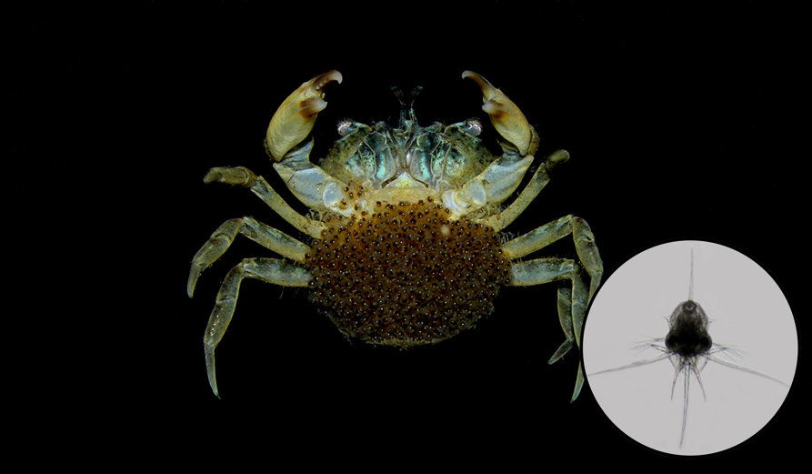
Harris’ mud crab (Rithropanopeus harrisii) with eggs and larvae (inset). Not known to be established in Victoria. Image supplied by DAWE.

Case Study 1
PREVENTION: Marine pests in ballast water
Ballast water is water taken on board by vessels to maintain stability and trim. Ballast water can contain thousands of aquatic microbes, plants and animals, which can be spread across the globe as the vessel releases ballast water.
Unmanaged ballast water released in foreign ports could potentially introduce a range of invasive marine species. Invasions have already taken place around the world, in some instances with significant consequences for the local ecosystem.
Vessel operators are able to use a specific risk-assessment tool to determine whether ballast water taken up at a particular Australian port, on a certain date, and discharged at a particular Australian port, will be considered Low or High Risk based on the Australian Ballast Water Risk Assessment. The risk assessment tool is available at: https://online. agriculture.gov.au/MARSWeb/faces/public/DomesticBallastWaterRiskAssessment.jsf
Any ballast water deemed to be High Risk must be managed prior to discharge at the intended port. The approved methods of ballast water management are:
- use of an International Maritime Organization (IMO) approved Ballast Water Management System
- ballast water exchange conducted in an acceptable area
- use of low risk ballast water (such as fresh potable water, high seas water or fresh water from an on-board fresh water production facility)
- retention of high-risk ballast water on board the vessel
- discharge to an approved ballast water reception facility.

BIOFOULING MANAGEMENT
Biofouling is a significant vector of marine pests. Some estimates suggest that more than half of marine pest introductions worldwide could be attributed to biofouling⁶. Biofouling is most commonly associated with vessels, both commercial and recreational vessels of all sizes, however a range of other marine structures are also potential vectors of fouling organisms. Mobile port and harbour infrastructure (such as floating pontoons and dredge equipment), mobile petroleum infrastructure and scientific and research infrastructure (such as artificial reefs and monitoring equipment) are frequently heavily fouled. The movement of this infrastructure between sites is a potential transporter of marine pests.
In Victoria, regulatory ability to control the movement of species via biofouling is currently limited to listed noxious species or vessels within ports and is generally applied on a case-by- case basis. Within Victoria’s parks and reserves, operating permits required by contractors, researchers and licensed tour operators, all contain conditions aimed at reducing the risk of marine pest introduction and spread. These include ensuring vessels and equipment are clean before entering the park and any pests encountered are reported.
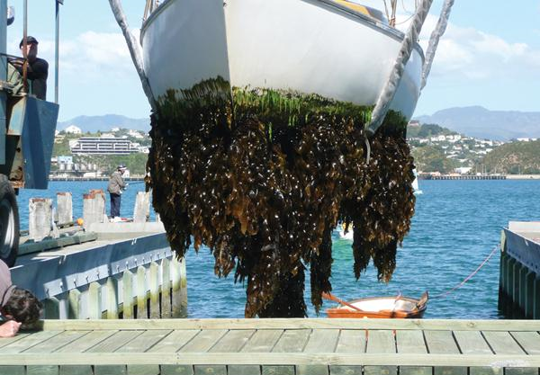
Biofouling on a recreational vessel. Image supplied by New Zealand Ministry of Primary Industries.

Case Study 2
PREVENTION: Reducing the risk of marine pest
spread to pest-free locations
The ex-HMAS Canberra was brought to Victoria to create an artificial reef and a recreational diving site outside Port Phillip Heads in 2009. It arrived from interstate free of pests then spent over a year at the Port of Geelong being prepared for scuttling. Near the end of its preparations in the Port of Geelong, Parks Victoria inspected the hull and found a prolific range of marine organisms including state and nationally listed marine pest species, such as the European fan worm (listed as a noxious aquatic species in Victoria) and the solitary ascidian. Those pests were not known within the scuttling site outside Port Phillip.
To protect the Port Phillip Heads Marine National Park and Barwon Bluff Marine Sanctuary (near the scuttling site), Parks Victoria organised for the hull to be completely cleaned and scraped. This was undertaken in-water, as the biofouling present could be confidently assumed to have originated in the Port of Geelong. Follow-up monitoring has been undertaken at regular intervals and failed to detect marine pests.
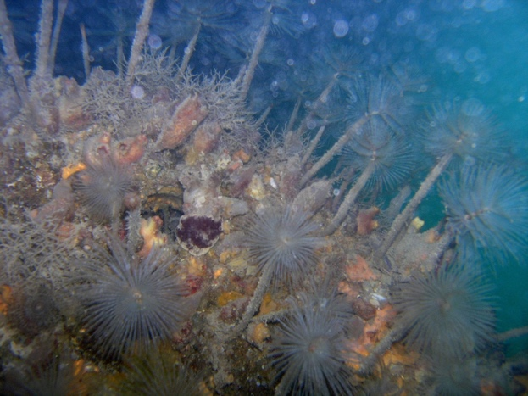
HMAS Canberra prior to cleaning. Image supplied by Parks Victoria.

Case Study 3
PREVENTION: Check, Clean, Dry
Recreational boat owners have a vital role to play in preventing the spread of organisms via biofouling, particularly when these vessels are readily moved between Victorian waters.
Through adaptation of a highly successful biosecurity campaign developed in New Zealand to manage the spread of aquatic pests, vessels owners are encouraged to adopt the principles of “Check! Clean! Dry!” as part of their regular boat maintenance.
The “Check! Clean! Dry!” campaign encourages all marine users to recognise the issue of marine pests and the potential impacts on a range of marine values including their own use of these areas such as fishing or diving. It seeks to have vessel operators adopt behaviours that reduce the likelihood of pests surviving and spreading including taking active steps to visually check for the presence of pests or fouling material and remove it, cleaning with freshwater, and thoroughly drying all equipment before moving to new locations.
Parks Victoria has developed several resources to promote these messages including brochures, ID guides, banners for events, and a series of videos (https://youtu.be/apb1gNel1ww) in which trusted messengers for the sailing, fishing, and diving communities encourage stakeholder engagement in reducing pest spread in Victoria.

PREPAREDNESS AND PREVENTION IN AQUACULTURE
The aquaculture industry is also adversely affected by marine pests brought into Victoria by any of the means described above. Marine pests can spread during the collection of brood stock, translocation of farmed species or aquaculture equipment between sites, or trade in live specimens.
The Victorian Fisheries Authority (VFA) has produced translocation guidelines and protocols for several aquaculture species (including abalone and blue mussels) along with other policy documents and regulation and licensing systems to help prevent the spread of marine pests in the aquaculture industry.¹³ The guidelines provide a risk assessment and administrative framework for the assessment of translocation proposals associated with closed, semi-closed or open system stocking proposals. In addition to the processes in place to manage the risks of pest and disease spread via aquaculture, the VFA also manages similar risk associated with the stocking of commercial and public waters.

Eradication
Eradication in marine waters is generally only possible in limited circumstances that allow treatment of an effectively isolated population in a relatively contained area. A decision to eradicate will depend on many factors including the extent of distribution of the invasive species when detected, the damage it might do in the long term, the likelihood of successful eradication and analysis of cost - benefit comparing the costs required to eradicate with the benefits of preventing establishment and further spread on environmental, economic, or social values.
The same principles can be applied to instances where a species that is already established in parts of Victoria such as Port Phillip where many pests occur but undergoes a significant range extension. Incursions of marine pests often reflect the movement of vessels within regional or global transportation networks. Once a species becomes established in a new location, it acts as a source population for subsequent spread to other parts of the coast. These ‘stepping stone’ invasions have been observed for several non-indigenous species in aquatic ecosystems.
Case Study 4
DETECTION: Asian Shore Crab
Early detection of marine pests is critical to ensure their successful management. Asian shore crab (Hemigrapsus sanguineus) is native to the waters of the north Pacific Ocean and is listed on the National Priority List of Exotic Environmental Pests, Weeds and Diseases. The main pathways for introduction and spread of the species is ballast water, biofouling, and marine debris. The species is a generalist predator, preferring bivalves and can reach very high densities in invaded habitats.
In late October 2020, a member of the public using the citizen science reporting app, iNaturalist reported a suspected Asian shore crab from Mount Martha. Taxonomic identification of suspected marine pests is a critical first step in responding to incursions and experts at Museums Victoria and the Australian Museum were engaged to confirm the identity of the species.
Museum staff confirmed the species as the Asian shore crab through investigation of its key morphological features. Having confirmed the identification, surveillance and removal activities were initiated involving community groups operating across Port Phillip. Unfortunately, the Asian shore crab was found to be established across numerous sites in the northern and eastern shores of Port Phillip. Follow up reports of the Asian shore crab indicate the species was present in Victoria prior to April 2018 but had remained unknown to authorities. Several preserved specimens were subsequently lodged in the collections at Museums Victoria and are available for future morphological and molecular study.

EMERGENCY MANAGEMENT ARRANGEMENTs
The State Emergency Management Plan authorised through the Emergency Management Act 2013. It contains provisions providing for the mitigation of, response to and recovery from emergencies, and specifies the roles and responsibilities of Victorian agencies in relation to emergency management in Victoria.
The Victorian Marine Pest Response Plan sets out the administrative and operational arrangements for marine pest incursion responses and guides the way future marine pest emergency responses are conducted.
The National Environmental Biosecurity Response Agreement (NEBRA) establishes national arrangements, including cost sharing, for responses to nationally significant biosecurity incidents where there are predominantly public benefits. The broad aim of the NEBRA is to reduce the impacts of pests and diseases on Australia’s environment and social amenity.
In the event of a nationally cost-shared response undertaken under the NEBRA, the affected jurisdiction remains responsible for implementing the response. However, through the Consultative Committee on Introduced Marine Pest Emergencies, other jurisdictions may offer advice and support (both monetary, as determined by the NEBRA provisions, and in-kind if available). Having clearly defined arrangements within Victoria will facilitate both giving and receiving this kind of support during marine invasive species emergencies in Victoria or Australia.
Where a response may not meet the criteria for national significance under the NEBRA, the direction outlined in the Victorian Marine Pest Response Plan will guide the response.

Case Study 5
ERADICATION: Black-striped false mussel
The black-striped false mussel is a close relative of the zebra mussel, a species that is known to have caused serious ecological and economic damage in the Great Lakes region of North America. When a small number of juvenile black-striped mussels were discovered in Darwin Harbour in 1999, the Northern Territory and Australian governments mounted a major eradication effort in order to avoid a similar disaster. Control efforts commenced within days of the first report, with chlorine and copper sulphate being added to areas of the harbour over a three-week period. Success was achieved at a cost of $2.2 million and the involvement of 300 people.
If the mussel had become established, it may have affected the pearling industry in the region, which was estimated at that time to have had a value of $225 million a year. The economic consequences of doing nothing could therefore have been devastating.⁸
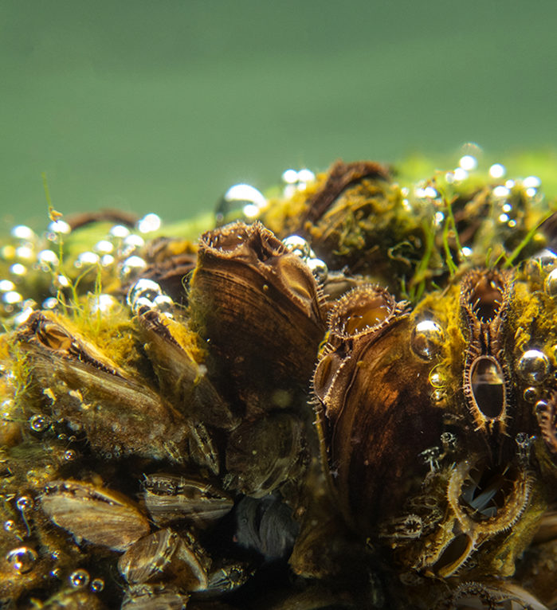
Black-striped false mussel (Mytilopsis sallei). Not known to be established in Victoria. Image supplied by DAWE.

Containment
Where eradication cannot be justified, a strategy of containment may be applied to prevent further spread of marine pests throughout Victoria. Containment programs are generally developed on a case-by-case basis. Given the large number of potential target species for containment, it is vital that a rigorous risk assessment and feasibility and cost–benefit analyses are applied to each species being considered by the Victorian Government for substantial investment to support state-wide containment. Containment will not be an automatic choice for all non-eradicable marine pest species with potential for further spread.
Where containment is deemed appropriate, industry, the marine and boating community and government must work together to achieve containment goals. Port Phillip poses a significant risk to other areas of Victoria. Port Phillip contains many marine pest species that are not present elsewhere in the state, it is also major hub for commercial and recreational vessels that travel to other parts of the state. A more strategic approach to containment could attempt to address Port Phillip status as a major source of marine pests within Victoria.
Case Study 6
CONTAINMENT: Northern Pacific seastar
The northern Pacific seastar is one of Australia’s most serious marine pests and is well established in Port Phillip. It is a strong space competitor and predator with potentially serious implications for the natural environment and aquaculture.
Each detection of the species outside of Port Phillip has triggered a strong response from government and the community as, not only would the species cause local damage, the establishment of satellite populations would potentially be a stepping stone for the spread of the species along the Victorian coastline and into neighbouring jurisdictions.¹⁴ The approach to these incursions has often been to attempt a local eradication as part of a Victorian containment strategy.
The operational response to a 2012 incursion at Wilsons Promontory National Park was led by Parks Victoria and was undertaken in line with Victoria’s emergency management framework and principles. Regular hand collections by divers and snorkelers were intended to keep the population size down while longer-term management strategies were considered.
Fortunately, a freshwater flush of Tidal River following a heavy rain event was believed to have resulted in total mortality of the population. Unfortunately, the species was rediscovered in Tidal River in late 2017 and was identified for the first time in Waratah Bay to the north west of Wilsons Promontory in early 2018.
It does, however, remain a priority to stop this species from spreading to new areas along Victoria’s coastline. Local campaigns to engage regional communities in preventing further spread by adopting good vessel hygiene and improving surveillance by encouraging users to identify and report any further sightings have been initiated by government.
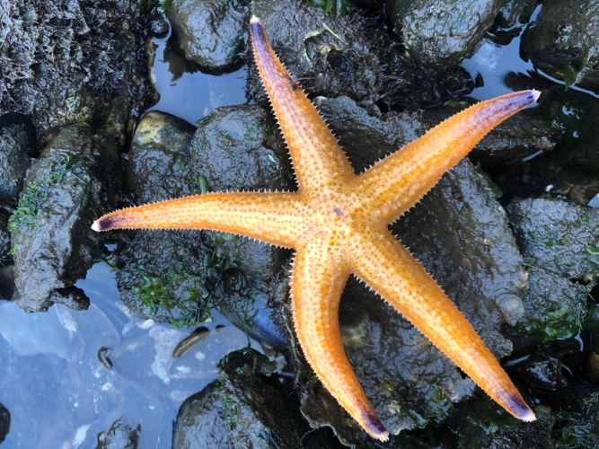
North Pacific seastar (Asterias amurensis). Established in parts of Victoria. Image supplied by DAWE.

Case Study 7
FAILED CONTAINMENT: Undaria
In July 1996, the northern Asian seaweed, Undaria, was identified in western Port Phillip covering an area of one to two square kilometres. In some locations Undaria had become the dominant species, with plants of various sizes occurring at densities up to 150 per square metre. Undaria can compete with native kelp species for space and quickly colonises areas that are subjected to some disturbance either natural or human induced. Undaria also has a microscopic spore stage in its lifecycle making eradication very difficult.
In August 1997, quarantine of the area was authorised by the Minister for Agriculture and Resources under the Fisheries Act 1995 to prevent spread of Undaria on the hulls or gear of recreational and commercial fishing vessels. An identification brochure was released, and a trial hand-pulling of the kelp was undertaken by divers to determine if containment was possible.
Although the quarantine was supported by users of the area – including abalone divers and recreational fishing groups – the species is now very widespread in Port Phillip and is commonly found growing in harbours and marinas around the bay, including on moored vessels that may easily help spread the pest to new locations.
Established populations of Undaria have now been detected in Apollo Bay harbour in western Victoria (2009) and in Port Welshpool in south Gippsland (2018).
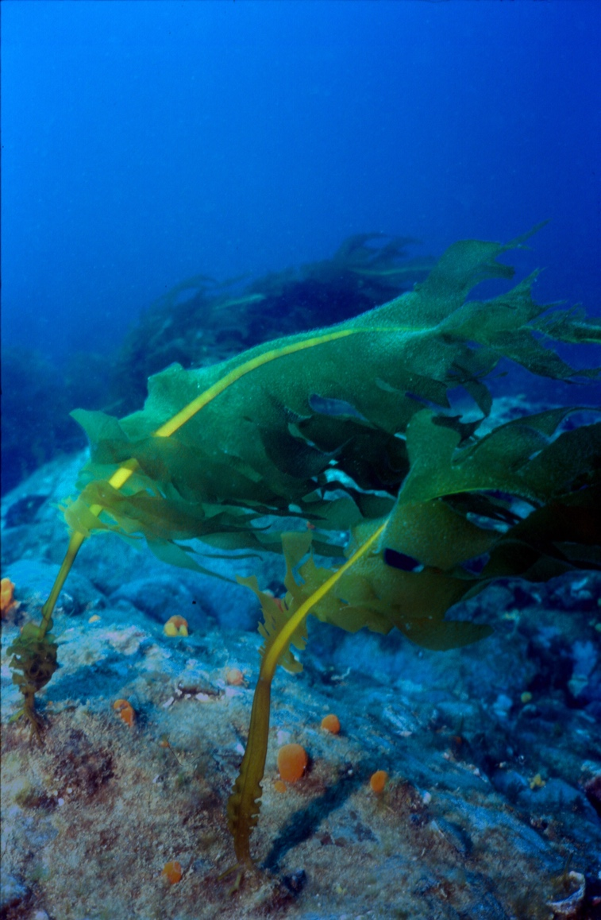
Japanese kelp (Undaria pinnatifida). Established in parts of Victoria. Image supplied by DAWE.

Case Study 8
CONTAINMENT: Reducing marine pest spread in the mussel industry
Victoria’s two largest bays, Port Phillip and Western Port, are only 60 kilometres apart but they differ widely in terms of the numbers of marine pests present. While Port Phillip is known to have at least 99 established pest species, surveys within Western Port have recorded only 18 invasive species, 12 of which were considered to have established self-sustaining populations.
The Victorian mussel aquaculture industry, based on the endemic blue mussel, has been operational in Port Phillip since the early 1980s and in Western Port since 1993. Juvenile mussels are established on ropes in Port Phillip or are sourced from hatcheries and translocated to Western Port each year to be matured at the Flinders Aquaculture Fisheries Reserve.
Protocols have been established to manage the risk of transporting marine pests on the hard surfaces (ropes and mussels) or in sediment associated with aquaculture activity. These protocols require the ropes and seed mussels to be immersed in fresh water for two hours followed by 12 hours of exposure to air.¹³ The protocols also cover the translocation of mussel stock into and within Victoria.
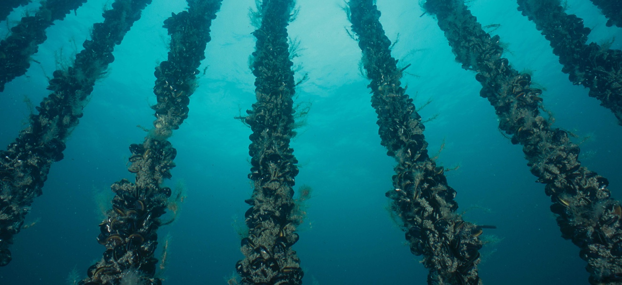
Blue mussel aquaculture. Image supplied by Victorian Fisheries Authority.

Asset-based protection
An asset-based protection approach is strategically applied when it is considered inefficient to attempt to control a widespread species everywhere it occurs. It focuses on managing invasive species only where benefits can be gained by achieving protection and restoration outcomes for specific highly valued assets.
The strategies used in an asset-based protection approach for invasive species should be closely integrated with other management actions being undertaken in the marine environment. Marine species and communities listed under national (i.e. the Environment Protection and Biodiversity Conservation Act 1999) and state (i.e. the Flora and Fauna Guarantee Act 1988) legislation are considered assets. Aquatic living resources that produce economic and social benefits for the commercial and recreational fishing, aquaculture and ecotourism sectors are also assets. The marine environment also contains many significant natural environmental values that may require protection, including internationally recognised Ramsar wetlands and the state’s network of marine protected areas.
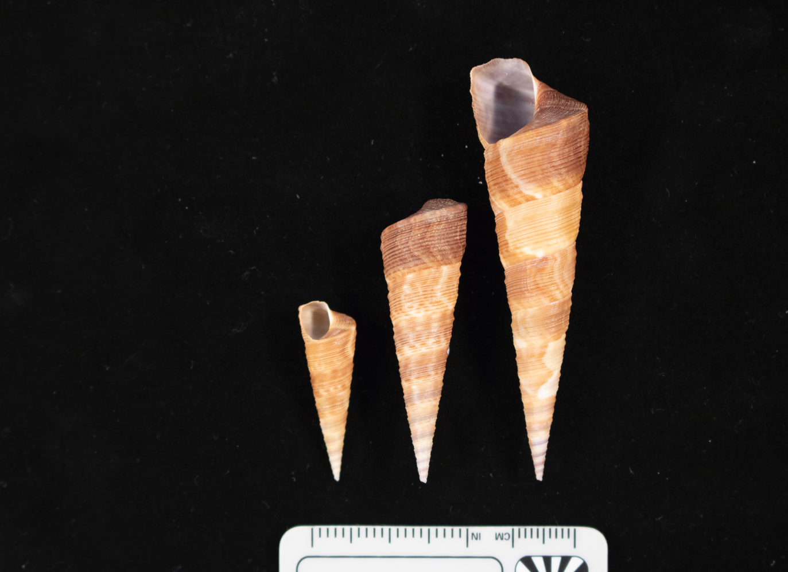
New Zealand screw shell (Maoricolpus roseus) competes with scallops, commercially-farmed shellfish and native species. Established in parts of Victoria. Image supplied by DAWE.
Case Study 9
ASSET PROTECTION: Reducing the risk of marine
pest spread to high-value areas
Pope’s Eye is an artificial reef in the Port Phillip Heads Marine National Park composed of bluestone boulders laid in a semi-circular ring. Pope’s Eye was initially set aside as a no-take section of the Harold Holt Fisheries Reserve in the late 1970s and has been a no-take zone since. Due to the long history of protection, Pope’s Eye features a broad diversity of marine species particularly fish including wrasse, morwongs, old wives, scaly fin and perch. It is also one of the only nesting and roosting site for Australasian gannets on an artificial substrate in Victoria. The seaward side of the structure supports a colourful array of sessile invertebrates such as sponges, ascidians, bryozoans, anemones, soft corals and gorgonians.
In late 2016, the invasive seaweed, Undaria, was detected growing at Pope’s Eye. To achieve conservation objectives for key natural values such as brown algal dominated reef communities and to minimise the impact on native species, Parks Victoria established a diver removal program in January 2017. These efforts were repeated later in the same year and the infestation was mapped to aid in future management of the site. A total dive time of 40 hours resulted in over 2 tonnes of Undaria (wet) being removed by local Parks Victoria teams with the support of the state-wide pest officers. Ongoing monitoring has been undertaken at Pope’s Eye since to measure the impact and effectiveness of the ongoing removal efforts in reducing the impact of Undaria to the high value site.
Since 2018, local Parks Victoria staff have continued to monitor and manage the site on a monthly basis, adopting a different approach to reduce manual handling of Undaria. This approach focuses on removing reproductive structures and juvenile plants and has been very effective in keeping the site largely pest free.

Policy and legislation

NEW BIOSECURITY LEGISLATION
The Agriculture Strategy, Strong, Innovative, Sustainable: A new strategy for agriculture in Victoria (2020), commits to consolidating Victoria’s biosecurity legislation into a single Biosecurity Act. To engage with the community on this process, a Discussion Paper proposing key reform topics was released on Engage Victoria in September 2022 for stakeholder and public comment. A summary of feedback received was released on 19 May 2023. The feedback is helping us to better understand stakeholder and community views and will inform any future reform.

FISHERIES ACT
The Fisheries Act 1995 provides the legislative framework for the regulation and management of fishing and aquaculture activities. It also supports the protection and conservation of fisheries resources, habitats and ecosystems, including the maintenance of aquatic ecological processes and genetic diversity. The current list of noxious aquatic species under the Fisheries Act 1995, is not exhaustive. There is a need to review the list to ensure Victoria is appropriately prepared for any new incursions of high-risk species into the state.
Unless authorised under this Act, a person must not bring into Victoria or take, hatch, keep, possess, sell, transport, put into any container, or release into protected waters any declared noxious aquatic species. Permits are required for organisations or groups that wish to undertake control or management of noxious aquatic species.
The Fisheries Act 1995 (with some limitations) includes powers to conduct an emergency eradication of a listed noxious aquatic species, including strong powers to seize, remove and destroy noxious aquatic species.

MARINE AND COASTAL ACT
The Marine and Coastal Act 2018 was established to provide improved governance and oversight of the marine and coastal environment and aims to:
- establish an integrated and co-ordinated whole-of-government approach to protect and manage Victoria’s marine and coastal environment; and
- provide for integrated and co-ordinated policy, planning, management, decision-making and reporting across catchment, coastal and marine areas.
It endeavours to establish clear objectives and guiding principles for planning, management and decision-making. This module of the IPAPF is recognised in the Marine and Coastal Policy and associated strategy as required under the Marine and Coastal Act 2018.

FLORA AND FAUNA GUARANTEE ACT
The Flora and Fauna Guarantee Act 1988 is the key piece of Victorian legislation for the conservation of threatened species and communities and for the management of potentially threatening processes.

ENVIRONMENT PROTECTION ACT
The Environmental Protection Act 2017 focuses on preventing waste and pollution impacts rather than managing those impacts after they have occurred. Activities associated with the introduction and spread of marine pests includes those relating to litter and waste. Biofouling is covered under a new General Environmental Duty which states that a person who is engaging in an activity that may give rise to risks of harm to human health or the environment from pollution or waste must minimise those risks, so far as reasonably practicable.

EMERGENCY MANAGEMENT ACT
The Emergency Management Act 1986 sets out the organisation of emergency management in Victoria and is one of the tools that may be used to manage eradications of marine pest incursions in the state. New exotic marine pest incursions may be dealt with under this Act, allowing for the implementation of agreed organisational structures and processes and providing certain powers to enable an attempt at eradication.

NATIONAL PARKS ACT
Victoria’s 13 marine national parks and 11 marine sanctuaries were established under the National Parks Act 1975 in 2002 following extensive community consultation, investigation and research.
The National Parks Act 1975 requires marine national parks and sanctuaries to be managed in a way that ‘promote(s) the prevention of the introduction of exotic flora and fauna’ and ‘provide(s) for the eradication or control of exotic flora and fauna’ detected in parks’.

PORT MANAGEMENT ACT
Under the Port Management Act 1995, port and harbour managers are required to develop a Safety and Environmental Management Plan for ports under their responsibility. While marine pests have been identified as a threat to the environmental values within local ports, there is scope for greater recognition of marine pests in these plans and in other facets of harbour planning.
The Port Management Act 1995 also empowers a port manager to act as a harbour master if there is no harbour master for a local port; this may allow a port manager to apply the relevant provisions of the Marine Safety Act 2010 even if no harbour master is in place.

STAKEHOLDER ENGAGEMENT AND EDUCATION
One of the key principles of the IPAPF and numerous pieces of biosecurity legislation across the country is that managing and responding to biosecurity threats is a shared responsibility across all sectors of the community. For this reason, building a sense of shared responsibility for minimising the risk of pest spread within and among these groups is an integral part of successful prevention and management.
Community and environmental groups, such as ‘Friends of’ groups with ties to Victoria’s marine parks and sanctuaries, can play an important role in early detection and reporting of new incursions, formal or informal monitoring programs and eradication or containment responses. Traditional Owners have rights and responsibilities in protecting and managing their cultural heritage and in caring for Sea Country.
Similarly, recreational water users as well as clubs such as sailing clubs and boating squadrons are in a position to detect marine pests and report incursions. Clubs can promote awareness of marine pests and encourage good boat hygiene to prevent the spread of marine pests.
Recreational and commercial fishers have a strong interest in the health of marine habitats to support a healthy fish supply and, like community groups and divers, are frequently in a position to detect and report new incursions of marine pests. Marine contractors, researchers and tour operators are similarly positioned.
Out of water cleaning facility owners and operators also have an important role in the early detection of marine pest species, at and near their operations, and encouraging the cleaning of vessels to prevent further spread of marine pests.
Engaging with stakeholders through events such as the Melbourne Boat Show, developing strong relationships with them and providing opportunities to build skills and capacity, will further facilitate their engagement and participation in marine pest management.
Industry groups can inadvertently be in the position of creating risks of introducing or spreading marine pests and are sometimes subject to measures to control this risk. Maintaining positive and cooperative relationships with industry groups in the development of these measures and strategies results in improved outcomes for industry, government, and the community.

MONITORING, EVALUATION, REPORTING AND IMPROVEMENT
Monitoring, evaluation, reporting and improvement of marine pest management activities is critical for investment decision-making. Although marine pests can impact on a wide range of environments including commercial and local ports, marinas, Marine Protected Areas or other marine environments, basic information on presence, extent and abundance of many pests is lacking. Datasets held by different agencies for various purposes are currently not well integrated to provide accessible and standardised information across the various agencies with responsibilities in the marine environment.
Surveillance and monitoring programs should adopt tools that are risk-based and fit for purpose. Techniques such as population modelling, analysis of eDNA and the use of Remote Operated Vehicles can reduce costs and time delays associated with time-consuming in- field visual techniques. Improved documentation and reporting of existing and future management programs will therefore facilitate continued learning and improvement of tools and techniques to prevent new incursions and improve the effectiveness of future eradication, containment, and asset protection programs.

RESEARCH AND DEVELOPMENT
Baseline knowledge about Victoria’s native marine species and marine pests is valuable for effective management of risks and for the design and evaluation of policy. However, compared to terrestrial communities, our current understanding of Victoria’s marine ecosystems and resources is poor.
Diagnostic capability and taxonomic collections are critical in identifying new marine pest incursions and may allow for faster responses when new incursions are detected. Institutions like Museums Victoria (see Case study 4) play a critical role in the identification of invasive marine pests. They also hold, exhibit and study research specimens and associated data/images from Victorian (and other) waters. Museums Victoria can also help with marine surveys and have participated in surveys across the state.
They have been involved with the documentation of established marine exotics in Port Phillip Bay in the late 1990s. There are few methods currently available to successfully eradicate, contain or control invasive marine pests. Research into new technologies and techniques to improve the effectiveness of our responses could represent significant savings if they result in minimised environmental, economic and social impacts and reduce the costs of management programs.

BUILDING CAPABILITY AND CAPACITY
A wide range of technical expertise and resources is required to guide and manage biosecurity planning and responses to incursions. Resources such online identification tools and databases can assist in early detection and identification of invasive marine species which in turn can help manage biosecurity responses to incursions.
Institutions like Museums Victoria run workshops on taxonomy and molecular techniques that can help build capability and capacity.

5. Strategies
Marine environments are not contained within physical geographical boundaries in the same way that inland waterway catchments are. Sea boundaries between adjacent jurisdictions are artificial human constructs that do not prevent the movement of marine pests. A high degree of cooperation between neighbouring jurisdictions and integration of management effort is required to effectively manage marine pest risks and incursions.

National strategies
National marine pest policy is coordinated through the national Marine Pest Sectoral Committee (MPSC). Membership of the MPSC includes representatives of each of the signatory governments (federal, all states and the Northern Territory) and the committee maintains close links with industry and environmental partners. The Consultative Committee on Introduced Marine Pest Emergencies performs a coordination role for marine pest emergency management.
The National Biosecurity Committee oversees the responsibilities of various national biosecurity sectoral committees, including the MPSC. It acts as an advisory committee to Australian Agriculture Ministers.

Figure 1: National marine pest management arrangements.
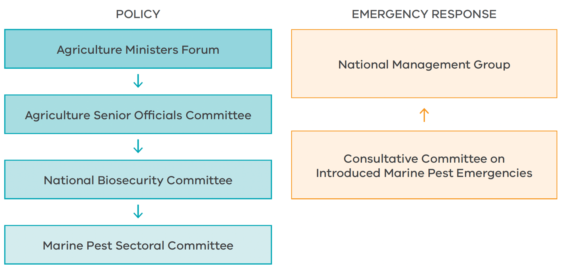

INTERGOVERNMENTAL AGREEMENT ON BIOSECURITY
The Intergovernmental Agreement on Biosecurity (IGAB), which came into effect in January 2012, is an agreement between the Commonwealth and all state and territory governments. The IGAB aims to strengthen the working partnership between governments and to improve the national biosecurity system and minimise the impact of pests and disease on Australia’s economy, environment and the community. The IGAB recognises that biosecurity is a shared responsibility of all sectors of the community and describes the key components and features for the national biosecurity system, primarily for animal and plant pests and diseases (including marine pests) in both aquatic and terrestrial environments.

NATIONAL ENVIRONMENTAL BIOSECURITY RESPONSE AGREEMENT
The National Environmental Biosecurity Response Agreement (NEBRA) was the first deliverable under the IGAB. The NEBRA establishes arrangements for responding to nationally significant biosecurity incidents (including marine pests) where the benefits of a response will primarily be public (the Emergency Animal Disease Response Agreement and Emergency Plant Pest Response Deed perform this role for animal and plant primary industries). Assessment of an incident as ‘nationally significant’ occurs according to a set of criteria identified in the NEBRA.

MARINE PEST PLAN 2018-2023
A coordinated and strategic national approach to marine pest biosecurity will ensure investment is targeted at the highest priority needs, and areas of greatest risk. Marine Pest Plan 2018-2023 is Australia’s national strategic plan for the management of marine pest biosecurity. It outlines a coordinated approach to building Australia’s capacity to manage the threat of marine pests.

AUSTRALIAN PRIORITY MARINE PEST LIST
The Australian Priority Marine Pest List (APMPL) was developed to ensure a prompt response to the detection of potentially severe pests in Australian waters. The list of nine priority marine pests assists in streamlining decisions about the level of response and cost-sharing between jurisdictions in the event of new incursions of these species, thereby facilitating more effective responses. The nine species recommended for the APMPL include three established and seven exotic species. All the established species identified for inclusion in the APMPL (Undaria, northern Pacific seastar and European shore crab) are found in Victoria.

NATIONAL PRIORITY LIST OF EXOTIC ENVIRONMENTAL PESTS, WEEDS AND DISEASES
The National Priority List of Exotic Environmental Pests, Weeds and Diseases identifies exotic species that are not established in Australia and that pose the highest risk to the environment, industry and heritage. It includes 20 marine species. https://www.agriculture.gov.au/biosecurity/ environmental/priority-list

AUSTRALIAN BALLAST WATER MANAGEMENT REQUIREMENTS
Nationally, the Australian Government is responsible for the management of ballast water from ships entering Australian waters carrying ballast sourced from overseas. The requirements of the ballast water system are mandatory for all internationally trading vessels. Under this system, the discharge of high-risk ballast water (deemed to be any salt water from ports and coastal waters outside Australia’s territorial sea) is prohibited anywhere inside Australia’s territorial sea. The Australian Ballast Water Management Requirements¹² apply to all vessels operating internationally and domestically in Australia.

NATIONAL BIOFOULING MANAGEMENT GUIDELINES
The growth and accumulation of aquatic organisms (biofouling) on vessels and other movable submerged structures affects their performance and can lead to the spread of marine pests. To address this, the National Biofouling Management Guidelines (the Biofouling Guidelines) were developed in 2009 by the Commonwealth in conjunction with key stakeholder groups including commercial fisheries, the aquaculture and petroleum industries, commercial shipping and recreational boating organisations. The Biofouling Guidelines provide practical information and promote the importance of biofouling management. Except for mobile offshore equipment in the petroleum industry (where there is legislation to reduce biofouling), the use of the guidelines is currently voluntary.

AUSTRALIAN BIOFOULING MANAGEMENT REQUIREMENTS
In 2022, the Australian Government, in consultation with state/territory jurisdictions and industry stakeholders, developed Australia’s Biofouling Management Requirements (the Biofouling Requirements) to manage the risks associated with biofouling on international vessels arriving in Australia.
Under the Biofouling Requirements, all vessels subject to biosecurity control will be required to provide information on how biofouling has been managed prior to arriving in Australian territorial seas. Vessel operators will have to comply with one of the following three accepted biofouling management practices:
- Implementation of an effective biofouling management plan; or
- Cleaned all biofouling within 30 days prior to arriving in Australian territory; or
- Implementation of an alternative biofouling management method pre-approved by the department.

ANTIFOULING GUIDELINES
These guidelines provide guidance on best-practice approaches for the application, maintenance, removal and disposal of anti-fouling coatings and the management of biofouling and marine pests on vessels and movable structures such as oil and other exploration rigs, floating dry docks, pontoons, aquaculture installations and navigational structures in Australia and New Zealand.
The guidelines provide detail about application, maintenance, removal and disposal of anti-fouling coatings at shore-based maintenance facilities.
A copy of the guidelines is available at: http:// www.agriculture.gov.au/biosecurity/avm/vessels/ biofouling/anti-fouling-and-inwater-cleaning- guidelines European green shore crab (Carcinus maenas), Museum Victoria. Established in parts of Victoria.

AUSTRALIAN IN-WATER CLEANING STANDARDS
In 2022, the Australian Government with state and territory regulators developed the Australian in-water cleaning standards to manage the biosecurity and chemical risks that may be caused by in-water cleaning and treatment activities.
The standards specify minimum requirements for in-water cleaning of biofouling from vessels in Australian territorial seas. The technical standards provide operators, developers and owners of in-water cleaning and treatment technologies with mechanisms to demonstrate that systems effectively meet Australian biosecurity and chemical contaminant standards.

NATIONAL CONTROL PLANS
National Control Plans have been developed for six marine pests. These six pests are known to have significant impacts on the marine environment or industry but are locally or regionally too well established to be candidates for national eradication. The National Control Plans aim to minimise the impacts of these species where they occur and prevent their spread into new areas. The six species are:
- Northern Pacific seastar (Asterias amurensis)
- European green shore crab (Carcinus maenas)
- Asian bag mussel (Arcuatula senhousia)
- European fan worm (Sabella spallanzanii)
- Japanese kelp or wakame (Undaria pinnatifida)
- European or basket shell clam (Varicorbula gibba)

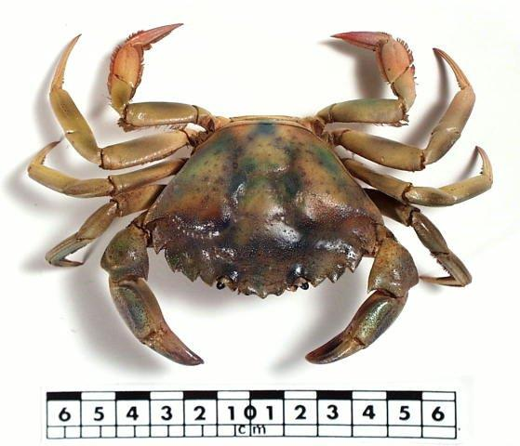
European green shore crab (Carcinus maenas), Museum Victoria. Established in parts of Victoria. Image supplied by Museums Victoria.

State strategies
The IPAPF represents the Victorian Government’s approach to managing existing and potential invasive species across the whole of Victoria. It is the overarching policy for this module.
The IGAB and NEBRA provides an impetus for Victoria to strengthen its legislative arrangements for marine pest management to ensure that it can meet its national obligations. Although several Acts have provisions that address elements of successful marine pest management, none provides the complete suite of tools required to manage marine pest incursions in line with the IGAB and NEBRA.
The Marine and Coastal Policy and associated strategy as developed under the Marine and Coastal Act 2018, will provide a long-term vision for the planning, management and sustainable use of our coast, including its associated marine biodiversity. This module of the IPAPF will guide the management of marine pests in Victoria and is recognised in the Marine and Coastal Policy.
The Port Phillip Bay Environmental Management Plan (PPB EMP) identifies the management of marine pests as a priority area. The actions within the PPB EMP seek to prevent introduction and dispersal of marine pests, monitor priority locations for early detection of marine pest introductions and respond rapidly to new introductions of marine pests.

Figure 2: Relationship between national and Victorian strategies for managing marine pests.
National agreements | Intergovernmental Agreement on Biosecurity | National Environmental Biosecurity Response Agreement
National strategies | Marine Pest Plan  2018-2023
Victorian frameworks | Invasive Plants and Animals Policy Framework | Marine and Coastal Policy and associated strategy | Port Phillip Bay Environmental Management Plan

6. Roles and responsibilities
The successful management of biosecurity threats requires strong partnerships between government, industry and community stakeholders. This includes collective decision- making and clarifying community, industry and government roles and responsibilities.

Australian Government
The Australian Government’s role in managing biosecurity is mainly in relation to national pre-border and border biosecurity, with a coordination and leadership role for achieving national biosecurity outcomes. This is likely to include cost-sharing arrangements for managing nationally significant incursions.

Victorian Government
The Victorian Government’s role is to:
- ensure the full biosecurity continuum is in place for marine pests in Victoria (Fig. 3)
- establish and maintain a state-wide strategic direction for marine pests
- work with other jurisdictions to ensure agreement between Victorian arrangements and national approaches
- provide pre-border and border biosecurity at a state level and provide preparedness, prevention, eradication and containment for those marine pests that are not yet present across their full potential range and for which government intervention can be justified
- collaborate with other jurisdictions during biosecurity emergencies, in accordance with national agreements
- engage with industry to minimise the risks of new incursions and to maximise protection from biosecurity risks
- engage with stakeholder groups and the community in pursuing coordinated action against widely established marine pests
- act where required as a regulator and enforcer in relation to marine pests
- provide policy and funding for strategic research.

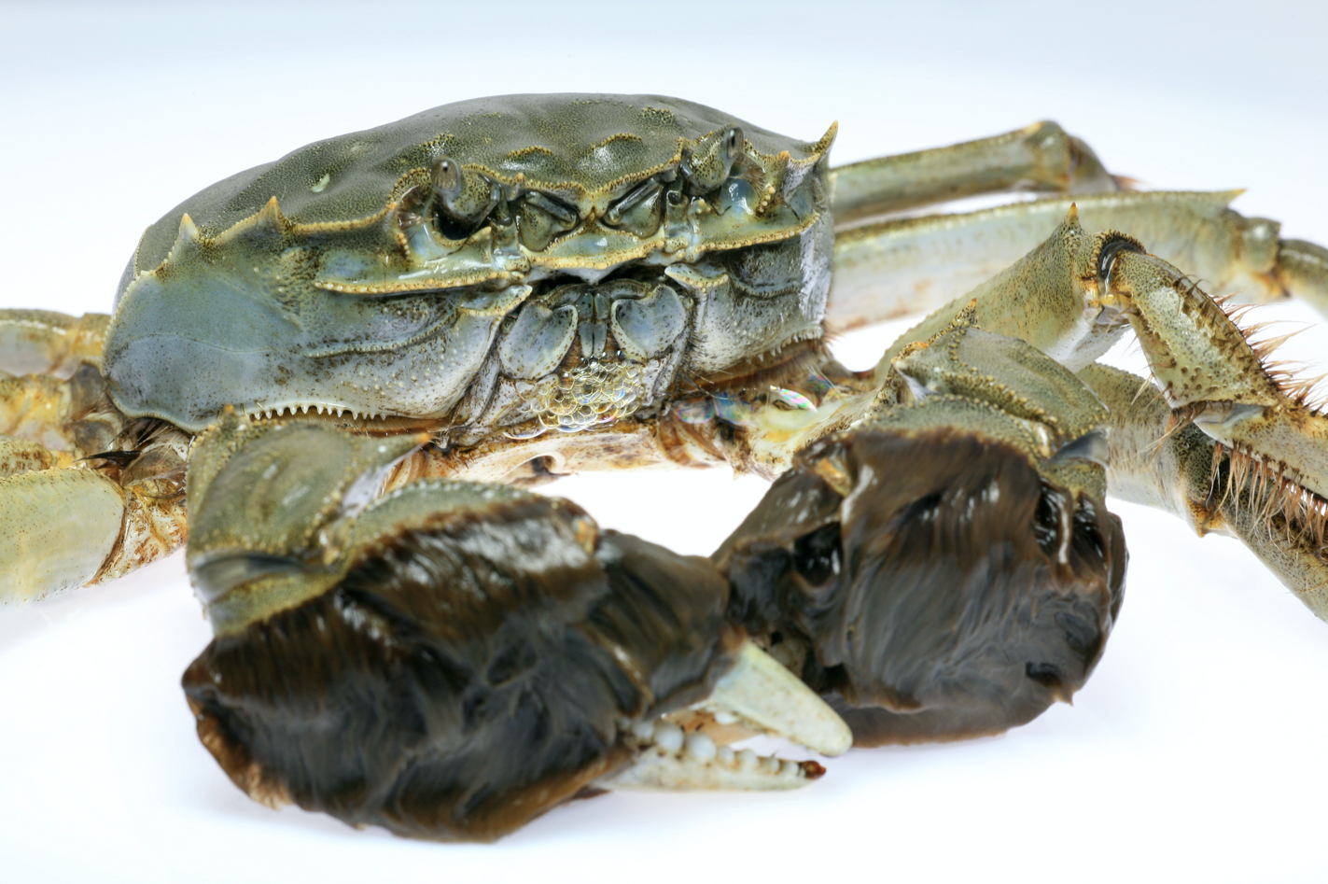
Established in part Chinese mitten crab (Eriocheir sinensis), an exotic pest of national significance. Not known to be established in Victoria. Image supplied by Agriculture Victoria.

Figure 3: Generalised invasion curve showing diminishing returns on biosecurity investment along the invasion axis.
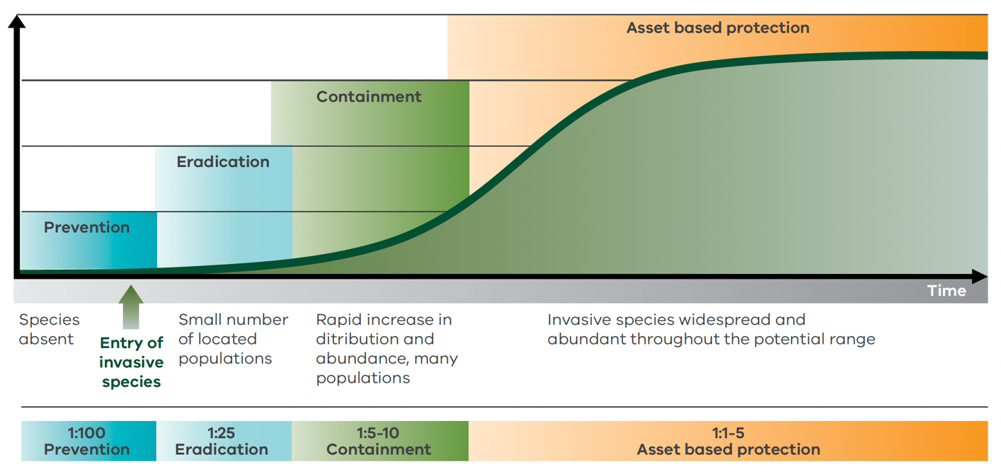
The current responsibilities of the Victorian government agencies for responding to marine pests are provided in Appendix D.

VICTORIAN MARINE PEST CONSULTATIVE COMMITTEE
The Victorian Marine Pest Consultative Committee (VMPCC) provides technical advice to decision makers on coordination of the operational response to marine pest incidents in Victoria. Members of the VMPCC represent those agencies with responsibilities in the marine environment (Appendix B).
VMPCC provides a technical forum to facilitate timely, well-informed decision making in response to primary/new introductions of a marine pest considered exotic to the Victorian marine environment.
VMPCC members may also convene informally to discuss secondary introductions (translocations) of a marine pest considered exotic to an area of the Victorian marine environment.

VICTORIAN INTER-AGENCY INVASIVE SPECIES COMMITTEE
The Victorian Inter-Agency Invasive Species Committee was established to institute high-level Victorian governance arrangements for invasive species biosecurity matters.

VICTORIAN MARINE AND COASTAL COUNCIL
The Victorian Marine and Coastal Council is established under the Marine and Coastal Act 2018 and is responsible for, among other things, providing advice on the implementation of the Marine and Coastal Policy and development of a Victorian Marine and Coastal Strategy.

CATCHMENT MANAGEMENT AUTHORITIES
Five of Victoria’s 10 catchment regions incorporate coastal and marine waters (estuaries, bays and seas) out to the state limit. Catchment Management Authorities (CMAs) are required to apply an integrated ‘whole-of- catchment’ approach to the management of land, biodiversity and water resources within their region of responsibility and thus consider the threats posed by invasive species to regional values. Regional catchment strategies, produced by each of the relevant CMAs incorporate targets and actions that are intended to respond to risks to natural assets, could be strengthened in regard to marine pests.

Local government
Local government is not usually directly involved in marine pest prevention, although it is positioned at the interface with the community and may be able to play a key role in communicating with the community about marine pest management – especially in emergency response situations. Some local governments also have delegated responsibility for the management of certain ports and harbours and play an active role in managing these sites and their facilities. Many manage assets such as boat ramps that can provide opportunities for marine pest prevention and management (for example with the addition of a washdown facility for recreational vessels) and are important sites for targeted community education and engagement.
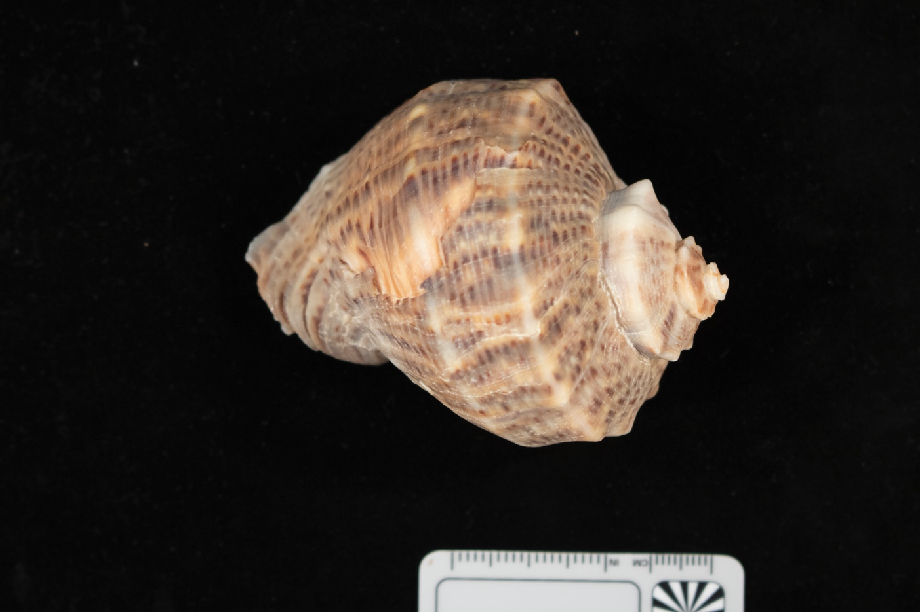
Veined whelk (Rapana venosa), a large mollusc that preys on native and aquaculture species. Not known to be established in Victoria. Image supplied by DAWE.

Industry
The responsibilities of commercial industry sectors (such as shipping, drilling, charter and passenger vessels, commercial fishing, contractors, private marina operators and tour operators) are to address their obligations under Australian Ballast Water Management Requirements and other legislation (where applicable). This includes compliance with the Fisheries Act 1995 which prohibits persons bringing into Victoria or taking, hatching, keeping, possessing, selling, transporting, putting into any container or releasing into protected waters any listed noxious aquatic species. Until national regulations are in place, there are additional voluntary measures that industry groups may take, such as control of biofouling, which can contribute to improved outcomes for marine pest management.
The aquarium industry provides a significant contribution to the Australian economy and was valued at $350 million in 2007.¹⁵ If released into waterways, ornamental fish, live rock or used aquarium gravel can contain bacteria, algae, worms, crabs, clams, snails, fish or snail eggs, larvae, plant fragments or diseases.
All individuals involved in the aquarium industry (i.e. traders, breeders, retail outlets or hobbyists) play an important role in preventing the risk of marine pest introduction and spread in Victorian waters. Individuals should be aware that:
- Only species on the live import list can be imported into Australia from approved countries.
- It is illegal to bring into Victoria, take, hatch, keep, possess, sell, transport, put into
- any container or release into protected waters any species that is declared as a noxious aquatic species under the Fisheries Act 1995 (www.vfa.vic.gov.au).
- Unwanted species must be disposed of correctly – always return unwanted species to an aquarium dealer or sewerage; do not release into local waterways or use as live bait.
- Live rock or used aquarium gravel must not be disposed of in waterways.

Recreational water users
All recreational water users must comply with the Fisheries Act 1995 which prohibits persons bringing into Victoria or taking, hatching, keeping, possessing, selling, transporting, putting into any container or releasing into protected waters any listed noxious aquatic species. In addition, they can adopt an appropriate level of boat and gear hygiene to assist with preventing the introduction or inadvertent spread of marine pests between locations.
Recreational boat owners can assist in reducing the risk of entry or spread of marine pest by observing measures related to boat hygiene (i.e. following the principles of Check, Clean, Dry). Recreational and professional divers can assist in preventing the spread of marine pests by thoroughly washing their equipment in fresh water and allowing it to dry between dives in different locations. Divers and snorkelers should also observe any directions given by the managers of a dive site or the relevant port manager.

Community and Environmental Groups
Community and environmental groups and ‘Friends of’ groups play an important part in passive surveillance. They must also comply with the Fisheries Act 1995 which prohibits persons bringing into Victoria or taking, hatching, keeping, possessing, selling, transporting, putting into any container or releasing into protected waters any listed noxious aquatic species.
The aim of environmental groups and ‘Friends of’ groups is to protect the natural environment and to increase community awareness and involvement in the protection of the natural environment. By working together with governments and non-government agencies, they help create awareness and appreciation of the diverse marine life in Victoria.
Environmental groups can also help in the removal of invasive marine pests. For example, since 2008, Earthcare St Kilda has been removing Northern Pacific seastars from the seagrass beds in St Kilda Harbour. This activity has expanded to include removal of seastars at Brighton Sea Baths. Once a month, volunteers attempt to minimise the impact of Northern Pacific Seastars on the native habitat in the St Kilda harbour and near Brighton Sea Baths.
Passive surveillance is reliant on people who interact with the marine environment and can keep an eye out for any unusual, strange or exotic marine pests. By reporting the sightings of marine pests, members of the community can help stop the introduction of exotic species into Victoria and preventing the spread of existing pests to other parts of our coastline.
Any sighting can be reported via email (marine.pests@agriculture.vic.gov.au), phone (Agriculture Victoria Customer Service Centre 1300 502 656.) or using the online form on the Agriculture Victoria website: https://agriculture.vic.gov.au/biosecurity/marine-pests/report-a- marine-pest-sighting.

Port, marina and mooring managers
Port managers are responsible for dredging and maintaining infrastructure within ports and harbours, which is often significantly fouled with marine growth. Port managers should be aware of the potential for marine pest to be transported on or in mobile infrastructure (such as floating pontoons and dredging equipment).
In some cases, port managers are also responsible for out of water vessel maintenance facilities (slipways, travel lifts etc) and other vessel maintenance infrastructure. There are also a significant number of slipways which are generally owned by private entities such as yacht clubs. These should be managed to maximise availability and ease of use for vessel hull cleaning and antifouling measures. Port managers may also be responsible for approving applications for in-water vessel cleaning in consultation with the relevant Victorian Government agencies. These requests should be considered in light of the Australian In-water Cleaning Standards.

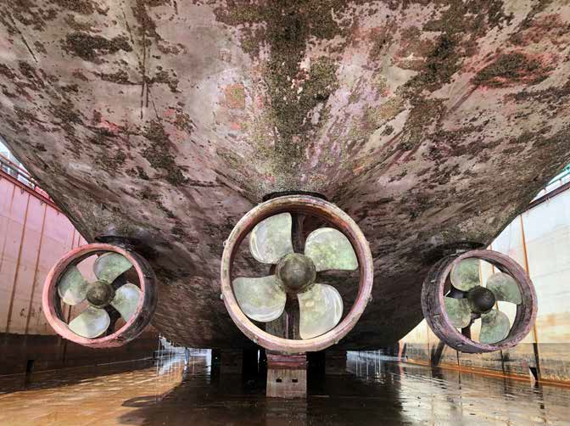
Commercial ship in dry dock with biofouling. Image supplied by DAWE.

7. Glossary

BALLAST | Material taken into ships to provide stability, formerly solid material such as rock, now generally sea water.
BIOFOULING | Accumulation of marine growth such as microorganisms, plants, algae and animals on vessel hulls and internal spaces, maritime equipment and mobile marine infrastructure.
BIOSECURITY | The management measures applied to reduce the likelihood of pest species being able to enter, establish or spread within a defined area or region.
CONTAINMENT | Restriction of a pest species potential range to a defined region through the establishment and maintenance of biosecurity conditions.
CRYPTOGENIC | A species whose origin is uncertain or unknown.
ERADICATION | Elimination of a pest species from a defined region. Eradication may be to an agreed level of confidence.
ESTABLISHED | A pest species that is expected, for the foreseeable future, to be present in an area.
MARINE PEST | Marine pests are non-native marine species that may harm Australia’s marine environment, social amenity or industries that use the marine environment, or species that have the potential to do so if they were to be introduced, established (that is, forming self-sustaining populations) or spread in Australia’s marine environment.
MONITORING | The structured collection of data for the purposes of assessing changes in the density or distribution of known pests in a defined area. The main distinction between surveillance and monitoring is that surveillance is concerned with new pests or recently introduced pest species, whilst monitoring is concerned with changes in the population structure and distribution of an established pest species.
PRIMARY  INTRODUCTION | Is the first detection of a non-indigenous species that is not known to be established elsewhere in Australia’s marine environment.
RAMSAR  WETLANDS | Wetlands of international importance listed under the Ramsar Convention on Wetlands.
RANGE | A species range is the area where a particular species can be found during its lifetime. Species range includes areas where individuals or communities may migrate or hibernate.
RANGE EXTENSION | Refers to the expansion of a species range due to factors such as climate change making it favourable for individual or communities to thrive outside of their traditional range.
SECONDARY INTRODUCTION | Is the first detection of a non-indigenous species in an area/locality of Australia’s marine environment that constitutes a significant range extension from where the species is established elsewhere in Australia’s marine environment.
SURVEILLANCE | The structured collection and analysis of data for the purpose of detecting the presence or demonstrating absence of a marine pest in a given environment. Surveillance may be further classified into ‘active’ and ‘passive’ activities or ‘general’ and ‘targeted’ activities (see below).  - Active surveillance - Collection of data specifically for marine pest surveillance purpose, usually to answer a certain question (for example, are particular marine pests present in this port?).  - Passive surveillance - Observer-initiated (for example, when a recreational diver sees an unusual animal—a potential marine pest—while out diving and reports it to the marine authority) or the result of sample collection for another purpose (for example, marine ecology research).  - Targeted surveillance - Surveillance activities targeted at a specific pest species. For example, eDNA surveillance programs using PCR will only provide data on a single or limited number of selected species.  - General surveillance - Surveillance activities not specifically focused on a single or small number of pest species.
VESSEL | Any ship, boat or other description of a craft used in marine environments. Includes ships, floating platforms, boats and barges (i.e. structures that can float and be steered or moved by their own means or by other means, e.g. if towed). Also, specifically includes smaller craft including recreational boats and other craft.

8. References
- Department of Primary Industries 2010. Invasive Plants and Animals Policy Framework, State Government of Victoria, Melbourne.
- Phillips, JA 2001. ‘Marine macroalgal biodiversity hotspots: why is there high species richness and endemism in southern Australian marine benthic flora?’ Biodiversity and Conservation, 10, 1555-1557.
- Department of Sustainability and Environment Victoria 2000. Flora and Fauna Guarantee Act 1988 – Action Statement No. 100 – Introduction of exotic organisms into Victorian Marine Waters, DSE, East Melbourne.
- Victorian Fisheries Authority 2018. Fish Production Information Statistics, Victorian Fisheries Authority, Melbourne.
- Victorian Fisheries Authority and Better Boating Victoria 2020. The economic value of recreational fishing in Victoria. Victorian Fisheries Authority and Better Boating Victoria, Melbourne.
- Hewitt, CL, Campbell, ML, Thresher, RE, Martin, RB, Boyd, S, Cohen, BF, Currie, DR, Gomon, MF, Keogh, MJ, Lewis, JA, Lockett, MM, Mays, N, McArthur, MA, O’Hara, TD, Poore, GCB, Ross, DJ, Storey, MJ, Watson, JE & Wilson, RS 2004. Introduced and cryptogenic species in Port Phillip Bay, Victoria, Australia, Marine Biology, 144, 183– 202.
- Environment Protection Authority 2006. Protecting the Victorian marine environment from marine pests – Policy Impact Assessment, EPA, Southbank.
- Department of Environment and Heritage 2000. The effectiveness of Australia’s response to the black striped mussel incursion in Darwin, Australia: A Report of the Marine Pest Incursion Management Workshop – 27-28 August 1999. Department of Environment and Heritage, Darwin.
- Fitridge et al. 2012. The impact and control of biofouling in marine aquaculture: a review. Biofouling, 28, 649-669.
- TSQAP Biotoxin management plan (Version 5). 4 Dec 2017. Department of Primary Industries, Parks, Water and Environment, Hobart.
- Maritime Safety Victoria 2018. Marine safety incident statistics: Maritime Safety Victoria 2018-19 Annual Report. Transport Safety Victoria, Melbourne.
- Commonwealth of Australia 2017. Australian Ballast Water Management Requirements v7. Department of Agriculture and Water Resources, Canberra.
- Hickman, N & Mercer, J 2006. Victorian Protocol for the Translocation of Blue Mussels: Fisheries Victoria Management Report Series, no 26, Department of Primary Industries Victoria, Melbourne.
- Floerl, O, Inglis, G, Dey, K, and Smith, A 2009. The importance of transport hubs in stepping-stone invasions. Journal of Applied Ecology, 46, 37-45.
- Natural Resource Management Ministerial Council 2006. A strategic approach to the management of ornamental fish in Australia. Bureau of Rural Sciences, Canberra.
- Victorian Environmental Assessment Council (VEAC) (2019) Assessment of the Values of Victoria’s Marine Environment – Summary. Victorian Environmental Assessment Council, Melbourne

9. Appendices

Appendix A: List of stakeholders
Aboriginal Victoria
Aquarium Industries
Aquarium Society of Victoria
Australian Government
Boating Industry Association of Victoria
CMAs: Corangamite, East Gippsland, Glenelg-Hopkins, Port Phillip and Westernport, West Gippsland
Coastal conservation groups
Coastcare
Fishcare Victoria
Conservation groups – e.g. Friends of Beware Reef, Friends of Jawbone Marine Sanctuary, Friends of Point Cook Marine Sanctuary, Friends of Ricketts Point, Earthcare St Kilda
Marina Industry Association Ltd
Marine Aquarium Society of Victoria
Municipal Association of Victoria
Municipal Councils
Museums Victoria
Oceanwatch Australia
Reef Life Survey
Sea Life Melbourne Aquarium
Seafood Industry Victoria
State and territory governments
Universities and other research centres
Victorian commercial ports – Port of Melbourne, Port of Geelong, Port of Hastings, Port of Portland
Victorian Environmental Assessment Council
Victorian local ports
Victorian marinas
Victorian Marine and Coastal Council
Victorian National Parks Association
Visit Victoria
Zoos Victoria

Appendix B: Victorian government agencies with an interest in marine pests
Department of Energy, Environment and Climate Action
Department of Transport and Planning
Environment Protection Agency
Parks Victoria
Victorian Fisheries Authority

Appendix C: Abbreviations
APMPL | Australian Priority Marine Pest List
CMA | Catchment Management Authority
DEECA | Department of Energy, Environment and Climate Action
DNA | Deoxyribonucleic Acid
DTP | Department of Transport and Planning
EPA | Environment Protection Authority
IGAB | Intergovernmental Agreement on Biosecurity
IPAPF | Invasive Plants and Animals Policy Framework
MERI | Monitoring, Evaluation, Reporting and Improvement
MPSC | Marine Pest Sectoral Committee
NEBRA | National Environmental Biosecurity Response Agreement
PPB EMP | Port Phillip Bay Environmental Management Plan
R&D | Research and Development
VFA | Victorian Fisheries Authority
VMPCC | Victorian Marine Pest Consultative Committee

Appendix D: Current responsibilities of Victorian Government agencies
Department of Energy, Environment and Climate Action (DEECA) is the lead agency for the formulation of policy and regulation and preparedness planning for marine pest incursions as well as the lead agency for responding to marine pest incursions and determines the government’s response on a case-by-case basis where there is public benefit. DEECA is also responsible for managing impacts of established marine pests in its waters in Victoria. The Victorian Marine Pest Consultative Committee and other Victorian Government agencies including Parks Victoria, the Victorian Fisheries Authority (VFA) and the Environment Protection Authority (EPA) support DEECA in this role. Supporting agencies advise DEECA, within their area of responsibility, on marine pest-related policy matters, and provide operational support for policy and emergency response implementation where appropriate.
For example:
- Parks Victoria plays a key role in planning and operational matters where marine pests threaten marine protected areas, Parks Victoria also has local port responsibilities.
- The VFA may provide compliance and operational support to responses.
- The EPA provides scientific expertise.

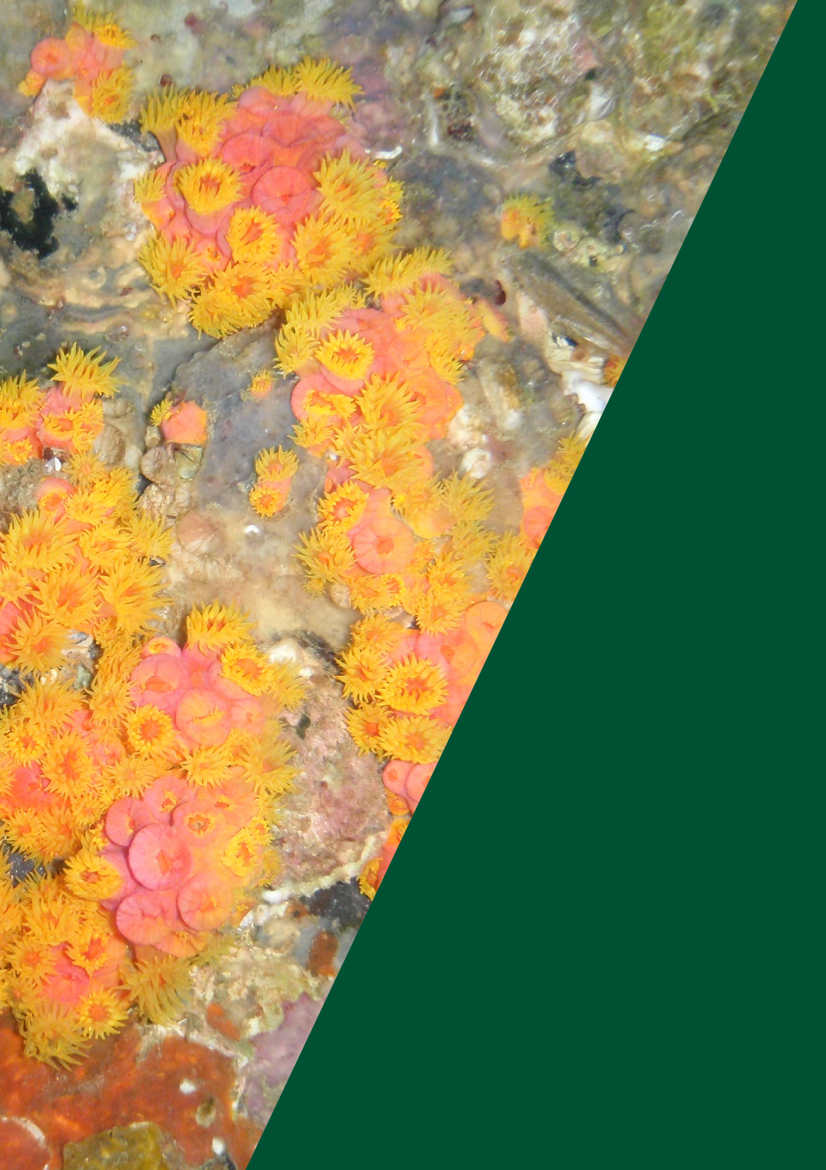

Image: General biofouling including Tubastrea coccinea.
Image supplied by DAWE.

www.agriculture.vic.gov.au

Copyright © 2022 Company Name. All rights reserved.

