Greenhouse Gas Farm Monitor
Victoria
Annual Report
2022-23

About the report
The Livestock Farm Monitor Project is Agriculture Victoria’s primary source of farm-level information for sheep and beef production practices, resource use, and economic data. The results of the annual Livestock Farm Monitor Project provide farm-level data to inform Agriculture Victoria’s decisions that impact at a farm-level and to inform the direction of future policy design, research themes and service delivery programs.
In 2022- 23 the type, source and quantity of greenhouse gas emissions and sequestration was estimated using the University of Melbourne Sheep and Beef Accounting Framework (SB-GAF) for each of the 135 farms surveyed. The aggregated emissions results generated from analysis are summarised in this report.
Agriculture Victoria staff are grateful for the cooperation of the farmers who contributed their data to this project.
This work is funded by Agriculture Victoria.
Data collection
The Livestock Farm Monitor Project annually collects detailed financial and production performance information from 135 farm businesses from across Victoria.
135 Farm businesses surveyed.
32 Sheep and beef businesses
37 Beef specialist businesses
51 Sheep specialist businesses
15 Sheep and grain businesses

Statewide summary
Farm emissions and sequestration are reported in carbon dioxide equivalents (CO₂e). This allows for more meaningful comparisons of total emissions by adjusting each different greenhouse gas type by its global warming potential.
Scope 1 emissions are direct greenhouse gas emissions that occur from sources owned or controlled by the farmer. Scope 2 greenhouse gas emissions are from purchased electricity consumed by the farm business. Scope 3 emissions are from upstream or downstream activities that are consequence of the farm business but from sources not controlled or owned by the farm business. For this analysis only upstream sources are included.
Average Farm Emissions profile
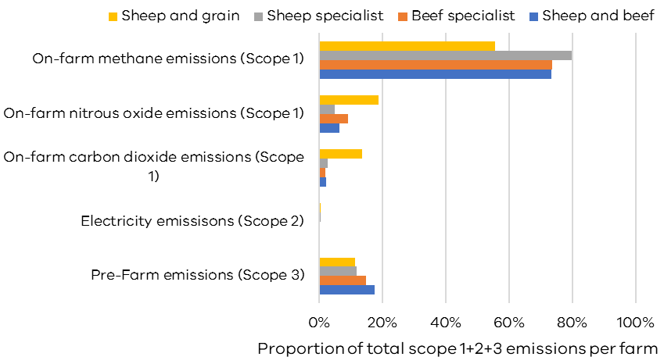
The major type of emissions from livestock farm businesses across the state is methane. Methane emissions ranged between 55% (sheep and grain) and 80% (sheep specialists) of total farm emissions. Most methane produced from livestock farms is from the process of ruminant digestion.
The average cropping enterprise in sheep and grain businesses used more nitrogen-based fertiliser to grow the crop and more fuel for machinery than the other livestock businesses. This resulted in on-farm nitrous oxide and carbon dioxide emissions making up a higher proportion of total emissions on sheep and grain farms than other livestock business types.

On-farm tree carbon sequestration
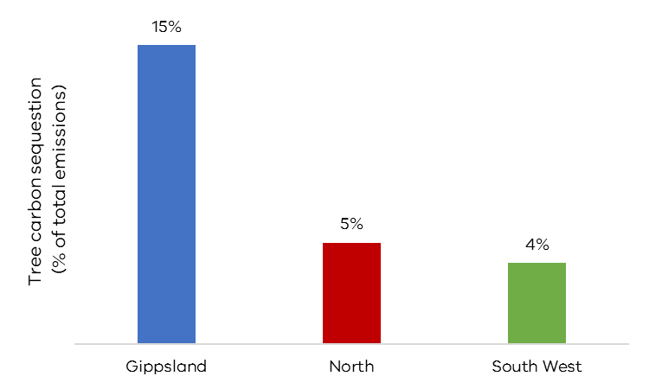
Trees can capture and store carbon, this process is called sequestration. Carbon that is sequestered in trees can be used in greenhouse gas accounting to balance against emissions produced from a farm business.
The average farm in Gippsland was able to offset 15% of total annual emissions with tree sequestration. Surveyed farms in Gippsland had the highest proportion of their farms allocated to trees compared to other regions.

Influence on farm size
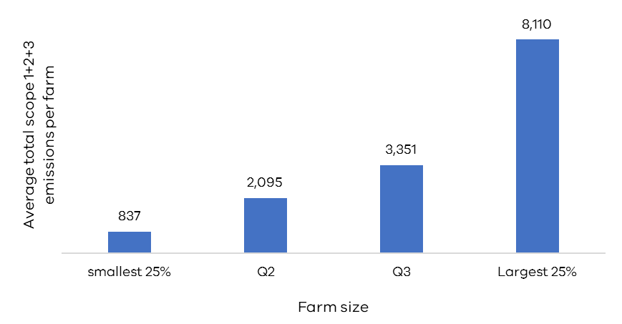
Farm size is an important determinant of the quantity of farm emissions.
Larger farms produce more emissions than smaller farms The largest 25% of farms surveyed produced an average of 8,110 tonnes CO₂e per farm during the 2022-23 year.

Influence on stock numbers
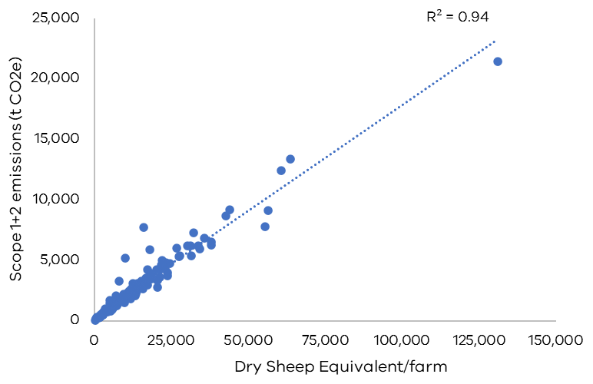
The total number of livestock on a farm is a very good predictor of the total farm emissions. Dry sheep equivalent (DSE) per farm explained 94% of the variation in on-farm Scope 1 and 2 emissions. An important consequence of this trend is that any changes to total farm emissions on livestock farms over time will very likely correspond with changes in total stock numbers.
Emissions intensity
The measure of emissions intensity is used to provide a comparison of the amount of emissions per unit of product. Emissions intensity includes Scope 1, 2 and 3 emissions but not sequestration. A lower emissions intensity number is the goal, as that describes a lower level of emissions per unit of farm product. Emissions intensity figures are indicators of business performance. Comparisons against industry averages need to be done with caution since individual farm circumstances, environment, resources and climatic variation between years can significantly affect the footprint of a farm business. Farmers should assess their baseline emissions, set goals and targets for emissions reduction in their own business and then compare track progress their own progress over time.

Production intensity
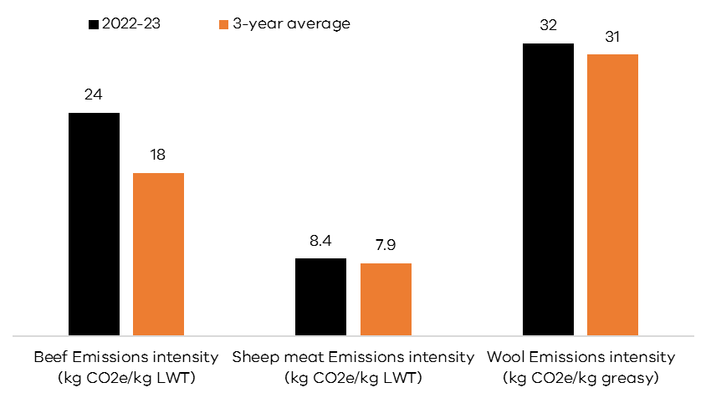
The emissions intensity of wool production on livestock farms in 2022-23 averaged 32 kg CO₂e emitted for every kilogram of wool shorn. Sheep meat averaged 8.4 kg CO₂e emitted for every kilogram of liveweight sold.
Beef emissions intensity was higher in 2022-23 compared to the 3-year average. Some beef farmers chose to purchase more stock than they sold in 2022-23, this skewed the emissions intensity results as the enterprise scope 1, 2 and 3 emissions increased with the purchased stock without a corresponding increase in stock weight sold.
Intensity per hectare (kg CO₂e/ha)
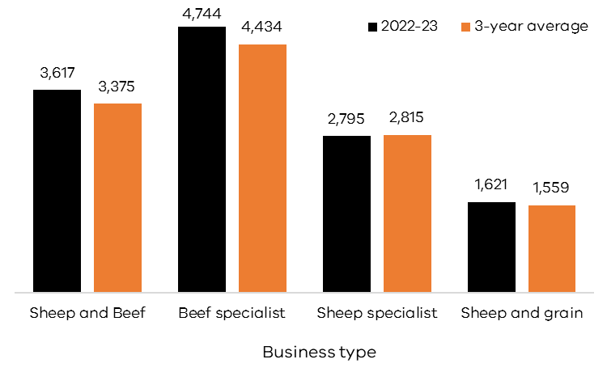

Intensity per DSE (kg CO₂e/DSE)
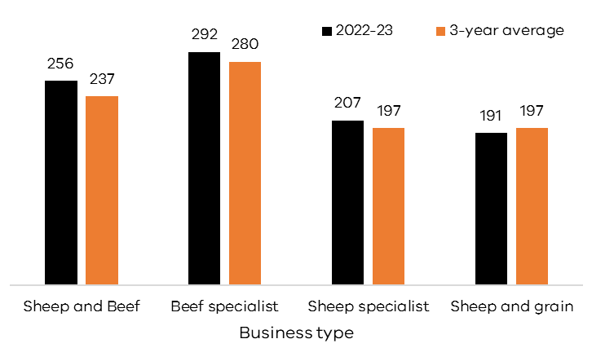
Specialist beef businesses were the most emission intensive livestock businesses in 2022-23. For every hectare and DSE managed, specialist beef businesses produced an average of 4,744 kg CO₂e and 292 kg CO₂e respectively. Sheep and grain businesses had the lowest emissions intensity per hectare because cropping activities emit less than livestock enterprises.
Intensity per dollar of income (kg CO₂e/$)
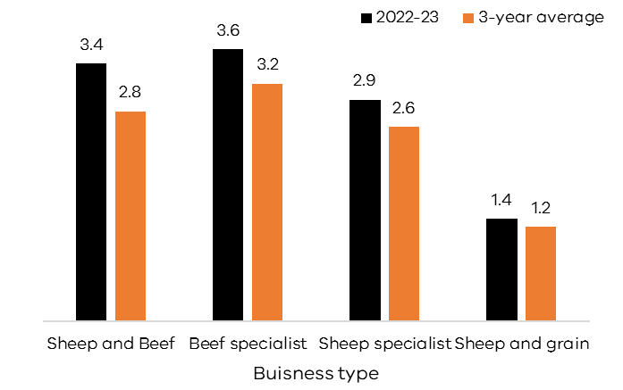

Intensity per million dollars of assets (t CO₂e/$m)
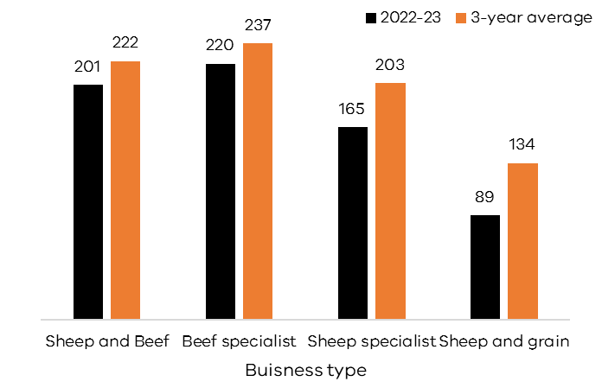
Specialist beef businesses were also the most emission-intensive livestock businesses when using a financial measure of emissions intensity. For every dollar of income and million dollars of assets managed, specialist beef businesses produced an average of 3.6 kg CO₂e/$ and 237 t CO₂e/$m respectively. Because financial emissions intensity metrics use units which are common to all industries they allow for comparisons within and across industries and sectors.

Profit and emissions
The Livestock Farm Monitor Project estimates the greenhouse gas and financial performance of all surveyed farms. Reporting these measures together allows farm managers to investigate the link between on-farm profit and emissions. Return per emission is a metric that enables comparison of the financial value produced for each tonne of greenhouse gas emissions.
Return per emission uses one of the main measures of farm profit, earnings before interest and tax (EBIT) divided by the farms total greenhouse gas emissions.
Return per emission (EBIT$/t CO₂e)
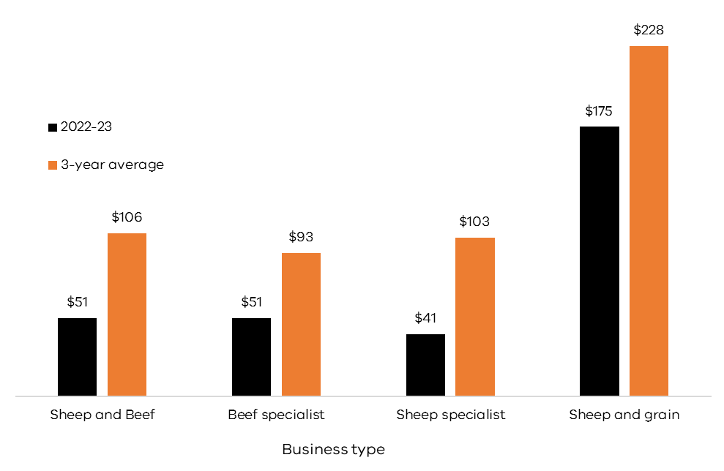
Return per emission in 2022-23 was more than 50% below the 3-year average for all business types except sheep and grain. This was due to reduced farm profits from the declining red meat and wool prices experienced in 2022-23.
When the cost of implementing on-farm emissions reduction technology is expressed as the cost in dollars per tonne of carbon dioxide equivalent reduced, return per emission can highlight whether a farm business can undertake emissions reduction and remain profitable.

Appendix
Table 1. 2022-23 Emissions intensity benchmarks (Scope 1, 2, 3 excl. sequestration) for each Livestock Farm Monitor region
 | Whole farm Emissions intensity | Whole farm Emissions intensity | Return per emission | Whole farm Emissions intensity | Whole farm Emissions intensity | Sheep Emissions intensity | Beef Emissions intensity | Beef Emissions intensity | Sheep meat Emissions intensity | Wool Emissions intensity
Region | kg CO2e/cash income $ | t CO2e/$m Assets | EBIT ($)/ t CO2e | kg CO2e/DSE | kg CO2e/ha | kg CO2e/DSE | kg CO2e/DSE | kg CO2e/kg LWT | kg CO2e/kg LWT | kg CO2e/kg greasy
Gippsland | 4.3 | 223 | $13 | 253 | 4,326 | 393 | 259 | 19 | 9.6 | 37
Northern Victoria | 2.7 | 157 | $54 | 252 | 2,924 | 210 | 269 | 16 | 7.5 | 29
South West Victoria | 2.9 | 180 | $81 | 260 | 3,364 | 206 | 481 | 33 | 8.6 | 32

Table 2. 2022-23 Emissions intensity benchmarks (Scope 1, 2, 3 excl. sequestration) for each Livestock Farm Monitor business type
 | Whole farm Emissions intensity | Whole farm Emissions intensity | Return per emission | Whole farm Emissions intensity | Whole farm Emissions intensity | Sheep Emissions intensity | Beef Emissions intensity | Beef Emissions intensity | Sheep meat Emissions intensity | Wool Emissions intensity
Business type | kg CO2e/cash income $ | t CO2e/$m Assets | EBIT ($)/ t CO2e | kg CO2e/DSE | kg CO2e/ha | kg CO2e/DSE | kg CO2e/DSE | kg CO2e/kg LWT | kg CO2e/kg LWT | kg CO2e/kg greasy
Sheep and Beef | 3.4 | 201 | $51 | 256 | 3,617 | 214 | 318 | 23 | 8.5 | 33
Beef specialist | 3.6 | 220 | $51 | 292 | 4,744 |  | 292 | 17
Sheep specialist | 2.9 | 165 | $41 | 215 | 2,795 | 215 |  |  | 8.8 | 32
Sheep and grain | 1.4 | 89 | $175 | 191 | 1,621 | 191 |  |  | 7.0 | 27

Table 3. 2022-23 Emissions intensity benchmarks (Scope 1, 2, 3 excl. sequestration) for each farm size quartile in the Livestock Farm Monitor
 | Whole farm Emissions intensity | Whole farm Emissions intensity | Return per emission | Whole farm Emissions intensity | Whole farm Emissions intensity | Sheep Emissions intensity | Beef Emissions intensity | Beef Emissions intensity | Sheep meat Emissions intensity | Wool Emissions intensity
Farm size | kg CO2e/cash income $ | t CO2e/$m Assets | EBIT ($)/ t CO2e | kg CO2e/DSE | kg CO2e/ha | kg CO2e/DSE | kg CO2e/DSE | kg CO2e/kg LWT | kg CO2e/kg LWT | kg CO2e/kg greasy
Smallest 25% | 3.7 | 160 | $17 | 253 | 3,404 | 272 | 293 | 21 | 9.3 | 34
Q2 | 3.1 | 186 | $53 | 228 | 3,114 | 215 | 228 | 18 | 8.9 | 33
Q3 | 3.0 | 181 | $53 | 245 | 3,281 | 203 | 429 | 44 | 7.6 | 29
Largest 25% | 2.5 | 194 | $113 | 299 | 3,771 | 212 | 543 | 16 | 8.2 | 32

Table 4. 2022-23 Statewide emissions intensity benchmarks (Scope 1, 2, 3 excl. sequestration)
 | Whole farm Emissions intensity | Whole farm Emissions intensity | Return per emission | Whole farm Emissions intensity | Whole farm Emissions intensity | Sheep Emissions intensity | Beef Emissions intensity | Beef Emissions intensity | Sheep meat Emissions intensity | Wool Emissions intensity
 | kg CO2e/cash income $ | t CO2e/$m Assets | EBIT ($)/ t CO2e | kg CO2e/DSE | kg CO2e/ha | kg CO2e/DSE | kg CO2e/DSE | kg CO2e/kg LWT | kg CO2e/kg LWT | kg CO2e/kg greasy
Statewide average | 3.1 | 180 | $61 | 256 | 3,393 | 161 | 238 | 24 | 8.4 | 32
Statewide median | 2.8 | 166 | $66 | 220 | 3,021 | 185 | 208 | 15 | 7.7 | 30
Statewide Q1-Q3 range | 2 - 4 | 119 - 224 | 11 - 125 | 198 - 254 | 2156 - 4136 | 179 - 220 | 211 - 335 | 12 - 24 | 7 - 9 | 25 - 37
Statewide 3-year average | 2.6 | 209 | 114 | 242 | 3,263 | 155 | 212 | 18 | 7.9 | 31

Glossary
Asset
Value of anything managed by the farm, whether it is owned or not. Assets include owned land and buildings, leased land, plant and machinery, stock and cash.
Business type
Specialist sheep: Businesses with more than 85% of DSE coming from sheep and less than 30% income coming from grain and cropping.
Specialist beef: Businesses with more than 85% of DSE coming from beef and less than 30% income coming from grain and cropping.
Sheep and beef: Businesses with less than 85% of DSE coming from beef, less than 85% DSE coming from sheep and less than 30% income coming from grain.
Sheep and grain: Businesses with more than 30% of income coming from grain and cropping sales and greater than zero sheep DSE.
Carbon accounting
The process used to quantify greenhouse gas emissions from an enterprise.
Carbon sequestration
The process whereby carbon dioxide is removed from the atmosphere and stored in soils and vegetation.
Carbon dioxide equivalents (CO₂e)
Carbon dioxide equivalents are a unit used to compare emissions from different greenhouse gases based on their global warming potential (GWP) over a specified time period, typically 100 years (GWP100).
Dry sheep equivalent (DSE)
A standardised animal unit. One DSE represents the energy requirement of a 50kg dry ewe that is maintaining condition.
Earnings before interest and tax (EBIT)
The return on all the capital used in the business before accounting for finance costs. Calculated as gross farm income minus total variable and total overhead costs. Also known as ‘Operating Profit’ or ‘Profit’.
Enteric methane
Enteric methane is produced through enteric fermentation where plant material is broken down in the rumen. Enteric methane is the by-product of this process and is expelled by the animal through belching.
Global warming potential (GWP)
A measure of cumulative radiative forcing, which aims to quantify the long-term contribution of a gas to global warming. Each GHG has a specific GWP value and this is relative to a specified time period (typically 100 years, but values are also available for 20-year and 50-year time horizons). For the 100-year time horizon, this is abbreviated as GWP100.
Greenhouse gases (GHGs)
Gases that absorb and emit radiant energy. The main GHGs associated with agriculture are carbon dioxide (CO2), methane (CH4) and nitrous oxide (N2O).
SB-GAF
The Sheep and Beef GHG accounting tool created and maintained by the University of Melbourne which generates farm emission and sequestration estimates.
https://piccc.org.au/resources/Tools.html
Return per emission
Calculated as farm EBIT divided by the total farm greenhouse gas emissions in tonnes of carbon dioxide equivalents.

Further information
Sam Henty
Agriculture Victoria
195-229 Lyttleton Terrace, Bendigo, Victoria, 3550
sam.henty@agriculture.vic.gov.au
Authorised and published by the Victorian Government, Department of Energy, Environment and Climate Action (DEECA) 2024. © The State of Victoria Department of Energy, Environment and Climate Action 2024.
This publication is copyright. No part may be reproduced by any process except in accordance with the provisions of the Copyright Act 1968.
For more information contact the Agriculture Victoria Customer Service Centre on 136 186.
Disclaimer
This publication may be of assistance to you, but the State of Victoria and its employees do not guarantee that the publication is without flaw of any kind or is wholly appropriate for your particular purposes and therefore disclaims all liability for any error, loss or other consequence which may arise from you relying on any information in this publication.
Accessibility
If you would like to receive this publication in an accessible format, such as large print or audio, please telephone 136 186.
Deaf, hearing impaired or speech impaired? Call us via the National Relay Service on 133 677 or visit www. relayservice.com.au
This document is also available on the Agriculture Victoria website.

