Tomato Potato Psyllid (TPP): what to look for

Tomato Potato Psyllid (TPP) has been detected in Victoria.

Be alert for the pest and the symptoms in plants.

What to look for
- Adults: small, less than 3 mm long, resembling small-winged cicadas
- Nymphs: flattened, oval, pale yellow, visible on underside of leaves
- Eggs: tiny, less than 0.5 mm long, orange-yellow with a short stalk, found on the lower leaf surface or along the leaf stalk
Figures 1 to 6 below show the range of signs and symptoms to look for in your crops.

Signs of TPP in crops
- Insects jumping or flying when disturbed
- Wilting, yellowing leaf edges, upward curling
- Stunted plant growth
- Sticky honeydew (psyllid sugars) that may result in sooty mould.
Figure 1: TPP adult and eggs on leaf. White substance is honeydew (sugar-like granules) excreted by TPP (Credit: Joseph Munyaneza, USDA)
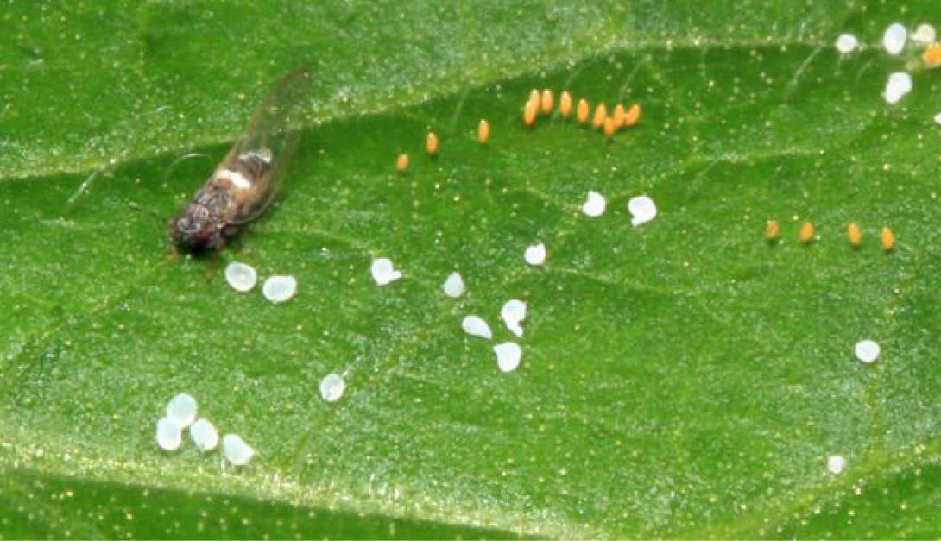
Figure 2: TPP adult and eggs showing egg stalks from side of leaf
(Credit: New Zealand Plant and Food)
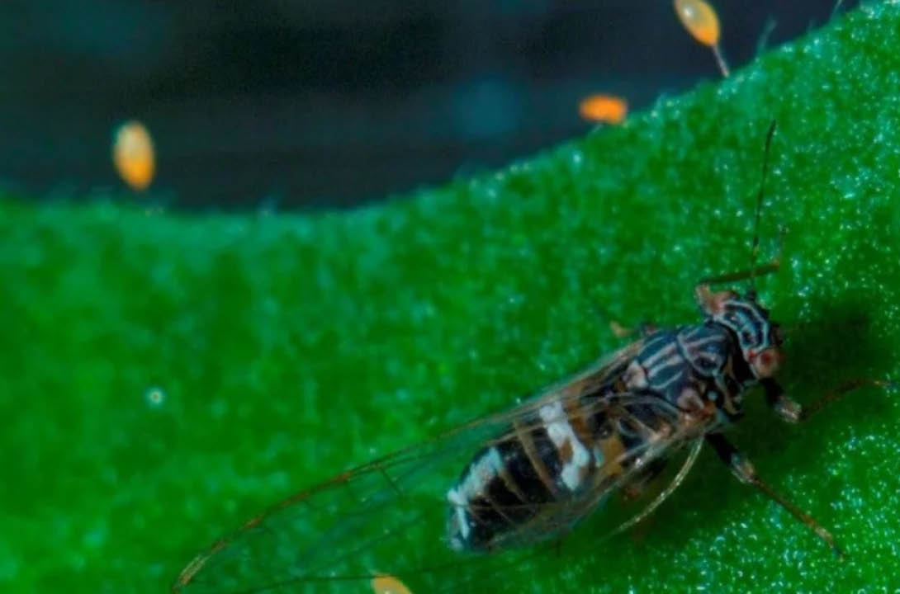
Figure 3: TPP eggs laid along leaf edge (Credit: Ashley De Vries)
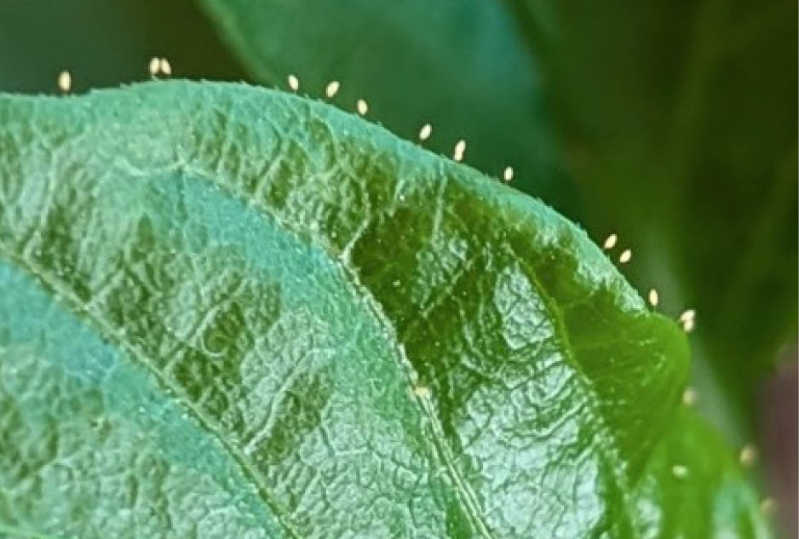
Figure 4: TPP size relative to 5 cent piece
(Credit: Department of Primary Industries and Regional Development, Western Australia)
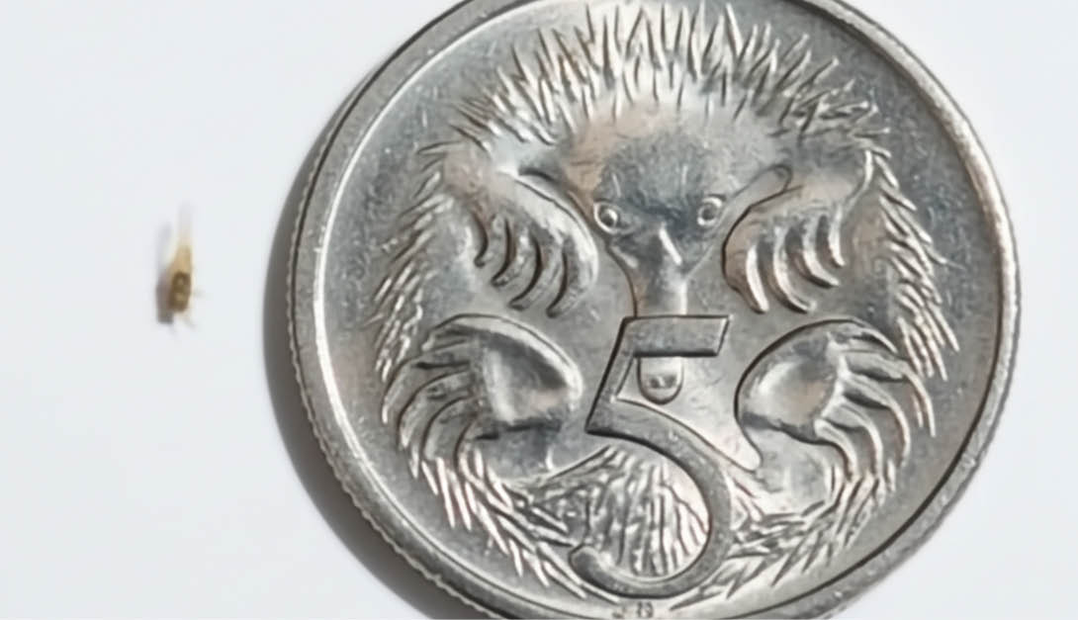
Figure 5: TPP adults and juveniles on the underside of a leaf
(Credit: Department of Primary Industries and Regional Development, Western Australia)
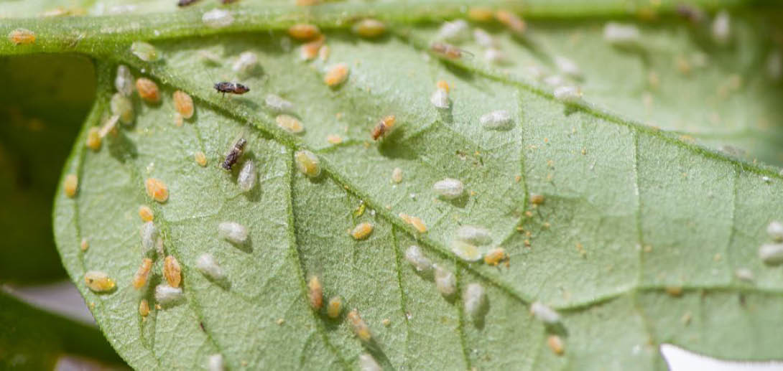
Figure 6: Honeydew (sugar-like granules) excreted by TPP
(Credit: Department of Primary Industries and Regional Development, Western Australia)
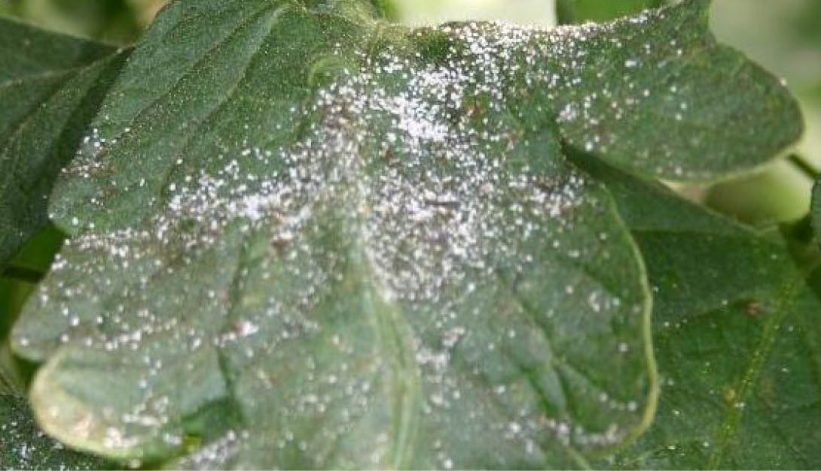

Why it matters
TPP causes damage to plants and can also transmit the bacteria Candidatus Liberibacter solanacearum (CLso). CLso causes zebra chip disease in potatoes that has the potential to cause up to 100 per cent crop loss.
CLso is NOT present in Australia.

Current situation
- On 8 December 2025, restrictions relating to TPP will come into effect when moving plants and produce interstate.
- Movement within Victoria is not affected and no additional intrastate requirements will be established.
- Businesses in Victoria will need to comply with destination jurisdiction entry requirements for TPP when moving plants or produce interstate.
- Agriculture Victoria is developing arrangements to facilitate businesses to maintain market access. This is supported by the development of online initial auditing and training processes to allow businesses to self-certify under the arrangements
- Visit the Agriculture Victoria website to apply for Interstate Certificate Assurances (ICA) and/or Bilateral Protocols.
- As new arrangements become available, they will be communicated to industry via Biosecurity Updates and the Agriculture Victoria website.
Please confirm state and territory requirements before shipment interstate.

What should you do?
If you suspect TPP please report with photos.
Report online at agriculture.vic.gov.au/reportaplantpest OR Call 1800 084 881

Need help taking pest photos?
Visit: agriculture.vic.gov.au/takeaphoto

For more information
More information about TPP can be found on the Agriculture Victoria website.
Scan the QR code to visit:


Publication information

Acknowledgements
We acknowledge and respect Victorian Traditional Owners as the original custodians of Victoria’s land and waters, their unique ability to care for Country and deep spiritual connection to it.
We honour Elders past and present whose knowledge and wisdom has ensured the continuation of culture and traditional practices.
DEECA is committed to genuinely partnering with Victorian Traditional Owners and Victoria’s Aboriginal community to progress their aspirations.

Copyright
© The State of Victoria Department of Energy, Environment and Climate Action, 2025.

Creative Commons
This work is licensed under a Creative Commons Attribution 4.0 International licence, visit the Creative Commons website (http://creativecommons.org/licenses/by/4.0/).
You are free to re-use the work under that licence, on the condition that you credit the State of Victoria as author. The licence does not apply to any images, photographs or branding, including the Victorian Coat of Arms, and the Victorian Government and Department logos.

Disclaimer
This publication may be of assistance to you but the State of Victoria and its employees do not guarantee that the publication is without flaw of any kind or is wholly appropriate for your particular purposes and therefore disclaims all liability for any error, loss or other consequence which may arise from you relying on any information in this publication.

Accessibility
To receive this document in an alternative format, phone the Customer Service Centre on 136 186, email customer.service@delwp.vic.gov.au, or contact National Relay Service on 133 677. Available at DEECA website (www.deeca.vic.gov.au).
End of document.

