Establishing
Safe Food Victoria
What you need to know

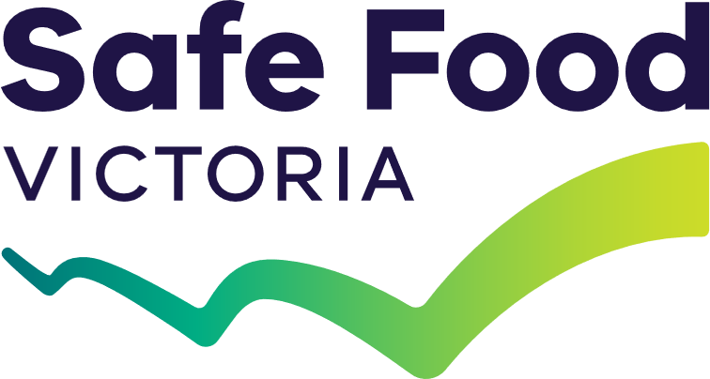


Safe Food Victoria (SFV) is the new food safety regulator for Victoria. It brings together existing Victorian Government regulatory functions to provide clearer leadership and a more consistent approach to food safety across the food supply chain.
The reform will simplify what has become a complex system, while maintaining strong protections for public health and supporting innovation and growth in the food industry.

What is changing on 1 July
SFV will commence on 1 July 2026 as an independent statutory authority governed by a board and CEO. From this date, functions currently undertaken by Dairy Food Safety Victoria, PrimeSafe and the Health Regulator will be consolidated into SFV, with staff, assets and contracts transferring.
SFV will become the single point of responsibility for leadership and coordination of food safety regulation in Victoria, including incident response, bringing together expertise currently spread across multiple agencies.
The reform does not introduce a new regulatory framework. Existing legislation (including the Food Act 1984, Dairy and Food Innovation Act 2000, Meat Industry Act 1993 and Seafood Safety Act 2003) will continue to operate, with SFV taking over the role of regulator under those laws.

What is not changing on 1 July
For most stakeholders, there will be little immediate change when SFV begins operating. Existing food safety requirements remain in place, and current compliance, audit and enforcement arrangements will continue as they do now.
This approach ensures continuity and stability, so that food safety outcomes are maintained while the new organisation is established.
Safe Food Victoria represents a significant structural reform, but for most stakeholders, there are no immediate changes to day-to-day requirements.

For food businesses
For food businesses, the key message is that there are no changes to obligations on 1 July 2026. Licences remain valid, audit and compliance arrangements continue unchanged, and businesses must continue to meet their existing food safety requirements.
Businesses do not need to take any actions to prepare for the commencement of SFV.
Businesses will also continue working with the same people they deal with now, as all PrimeSafe and Dairy Food Safety Victoria staff are transferring into SFV and will continue performing their current roles. However, their contact details (including email and website addresses) will change on 1 July.
Impacted businesses will be advised through existing channels of the new contact details.
Over time, businesses can expect a more consistent and streamlined experience. The move to a single regulator will make it easier to navigate the system, reduce duplication, and provide clearer and more consistent advice. It will also better support innovation, including new food technologies that do not fit neatly within the current framework.
For egg, sprout and horticulture businesses, regulatory responsibility will initially remain with Agriculture Victoria, with a transition to SFV planned for a later stage (expected in 2027).

For local government and Environmental Health Officers
Local councils and Environmental Health Officers (EHOs) will continue to play their same critical role as co-regulators of food safety. Day-to-day responsibilities, including inspections, enforcement and local engagement with food businesses, remain unchanged.
SFV will become the central point of coordination for local councils, taking over from the Health Regulator. This includes providing clearer leadership, system stewardship and more consistent guidance. This is expected to support EHOs through improved alignment of policy, advice and incident management. Many staff from the Department of Health that currently work closely with local councils on food safety regulation will be transferring to SFV.
The role of councils in the broader regulatory framework will be considered as part of Stage 2 reforms (see below), with consultation planned to ensure councils remain closely involved in shaping the future system.

For other stakeholders
For external auditors, suppliers and industry organisations, existing contracts and arrangements with current regulators will automatically transfer to SFV. There is no need to take action or renegotiate agreements.
Some practical changes will occur over time, including new SFV contact details, branding and communications. These will be clearly communicated to ensure stakeholders can continue to engage easily with the regulator.

Role of the Department of Health
The Department of Health and the Chief Health Officer will continue to play a central role in protecting public health. This includes responsibilities for major incident management, disease surveillance and epidemiological investigations.
Safe Food Victoria will work closely with the Department of Health to ensure a coordinated and effective food safety system.

Why changes are being made
Victoria’s food safety system has evolved over many years and involves multiple regulators and pieces of legislation. While it has been effective, it can be complex for businesses to navigate and can lead to duplication and inconsistent advice.
Establishing SFV is intended to simplify the system, improve consistency and provide clearer accountability.
The reform will also support better incident management and ensure the system can adapt to emerging technologies and industry changes.

Future changes
The reform is being delivered in two stages.
Stage 1, culminating in the establishment of SFV on 1 July 2026, focuses on bringing regulators together and setting up the new organisation.
Stage 2, to be developed from 2026 into 2027, will involve consultation on broader system improvements.
This includes exploring a more streamlined and risk-based regulatory framework, reviewing funding arrangements, and considering the roles of different parts of the system, including local councils.
These later changes will be implemented gradually and will involve further engagement with stakeholders.
We acknowledge Victorian Traditional Owners and their Elders past and present as the original custodians of Victoria’s land and waters and commit to genuinely partnering with them and Victoria’s Aboriginal community to progress their aspirations.
© Safe Food Victoria May 2026.
Creative Commons
This work is licensed under a Creative Commons Attribution 4.0 International licence, visit the Creative Commons website (http://creativecommons.org/licenses/by/4.0/). You are free to re-use the work under that licence, on the condition that you credit the State of Victoria as author. The licence does not apply to any images, photographs or branding, including the Victorian Coat of Arms, and the Victorian Government and Department logos.
Disclaimer
This publication may be of assistance to you but the State of Victoria and its employees do not guarantee that
the publication is without flaw of any kind or is wholly appropriate for your particular purposes and therefore disclaims all liability for any error, loss or other consequence which may arise from you relying on any
information in this publication.
Accessibility
To receive this publication in an alternative format, please contact foodreform@deeca.vic.gov.au.

