


APIARY BUSINESS MONITOR REPORT

2024-25
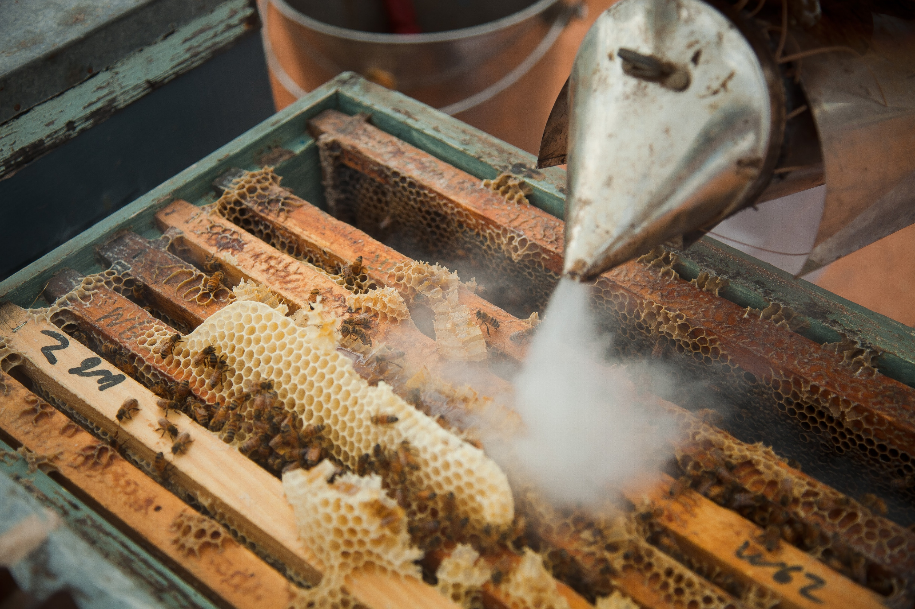


CONTENTS
ABOUT THE REPORT 2
METHOD 2
COMPARING RESULTS 2
STATE SUMMARY 4
SEASONAL CONDITIONS 4
APRIARY BUSINESS PERFORMANCE SUMMARY 4
INCOME 5
PRICE RECEIVED 5
SOURCES OF INCOME 5
HONEY PRODUCTION 5
COSTS 6
ASSETS 7
RETURN ON ASSETS 7
APPENDIX 8
GLOSSARY 9
FURTHER INFORMATION 11

ABOUT THE REPORT

In 2024-25, the Apiary Business Monitor (ABM) surveyed Victorian beekpeers and provided them with detailed financial and production performance information. Beekeepers who participated in the project increased their understanding of their business, helping build resilience and improve their ability to adapt to change.
Agriculture Victoria collated the individual business performance information of all surveyed beekeeping businesses to provide insights in this report.
The ABM is Agriculture Victoria’s primary source of apiary business information for production practices, resource use, and economic data. The results of this annual survey provide business-level data to inform Agriculture Victoria’s decisions that impact at a beekeeper level, and to inform the direction of future policy design, research themes and service delivery programs.
Results published in this report are not statistically representative of the industry.

Acknowledgements
Agriculture Victoria staff are grateful for the cooperation of the beekeepers who contributed their time, effort and knowledge to this project. This work is funded by Agriculture Victoria.

Now recruiting
The Apiary Business Monitor is looking for beekeepers to get involved in 2025- 26. Participants get a free, confidential business benchmarking report for their business. Scan the QR code or click the link below to get involved. forms.office.com/r/s6rFiP0Sje

METHOD
Measures in this report are based on farm management economics and are consistent with other reports that estimate farm business economic performance. Figure 1 outlines the relationship between income, costs, profit, and returns on assets and equity. Figure 1 also shows business equity is equal to assets minus debt. The glossary contains definitions of the finaincial terms used in this report.

COMPARING RESULTS
The appendix tables at the end of this report lists various average performance measures. Comparing your business results to the financial ratios and other performance measures with values in this report needs to be done with caution. Averages are made up of a range of businesses all with different goals, skill level, age, access to capital and attitude to risk. The best comparison is therefore with your own business overtime and the best standard to compare against is the goals and targets of your own busines
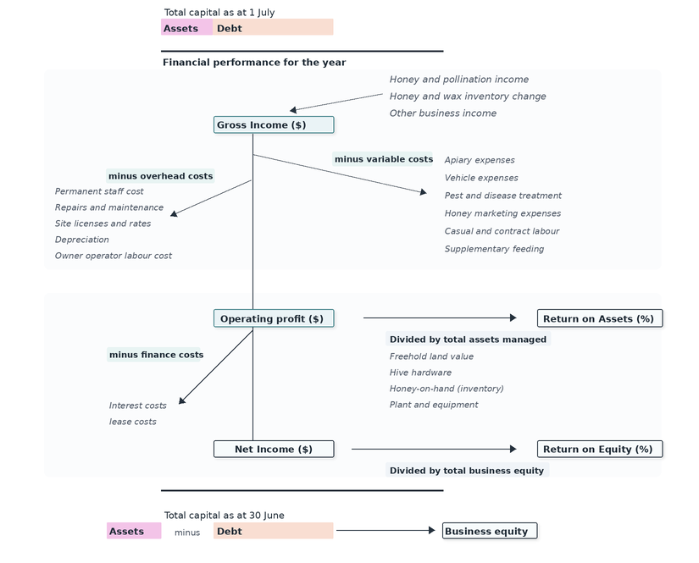
Figure 1. Apiary business profit map

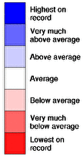
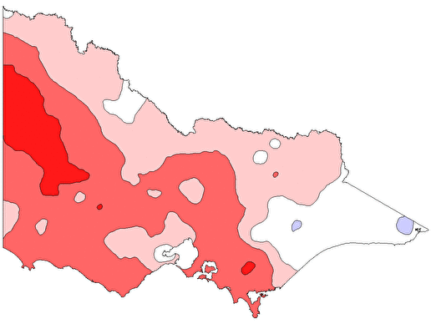
STATE SUMMARY

SEASONAL CONDITIONS

Prolonged drought across large parts of the state (Figure 2), bushfires in the west of the state, and the beginning of varroa mite management meant that 2024-25 was a challenging year for many Victorian beekeepers.
The dry seasonal conditions had a significant effect on floral resources available to beekeepers. Suppressed budding and reduced nectar availability decreased honey flows. The hot, dry conditions led to bushfires in the west of the state, burning large sections of the Grampians (Gariwerd) National Park, and the Little Desert National Park. The fires destroyed a large number of bee hives and impacted many public land bee sites across the two locations.

Figure 2. 2024-25 rainfall relative to historic rainfall (Source BOM)

APIARY BUSINESS PERFORMANCE SUMMARY
Apiary business gross income decreased in 2024-25 despite improved prices for commercial pollination services. The decrease in income was due to reduced honey prices compounded by decreased honey production and reduced honey inventories. Many beekeepers responded to reduced honey production by selling honey inventories. Lower income and relatively unchanged costs resulted in average apiary business operating profit declining by 59% to $79 per hive in 2024-25 (Figure 3).

Figure 3. Average apiary income, costs and profit for 2023-24 and 2024-25

INCOME

PRICE RECEIVED
Honey
Pollination
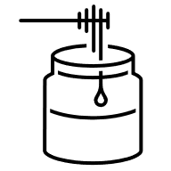

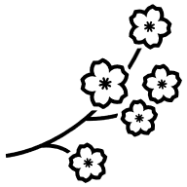

$5.7/kg
(2024-25 average)

$225/hive
(2024-25 average)

SOURCES OF INCOME

In 2024-25, commercial pollination was the largest source of cash income for participant beekeeping businesses (Figure 4). Pollination income made up 52% of total cash income, followed by income from honey sales (42%). Other income made up the remaining 6%, which includes live bee, queen bee and nucleus colony sales.

HONEY PRODUCTION
Honey production fell to an average of 34 kg honey per hive in 2024-25, close to half the production recorded in 2023-24 (Figure 5). Honey production decreased in 2024-25 because of the lack of budding and floral feed sources from the dry conditions and extreme hot days in key flowering trees.

Figure 4. 2024-25 average proportion of total cash income.

Figure 5. Honey production (kg honey per hive). The dots represent the average and the bars represent the absolute range recorded.

COSTS

Most operating costs were attributed to labour and vehicles. Labour costs (owner, permanent, contract and casual) was the largest cost item for participant beekeepers in 2024-25, making up around 50% of operating costs (Figure 7). Participating businesses required an average of 6.2 hours of labour per hive for the year. However, there was a large range in labour use across participants (Figure 6).
Vehicle costs (fuel, registration, rates, depreciation) were the next largest cost, accounting for an average of 24% of total operating costs. This cost profile reflects the need to transport beehives, often large distances, to wherever the best floral resources for honey flow or where crops that require pollination are located. Varroa mite did not establish in Victoria until late autumn 2025, therefore expenditure on pest and diseases remained low (1%).
Figure 6. Average annual labour
use (hours per hive). The dot represents
the average and the bars represent
the absolute range recorded.

Figure 7. The average cost profile for participating beekeepers in 2024-25 (% of total operating costs)

ASSETS
Apiary asset structure can be characterised into thirds. Plant and equipment (machinery and vehicles) make up approximately one third (31%) of the average asset base of participating beekeeping businesses (Figure 8). Hives and honey inventory made up a third (29%) and land made up the remaining third (39%).
Vehicles, machinery and hives gradually wear out or decline in value over time. This highlights the continual need for beekeepers to maintain and reinvest in these assets, which is reflected in the high depreciation and repairs and maintenance costs (Table 4).
Figure 8. Average apiary business
asset base components
(% of total asset value)

RETURN ON ASSETS
Average return on assets in 2024-25 for participating beekeepers was 7.0% (excluding capital appreciation). Apiary returns were significantly higher than average livestock and dairy returns for the year (Figure 9). However, land makes up the majority of the total asset value in dairy and livestock businesses, which means farm businesses in these industries have the opportunity for more returns from capital appreciation (growth) compared to apiary businesses.

Figure 9. Average return on assets (excluding capital appreciation) for apiary, livestock and dairy businesses in 2024-25

APPENDIX
Table 1. Average apiary financial performance metrics 2024-25
Business performance
 | Cash income | Gross income | Variable costs | Overhead costs | Operating profit | Return on Assets (RoA)
 | $/hive | $/hive | $/hive | $/hive | $/hive | profit/total assets
2024-25 | 632 | 601 | 138 | 384 | 79 | 7.0%

Table 2. Average honey and pollination information 2024-25
Honey production and pollination information
 | Honey production | Honey price received | Honey income | Pollination price received | Pollination income
 | kg/hive | $/kg | % total cash income | $/hive | % total cash income
2024-25 | 33 | 5.7 | 42% | 225 | 52%

Table 3. Average apiary variable costs 2024-25
Variable cost
 | Apiary expenses | Vehicle expenses | Pest and disease treatment | Honey marketing expenses | Casual and contract labour | Supplementary feeding | Total variable costs
 | $/hive | $/hive | $/hive | $/hive | $/hive | $/hive | $/hive
2024-25 | 36 | 78 | 3 | 9 | 6 | 7 | 138

Table 4. Average apiary overhead costs 2024-25
Overhead costs
 | Permanent staff cost | Repairs and maintenance | Site licenses and rates | Other cash overhead costs | Depreciation | Owner operator labour cost | Total Overhead costs
 | $/hive | $/hive | $/hive | $/hive | $/hive | $/hive | $/hive
2024-25 | 75 | 46 | 8 | 45 | 46 | 164 | 384
Figure 10. Average apiary labour information 2024-25
Labour
 | Labour use | Labour use | Labour costs
 | Hives/FTE | hrs/hive | % of total operating costs
2024-25 | 344 | 6.2 | 47%

GLOSSARY

Appreciation
An increase in the value of an asset in the marketplace. Often only applicable to farmland value.

Asset
Anything managed by the farm, whether it is owned or not. Assets include owned land and buildings, leased land, plant and machinery, fixtures and fittings, trading stock, farm investments (i.e., Farm Management Deposits), debtors and cash.
Average
The sum of a collection of numbers divided by the count of numbers in the collection.

Cash Income
The sum of all cash income related to the operation of the farm/enterprise.

Cash overheads
All fixed costs have a cash cost to the business. Includes all overhead costs except imputed labour costs and depreciation.
Casual labour
A casual employee is an employee engaged casually and paid by the hour. Casual loading is paid instead of annual leave, a notice of termination, redundancy benefits and other attributes of permanent labour.
Contract labour
A contractor controls the work to be done and how it is to be performed. They can employ their own staff and can subcontract or delegate.
Depreciation
Decrease in value over time of capital asset, usually as a result of using the asset. Depreciation is a non-cash cost of the business but reduces the book value of the asset and is therefore a cost.
Earnings before interest and tax (EBIT)
See Operating Profit.
Equity
The equity of a farm business is the total value amount remaining if all assets were sold and all debts were repaid (total assets minus total debts). Equity is often expressed as percentage and is used to represent the extent to which borrowed funds are used to finance a farm business (also called leverage). It’s calculated as the proportion of total assets owned outright relative to total assets.

Full time equivalent (FTE)
Standardised labour unit. Equal to 1,824 hours a year. Calculated as 48 hours a week for 38 weeks a year.

Gross income
The total income received from a farm. Includes all cash receipts and the value of changes in stock, feed, and wool inventory.

Liability
Money owed to someone else, e.g., family or a financial institution.
Net income
Operating profit minus interest and lease costs. The amount of profit available for capital investment, loan principal repayments and tax.
Operating costs
Overhead and variable costs, i.e., the costs associated with the annual operation of the farm.
Operating Profit (s)
Also known as ‘earnings before interest and tax (EBIT)’ or ‘Profit’. Calculated as gross farm income minus total variable and total overhead costs.
Overhead costs
All fixed costs incurred by the farm business that do not vary with the level of production. These include cash overhead costs such as permanent labour and noncash costs such as owner-operator labour, family labour and depreciation of plant and equipment. It excludes interest, lease costs, capital expenditure, principal repayments, drawings, and tax.
Owner/Operator labour
Staff members (such as family) that take income from business drawings rather than wages. The operators’ labour and management are an input to make a profit and so these must be costed and deducted to estimate the true profit and return to the capital in the business.

Permanent labour
Farm staff who have an ongoing expectation of work, generally work standard or set hours, are entitled to paid leave and notice of termination.
Return on equity (RoE)
Measures the per cent return to owner’s equity. ROE is calculated using your net farm income divided by the total equity (total assets minus total debt). If the farm business has no debts and no leased land, ROE will be the same as ROA.

Return on assets (RoA)
Earnings before interest and tax divided by the value of total assets under management, including owned and leased land.
Variable costs
Variable costs (sometimes called direct costs) vary directly as the output of an enterprise varies.

FURTHER INFORMATION
Sam Henty
Agriculture Victoria
195-229 Lyttleton Terrace, Bendigo, Victoria, 3550
sam.henty@agriculture.vic.gov.au
James Rowe
Agriculture Victoria
402-406 Mair Street, Ballarat,
Victoria, 3350
james.rowe@agriculture.vic.gov.au
Authorised and published by the Victorian Government, Department of Energy, Environment and Climate Action (DEECA) 2026. © The State of Victoria Department of Energy, Environment and Climate Action 2026.
This publication is copyright. No part may be reproduced by any process except in accordance with the provisions of the Copyright Act 1968.
For more information contact the Agriculture Victoria Customer Service Centre on 136 186.

Creative Commons
This work is licensed under a Creative Commons Attribution 4.0 International licence, visit the Creative Commons website (http://creativecommons.org/licenses/by/4.0/).
You are free to re-use the work under that licence, on the condition that you credit the State of Victoria as author. The licence does not apply to any images, photographs or branding, including the Victorian Coat of Arms, and the Victorian Government and Department logos.
Disclaimer
This publication may be of assistance to you, but the State of Victoria and its employees do not guarantee that the publication is without flaw of any kind or is wholly appropriate for your particular purposes and therefore disclaims all liability for any error, loss or other consequence which may arise from you relying on any information in this publication.
Accessibility
If you would like to receive this publication in an accessible format, such as large print or audio, please telephone 136 186.
Deaf, hearing impaired or speech impaired? Call us via the National Relay Service on 133 677 or visit www. relayservice.com.au
This document is available on the Agriculture Victoria website.
agriculture.vic.gov.au/livestock-and-animals/honey-bees

