Body language of feline fear stress and anxiety
Subtle signs of fear and anxiety.
One or more signs may be observed.
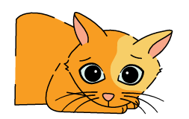  Dilated pupils | 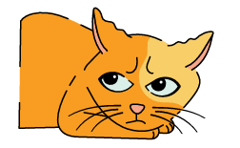  Ears turned back, furrowed brows | 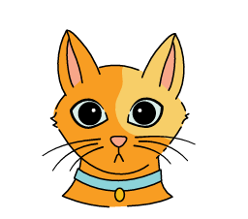  Staring, focused on the source or fear or anxiety
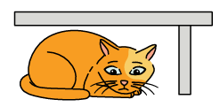  Hiding | 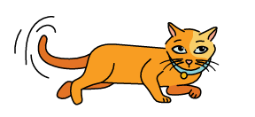  Laying on side, tail flicking | 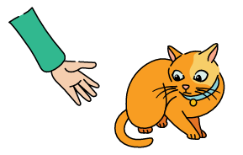  Slight crouching
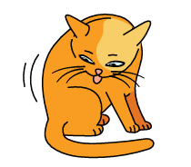  Sudden grooming, excessive grooming | 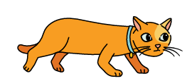  Lowered body posture, tail down. | 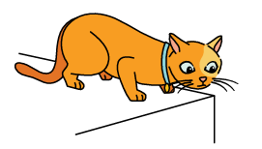  Trying to escape

  - Major signs of fear and anxiety.
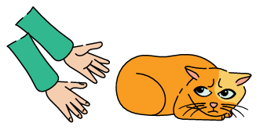  Major crouching. | 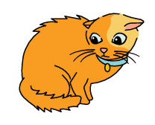  Hair raised, staring, ears turned back | 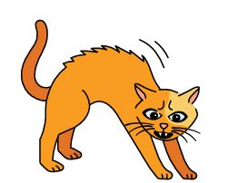  Hissing and/or swiping

Body language of fear stress and anxiety in dogs
Subtle signs of fear and anxiety.
One or more signs may be observed.
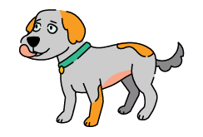  Licking lips  when no food is nearby | 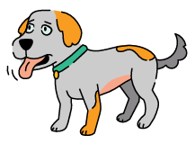  Panting  when not hot or thirsty | 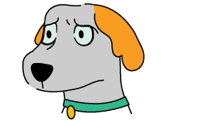  Brows furrowed, ears to side or in lowered position
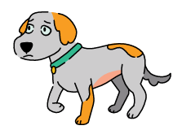  Walking in slow motion,  lifting a paw | 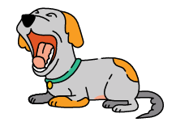  Yawning  when they shouldn’t be tired | 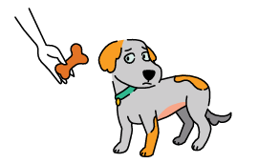  Suddenly won’t eat but was hungry earlier
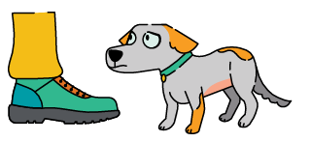  Slight cowering | 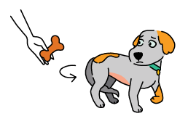  Moving away

  - Major signs of fear and anxiety.
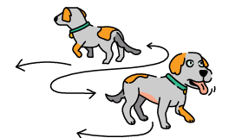  Pacing  Sometimes with sweaty paws | 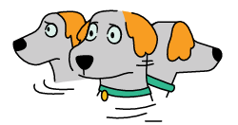  Hypervigilant  looking in many different directions | 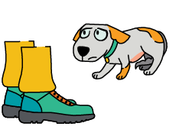  Major cowering

