

Regional Drought Resilience Planning Program

Implementation Grant Guidelines (2026-2029)
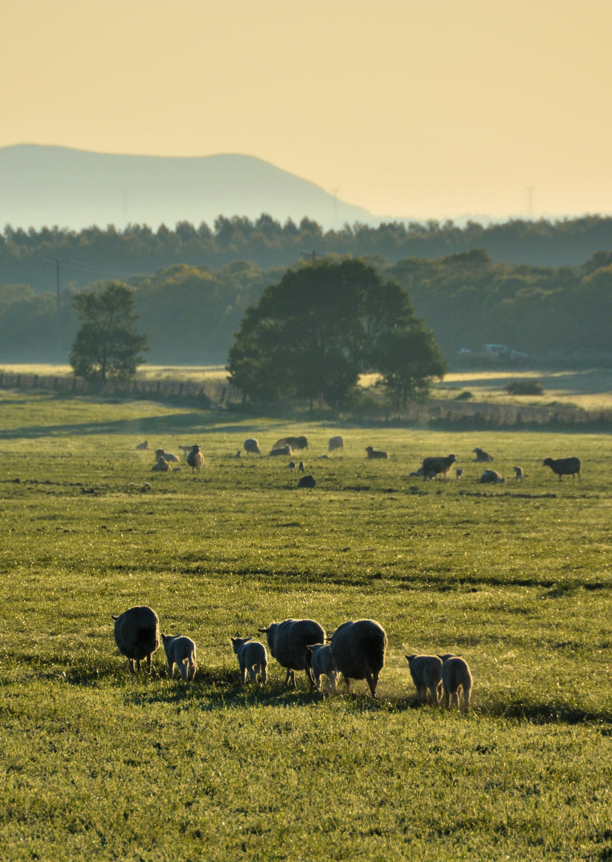




Contents
1. Program Overview 2
1.1 What is the Regional Drought Resilience Planning program? 2
1.2 What are the RDRP 2.0 Implementation Grants (2026-29)? 3
1.3 Program objectives 3
2. Eligibility 4
2.1 Who can apply? 4
2.2 Who cannot apply? 4
3. Funding 4
3.1 Funding amounts 4
3.2 What will be funded? 4
3.3 What will not be funded? 5
4. Assessment process 6
4.1 Assessment criteria 6
5. Application process 7
5.1 How to apply 7
5.2 Required documentation 7
6. Grant conditions and responsibilities 8
6.1 Funding agreements 8
6.2 Legislative and regulatory requirements 8
6.3 Tax implications 8
6.4 RDRP program co-branding and acknowledgement guidelines 8
6.5 Payment of grants 9
6.6 Monitoring and reporting 9
6.7 Privacy 9
6.8 Intellectual Property 9
7. Additional information 9
8. What is the notification process? 10
9. Key dates 10
10. Checklist 10
Appendix 1: Assessment Scoring Table 11

1. Program Overview

1.1 What is the Regional Drought Resilience Planning program?
The Regional Drought Resilience Planning (RDRP) program was established in 2021 as a foundational program of the Australian Government’s Future Drought Fund. The program supports agricultural regions across Australia to develop and implement Regional Drought Resilience (RDR) Plans.
In Victoria, the RDRP program is co-funded by the Australian and Victorian Governments and is delivered by Agriculture Victoria.
In Phase 1 of the program (2021-25), 9 RDR Plans were developed through a collaborative, place-based and community-led approach. Their long-term objective is to build social, economic and environmental resilience to drought and climate change in line with local priorities. Each RDR Plan identifies actions to build resilience within the agriculture sector, broader regional economy, community and landscapes.
Nine RDR Plans are now published, covering all of Victoria with the exception of metro and peri-urban Melbourne.
- Barwon | - Goulburn | - Mallee
- Central Highlands | - Great South Coast | - Ovens Murray
- Gippsland | - Loddon Campaspe | - Wimmera Southern Mallee
In Phase 1, Implementation Grants of up to $380,000 were awarded to 9 regional organisations, known as Plan Coordinators. Each Plan Coordinator, with the support of an Implementation Governance Group, delivered a diverse range of activities to build regional drought resilience, aligned to priority actions from their region’s RDR Plan. Implementation Governance Group members included the region’s agriculture sector, state and local government, water authorities, and other community, health, education and industry representatives.
Phase 2 of the RDRP program (RDRP 2.0) will build on the momentum from Phase 1, with a focus on implementing priority actions from the existing RDR Plans, both through regional activities and cross-regional/statewide projects. Plan Coordinators will again play a key role to identify and deliver activities to build regional drought and climate resilience.
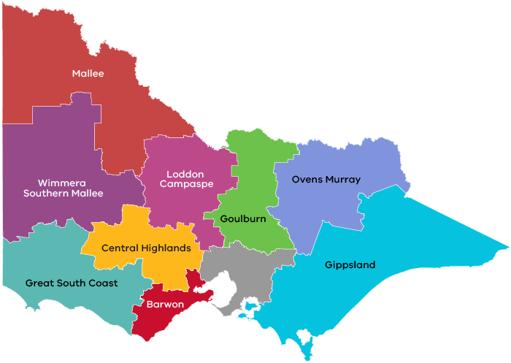

1.2 What are the RDRP 2.0 Implementation Grants (2026-29)?
RDRP 2.0’s Implementation Grants (2026-29) will build on the momentum of Phase 1. Program funding will continue to be provided by the Australian Government’s Future Drought Fund and the Victorian Government, with a total of $13.95 million available for RDRP 2.0 Implementation Grants.
The Implementation Grants will continue to support collaborative, place-based delivery of activities in and across Victoria’s 9 regions. Activities will address priority actions from a region’s RDR Plan and explicitly aim to improve the drought preparedness and resilience of the region’s agriculture sector, supply chains, communities and/or natural resources.
The Implementation Grants will be awarded to 9 regionally-based organisations who will be referred to as Plan Coordinators. Plan Coordinators will firstly be required to establish Implementation Governance Groups (guided by Terms of Reference developed by Agriculture Victoria) and work with Implementation Governance Groups (IGG) to:
- prioritise the RDR Plan actions to be addressed with grant funding
- develop and test proposed activities at a preliminary workshop with Agriculture Victoria, Future Drought Fund program leads and other relevant agencies
- document activities in an Implementation Plan for approval by Agriculture Victoria.
Plan Coordinators will also be key members in an Advisory Committee to inform the prioritisation and development of cross-regional / statewide projects. Projects will address common actions in many, if not all, RDR Plans.
The Implementation Grants will include 2 financial components, both paid to Plan Coordinators:
- Coordination grant - to directly fund the successful applicant to act as Plan Coordinator from execution of Grant Agreement to 30 June 2029. Plan Coordinators will be required to govern, coordinate, evaluate and report on grant outputs and outcomes.

- Activity grant - to fund approved activities in the region that will build regional drought resilience. Activities will be delivered from approval of region’s Implementation Plan to 30 June 2029, and are to be implemented by regional organisations through subcontracting, grant and/or other procurement processes.

1.3 Program objectives
The RDRP 2.0 Implementation Grant Program (2026-29) will support achievement of the following national RDRP program outcomes:
- Regional drought resilience planning and action is locally-led and owned by regional communities
- Regional communities are developing a culture of deliberative, proactive and coordinated regional drought resilience planning and action
- RDR Plan actions are enhancing regional drought and climate resilience in line with local priorities
These program-level outcomes support the Future Drought Fund’s long-term outcome of an innovative and profitable agriculture sector, a sustainable natural environment and adaptable rural, regional and remote communities – all with increased resilience to the impacts of drought and climate change.

2. Eligibility

2.1 Who can apply?
Applicants be one of the following entities:
- a company incorporated in Australia
- an incorporated trustee on behalf of a trust
- an industry association or business chambers
- a partnership
- a joint (consortia) application with a lead organisation
- a registered charity or not-for-profit organisation
- a community-based organisation
- a publicly funded research organisation
- a Victorian state agency or body
In addition, to be eligible for funding applicants must:
- operate a business located within Victoria (unless the applicant is a Victorian state agency/body)
- be financially solvent
- hold an Australian Business Number (ABN)
- be registered for Goods and Services Tax (GST) if required
- attest that they will participate in future program evaluation activities

2.2 Who cannot apply?
Individuals, Victorian Local Government Authorities, and Australian agencies and bodies are not eligible to apply.

3. Funding

3.1 Funding amounts
A grant of up to $1.55 million (excl GST) if available to each of the 9 regions.
Applicants’ contributions can be financial or in-kind, but are not mandatory.

3.2 What will be funded?
Grant funding to Plan Coordinators will comprise Coordination and Activity components.
Coordination grant funding (up to $460,000) will be for the Plan Coordinator to:
- establish and coordinate a regional Drought Resilience Implementation Governance Group (IGG) in line with provided Terms of Reference
- collaboratively identify priority actions from the region’s RDR Plan guided by a provided prioritisation framework
- collaboratively identify and develop evidence informed activities that will address the priority RDR Plan actions
- prepare an Implementation Plan for Agriculture Victoria’s approval
- coordinate delivery of approved activities to 30 June 2029
- reconcile regional activities with RDR Plan and where required, review and revise the RDR Plan in consultation with the IGG and Agriculture Victoria
- be a member of the Advisory Committee to prioritise cross-regional/statewide projects with other regional Plan Coordinators, Agriculture Victoria and First Nations
- complete reporting and evaluation of activity delivery over the lifetime of the grant
Activity grant funding (up to $1.09 million) will be awarded to Plan Coordinators to implement activities in their region’s approved Implementation Plan.
Implementation Plans will be required to detail activities to address specific actions within the region’s RDR Plan. All activities must demonstrate public benefit. Activities that might be funded include, but are not limited to:
- initiatives and events that build community capacity, capability and connectedness, and/or increase skills, knowledge and understanding of the risks posed by drought and climate change to the region.
- detailed planning/feasibility studies on drought resilient alternative land uses in the region and transition planning.
- reviewing regional services and capability as relevant to drought preparedness, response and/or recovery, with the aim of improving the availability, targeting and/or coordination of those services.
- projects that support the collection, management, public accessibility, analysis and/or application of data and information to improve regional drought preparedness, response and/or recovery.
- development or application of land management practices or strategies to improve natural resource management, including practices based on, or which integrate, Traditional knowledge.
- development of local water demand reduction strategies, policies to enhance water security, or detailed investigations of current water use.
- small-scale public infrastructure which does not incur significant ongoing operational and maintenance costs, which provides a public benefit and aims to improve drought resilience in the region.
Plan Coordinators will be encouraged and supported by Agriculture Victoria to develop partnerships with local Traditional Owner groups – either through the IGG or alternative arrangements – to co-design and deliver activities aligned with their Plan and which support Traditional Owners’ self-determined priorities and unique rights and obligations in caring for Country.

3.3 What will not be funded?
The program will not fund the following activities:
- provision of in-drought assistance to directly address hardship.
- on-farm infrastructure.
- major infrastructure projects which incur significant ongoing operational and maintenance costs.
- activities which duplicate current/planned offerings from other programs and initiatives, including (but not limited to) other Future Drought Fund programs of Farm Business Resilience, Communities and the Victorian Drought Resilience Adoption and Innovation Hub.
- activities that take place wholly or mostly outside of the relevant region.

4. Assessment process
After applicant eligibility checks are completed, Expressions of Interest (EoI) deemed eligible will be assessed by an Agriculture Victoria Assessment Panel.
The Assessment Panel will include a minimum of 3 senior and/or executive level Agriculture Victoria staff.
EoIs will be assessed and scored against the assessment criteria outlined in Appendix 1. Applicants with the highest score for their respective region will be recommended to the Minister for Agriculture to decide the grant recipient in each region.
If scoring of EoIs by the Assessment Panel does not indicate a recommended recipient, an interview step will be included to determine the best suited grant recipient for the region. Applicants will receive at least 2-weeks notice of an intention to interview.

4.1 Assessment criteria
First, EoIs will be checked for eligibility to ensure that the applicant is a suitable entity and eligible for funding.
Eligible EoIs will then be assessed against the criteria listed below. Each criterion is weighted to reflect its relative importance in the assessment process. Applications should address all relevant criteria.
Assessment criteria 1: Track record, capability and strategic alignment (50%)
This criterion assesses the extent to which the applicant:
- can demonstrate organisational experience in project delivery, including ‘on-time on-budget’ track record.
- can demonstrate leadership on multi-stakeholder regional projects and/or the ability to bring together stakeholders to share knowledge, partner and collaborate.
- can demonstrate an understanding of the region and its issues through organisational experience in delivering relevant projects/initiatives, including the effects of drought and climate change in the region.
Assessment criteria 2: Readiness to implement (50%)
This criterion assesses the extent to which the applicant has:
- identified appropriate expertise and capacity within the organisation and adequate resources and financial viability to deliver the grant.
- identified appropriate governance arrangements for the project, including known and anticipated IGG membership.
- documented grant planning and implementation including timeline, coordination grant budget, and risk management, such as:
- the personnel, expertise, time and expenses required to govern and coordinate the RDRP Implementation grant.
- evaluation and monitoring of activities over the life of the grant.
- a risk management plan, which outlines risks to the progression of the project and appropriate treatments.
- Documentation is NOT to include a plan of activities for implementation (to be determined through collaborative process of the IGG and documented in an Implementation Plan).

5. Application process

5.1 How to apply
Expressions of Interest are submitted via email to drought.support@agriculture.vic.gov.au.
The EoI form is available at www.agriculture.vic.gov.au/farm-management/drought-support/drought-programs-and-policy/future-drought-fund.
Applicants are strongly encouraged to commence their EoI early to allow sufficient time to complete all sections and upload required attachments. If you encounter technical issues or require support, please contact drought.support@agriculture.vic.gov.au.
Late EoIs
Late or incorrectly submitted EoIs will only be accepted at DEECA’s discretion if doing so aligns with probity principles and does not compromise the integrity of the application process.
Applicants should not assume that they will be given any further opportunity to amend their EoI. The original EoI lodged should be considered final.

5.2 Required documentation
Please submit the following documents with your application:
- completed Expression of Interest (EoI) form, using the template provided that includes:
- details of your organisation’s track record, capability, and strategic alignment
- readiness to implement documentation of grant planning and implementation including timeline, coordination grant budget, and risk management.
- The following financial documentation:
- Audited financial reports for the last 3 financial years. This should be the ‘final accounts’ with Directors’ Report and Declaration and should include:
- Profit and loss statement
- Balance sheet
- Cash flows
- Notes to the accounts
- Financial projections for the next 3 financial years, including:
- Profit and loss
- Cash flow

Supporting documents must be in an acceptable file type, such as Word, Excel, PDF, or JPEG. The maximum file size for each file is 10MB.
You will receive a confirmation email on submission of the EoI.
Expression of Interest period closes at 5:00pm AEDT on Monday 23 November 2026.

6. Grant conditions and responsibilities

6.1 Funding agreements
Successful applicants will be invited to enter into a legally binding agreement with Department of Energy, Environment and Climate Action (DEECA). A copy of the agreement can be provided to applicants upon request.
The activity does not include using the funding for political campaigning or advocacy activities for political parties.

6.2 Legislative and regulatory requirements
In delivering the activity grant recipients are required to comply with all relevant Australian and state/territory legislations and regulations, including but not limited to:
- The Privacy Act 1998 (Australian)
- The Freedom of Information Act 1982 (Vic)
- Occupational Health and Safety Act 2004 (Vic)
- Water Act 1989 (Vic)
- Planning and Environment Act 1987 (Vic)
- Aboriginal Heritage Act 2006 (Vic)
- Flora and Fauna Guarantee Act 1988 (Vic)

6.3 Tax implications
Applicants should consult the Australian Taxation Office or seek professional advice on any taxation implications that may arise from this grant funding.

6.4 RDRP program co-branding and acknowledgement guidelines
Successful applicants are required to acknowledge the support of the Australian Government’s Future Drought Fund and the Victorian Government in all promotional activities, including but not limited to:
- events and announcements
- public relations activities including workshops, forums and conferences
- display materials such as banners, posters and on-ground project signs
- publications such as reports, books and case studies
- digital information kits and fact sheets
- websites and social media, either through direct acknowledgement or the use of hashtags where space allows.
Guidelines will be provided to successful applicants and will form part of funding agreements.

6.5 Payment of grants
Grant payments will be made as long as:
- the funding agreement has been signed by both parties;
- milestone obligations are met; and
- other terms and conditions of funding continue to be met.

6.6 Monitoring and reporting
Grant recipients are required to comply with project monitoring and reporting requirements as outlined in the funding agreement. This may include progress reports, activity completion records and acquittal documentation.

6.7 Privacy
Any personal information about you or a third party in your application will be collected by the department for the purposes of administering your grant application and informing Members of Parliament of successful applications. Personal information may also be disclosed to external experts, such as members of assessment panels, or other Government Departments for assessment, reporting, advice, comment or for discussion regarding alternative or collaborative grant funding opportunities. If you intend to include personal information about third parties in your application, please ensure that they are aware of the contents of this privacy statement.
Any personal information about you or a third party in your correspondence will be collected, held, managed, used, disclosed or transferred in accordance with the provisions of the Privacy and Data Protection Act 2014 and other applicable laws.
DEECA is committed to protecting the privacy of personal information. You can find the DEECA Privacy Policy online at www.deeca.vic.gov.au/privacy.
Requests for access to information about you held by DEECA should be sent to the Manager Privacy, P.O. Box 500 East Melbourne 8002 or contact by emailing foi.unit@deeca.vic.gov.au.

6.8 Intellectual Property
The grant agreement contains standard departmental clauses relating to intellectual property.
All Intellectual Property created in relation to the project or in any reports, documents or other material created for the purposes of or as a consequence of the grant recipient performing or complying with its obligations under the agreement, vest in the recipient on creation.
The recipient hereby grants to the Department a world-wide, non-exclusive, royalty free licence (including the right to sub-licence), to reproduce, publish, adapt, modify or otherwise use for non-commercial purposes the reports and any documents and other materials provided by the recipient under the agreement.

7. Additional information
Additional information is available at the program web page www.agriculture.vic.gov.au/farm-management/drought-support/drought-programs-and-policy/future-drought-fund.
If you require assistance submitting your Expression of Interest, email drought.support@agriculture.vic.gov.au.

8. What is the notification process?
Successful and unsuccessful applicants will be notified in writing after the assessment process is completed. All decisions are final and are not subject to further review. Unsuccessful applicants can ask for feedback on their application.

9. Key dates
Milestone | Date
EoI open | 2 October 2026
EoI close | 23 November 2026
Activities completed and acquittal reports submitted | 30 June 2029
These dates are indicative only and may change.

10. Checklist
Read these guidelines and the information about this grant program at www.agriculture.vic.gov.au/farm-management/drought-support/drought-programs-and-policy/future-drought-fund before applying and complete the checklist below.
Have you:
☐ read these guidelines carefully?
☐ checked if your organisation is eligible for this grant funding?
☐ checked that you understand the assessment criteria?
☐ checked the key dates?
☐ prepared the appropriate supporting documents

Appendix 1: Assessment Scoring Table
Assessment scoring table
Assessment Criteria | Rating = 10 | Rating = 7.5 | Rating = 5 | Rating = 2.5 | Rating = 0 | Requirements
Track record, capability and strategic alignment (50%) | The applicant has demonstrated a very strong track record of project delivery and capability to bring stakeholders together to share knowledge and collaborate.  Applicant also demonstrates an excellent understanding of the region and its issues and articulates a strategic approach to delivery which is aligned with the community-led ethos of the program. | The applicant has demonstrated a strong track record of project delivery and shows good capability to bring stakeholders together for collaboration.  The applicant possesses a good understanding of the region and its issues and articulates an approach to delivery which is generally aligned with the community-led ethos of the program, though some areas could be more explicitly detailed. | The applicant presents an acceptable track record of project delivery and some evidence of capability to effectively engage and bring stakeholders together to collaborate.  The applicant demonstrates a basic understanding of the region and its core issues. While the approach to delivery is outlined, the strategic alignment with the program's community-led ethos is general and lacks specific detail. | The applicant has demonstrated a weak track record of project delivery, with limited evidence of success. Capability to engage stakeholders and foster collaboration is poor or undeveloped.  The understanding of the region and its issues is superficial or contains inaccuracies. The proposed approach to delivery shows little to no strategic alignment with the community-led ethos of the program. | The applicant has demonstrated no relevant track record of project delivery and there is no discernible capability to work effectively with stakeholders or foster collaboration.  The applicant shows no discernible understanding of the region, its issues, or the program's context. The proposed approach to delivery is non-existent or is fundamentally misaligned with the program's objectives. | This criterion assesses the extent to which the applicant:  - demonstrates organisational experience in project delivery, including ‘on-time on-budget’ track record.  - demonstrates leadership on multi-stakeholder regional projects and/or the ability to bring together stakeholders to share knowledge, partner and collaborate.  can demonstrate an understanding of the region and its issues – including the effects of drought and climate change in the region – through organisational experience in delivering relevant projects/initiatives.
Readiness to implement (50%) | The applicant has identified a highly experienced project team and adequate organisational resources to deliver the project.  Project governance arrangements are rigorous and clearly identify the role of an Implementation Governance Group in supporting implementation planning, delivery and evaluation.  Grant planning – including indicative timelines, budget, risk management, coordination and monitoring and evaluation details – is rigorous and clearly addresses all required elements. | The applicant has identified an experienced project team and adequate organisational resources to deliver the project.  Project governance arrangements are clear and identify the role of an Implementation Governance Group in supporting implementation planning, delivery and evaluation.  Grant planning – including indicative timelines, budget, risk management, coordination and monitoring and evaluation details – is detailed and clearly addresses most of the required elements. | The applicant has identified a project team with mixed experience and adequate organisational resources.  Project governance arrangements are acceptable but general, with some reference to the role of an Implementation Governance Group in supporting implementation planning, delivery and evaluation.  Basic grant planning is provided – including indicative timelines, budget, risk management, coordination and monitoring and evaluation details. However, detail is lacking and greater consideration is required. | The applicant has identified a team with limited or unclear experience and organisational resources that are insufficient for the project’s scope.  Project governance arrangements are weak, vague, or misaligned, with key stakeholders and roles/ responsibilities poorly articulated.  Basic grant planning is provided, with key required elements absent and a general lack of detail present. | The applicant has identified a team with no relevant experience and organisational resources that are insufficient for the project’s scope.  No discernible project governance arrangements have been outlined.  Grant planning has not been provided. | This criterion assesses the extent to which the applicant has:  - identified appropriate expertise and capacity within the organisation and adequate resources and financial viability to deliver the grant.  - identified appropriate governance arrangements for the project, including known and anticipated IGG membership.  - documented grant planning and implementation including indicative timeline, coordination grant budget, and risk management, such as:  - personnel, expertise, time and expenses required to govern and coordinate the RDRP Implementation grant.  - evaluation and monitoring of activities over the life of the grant.  - a risk management plan, which outlines risks to the progression of the project and appropriate treatments.  - Documentation is NOT to include a plan of activities for implementation.

