Withholding Period Statements on Labels

*A withholding period (WHP) can be defined as the minimum period of time that must elapse between the last application of an agricultural or veterinary (agvet) chemical product, and the ‘use’ of the agricultural produce to which the chemical was applied.*

The WHP on a label is designed to ensure that food and fibre derived from treated animals and crops complies with the maximum residue limits (MRLs) set by the Australian Pesticides and Veterinary Medicines Authority (APVMA) and Food Standards Australia New Zealand (FSANZ).

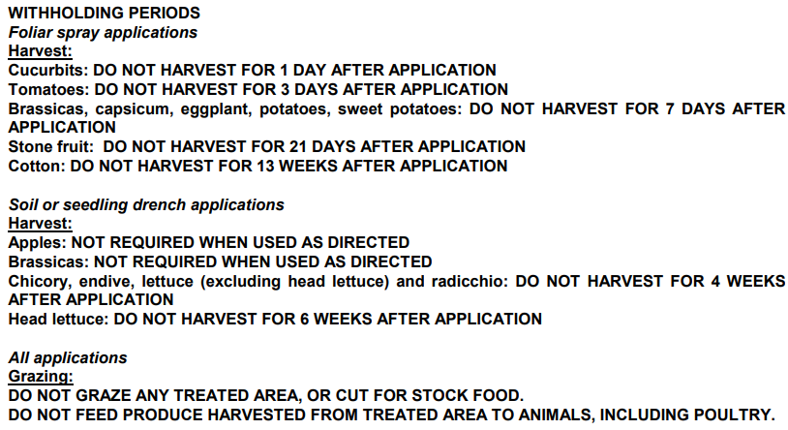

Figure 1 Example of a WHP featured on a Confidor 200SC label

Withholding period statements are found on many chemical product labels within or below the Directions for Use table. The ‘use’ of the agricultural produce is usually clearly defined in the WHP statement on the label, and can include such uses as harvest, sale, grazing, slaughter, cut for stock food, feed to animals, use for recreation etc, and will usually, but not always, include a specific period of time for the WHP.

The period of time for a WHP may be written in days, (1 day, 14 days), or weeks (3 weeks, 16 weeks), but in a few cases, no time period is given.

An example of this is ‘Withholding Period: DO NOT graze treated crops’. In this case, if grazing the crop would normally be an option, the treated crop can never be grazed during its life cycle.

# Witholding period vs re-entry period

The term re-entry period also appears on some labels and can be confused with WHP.

A WHP is different to a re-entry period, which refers to the minimum period of time which must elapse between the application of a chemical product, and re-entry of people to the treated area, unless wearing the same protective clothing recommended during application.

Re-entry periods relate to the safety of people re-entering the treated area, whereas WHPs relate to food safety.

# Withholding period responsibility

It is the responsibility of the owner of any agricultural produce that has been treated with an agvet chemical to ensure that all relevant WHPs are complied with.

When a contractor applies an agvet chemical to agricultural produce on behalf of the owner of the produce, it is essential to inform the owner about the application and in particular, of any relevant WHPs that need to be adhered to.

When agricultural produce (e.g., grain, fruit, vegetables) is to be treated in a post-harvest situation by a person who is not the owner of the produce, the person applying the chemical must have written permission from the owner before the chemical application proceeds.

# Planning chemical use

When planning to treat agricultural produce with an agvet chemical, all relevant WHPs must be taken into consideration.

Planning should ensure that any relevant WHP will expire before any use is made of the produce.

For agricultural produce that may be stored after harvest (e.g., grain, fruit, vegetables), harvest WHPs must expire before the actual harvest of the produce, and the WHP must not include the period of time the produce is in storage.

Planning should take account of the possibility of unforeseen events arising, such as unseasonal weather conditions, or changed priorities, to ensure that WHPs have time to expire before the agricultural produce is used.

In the case of treated crops or stored grain, it may become necessary to sell the agricultural produce before the relevant WHP expires. Sale of any treated produce before the WHP expires is prohibited unless the seller notifies the buyer in writing that the WHP has not expired. In this case, sale includes offer for sale and delivery for sale, therefore stored produce such as grains, fruit and vegetables should not be loaded for delivery, or offered for sale until the WHP has expired, or unless the buyer has been notified by the seller in writing.

Record keeping is an essential management tool for complying with WHPs.

It is compulsory to make specified records within 48 hours of using an agricultural chemical product, and keep these records for a period of two years. This applies to all agricultural chemicals used, including poison baits used for pest animal control. This requirement came into effect on 24 July 2007 and excludes the use of household or home garden products.

# Grazing Withholding periods

Grazing WHPs on labels usually refer to the period of time that must elapse after the last application of a chemical product before grazing livestock on treated plants.

If animals graze on treated plants before the WHP expires, or if treated plants are cut and fed as stockfeed before the WHP expires, there is a possibility that the animals may contain unacceptable residues. Any agricultural produce derived from the animals (e.g., meat, milk, eggs, and wool) may also contain unacceptable residues.

In situations where animals have grazed, or have been fed treated plants before the WHP has expired, and the animals or produce derived from the animals is sold, the seller must inform the buyer in writing that the WHP has not expired.

Dairy cattle grazing pasture

Figure 2 Cows grazing pasture

# Export intervals

To provide guidance on appropriate WHPs to satisfy export market requirements, industry have developed several export intervals for key products including:

(a) Export Grazing Interval (EGI)

Minimum time interval between the application of a chemical to a crop or pasture that is continually grazed, and slaughter, where putting stock onto clean feed (untreated or where an EGI or EAFI has been observed) is not possible.

(b) Export Animal Feed Interval (EAFI)

Minimum interval between the application of a chemical to a crop or pasture and its harvest or being cut for stock food.

(c) Export Slaughter Interval (ESI)

Minimum time interval that stock must be on clean feed before slaughter unless an EGI or EAFI has been observed.

Minimum interval that must pass before slaughter for stock treated with an animal health or veterinary chemical product.

# WHPs and quality assurance (QA)

All QA systems require that MRLs are met, and where agvet chemicals are used off-label in accordance with the legislation, residue testing is required to verify that the appropriate WHP has been applied to achieve compliance with the MRLs.

# Conclusion

WHP statements on labels aim to ensure that agricultural produce treated with agvet chemicals meets the standards set by FSANZ, and that the food we eat and the fibre we wear does not contain unacceptable agvet chemical residues.

# Further information

**Australian Pesticides and Veterinary Medicines Authority website:** www.apvma.gov.au

**Agriculture Victoria Chemical Use website** www.agriculture.vic.gov.au/chemicals

**Agriculture Victoria Chemical Standards Officers**

Email: chemicalstandards@agriculture.vic.gov.au

**© THE STATE OF VICTORIA DEPARTMENT OF**

**JOBS, PRECINCTS &**

**REGIONS, AUGUST 2022.**

|  |
| --- |
| Accessibility |
| If you would like to receive this publication in an accessible format, please telephone Agriculture Victoria on 1300 502 656.  This document is also available in PDF and Word format at [www.agriculture.vic.gov.au/chemicals](http://www.agriculture.vic.gov.au/chemicals) |