Guide to chemical use in Victoria – What I can and can’t do

Chemical users should familiarise themselves with chemical use legislation in Victoria to ensure they meet their legal obligations. It is considered a user’s ‘duty of care’ to understand and comply with their legal obligations.

Chemical use in Victoria is governed by the *Agricultural and Veterinary Chemicals (Control of Use) Act 1992*. This factsheet is designed for all chemical users in Victoria and explains:

* restrictions on the supply and use of certain high-risk chemicals
* the use of chemicals ‘off-label’,
* record keeping requirements,
* designation of Agricultural Chemical Control Areas (ACCAs), designed to protect susceptible crops from damage.

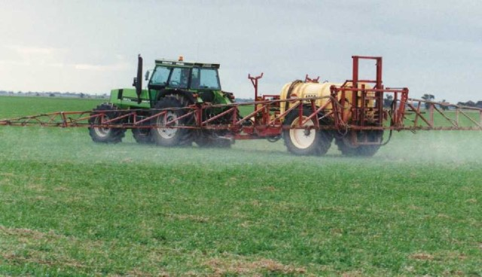

# ‘Restricted Supply’ Chemicals

The Australian Pesticides and Veterinary Medicines Authority (APVMA) is responsible for all aspects of AgVet chemical manufacture, importation, registration, and review, up to and including the point of sale and supply.

The APVMA restricts the supply of high-risk chemicals to ensure they are only supplied to ‘authorised persons’ who have successfully completed accredited training. These chemicals are known as ‘restricted supply’ chemicals and include 1080, endosulfan and mevinphos.

It is a condition of registration that these products only be supplied to individuals authorised by the State, and it is an

APVMA offence to supply these chemical products to an unauthorised person.

In most cases in Victoria, this authorisation is an Agricultural Chemical User Permit (ACUP). A valid ACUP must be held by the person receiving one of these products, whether they will be the end user (who must also hold an ACUP) or not.

**I CAN be supplied with ‘restricted supply’ chemicals if I hold an ACUP.**

# Figure 2 Example of an ACUP

# I CAN’T pass these chemicals on to a user who does not hold an ACUP.

# ‘Restricted Use’ chemicals

Agriculture Victoria (AgVic) is responsible for regulating the use of chemicals in Victoria. AgVic has a system of restricting the use of certain high-risk chemicals. These chemicals are referred to as ‘restricted use’ chemicals and include herbicides, fungicides, insecticides and fumigants.

‘Restricted use’ chemicals are products that:

* are Schedule 7 Poisons (Dangerous Poisons)
* contain atrazine, metham sodium or ester formulations of 2,4-D, 2,4-DB, MCPA or triclopyr.

Individuals using ‘restricted use’ chemicals must hold a valid ACUP or be working under the direct supervision of an ACUP holder or holder of a Commercial Operators Licence (COL).

Restricted use chemicals must also be used according to label directions unless a specific permit has been sought.

## ‘Restricted Use’ Vs ‘Restricted Supply’

It is important to note that ‘restricted supply’ chemicals (APVMA) are different from ‘restricted use’ chemicals (AgVic). A product may have AgVic state use restrictions, but not APVMA supply restrictions.

**I CAN use ‘restricted use’ chemicals provided I hold an ACUP and follow label directions.**

**OR**

**I CAN use ‘restricted use’ chemicals provided I am working under the supervision of an ACUP or COL holder and follow label directions.**

**BUT**

**I CAN’T use ‘restricted use’ chemicals in any manner contrary to label directions UNLESS I hold a specific permit to do so.**

## Off-Label Permits for ‘restricted use’ chemicals

If a person proposes to use a ‘restricted use’ chemical for a use that is not listed on the chemical product label, they must submit an application to the APVMA.

Application forms are available from the APVMA website at <https://apvma.gov.au/node/611>

On receipt of an application, APVMA will conduct a risk assessment of the proposed use (this may require the applicant to collect data), and will decide whether or not to issue the permit depending on the results.

# Chemical use records

It is compulsory to make specified records within 48 hours of using an agricultural chemical product, and keep these records for a period of two years.

This applies to all agricultural chemicals used, including poison baits used for pest animal control. This requirement excludes the use of household or home garden products applied by hand.

Likewise, specified records must be made within 48 hours of using a veterinary chemical product that is classified as a Schedule 4 Poison (Prescription Animal Remedy) or any animal health product which has an applicable withholding period to treat stock animals. Again, these records must be kept for a period of two years.

## Record Format

AgVic does not specify the format in which these records must be kept. This is to provide a degree of flexibility to users who may wish to keep records on computer, in hard copy (e.g. record book, paper files) or a combination of both.

An important feature of any record is that it must be readily available to an AgVic authorised officer upon request.

Chemical record books that comply with regulatory requirements are available commercially. Record keeping templates for recording the use of agricultural chemicals, poison baits and veterinary chemicals (including hormonal growth promotants) are also available from the AgVic Chemical Use website.

**I CAN keep records in a format that suits me, providing that I capture all the necessary information.**

**BUT**

**I CAN’T dispose of chemical use records for two years.**

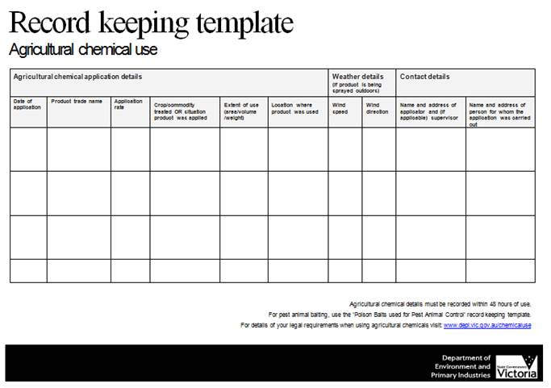

# Off-label use of all other chemicals

Off-label use refers to situations when a chemical is used in a manner that is not specified on the chemical’s product label.

Examples of off-label use include when a chemical is used to control a different pest or to protect a different host (crop or animal), at a different rate, or in a different manner to that listed on the label. Any variation from the label Directions for Use constitutes an off-label use.

In Victoria, it is legal to use chemicals, other than ‘restricted use’ chemicals, “off-label” providing that:

* the maximum label rate is not exceeded
* the label frequency of application is not exceeded
* any specific label statements prohibiting the use are complied with (e.g. DO NOT statements).

Any person who chooses to use these chemicals in an off-label manner does so accepting total responsibility for:

* Efficacy - whether the chemical achieves the desired result or not
* Residues in the environment
* Occupational Health and Safety issues
* Residues in produce. (It is an offence for a person to sell produce derived from a plant or animal that contains a chemical residue that is above the Maximum Residue Limit).

**I CAN use chemicals off-label without a specific permit if they are not classified as ‘restricted use’ and I am willing to accept responsibility for my actions.**

**BUT**

**I CAN’T use chemicals ‘off-label’ if I intend to use them**

* at a higher rate than that listed on the label
* more frequently than the frequency listed on the label
* contrary to a specific ‘DO NOT’ label statement.

**UNLESS I obtain a specific APVMA permit**

# Agricultural Chemical control Areas



Nine Agricultural Chemical Control Areas (ACCAs) have been established in Victoria to protect herbicide sensitive and high value crops (such as grapevines, vegetables, and fruit trees) from damage.

The types of herbicides, their method of application and the periods in which certain chemicals can be applied are restricted in these areas.

**Table 1: Dates ACCA restrictions are operational**

|  |  |
| --- | --- |
| Melbourne | All year |
| Lindenow | All year |
| Orbost | All year |
| Boisdale | All year |
| Mallee and Mid Murray | 1 August – 30 April the following year |
| Extended Mallee | 1 August – 30 April the following year |
| Goulburn Valley | 1 September – 30 April the following year |
| North-Eastern | 1 September – 30 April the following year |
| Rutherglen | 1 September – 30 April the following year |

Chemicals prohibited by aerial spraying or mister application whilst an ACCA is in operation (except Extended Mallee) are:

* any formulation of picloram
* hexazinone applied as a liquid
* products containing sulfometuron methyl
* ester formulations of triclopyr.

Chemicals prohibited by all methods of application whilst an ACCA is in operation (except Extended Mallee):

* ester formulations of 2,4-D, 2,4-DB or MCPA

**I CAN’T use ester formulations of 2,4-D, 2,4-DB or MCPA in an ACCA while it is in operation**.

Chemicals prohibited from aerial spraying or mister application whilst an ACCA is in operation (except Extended Mallee) unless a permit has been granted by AgVic are:

* any formulation of chlorsulfuron, clopyralid, glyphosate or metsulfuron methyl
* any amine formulation of MCPA, MCPB, 2,4-D, 2,4-DB, dicamba, mecoprop or triclopyr.

Chemicals prohibited while the Extended Mallee ACCA is in operation are ester formulations of:

* 2.4-D or MCPA – by any means of application
* triclopyr – by aircraft or mister application.

(Mister = spraying equipment that uses air for dispersing the spray, including orchard sprayers, air blasters and air shear sprayers that produce a fine or very fine spray quality according to the American Society of Agricultural Engineers Standard 572.1, but not air assisted boom sprayers, twin fluid nozzle sprayers or knapsack sprayers.)

ACCAs are defined by Parish boundaries, and the Lot numbers within those boundaries. Knowing this information for a property will help determine whether or not it is within an ACCA. Maps and descriptions of ACCA boundaries are available from AgVic offices and website.

# Conclusion

Before using any chemical, users should always read and familiarise themselves with the entire label, and obtain a copy of the product’s Safety Data Sheet (SDS). Both provide useful information about the chemical product, its contents, health hazards, safe use and handling instructions, Personal Protective Equipment (PPE) and first aid. Copies of SDS’s are available free upon request from chemical resellers or manufacturer’s websites

For further advice on specific regulations outlined in this publication please see the following contact information.

# Further information

**Agriculture Victoria Chemical Use website:** [agriculture.vic.gov.au/agriculture/farm-management/chemicals](http://agriculture.vic.gov.au/agriculture/farm-management/chemicals)

**Australian Pesticides and Veterinary Medicines Authority website:** [www.apvma.gov.au](http://www.apvma.gov.au)

**Chemical manufacturers**

**Chemical resellers and agronomists**

**Agriculture Victoria Chemical Standards Officers**

Email: [chemicalstandards@agriculture.vic.gov.au](mailto:chemicalstandards@agriculture.vic.gov.au)