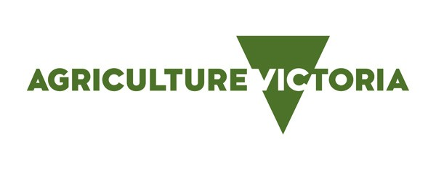
Case Study

Finishing systems for growing lambs – Enhanced Producer Demonstration Site

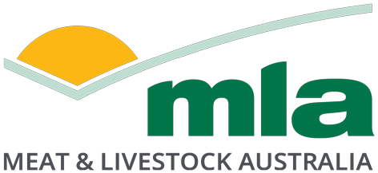Location and landscape

From flats to undulating and steep hills at Cudgewa

Property size, soils and rainfall

400ha; sandy alluvial soils on the flats with granitic soils on the slopes; rainfall annual average of 700mm

Enterprises

Self-replacing White Suffolk sheep flock: 450 ewes for prime lamb production

Self-replacing Poll Hereford cattle herd: 100 breeding cows, selling progeny at around two years old (550–
600kg lwt)

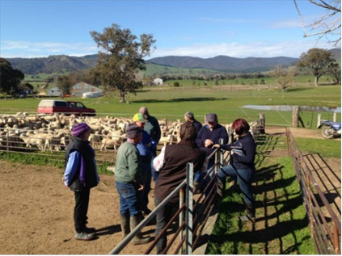Bullioh BestWool/BestLamb group

Linton and Jan Vogel, along with their son Warren, operate a dryland farm at Cudgewa in the Upper Murray region of Victoria. Linton is a founding member of the Bullioh BWBL group, which formed in 2011 with 10 members from Talgarno to Cudgewa in the Upper Murray region. This local group, part of the larger BWBL network, meets regularly and provides producers with a forum to discuss improved management of their sheep enterprises, covering topics such soil and pastures, managing steep hill country, animal health, lamb survival, wool marketing and wild dog impacts.

Producer demonstration project

Linton was a host producer for the Enhanced Producer Demonstration Site (EPDS) project ‘Finishing systems for growing lambs’ delivered through the Bullioh BWBL group between May 2015 and May
2017. The project was funded by Agriculture Victoria and Meat & Livestock Australia, and delivered in partnership with the group’s coordinator, Inspiring Excellence.

One of the common challenges for members of the Bullioh BWBL group is achieving high lamb growth rates so the maximum number of lambs can be sold before pasture growth and quality declines at the end of spring.

The aim of this EPDS project was to improve management to ensure a higher proportion of lambs born in June/July, and weaned at first sale around October, reached target sale weights prior to the end of the spring pasture flush and reduce the number of carry-over lambs into the following year.

The demonstration focused on managing ewe and lamb nutrition, based on monitoring pasture quantity and quality, ewe condition and lamb growth rates.

Completing a range of pasture and livestock assessments was the core focus for the demonstration site participants and members of the Bullioh BWBL group. Regular livestock assessments included condition
scoring ewes and recording weight of all trial lambs utilising electronic identification (EID) tags to capture data.

Key results

Year 1 of this EPDS included monitoring of two mobs, being Maiden and Adult ewes, with both Single and Twin lambs, from marking until first sale of lambs. In Year 2, four mobs were monitored, being Maiden ewes with Single or Twin lambs and Adult ewes with Single or Twin lambs. All lambs were monitored and managed similarly.

Year 1

Pasture feed quality and quantity – feed on offer (FOO) – were sampled at marking and pre-sale during the lamb growth cycle (Table 1). The pasture feed quality samples taken at the time of lamb marking showed a considerable difference in the metabolisable energy (ME) status between the Hill Paddock being 9.4 ME (Maiden ewes and lambs) and the Shed Paddock of 5.2 ME (Adult ewes and lambs). FOO was most limiting, <600kg DM/ha, at the time of marking, which is when the nutritional requirement of ewes is at a peak. Pasture quality sampling showed less variation in ME between these two paddocks at pre-sale.

Table 1: Pasture feed quality* and quantity* results 2015

Month | Mob – Paddock | DM% | CP % | ME (MJ/kg DM) | FOO (kg DM/ha)
August  Marking | Maiden – Hill Paddock | 15.6 | 24.9 | 9.4 | 550
 | Adult – Shed Paddock | 18 | 17.8 | 5.2 | 533
October  Pre-sale | Maiden – Hill Paddock | 23.8 | 15 | 9.4 | 2100
 | Adult – Shed Paddock | 18.3 | 21.5 | 10 | 2000

*DM – dry matter; CP – crude protein; ME – metabolisable energy; FOO – feed on offer

Lamb average weight pre-sale (15 October 2015) across both mobs (n=256) was 46.8kg with the lambs from the Maiden ewes being heavier on average (48kg, ADG 382g/day where ADG represents average daily growth rate) compared to the lambs from the Adult ewes (45.5kg, ADG 349g/day). A contributing factor to the lambs of the Adult ewe mob being lighter is the low 5.2 ME value of the pastures in the
Shed Paddock. Lambs across both mobs had high average growth rates of 366g/day from marking to pre- sale. A total of 71% of lambs were sold by 31 December 2015.

Ewe condition scores averaged 2.7 for Maiden ewes and 2.6 for Adult ewes at marking, 3.2 for Maiden ewes and 3.1 for Adult ewes at pre-sale. Averages were calculated based on assessing at least 50 lactating ewes from each of these mobs.

Year 2

Table 2 shows the pasture quantity and quality of the paddocks used in the demonstration. There was relatively low pasture quality in the Shed Paddock sampled on 28 August 2016, where the Maiden Single mob was grazing. This was reflected in the relatively low weight of the Maiden Singles’ female and wether lambs at the first weighing.
Pasture quality of the Caravan Paddock for 1 December 2016 declined to 8.9 ME from 10.9 ME when previously sampled on 13 October 2016 (Table 2). This decline in pasture quality continued through December to 7.6 ME (Table 2), resulting in lower lamb growth rates between November and December, when all weaned lambs were grazing this paddock (Table 3).

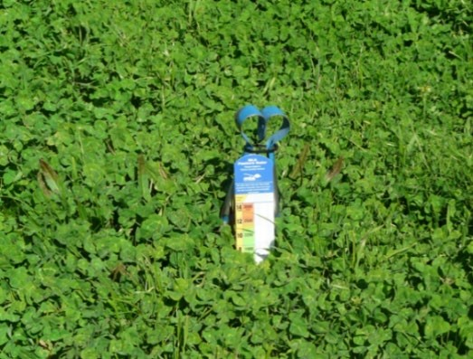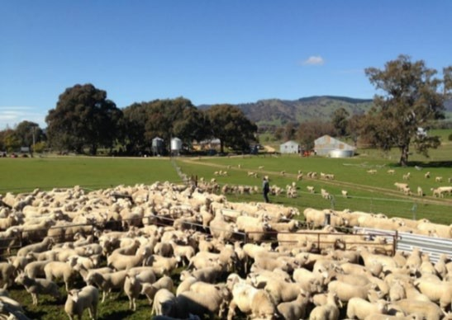

Figure 1: White Suffolk ewes and lambs. Figure 2: Pasture measurement with MLA pasture ruler.

Table 2: Pasture feed quality* and quantity* results 2016

Paddock

Measure
Month | FOO (kg  DM/ha) | Digestibility  (DDM%) | ME (MJ/kg  DM) | Protein  (CP%)
Hill Paddock (Adult Singles)
August | 900 | 74.4 | 11.2 | 20.7
September | 1700 | 76 | 11.4 | 21.5
October | 1622 | 67 | 9.9 | 17.6
50 Acres Paddock (Adult Twins)
August | 1116 | 76.9 | 11.6 | 21.7
September | 1400 | 81 | 12.4 | 21.7
October | 1512 | 75 | 11.4 | 18.0
Shed Paddock (Maiden Singles)
August | 883 | 43.4 | 5.8 | 14.3
September | 1000 | 74 | 11.1 | 19.9
October | 1408 | 69 | 10.2 | 15.4
Caravan Paddock (Maiden Twins)
August | 710 | 79 | 12.0 | 24.0
September | 1600 | 77 | 11.6 | 23.8
October | 1862 | 73 | 10.9 | 20.4
Caravan Paddock (W eaned lambs)
1 December | >2500 | 61 | 8.9 | 11.4
20 December | Not measured | 53 | 7.6 | 12.6
*DDM – digestibility dry matter; ME – metabolisable energy; CP – crude protein; FOO – feed on offer
Lamb average weight pre-sale (8 November 2016) across all mobs (n=349) was 53.5kg with lambs from the Adult Single mob being on average heavier (56.7kg) than lambs from all other treatments. In comparison the Maiden Single lambs, being grazed in the Shed Paddock, recorded the lowest average weight at all four weighings, and had an average weight pre-sale (8 November 2016) of 51.6kg. Approximately 81% of all lambs were sold by 31 December 2016, which was an increase of 10% from Year 1.

Table 3 shows lambs maintained a high overall ADG rate of 372g/day from marking to first sale (ADG at weighing intervals August to November) which was slightly higher than overall ADG 366g/day observed in Year 1 from marking to first sale.
Lamb growth rates dropped significantly from November to December 2016, with an overall ADG being less than 100g/day (Table 3). This trend is expected as the lambs had been weaned, shorn and the pasture feed quality had declined. Ewe condition scores averaged 2.8 for Maiden Single ewes at marking and 2.7 for Maiden Single ewes and 3.4 for Maiden Twin ewes at pre-sale.

Table 3: Average daily growth rate (ADG g/day) for lambs between weighing intervals from August to December

Aug–Nov
ADG Number | Aug–Sep  329 | Sep–Oct  314 | Oct–Nov  291 | Nov–Dec 1  111 | Dec 1–Dec  26  81 (ewes only)
Adult Single | 419 | 411 | 331 | 128 | 77
Adult Twin | 324 | 427 | 318 | 145 | 72
Maiden Single | 374 | 293 | 383 | 80 | 111
Maiden Twin | 371 | 401 | 351 | 62 | 105
Overall average | 372 | 390 | 346 | 96 | 90

303

393

364

357

372

372
The Bullioh BWBL group implemented management practices and identified key learnings from their involvement in this demonstration as follows:
• condition scored ewes to manage their nutritional requirements
• monitored lamb growth rates using EID tags and recorded individual lamb weights
• pregnancy scanned ewes
• separated ewes into single and twin mobs
• selected replacement ewe lambs for early joining based on their liveweight
• identified the impact that different pasture quantity and/or quality has on lamb growth rates
• quantified daily lamb growth rates (e.g.
300+ g/day until November then less than
100g/day from December)
• improved lamb marketing alternatives by predicting target weights
• challenged current thinking of carrying over lambs into next autumn before selling.

Linton identified the following benefits to his sheep enterprise from being a host producer to this EPDS project:
• Value of this demonstration: “Improved management skills including separating mobs into singles and twins, weighing lambs, and allocating pasture based on the nutritional requirements of a specific mob.”
• Value of weighing lambs: “A terrific aid to matching lamb weight to market trends to better target your market, and I’ve purchased an immobiliser and scales since the start of the trial.”
• “For the next joining I will implement Lifetime Ewe Management guidelines to include a shorter joining period, to pregnancy scan ewes, to remove non- pregnant ewes, as well as mark lambs at six weeks old and wean lambs at 12–14 weeks of age.”

By the end of this EPDS project the Vogel family and the Bullioh BWBL producers gained a better understanding of:
• the techniques that are available to determine pasture quantity and quality, and
• the impacts of pasture quantity and quality on prime lamb growth rates, ewe condition and their reproductive performance.
Acknowledgements

The authors acknowledge: producer Linton Vogel for his participation in the project; the Bullioh BestWool/BestLamb group members, and Kristy Howard (Bullioh BWBL group facilitator) of Inspiring Excellence.

Authors:

Ian Gamble and Gervaise Gaunt, May 2019

For further information contact:

Ian Gamble
Agriculture Victoria – Rutherglen
02 6030 4528 ian.gamble@agriculture.vic.gov.au

Disclaimer

Any recommendations, suggestions or opinions contained in this publication do not necessarily represent the policy or views of Meat & Livestock Australia (MLA). No person should act on the basis of the contents of this publication without first obtaining specific, independent professional advice. MLA takes no responsibility, in any way whatsoever, to any person in respect to the document, including any errors or omissions therein, arising through negligence or otherwise however caused.

© Meat & Livestock Australia 2019 ABN 39 081 678 364

This work is copyright. Apart from any use permitted under the Copyright Act 1968, all rights are expressly reserved. Requests for further authorisation should be directed to
the Corporate Communications Manager, PO Box 1961, North Sydney, NSW 2059 or info@mla.com.au.

Published in March 2020.

