Demonstration Summary

Gibberellic acid use in phalaris-based pastures in lower-rainfall areas
of western Victoria – Enhanced Producer Demonstration Site

The Perennial Pasture Systems (PPS) group completed an Enhanced Producer Demonstration Site project, co-funded by Agriculture Victoria and Meat & Livestock Australia. The project looked at the effect of gibberellic acid (GA) on phalaris-based pastures in the upper Wimmera and central region of Victoria during 2016–2018.

What is gibberellic acid

Gibberellic acid (GA) is made naturally in plant roots during spring and stimulates shoot and cell elongation, promoting plant growth. The application of manufactured GA in winter stimulates plant growth and creates an increase in winter feed availability.

How does gibberellic acid work?

Applied GA products work by elongating the cells in the plant, rather than increasing the number
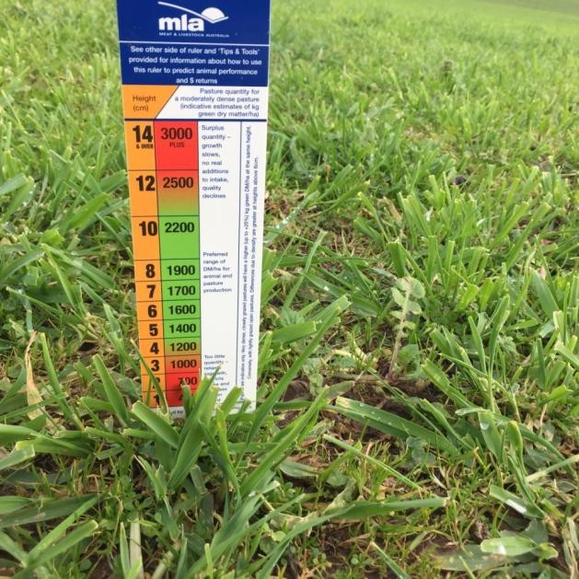of cells. This results in longer, more upright leaves, as opposed to more leaves.

Why do gibberellic acid-treated pastures temporarily turn yellow?

Yellowing of treated plants is quite normal due to a ‘diluting’ effect of the chlorophyll in elongated leaves.

Does gibberellic acid grow more feed?

Yield increases in pasture swards can be
expected following GA application. A study of GA research found a median increase of 500kg DM/ha, although this ranged from 50–1300kg DM/ha and depended on the species and rate applied (Matthew et al., 2009). Whilst a response to most species can be expected, phalaris pastures require lower application rates than some other species, such as perennial ryegrass. Other requirements for growth, such as soil moisture and fertility, should also not be limiting to ensure good results.

Does gibberellic acid affect feed quality?

Feed quality is generally unaffected by GA application, although reductions in plant crude protein have been reported in some research trials (Matthew et al., 2009). Nevertheless, these decreases in crude protein are generally offset
by increased yields, giving an overall increase in crude protein per hectare. The protein levels of pastures at the time of year that GA is applied (winter) is surplus to most animal requirements anyway.
Figure 1: Phalaris prior to GA applications.

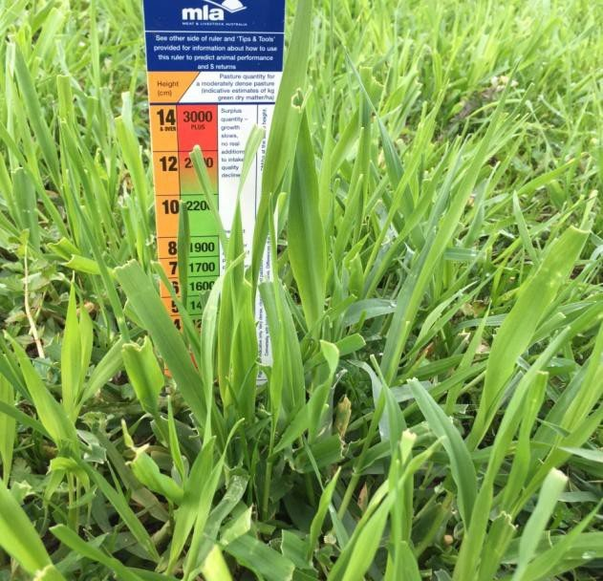Figure 2: Phalaris eight days after GA treatment.

Can it be used with other treatments?

GA manufacturers have tested GA and found it
to be compatible with a range of other chemicals (e.g. Sumitomo Product Information, see references). Producers should refer to product information or seek agronomic advice prior to combining with other chemicals.
Figure 2: Phalaris eight
Figure 2: Phalaris eight
Figure 2: Phalaris eight
Figure 2: Phalaris eight
It should be noted some field work has shown possible lower total growth from GA when combined with herbicides (Conboy and Speirs, unpublished trial data).

Does gibberellic acid have a withholding period?

Additional pasture with GA compared to nil GA(kg/dm/ha)

500

400

GA is a naturally occurring plant hormone and has no withholding period for meat or milk and can be used in organic farming systems. GA should always be used as recommended by the manufacturer.

General practice for using GA

kg DM
/ha
300

200

100

0

Site
1

Site
2

Site
3

Site
4

Site
5

Site
6

Site
7

2016

2017

2018
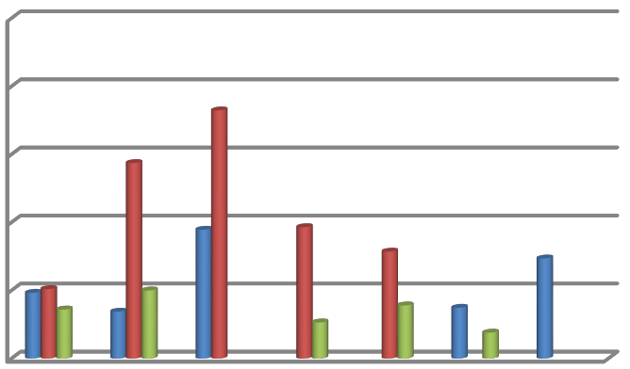
GA should be applied when the air temperature
is between 5–15°C, when natural levels of GA are low.

The best response will occur when moisture and soil fertility are not limiting and are adequate to sustain additional pasture growth.

Pasture should be grazed prior to application, leaving a minimum of 1000kg DM/ha green material to allow GA absorption by leaves. Applications should then occur within five days of stock leaving the pasture, avoiding frost events. Stock should be kept off the pasture for
21 days to allow a good response.

Due to the erect form of the extra feed grown with GA applications, it is estimated 90–100% of it can be used by stock, compared to less than
70% of feed grown without treatment. Careful management and monitoring is required to ensure ample recovery time for plants prior to the next grazing.

The demonstration

The demonstration compared treatments on phalaris-based pastures across seven sites over three years. Treatments included:

1) nil

2) GA only (applied mid-to-late June at a rate of
10g ProGibb™/ha or liquid equivalent Gala™)

Figure 3 shows the additional pasture dry matter (DM) produced at each site in GA treatments compared to nil treatments, showing a high level of variability between sites and years (ranging from 60–370kg DM/ha). The lower growth rates were seen under the drier conditions of 2016
and 2018.

Figure 1: Additional pasture grown (DM) at each site after GA treatments compared to Nil, for each year (2016–2018).

GA produced useful quantities of extra feed in the good growing season of 2017, when moisture was available and phalaris pastures were dense (1500kg DM/ha prior to GA application). However, the extra feed produced was surplus to requirements and was not fully utilised and the economic benefit was not realised.

The demonstration indicated phalaris needed to make up at least 40% of the total pasture composition to make GA application worthwhile. Even good phalaris and sub-clover based
pastures often contain less than 40% phalaris.

Results from the demonstration indicate the use of GA on phalaris-based pastures should be opportunistic, rather than strategic, in lower- rainfall regions and seasons. The sites achieved vastly different yearly growth patterns due to variable autumn breaks, which limited the moisture availability and subsequent pasture growth. This also affected the ability to fit GA treatments and the recommended period of destocking (21 days) into grazing rotations.

References

Conboy C. and Speirs A. (2009) Gibberellic Acid on Phalaris Trial Quamby, Dobie; unpublished

Matthew C., Hofmann W.A. and Osborne M.A. (2009) Pasture response to gibberellins: a review and recommendations. New Zealand Journal of Agricultural Research 52:2, 213-225
Sumitomo Product Information, ProGibb SG product information, viewed 5 November 2018, www.sumitomo-chem.com.au

Vicchem Product Information, Gala product information, viewed 5 November 2018, www.vicchem.com

For further information contact:

Rob Shea
Perennial Pasture Systems yadin@netconnect.com.au

Rachael Campbell Agriculture Victoria Rachael.campbell@ecodev.vic.gov.au

Disclaimer

Any recommendations, suggestions or opinions contained in this publication do not necessarily represent the policy or views of Meat & Livestock Australia (MLA). No person
should act on the basis of the contents of this publication without first obtaining specific, independent professional advice. MLA takes no responsibility, in any way whatsoever, to any person in respect to the document, including any errors or omissions therein, arising through negligence or otherwise however caused.

© Meat & Livestock Australia 2019 ABN 39 081 678 364

This work is copyright. Apart from any use permitted under the Copyright Act 1968, all rights are expressly reserved. Requests for further authorisation should be directed to the Corporate Communications Manager, PO Box 1961, North Sydney, NSW 2059 or info@mla.com.au.

Published in March 2020.

