Reducing weed risk

The risk of weed invasion, and their impact on farms and the environment dramatically increases during and after an emergency such as drought, fire or flood.
The problem is often compounded, as dealing with other pressing emergency response and recovery issues, the spread of weeds can often be overlooked.
It is not until some months after the emergency that it becomes obvious that weed impact may be a most costly legacy to the farmer.
To minimise this risk, farmers and land managers can implement some simple actions which may save money, environmental values and avoid future stress whilst recovering from an emergency.
The activity that poses the greatest risk of weed invasion during and after an emergency is the movement and importation of hay and grain as stockfeed onto farmland. Be especially careful of feed or hay that may have been imported from interstate, as it could potentially carry new weeds into Victoria.

What can you do?
Stockfeed on farm
• Feed-out in a confined area away from drainage lines (stock containment areas) to reduce the likelihood of weeds being spread throughout your property.
• Monitor feed-out areas regularly and be suspicious of unfamiliar plants that germinate.
• Sending a photograph to your local agronomist or to Agriculture Victoria is a good avenue for identification. Unexplained illness or death of livestock should also be promptly investigated by a private vet or report to Agriculture Victoria animal health staff.

Transporting hay or grain stockfeed
• Vehicles should be cleaned down after deliveries.

• Vehicle cleaning should occur in a designated area to prevent weed dispersal and contain new infestations for easier management.
• During drought or after fire, keep an eye on local roadsides and for 12 months afterwards, to detect new weed infestations.
Stock
• Building up stock numbers when recovering from an emergency is also another high-risk activity that can introduce weeds.
• Quarantine new stock for up to 14 days, allowing time for viable seed to pass through the animal.
• Check for weed seed in fleece and continue to check for the weeds in areas with new stock.
• Where possible, purchase shorn sheep.
• When moving stock along roadsides try to avoid travel through known weed infestations.
• Monitor stock routes during drought or after fire and for 12 months afterwards, to detect new weed infestations.
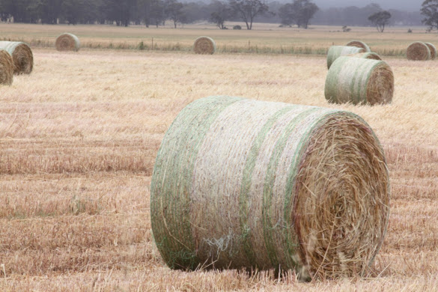

Other weed-spread risks during emergency and recovery:
DROUGHT:
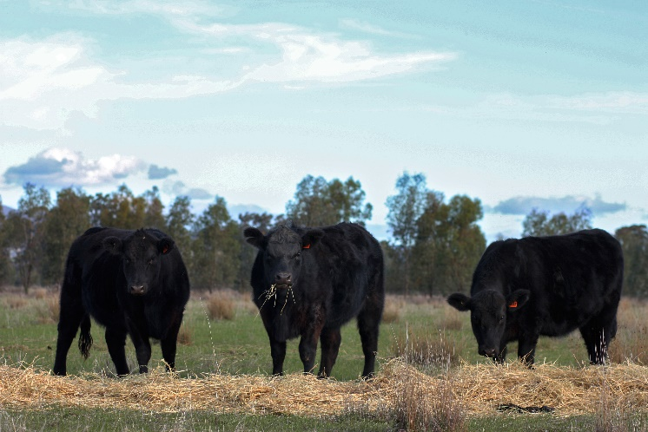
• Ensure that vehicles and equipment of contractors/advisors are clean and free of weeds before entering and leaving your property to clean dams, cart water or carry out other works which, in the case of drought or fire, take advantage of the dry conditions.
• Use contractors that are accredited in vehicle/machinery hygiene.
FIRE:
• Firefighting activities may spread weeds – monitor areas burnt by wildfire for weed germination.
• Ensure that vehicles and equipment of contractors/advisors are clean and free of weeds before entering and leaving your
property to replenish water supplies, rehabilitate fire breaks, clear fence lines and re-establish vegetation.
• Weed seeds can also be easily spread by water flow across bare ground during rain events.
FLOOD:
• Weed propagules can be dispersed in flood waters. Monitor areas previously flooded for 12 months afterwards to detect new weed infestations.
• Weed propagules can easily attach to vehicles and equipment in muddy conditions and when being moved between properties to repair flood damage and assist with recovery, they can pose a high risk of weed spread. Ensure that vehicles and equipment of contractors/advisors are clean and free of weeds before entering and leaving your property
For more information or phone our customer service centre on 136 186.

