Evapotranspiration provides a relatively objective and reliable estimate of the water requirements of actively growing plants in a farm situation. Evapotranspiration information can be used by irrigators to more accurately schedule irrigations to help achieve top yields and improve water productivity.
What is evapotranspiration and how do I use it to schedule irrigations?

WHAT IS EVAPOTRANSPIRATION?
Evapotranspiration is an estimate of the loss of water from both plants and the soil. The main drivers of evapotranspiration are sunlight, wind, humidity and temperature.

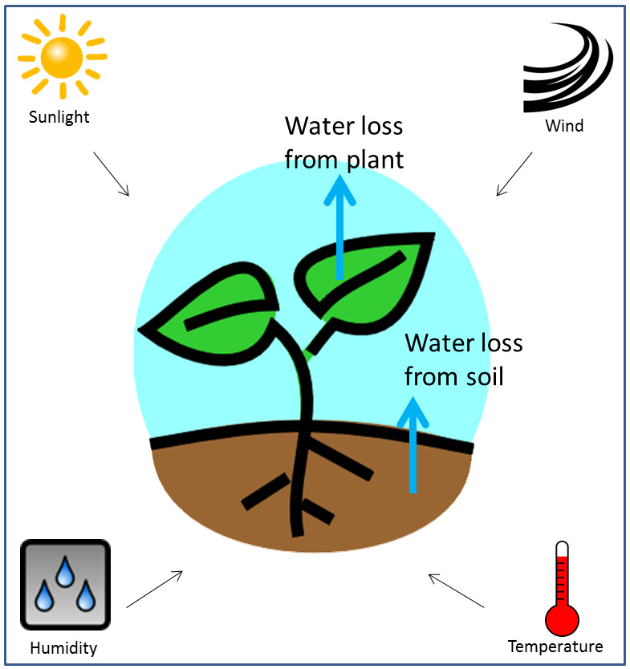
Figure 1 - Evapotranspiration concept diagram, showing the process of evapotranspiration (middle illustration) and the main drivers of evapotranspiration (far corners of the diagram).

‘Reference evapotranspiration’ (ETo) is commonly used as a standard estimate of evapotranspiration. ETo specifically refers to evapotranspiration from a reference stand of actively growing, well-watered grass, 120mm in height. For practical purposes, ETo provides a workable representation of the water requirements of good productive pasture on an irrigated farm.

ETo rates are typically measured in millimetres per day (mm/day) and are highest in the summer months and comparatively lower in spring and autumn. (Table 1.)

 | Aug | Sept | Oct | Nov | Dec | Jan | Feb | Mar | Apr
ETo (mm/day) | 1.7 | 2.8 | 4.3 | 5.5 | 6.8 | 7.2 | 6.1 | 4.5 | 2.7
Data source: Bureau of Meteorology.
Table 1 - Average daily reference evapotranspiration (ETo) rates at Kyabram, Victoria calculated over the last seven years.
Why would I want to use ETo to schedule irrigations?
Over the last few years there has been increasing interest in ETo and other irrigation scheduling tools due partly to the rising cost of water and the need to improve water productivity. The increasing interest is also a result of on-farm and irrigation supply system upgrades. As a result of these upgrades, many irrigators have found they have more control of water on farm and are able to obtain more value from irrigation scheduling tools.
ETo information enables irrigators to better match irrigations with the requirements of actively growing plants, thereby assisting to achieve higher yields and improve water productivity.
ETo helps take the guess-work out of irrigating. A small, but regular improvement in irrigation scheduling can significantly increase over-all plant production and quality.
ETo also provides an objective estimate that can be used in conjunction with subjective scheduling methods already used by irrigators such as digging up the soil with a shovel or using an electric fence post (effectively as a penetrometer) to gauge how hard and dry the soil is. By regularly monitoring ETo data, irrigators can become better informed about plant water requirements and are able to improve their scheduling skills and ‘re-calibrate’ other convenient scheduling methods. ETo can be a very useful learning tool.
Another advantage of using ETo is that local ETo values are relevant across a whole paddock and in most cases across a whole farm or small district. On the plains, ETo tends to be relatively consistent over distances in excess of several kilometres. This is unlike rainfall, which can vary from one end of the property to the other.
On the other hand, soil moisture measurements are usually only measured from a very small volume of soil. Care needs to be taken when using soil moisture information to schedule irrigations across a paddock or larger farm area because of variability in soil types, soil water holding capacity, water extraction rates and evenness of watering. Having said this, soil moisture monitoring can provide very valuable information related to irrigation scheduling. Soil moisture monitoring complements ETo information and vice versa. Ideally ETo information and soil moisture monitoring are used together to inform irrigation decisions.
Irrigators report the use of ETo information is of added value after a rainfall event and in spring and autumn when the weather and plant water use tend to be most variable.
Without objective information it can be difficult to work out the best time to schedule irrigations particularly at these times. Some irrigators also pay special attention to ETo data in summer when plant water demands are high and growth rates are more sensitive to delayed irrigations. Other irrigators find ETo information particularly useful in assisting to better understand the water requirements of crops they are growing for the first time or have had limited experience with.
Past and forecast ETo data can usually be obtained free of charge, as described later in this document. Forecast ETo is unique information about future plant water requirements that allows you to more accurately plan irrigations.
User-friendly tools are also available that take the hassle out of doing the calculations involved with using ETo information. These interactive tools assist with improved irrigation decision making for your unique circumstances. More detail about these tools is provided later in this Tech Note under the heading “Where can I source ETo data?”
ETo is regarded as a more reliable method of determining plant water requirements than traditional “pan evaporation” – which refers to the water loss from a standard evaporation pan. For example, water continues to evaporate from an evaporation pan at night, even though plant water use at this time is usually negligible.
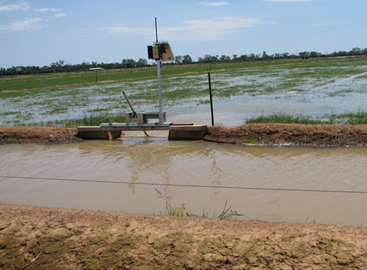
Figure 2. - Pasture being surface irrigated. Tongala, Victoria.

What are the basic principles of using ETo for irrigation scheduling?
In order to match irrigation with actively growing plant requirements, irrigation scheduling needs to relate to the amount of water in the soil that is readily available to plants (also known as “Readily Available Water” or “RAW”). Consideration also needs to be given to the water use of the actively growing crop. These two concepts can also be thought of as the “size of the bucket” and the “water use from the bucket.”
i) RAW (or the “size of the bucket”). RAW is the component of soil moisture that can be readily extracted by plants before they suffer from moisture stress and lower growth rates.
The basic concept is that as plants extract water, the soil water content decreases and reaches a threshold value beyond which water becomes more strongly bound to the soil and more difficult to extract. When cumulative water extraction exceeds the RAW value, soil water can no longer be extracted quickly enough to meet actively growing plant water requirements.
There is a risk of a “green drought” if the irrigation interval is ‘stretched out’ and cumulative water extraction exceeds the estimated RAW value. If this occurs, plants can appear healthy, but growth is compromised. In the extreme case without irrigation or rain, eventually a point is reached where water uptake is zero and plants permanently wilt and die.
Typically RAW will vary depending on the crop and soil type. For example, RAW for crops such as mature lucerne, maize or sorghum is likely to be higher than for pasture because these crops have a deeper and stronger root system to extract moisture.
Usually on surface irrigated soils in the Goulburn Murray Irrigation District (GMID) of Northern Victoria, up to ‘30mm to 60mm’ of moisture (0.3 megalitres per hectare to 0.6ML /ha) will be readily available for established ryegrass-clover based pasture. In the GMID, 40mm (0.4ML /ha) between irrigations after the bay has drained is a commonly used RAW value on good quality established ryegrass-clover based pasture.
For mature maize there will typically be up to 60mm to 70mm of RAW on these soils. Where-as for mature lucerne RAW tends to be in the range of 70mm to 100mm.
Under conditions with relatively low ETo (eg. during the cooler months of spring and autumn), slightly more water may be readily available to plants than in high ETo conditions, simply because the plants are able to extract soil moisture at a slower rate to meet their water requirements.
RAW will also be lower for newly established plants with a smaller root system. Generally RAW is higher in loam soils, than in sands or heavy clays.
Paddock assessments, along with soil moisture monitoring can be used over time to more accurately estimate the appropriate RAW value for specific circumstances.
ii) The water use of the particular crop (or the “water use from the bucket”). The water use of an actively growing crop can be described relative to the reference stand of healthy productive pasture. For example, mature lucerne, maize or sorghum is likely to have a bigger crop canopy and will require more water than pasture under the same conditions for top growth rates.
A “crop coefficient” (Kc) is used to express a crops relative water use. The reference stand of pasture is given a Kc of 1.0. Where-as, the appropriate Kc for mature actively growing lucerne, maize or sorghum is likely to approximate 1.2. A Kc of 1.2 indicates the crop requires 120% of the water needed for good pasture.
Well grazed or freshly cut lucerne will only have remnants of a full canopy and the Kc is likely to be in the range of 0.4 to 0.8. The Kc for irrigated and well managed pasture (Kc = 1) on the other hand, is not likely to be significantly reduced after grazing due to high plant density and the presence of a ‘good’ grazing residual.
Following sowing when new leaves have just emerged, Kc’s for different crops are usually less than 0.4. For example, maize or sorghum at this stage is likely to have a Kc of 0.2 to 0.3. The Kc increases in line with plant growth until a full canopy is developed.
The estimated crop water requirement (ETc) for high growth rates is obtained by multiplying the specific crop coefficient (Kc) by reference evapotranspiration (ETo). ie. ETc = ETo x Kc.

How do I use ETo to schedule irrigations for pasture?
Surface irrigations: To optimise pasture production, surface irrigations are typically timed when pasture water uptake (which can be estimated with ETo,) has drawn RAW down to a value equal or close to zero.
Usually when pasture is surface irrigated, it takes one or two days for excess water to freely drain from the soil. Optimum irrigation timing is determined by subtracting subsequent (after the soil has drained) daily ETo values from the estimated maximum RAW value (eg. 40mm), until it is close to zero. When RAW has been drawn down close to zero, it is time to irrigate again. (Table 2 and Figure 3.)
Rainfall: As well as plant water uptake, rainfall can also affect RAW. It is important that the scheduling calculations described above include rainfall (“R”), which will extend the irrigation interval. (Table 2 and Figure 3.)

 | Day 0 | Day 1 | Day 2 | Day 3 | Day 4 | Day 5 | Day 6 | Day 7 | Day 8 | Day 9 | Day 10
ETo (mm) | - | 5.1 | 4.9 | 5.8 | 5.3 | 5.3 | 5.9 | 5.9 | 5.7 | 6.3 | -
Kc | - | 1.0 | 1.0 | 1.0 | 1.0 | 1.0 | 1.0 | 1.0 | 1.0 | 1.0 | -
ETc (ETo x Kc, mm) |  | 5.1 | 4.9 | 5.8 | 5.3 | 5.3 | 5.9 | 5.9 | 5.7 | 6.3
Rain (mm) | - | - | - | 5.0 | - | - | - | - | 6.0 | - | -
ETc-R (mm) | - | 5.1 | 4.9 | 0.8 | 5.3 | 5.3 | 5.9 | 5.9 | -0.3 | 6.3 | -
Cumulative ETc-R (mm) | - | 5.1 | 10.0 | 10.8 | 16.1 | 21.4 | 27.3 | 33.2 | 32.9 | 39.2 | -
RAW (mm) | 40 | 34.9 | 30 | 29.2 | 23.9 | 18.6 | 12.7 | 6.8 | 7.1 | 0.8 | 40
Irrigation | √ | - | - | - | - | - | - | - | - | - | √
Table 2 - Depleting Readily Available Water (RAW). Figures in this table show how daily reference evapotranspiration (ETo) and rainfall (R) figures are used to estimate daily pasture RAW to determine the timing of the next surface irrigation. To help optimise water productivity, the next irrigation is timed when RAW is depleted, or close to zero. It is estimated the soil in this case can hold up to 40mm of ryegrass-clover pasture RAW and the soil has freely drained by the end of “Day 0”.
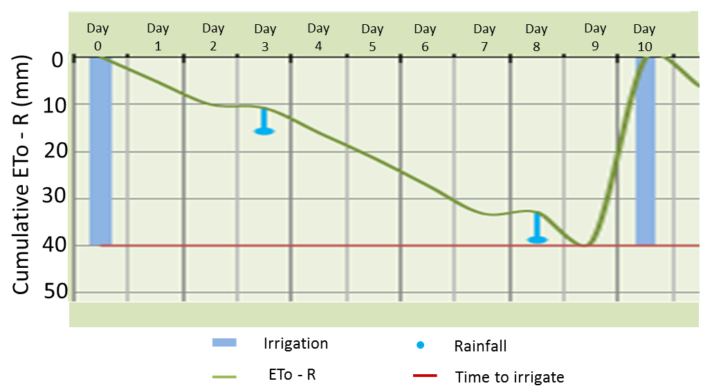
Figure 3 - Depleting Readily Available Water (RAW). The graph represents data in Table 2 above. It shows how plant RAW progressively depletes each day with evapotranspiration and recharges with rainfall. RAW is represented ‘in reverse’ on the vertical axis by “Cumulative ETo - R (mm).

Because of the variation in rainfall over short distances, usually it is preferable to collect individual farm rainfall figures rather than using local Bureau of Meteorology station data.
Rainfall that does not contribute to plant available moisture reserves (“ineffective” rainfall), shouldn’t be included in the irrigation scheduling calculations. For example, any rain that is lost as run-off or as seepage beyond the root-zone (or reduces ‘cumulative ETo - R’ back below 0mm), needs to be disregarded. Technically the first 2mm of a rainfall event on an established crop is unlikely to reach the soil and will not be used by plants, so can also be disregarded.
Spray irrigation: Spray irrigation systems provide more flexibility in the amount of water that can be applied. Typically water is applied more frequently and in smaller applications with spray systems compared to surface irrigation.
For example with spray irrigation, effective applications of 25mm (0.25ML /ha) may be regularly applied over a season. In this case, the soil is only being recharged by 25mm, not to the maximum RAW of 40mm as described in the above surface irrigation example.
To optimise water productivity, the timing of regular spray irrigation applications can be determined using a similar process described for surface irrigation. However, ‘cumulative ETo - R’ is subtracted initially from the effective application amount, in this case 25mm. The next irrigation occurs when the effective application amount (25mm) minus ‘cumulative ETo - R’ equals or is close to zero. Irrigations will be more frequent when smaller irrigation applications are used and less frequent with larger applications.
Because there is typically only limited waterlogging with spray irrigation applications, ETo on the day of the irrigation is usually included in the calculations.
Before a seasonal spray irrigation cycle, care needs to be taken that the soil has not dried out beyond the point at which plants can readily extract moisture. If this is the case, extra irrigation will be needed initially to bring the soil back in to the plant Readily Available Water zone.
During the spray irrigation season, frequent monitoring (such as soil moisture testing) is needed along with the use of ETo data to ensure soil moisture does not deplete beyond the point of plant Readily Available Water, resulting in plant moisture stress and loss of growth.
Spray uniformity (evenness of water application) and application efficiency (proportion of water used by plants) also need to be considered with spray systems for irrigation scheduling. If an irrigation system has poor spray uniformity or application efficiency, more irrigation water will be needed to allow for system inefficiencies.
In relation to meeting plant water requirements, spray irrigation tends to be less “forgiving” than surface irrigation and a higher level of management is needed to effectively schedule irrigations with spray systems.
How do I use ETo to schedule irrigations for crops other than pasture?
The process of using ETo data for irrigation scheduling on crops other than pasture is similar to that for pasture described above. However for crops, the crop coefficient (Kc) is more likely to vary through the season.
Surface irrigation: The process of using ETo data to schedule irrigations for crops other than pasture for surface irrigation is shown in Table 3 below.

 | Day 0 | Day 1 | Day 2 | Day 3 | Day 4 | Day 5 | Day 6 | Day 7 | Day 8 | Day 9
ETo (mm) | - | 7.2 | 7.5 | 7.7 | 6.8 | 7.6 | 8.1 | 7.3 | 6.7 | -
Kc | - | 1.2 | 1.2 | 1.2 | 1.2 | 1.2 | 1.2 | 1.2 | 1.2 | -
ETc (ETo x Kc, mm) | - | 8.6 | 9.0 | 9.2 | 8.2 | 9.1 | 9.7 | 8.8 | 8.0 | -
Rain (mm) | - | - | - | 5.0 | - | - | - | - | 8.0 | -
ETc-R (mm) | - | 8.6 | 9.0 | 4.2 | 8.2 | 9.1 | 9.7 | 8.8 | 0 | -
Cum ETc-R (mm) | - | 8.6 | 17.6 | 21.8 | 30.0 | 39.1 | 48.8 | 57.6 | 57.6 | -
Est RAW (mm) | 60 | 51.4 | 42.4 | 38.2 | 30.0 | 20.9 | 11.2 | 2.4 | 2.4 | 60
Irrigation | √ | - | - | - | - | - | - | - | - | √
Table 3 - Figures in this table demonstrate how reference evapotranspiration (ETo) data is used to schedule surface irrigation on a crop of actively growing mature maize. In this case, daily ETo is multiplied by a crop coefficient of 1.2 to determine the crop water requirement (ETc). It is estimated there is 60mm of soil Readily Available Water for the maize crop following irrigation and the soil has freely drained by the end of “Day 0.

Spray irrigation: The process of determining optimum irrigation timing for crops (other than pasture) under spray irrigation systems is similar to that described above for a crop under surface irrigation. However, the daily crop water requirements are subtracted from the effective application amount (eg. 25mm) rather than from the crops maximum RAW. To optimise productivity, the next irrigation is timed when the applied amount (“25mm”) minus ‘cumulative ETc - R’ equals or is close to zero.
Similar to the spray irrigation situation with pasture, crop evapotranspiration on the day the irrigation occurs is typically included in the above calculation.
Where can I source ETo data?
- Bureau of Meteorology. http://www.bom.gov.au/watl/eto/
- SILO Meteorology for the Land. (Queensland government.) https://www.longpaddock.qld.gov.au/silo/datadrill/
- irriGATEWAY (CSIRO). http://weather.csiro.au/?aws_id=8&view=summary
- The YIELD. App. https://www.theyield.com/products/free-growers-app
- irriSAT. App. https://irrisat-cloud.appspot.com/
- Weekly email services:
- Northern Victoria - robert.oconnor@ecodev.vic.gov.au
- North East Victoria – dennis.watson@ecodev.vic.gov.au
- Sunraysia – maxine.schache@ecodev.vic.gov.au
- Macalister – alexis.c.killoran@ecodev.vic.gov.au
The above sources of ETo data, apps and weekly email services are free of charge.
Some of the weekly email services provide irrigation scheduling advice based on past and forecast ETo data. Interactive tools are also available that use ETo data to determine optimum timing of the next irrigation for your specific circumstances, such as the irriSAT app and spreadsheet tools included in the weekly email updates.
The irriSAT app can also provide a record of irrigations through the season. This record can be used to evaluate farm irrigation performance in terms of how well your irrigations were matched to plant water requirements (ETc).
ETo values may vary slightly between the different sources. Where possible it is best to use a single and consistent source of ETo for your own situation.

Grower experiences
Many irrigators from different agricultural industries and locations around Australia and the world regularly use ETo information to schedule irrigations.
Irrigators say one of the big benefits of using ETo related information is they save valuable time determining plant water needs and planning farm irrigations.
“There was (before using ETo data) a lot more riding around the farm and visualising if pastures had wilted. If they had, you are already behind and… the plants are under severe moisture stress… I’m improving efficiency heaps (by using ETo information),” one Northern Victorian irrigator said.
Importantly the ETo information assists in getting irrigation right and improving productive water use. One irrigator commented:
“I'm finding this info very useful. I'm following your advice on suggested irrigation interval (based on ETo data) and are growing the best pastures on this place… Milk production is up as a result (of using ETo based advice and other irrigation related changes made on farm)”.
Irrigators have also indicated they use ETo information in different ways including better scheduling irrigations, minimising irrigation pumping costs and helping to calibrate other convenient scheduling methods.
ET information is particularly valued by spray irrigators. One irrigator using a centre pivot explained:
“I use ET to keep up with crop water requirements, because if I get behind I can’t keep up.”
Commercial agronomists report they regularly use ETo information to tailor irrigation schedules for their irrigator clients. Farm consultants are also successfully encouraging their clients to make better use of ETo information.
Risk Management
Like any other irrigation scheduling method or tool, ETo should not be used in isolation for irrigation scheduling decisions. While ETo is a relatively objective and reliable method, it should be used in conjunction with other preferred scheduling methods and tools.

Further Information
A shorter version of this Tech Note can be obtained through the Dairy Australia, Dairying for Tomorrow project or by contacting Rob O’Connor (Agriculture Victoria. Telephone (03) 5482 1922).
Weekly ETo updates for Northern Victoria and other valuable irrigation information can be viewed online at http://extensionaus.com.au/irrigatingag/
Alternatively, information about using ETo for irrigation scheduling can be obtained from irrigation officers, agronomists and farm consultants.
More general information about evapotranspiration, plant water requirements and crop coefficients can be obtained from The Food and Agricultural Organisation of the United Nations irrigation and drainage paper 56 - Crop evapotranspiration - Guidelines for computing crop water requirements. http://www.fao.org/docrep/X0490E/X0490E00.htm
For information on a range of irrigation related subjects including irrigation scheduling, design, technologies and management, visit http://agriculture.vic.gov.au/agriculture/farm-management/soil-and-water/irrigation
This Tech Note was prepared by Rob O’Connor with technical input provided by other Agriculture Victoria staff including Kevin Kelly, Dennis Watson, Craig Dyson, Deb Banks, Greg Turner and Shelley Howe. Amy Fay from Murray Dairy also provided technical support.

ACCESSIBILITY
If you would like to receive this publication in an alternative format, please telephone the DEDJTR Customer Service Centre on 136 186, email customer.service@ecodev.vic.gov.au or via the National Relay Service on 133 677, www.relayservice.com.au. This document is also available on the internet at http://agriculture.vic.gov.au or htttp://murraydairy.com.au

DISCLAIMER
This publication may be of assistance to you but the State of Victoria and its employees do not guarantee that the publication is without flaw of any kind or is wholly appropriate for your particular purposes and therefore disclaims all liability for any error, loss or other consequence which may arise from you relying on any information in this publication.
© The State of Victoria Department of Economic Development, Jobs, Transport & Resources, December 2017

