Antibiotic Use in Cattle: Traffic light diagram
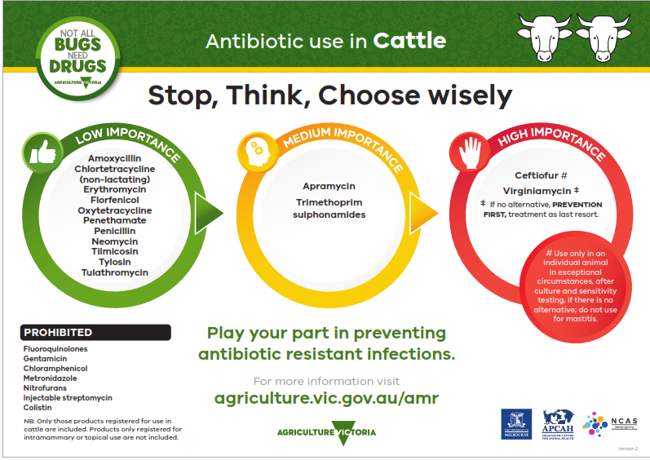
Stop, Think, Choose wisely
The information provided sets out the prioritisation of antibiotics for use by veterinarians as per Antibacterial Importance Ratings developed by the Australian Government with expert advice from the Australian Strategic and Technical Advisory Group (ASTAG).
LOW IMPORTANCE (in a green circle)
Amoxycillin
Chlortetracycline (non-lactating)
Erythromycin
Florfenicol
Oxytetracycline
Penethamate
Penicillin
Neomycin
Tilmicosin
Tylosin
Tulathromycin
MEDIUM IMPORTANCE (in a yellow circle)
Apramycin
Trimethoprim sulphonamides
HIGH IMPORTANCE (in a red circle)
Ceftiofur (Use only in an individual animal in exceptional circumstances, after culture and sensitivity testing, if there is no alternative; do not use for mastitits)
Virginiamycin (If no alternative, PREVENTION FIRST, treatment as a last resort.)
Prohibited
Fluoroquinolones
Gentamicin
Chloramphenicol
Metronidazole
Nitrofurans
Injectable streptomycin
Colistin
Note: Only those products registered for use in cattle are included. Products only registered for topical or intramammary use are not included in this list.
Play your part in preventing antibiotic resistant infections
For more information visit the Antibiotic resistant infections page of the Agriculture Victoria website at agriculture.vic.gov.au/amr
Agriculture Victoria logo
Developed and designed by Agriculture Victoria, the University of Melbourne, the Asia-Pacific Centre for Animal Health and the National Centre for Antimicrobial Stewardship.

