Antibiotic Use in Chickens: Stop, Think, Choose wisely
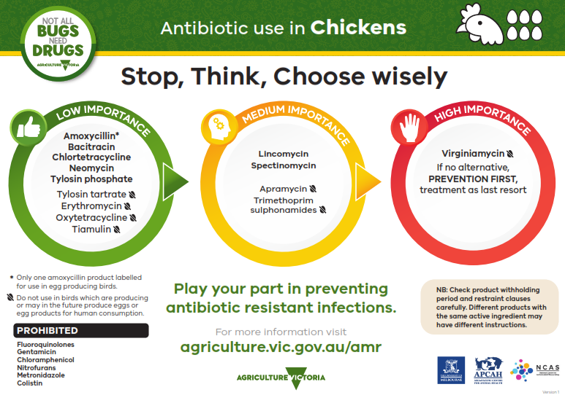

The information provided sets out the prioritisation of antibiotics for use by veterinarians as per Antibacterial Importance Ratings developed by the Australian Government with expert advice from the Australian Strategic and Technical Advisory Group (ASTAG). The antibiotics are displayed in circles corresponding to the colours of a traffic light; green, orange and red.
LOW IMPORTANCE (in a green circle)
Amoxycillin (Only one amoxycillin product labelled for use in egg producing birds).
Bacitracin
Chlortetracycline
Neomycin
Tylosin phosphate
Tylosin tartrate (Do not use in birds which are producing or may in the future produce eggs or egg products for human consumption).
Erythromycin (Do not use in birds which are producing or may in the future produce eggs or egg products for human consumption).
Oxytetracycline (Do not use in birds which are producing or may in the future produce eggs or egg products for human consumption).
Tiamulin (Do not use in birds which are producing or may in the future produce eggs or egg products for human consumption).
MEDIUM IMPORTANCE (in an orange circle)
Lincomycin
Spectinomycin
Apramycin (Do not use in birds which are producing or may in the future produce eggs or egg products for human consumption).
Trimethoprim sulphonamides (Do not use in birds which are producing or may in the future produce eggs or egg products for human consumption).
HIGH IMPORTANCE (in a red circle)
Virginiamycin (Do not use in birds which are producing or may in the future produce eggs or egg products for human consumption).
If no alternative, PREVENTION FIRST, treatment as last resort
PROHIBITED
Fluoroquinolones
Gentamicin
Chloramphenicol
Nitrofurans
Metronidazole
Colistin
NB: Check product withholding period and restraint clauses carefully. Different products with the same active ingredient may have different instructions.
Play your part in preventing antibiotic resistant infections
For more information visit the Antimicrobial resistant infections webpage of the Agriculture Victoria website at agriculture.vic.gov.au/amr
Developed and designed by Agriculture Victoria, the University of Melbourne, the Asia-Pacific Centre for Animal Health and the National Centre for Antimicrobial Stewardship.

