Demonstrating strategies for barley grass control
Tess McDougall, Agriculture Victoria and Rob Shea, PPS Project Manager
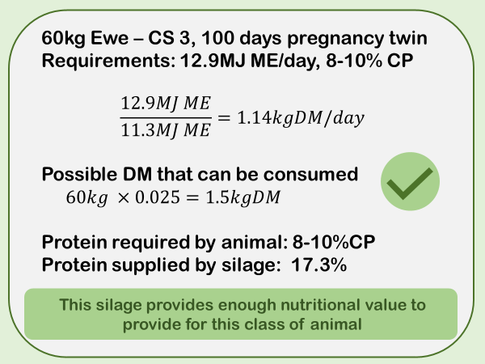
Figure 1: feed budget using feed test results from silage made at Tulkara
The Perennial Pasture Systems (PPS) group’s barely grass control demonstration project, now in its second spring, is testing some innovative methods of reducing barley grass infestations, including; increasing competition, herbicide use and mechanical removal such as hay and silage making. Barley grass is seen as a formidable and adaptive plant with characteristics that would be sought after, if it wasn’t for the sharp seed head causing injury and vegetable matter downgrades to sheep meat and wool clips.
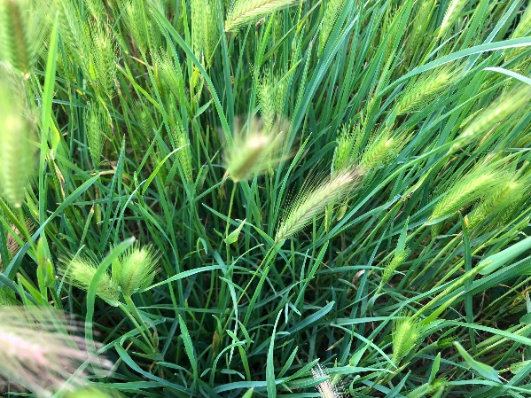
Figure 2: 2020 silage site prior to cutting October.
Making silage from barley grass infested pasture is showing promise in some areas, however given the region’s topography, it’s not a method that could be used at most demonstration sites. The first site at Ben Nevis Farms made silage from a heavily infested barely grass site in spring 2019 at Tulkara (east of Stawell). Feed tests showed that the silage was good quality, measuring 12.9 MJ Metabolizable Energy (ME) and 17.3 % Crude Protein (CP) and classified in the A2 quality range (Figure 1).
Given the excellent 2020 season, limited silage has been fed out to stock, however farm owner Hayden, described it as “highly palatable to sheep”.
Seed viability testing of the silage made from barley grass measured zero viable seeds. This means that although the seed head is still present, the seeds won’t germinate and the infestation can’t be spread to another area. We are hoping to replicate these results with 2020 silage production.
The second site at Crowlands, on a new site was heavily infested with barley grass, overlaying a healthy understorey of Uplands Cocksfoot in late vegetative stage (see Figure 2). This silage will be sampled in the coming weeks to check seed viability and feed test for quality.

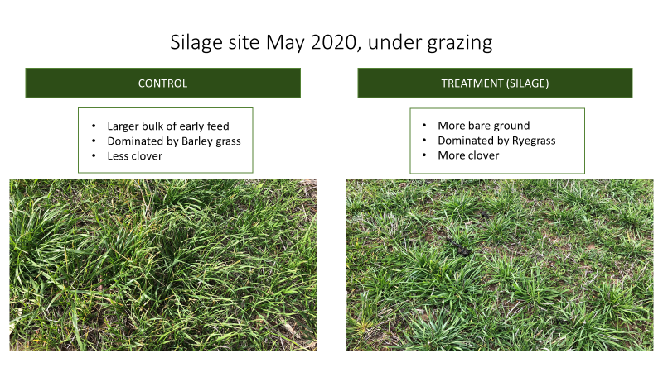
Figure 3: Tulkara silage demonstration site May 2020

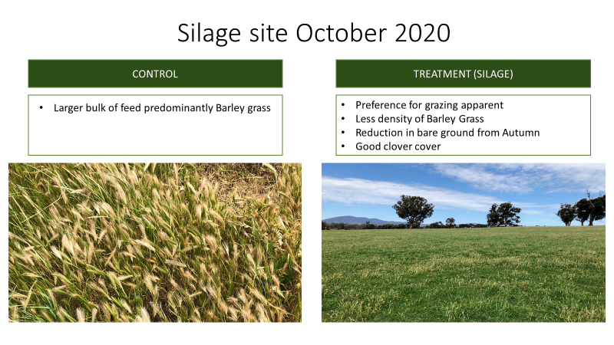
Figure 4: Tulkara silage demonstration site October 2020
A clear reduction in barley grass was seen in the 2019 silage (treatment) site compared to the uncut (control) site in both May (Figure 3) and October 2020 (Figure 4).
Pasture assessments in October 2020 involved counting barely grass seed heads in the silage (treatment) and uncut (control) sites. The results indicated a large reduction in barley grass seed heads where silage was made in 2019, with approximately 2000 seed heads/m² in the control site and 200 seed heads/m² in the treatment sites (Figure 5).
The overall reduction in barley grass seed heads, combined with the zero viability of the seed heads within the silage is a positive result for the group.
Demonstration host Hayden described the silage production as a ‘useful tool’. “It didn’t get rid of all the weeds, but it got rid of a lot,” he said.
Hayden was also pleased with the pasture quality this year, following silage production. “By harvesting the silage in 2019 there’s a lot more ryegrass than I expected, which has led to great palatability and utilisation in 2020. I would certainly do it again.” Hayden said.
Results from other demonstration treatments are currently being assessed and will be reported in autumn 2021. This work is funded by Agriculture Victoria and Meat & Livestock Australia and delivered by Perennial Pasture Systems in collaboration with Agriculture Victoria.

Figure 5: Tulkara Barley grass seed head counts, October 2020

