Livestock Farm Monitor Project

Victoria │ Annual Report

2020-21

In 2020-21, the Livestock Farm Monitor Project (LFMP) provided 113 Victorian sheep, beef and mixed farming, including cropping, producers with detailed financial and production performance information. Agriculture Victoria collated the individual business performance information of all surveyed farms to provide the insights in this report.
The LFMP is Agriculture Victoria’s primary source of farm level information for sheep and beef production practices, resource use, and economic well-being data.
The results of this annual survey provide farm-level data to inform Agriculture Victoria’s decisions that impact at a farm level and to inform the direction of future policy design, research themes and service delivery programs.
Farmers who participate in the project increase their understanding of their farm business which builds resilience and improves their ability to adapt to change.
Results published in this report are not statistically representative of an industry or a region.
Agriculture Victoria staff are grateful for the cooperation of the farmers who contributed their data to this project.
The theory and methods used to generate the profitability data in this report can be found in the references.
This report has been funded by Agriculture Victoria.
Further information regarding the LFMP may be obtained from:
Sam Henty
Agriculture Victoria
PO Box 3100, Bendigo DC, Victoria 3400
sam.henty@agriculture.vic.gov.au

Authorised and published by the Victorian Government, Department of Jobs, Precincts and Regions 2021. © The State of Victoria Department of Jobs, Precincts and Regions 2021.
This publication is copyright. No part may be reproduced by any process except in accordance with the provisions of the Copyright Act 1968.
For more information contact the DJPR Customer Service Centre 136 186.

Disclaimer
This publication may be of assistance to you, but the State of Victoria and its employees do not guarantee that the publication is without flaw of any kind or is wholly appropriate for your particular purposes and therefore disclaims all liability for any error, loss or other consequence which may arise from you relying on any information in this publication.
Accessibility
If you would like to receive this publication in an accessible format, such as large print or audio, please telephone 136 186.
Deaf, hearing impaired or speech impaired? Call us via the National Relay Service on 133 677 or visit www. relayservice.com.au
This document is also available in PDF format on the Agriculture Victoria website.

State summary

Key points
- Many participant farm businesses recorded high profits across all regions
- Good seasonal conditions and increased pasture availability enabled producers to increase stocking rates
- Strong red meat prices ensured farm incomes remained high
- High cash flows resulted in increased expenditure on repairs and maintenance and fertiliser
- Larger farms tended to have higher return on assets than smaller farms
- Debt was part of the business structure for most surveyed farms but increases in land values meant farm equity levels remained strong.
Across the state, eighty-five percent of surveyed businesses recorded positive returns in 2020-21. Farm businesses in the South West achieved the highest profits in 17 years, while businesses in Northern Victoria and Gippsland recorded the second and third highest profits respectively (Appendix B12, C12 and D12). Farm income increased from already high levels as businesses took advantage of the high prices for red meat. Increases to variable costs were minimised as favourable seasonal conditions reduced the reliance on purchased supplementary feed. This was coupled with a decrease in the market price of stock feed (hay and grain).
In 2020-21, Return on Assets were above the long-term average in all regions. Surveyed farms located in South West Victoria recorded the highest average returns for the state, while farms in Northern Victoria had the largest annual percentage increases. Regardless of the average, each region had participant farms that recorded high returns and negative returns (Figure 1).
For most participating businesses, annual rainfall was close to average (Appendix B2, C2 and D2). Timely rainfall across the year meant participant farms increased expenditure on pastures predominately through fertiliser application. Fertiliser usage was high across the state with superphosphate being the most common fertiliser applied (Figure 5). A high proportion of South West farms applied urea influenced in-part by mixed farming enterprises (including cropping) in the South West dataset. The application of lime was common across the state with almost half the participants in each region applying lime. The increased investment in pasture enabled managers to increase stocking rates and pasture utilisation.
High cashflows resulted in increased expenditure on repairs and maintenance across the state. The increase in repairs and maintenance expenditure is attributable to a combination of attending to delayed repairs, and tax minimisation. Repairs and maintenance of buildings and fences were prioritised in each region (Figure 3) followed closely by plant and equipment.
In 2020-21, farm scale was measured according to total farm cash income. When the LFMP dataset was disaggregated by scale, there were farms with good returns across all cash income categories, with larger farms tending to have higher return on assets than smaller farms (Figure 2). Surveyed farms with cash income less than $340,000 had lower Return on Assets than farms with a higher cash income. Smaller farms are commonly supplemented by off-farm income which is not included when estimating farm performance. On a per hectare basis, smaller farms have lower labour use efficiency (Appendix A5), have high labour costs, generate less income, and have significantly higher overhead costs compared to larger farms. Together, these factors contribute to the overall lower economic performance of smaller farms.
Farm business profits in 2020-21 allowed a high proportion of surveyed farms to reduce debt (Figure 4). However, some farm business debt levels increased as managers chose to invest in land, plant and equipment and other on-farm improvements. Debt was part of the business structures for a substantial proportion of surveyed farms. The use of debt increases the obligatory costs of farm businesses as principal and interest repayments must be paid in good and poor years. For this reason, farm management strategies employed throughout the year are influenced by the level of debt held by the business.
Figure 1: Return on Assets of Statewide LFMP Participants 2020-21
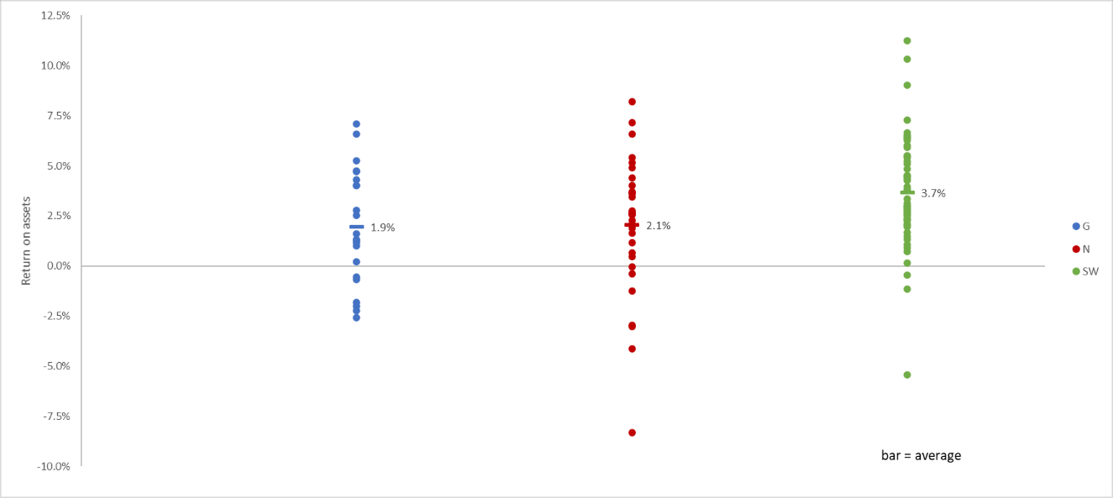
Figure 2: Return on Assets for Different Cash Income Bands of Statewide LFMP Participants 2020-21
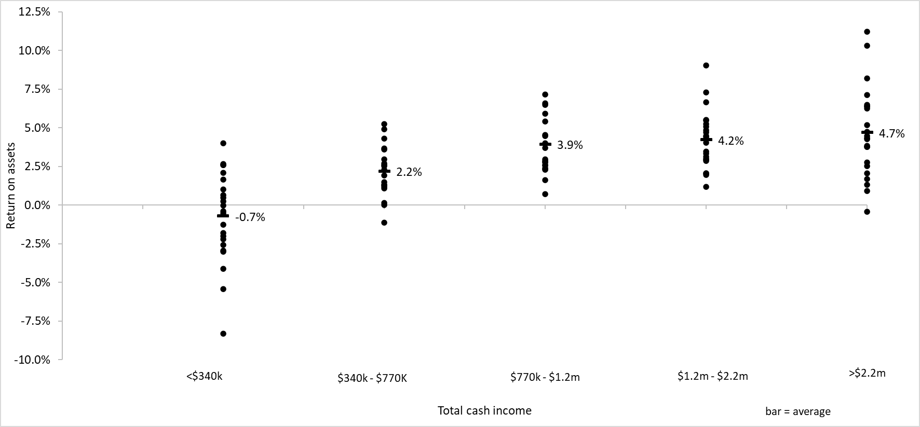
Figure 3: Repairs and Maintenance Expenditure of Statewide LFMP Participants 2020-21
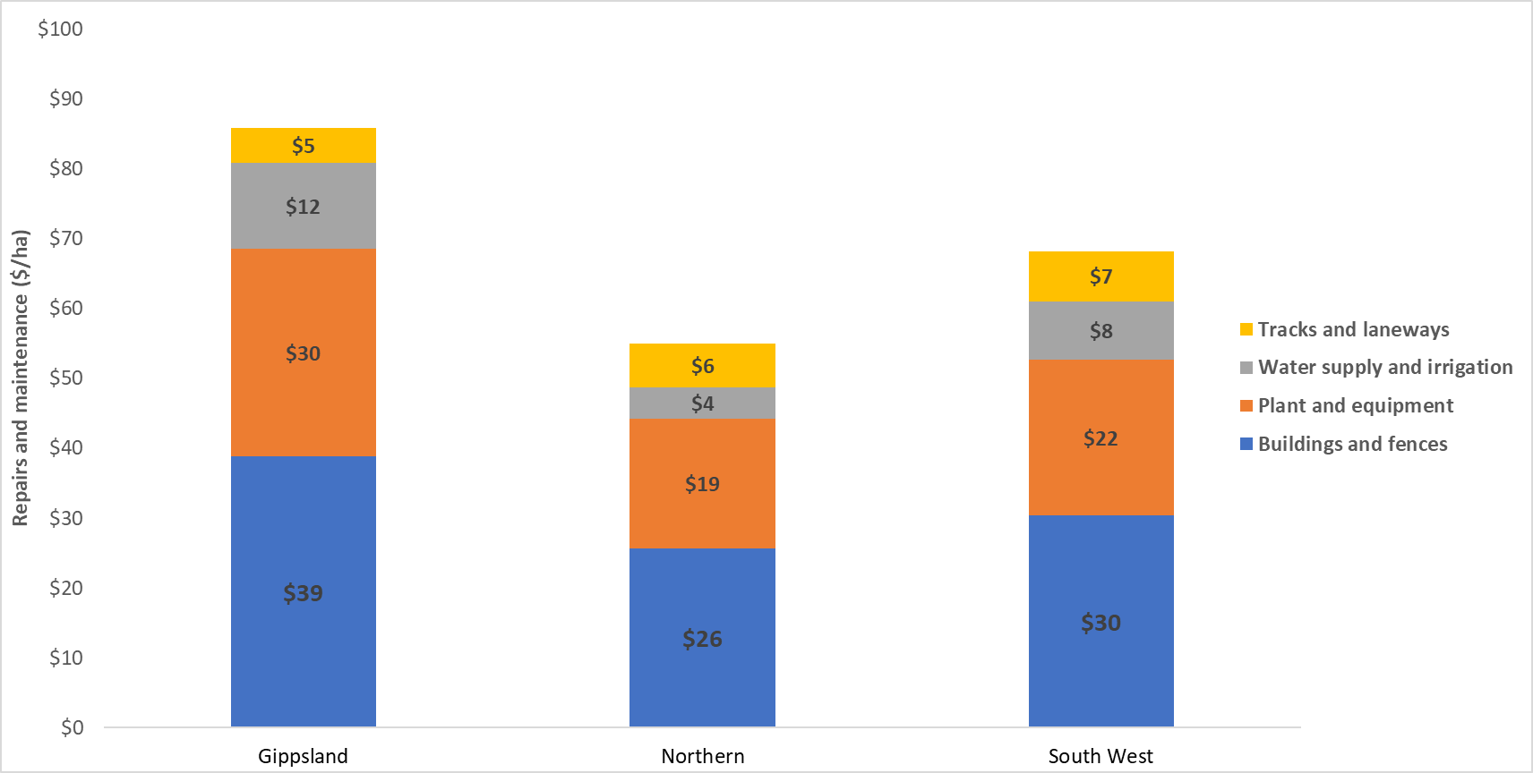
Figure 4: Liability Movement of Statewide LFMP Participants 2020-21
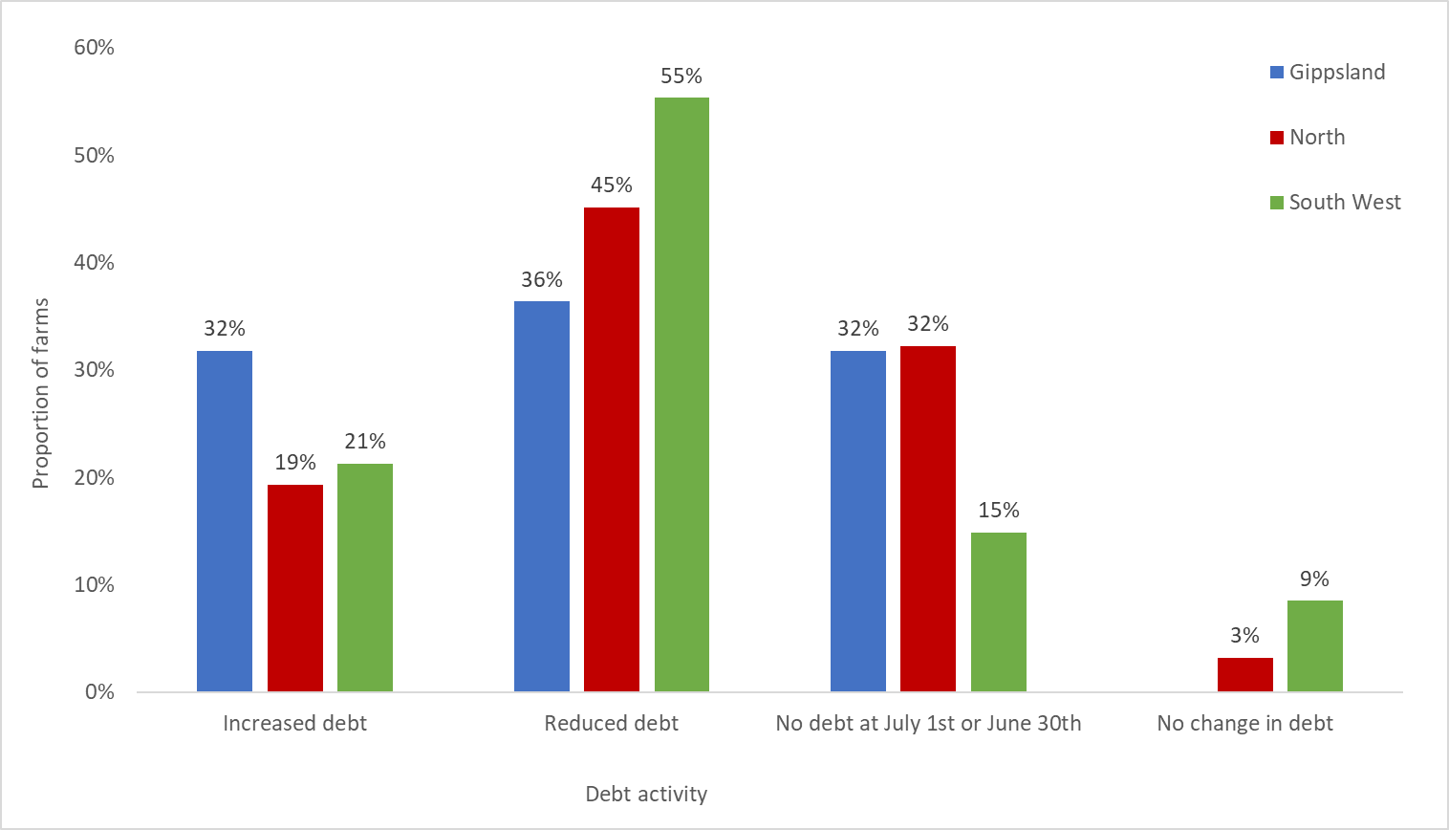
Figure 5: Fertiliser Application Decisions of Statewide LFMP Participants 2020-2021
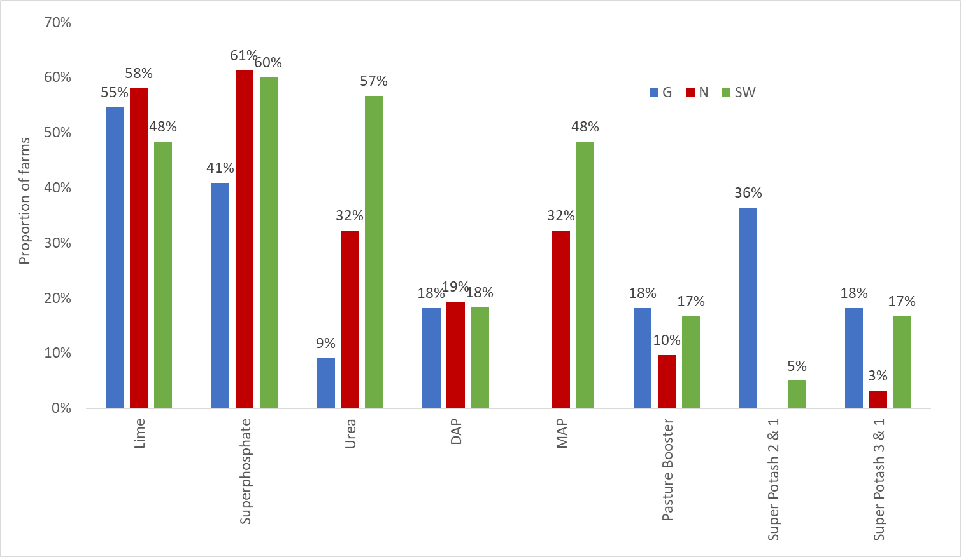

Table 1: State Physical and Financial Performance Summary
State summary
Financial parameter bars: | Gippsland | North | South West
Gross farm income ($/ha) | $1,183 | $1,027 | $1,317
Variable costs ($/ha) | $387 | $354 | $485
Overhead costs ($/ha) | $557 | $426 | $341
Earnings before interest and tax (EBIT) ($/ha) | $238 | $247 | $491
Interest and lease cost ($/ha) | $64 | $55 | $73
Net farm income ($/ha) | $174 | $192 | $417
Return on assets (%) | 1.9% | 2.1% | 3.7%
Return on equity (%) | 2.2% | 2.1% | 4.2%
Physical parameter bars: | Gippsland | North | South West
Effective area (ha) | 656 | 747 | 1453
Labour use (FTE/farm) | 2.0 | 1.9 | 3.2
Financial year rainfall (mm) | 826 | 632 | 657
Stocking rate (DSE/ha) | 16.4 | 12.6 | 17.7
Beef sold (kg lwt/ha) | 395 | 255 | 719
Lamb sold (kg cwt/ha) | 84 | 199 | 123
Wool sheep wool cut (Gr.kg/ha) | 38 | 37 | 48
Total pasture utilised (grazed and conserved tDM/ha) | 4.8 | 3.6 | 4.9

Gippsland
In 2020-21, average Earnings before interest and tax (EBIT) on Gippsland farms remained similar to 2019-20 and was the third highest recorded in 17 years of the project. (Appendix D12)
Beef is the dominant enterprise of the region, therefore many participant farms in Gippsland were well placed to take advantage of the record high beef prices. Beef prices continued to rise through the year. Average gross farm income remained at similar levels recorded in 2019-20 and well above the 10-year regional average (Appendix D12).
July and August were the peak months for lambing in sheep enterprises while September and October were the peak months for calving in beef enterprises (Figure 6). Consequently, spring represented the months of highest feed demand. Spring 2020 rainfall events in South and West Gippsland left some soils saturated and provided a challenge to harvest pasture for conservation. Reduced quantities of fodder were harvested contributing to the decrease in regional hay and silage making costs and feed inventories. East and Central Gippsland had more favourable rainfall through spring and summer, resulting in increased pasture availability and less reliance on supplementary feed which contributed to the reduction in regional variable costs. Conditions in East Gippsland offered some respite from the preceding drought years experienced in the region. Producers used the improved conditions as an opportunity to rebuild herds by retaining trading stock. Variable seasonal conditions experienced across Gippsland farms resulted in overall stocking rate remaining at similar levels to 2019-20 (Figure 9).
Consistent with the trend across the state, fertiliser was the largest cost item on Gippsland farms. On average, expenditure on fertiliser increased in Gippsland, and this region also had the highest fertiliser cost per hectare compared to the rest of the state. While fertiliser application rates in Gippsland was similar to the South West and Northern Victoria, Gippsland farms paid more per unit of fertiliser due to additional freight costs.
Of the three regions, Gippsland has the smallest average effective area managed. High overhead costs per hectare on smaller sized farms is commonly due to lower labour use efficiency, which results in high permanent and imputed labour cost relative to the area operated. Reflecting this, Gippsland recorded the highest average overhead costs per hectare.
Beef and wool sheep gross margins increased significantly in 2020-21 due to large increases in income from the respective enterprises. Average fine wool price received, and wool income remained similar to 2019-20, with wool sheep producers reducing stock sales and rebuilding flocks, which resulted in an increase in stock inventory and bolstering wool sheep (non-cash) income. Wool sheep producers, who are predominantly located in central and east Gippsland, were able to reduce variable costs associated with the enterprise by decreasing expenditure on purchased supplementary feed.
Rising farmland and cattle prices resulted in Gippsland participants managing the highest value total assets per hectare. The increase in the value of total assets managed was the reason for differences in the proportional change between earnings before interest and tax (EBIT) and ROA (return on assets does not include capital appreciation). Increases in land prices matched the increases in debt levels resulting in an average annual addition to farmers wealth (equity) of $1,853/ha.
Table 2: Average Selected Measures of Gippsland LFMP Participants 2020-21
Financial parameter bars: | Gippsland
Top 5 cash operating cost items
Pasture fertiliser cost ($/ha) | $120
Livestock selling costs ($/ha) | $69
Wages for permanent staff ($/ha) | $56
Repairs and maintenance cost - Buildings and fences ($/ha) | $39
Rates cost ($/ha) | $38
Enterprise income
Beef income ($/ha) | $1,228
Prime Lamb income ($/ha) | $836
Wool Sheep income ($/ha) | $741
Cropping income ($/ha) | -
Enterprise variable costs
Beef variable costs ($/ha) | $537
Prime Lamb variable costs ($/ha) | $308
Wool Sheep variable costs ($/ha) | $260
Cropping variable costs ($/ha) | -
Capital
Total assets managed ($/ha) | $16,075
Lease costs (% land value) | 1.3%
Total debt ($/ha) | $1,148
Annual increase in equity ($/ha) | $1,853
Physical parameter bars: | Gippsland
Labour use efficiency (ha/FTE) | 311
Labour use efficiency (DSE/FTE) | 4,756
Labour use efficiency (cash income/FTE) | $404,141
Grazed pasture (tDM/ha) | 4.4
Conserved pasture (tDM/ha) | 0.4
Pasture Water Use Efficiency (tDM/100mm/ha) | 0.6
Beef supplementary feeding rate (MJ ME/DSE) | 248
Prime Lamb supplementary feeding rate (ME/DSE) | 82
Wool Sheep supplementary feeding rate (ME/DSE) | 49
Mature cow calving rate | 87%
Mature ewe lamb marking rate (Prime lamb) | 115%
Mature ewe lamb marking rate (Wool sheep) | 99%
Beef - Average weaning age (months) | 7.9
Prime Lamb - Average weaning age (months) | 4.7
Wool Sheep - Average weaning age (months) | 3.3
Enterprise mix pie graph | Gippsland
Beef cattle sales | 69%
Sheep sales | 13%
Wool sales | 14%
Grain sales | 0%
Other income | 5%

Figure 6: Time of Calving and Lambing for Gippsland LFMP Participants 2020-21
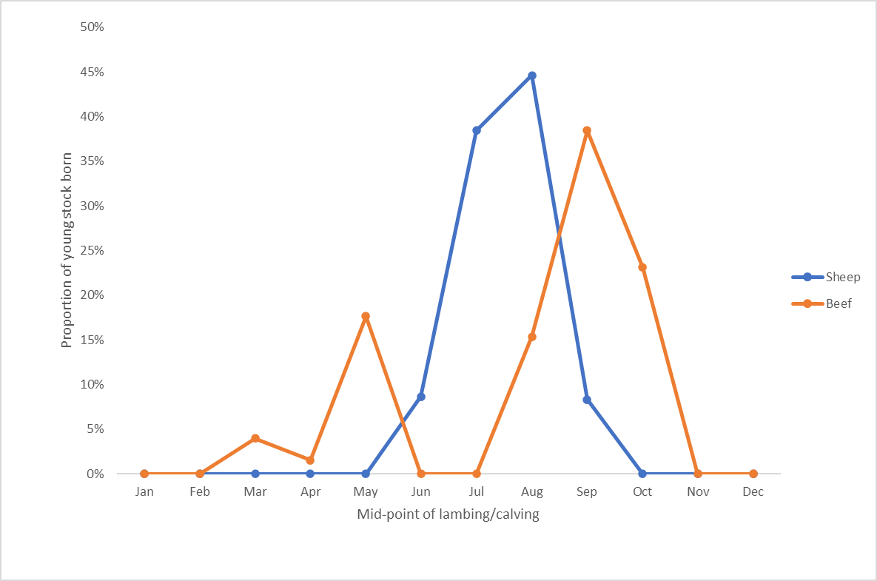
Figure 7: Time of Cattle, Lamb and Wool Sales for Gippsland LFMP Participants 2020-21
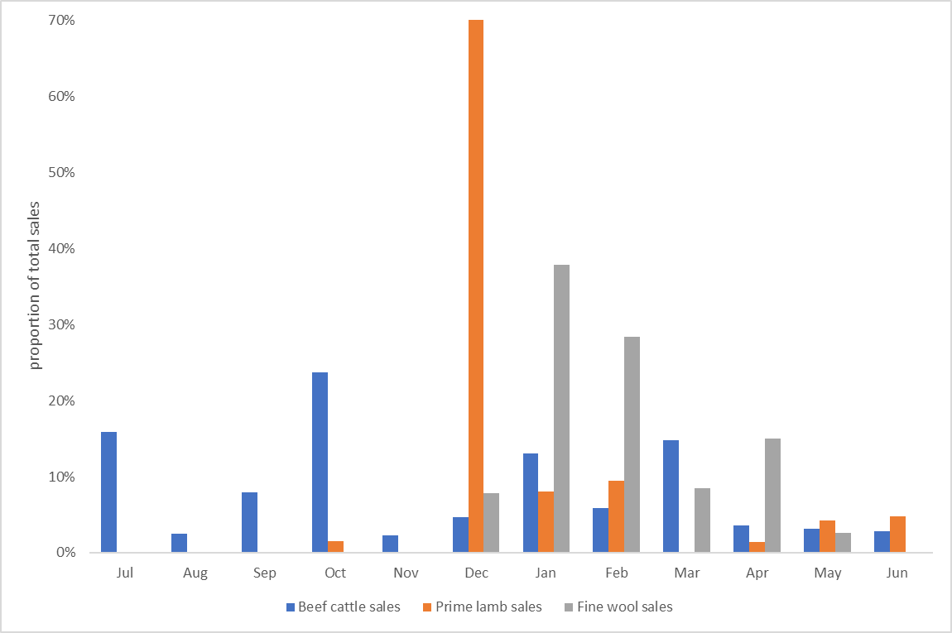
Figure 8: Prices received for Lamb, Beef and Wool for Gippsland LFMP participants 2020-21
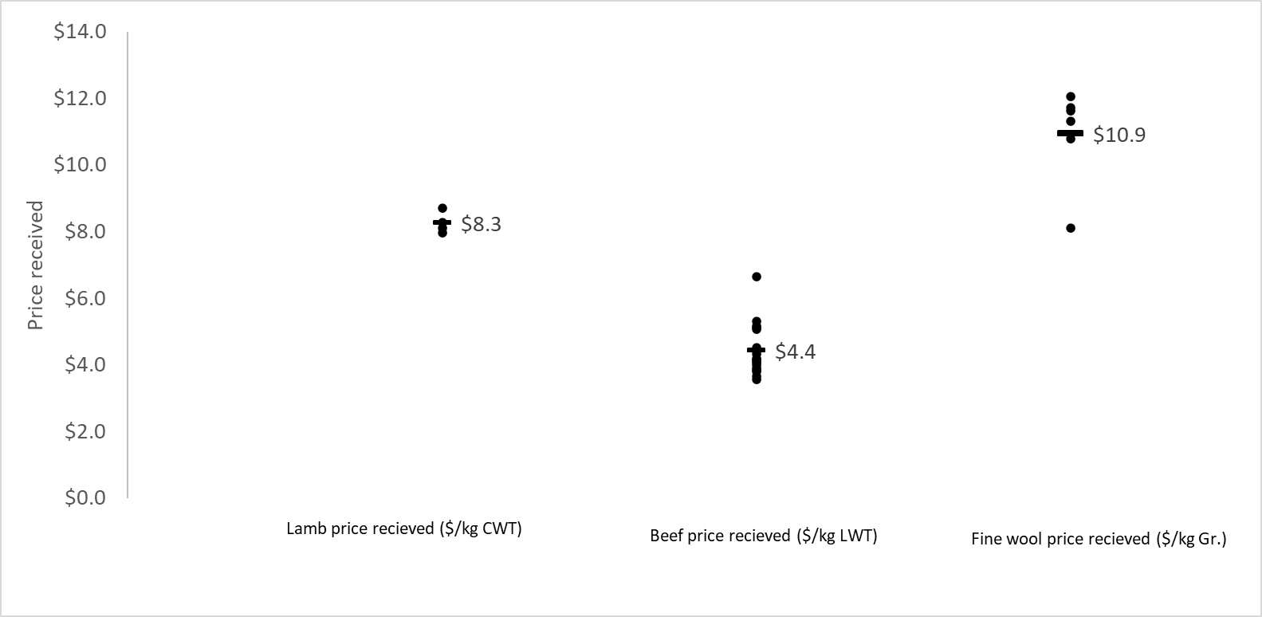
Figure 9: Average Stocking Rate (DSE/ha) of Gippsland LFMP over time.
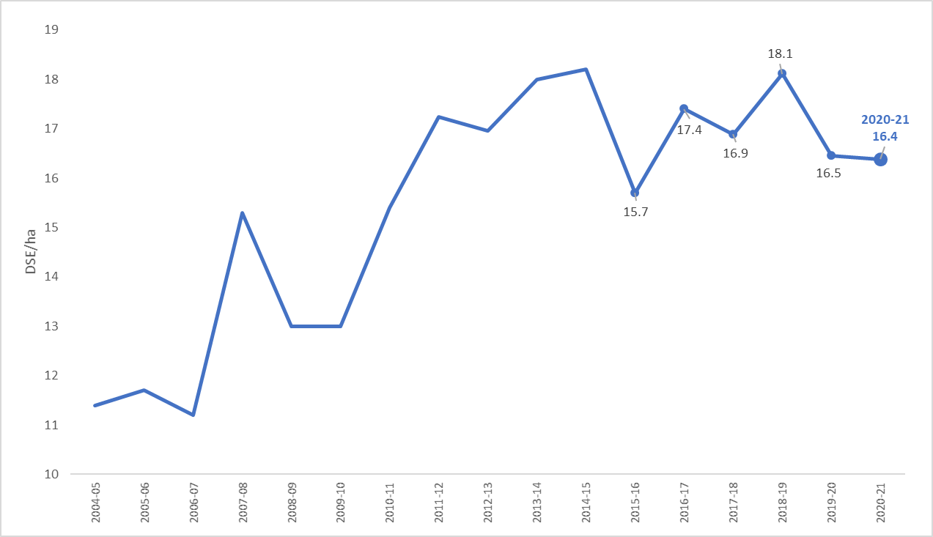

South West Victoria
2020-21 was a highly profitable year in the South West, with farm businesses recording the highest average EBIT in 17 years of the project (Appendix B12)
Surveyed farms in South West Victoria were again well positioned to take advantage of the excellent operating conditions during 2020-21 (Table 3). Timely rainfall throughout the year and maintaining quality pastures allowed businesses to increase stocking rates to the second highest levels in fifty-one years of the project (Figure 13). The increase in stocking rates was coupled with high red meat prices and improved fine wool prices resulting in the second highest average gross farm income recorded in the fifty one years of the project. (Appendix B12).
Fertiliser and purchased concentrates represented the largest expenditure items for South West participants. Fertiliser costs were influenced by high fertiliser usage coupled with an increased market price for fertiliser. Purchased concentrate costs were a result of marketing decisions made on many South West farms to retain and supplementary feed lambs over the summer period. February and March made up approximately 30 per cent of all lamb sales from South West farms (Figure 11).
The distribution of lambing dates on surveyed farms in the South West (Figure 10) can be explained by the large proportion of self-replacing prime lamb enterprises. Lambing in prime lamb enterprises tends to peak in mid-winter as producers attempt to use the high pasture growth in spring to meet the feed demand of lactating ewes and target weights of lambs to be sold in early summer.
While lamb and mutton prices remained high in 2020-21, a decline from the record prices experienced in 2019-20 resulted in reduced sheep sales income which was the major influence on the decreases in prime lamb and wool sheep gross margins. Wool sheep gross margins decreased despite an increase in the market price received for fine wool. Producers reduced wool sheep stock sales and rebuilt wool sheep flocks, with the resultant increase in inventory bolstering wool sheep (non-cash) income. Product quality, farm system and marketing strategies all influenced the price received for the major products sold in 2020-21. The difference in managing these factors is highlighted by the variability in the average annual price received across all farms for fine wool, lamb, and beef (Figure 12).
Profitable conditions and positive producer sentiment led to more on-farm capital expenditure. Additional total capital invested in businesses and large increases in farmland values resulted in an average annual addition to farmers wealth (equity) of $3,089/ha. This increase in the value of total assets managed was the reason earnings before interest and tax (EBIT) increased but average ROA decreased (return on assets does not include capital appreciation).

Table 3: Average Selected Measures of South West LFMP participants 2020-21
Financial parameter bars: | SW
Top 5 cash operating cost items
Pasture fertiliser cost ($/ha) | $85
Purchased supplementary feed - concentrates ($/ha) | $65
Contract shearing and crutching cost ($/ha) | $57
Animal health cost ($/ha) | $47
Livestock Selling costs ($/ha) | $40
Enterprise income
Beef income ($/ha) | $1,349
Prime Lamb income ($/ha) | $1,307
Cropping income ($/ha) | $1,220
Wool Sheep income ($/ha) | $1,106
Enterprise variable costs
Cropping variable costs ($/ha) | $535
Prime Lamb variable costs ($/ha) | $514
Wool Sheep variable costs ($/ha) | $486
Beef variable costs ($/ha) | $435
Capital
Total assets managed ($/ha) | $13,996
Lease costs (% land value) | 3.8%
Total debt ($/ha) | $1,407
Annual increase in equity ($/ha) | $3,089
Physical parameter bars: | SW
Labour use efficiency (ha/FTE) | 434
Labour use efficiency (DSE/FTE) | 6,732
Labour use efficiency (cash income/FTE) | $577,544
Grazed pasture (tDM/ha) | 4.8
Conserved pasture (tDM/ha) | 0.1
Pasture Water Use Efficiency (tDM/100mm/ha) | 0.8
Beef supplementary feeding rate (ME/DSE) | 174
Prime Lamb supplementary feeding rate (ME/DSE) | 281
Wool Sheep supplementary feeding rate (ME/DSE) | 308
Mature cow calving rate | 90%
Mature ewe lamb marking rate (Prime lamb) | 125%
Mature ewe lamb marking rate (Wool sheep) | 91%
Beef - Average weaning age (months) | 6.8
Prime Lamb - Average weaning age (months) | 3.7
Wool Sheep - Average weaning age (months) | 3.6
Enterprise mix pie graph | SW
Beef cattle sales | 20%
Sheep sales | 51%
Wool sales | 18%
Grain sales | 9%
Other income | 2%

Figure 10: Time of Calving and Lambing for South West LFMP participants 2020-21
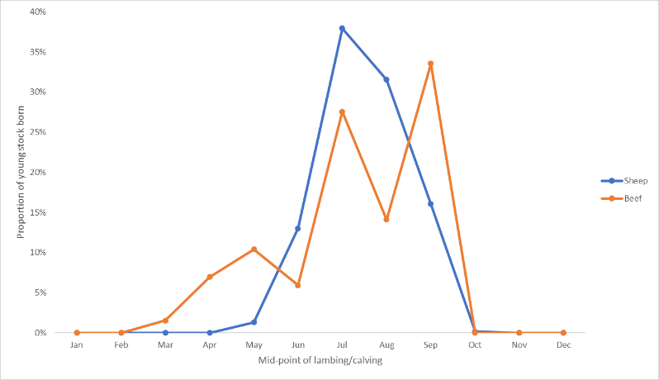
Figure 11: Time of Cattle, Lamb and Wool Sales for South West LFMP participants 2020-21
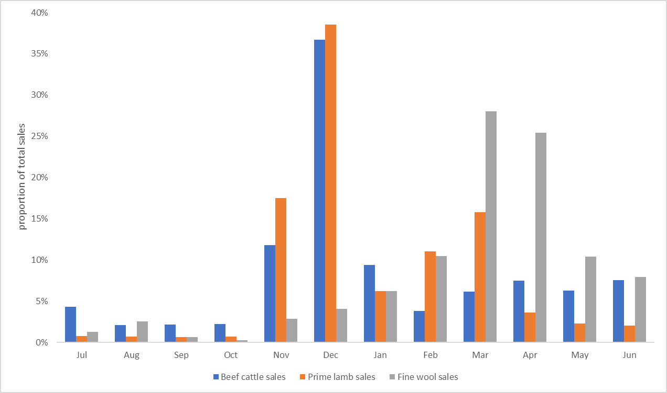

Figure 12: Prices received for Lamb, Beef and Wool for South West LFMP participants 2020-21
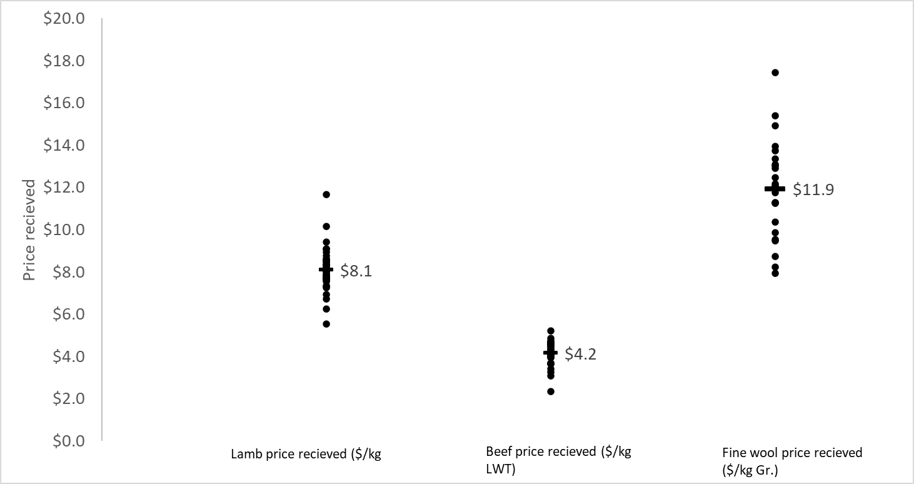
Figure 13: Average Stocking Rate (DSE/ha) of South West LFMP over time.
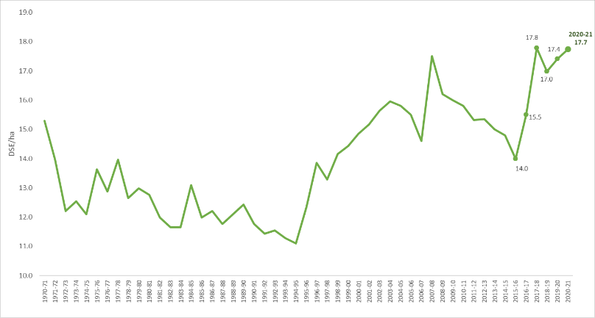

Northern Victoria
In 2020-21, Northern Victoria farm profitability rebounded from the lows reported in 2018-19 and 2019-20 to the second highest levels recorded in the 17 years of the project (Appendix C12) and Table 4.
Seasonal conditions improved for many farms across Northern Victoria in 2020-21. As a result of the favourable conditions, producers increased expenditure on their pastures through increased fertiliser application and expenditure. Producers used the additional pasture growth to sell trading stock later and rebuild stock numbers, particularly in sheep enterprises. As a result, farm stocking rates increased to the highest levels recorded in 17 years (Figure 17). High cash income and increased livestock and feed inventories led to the highest average gross farm income recorded by the project in Northern Victoria (Appendix C12). Improved pasture availability reduced the reliance on supplementary feed and allowed farms to reduce expenditure on purchased stock feed. The combination of reduced expenditure on supplementary feed and increased fertiliser costs resulted in minimal year on year change in average variable costs, with these remaining at the second highest level recorded by the project in Northern Victoria (Appendix C12).
The distribution of lambing and calving times on surveyed farms in Northern Victoria can be explained by seasonal and pasture growing conditions. Rain-fed Northern Victorian farms experience a shorter spring pasture growing period due to higher temperatures and drier conditions. Consequently, breeding schedules tend to be tighter in timeframes on Northern farms with the majority of lambs and calves born in in August and September (Figure 14).
Fertiliser and livestock selling costs represented the largest expenditure items for Northern participants. Fertiliser cost was influenced by high fertiliser usage coupled with an increased market price of fertiliser. Livestock selling costs made up a high proportion of operating costs on Northern farms and were the second largest expenditure item. Many Northern farmers relied on selling agents to market their trading stock. A common payment method for selling agents is to take a percentage of sales, the high value of the trading stock in 2020-21 corresponded with high agent costs.
Beef and wool sheep gross margins increased significantly in 2020-21 due to large increases in income from respective enterprises. While average fine wool price received remained unchanged from 2019-20 (Appendix C14), wool sales income increased as producers cut and sold more wool than the previous year. Producers reduced wool sheep stock sales and rebuilt wool sheep flocks, with the resultant increase in inventory also bolstering wool sheep (non-cash) income. The average beef price received by Northern farmers increased 32 per cent in 2020-21. Beef prices continued to rise through the year and northern producers capitalised on this trend by holding on to trading stock longer and selling later. Figure 15 shows that 40 per cent of all beef cattle were sold late in the year (Mar-Jun) when prices were highest. Despite good market conditions there was large variability in average annual price received across all farms for fine wool, lamb, and beef (Figure 16).
Large increases in farmland values across Northern Victoria resulted in an average annual addition to farmers wealth (equity) of $1,425/ha. This increase in the value of total assets managed was the reason earnings before interest and tax (EBIT) increased proportionally more than the average ROA.

Table 4: Average Selected Measures of Northern LFMP participants 2020-21
Financial parameter bars: | Northern
Top 5 cash operating cost items
Pasture fertiliser cost ($/ha) | $66
Livestock Selling costs ($/ha) | $44
Repairs and maintenance cost - Buildings and fences ($/ha) | $26
Animal health cost ($/ha) | $25
Rates cost ($/ha) | $23
Enterprise income
Cropping income ($/ha) | $1,393
Prime Lamb income ($/ha) | $946
Beef income ($/ha) | $891
Wool Sheep income ($/ha) | $776
Enterprise variable costs
Cropping variable costs ($/ha) | $634
Prime Lamb variable costs ($/ha) | $476
Beef variable costs ($/ha) | $314
Wool Sheep variable costs ($/ha) | $265
Capital
Total assets managed ($/ha) | $11,849
Lease costs (% land value) | 2.0%
Total debt ($/ha) | $789
Annual increase in equity ($/ha) | $1,425
Physical parameter bars: | Northern
Labour use efficiency (ha/FTE) | 427
Labour use efficiency (DSE/FTE) | 4,764
Labour use efficiency (cash income/FTE) | $402,842
Grazed pasture (tDM/ha) | 3.4
Conserved pasture (tDM/ha) | 0.2
Pasture Water Use Efficiency (tDM/100mm/ha) | 0.6
Beef supplementary feeding rate (ME/DSE) | 219
Prime Lamb supplementary feeding rate (ME/DSE) | 281
Wool Sheep supplementary feeding rate (ME/DSE) | 202
Mature cow calving rate | 88%
Mature ewe lamb marking rate (Prime lamb) | 119%
Mature ewe lamb marking rate (Wool sheep) | 93%
Beef - Average weaning age (months) | 7.5
Prime Lamb - Average weaning age (months) | 4.3
Wool Sheep - Average weaning age (months) | 3.4
Enterprise mix pie graph | N
Beef cattle sales | 43%
Sheep sales | 31%
Wool sales | 15%
Grain sales | 5%
Other income | 5%

Figure 14: Time of Calving and Lambing for Northern LFMP participants 2020-21
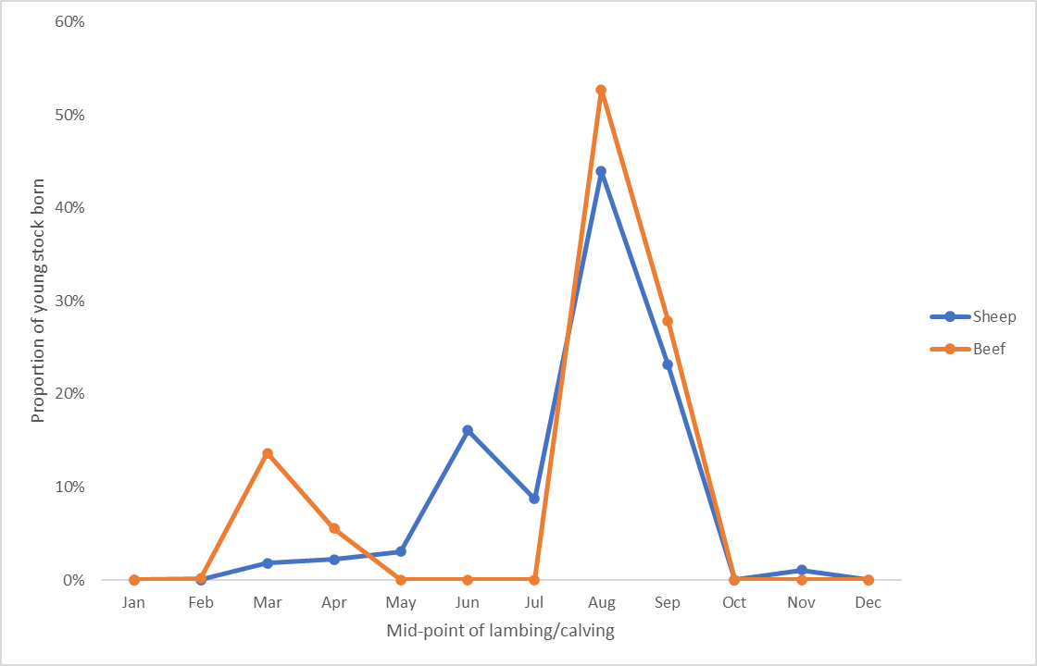
Figure 15: Time of Cattle, Lamb and Wool Sales for Northern LFMP participants 2020-21
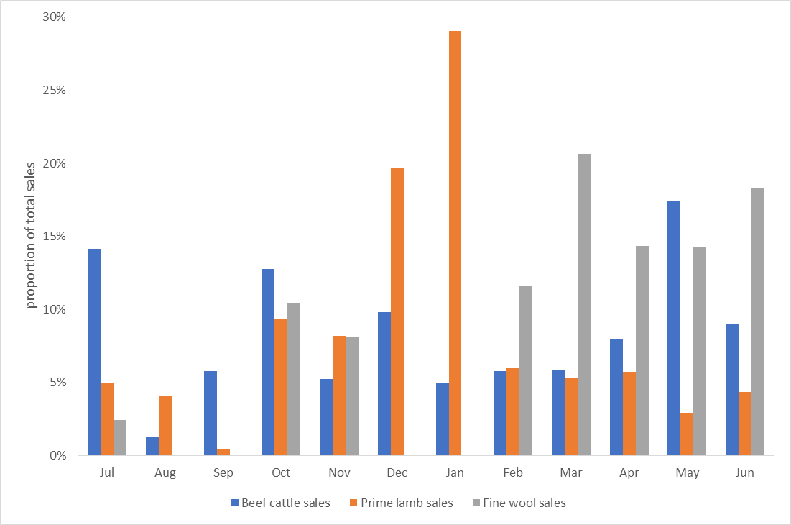
Figure 16: Prices received for Lamb, Beef and Wool for Northern LFMP participants 2020-21
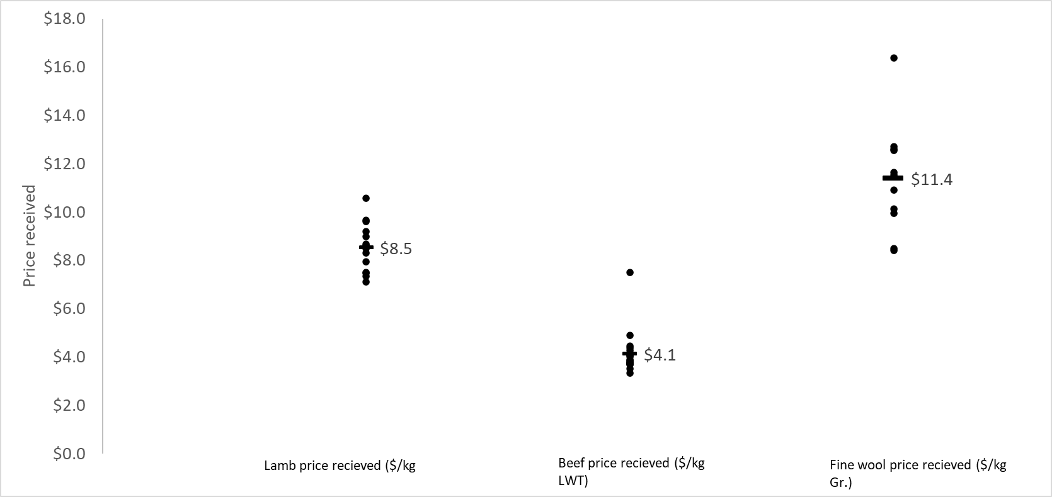
Figure 17: Average Stocking Rate (DSE/ha) of Northern LFMP over time.
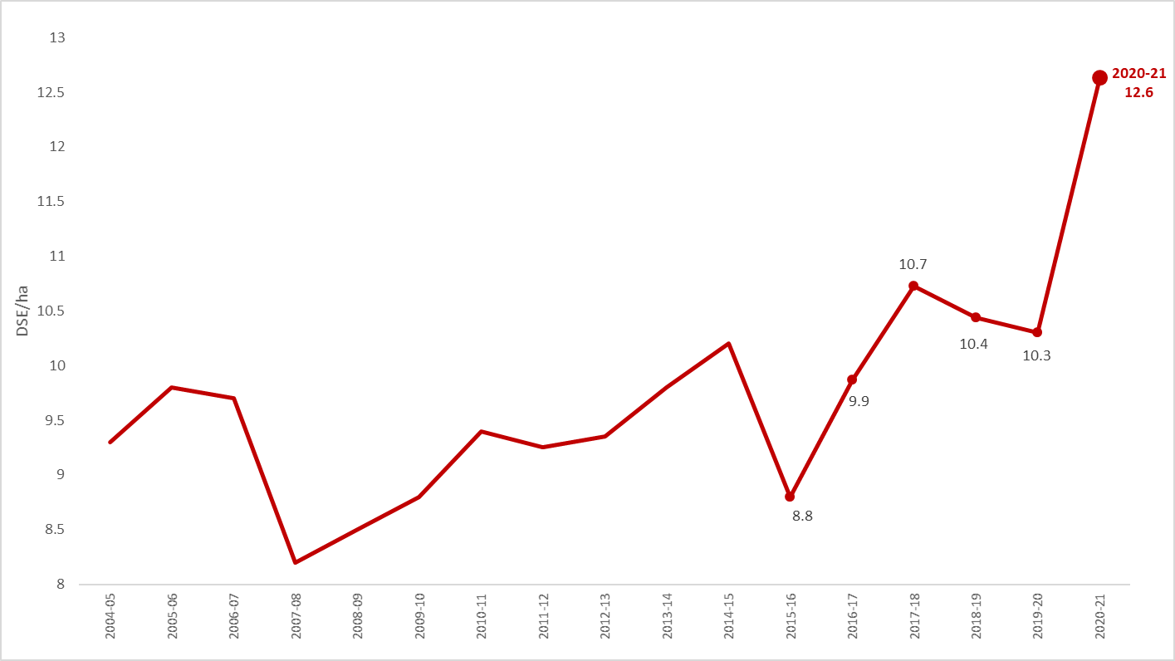

Glossary
Appreciation
An increase in the value of an asset in the marketplace.
often only applicable to land value.
Asset
Anything managed by the farm, whether it is owned or not. Assets include owned land and buildings, leased land, plant and machinery, fixtures and fittings, trading stock, farm investments (i.e., Farm Management Deposits), debtors, and cash.
Average
The sum of a collection of numbers divided by the count of numbers in the collection

Cash Income
The sum of all cash income related to the operation of the farm/ enterprise.

Cash overheads
All fixed costs that have a cash cost to the business. Includes all overhead costs except imputed labour costs and depreciation.
Casual Labour
A casual employee is an employee engaged casually and paid by the hour. Casual loading is paid instead of annual leave, notice of termination, redundancy benefits and other attributes of permanent
Contract Labour
A contractor controls the work to be done and how it is to be performed. They can employ their own staff and can sub-contract or delegate.
Concentrate
Category of feed that includes grains, oilseeds, and pellets

Depreciation
Decrease in value over time of capital asset, usually as a result of using the asset. Depreciation is a non-cash cost of the business but reduces the book value of the asset and is therefore a cost.
Dry Sheep Equivalent (DSE)
Standard unit used to compare the ME requirements of different classes of stock for feed budgeting purposes

Earnings before interest & tax (EBIT)
Also known as ‘Operating Profit’ or ‘Profit’ is the return on all the capital used in the business before accounting for finance costs. Calculated as gross farm income minus total variable and total overhead costs.
Effective area
Total hectares managed minus the area of land which is of little or no value for livestock or crop production.
Equity
Total assets minus total liabilities. Equal to the total value of capital invested in the farm business by the owner/ operator(s).
Equity %
Total equity as a percentage of the total assets owned.
The proportion of the total assets owned by the business.
Feed inventory change
An estimate of the feed on hand at the start and end of the financial year.
Full time equivalent (FTE)
Standardised labour unit. Equal to 1,920 hours a year.
Calculated as 48 hours a week for 40 weeks a year.
Grazed area
Pasture area plus an estimate of annual cropping area grazed. If a farm has multiple livestock enterprises, grazed area is apportioned based on the total annual ME demand of each enterprise.

Grazed pasture utilised
Calculated using the back-calculation approach. Grazed feed is calculated as the difference between total metabolisable energy required by livestock over the year and amount of metabolisable energy consumed from other sources (hay, silage, grain, and concentrates).
Total metabolisable energy required by livestock is a factor of age, weight, growth rate, pregnancy and lactation requirements and number of animals.
Gross income
The total income, cash, and non-cash, received from a farm or enterprise, before any expenses are paid.
Gross margin
Gross farm income minus total variable costs.
Imputed
An estimated amount introduced into economic management analysis to allow reasonable comparisons between years and between other businesses.
Interest and lease costs
Total interest plus total lease costs paid. Also known as “finance costs”
Liability
Money owed to someone else, e.g., family or a financial institution.

Livestock trading profit
An estimate of the annual contribution to gross farm income by accounting for the changes in the number and value of livestock during the year. It is calculated as the trading income from sales minus purchases, plus changes in the value and number of livestock on hand at the start and end of the year, and accounting for births and deaths. An increase in livestock trading indicates there was an appreciation in the value of livestock per head or an increase in livestock numbers over the year.
Metabolisable energy (MJ ME)
The energy available for use by the animal. It is the energy used for maintenance of body systems, activity, milk production, pregnancy and weight gain. Metabolisable is net of energy lost in the form of urine and methane gas released by rumen and hind–gut microbes.

Net farm income
Earnings before interest and tax (EBIT) minus interest and lease costs. The amount of profit available for capital investment, loan principal repayments and tax.
Nominal terms
Dollar values or interest rates that include an inflation component.
Livestock costs
All expenses relating to assisting with herd and flock management. Includes: animal health costs and shearing contractors.
Livestock Marketing Costs
All costs associated with buying and selling livestock including freight and cartage.
Operating costs
Overhead and variable costs i.e. The costs associated with the annual operation of the farm.
Overhead costs
All fixed costs incurred by the farm business that do not vary with the level of production. These include cash overhead costs such as permanent labour and noncash costs such as owner-operator labour, family labour and depreciation of plant and equipment. It excludes interest, lease costs, capital expenditure, principal repayments, drawings, and tax.
Owner/Operator labour
Staff members (such as Family) that take income from business drawings rather than wages. The operators labour and management are an input to make a profit and so these must be costed and deducted to estimate the true profit and return to the capital in the business.
Pasture costs
All costs associated with growing pasture including fertiliser, seed and chemical.
Permanent Labour
Farm staff who have an on-going expectation of work, generally work standard or set hours, entitled to paid leave and notice of termination
Profit (s)
See Earnings before interest & tax (EBIT) definition.
Real terms
Dollar values or interest rates that have no inflation component.
Return on equity (ROE)
Net farm income divided by the value of total equity.
Return on assets (ROA)
Earnings before interest and tax divided by the value of total assets under management, including owned and leased land.
Standard deviation
The standard deviation is a measure of how widely values are dispersed from the average value
Top 20%
Regional average for the top 20% of farms ranked by return on assets
Variable costs
Variable costs (sometimes called direct costs) vary directly as the output of an enterprise varies.

List of abbreviations
CWT | Carcass weight
DJPR | Department of Jobs, Precincts and Regions, Victoria
DSE | Dry Sheep Equivalent
EBIT | Earnings before interest and tax
GM | Gross Margin
ha | Hectare(s)
kg | Kilograms
Kg Gr. or  Gr. kg | Kilograms of greasy wool
LFMP | Livestock Farm Monitor Project
LWT | Live weight
ME or  MJ ME | Megajoules of Metabolisable energy
ML | Megalitre
mm | Millimetres.
NFI | Net Farm Income
ROA | Return on assets
ROE | Return on equity
t | Tonne = 1,000 kg
tDM | Dry matter of feed stuffs measured in tonnes
yrs | Years old

References
Kay RD, Edwards WM, Duffy PA 'Farm Management' (Mcgraw-Hill Companies)
Malcolm B, Makeham J, Wright V 'The Farming Game - Agricultural Management and Marketing.' (Cambridge University Press: Melbourne)
Nuthall P ‘Farm Business Management: Analysis of Farming Systems ‘ (CAB international)

