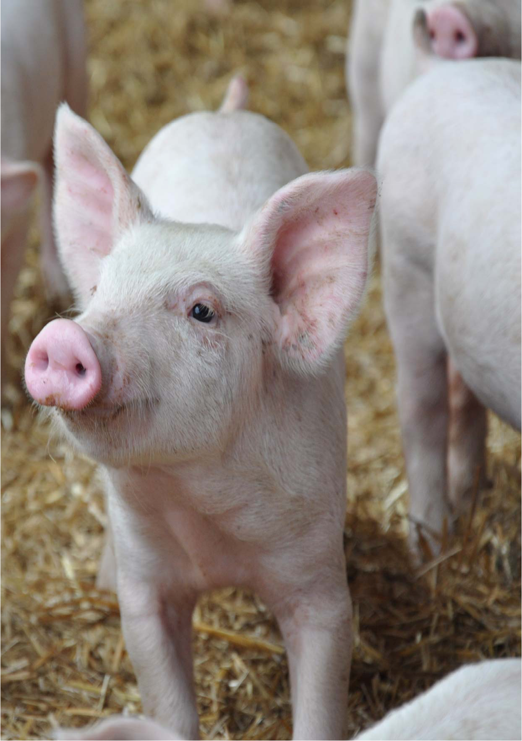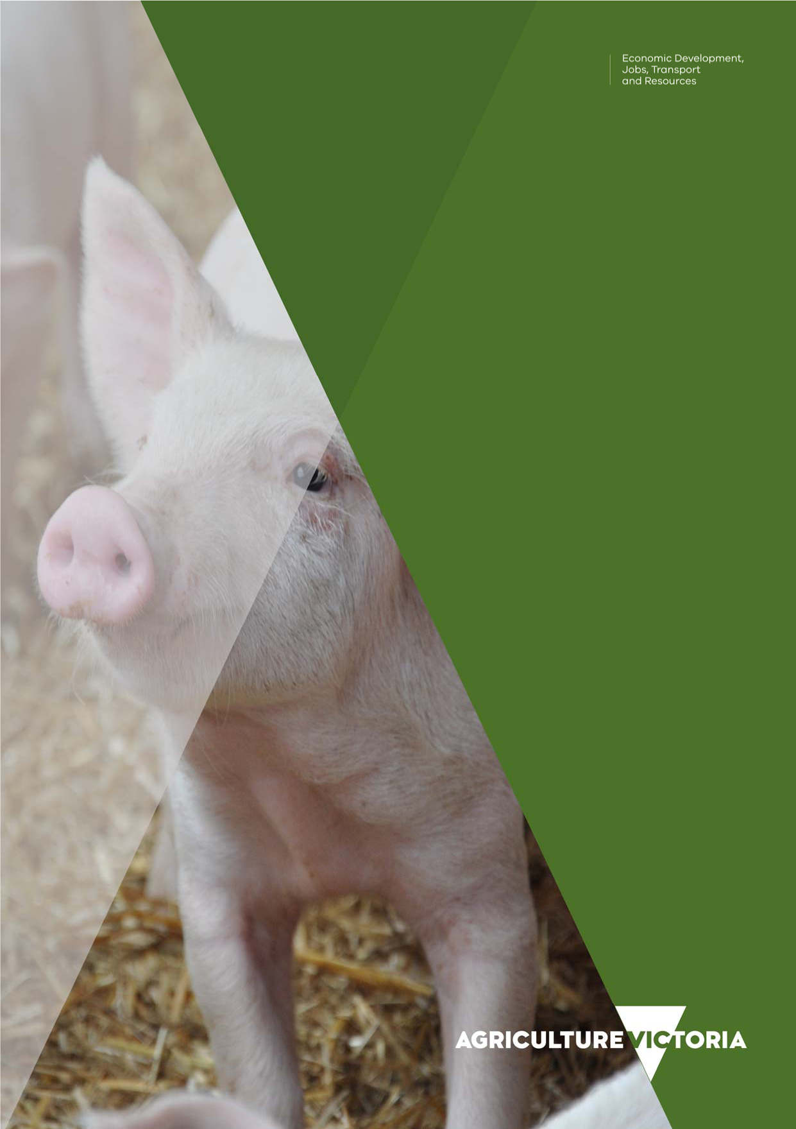

Swine Compensation
Fund

Summary of Projects
2017-18

Swine Compensation Fund Summary of Projects 2017-2018 2

Swine Compensation Fund overview

Victoria's Swine Compensation Fund (SCF) is established under the Livestock Disease Control Act 1994. The fund collects livestock duties paid on the sale of pigs or the carcasses of pigs under the Duties Act 2000.

The SCF receives approximately $0.16 for each pig or each carcass sold.

Money in the Fund may be invested in any manner in which money may be invested under the Trustee Act 1958 or any other manner that the appropriate Minister approves.

The Minister for Agriculture must not make a payment from the fund unless the Minister has considered any relevant recommendations from the Swine Industry Projects Advisory Committee (SIPAC).

Committee members

The SIPAC has been established to provide advice to the Minister for Agriculture on any proposed project for which payments should be made from the SCF and any other matter referred to it by the Minister.

Under Section 87 (3) of Livestock Disease Control Act 1994, the SIPAC comprises five members appointed by the Minister as follows:

(a) 3 are chosen from a panel submitted to the Minister by the Victorian Farmers Federation of the names of at least 5 people whom the Federation considers to represent the swine industry in Victoria;

(b) 2 are officers of the Department of Economic Development, Jobs, Transport and Resources (DEDJTR).

TABLE 1: Swine Industry Projects Advisory Committee membership

Representation | Representative
Victorian Farmers Federation | Mr John Bourke, VFF Pig Group  Dr Patricia Mitchell, VFF Pig Group  Mr Tim Kingma, VFF Pig Group
State Government | Ms Beth Jones, Executive Director, Biosecurity and Agriculture Services (Chair) Dr Rachael Holmes, Senior Officer, Animal Welfare, Agriculture Victoria

Swine Compensation Fund Summary of Projects 2017-2018 3
FUNDING FROM THE SWINE COMPENSATION FUND In 2017-18 the Swine Compensation Fund funded six projects. TABLE 2: Projects funded by the Swine Compensation Fund

Project | Objective | Administered by | Fund  Use | 2017-18 budget | 2017-18 expended
Anthrax vaccination | The SCF approved up to $20,000 in the  2017-18 financial year to the Pig Services  Centre to provide financial support to approved producers to assist them to vaccinate livestock during an anthrax response in a timely manner and undertake annual preventative anthrax vaccination  (post outbreak). These measures reduce the likelihood of anthrax incidents through  ongoing preventive vaccination of livestock  on previously infected farms and in anthrax- prone areas. | Agriculture | SCF | $20,000 | $0
of swine. |  | Victoria |  |  | * No private
 |  |  | Minister |  | veterinary fees
 |  |  | approved |  | were incurred
 |  |  | project |  | for
 |  |  |  |  | administering
 |  |  |  |  | anthrax vaccine
 |  |  |  |  | to pigs during the 2017-18 financial year.
Progress and | The SCF contributed $39,000 in the 2017-18 financial year to the Pig Services Centre to provide training and assessment for two courses ‘Pork Industry Skill Set’ and  ‘Certificate III in Agriculture (Pig Production)’. | Agriculture | SCF | $39,000 | $39,000
improve training in  Certificate III |  | Victoria | Minister
Agriculture (Pork |  |  | approved
Productivity) and  Pork Industry Skill Set to the pig industry. |  |  | project
Development, | The SCF contributed $57,000 in the 2017-18 financial year to the Pig Services Centre to improve stability upon storage of an effective E. coli vaccine and obtain a permit from Australian Pesticides and Veterinary Medicines Authority to manufacture the vaccine and supply it to pig producers at a relatively affordable price | Agriculture | SCF | $57,000 | $57,000
production and |  | Victoria
supply of an |  |  | Minister
effective vaccine |  |  | approved
against scouring in  pigs. |  |  | project
Significant disease | The SCF contributed $2,428.80 (of $20,000 approved) to provide a subsidy of $200 (plus GST) to livestock producers towards the cost of consulting a private veterinary practitioner for investigations approved under the SDI Program. It is important to obtain epidemiological data from significant disease events for Victoria’s animal health surveillance system. The project also provides an incentive payment of $300 (plus GST) to private veterinary practitioners for investigating and reporting investigations of significant disease events that meet specific criteria, following approval by a DEDJTR Veterinary Officer. | Agriculture | SCF | $20,000 | $2,428.80
investigations (SDI). |  | Victoria | Minister |  | * 5 Veterinary and 4 Producer
 |  |  | approved |  | subsidies were
 |  |  | project |  | paid during the  2017-18 financial year.

