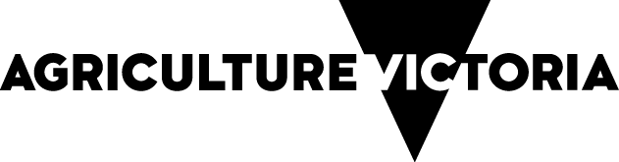

Farm Fitness Checklist
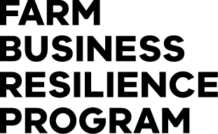
Contents
Farm Business Resilience Program 2
Partners 2
Farm Business Resilience Program 3
Farm Fitness Checklist 3
Where are you and your farm at now? 3
Now, where, how? 3
How to use this checklist 3
Our People 5
Things we can do 6
Our Farm 7
Things we can do 8
Our Business 9
Things we can do 10
Our Landscape 11
Things we can do 12
Our Risks 14
Things we can do 15
SWOT Analysis 16
Internal Factors 16
Strengths 16
Weaknesses 17
External Factors 17
Opportunities 17
Threats 17
Your Farm Business Plan 18

Farm Business Resilience Program

Partners
This Farm Fitness Checklist has been developed by Dairy Australia in collaboration with the NSW Department of Primary Industries and Agriculture Victoria. It will be used to support the roll out of the Farm Business Resilience Program, a key initiative of the Australian Government’s Future Drought Fund.
The checklist is designed to assist all Australian farmers to be more prepared and better planned, ultimately making them more resilient and able to meet challenges and grasp opportunities.
Dairy Australia would like to acknowledge the support of the Gardiner Dairy Foundation and DairyNZ.
The Gardiner Dairy Foundation has supported the development and roll out of the Our Farm, Our Plan program to all dairy farmers, reinforcing the value of the dairy industry working together. DairyNZ kindly gave permission to Dairy Australia to adapt their Farm Fitness Checklist for use in the Our Farm, Our Plan program, another example of Trans-Tasman collaboration providing benefit to Australasian dairy farmers.

Farm Business Resilience Program

Farm Fitness Checklist

Where are you and your farm at now?
A fit and healthy farm business provides the platform needed to achieve your goals (business and personal), and be profitable and resilient in the long term.
How well do you and your partners know your farm and your business, and its fitness for the future? Use this checklist to assess where you’re at now and to help identify opportunities for improvement. It also suggests where to go to get the information, resources and support you need to make it happen.

Now, where, how?
Completing the checklist will give you a good sense about where you and your business are at now. This is an important step in the planning process, followed by clearly identifying your ‘where and how’ and, preferably, getting it down on paper.

How to use this checklist
Each section of this checklist is designed to prompt your thinking about different aspects of your farm business. It’s a ‘self-assessment’ and there are no right or wrong answers. Your job is to identify areas that might be a priority for you by ticking the box that best describes where you are at for each question.
Yes, we’ve nailed it | Ok, but we could do better | No, and we should do something about it | No, and it’s not relevant to us
P | P | P | P

Try scanning through the checklist before you start ticking so that you have an idea of what’s included. The aim is to identify and focus on a small number of areas that will move you forward significantly.
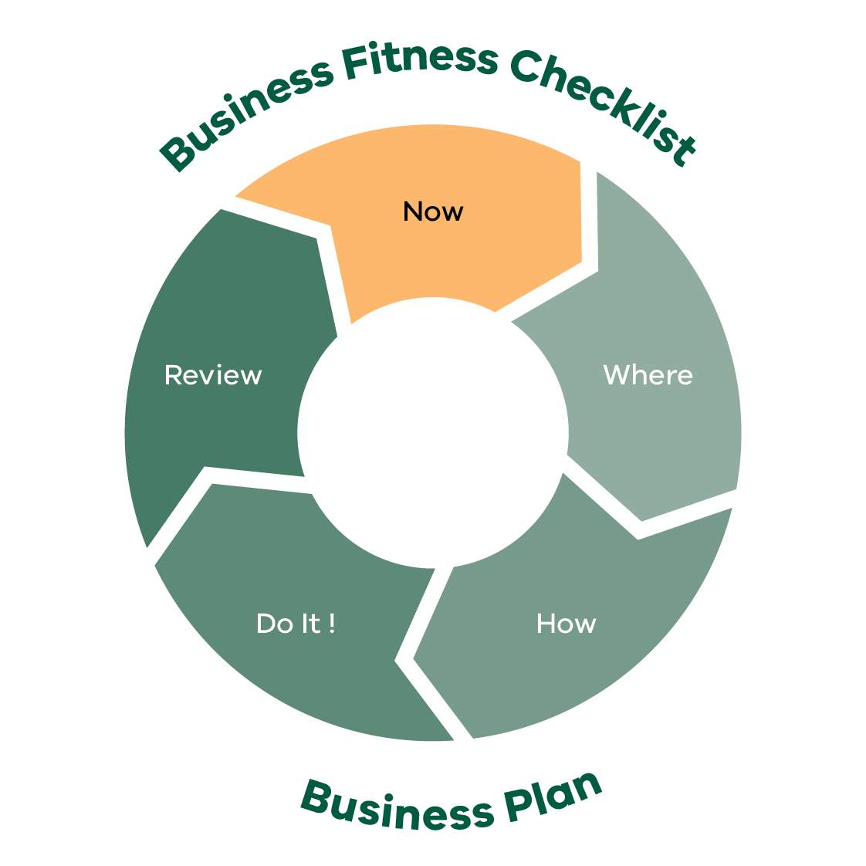
Business Fitness Checklist Business Plan
- Now
- Where
- How
- Dot It!
- Review
This process will help you to focus on what’s achievable — none of us can do everything at once.
After completing each section think about how you’ve rated yourself and list some goals and actions that you reckon will make the biggest difference in improving what you do.

Our People
(Please place x in relevant cell)
Questions | Yes, we’ve nailed it | Ok, but we could do better | No, and we should do something about it | No, and it’s not relevant to us
We know who our neighbours are and we help them in times of need
We really enjoy what we are doing
We know what we want our life to look like in 5 years’ time
We have considered our retirement needs and what it will take to get there
We have a plan to develop our skills (e.g. communication, people management, financial)
We have enough time to spend with family and friends
Most days I am happy to go to work
We have a healthy lifestyle
Our team understands our business purpose and their role in achieving that purpose
Our employees/contractors have been inducted and the induction process is recorded
We are compliant with our legal obligations when employing staff
We have regular team meetings
We are involved in local groups and activities that strengthen the local community
We have an emergency management plan in place

Things we can do
Think about the ratings you’ve given yourself above. What areas do you want to focus on? Can you see opportunities? Write some goals and actions down here.

Things to think about (goals/ actions) | Who is responsible | Priority level | Timeframe

Notes

Our Farm
(Please place x in relevant cell)
Questions | Yes, we’ve nailed it | Ok, but we could do better | No, and we should do something  about it | No, and it’s not relevant to us
The farm housing is suitable (e.g. family home and staff accommodation)
We have a plan to improve our farm infrastructure to meet future needs
Farm fencing is adequate for livestock and we have sound boundary fences
Our grain and fodder storage capacity is sufficient
We had sufficient on farm stock water supply in the last drought
We had enough house water to get us through the last drought
Our investment in farm machinery and technology is well planned and suitably matched to the needs and scale of the operation
We monitor and record farm information on a regular basis

Things we can do
Think about the ratings you’ve given yourself above. What areas do you want to focus on? Can you see opportunities? Write some goals and actions down here.

Things to think about (goals/ actions) | Who is responsible | Priority level | Timeframe

Notes

Our Business
(Please place x in relevant cell)
Questions | Yes, we’ve nailed it | Ok, but we could do better | No, and we should do something  about it | No, and it’s not relevant to us
We have a written business plan and a list of goals that we are working towards
I feel we are in control of our business
We have measures and targets for our farm production
We are aware of our financial performance measured by profitability and net worth over time
We know our cash flow position and ability to pay the bills on a monthly basis
We have a good handle of our costs of production and profit-making commodity price targets
We develop an annual plan and budget and update it throughout the year
We look at other businesses for ways we can improve what we do
We have a documented succession plan which is regularly reviewed and discussed with family members
We have good relationships with our accountant, our bank and other service providers
We have off farm income streams (e.g. rental income, day job, contracting)
We understand what the likely affects of climate change will be on our farm business and have plans (short/long) to adapt accordingly

Things we can do
Think about the ratings you’ve given yourself above. What areas do you want to focus on? Can you see opportunities? Write some goals and actions down here.

Things to think about (goals/ actions) | Who is responsible | Priority level | Timeframe

Notes

Our Landscape
(Please place x in relevant cell)
Questions | Yes, we’ve nailed it | Ok, but we could do better | No, and we should do something about it | No, and it’s not relevant to us
We have a whole farm plan and map identifying environmental risks (e.g. water ways, wells, bridges, culverts, infrastructure, erosion areas)
We apply sprays responsibly and fully understand the spray set up and environmental conditions required to avoid drift, run off and off target damage
Stock are excluded from waterways
We are on track to leave an improved natural resource base for the next generation
Our farm management strategies optimise soil water retention
We monitor our soil health and our management strategies enhance our soil capability (e.g. ground cover preservation, reduced tillage)
We know our soils and what’s needed to manage any constraints
We strategically use and plant trees for multiple purposes (e.g. stock shelter, erosion, salinity, timber capturing carbon and/or biodiversity)
Our community works together to improve/enhance the local landscape

Things we can do
Think about the ratings you’ve given yourself above. What areas do you want to focus on? Can you see opportunities? Write some goals and actions down here.

Things to think about (goals/ actions) | Who is responsible | Priority level | Timeframe

Notes

Our Risks
(Please place x in relevant cell)
Questions | Yes, we’ve  nailed it | Ok, but we could do better | No, and we should do something  about it | No, and it’s not relevant to us
Our business is robust and can withstand various ‘shocks’ (e.g. commodity price drops, interest rate hikes, drought, floods, staff vacancies)
In the event of these shocks, we have recovery plans and know where to access support information
We have an appropriate business structure in place (e.g. sole trader, partnership, company or trust)
We have effective insurance coverage (e.g. farm and life insurance)
We have identified the major risks associated with our business and have risk mitigation strategies in place
We have access to finance that allows us to invest in development work or opportunities when they arise
We have identified and documented the hazards on farm which are effectively managed to keep ourselves, our team and our visitors safe
In the last drought we had enough livestock feed on farm
We have a plan for managing the farm and animals during extreme weather (e.g. droughts, fire, floods, storms)
We have a biosecurity plan in place
We are confident that all our animals are healthy and well fed, and meet animal welfare expectations
We are effectively managing chemical resistance for pests of crops and animals
Our team has health and safety front of mind, the safety risks are identified and systems are in place to isolate or minimise these
We use short and long term seasonal forecasts to make informed decisions and adapt our management practices and business plans

Things we can do
Think about the ratings you’ve given yourself above. What areas do you want to focus on? Can you see opportunities? Write some goals and actions down here.

Things to think about (goals/ actions) | Who is responsible | Priority level | Timeframe

Notes

SWOT Analysis
Considering your business Strengths, Weaknesses, Opportunities and Threats (SWOT) after completing Checklist questions can assist with your next move and priorities.

Internal Factors

Strengths
“Build on…”

Weaknesses
“Correct or avoid…”

External Factors

Opportunities
“Take advantage of…”

Threats
“Mitigate…”

Developing strategies will help you achieve your goals and objectives. Use your strengths to take advantage of opportunities, and work to mitigate your weaknesses and minimize threats. Remember that creating a SWOT plan is an ongoing process. You should continually assess your Strengths, Weaknesses, Opportunities and Threats, and adjust your plan accordingly to stay ahead of the curve.
Questions | Strategies to build on
Ways to build on strengths
Ways to take advantage of opportunities
Ways to reduce the effects of weaknesses
Ways to reduce the effects of threats

Your Farm Business Plan
Putting your goals and actions on in a plan will help you to focus on the things that matter the most. It means you have taken the plans in your head and put them on paper, which also means you get the full picture of the things you’d like to achieve next in one place.
This gives all of the decision makers in your business the chance to see the plan and to make sure you’re all on the same page.
Importantly it allows you to:
be confident that you have a shared view of what’s next
communicate your plan with other people, either inside or outside your business
refer back to your plans and track your progress and achievements.
You can find the Farm Business Plan template and other resources on the Farm Business Resilience Program webpage: agriculture.vic.gov.au/FBRP
Notes

The Farm Business Resilience Program is supporting farmers to build stronger, more productive agricultural businesses.
Visit: agriculture.vic.gov.au/FBRP
The Farm Business Resilience Program is jointly funded through the Australian Government’s Future Drought Fund and the Victorian Government’s Future Agriculture Skills Capacity Fund.

