# **Livestock Farm Monitor Project**

# **Victoria │ Annual Report**

# **2023-24**

**Further information regarding the Livestock Farm Monitor Project may be obtained from:**

Sam Henty  
Agriculture Victoria  
195-229 Lyttleton Terrace, Bendigo, Victoria, 3550

[sam.henty@agriculture.vic.gov.au](mailto:sam.henty@agriculture.vic.gov.au)

Authorised and published by the Victorian Government, Department of Energy, Environment and Climate Action (DEECA) 2024. © The State of Victoria Department of Energy, Environment and Climate Action 2024.

This publication is copyright. No part may be reproduced by any process except in accordance with the provisions of the *Copyright Act 1968*.

For more information contact the Agriculture Victoria Customer Service Centre on 136 186.

**Disclaimer**

This publication may be of assistance to you, but the State of Victoria and its employees do not guarantee that the publication is without flaw of any kind or is wholly appropriate for your particular purposes and therefore disclaims all liability for any error, loss or other consequence which may arise from you relying on any information in this publication.

**Accessibility**

If you would like to receive this publication in an accessible format, such as large print or audio, please telephone 136 186.

Deaf, hearing impaired or speech impaired? Call us via the National Relay Service on 133 677 or visit www. relayservice.com.au

This document is also available on the [Agriculture Victoria](http://www.agriculture.vic.gov.au/livestockfarmmonitor) website.

Contents

**Livestock Farm Monitor Project** 1

State summary 5

**Business profit and returns** 6

**Scale** 6

**Debt** 7

**Debt servicing** 7

**The principle of increasing financial risk** 8

Gippsland 9

**Gross margins** 9

**Costs** 9

**Price received** 10

**Capital structure** 10

**Return on assets and equity** 10

Northern Victoria 12

**Gross margins** 12

**Costs** 12

**Price Received** 13

**Capital structure** 13

**Return on assets and equity** 13

South West Victoria 16

**Gross margins** 16

**Costs** 16

**Price received** 17

**Capital structure** 18

**Return on assets and equity** 18

**Glossary** 20

**References** 23

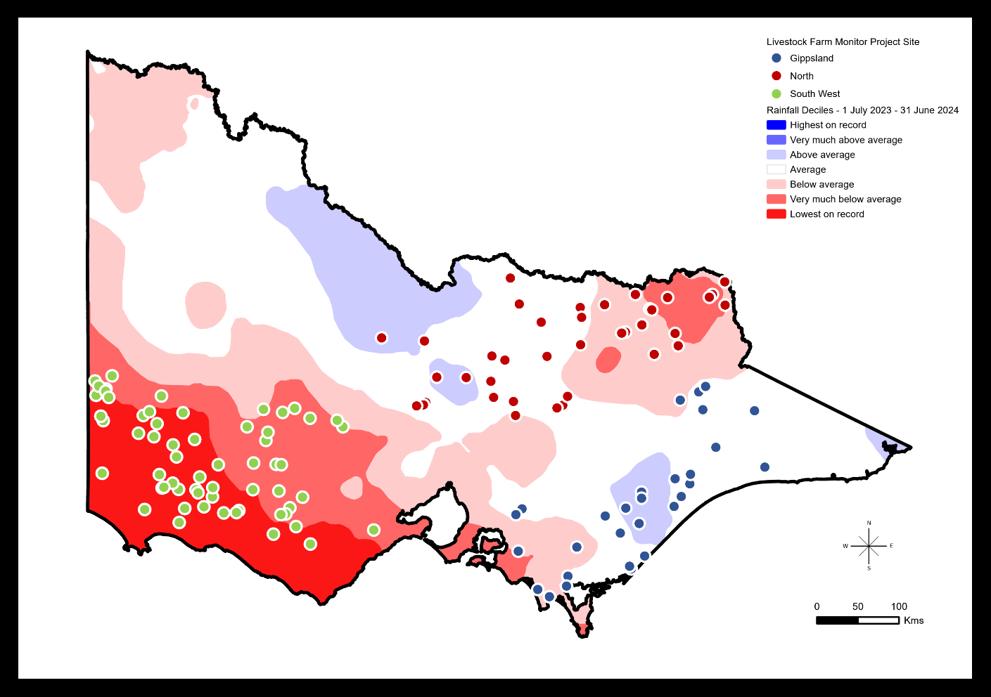

In 2023-24, the Livestock Farm Monitor Project (LFMP) provided 133 Victorian sheep, beef and stock/cropping farmers with detailed financial and production performance information. Of the 133 farms that participated, 105 are continuing farms from 2022-23 and 28 farms are new to the project.

Agriculture Victoria collated the individual business performance information of all surveyed farms to provide insights in this report.

The LFMP is Agriculture Victoria’s primary source of farm-level information for sheep and beef production practices, resource use, and economic data.

The results of this annual survey provide farm-level data to inform Agriculture Victoria’s decisions that impact at a farm level, and to inform the direction of future

policy design, research themes and service delivery programs.

Farmers who participate in the project increase their understanding of their farm business, which builds resilience and improves their ability to adapt to change.

Results published in this report are not statistically representative of an industry or a region.

Agriculture Victoria staff are grateful for the cooperation of the farmers who contributed their data to this project.

This project has been running continuously since 1971 and is funded by Agriculture Victoria.

## State summary

Key points

* Farm profits and returns fell to the lowest values recorded since 2006-07.
* Reduced farm profitability was a result of lower farm incomes from the continued decline in red meat and wool prices while costs remained high and were similar to 2022-23.
* Negative profits were recorded by 48% of farms.
* More debt, higher interest rates and lower incomes meant total interest costs made up 12% of farm income, four times higher than two years ago.
* Stock and grain businesses were the best performing and on average the only business type with positive annual return on assets.
* Farms with more debt and low equity experienced much larger losses than farms with less debt and high equity, as measured by return on equity.
* Supplementary feeding rates and expenditure increased in the South West as a result of dry conditions and lower pasture growth.

|  |  |  |  |  |  |  |
| --- | --- | --- | --- | --- | --- | --- |
| **State summary** |  |  |  |  |  |  |
|  |  |  |  |  |  |  |
| **Financial parameter bars:** | **10-yr average** | **G** | **10-yr average** | **N** | **10-yr average** | **SW** |
| Gross Farm Income ($/ha) | $1,239 | $1,322 | $910 | $864 | $1,255 | $991 |
| Variable costs ($/ha) | $474 | $600 | $343 | $398 | $502 | $614 |
| Overhead costs ($/ha) | $562 | $723 | $399 | $507 | $365 | $346 |
| Earnings before Interest and Tax (EBIT) ($/ha) | $203 | $0 | $168 | -$41 | $389 | $31 |
| Return on Assets (%) | 1.4% | -0.1% | 1.7% | -0.2% | 3.4% | 0.1% |
| Return on Equity (%) | 1.0% | -3.1% | 1.3% | -2.3% | 3.3% | -1.7% |
|  |  |  |  |  |  |  |
| **Physical parameter bars:** | **10-yr average** | **G** | **10-yr average** | **N** | **10-yr average** | **SW** |
| Effective area (ha) | 737 | 603 | 885 | 774 | 1,252 | 1,620 |
| Stocking rate (DSE/ha) | 16.9 | 19.2 | 10.8 | 13.5 | 15.5 | 16.1 |
| Sheep (head) | 2,928 | 2,836 | 3,586 | 4,267 | 7,351 | 9,896 |
| Cattle (head) | 565 | 681 | 429 | 626 | 366 | 747 |

### **Business profit and returns**

In 2023-24, farm profitability was the lowest since 2006-07. Negative profits were recorded by 48% of surveyed farms, with average earnings before interest and tax (EBIT) decreasing to well below the 10-year average in each respective region. South West Victoria recorded the lowest EBIT since 2006-7 and northern Victoria the lowest in the history of the project (Figure 1). The decline in red meat and wool prices experienced in 2022-23 continued in 2023-24 resulting in decreased farm incomes across the state. Variable and overhead costs in Gippsland and northern Victoria remained high but at similar levels to 2022-23. Variable costs in South West Victoria increased to a 10-year high as farmers responded to very dry seasonal conditions.

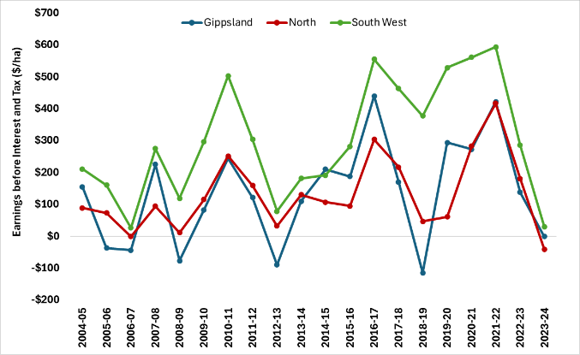

Figure 1. Regional profitability over time

In 2023-24, average return on assets (RoA) was below the 10-year average in all regions. Regardless of the average, each region had participant farms that recorded high returns and negative returns (Appendix B1, C1, D1).

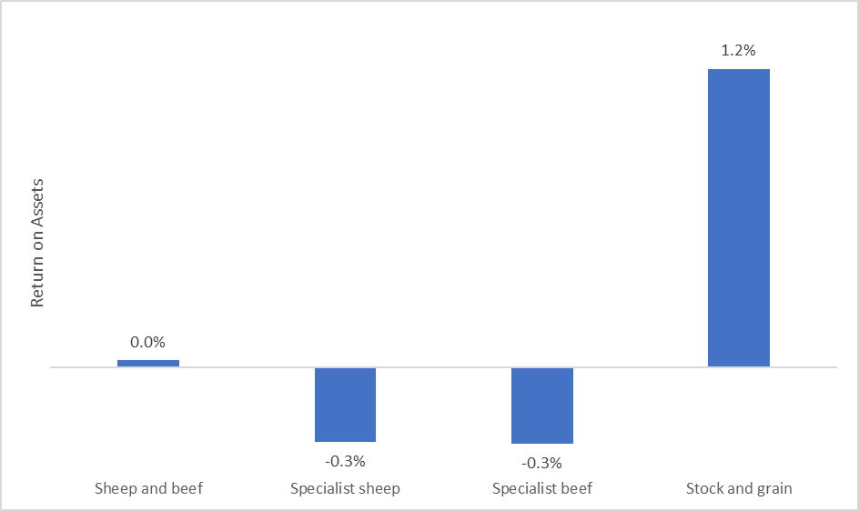

Figure 2. 2023-24 return on assets for each business type

|  |  |  |  |  |  |  |
| --- | --- | --- | --- | --- | --- | --- |
| **Business type** | **Gross Farm Income** | **Total Variable costs** | **Total Overhead costs** | **Earnings before Interest and Tax** | **Return on Assets** | **Return on Equity** |
|  | $/ha | $/ha | $/ha | $/ha | % | % |
| Sheep and beef | 884 | 477 | 372 | 35 | 0.0% | -1.9% |
| Specialist sheep | 828 | 554 | 324 | -51 | -0.3% | -1.9% |
| Specialist beef | 1,171 | 551 | 699 | -78 | -0.3% | -3.2% |
| Stock and grain | 1,673 | 683 | 641 | 349 | 1.2% | -0.7% |

When the dataset was separated into farm business types (see glossary for definitions), on average stock and grain businesses were the best performing and the only business type with positive average annual returns (Figure 2). Stock and grain businesses recorded the highest average farm income but also recorded the highest average operating (variable plus overhead) costs. Businesses specialising in sheep and businesses specialising in beef had the lowest average return on assets in 2023-24 (Table 1).

Table 1. Average performance measures for each business type for the 2023-24 LFMP dataset.

### **Scale**

When the LFMP dataset was separated by business scale, larger farms tended to have slightly higher average return on assets than smaller farms (Figure 3). Surveyed farms with cash income less than $386,000 had the lowest average return on assets.

Small and large farms relied on different enterprises for income generation. Beef cattle sales made up an average of 60% of total cash income on the smallest 25% of farms. Whereas cattle sales contributed only 22% of total cash income on the largest 25% of farms (Appendix A3).

Grain sales made up an average of 11% of total cash income on the largest 25% of farms and only contributed 2% of total cash income on the smallest 25% of farms.

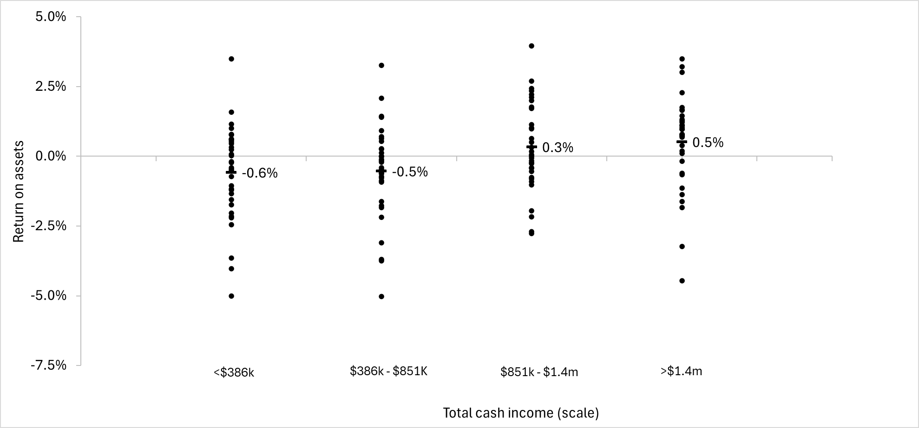

Figure 3. 2023–24 return on assets separated by farm scale (defined by total cash income).

When livestock businesses were separated by scale (based on total DSE), scale economies were observed. Figure 4 shows the major sources of scale economies in sheep and cattle production were in overhead costs. There were significant differences among each of the size group overhead costs, but less differences for variable costs. This result highlights that larger farms can reduce their costs through scale by spreading overhead costs over more output.

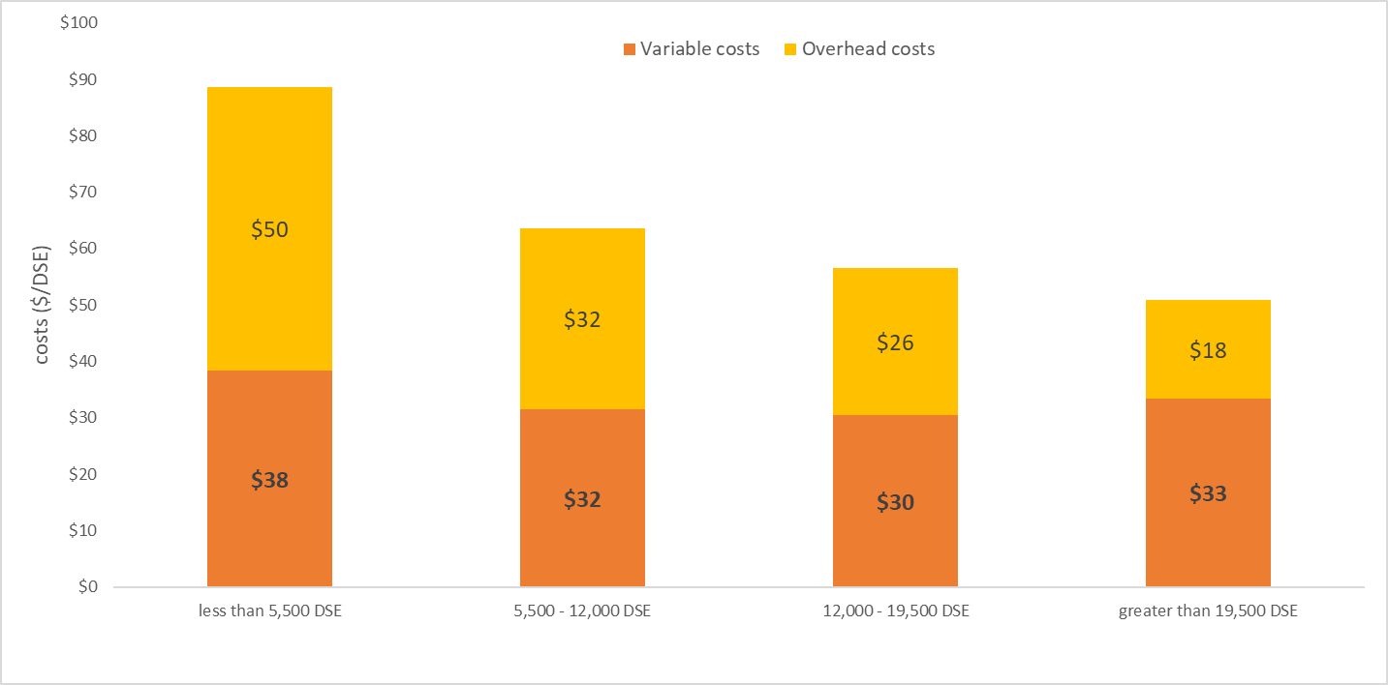

Figure 4. Variable and overhead costs ($/DSE) for livestock businesses separated by farm scale (defined by total DSE).

### **Debt**

Over half of South West farms increased debt during 2023-24 (Figure 5). This contrasted with Northern farms where only 21% of farms increased debt but 43% reduced debt throughout 2023-24. Gippsland had the highest proportion of farms with no debt (35%).

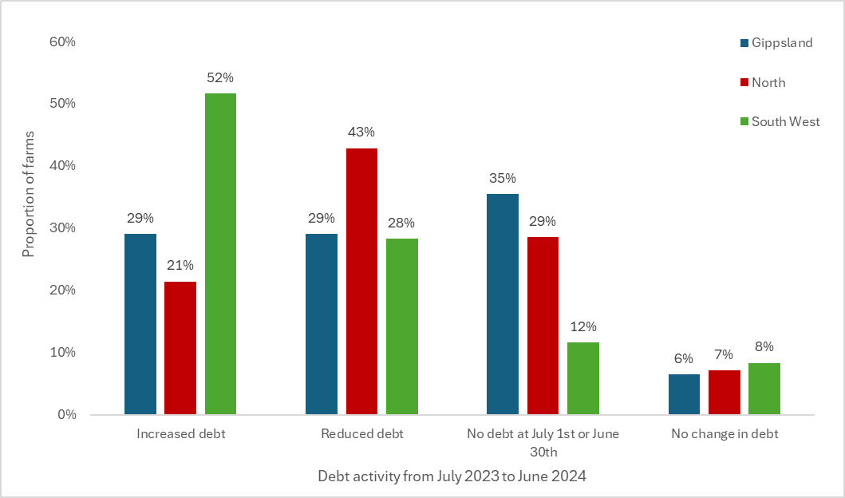

Figure 5. Debt activity from 1 July 2023 to 30 June 2024

### **Debt servicing**

Servicing debt consists of making interest payments and repaying principal. The proportion of farm cash income spent on interest expenses (interest expense ratio) is useful to determine the capacity of a farm business to service debt.

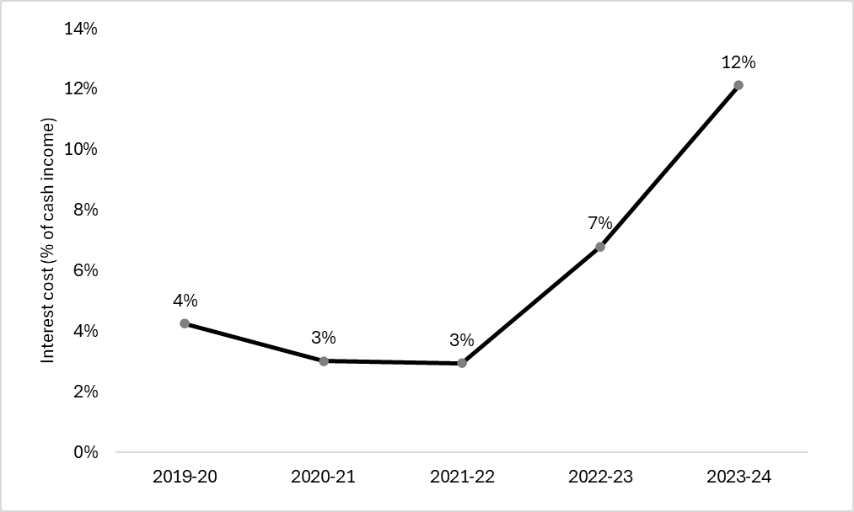

Figure 6. The proportion of farm cash income spent on interest payments from 2019-20 to 2023-24.

In 2023-24 the average interest expense ratio for LFMP participants was 12%, four times higher than two years ago (Figure 6). The large increase in interest expense ratio was caused by an increase in borrowing, falling incomes and rising interest rates in 2023-24.

### **The principle of increasing financial risk**

The relationship between debt, equity, total assets and debt servicing is the key to business survival and growth.

When a farm borrows to expand, it takes on increased financial risk. In good years, this borrowing can mean the owner’s net worth (equity) grows more quickly than not having debt. But in poor years, this borrowing can lead to equity being eroded faster than it would have grown in the good years. The rate of building equity and erosion of equity are not symmetrical, which is why the principle is called 'increasing financial risk'.

The data from LFMP across the last 20 years demonstrates the principle of increasing risk The 3 most profitable and least profitable years were identified in Figure 1 and investigated in Figure 7. In the 3 most profitable years, farms with less than 75% equity (more debt) had higher returns than farms with higher than 75% equity (less debt). However, in the 3 least profitable years farms with less than 75% equity experienced much larger losses than farms with higher than 75% equity.

This is because as a farm takes on more debt it takes on higher debt repayments which need to be paid regardless of the season or how well the business is doing. The losses in the least profitable years were much greater than the gains they experienced in most profitable years.

In agriculture, the principle of increasing risk is an ever-present risk because expansion in farm size is mainly through borrowed funds.

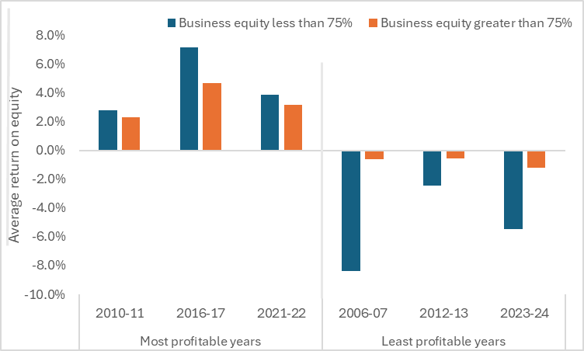

Figure 7. The average return on equity (ROE) for LFMP farms in the three most and least profitable years over the last 20 years, separated by levels of business equity (the proportion of the total value of farm assets relative to its debt).

## Gippsland

### **Gross margins**

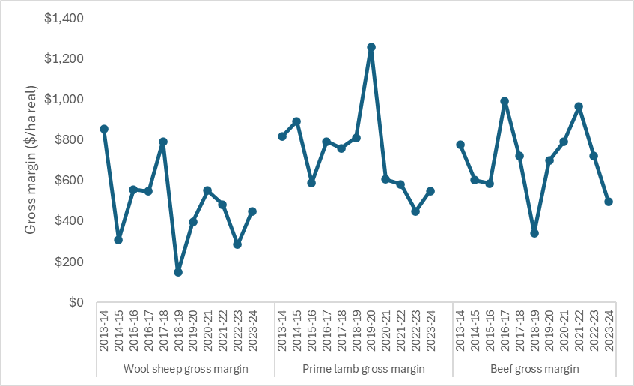

Figure 8. Gippsland average gross margin for wool sheep, prime lamb and beef (2013-14 to 2023-24)

Gippsland beef gross margins continued to decrease to be the second lowest average recorded in the last ten years (Figure 8). This result in 2023-24 was 32% below the five-year average. Prime lamb average gross margin increased slightly in 2023-24, from the previous year, but remained 20% below the 5-year regional average. Wool sheep average gross margins increased in 2023-24 to be 4% above the 5-year regional average. Prime lamb and wool sheep enterprises were less common than beef in Gippsland and enterprise averages were more sensitive to skewing because of outliers.

### **Costs**

Annual prices of key fertilisers (urea, superphosphate) were lower in 2023-24 which helped to lower fertiliser costs. The easing fertiliser prices resulted in the lowest expenditure on pasture fertiliser in the last five years (Figure 9) despite recording an annual increase in average phosphorus application rates. Pasture fertiliser remained the largest cost item on Gippsland farms in 2023-24, making up 13% of average farm cash operating costs.

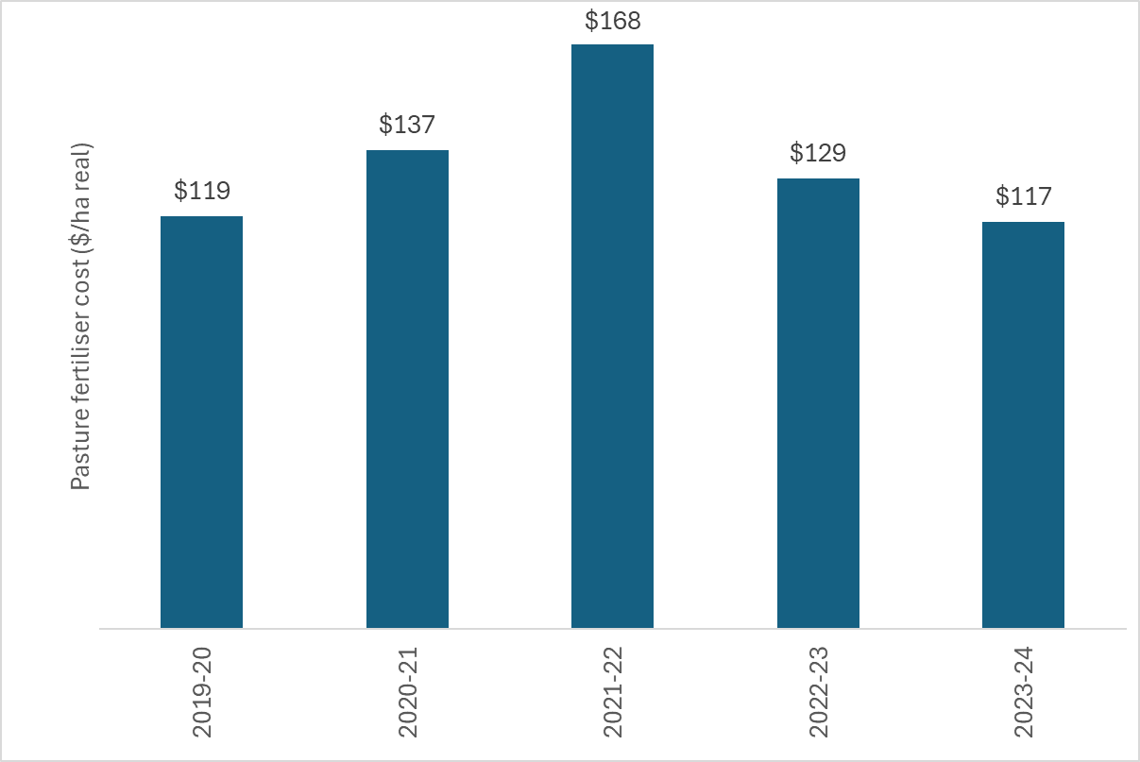

Figure 9. Gippsland farms average expenditure on fertiliser applied to pasture (2019-20 to 2023-24)

On average, Gippsland farms received 98% of their long-term average annual rainfall (Appendix D2). The favourable seasonal conditions enabled a decreased reliance on supplementary feed. Gippsland farmers had the lowest supplementary feeding rates for the whole state, however expenditure on purchased supplementary feed increased for the region (Figure 10) as the price of supplementary feed increased in 2023-24. Beef enterprises were most reliant on supplementary feed (182 ME fed per DSE). Hay was the most common form of supplementary feed fed to beef enterprises in Gippsland.

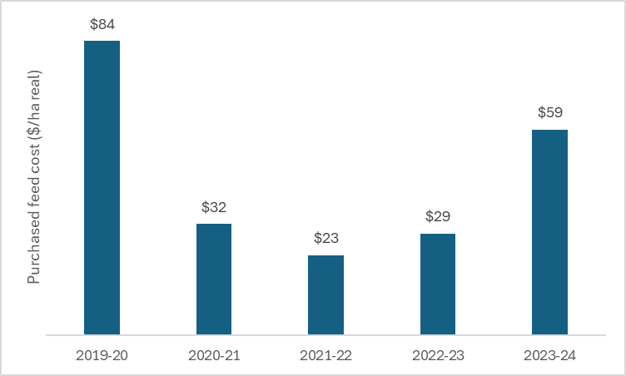

Figure 10. Gippsland farms average expenditure on purchased supplementary feed (2019-20 to 2023-24)

### **Price received**

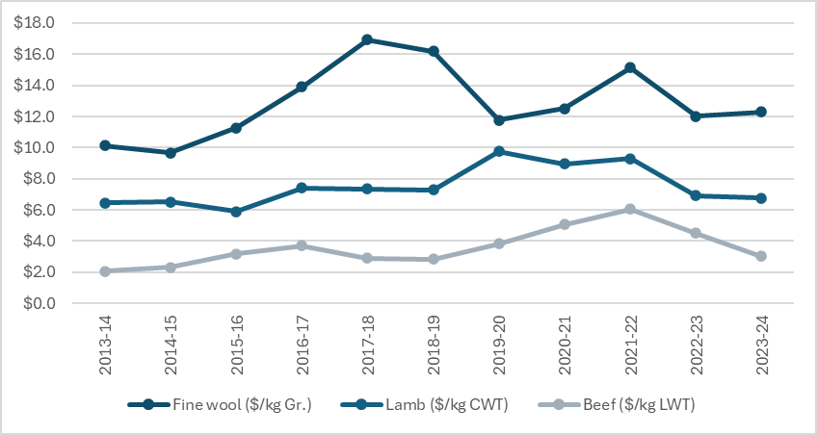

Figure 11. Wool, lamb and beef price received for Gippsland LFMP farms (2013-14 to 2023-24).

Cattle sales was the dominant source of income on Gippsland farms in 2023-24 (Appendix D3). Farms were highly exposed to falling beef prices which decreased by 33% from 2022-23 prices (Figure 11) and were 32% below the regional 5-year average. Average prices received for prime lamb and wool sheep remained similar to the previous year, this was mostly because the average was made up of a smaller number of enterprises (compared to beef) and therefore more sensitive to outlier results.

### **Capital structure**

Farm debt levels increased in 2023-24, to the highest level in 10 years, as Gippsland farms continued to invest in their business despite the poorer market conditions. New machinery, new fences, water storage and irrigation infrastructure were the most common forms of capital expenditure on Gippsland farms in 2023-24. Farmland values continued to rise in most parts of Gippsland resulting in Gippsland farms managing the highest value of total assets per hectare of the LFMP regions ($23,619/ha). Increases in farmland values were not enough to offset the increase in debt levels as 35% of farms reduced their equity in 2023-24 and the regional average equity percentage dropped to 85% (Appendix A6).

### **Return on assets and equity**

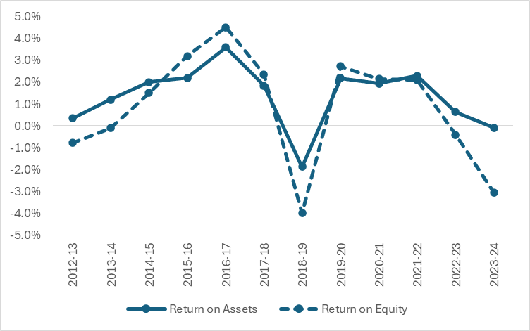

Figure 12. Gippsland return on assets and equity.

Negative profits were recorded by 61% of LFMP farms in Gippsland. Low farm profits on most farms meant that Gippsland average return on assets was negative (-0.1%) for the first time since the 2018-19 (Figure 12). Increases in debt levels, and interest rates since 2018-19 have increased the average expenditure on interest payments. The higher interest costs have accentuated farm businesses losses and Gippsland average return on equity fell well below the regional 10-year average in 2023-24.

Gippsland regional summary

* Beef was the dominant source of income on Gippsland farms in 2023-24.
* Negative profits were recorded by 61% of LFMP farms in Gippsland.
* Average beef price received dropped by 33% from 2022-23 levels.
* Lower unit prices of some farm inputs meant costs remained steady, albeit at historically high levels.
* Debt levels increased by 37% to $2,889/ha, the highest levels in 10 years.
* Average return on equity fell to -3.1% the second lowest returns in the last 10 years.
* Gippsland farms received 98% of their long-term average annual rainfall.

l

|  |  |  |
| --- | --- | --- |
| **Regional summary** |  | **G** |
|  | **5-yr average** | **2023-24** |
| **Enterprise income** |  |  |
| Beef income ($/ha) | 1288 | 1,043 |
| Prime Lamb income ($/ha) | 1,154 | 1045 |
| Wool Sheep income ($/ha) | 746 | 769 |
|  |  |  |
| **Variable costs** |  |  |
| Beef variable costs ($/ha) | 555 | 546 |
| Prime Lamb variable costs ($/ha) | 466 | 498 |
| Wool Sheep variable costs ($/ha) | 318 | 321 |
|  |  |  |
| **Production** |  |  |
| Beef sold (kg lwt/ha) | 383 | 514 |
| Lamb sold (kg cwt/ha) | 120 | 150 |
| Wool sheep wool cut (kg Gr./ha) | 39 | 42 |
|  |  |  |
| **Labour** |  |  |
| Labour use efficiency (ha/FTE) | 304 | 268 |
| Labour use efficiency (DSE/FTE) | 4,813 | 4,511 |
|  |  |  |
| **Phosphorus application** |  |  |
| Phosphorus applied to pasture (kg/ha) | 11 | 9 |
| Phosphorus applied to pasture (kg/DSE) | 0.6 | 0.5 |
|  |  |  |
| **Business structure** |  |  |
| Total assets managed ($/ha) | 20,099 | 23,619 |
| Total debt ($/ha) | 2,008 | 2,889 |
|  |  |  |
| **Top 5 costs (Proportion of total cash operating costs)** | |  |
| Pasture fertiliser costs (%) | 13% |  |
| Livestock selling costs (%) | 7% |  |
| Animal health (%) | 6% |  |
| Wages for permanent staff (%) | 6% |  |
| Rates (%) | 5% |  |

## Northern Victoria

### **Gross margins**

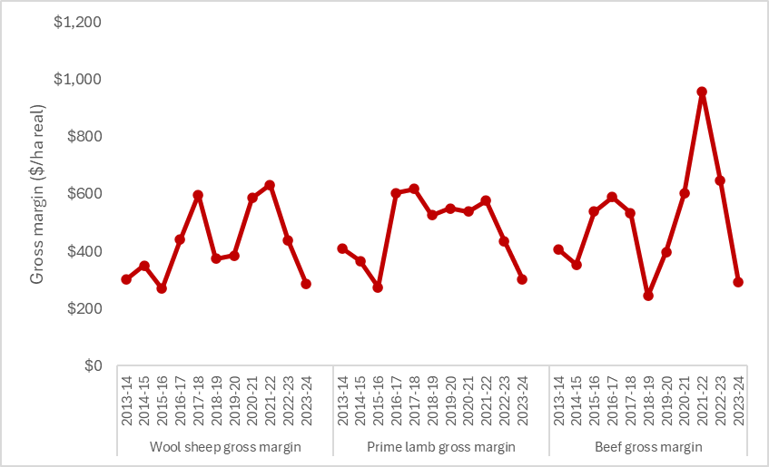

Figure 13. Northern average gross margin for wool sheep, prime lamb and beef (2013-14 to 2023-24)

Falling commodity prices and incomes across all enterprises meant gross margins recorded by Northern farms were below the 5-year average for each of the livestock enterprises. Prime lamb and wool sheep gross margins were the lowest since 2015-16 (Figure 13). Beef gross margins per hectare were the second lowest and per DSE the lowest for the region in 20 years (Appendix C13).

### **Costs**

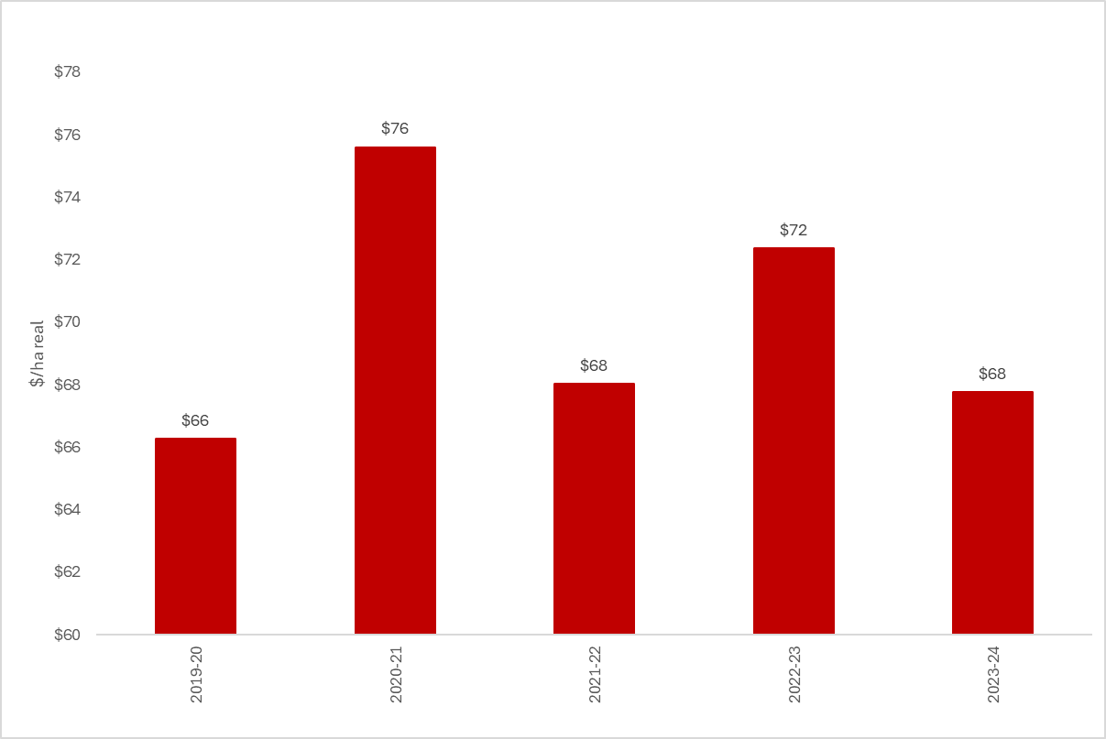

Figure 14. Northern farms average expenditure on fertiliser applied to pasture (2019-20 to 2023-24)

After three consecutive years of decreasing fertiliser applications rates, in 2023-24 Northern farms responded to lower fertiliser prices by increasing application rates. The lower fertiliser price offset the increase in application rate and overall expenditure on pasture fertiliser decreased in 2023-24 (Figure 14). Despite the reduced costs, fertiliser remained the largest cost item on Northern farms in 2023-24, making up 11% of average farm cash operating costs.

Northern farms received close to long-term average annual (98%) and spring 2023 (93%) rainfall (Appendix D2). Good pasture availability meant that expenditure on purchased supplementary feed remained steady (Figure 15). Supplementary feeding rates (metabolisable energy in supplementary feed fed per DSE) in beef and wool sheep enterprises increased, but rates decreased in prime lamb enterprises. Despite the decrease, prime lamb enterprises were most reliant on supplementary feed (351 ME fed per DSE) (Appendix C8). Grain and pellets were the most common form of supplementary feed fed to prime lamb enterprises in Northern Victoria.

Unchanged supplementary feed costs and reduced fertiliser costs resulted in minimal year-on-year changes in average variable costs. However, variable costs remained above the regional 10-year average.

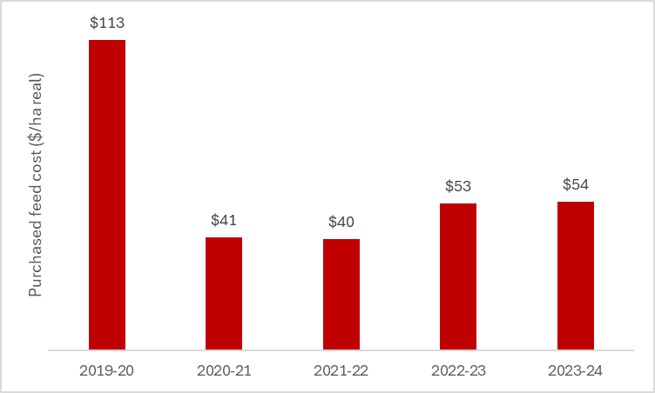

Figure 15. Northern farms average expenditure on purchased supplementary feed (2019-20 to 2023-24).

### **Price Received**

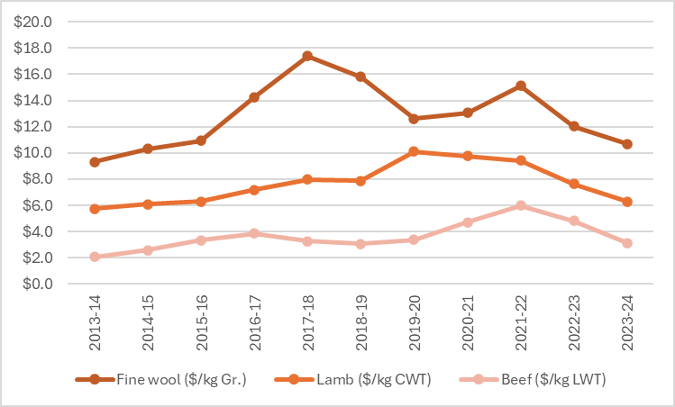

Figure 16. Wool, lamb and beef price received for northern LFMP farms (2013-14 to 2023-24).

Cattle (53%) and sheep sales (24%) were the major components of farm cash income in Northern Victoria (Appendix C5). Increases in average sales quantities were not enough to compensate for drops in beef, lamb and wool prices (Figure 16). This resulted in a 14% annual decrease in the average gross farm income and was below the 10-year average.

### **Capital structure**

The average amount of farm debt owed increased to 2,097/ha in 2023-24. Between July 2023 and June 2024, 21% of Northern farms (Figure 5) increased their debt by an average of $410/ha. New machinery was the most common form of capital expenditure on Northern farms in 2023-24.

The equity (net-worth) of 31% of northern farms reduced in 2023-24. As a result, regional average equity percentage (total equity as a proportion of total assets) decreased year-on-year but remained high at 88% (Appendix A6).

### **Return on assets and equity**

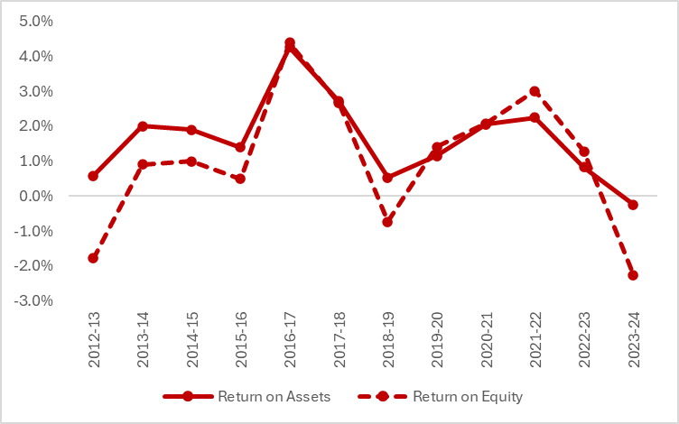

Figure 17. Northern return on assets and equity (2012-13 to 2023-24)

In 2023-24, return on assets on Northern farms fell to -0.2% (Figure 17), the first time an average negative return on assets was recorded and the lowest regional average in the 20 years (Appendix C12). Negative profits were observed on 45% of Northern LFMP farms in 2023-24. For most farms the main factor contributing to the decrease in return on assets was the decline in farm income not being matched with decreases in operating costs.

Increases in debt levels and interest rates over the last decade have resulted in larger interest payments on northern farms. The higher interest costs have amplified farm businesses losses and the average return on equity fell to -2.1%, the lowest level recorded in 20 years.

Northern Victoria regional summary

* Negative profits were recorded by 45% of northern LFMP farms.
* Average gross farm income decreased by 14% from 2022-23 levels.
* Prime lamb and wool sheep gross margins were the lowest since 2015-16 and beef gross margins lowest in 20 years.
* Average return on assets and return on equity fell to the lowest levels in the 20 years of the project.
* More debt, higher interest rates and larger interest payments worsened businesses losses.
* Northern farms received close to long-term average annual and spring rainfall.

|  |  |  |
| --- | --- | --- |
| **Regional summary** |  | **N** |
|  | **5-yr average** | **2023-24** |
| **Enterprise income** |  |  |
| Beef income ($/ha) | 1030 | 735 |
| Prime Lamb income ($/ha) | 919 | 669 |
| Wool Sheep income ($/ha) | 816 | 647 |
|  |  |  |
| **Variable costs** |  |  |
| Beef variable costs ($/ha) | 405 | 443 |
| Prime Lamb variable costs ($/ha) | 456 | 366 |
| Wool Sheep variable costs ($/ha) | 338 | 362 |
|  |  |  |
| **Production** |  |  |
| Beef sold (kg lwt/ha) | 286 | 345 |
| Lamb sold (kg cwt/ha) | 138 | 115 |
| Wool sheep wool cut (kg Gr./ha) | 36 | 43 |
|  |  |  |
| **Labour** |  |  |
| Labour use (FTE/farm) | 2.0 | 2.1 |
| Labour use efficiency (ha/FTE) | 416 | 368 |
| Labour use efficiency (DSE/FTE) | 4,635 | 4,663 |
|  |  |  |
| **Nutrient application** |  |  |
| Phosphorus applied to pasture (kg/ha) | 10 | 8 |
| Phosphorus applied to pasture (kg/DSE) | 0.7 | 0.6 |
|  |  |  |
| **Business structure** |  |  |
| Total assets managed ($/ha) | 16,914 | 20,960 |
| Total debt ($/ha) | 1,244 | 2,097 |
|  |  |  |
| **Top 5 costs (Proportion of total cash operating costs)** | |  |
| Pasture fertiliser costs (%) | 11% |  |
| Livestock Selling costs (%) | 7% |  |
| Wages for permanent staff (%) | 7% |  |
| Animal Health (%) | 6% |  |
| Rates (%) | 5% |  |

## South West Victoria

### **Gross margins**

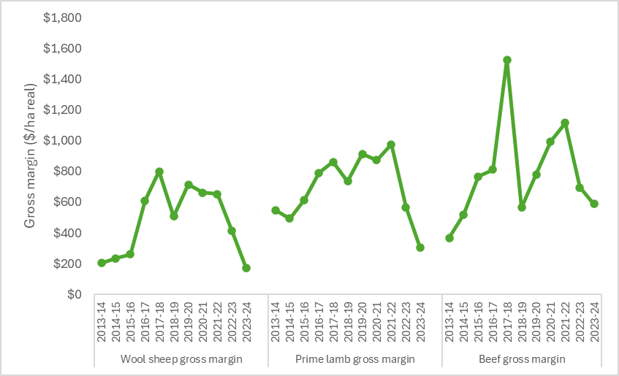

Figure 18. South West average gross margin for wool sheep, prime lamb and beef (2013-14 to 2023-24)

Falling enterprise income coupled with increases to variable costs meant prime lamb and wool sheep gross margins dropped to the lowest levels in 10 years (Figure 18). Wool sheep gross margins were also the lowest in the state. Beef gross margins were well below the 5-year regional average, recording a 14% annual decrease.

### **Costs**

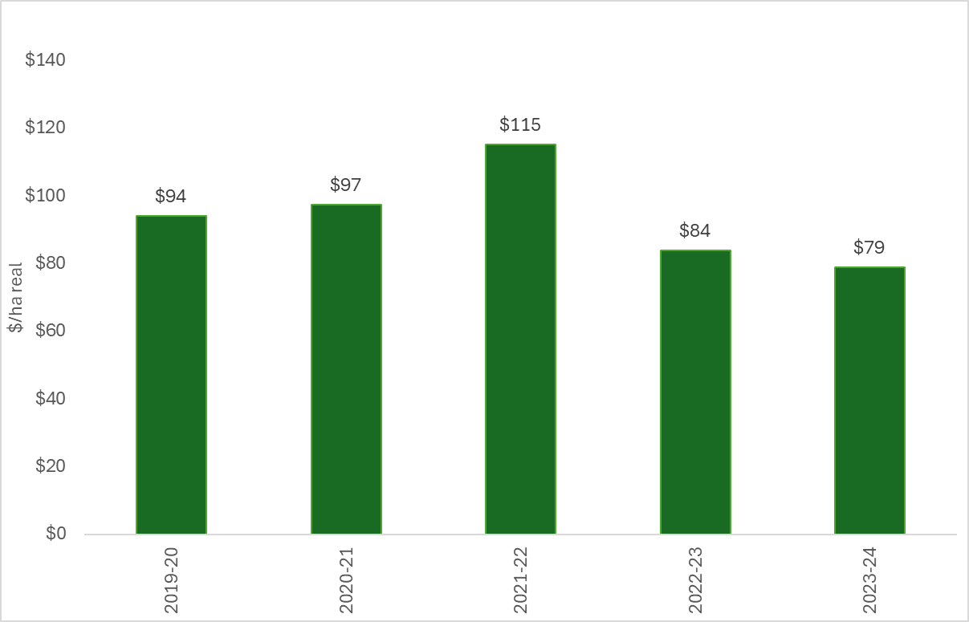

Figure 19. South West farms average expenditure on fertiliser applied to pasture (2019-20 to 2023-24)

Superphosphate (SSP) was the most common fertiliser applied on South West farms and managers responded to lower SSP prices in 2023-24 with an annual increase in their phosphorus application rate. Lower fertiliser prices combined with 7% of South West farms applying zero fertiliser resulted in expenditure on pasture fertiliser costs decreasing to a 5-year low (Figure 19).

South West farms experienced very dry conditions in 2023-24, with some farms recording their lowest rainfall on record.

Most lambing in wool sheep and prime lamb enterprises occurred in the South West during the winter months. Producers attempt to use the high pasture growth in spring to meet the feed demand of lactating ewes and target weights of lambs to be sold in early summer. However, the spring months in 2023 were dry with farms receiving an average of 67% of long-term spring rainfall (with some farms receiving as low as 39%). Dry conditions during this critical period resulted in less pasture growth. Pasture utilisation dropped to an average of 4 tonne of dry matter per hectare (Appendix B2), the lowest level for the region in 5 years and close to the lowest for the state.

When spring 2023 rainfall and pasture growth was low, some South West farm managers chose to increase the level of supplementary feed in their stocks diet to ensure feed demand was met.

Prime lamb enterprises increased feeding by 50% to be the most reliant on supplementary feed (519 ME fed per DSE). While South West wool sheep supplementary feeding rate was 455 ME per DSE, a 70% increase from 2022-23 levels.

Grain and concentrates were the most common form of supplement fed to prime lamb and wool sheep enterprises in the South West, making up an average of 15% and 13% of the diets, respectively.

Spending on purchased supplementary feed increased by 81% in 2023-24, to be the highest level in 5 years (Figure 20). Purchased supplementary feed was the largest cost item on South West farms in 2023-24, making up 16% of average farm cash operating costs.

Average farm variable costs were $614/ha, only a slight increase (+2%) from 2022-23 but the highest recorded in the 54-year history of the project in the South West.

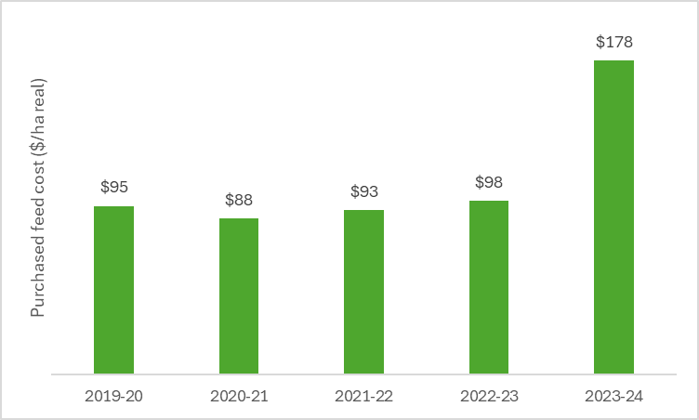

Figure 20. South West average farm expenditure on purchased supplementary feed (2019-20 to 2023-24).

### **Price received**

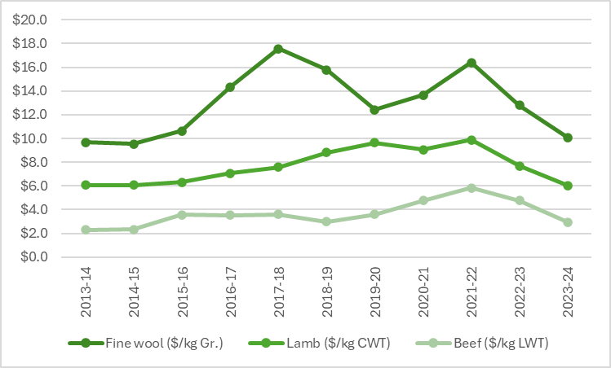

Figure 21. Wool, lamb and beef price received for South West LFMP farms (2013-14 to 2023-24).

Wool sheep and prime lamb were the dominant enterprises in the South West. Sheep sales (47%) and wool sales (18%) made up the majority of total farm income (Appendix B5). In 2023–24, prices received for lamb, wool and beef on South West farms fell to below the 10-year and 20-year average for each commodity. Average gross farm income decreased for the second consecutive year to $991/ha, a 22% reduction from 2022-23 and below the regional 10-year and 20-year average.

### **Capital structure**

In 2023-24, the average amount of farm debt owed by South West farms increased slightly (+3%) to $2,546/ha, a 10-year high. Between July 2023 and June 2024, 52% of South West farms (Figure 5) increased their debt by an average of $609/ha. Additional debt was taken on to invest in business growth through capital expenditure. New machinery was the most common form of capital expenditure. Additional farmland was also purchased by 8 % of South West farmers.

In 2023-24, farmland values decreased across South West Victoria. As result of decreased farmland value and increased debt, the equity (net-worth) levels on a large proportion (67%) of farms in the South West reduced. The regional average equity percentage decreased to 84% from 86% in 2022-23 (Appendix A6).

### **Return on assets and equity**

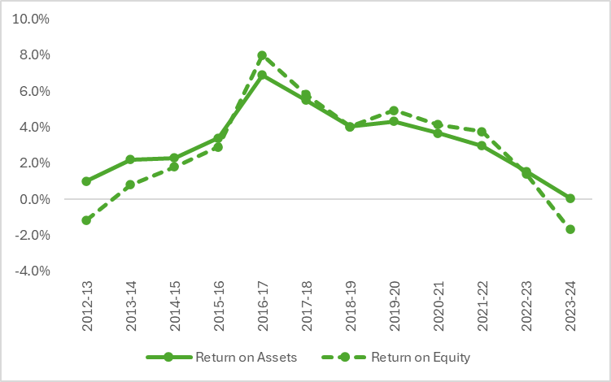

Figure 22. South West return on assets and equity (2012-13 to 2023-24)

South West farm profits plummeted in 2023-24, decreasing by 89% to $31/ha. The number of farms that recorded negative profits tripled from 8 farms (13%) in 2022-23 to 26 farms (43%) in 2023-24. Regional average return on assets fell to 0.1% (Figure 22), the lowest level in the South West since 2006-07 (Appendix B12).

Larger interest payments on higher levels of debt worsened farm businesses losses and the average return on equity fell to -1.7%, the lowest returns since 2012-13.

South West Victoria regional summary

* South West farm profits (EBIT) decreased to the lowest levels since 2006-07
* Prime lamb and wool sheep gross margins dropped to the lowest levels in 10 years, with South West wool sheep gross margins the lowest in the state.
* Average gross farm income decreased for the second consecutive year to be below the regional 10-year and 20-year average.
* South West average farm variable costs were the highest recorded in the 54-year history of the project.
* Decreased farmland value and increased debt contributed to lower equity (net-worth) across the 12 months on 67% of farms in the South West.
* South West farms experienced very dry conditions in 2023-24, with some farms recording their lowest rainfall on record.

|  |  |  |
| --- | --- | --- |
| **Regional summary** |  | **SW** |
|  | **5-yr average** | **2023-24** |
| **Enterprise income** |  |  |
| Beef income ($/ha) | 1362 | 1,091 |
| Prime Lamb income ($/ha) | 1,327 | 1027 |
| Wool Sheep income ($/ha) | 1032 | 790 |
|  |  |  |
| **Variable costs** |  |  |
| Beef variable costs ($/ha) | 513 | 503 |
| Prime Lamb variable costs ($/ha) | 646 | 721 |
| Wool Sheep variable costs ($/ha) | 567 | 617 |
|  |  |  |
| **Production** |  |  |
| Beef sold (kg lwt/ha) | 617 | 625 |
| Lamb sold (kg cwt/ha) | 123 | 139 |
| Wool sheep wool cut (kg Gr./ha) | 49 | 51 |
|  |  |  |
| **Labour** |  |  |
| Labour use (FTE/farm) | 3.5 | 3.9 |
| Labour use efficiency (ha/FTE) | 405 | 413 |
| Labour use efficiency (DSE/FTE) | 6,011 | 5,930 |
|  |  |  |
| **Nutrient application** |  |  |
| Phosphorus applied to pasture (kg/ha) | 12 | 10 |
| Phosphorus applied to pasture (kg/DSE) | 0.8 | 0.6 |
|  |  |  |
| **Business structure** |  |  |
| Total assets managed ($/ha) | 17,393 | 18,704 |
| Total debt ($/ha) | 2,131 | 2,546 |
|  |  |  |
| **Top 5 costs (Proportion of total cash operating costs)** | |  |
| Purchased supplementary grain and pellets (%) | 16% |  |
| Contract shearing and crutching (%) | 11% |  |
| Pasture fertiliser costs (%) | 9% |  |
| Animal Health (%) | 7% |  |
| Wages for permanent staff (%) | 7% |  |

# **Glossary**

**Appreciation**

An increase in the value of an asset in the marketplace. Often only applicable to farmland value.

**Asset**

Anything managed by the farm, whether it is owned or not. Assets include owned land and buildings, leased land, plant and machinery, fixtures and fittings, trading stock, farm investments (i.e., Farm Management Deposits), debtors and cash.

**Average**

The sum of a collection of numbers divided by the count of numbers in the collection.

**Business type**

Specialist sheep

Businesses with more than 85% of DSE coming from sheep and less than 30% income coming from grain and cropping.

Specialist beef

Businesses with more than 85% of DSE coming from beef and less than 30% income coming from grain and cropping.

Sheep and beef

Businesses with less than 85% of DSE coming from beef, less than 85% DSE coming from sheep and less than 30% income coming from grain.

Stock and grain

Businesses with more than 30% of income coming from grain and cropping sales and greater than zero stock DSE.

**Cash Income**

The sum of all cash income related to the operation of the farm/enterprise.

**Cash overheads**

All fixed costs have a cash cost to the business. Includes all overhead costs except imputed labour costs and depreciation.

**Casual labour**

A casual employee is an employee engaged casually and paid by the hour. Casual loading is paid instead of annual leave, a notice of termination, redundancy benefits and other attributes of permanent labour.

**Contract labour**

A contractor controls the work to be done and how it is to be performed. They can employ their own staff and can subcontract or delegate.

**Concentrate**

Category of feed that includes grains, oilseeds, and pellets.

**Depreciation**

Decrease in value over time of capital asset, usually as a result of using the asset. Depreciation is a non-cash cost of the business but reduces the book value of the asset and is therefore a cost.

**Dry sheep equivalent (DSE)**

The standard unit used to compare the metabolisable energy (ME) requirements of different classes of stock for feed budgeting purposes.

**Earnings before interest and tax (EBIT)**

Also known as ‘Operating Profit’ or ‘Profit’ is the return on all the capital used in the business before accounting for finance costs. Calculated as gross farm income minus total variable and total overhead costs.

**Effective area**

Total hectares managed minus the area of land which is of little or no value for livestock or crop production.

**Enterprise income**

The total income received from an enterprise before any expenses are paid. Includes cash receipts relevant to that enterprise and the value of changes in inventory relevant to that enterprise.

**Equity**

Total assets minus total liabilities. Equal to the total value of capital invested in the farm business by the owner/operator(s).

**Equity %**

Total equity as a percentage of the total assets owned.

The proportion of the total assets owned by the business.

**Feed inventory change**

An estimate of the quantity and value of grain, hay and silage on hand at the start and end of the financial year.

**Full time equivalent (FTE)**

Standardised labour unit. Equal to 1,920 hours a year.

Calculated as 48 hours a week for 40 weeks a year.

**Grazed area**

Pasture area plus an estimate of annual cropping area grazed. If a farm has multiple livestock enterprises, the grazed area is apportioned based on the total annual ME demand of each enterprise.

**Grazed pasture utilised**

Calculated using the back-calculation approach. Grazed feed is calculated as the difference between the total metabolisable energy required by livestock over the year and the amount of metabolisable energy consumed from other sources (hay, silage, grain, and concentrates).

The total metabolisable energy required by livestock is a factor of age, weight, growth rate, pregnancy and lactation requirements and the number of animals.

**Gross farm income**

The total income received from a farm. Includes all cash receipts and the value of changes in stock, feed, and wool inventory.

**Gross margin**

Enterprise income minus enterprise variable costs.

**Imputed**

An estimated amount is introduced into economic management analysis to allow reasonable comparisons between years and between other businesses.

**Interest and lease costs**

Total interest plus total lease costs paid. Also known as ‘finance costs’.

**Liability**

Money owed to someone else, e.g., family or a financial institution.

**Livestock trading profit**

An estimate of the annual contribution to gross farm income by accounting for the changes in the number and value of livestock during the year. It is calculated as the trading income from sales minus purchases, plus changes in the value and number of livestock on hand at the start and end of the year, and accounting for births and deaths. An increase in livestock trading indicates there was an appreciation in the value of livestock per head or an increase in livestock numbers over the year.

**Metabolisable energy (ME)**

The energy available for use by the animal. It is the energy used for maintenance of body systems, activity, milk production, pregnancy and weight gain. Metabolisable is net of energy lost in the form of urine and methane gas released by rumen and hind-gut microbes.

**Net farm income**

Earnings before interest and tax (EBIT) minus interest and lease costs. The amount of profit available for capital investment, loan principal repayments and tax.

**Nominal terms**

Dollar values that have no inflation component.

**Livestock costs**

All expenses relating to assisting with herd and flock management. Includes animal health costs and shearing contractors.

**Livestock marketing costs**All costs associated with buying and selling livestock including freight and cartage.

**Operating costs**Overhead and variable costs, i.e., the costs associated with the annual operation of the farm.

**Overhead costs**

All fixed costs incurred by the farm business that do not vary with the level of production. These include cash overhead costs such as permanent labour and noncash costs such as owner-operator labour, family labour and depreciation of plant and equipment. It excludes interest, lease costs, capital expenditure, principal repayments, drawings, and tax.

**Owner/Operator labour**

Staff members (such as family) that take income from business drawings rather than wages. The operators’ labour and management are an input to make a profit and so these must be costed and deducted to estimate the true profit and return to the capital in the business.

**Pasture costs**All costs associated with growing pasture including fertiliser, seed and chemicals.

**Permanent labour**Farm staff who have an ongoing expectation of work, generally work standard or set hours, are entitled to paid leave and notice of termination.

**Profit (s)**

*See Earnings before interest and tax (EBIT)*.

**Real terms**

Dollar values that include an inflation component.

**Return on equity (ROE)**

Net farm income divided by the value of total equity.

**Return on assets (ROA)**

Earnings before interest and tax divided by the value of total assets under management, including owned and leased land.

**Standard deviation**

The standard deviation is a measure of how widely values are dispersed from the average value.

**Variable costs**

Variable costs (sometimes called direct costs) vary directly as the output of an enterprise varies.

**List of abbreviations**

|  |  |
| --- | --- |
| **CWT** | Carcass weight |
| **DEECA** | Department of Energy, Environment and Climate Action, Victoria |
| **DSE** | Dry sheep equivalent |
| **EBIT** | Earnings before interest and tax |
| **GM** | Gross margin |
| **ha** | Hectare(s) |
| **kg** | Kilograms |
| **Kg Gr. or**  **Gr. kg** | Kilograms of greasy wool |
| **LFMP** | Livestock Farm Monitor Project |
| **LWT** | Live weight |
| **ME or**  **MJ ME** | Megajoules of Metabolisable energy |
| **ML** | Megalitre |
| **mm** | Millimetres |
| **NFI** | Net Farm Income |
| **ROA** | Return on Assets |
| **ROE** | Return on Equity |
| **t** | Tonne = 1,000 kg |
| **tDM** | Dry matter of feed stuffs measured in tonnes |
| **yrs** | Years old |

### **References**

Kay RD, Edwards WM, Duffy PA 'Farm Management' (Mcgraw-Hill Companies)

Malcolm B, Makeham J, Wright V 'The Farming Game - Agricultural Management and Marketing.' (Cambridge University Press: Melbourne)

Malcolm B. (2011). Financing matters. Australian Farm Business Management Journal, 8(1), 11-18.

Sinnett A, Ho C. K. M, & Malcolm, B. (2016). Expanding a dairy business affects business and financial risk. Animal Production Science, 57(10), 2167-2174.