Join the great Biosecurity Quest
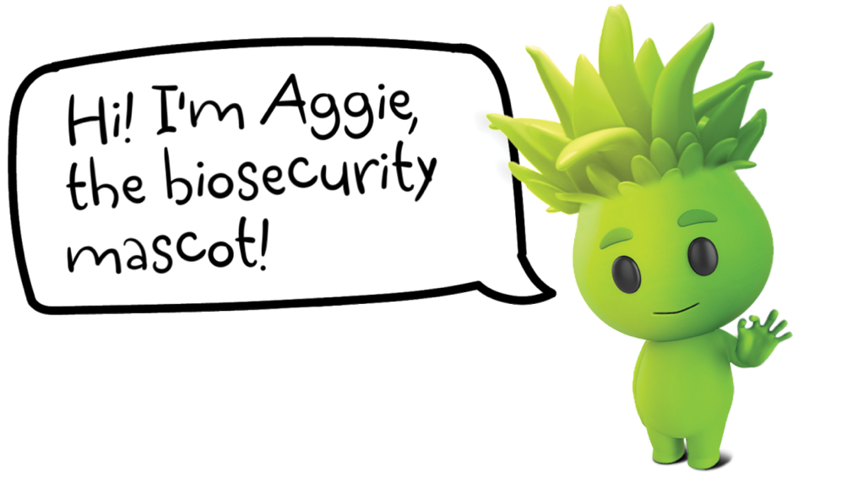
This year, Aggie is asking Victorians to join the Quest and be on the lookout for leafhoppers which includes the invasive glassy-winged sharpshooter!

What is Biosecurity?
Biosecurity is a collective effort to protect what we value most by preventing and managing harm caused by pests and diseases.
If we all work together to protect our biosecurity, we can continue to spend time in the great outdoors, enjoy clean and safe food and protect the agricultural industries that provide so much for us all.

Play your part – Join the Great Biosecurity Quest!
The responsibility falls to all of us to protect Victoria’s biosecurity, and a strong biosecurity system requires community, industry and government working together. Early detection and reporting of outbreaks is critical to minimise the impacts of biosecurity emergencies.
One way you can play your part is by joining the Great Biosecurity Quest and be on the lookout for bugs, including the invasive glassy-winged sharpshooter! You can use this toolkit to help you to identify different bugs you might find.
Another great tool you can use when looking for leafhoppers as well as other species is the iNaturalist app. You can join our Great Biosecurity Quest project on iNaturalist where you can become a citizen scientist by submitting photos of leafhoppers and any other interesting critters you find, and bug experts at iNaturalist will help to identify them! These observations will also contribute to data that scientists can use to identify biosecurity pests and learn more about our natural environment.

How to report a pest
If you have found an unusual plant, pest or disease, you should visit agriculture.vic.gov.au/reportaplantpest to make a report.
The type of information you will need to provide may include:
- What you think the pest might be
- Where and how you found it
- The type of plant you found the pest or disease on
- Photos of the pest or symptoms of the disease
If you believe you have identified a pest, and if it is safe to do so, please secure it.

Glassy-winged sharpshooter
Victoria is lucky to be free from many of the world’s most damaging plant pests, including the glassy-winged sharpshooter. Exotic pests like the glassy-winged sharpshooter can damage our natural environment, destroy our food production and agriculture industries, and some could change our way of life. Outbreaks of plant pests and diseases are increasing due to climate change, and more people and goods coming into the state.

Glassy-winged sharpshooter
Homalodisca vitripennis
Glassy-winged sharpshooter (Homalodisca vitripennis) is an exotic plant pest that is a high priority for Australia.
Figure 1: Illustration of the glassy-winged sharpshooter
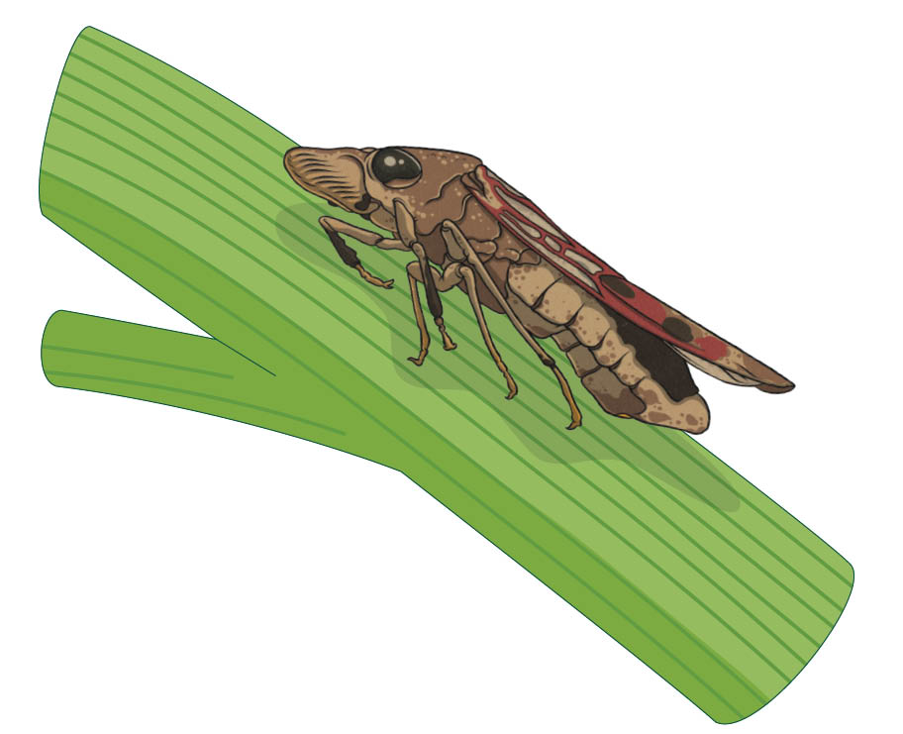

What does it look like?

Adults:
Figure 2: Two images of adult glassy-winged sharpshooters
(Photo credits: Russ Ottens, University of Georgia, Bugwood.org (left);
Reyes Garcia III, USDA Agricultural Research Service, Bugwood.org (right)
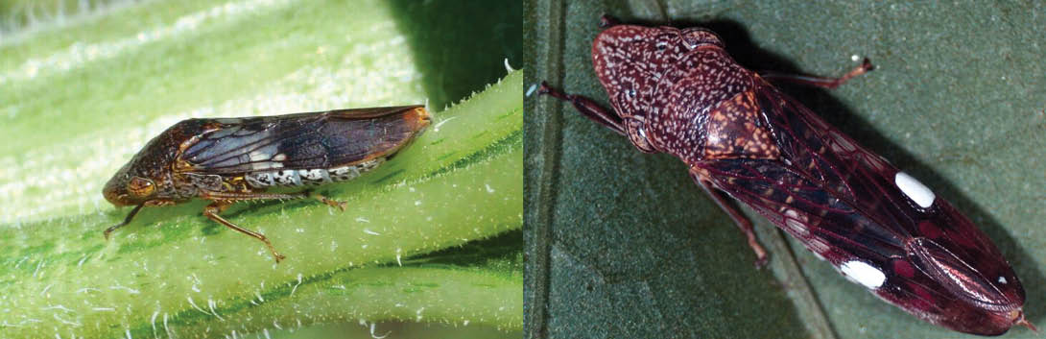
- It is a large leafhopper, around 12-14 mm long
- Brown to black body with small yellow to white (ivory) spots on the head and thorax
- White underside on the abdomen
- Transparent wings with reddish veins

Juveniles (nymphs):
- Five growth stages, ranging from 2–8 mm long
- Dark grey (1st and 2nd stage)
- Grey (3rd - 5th stage)
- Wingless when young
- Initially feed on veins on the underside of leaves before moving to woody stems and branches as they mature
Figure 3: Glassy-winged sharpshooter adult and nymphs (© 2022 Pat, iNaturalist)
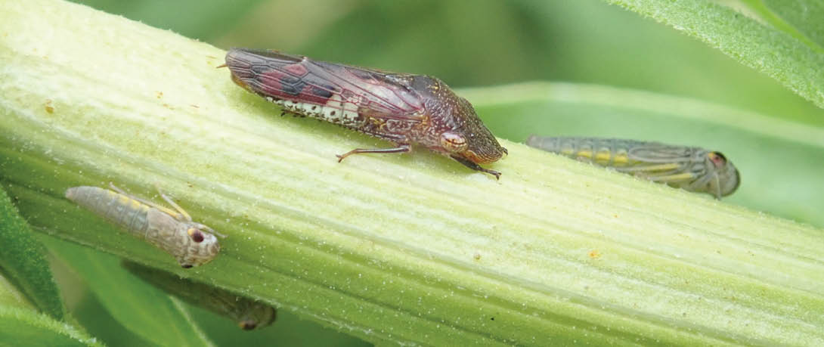

Eggs:
Figure 4: Dead egg mass (top) and viable egg mass (bottom)
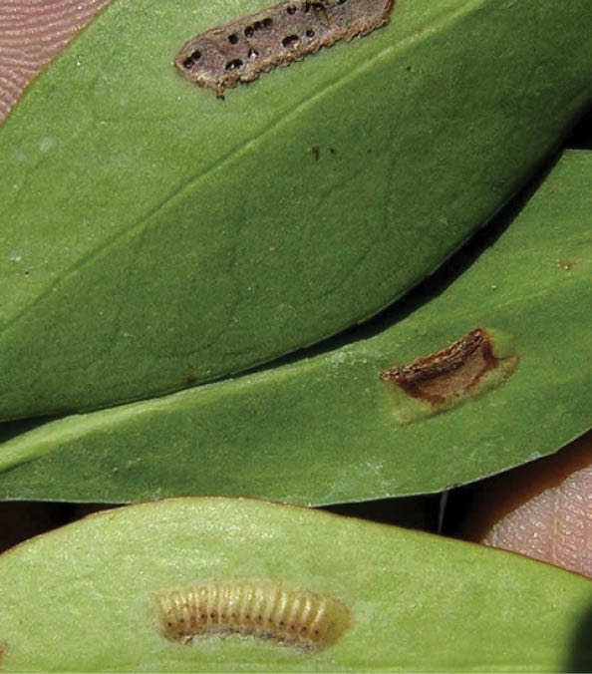
- Small, sausage shaped, laid in clusters of around up to 27
- Arranged side by side
- The egg masses appear as greenish elongated water blisters beneath the leaf

Why is it a pest?
The glassy-winged sharpshooter is a sap-feeding insect that can spread the devastating Xylella bacteria—but thankfully, Xylella is not present in Australia. Xylella is Australia’s number one most unwanted plant disease, capable of causing billions of dollars in damage to crops and the environment. It spreads through sap and can infect over 650 different plant species.
The glassy-winged sharpshooter feeds on over 500 recorded host plant species - including Australian natives like Eucalyptus and Melaleuca. The sharpshooter is a highly efficient transmitter (called a vector) of Xylella and if introduced, this pest could pose a serious threat to Australia’s agricultural and natural ecosystems.

How do I report it?
If you think you have found glassy-winged sharpshooters, report this immediately to Agriculture Victoria by calling the Exotic Plant Pest Hotline on 1800 084 88, visiting agriculture.vic.gov.au/reportaplantpest or using the QR code.
Figure 5: QR Code to make a report to Agriculture Victoria

It’s important to make a report as soon as possible. Make sure to take clear photos of the pests and damage to include in your report if you can. Information on how to take a quality photo for identification can be found on our reporting page.

Other bugs you might find
Leafhoppers (or jassids) are widespread and common in Australia and may look similar to the glassy-winged sharpshooter. They are usually only minor or occasional pests and can be easily distinguished from other small insects by their wedge shape and tendency to jump. Some of these insects are listed below and can help you to identify leafhoppers in the Great Biosecurity Quest! Remember, if you think you have found a glassy-winged sharpshooter or other exotic pest, make sure you report it immediately.

What could it be confused with?

Cotton leafhopper (Amrasca terraereginae)
Figure 6: Cotton leafhopper (Amrasca terraereginae)
Source: thebeatsheet.com.au/investigating-unusual-chlorosis-in-cotton/
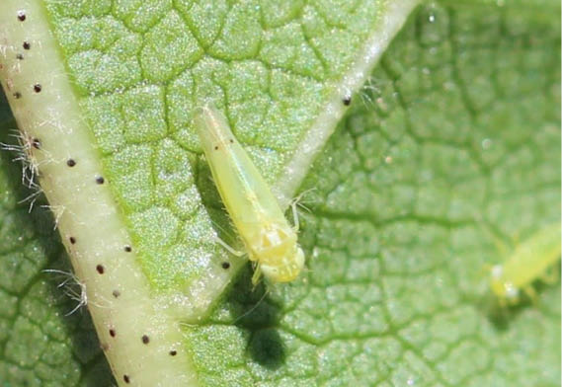
Present in Australia: NSW, QLD

Brown leafhoppers (Orosius spp.)
Figure 7: Brown leafhoppers (Orosius spp.) © CSIRO
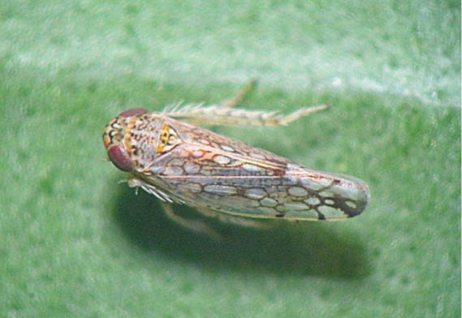
Present in Australia: NSW, ACT, QLD, Vic, SA, NT, WA

Spotted leafhopper (Austroagallia torrida)
Figure 8: Spotted leafhopper (Austroagallia torrida)
Source: thebeatsheet.com.au/key-pests/leafhoppers/
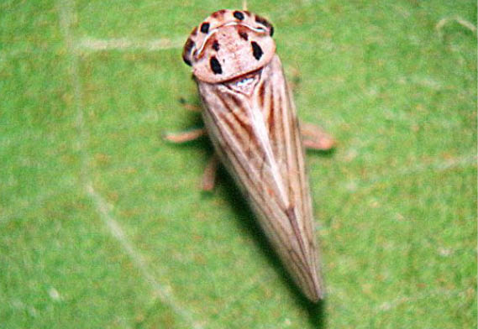
Present in Australia: NSW, QLD, Vic, WA

Planthopper (Oteana lubra)
Figure 9: Planthopper (Oteana lubra)
Source: Carol Page iNaturalist.org (CC BY NC 4.0)
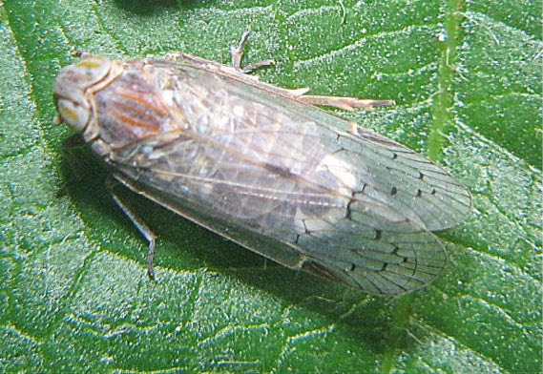
Present in Australia: NSW, NT, QLD, SA, Vic

Vegetable and lucerne leafhoppers (Austroasca spp.)
Figure 10: Vegetable and lucerne leafhoppers (Austroasca spp.)
Source: thebeatsheet.com.au/key-pests/leafhoppers/
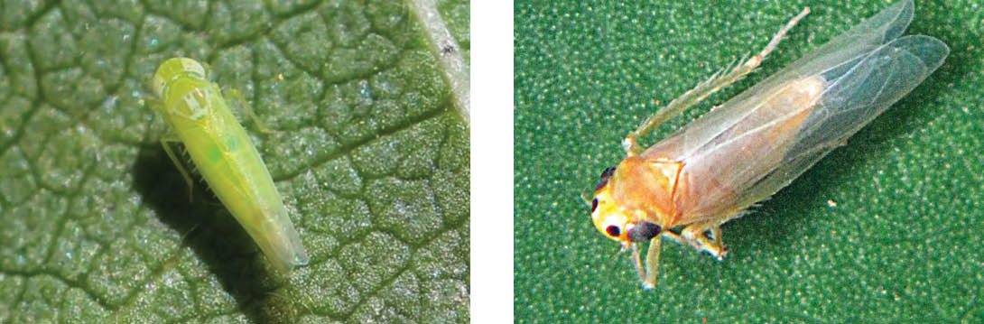
Present in Australia: ACT, NSW, NT, QLD, SA, Tas, Vic, WA

Maize leafhopper (Cicadulina bimaculata)
Figure 11: Maize leafhopper (Cicadulina bimaculata)
Source: thebeatsheet.com.au/key-pests/leafhoppers/
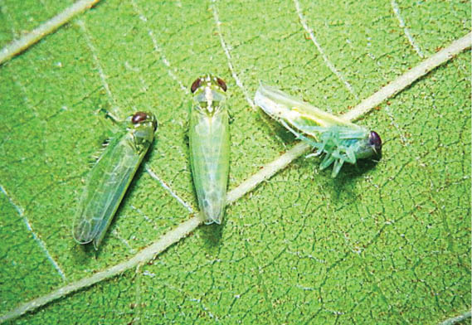
Present in Australia: ACT, NSW, QLD
www.agriculture.vic.gov.au/getinvolved

Publication information

Acknowledgements
We acknowledge and respect Victorian Traditional Owners as the original custodians of Victoria’s land and waters, their unique ability to care for Country and deep spiritual connection to it.
We honour Elders past and present whose knowledge and wisdom has ensured the continuation of culture and traditional practices.
DEECA is committed to genuinely partnering with Victorian Traditional Owners and Victoria’s Aboriginal community to progress their aspirations.

Copyright
© The State of Victoria Department of Energy, Environment and Climate Action, July 2025.

Creative Commons
This work is licensed under a Creative Commons Attribution 4.0 International licence, visit the Creative Commons website (http://creativecommons.org/licenses/by/4.0/).
You are free to re-use the work under that licence, on the condition that you credit the State of Victoria as author. The licence does not apply to any images, photographs or branding, including the Victorian Coat of Arms, and the Victorian Government and Department logos.

Disclaimer
This publication may be of assistance to you but the State of Victoria and its employees do not guarantee that the publication is without flaw of any kind or is wholly appropriate for your particular purposes and therefore disclaims all liability for any error, loss or other consequence which may arise from you relying on any information in this publication.
Information is correct as of July 2025.

Accessibility
To receive this document in an alternative format, phone the Customer Service Centre on 136 186, email customer.service@delwp.vic.gov.au, or contact National Relay Service on 133 677. Available at DEECA website (www.deeca.vic.gov.au).
End of document.

