

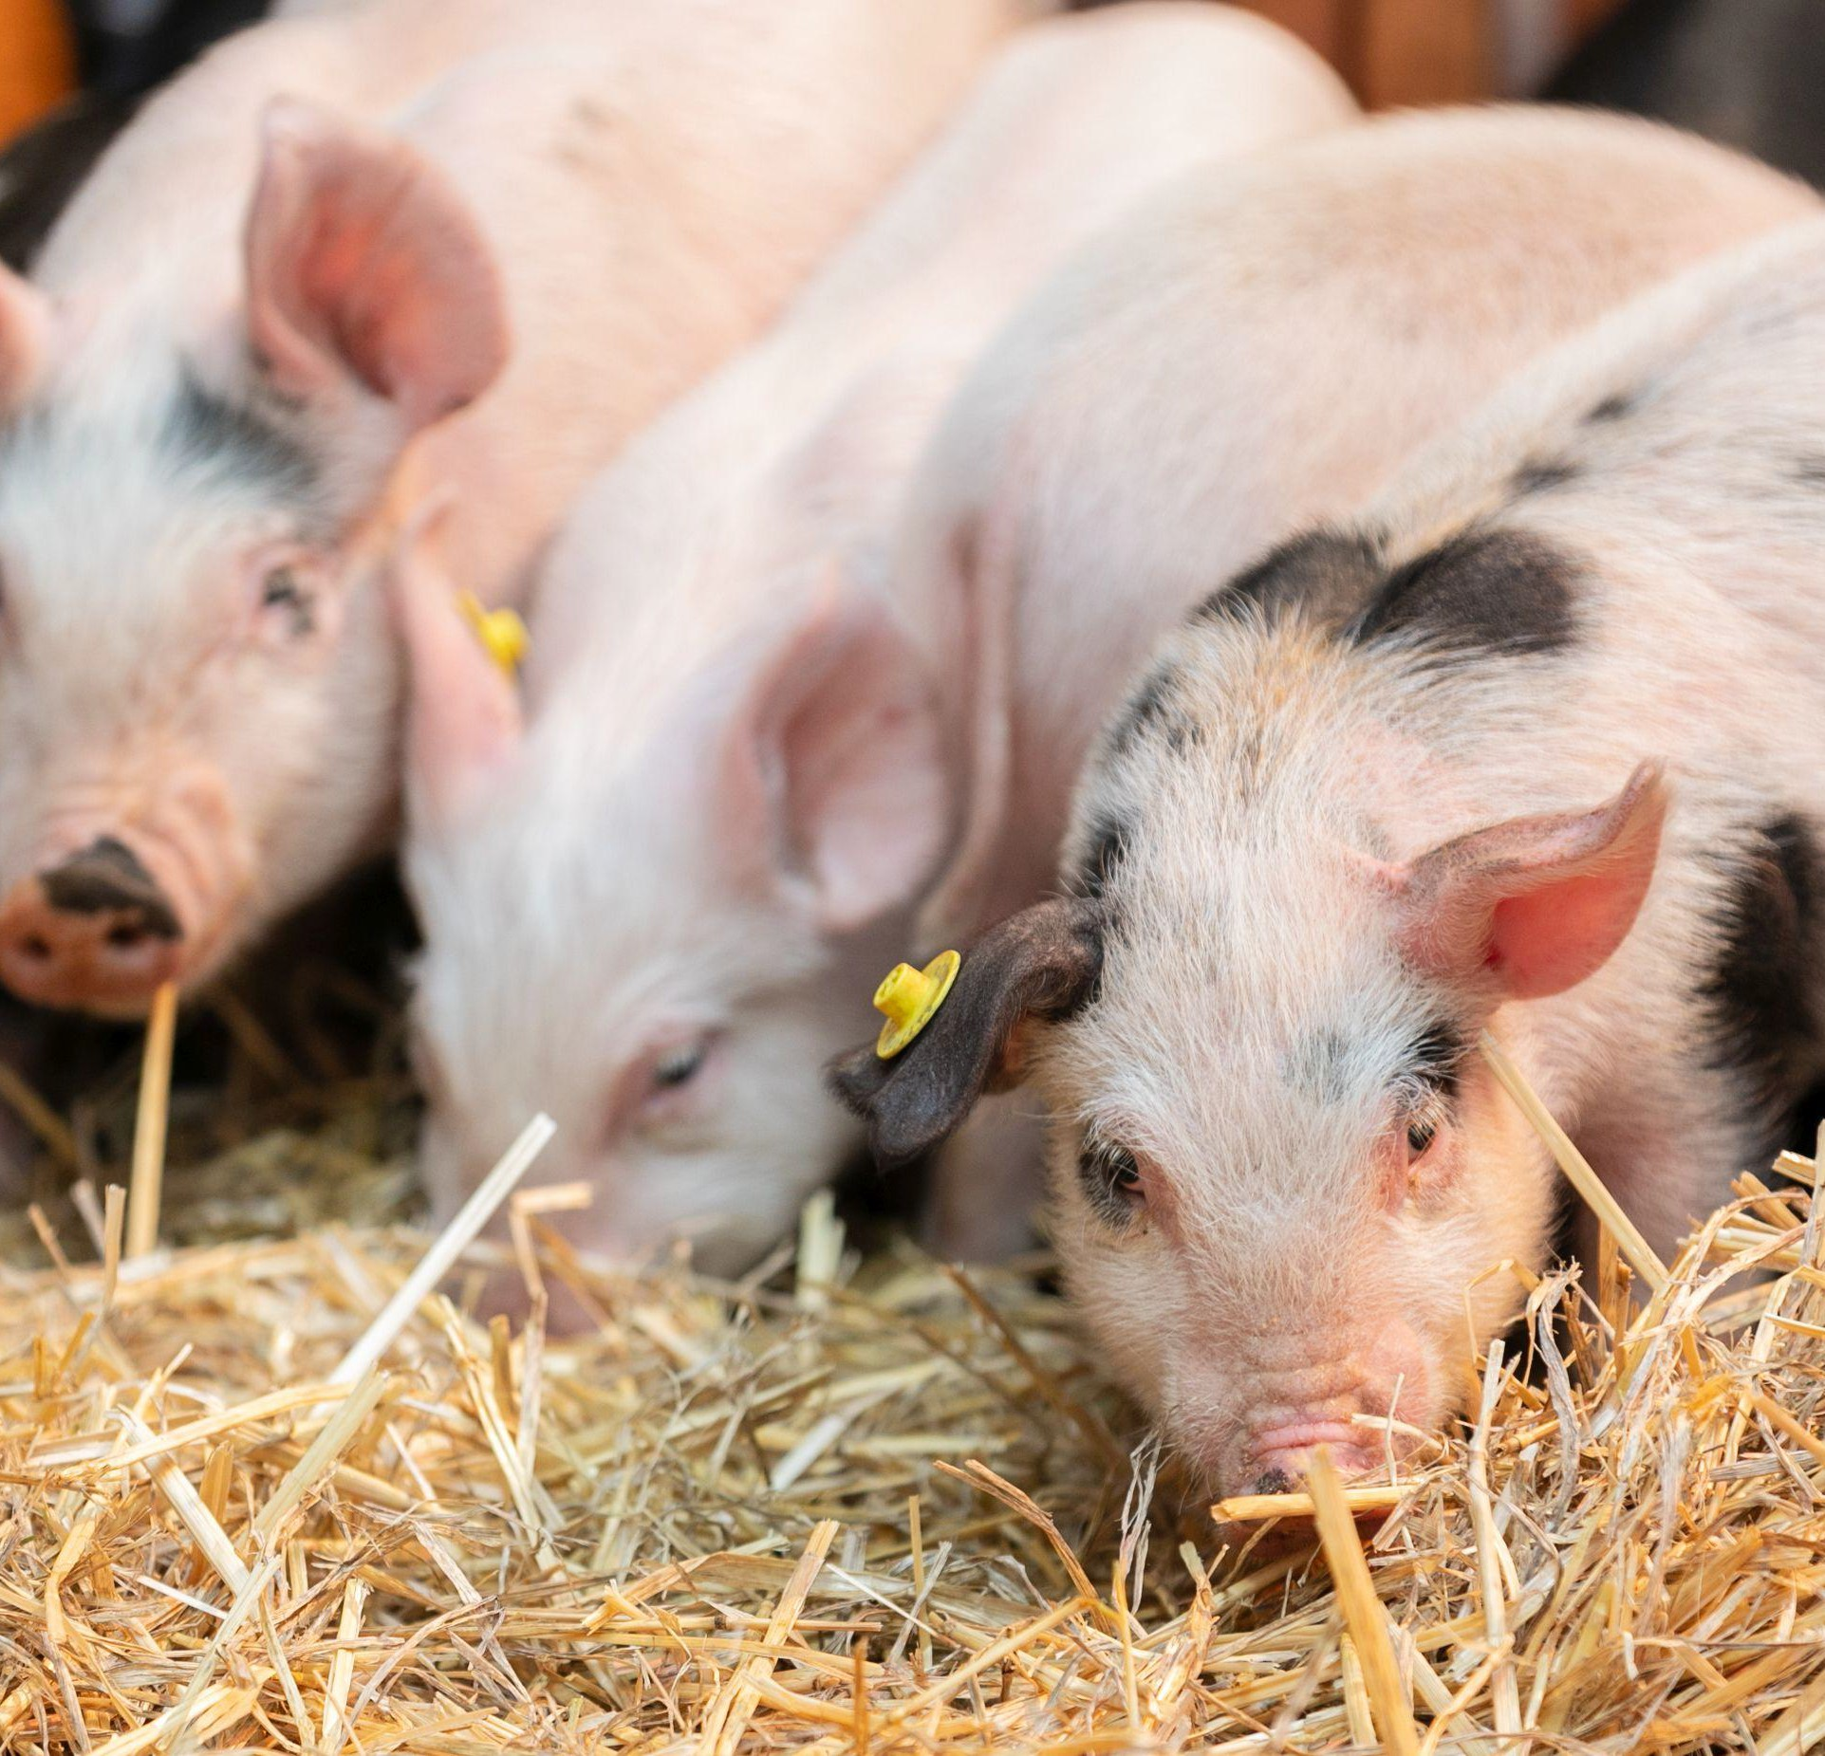

OFFICIAL

Swine Compensation Fund
2024-25 Outcomes Summary

Further information regarding the Livestock Biosecurity Funds may be obtained from: Manager, Governance Support and Coordination
Agriculture Victoria
475 Mickleham Road, Attwood, Victoria Australia
LivestockBiosecurityFund@agriculture.vic.gov.au
Authorised and published by the Victorian Government, Department of Energy, Environment and Climate Action (DEECA) 2025. © The State of Victoria Department of Energy, Environment and Climate Action 2025.
This publication is copyright. No part may be reproduced by any process except in accordance with the provisions of the Copyright Act 1968.
For more information contact the Agriculture Victoria Customer Service Centre on 136 186.

Disclaimer
This publication may be of assistance to you, but the State of Victoria and its employees do not guarantee that the publication is without flaw of any kind or is wholly appropriate for your particular purposes and therefore disclaims all liability for any error, loss or other consequence which may arise from you relying on any information in this publication.

Accessibility
If you would like to receive this publication in an accessible format, such as large print or audio, please telephone 136 186.
Deaf, hearing impaired or speech impaired? Call us via the National Relay Service on 133 677 or visit www. relayservice.com.au
This document is also available on the Agriculture Victoria website.

Swine Industry Projects Advisory Committee
The Swine Industry Projects Advisory Committee (SIPAC) provides recommendations to the Minister for Agriculture on the allocation of funds from the Swine Compensation Fund (SCF), delivered annually through the Livestock Biosecurity Funds grant program.
Funded projects aim to prevent, monitor, and control diseases, thereby improving animal health, biosecurity and supporting market access for the benefit of Victoria’s swine industry.
The Minister for Agriculture appoints the SIPAC chairperson and members based on their expertise and experience in accordance with the requirements of the Livestock Disease Control Act 1994 (the Act).
During the 2024-2025 financial year, SIPAC convened eight times, with secretariat support provided by Agriculture Victoria.

Activities of the Committee
Key activities since July 2024 include:
- Assessment of applications for the 2025 Livestock Biosecurity Funds grant program and contributing to the continuous improvement of future grant rounds
- Reviewed and refined the strategic focus for the 2025 grant program to align with industry priorities
- Provided oversight of the Swine Compensation Fund (SCF) including monitoring milestones and the progress of funded projects.

Livestock Biosecurity Funds Grant Program
Since the last report, the SIPAC participated in the 2025 Livestock Biosecurity Funds grant program round. Further details are provided in the background section below.
SIPAC members individually and the Committee collectively assessed each application received against the selection criteria outlined in the program Guidelines. In finalising recommendations and supporting justifications to the Minister, SIPAC considered members’ individual assessments, the available balance of the SCF and input from an independent assessment panel to determine recommended projects. An independent Probity Advisor oversaw the process, including the management of conflict-of-interest declarations, and advised on appropriate actions to ensure integrity and transparency.

2025 Livestock Biosecurity Funds Grant Program
The 2025 Livestock Biosecurity Funds Grant Program was open for applications from 7 March to 14 April 2025. The round was launched with a webinar featuring presentations from all four advisory committees.
In May 2025, SIPAC assessed all applications and recommended one project, totalling
$89,500, to the Minister for Agriculture for approval:
- Japanese encephalitis Virus (JEV) surveillance in Victoria using effluent testing in 2025-26

Improvements to the governance and operation of the committee

Improved communications and engagement
In 2024, the SIPAC developed a three-year Communications and Engagement Strategy to guide how it promotes the grant program and shares the outcomes of funded projects with industry. The strategy outlines key tools, channels, and activities aimed at attracting high-quality applications and increasing awareness of the benefits delivered through Swine Compensation Fund (SCF) projects. Implementation of the strategy commenced in 2024 and will continue over the next two grant rounds, with a formal review scheduled at the end of the 3-year period.
As part of the rollout of the SIPAC Communications and Engagement Strategy, a webinar launching the 2025 LBF grant program was held on 7 March 2025. The
chair persons of the four Livestock Advisory Committees presented an overview of the 2025 program, including each committee’s strategic focus, eligibility criteria, application process, and participated in a Q&A session. The recording of the webinar is available on the Program Website.

Strategic focus for annual rounds
The SIPAC reviewed the strategic direction for the SCF in late 2024 and identified 5 key themes:
- Prevention – build ability for industry to reduce the risks of a biosecurity event.
- Preparedness for response to biosecurity events – build response capability, capacity and planning of government and industry.
- Traceability and early detection – enhance capability to improve surveillance and monitoring, including domestic and feral pigs, and traceability, system integrity and effectiveness.
- Education – awareness and training for industry to better manage biosecurity risks, including swill feeding, traceability, mixed species awareness and interaction, and small producer legal and biosecurity obligations
- Research – particularly technologies for testing and treatment (eg vaccines).

This strategic focus informed the selection criteria for the 2025 grant round and was incorporated into the program Guidelines.

LBF grant program projects
Milestone management of the successful projects is overseen by the Department of Energy, Environment and Climate Action (DEECA), in consultation with the SIPAC.
A summary of project activity since 1 October 2024 to 30 August 2025 is provided below.

Summary of active SCF projects

Project (Recipient) | Project Timeline | Total allocated from SCF | Achievements to 30 August 2025
25.03 Japanese encephalitis Virus (JEV) surveillance in Victoria using effluent testing in 2025-26 (Biosecurity Victoria, DEECA)  To support surveillance across the 2025-26 summer JEV season on high-risk farms using new technology, weekly PCR testing of piggery effluent to improve the predictability of occurrence and impacts of JEV in Victorian piggeries in future seasons. | TBC | $89,500 | Successful project applicant 2025 LBF grant program round
21.10 Pig Biosecurity Management Planning (Biosecurity Victoria, DEECA)  To drive producer interest and engagement in biosecurity plan development (including those that wish to meet the new requirements under the Livestock Management Act 2010) by aligning it with a simple parasitology survey. | Aug 2022  to  Dec 2025 | $223,067 | Pig Biosecurity Project Plan Aug 2022 – Jan 2025  complete.  Farm visits have been completed with 3 herds to road test the documentation and procedural documents developed for the projects.  Laboratory results for those 3 farms have been received and advice provided to the farms.

Project (Recipient) | Project Timeline | Total allocated from SCF | Achievements to 30 August 2025
22.26 Sustainable control of parasites in Victorian pigs  (University of Melbourne)  Research into the prevalence and intensity of internal parasites in commercial and backyard pigs, and associated risk factors, (ii) a new serological diagnostic test for the early detection of Ascaris sum and (ii) the parasite control practices presently used by pig producers, to promote pig health, welfare, and biosecurity. | Jul 2023  to  Jun 2025 | $147,656 | The University of Melbourne has provided ethical clearance for working with Victorian piggeries, pig producers and vegetarians. The online questionnaire survey is underway to assess the parasite control practices used by pig producers and veterinarians. A cross-sectional study to unravel the parasites in Victorian pigs is approximately 70% completed. An assessment of a serological test that detects antibodies against A. suum infection in pigs is also underway. The field and laboratory work related to various components of the project is expected to be completed by December 2024 so that the report can be written in early 2025. This project also provides capacity-building opportunities in pig parasitology to two Bachelor of Honours in Veterinary Science students enrolled at the University of Melbourne. Three papers have been accepted for oral presentations at the annual meeting of the Australian Society for Parasitology, which will be held on 26-29 August 2024 in Auckland, New Zealand.

Project (Recipient) | Project Timeline | Total allocated from SCF | Achievements to 30 August 2025
22.27 Significant Disease Investigation (SDI) subsidies (Biosecurity Victoria, DEECA)  To enhance the capacity for early detection and control of diseases of livestock that could impact human health, animal health, farm productivity and market access and trade | Jul 2023  to  Oct 2026 | $30,000 | There were 52 pig disease investigations, from 31 different properties, undertaken and reported to Agriculture Victoria between 1 July 2024 and 30 June  2025.  The SDI program was featured in a special edition of VetWatch, Agriculture Victoria’s newsletter for veterinary practitioners. This edition focused on the global H5N1 situation and an update on the 2024 Avian influenza (AI) response in Victoria.
22.07 Online 'Pathology of the Pig' resource  (Biosecurity Victoria, DEECA)  Recreating the content rich ‘Pathology of the Pig – A diagnostic guide’ text book into a user friendly, online pathology of the pig resource, accessible anywhere, any-time, principally for veterinarians. | Aug 2024  to June 2025 | $63,890 | Written support received from APL.  Project plan developed, and online repository created.  All chapters of Pathology of the Pig resource uploaded.
24.08 Assessing in-field decontamination for EAD responses using ATP metering  (Biosecurity Victoria, DEECA)  This project explores the feasibility of using Hygiena Ensure luminometer ATP devices, commonly used in food and medical settings,  alongside visual | Aug 2024  to  Oct 2025 | $40,686 | Project plan developed in consultation with industry and AgriBio representatives, including a feasibility test conducted at Huntly farms. Consumables have been ordered with field trials, lab testing and analysis ready to commence.

Project (Recipient) | Project Timeline | Total allocated from SCF | Achievements to 30 August 2025
(photographic) and microbiological testing to enhance Cleaning & Disinfection (C&D) practices in Emergency Animal Disease scenarios. The study aims to establish parameters for interpreting ATP test results and assess the effectiveness of current C&D practices in the piggery industry.
24.22 Identifying transmission pathways to inform management of vector-borne diseases  (University of Queensland)  This project will identify the transmission pathways of vector-borne diseases that threaten swine health and deliver a mosquito management strategy to Victorian commercial piggeries | Apr 2025  to  Oct 2026 | $44,000 | A total of 1,986 mosquitoes were collected from three commercial piggeries in Victoria, Australia, have been identified through morphological analysis. The majority of these were Culex annulirostris—a key mosquito species known to transmit Japanese encephalitis virus (JEV).  An initial blood meal analysis of 330 mosquitoes revealed surprisingly diverse feeding habits with 29 vertebrate species identified in bloodmeals, and 19 of these being birds. While Cx. annulirostris did feed on pigs, they also fed on a wide range of birds and mammals (including sheep, cows, foxes, kangaroos and possums).  This indicates that the feeding patterns of mosquitoes at southern Australian piggeries are far  more complex than

Project (Recipient) | Project Timeline | Total allocated from SCF | Achievements to 30 August 2025
previously reported in studies from northern Australia, where mosquitoes showed a strong preference for pigs.
These findings suggest that JEV transmission is likely shaped by a dynamic web of interactions between multiple host species and mosquito vectors, rather than a simple pig-mosquito cycle. Understanding this complexity is essential for developing effective surveillance and control strategies to protect both livestock and public health.
24.29 Infected Premises - Livestock Producers Awareness Course  (P2r2 Consulting Pty Ltd)  This project aims to inform livestock producers as to what happens on an Infected Premises after an emergency animal disease has been diagnosed. This includes what quarantine and movement restrictions look like and the sequence of on-farm control activities that are required for the producer to be able to return to normal production. | Aug 2024  to  Aug 2026 | $41,060 | Completion of extensive stakeholder consultation program and subsequent development of training strategy session plans & materials.
24.38 Informing disease transmission risks at the feral-domestic pig interface (Western Plains Pork Trust)  This pilot project aims to map contact between feral and | Aug 2024  to  Jun 2028 | $155,000 | Community meeting held with land managers in February 2025 with consent forms signed to participate in the program.

Project (Recipient) | Project Timeline | Total allocated from SCF | Achievements to 30 August 2025
domestic pigs to understand disease transmission risks, enhance and sustain land manager participation, optimise industry preparedness, enhance risk management, develop decision support capacity and capability and promote biosecurity behaviour change by land managers. |  |  | Animal ethics applications, research permits, approvals to release collared feral pigs into the landscape and institutional permits initiated and/or obtained.
24.16 Private veterinary practitioner up-skill, online project  (Biosecurity Victoria, DEECA)  This project aims to increase the capability and confidence of private veterinary practitioners (PVP’s) to identify and respond appropriately to the suspicion of significant diseases (SD’s) in cattle, sheep, goats and pigs. PVP’s will be provided with the opportunity to upskill and then maintain diagnostic skills. | Aug 2024  to  Jan 2026 | $10,000 | Engagement of species specialists to prepare case studies for each species.  Agreement of 10 case study diseases for each species group. Including, diseases that are zoonotic, endemic and exotic to Australia.  A Learning Management System Platform has been written ready for use and a case study template developed.  Pre and post course evaluation framework has been developed.  Communication plan and materials have been developed and approved ready for release.
21.11 Pig Necropsy Learning Workshops  (Biosecurity Victoria, DEECA)  To deliver face to face, interactive post-mortem workshops (supported by  access to online collateral) | Sep 2022  – Sep 2025 | $59,705.50 | Completion of consultations with pig veterinarians as to their needs and appetite for attending a pig post-mortem workshop supported by online content.

Project (Recipient) | Project Timeline | Total allocated from SCF | Achievements to 30 August 2025
led by a specialist pig pathologist to facilitate elevated knowledge and capability of pig veterinarians and enhanced disease surveillance. |  |  | Professor John Glastonbury ran 2 workshops, and they were favourably received by audience with contributions to the discussion from all participants throughout the day.
Summary of SCF projects closed - July 2024 to June 2025
No SCF projects have been closed since the last reporting period.

Background

SCF
Victoria's Swine Compensation Fund (SCF) is established under the Livestock Disease Control Act 1994 (the Act) and is funded through duties collected on the sale of pigs or pig carcasses.
A duty of 2 cents ($0.02) is payable for every $5 or part thereof, of the sale price for a single pig or carcass sold individually, or on the total sale price for any number of pigs or carcasses sold as a single lot.
The maximum duty payable for any one pig or carcass, whether sold individually or as part of a lot, is 16 cents ($0.16).
The Act outlines the permitted uses of funds from the Swine Compensation Fund (SCF). These funds are generally allocated to support projects and programs that benefit the Victorian swine industry, provide compensation for specified endemic diseases, and cover the administration of SCF.
All expenditure from the funds requires approval from the Minister for Agriculture, following consideration of advice from the Swine Industry Projects Advisory Committee (SIPAC).

Livestock Biosecurity Funds Grant Program
The Livestock Biosecurity Funds Grant Program is administered by the Department of Energy, Environment and Climate Action, with funding from the respective fund:
- Cattle Compensation Fund
- Sheep and Goat Compensation Fund
- Swine Compensation Fund
- Honey Bee Compensation and Industry Development Fund.
The Livestock Biosecurity Funds Grant Program aims to support projects and programs that prevent, monitor, and control diseases, thereby improving animal health, biosecurity and market access for the benefit of Victoria’s cattle, sheep, goat, swine and honey bee industries.
Funds from the Livestock Biosecurity Funds Grant Program are allocated to projects that deliver outcomes aligned with the Act, and demonstrate the following principles:
- Innovative solutions and emerging technologies for unsolved livestock biosecurity issues, needs or gaps.
- Collaboration where possible across value chains.
- Quantifiable benefits to the whole of the livestock industries, which are measured and evaluated with evidence and data.

Each fund has a statement of strategic intent that outlines priority investment areas and desired outcomes aligned with the purpose and objectives of the Act. These statements are incorporated into the Guidelines annually.
For more information on the Program, see agriculture.vic.gov.au/support-and-resources/funds-grants-programs/livestock-biosecurity-funds.

Current membership
The Minister for Agriculture appointed the below members for a 3-year term, from 25 March 2024.
- Mr Tim Kingma (chairperson) is a manager and part-owner of Gunpork Joint Venture, a 1400-sow piggery, KEPiggery, a 500-sow piggery & Pentagon Feeds, producing around 900T/wk of pellets in North Central Victoria.
Tim has a Bachelor of Agricultural Science from the University of Melbourne and has completed the Australian Institute of Company Directors Course.
- Dr Cherie Collins (member) has over 20 years of experience within the swine industry and pig production. Dr. Collins is a research scientist who has extensive experience in pig nutrition and animal welfare, completing her PhD in Protein restriction and compensatory growth responses in pigs.
Dr Collins is currently a Pig Operations Manager at Rivalea (Australia) and manages all the Rivalea piggery sites and contact systems.
- Dr Patricia Mitchell (member) has been involved in the Pig Industry for over 30 years in several roles including farm hand, farm manager (including family pig enterprise), industry training, extension officer, researcher, and technical support.
Pat has previously worked for APL for 10 years as R & I Manager - Production Stewardship; she was also the Program Leader for Program 2-Herd Health Management, for the Pork CRC. Since June 2018, Pat has been employed by PIC Australia as Genetic Technical Services Manager, managing the technical Newsletters, Production Tools, and Benchmarking/Percentile Reports; Pat is also the PIC Field services representative in Victoria and southern NSW.
Pat’s family are fifth-generation farmers.
- Dr Robert Smits (member) has been part of the Australian Pork industry since 1992. For 25 years Rob managed key projects including the registration for Reporcin (porcine somatotrophin, pST), Improvac (immunocastration vaccine), Paylean (porcine ractopamine), as well as research into many feed additives, veterinary medicines and vaccines, and meat quality, welfare and new pork product development for the Rivalea brand and Coles, Woolworths, Aldi and Costco.
Rob has also worked as a Director for Research and Innovation at Australian Pork Ltd representing the pork industry in biosecurity.

- Dr Kylie Hewson (member) is the Lead for Animal Health and Environment in the Minimising Antimicrobial Resistance Mission at CSIRO.
Kylie played an integral part in response to the COVID-19 and the Avian Influenza outbreaks in 2020, Program Manager for the industry’s levied R&D program, Chair of Animal Health Australia’s Industry Forum, is the current chair of Animalplan, Australia’s National Action Plan for Terrestrial Agricultural Animal Health, and started (and still manages) the company Sativus Pty Ltd which supports quality science and science communications in Australia, working primarily with rural industry research and development corporations and companies.

Changes to membership during reporting period
Resignation
- Mr Robert Bayley (member) is a fifth-generation farmer, who currently manages Blackwood Piggery which was originally established by his father in the 1980’s. Rob’s eye for numbers and efficiency measures has brought new modern farming methods to the West Gippsland piggery.
Rob is a member of Australian Pork Emerging Leaders group and a committee member of the Victorian Farmers Federation.
Rob was a member under the current SIPAC membership between 25 March 2024 and 15 January 2025.

