Accessing and Completing the Authorised Inspection Person eLearn
Agriculture Victoria Learning Management System



Before you start
You need:
- A valid email address
- Internet access
- Approximately 30–60 minutes to complete the training

Step 1: Access the learning management system
- Go to: https://learning.agriculture.vic.gov.au
- Log in if you already have an account
- If new, click 'Sign Up' to create an account
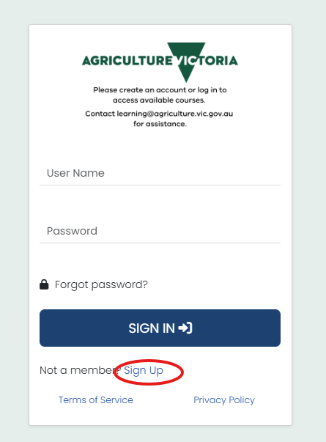

Step 2: Create your account

Account details
- Create a username or use your email address. Keep note of your username. You will need it for future log ins.
- Password (minimum 13 characters with uppercase, lowercase and special character)

Personal details
- First name and last name (as they should appear on certificate)
- Email address
- State/Territory

Other details
- Why are you here? (select General Education).
- Occupation (usually Horticulture industry worker or Other)
- Organisation (select Other if not listed)
- Place of Work (optional)

Click 'Sign Up'

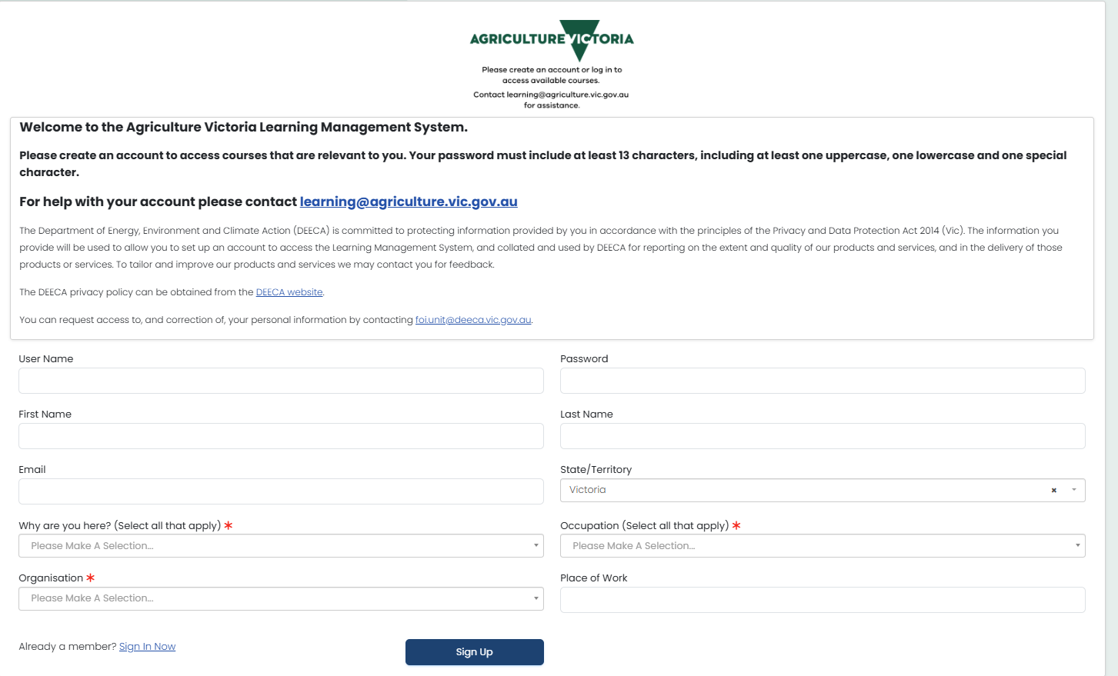

Step 3: Verify your account
- Check your email (including spam)
- Open the validation email
- Click the activation link
- Log in using your credentials

Step 4: Find and enrol in the course
- Click 'Goals Catalogue'
- Search for Tomato-Psyllid Authorised Inspection Person Training eLearn
- Select the course
- Click 'Register'

Step 5: Complete the training
- Click 'Launch'
- Select your preferred language
- Complete all modules
- Click 'Return to LMS' when finished

Step 6: Review and confirm
- Review reference materials
- Click 'Confirm Viewed' to acknowledge completion

Step 7: Download your certificate
- Go to 'Goals Centre'
- Select 'Completed'
- Click 'Certificate' to download

You're finished when:
- Training is completed
- Procedure acknowledged
- Certificate downloaded

Need help?
- Check spam if email not received
- Use 'Forgot password' if needed
- Check Goals Catalogue if course not visible
- Contact learning@agriculture.vic.gov.au for assistance.

