Hover flies
(Diptera: Syrphidae)

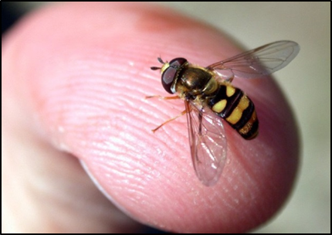
Hover flies, often referred to as flower flies or drone flies, are beneficial insects that appear in large numbers during the spring and summer. They are often mistaken for bees or wasps and can cause undue fear over potential stings. Fortunately, they do not possess stingers. Hover flies can be readily distinguished from wasps and bees by their single pair of wings.

Identification
Hover flies belong to the order Diptera and the family Syrphidae. As can be seen in Figures 1, 2 & 3 hover flies, like all true flies, have only one pair of wings. In comparison, bees and wasps have two pairs of wings. Hover flies also have a typical fly head with short antennae and bulbous eyes (Figures 1 & 3). Adult hover flies are 4-10 mm long and have dark flattened bodies with black and yellow markings.
During flight, many hover flies move in a characteristic way. As their name suggests, they hover over objects but will also dart to and fro.
The immature hover fly looks like a maggot and can grow up to 10 mm long. The larvae hunts by touch. They have mouth hooks which grip and pierce the skin of their prey prior to extracting their body contents (Figure 4).

Management
Management is usually not necessary as hover flies are beneficial insects. They are considered the second most important pollinator next to bees (Figure 2). Further, some species of hover flies can control garden pests such as soft-bodied aphids and scale insects.
Figure 1: Hover fly on a finger to illustrate size.
Image credit Timothy Gibb, Purdue Agriculture [5].
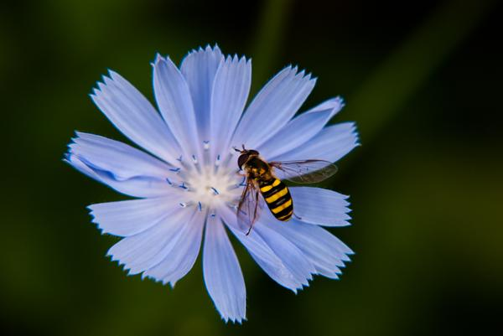
Figure 2: Hover fly collecting pollen.
Image credit Steve Schoof, North Caroline State University [7].

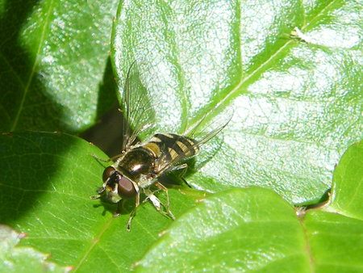
Figure 3: Hover fly on a rose leaf.
Image credit Ashley Walsh, ABC Adelaide [1].
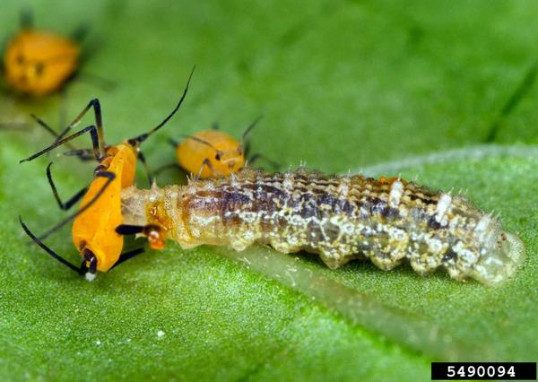

Figure 4: Hover fly larva feeding on an aphid.
Image credit David Cappaert, Bugwood.org [6].

Further information
For further information phone 136 186 or email plant.protection@ecodev.vic.gov.au.

References
- Walsh, A. (2009) Good garden bugs. ABC Adelaide. Retrieved from https://www.abc.net.au/local/stories/2009/11/21/2742166.htm (Accessed 01 February 2021)
- Australian Government, Department of the Environment and Energy (2016) Family Syrphidae, hoverflies, rat-tailed maggots [Web page]. Retrieved from https://biodiversity.org.au/afd/taxa/SYRPHIDAE? (Accessed 20 October 2016).
- Australian Museum (2009) Animal species: Hover flies [Web page]. Retrieved from http://australianmuseum.net.au/hover-flies (Accessed 20 October 2016).
- Larson, B.M.H. et al. (2001) Flies and flowers: taxonomic diversity of anthophiles and pollinators, The Canadian Entomologist, 133(4), pp. 439–465.
- Gibb T. (2015) Do not confuse hover flies with sweat bees. Purdue Agriculture [Web page]. Retrieved from https://ag.purdue.edu/btny/ppdl/Pages/wh19082015.aspx (Accessed 20 October 2016).
- David Cappaert, Michigan State University. Bugwood.org. [Web page]. Retrieved from https://content.ces.ncsu.edu/syrphid-flies (Accessed 01 February 2021).
- Steve Schoof, North Carolina State University [Web page]. Retrieved from https://content.ces.ncsu.edu/syrphid-flies (Accessed 01 February 2021).

