Dairy Farm
Monitor Project
Victoria │Annual Report
2019-20

Acknowledgements

Data collection for the Dairy Farm Monitor Project was conducted remotely in 2020. The additional efforts from participant farmers and data collectors to collect high-quality data remotely is greatly appreciated.
The cooperation, patience and goodwill of the participant farmers who willingly supplied their farm information are gratefully acknowledged. For continuing participants and those new to the project, thank you for your participation.
The diligent work of Agriculture Victoria, Dairy Services staff who prepared the report; Natalie Nelson and Olive Montecillo, and those who gathered the final performance data are deserving of our thanks, especially Michele Jolliffe, David Shambrook, and Sarah Clack. Thanks to Penny Shaw and Julie Harman for providing a thorough review of the report.
The project was also made possible this year through the contributions of Dan Armstrong, Tom Farran, Cameron Smith, Paul Groves, Janet Sloan, Lisa Birrell, Lachlan Barnes and Shane Byrne who collected farm data, in addition to data collected by Agriculture Victoria staff, and provided feedback and validation to ensure its accuracy.
Thank you to Brett Mitchard from Agriculture Victoria for creating the map used in this publication.
This report has been produced in conjunction with Dairy Australia.
Further information regarding the Dairy Farm Monitor Project may be obtained from:

Claire Waterman
Agriculture Victoria
PO Box 3100, Bendigo DC, Victoria 3400
Telephone: 0408 785 368
claire.waterman@agriculture.vic.gov.au

To find out the latest information on the project visit the project websitewww.agriculture.vic.gov.au/dairy.

Authorised by the Victorian Government
Department of Jobs, Precincts and Regions
1 Spring Street Melbourne Victoria 3000
Telephone (03) 9651 9999
© Copyright State of Victoria,
Department of Jobs, Precincts and Regions 2020
Except for any logos, emblems, trademarks, artwork and photography this document is made available under the terms of the Creative Commons Attribution 3.0 Australia license.
This document is also available in an accessible format at agriculture.vic.gov.au

ISSN 1835-9922
Print managed by Finsbury Green.
Disclaimer
This publication may be of assistance to you, but the State of Victoria and its employees do not guarantee that the publication is without flaw of any kind or is wholly appropriate for your particular purposes and therefore disclaims all liability for any error, loss or other consequence which may arise from you relying on any information in this publication.

Accessibility
If you would like to receive this publication in an accessible format, please telephone the department’s Customer Service Centre on 1300 502 656.
This document is also available in PDF and Word format at www.agriculture.vic.gov.au/dairyfarmmonitor
or PDF format at
www.dairyaustralia.com.au/dairyfarmmonitor

Contents
Acknowledgements 2
How to read this report 5
What’s new in 2019-20 6
I. Summary 7
Summary 8
Victoria overview 8
The North 8
The South West 8
Gippsland 8
Expectations for profit in 2020-21 8
II. DFMP method 9
Dairy Farm Monitor Project method 10
Part One: Statewide overview 12
Statewide overview 13
Whole farm analysis 15
Physical measures 19
Part Two: The North 22
Seasonal conditions 23
Whole Farm Analysis 25
Feed consumption and fertiliser 31
Part Three: The South West 33
Seasonal conditions 34
Whole Farm Analysis 35
Feed consumption and fertiliser 41
Part Four: Gippsland 43
Seasonal conditions 44
Whole Farm Analysis 45
Feed consumption and fertiliser 51
Part Five: Business Confidence Survey 53
Expectations for business profit 54
Part Six: Greenhouse Gas Emissions 58
2019-20 Greenhouse gas emissions 59
Part Seven: Historical analysis 60
Historical analysis 61
Appendices 65
Appendix A: Statewide summary tables 66
Appendix B: North summary tables 74
Appendix C: South West summary tables 90
Appendix D: Gippsland summary tables 107
Appendix E: Glossary of terms, abbreviations and standard value 123

List of Figures

Figure 1. Dairy Farm Monitor profit map - State average data 2019-20
Figure 2. Distribution of participant farms in 2019-20 across Victoria
Figure 3. Monthly rainfall 2019-20
Figure 4. Average EBIT
Figure 5. Distribution of farms by ROTA
Figure 6. Distribution of farms by ROE
Figure 7. Sources of whole farm metabolisable energy
Figure 8. Estimated tonnes of homegrown feed removed
Figure 9. Nutrient application
Figure 10. Monthly distribution of milk sold
Figure 11. Monthly distribution of calving
Figure 12. Annual rainfall and long-term average rainfall – North
Figure 13. Milk solids sold – North
Figure 14. Gross farm income – North
Figure 15. Variable and overhead costs – North
Figure 16. EBIT – North
Figure 17. ROTA – North
Figure 18. ROE – North
Figure 19. Sources of whole farm metabolisable energy – North
Figure 20. Estimated tonnes of homegrown feed removed – North
Figure 21. Nutrient application – North
Figure 22. Annual rainfall and long-term average rainfall – South West
Figure 23. Milk solids sold – South West
Figure 24. Gross farm income – South West
Figure 25. Variable and overhead costs – South West
Figure 26. EBIT - South West
Figure 27. ROTA - South West
Figure 28. ROE - South West
Figure 29. Sources of whole farm metabolisable energy – South West
Figure 30. Estimated tonnes of homegrown feed removed – South West
Figure 31. Nutrient application – South West
Figure 32. Annual rainfall and long-term average rainfall – Gippsland
Figure 33. Milk solids sold – Gippsland
Figure 34. Gross farm income – Gippsland
Figure 35. Variable and overhead costs – Gippsland
Figure 36. EBIT – Gippsland
Figure 37. ROTA – Gippsland
Figure 38. ROE – Gippsland
Figure 39. Sources of whole farm metabolisable energy – Gippsland
Figure 40. Estimated tonnes of homegrown feed removed – Gippsland
Figure 41. Nutrient application – Gippsland
Figure 42. Expected change to farm business profit in 2020-21
Figure 43. Producer expectations of milk prices and production in 2020-21
Figure 44. Producer expectations of fodder production in 2020-21
Figure 45. Producer expectations of costs for the dairy industry in 2020-21
Figure 46. Major issues for individual businesses – 12-month outlook
Figure 47. Major issues for individual businesses – 5-year outlook
Figure 48. Estimated 2019-20 average greenhouse gas emissions (CO₂ equivalent)
Figure 49. Farm profitability (real $) between 2006-07 and 2019-20 – North
Figure 50. Whole farm performance between 2006-07 and 2019-20 – North
Figure 51. Farm profitability (real $) between 2006-07 and 2019-20 – South West
Figure 52. Whole farm performance between 2006-07 and 2019-20 – South West
Figure 53. Farm profitability (real $) between 2006-07 and 2019-20 – Gippsland
Figure 54. Whole farm performance between 2006-07 and 2019-20 – Gippsland

List of Tables

Table 1. Average farm physical data –State overview 2019-20
Table 2. Average farm financial performance - Statewide
Table 3. Risk indicators
Table 4. Farm physical data – North
Table 5. Average farm financial performance – North
Table 6. Cost of production – North
Table 7. Farm physical data – South West
Table 8. Average farm financial performance – South West
Table 9. Cost of production – South West
Table 10. Farm physical data – Gippsland
Table 11. Average farm financial performance – Gippsland
Table 12. Cost of production – Gippsland

How to read this report
This section explains calculations used and data presented in this report.

Participants were selected for the project to represent a distribution of farm size, feeding system, herd size and geographical location within each region. The farms selected do not fully represent the entire dairy farm population as the participant farms were not solely chosen on the basis of providing a representative sample.
The report provides visual representations of the data for the 2019-20 year. It is presented for individual farms, as regional averages and for the regional top 25% of farms ranked by Return on Total Asset (ROTA). The presented averages should not be considered as the average for the dairy industry in each region.
The top 25% of farms are presented as darker coloured bars in the regional overview figures. The ROTA was used to identify the top 25% of producers as it provides an assessment of whole farm performance irrespective of differences in location and production system.
The Quartile one (Q1) to Quartile three (Q3) data range for key measures are presented to provide an indication of the range in the data. The Q1 value is the quartile 1 value, that is, the value of which one quarter (25%) of data in that range are less than the average. The Q3 value is the quartile 3 value, that is, the value of which one quarter (25%) of data in that range is greater than the average. Therefore, the middle 50% of data reside between the Q1-Q3 data range. Given there will be differences in variation in the data for each region, one region should not be compared to another.
This report refers to the group of participating farms in a given region by their regional name:
- The 30 participating farms in the Northern Victoria region are referred to as ‘the North’.
- The 25 participating farms in the South Western Victoria region are referred to as ‘the South West’.
- The 25 participating farms in the Gippsland region are referred to as ‘Gippsland’.
The appendices include detailed data tables, a list of abbreviations, standard values used and a glossary of terms.
Milk production is presented in kilograms of milk solids sold (kg MS) as farmers are paid on this basis.
The report provides averages on a per kg MS basis, with occasional reference to measures on a per farm, per hectare or per cow basis. The Appendix Tables contain most of the financial information per kg MS.
Percentage differences are calculated as [(new value – original value)/original value]. For example, ‘costs went from $80/ha to $120/ha, a 50% increase’: [{(120-80)/80} x (100/1)] = [(40/80) x 100] = 0.5 x 100 = 50%, unless otherwise stated.
The regional top 25% consists of seven farms in the North and six farms each in the South West and Gippsland regions. The statewide top 25% group has 20 farms which is taken by considering all 80 farms as the one sample and not from combining the top farms from each region.
The project commenced in 2006-07 and was delivered for the 14th time in 2019-20. Any reference to ‘last year’ refers to the 2018-19 Dairy Farm Monitor Project (DFMP) Victoria Annual Report. Price and cost comparisons between years are nominal unless otherwise stated. Not all participant data from 2018-19 are included in the 2019-20 report, as there were new participants in the 2019-20 dataset. This is an important consideration when comparing datasets between years. At the start of each regional chapter, farms that are new to the project are identified.

The presented averages should not be considered as the average for the dairy industry in each region and one region should not be compared to another.

What’s new in 2019-20
The Dairy Farm Monitor Report for 2019-20 includes several changes from last year’s report.

The number of farms in the North increased by five in 2019-20, taking the total in the region to 30 and across Victoria to 80. The increased sample size in this region attempts to reflect the greater diversity in feeding systems as compared to other regions. The additional farms recruited to the project are located in the Goulburn Murray Irrigation District (GMID).
The appendix tables reporting the percent of total costs that were included in previous reports have been removed. This information can be sourced from DairyBase.
The measure of inflation used to determine real prices for the historical analysis were sourced from the Reserve Bank of Australia and are the year-ended weighted median inflation as at 30 June each financial year.
The farm performance analysis generated through the project relies on objective estimates of market values on individual participant properties located across Victoria. The essential criteria in evaluating the financial health of a business, in terms of profit, is the nature and amount of total asset controlled. Changes to the handling of land, feed and water values in 2020 include:
- Regional land values were compared with the Valuer General dataset to validate and standardise land values among farms in 2020. Adjustments were made subject to the review and validation of the data collection team.
- Standard values for homegrown feed were calculated as a yearly average of weekly market prices sourced from Dairy Australia’s hay and grain report. This year a 20% discount was applied to homegrown feed inventories to account for the lower quality relative to bought feed.
- Standard opening values for allocation water and high and low reliability water shares were derived from the trading zone prices where the farm is located, rather than a weighted average of the trading zones in northern Victoria. Standard closing values were calculated as weighted average of standard opening values and the farm’s purchases and/or sales, if applicable.

View previous reports on the project website:
http://www.agriculture.vic.gov.au/dairyfarmmonitor or
http://www.dairyaustralia.com.au/dairyfarmmonitor

Summary

Summary
A challenging first six months of 2019-20 preceded improved seasonal and business conditions in the second half of the year to lift performance across Victoria’s dairy regions compared to the previous year. Farms were able to lower their costs and with a 17% improvement in milk price, average earnings before interest and tax increased to $346,000 ($1.68/kg MS).

Victoria overview
In 2019-20, average earnings before interest and taxes (EBIT) rose to $346,000 ($1.68/kg MS), a significant increase from $85,000 ($0.25/kg MS) in 2018-19. All but three farms recorded a positive EBIT performance per farm in 2019-20 lifting the average to the third highest level recorded for the project. The average return on total assets (ROTA) also increased to 5.4% from 0.7% In 2018-19. Farms were able to grow their business on average as reflected by return on equity (ROE) increasing from
-3.5% in 2018-19 to 8.3% in 2019-20.
Seasonal conditions across the three dairying regions were characterised by challenges through winter and spring 2019, followed by a mild summer and good autumn 2020 rains. Farms in each of the regions responded differently depending on the relative positions heading into 2019-20. While nearly all Dairy Farm Monitor Project (DFMP) farms experienced positive profits in 2019-20, with consistent performance reported across the regions, many farms have not fully recovered from the recent years of challenging conditions and lower performance.
In 2019-20, there was greater pasture availability in some regions (South West and Gippsland) and lower feed prices in the second half of the season compared to the previous year. This enabled farmers to source relatively cheaper feed and increase their feed and water reserves. Average milk production increased from greater levels of feeding (6.4 t DM/cow in 2019-20, compared to 6.2 t DM/cow in 2018-19). Milk price improved by 17% to $7.15/kg MS in 2019-20, contributing to the improved performance seen in all regions.

The North
Tough seasonal conditions and high input prices, notably irrigation water, from 2018-19 continued through to the first half of the season. Good business decisions and better seasonal conditions in the second half were reflected in an improved overall performance of the North participants for the whole year.
Early in the 2019-20 year, farmers budgeted for high prices of allocation water and many chose to purchase fodder in favour of irrigating. This decision lowered their irrigation and fertiliser costs, leading to a 7% decrease in variable costs per kg MS compared to the previous year. The continued rainfall events and mild temperatures in the second half of 2019-20 has allowed farmers to carry-over unused feed and water inventories into 2020-21. Overhead costs also decreased in 2019-20, a fall of 6% to $2.18/kg MS as farmers maintained a tight control on expenditure.
These lower costs combined with a 16% improvement in milk price to $7.31/kg MS lifted the profit performance for the North from the low returns experienced in previous years. Average EBIT increased to $323,000 ($1.22/kg MS) and net farm income was $221,000 ($0.77/kg MS) in 2019-20. Elevated value of water assets constrained the ROTA and ROE performance of 4.1% and 3.7%, respectively.

The South West
Farms in the South West capitalised on the favourable seasonal conditions to harvest above average homegrown feed. Feed costs decreased by 6% to $2.95/kg MS in 2019-20 as farmers were able to increase their fodder inventories and reduce their reliance on purchased feed. Average homegrown feed costs increased, mostly as a result of applying greater quantities of fertiliser, than the previous year to support good crop and pasture growth. Repairs and maintenance expenditure increased as farmers utilised their cashflow to make deferred upgrades. Overhead costs increased by 3% to $2.63/kg MS in 2019-20.
On average, milk sold per cow and per farm increased. The milk price improved 16% to $7.16/kg MS helping all farms achieve positive EBIT performance. On average, EBIT was $382,000 ($1.83/kg MS) and net farm income was $273,000 ($1.29/kg MS). The ROTA was 5.8% and ROE was 9.6% in 2019-20.

Gippsland
Despite the challenging operating conditions in Gippsland for the first six months of 2019-20, herd size remained stable and there was improved per cow and per hectare milk production. This was supported by the improved growing conditions later in the season when moisture allowed harvesting of excess fodder. The geographical location of farms influenced their ability to harvest pasture. Those in central and east Gippsland experienced dry seasonal conditions and irrigators in the Macalister Irrigation District had low opening water allocations. Costs for imported feeds were lower and there was greater reliance on homegrown forage sources. More than 75% of participants increased fodder on-hand and there was an 11% decrease in purchased feed costs to $1.98/kg MS.
The Gippsland farms received among the highest average milk price (in real terms) in the 14-year history at $6.95/kg MS, up 16% from 2018-19. On average, EBIT was $337,000 ($2.07/kg MS) in 2019-20, and net farm income was $238,000 (1.43/kg MS). The improved performance in 2019-20 resulted in a ROTA of 6.6% and ROE of 12.4%.

Expectations for profit in 2020-21
Most participant farms across all regions are expecting profits and milk prices to either remain stable or increase in 2020-21. Some respondents commented they were uncertain of the long-term coronavirus (COVID-19) impacts on export milk price.

DFMP method

Dairy Farm Monitor Project method
This chapter describes the method used in the DFMP and defines the key terms used. The profit and production performance of dairying businesses is generated using whole farm analysis principles and is consistent with Dairy Australia’s DairyBase.

The DFMP provides the dairy industry and government with objective, farm-level information to assist with targeted and strategic decision making. The method was adapted from The Farming Game (Malcolm et al. 2005) and is consistent and comparable with previous DFMP and Dairy Australia’s DairyBase.
DairyBase is a national dairy database that enables dairy farmers to measure and compare farm business performance over time. The database stores farm-level data generated from the DFMP and publishes aggregated data from a minimum of six other farms. The standardised database provides the dairy industry with a consistent method and terms for farm financial reporting.
The DFMP method is presented as a profit map in Figure 1 and shows how the different measures are calculated. The performance of all project participants in 2019-20 is also shown.
Growth in profit is achieved by investing in assets which generate income. These assets can be owned with equity (one’s own capital) or debt (borrowed capital). The amount of growth is dependent on maximising the margin between income and costs, or cost efficiency relative to income generation.
Gross farm income
The farming business generates a gross farm income which is the sum of milk cash income (net), livestock trading profit and other sources.
Variable costs
Variable costs are the costs specific to an enterprise, such as herd, shed and feed costs. These costs vary in relation to the size of the enterprise. Subtracting variable costs for the dairy enterprise from gross farm income, gives the gross margin. Gross margins are often used to compare between similar enterprises and are commonly used in broad acre cropping and livestock enterprises. Gross margins are not generally used in isolation for economic analyses of dairy farming businesses due to the specific infrastructure investment required to operate a dairy farm making it less desirable to switch enterprises.
Overhead costs
Overhead costs are those costs not directly related to an enterprise as they are expenses incurred through the general operating of the business. The DFMP separates overheads into cash and non-cash overheads, to distinguish between different cash flows within the business.
Cash overheads include rates, insurance, and repairs and maintenance. Non-cash overheads include costs that are not actual cash receipts or expenditure; for example, depreciation on a piece of equipment. Imputed operator’s allowance for labour and management is also a non-cash overhead that must be costed and deducted from income if a realistic estimate of costs, profit and return on the capital of the business is to be obtained.
Earnings before interest and tax
Gross farm income minus variable and overhead costs is EBIT and is the return from all capital used in the business.
Net farm income
Net farm income is EBIT minus interest and lease costs and is the reward to the farmer’s own capital. Interest and lease costs are viewed as financing expenses, either for borrowed money or leased land or water that is being utilised.
Net farm income is then used to pay tax and what is remaining is net profit or surplus and therefore growth, which can be invested into the business to expand the equity base, either by direct reinvestment or the payment of debt.
Return on total assets and return on equity
Two economic indicators of whole farm performance are ROTA and ROE. They measure the return to their respective capital base.
An indicator of the overall earning rate of the total farm assets is ROTA, irrespective of the capital structure of the business. It is EBIT expressed as a percentage of the total assets under management in the farm business, including the value of leased assets.
A measure of the owner’s rate of return on their own capital investment in the business is ROE. It is net farm income expressed as a percentage of total equity (one’s own capital).
The equity percent of total capital or debt: equity ratio varies depending on the individual farm business and farm owner’s attitude towards risk.
Further ROTA from any increase in the value of assets over the year, such as capital appreciation, is not considered in the DFMP method. If land value increases 5% over the year, this is added to the return from farming to give total return to the investment. This ROTA can be compared with the performance of alternative investments with similar risk in the economy.

FIGURE 1. DAIRY FARM MONITOR PROFIT MAP - STATE AVERAGE DATA 2019-20
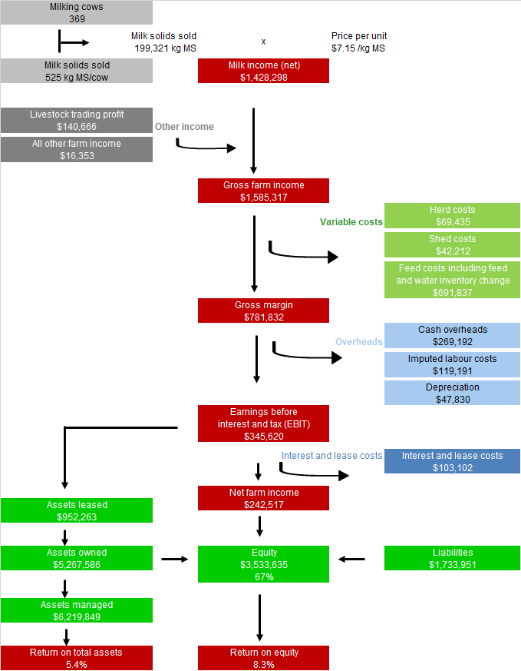

Part One: Statewide overview

Statewide overview
On average, the performance of the DFMP farms improved in 2019-20 compared to the previous year. For the surveyed farms across North, South West and Gippsland regions of Victoria the influences of seasonal conditions, change of water and feed inventories, managing costs and improved milk price all contributed to the improved performance.

Victoria produced 5.57 billion litres of milk in 2019-20, 63% of Australia’s total milk production. Victorian dairies accounted for 79% of national dairy exports, the largest consumers being China ($472 million) and Japan ($452 million). China overtook Japan as the largest export market for dairy products for second year in a row despite exports to Japan increasing $10 million (2%). Most of Victoria’s dairy products are sold on the global market and as such returns to Victorian dairy farmers are strongly connected to global commodity prices.
The statewide overview section presents the average performance and range in physical and financial indicators for all participant farms across the North, South West and Gippsland regions of Victoria.
The location of Victoria’s dairy industry is predominantly in the North, South West and Gippsland regions. The approximate locations of the participating DFMP farms in 2019-20 are shown in Figure 2.

FIGURE 2. DISTRIBUTION OF PARTICIPANT FARMS IN 2019-20 ACROSS VICTORIA
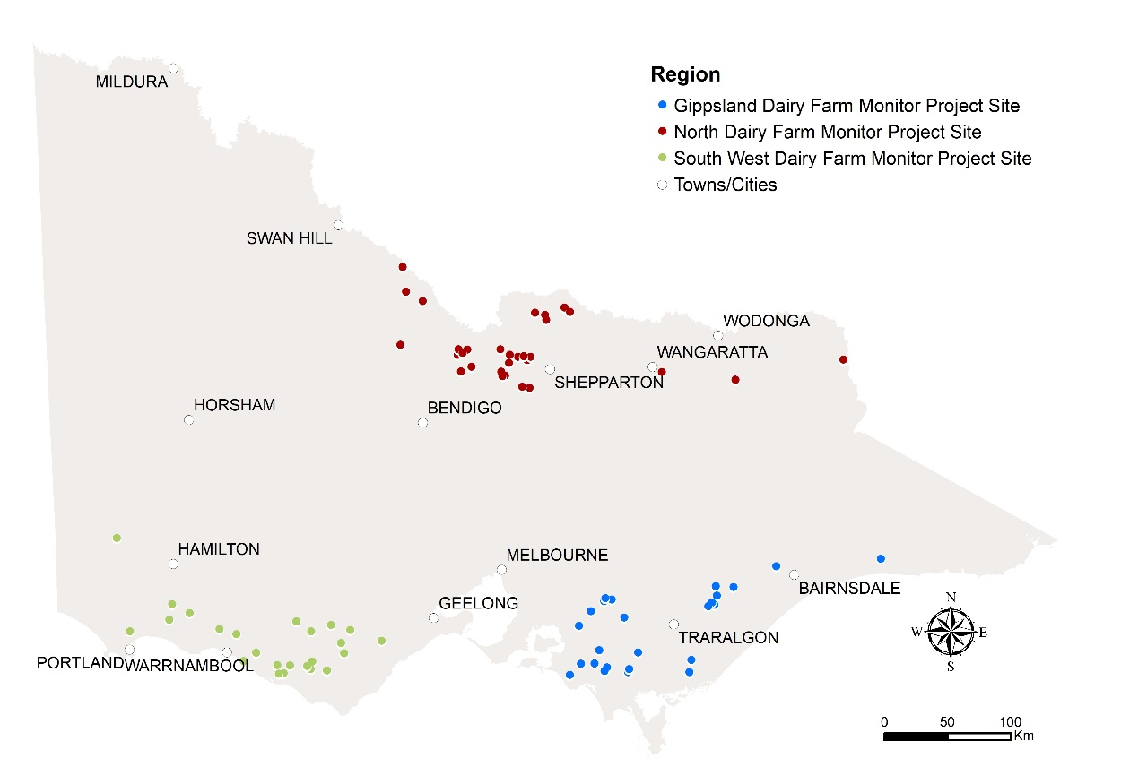

Seasonal conditions

The 2019-20 seasonal conditions across the three dairying regions were characterised by challenges through winter and spring 2019, followed by a mild summer and good autumn rains in 2020. Farms in each of the regions responded differently to these conditions, depending on their relative positions heading into 2019-20.
In the North, it was a year of two halves. During the first six months of 2019-20, the region experienced dry and hot seasonal conditions (for some farms there was no rain received in October and November 2019), and a code red day was declared in November 2019. Failed cereal crops were cut for good quality hay. In the second half of 2019-20, the region experienced cooler than average conditions and consistent rainfall. The improved conditions meant farmers did not utilise all their water and inventory reserves and have carried these into the next season (2020-21).
The South West had favourable growing conditions for crop and pasture growth. The season started wet and turned dry through early spring. Significant rain in October and November enabled good quantities of silage production. A mild summer and consistent rainfall through to the autumn set up the region well.
While there was geographical variation of seasonal conditions across Gippsland, seasonal conditions were also characteristic of two halves. In south and west Gippsland, average rain and mild temperatures allowed for first cuts of silage in spring and then rain in November enabled second cuts of silage or hay. Rainfall events in mid-January 2020 resulted in sufficient soil moisture for the remaining months of 2019-20. However, central and east Gippsland headed into the season drier than their counterparts, having experienced a third year of drought conditions following very much below average to lowest on record rainfall since late 2016. The season started to improve with January rains that supported pasture growth. Irrigated farms in the Macalister Irrigation District started the year with 70% allocation and ended at 100% with no spill entitlements from Lake Glenmaggie for the second year running.
Figure 3 shows regional monthly rainfall. More detail on seasonal conditions is provided in the regional sections.

FIGURE 3. MONTHLY RAINFALL 2019-20
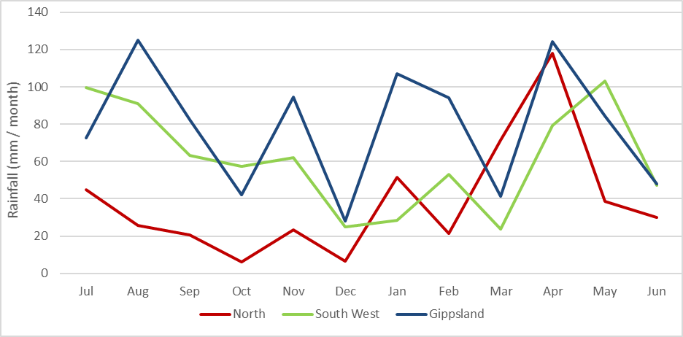

Whole farm analysis
Improved seasonal and market conditions helped lift performance in each of the regions, resulting in a six-fold increase in EBIT to $1.68/kg MS in 2019-20 for the state average, compared to the previous year.

Average herd size across all three regions increased slightly this year to 369 cows from an average of 357 cows the previous year (Table 1). The average usable farm area also increased to 277 ha from 259 ha the previous year.
The amount of milk solids sold increased on a per cow and per hectare performance. Milk solids sold increased to 525 kg MS/cow, from 495 kg MS/cow the previous year and milk solids sold per hectare (MS/ha) increased to 794 kg MS/ha from 757 kg MS/ha in 2018-19. An increase was seen across all regions.
Labour efficiency for the state remained stable at 107 cows/FTE while MS/FTE slightly increased to around 55,500 kg MS/FTE, due to the higher milk production in 2019-20.
The regional data show that herd size in the North was larger, while land area was the greatest for South West farms. Gippsland farms have the highest stocking rate on average at 1.9 cows/ha and have the greatest homegrown feed as per cent of metabolisable energy (ME) consumed. For the Gippsland farms, on average the grazed pasture constituted 60% of the cow diet compared to 49% for South West and 36% for the North.
Table 1 presents the average farm physical parameters for the state and for each region. Further details can be found in Appendix Table 2 for each region.

TABLE 1. AVERAGE FARM PHYSICAL DATA –STATE OVERVIEW 2019-20
Farm physical parameters | State | North | South West | Gippsland
Number of farms in sample | 80 | 30 | 25 | 25
Annual rainfall 19-20 (mm) | 696 | 459 | 733 | 944
Herd size | 369 | 418 | 369 | 310
Total water use efficiency (t DM/100mm/ha) | 0.8 | 0.8 | 0.8 | 0.8
Total usable area (hectares) | 277 | 304 | 333 | 187
Milking cows per usable hectare | 1.5 | 1.5 | 1.1 | 1.9
Milk solids sold (kg MS /cow) | 525 | 566 | 516 | 486
Milk solids sold (kg MS /ha) | 794 | 867 | 577 | 925
Home grown feed as % of ME consumed | 61% | 50% | 68% | 68%
Labour efficiency (cows / FTE) | 107 | 103 | 99 | 121
Labour efficiency (kg MS / FTE) | 55,478 | 57,272 | 50,658 | 58,145

Gross farm income
In 2019-20, average gross farm income increased by 16% to $7.87/kg MS. This comprised of 91% from milk sales, 8% from livestock trading and 1% from other farm income sources.
An improvement in the milk price by more than $1/kg MS to $7.15/kg MS, was the third highest in real terms (when the effects of inflation are excluded) received in the history of the project. Farms in the North received the highest milk price at $7.31/kg MS, followed by the South West at $7.16/kg MS and Gippsland at $6.95/kg MS.

One of the decisions to maintain and improve profitability, made by participating farmers in the DFMP was to negotiate supplier agreements with milk processors as they continued to evaluate their milk price and find a payment structure that best suited their farm business.
Some farmers were able to take advantage of the strong livestock market to help lift the participant farms’ average livestock trading income by 12% to $0.65/kg MS in 2019-20. A small number of farmers benefited from selling their heifers for export, which further increased livestock trading gains.

Variable costs
Average variable costs were lower in 2019-20, falling by 7% to $3.88/kg MS compared to $4.17/kg MS in 2018-19. Herd and shed costs remained the same at $0.32/kg MS and $0.23/kg MS respectively, while feed costs decreased by 8% to $3.33/kg MS year-on-year (Table 2). Lower homegrown feed costs and improved fodder and water inventory contributed to the overall lower feed costs, while average purchased feed costs remained similar for DFMP farms.
The lower homegrown feed costs were largely due to the reduced irrigation costs on irrigated farms and lower hay and silage making costs. Farmers in the North also reduced their expenditure on fertiliser as they chose to purchase fodder rather than produce their own feed. In contrast, farms in the South West applied additional fertiliser to capitalise on the rainfall for enhancing pasture growth and silage yields. On average, statewide homegrown feed costs were $1.19/kg MS in 2019-20, down from $1.30/kg MS in 2018-19.
Feed and water inventory changes contributed to the lower feed costs in 2019-20. Changes to feed and water inventory are considered feed costs and as such, negative inventory changes of -$0.17/kg MS and -$0.04/kg MS, respectively mean a reduction in feed cost. Many farmers in the North who purchased allocation water with the intention of using it in the second half of 2019-20 did not use it when the seasonal conditions improved, and farms carried this into the next season. Some farms purchased allocation water late in the season at reduced costs to carry-over into 2020-21 as a risk management strategy. Of the 80 DFMP farms, 60 built their fodder reserves by an average of 178 t DM, or 17% of the total t DM conserved on farm (650 t DM conserved on the usable area).
Purchased feed and agistment costs on average were $2.36/kg, which is similar to last year’s $2.33/kg MS. While the South West and Gippsland DFMP farms reduced their reliance on purchased feed as there was greater pasture availability, farms in the North had an increase as they chose to purchase feed instead of irrigating.
The improved milk price combined with the lower costs to record an average gross margin of $3.99 /kg MS, up from $2.59/kg MS in 2018-19.
Overhead costs
Average overhead costs were comparable between years with $2.31/kg MS spent in 2019-20. Farms in the North reduced their overhead expenditure as they focused on tightly managing costs in response to dry seasonal conditions. In contrast, farms in the South West attended to deferred repairs and maintenance increasing this cost category. Gippsland farms maintained overhead expenditure at the same level between years.
See Appendix Table 4 for a breakdown of variable costs and Appendix Table 5 for overhead costs. Standard values used to calculate imputed labour can be found in Appendix E.
TABLE 2. AVERAGE FARM FINANCIAL PERFORMANCE - STATEWIDE
 | State  $/kg MS | North  $/kg MS | South West  $/kg MS | Gippsland  $/kg MS
INCOME
Milk income (net) | $7.15 | $7.31 | $7.16 | $6.95
Livestock trading profit | $0.65 | $0.61 | $0.74 | $0.61
Other farm income | $0.07 | $0.10 | $0.07 | $0.02
Gross farm income | $7.87 | $8.01 | $7.98 | $7.59
VARIABLE COSTS
Herd costs | $0.32 | $0.33 | $0.31 | $0.32
Shed costs | $0.23 | $0.20 | $0.26 | $0.22
Home grown feed cost | $1.19 | $1.29 | $1.21 | $1.06
Purchased feed and agistment | $2.36 | $3.00 | $1.97 | $1.98
Feed inventory change | -$0.17 | -$0.09 | -$0.22 | -$0.22
Water inventory change | -$0.04 | -$0.11 | $0.00 | -$0.01
Total feed costs | $3.33 | $4.08 | $2.95 | $2.81
Total variable costs | $3.88 | $4.61 | $3.52 | $3.36
GROSS MARGIN | $3.99 | $3.40 | $4.46 | $4.23
OVERHEAD COSTS
Employed labour | $0.59 | $0.60 | $0.60 | $0.59
Repairs and maintenance | $0.36 | $0.31 | $0.47 | $0.30
All other overheads | $0.29 | $0.29 | $0.31 | $0.28
Imputed labour | $0.83 | $0.77 | $0.92 | $0.82
Depreciation | $0.24 | $0.20 | $0.34 | $0.17
Total overhead costs | $2.31 | $2.18 | $2.63 | $2.16
Variable and overhead costs | $6.19 | $6.79 | $6.15 | $5.51
EBIT | $1.68 | $1.22 | $1.83 | $2.07

Earnings before interest and tax

Improved operational efficiency saw average EBIT increase from $0.25/kg MS in 2018-19 to $1.68/kg MS in 2019-20 (Figure 4). All regions enjoyed improved economic performance with farms in the North experiencing the largest improvement increasing by $1.67/kg MS. Gippsland farms also recorded $1.56/kg MS more profit, taking the average EBIT to $2.07/kg MS in 2019-20. South West farms increased their EBIT performance by $1.12/kg MS, with an average of $1.83/kg MS in 2019-20.
The increases in EBIT across all the regions indicate that the improved performance was more than the result of an average $1/kg MS increase in milk price. The improved performance was also a combination of higher volume of milk solids sold, greater pasture availability for some farms and lower variable costs.
In 2019-20, most farms were able turn around their financial position. While the first six months provided challenging seasonal conditions, particularly for those farms in the North and those located in east Gippsland, they have been able to use the second half of the year to increase their cashflows and build equity through feed and water reserves. The better financial position of these farms is supported by the sentiment that 73% of all farms are expecting their business returns to remain stable or improve in the coming year. Refer to Part Five of this report for details on expectations for profit and costs.
Figures 16, 26 and 36 in the regional sections present the range in EBIT received by participant farms this year.
Return on total assets and equity
Average ROTA was 5.4% in 2019-20, an increase from 0.7% in 2018-19. The improved economic performance is shown by a greater number (35% of all farms) recording ROTA between 5% and 10% (Figure 5). All but three farms recorded a positive ROTA performance.
Most farm businesses were operated as a mix of owned and borrowed capital (finance loan). The average ROE was 8.3%, up from -3.5% recorded in 2018-19. Most farms achieved ROE between 5% and 10% however, there were a greater number of farms recording a higher ROE, therefore resulting in the average ROE being above the ROTA (Figure 6). The average interest and lease costs were $0.54/kg MS, down from $0.64/kg MS in 2018-19.
The top 25% of farms across the state recorded a ROTA of 9.8% and ROE of 20.8% highlighting the strong returns possible from well-operated businesses in 2019-20.
Further discussion of ROTA and ROE occurs in the risk section below and in the regional chapters. Appendix Table 1 presents ROTA and ROE for the participant farms for each region.

FIGURE 4. AVERAGE EBIT
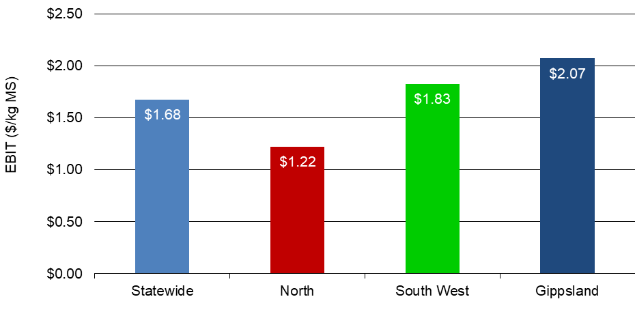

FIGURE 5. DISTRIBUTION OF FARMS BY ROTA
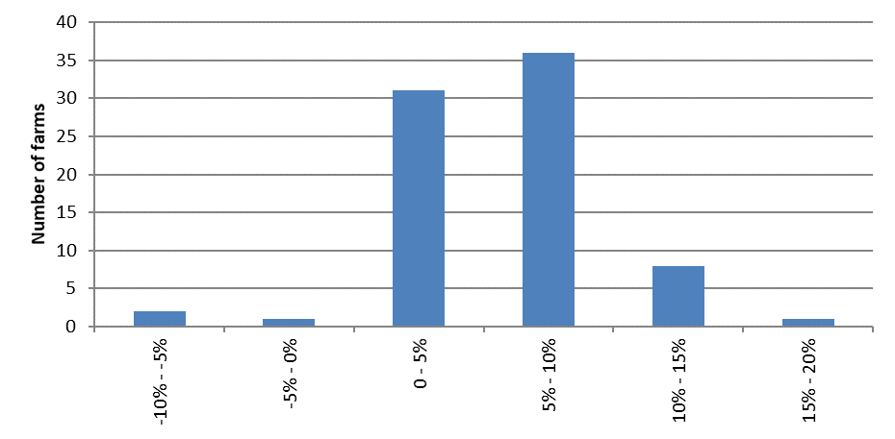

FIGURE 6. DISTRIBUTION OF FARMS BY ROE
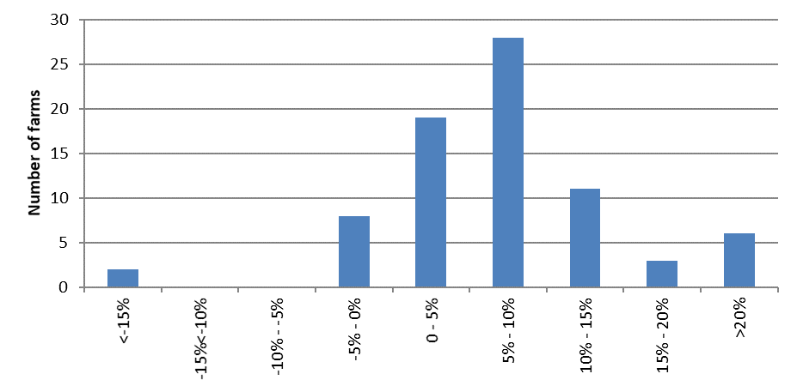

Risk

“Risk is conventionally classified into two types: business risk and financial risk. Business risk is the risk any business faces regardless of how it is financed. It comes from production and price risk, uncertainty and variability. Business risk refers to variable yields of crops, reproduction rates, disease outbreaks, climatic variability, unexpected changes in markets and prices, fluctuations in inflation and interest rates, and personal mishap…. Financial risk derives from the proportion of other people’s money that is used in the business relative to the proportion of owner-operator’s capital…”
As most farms use a mix of borrowed and owned capital, most farms are exposed to business and financial risk. It is important to understand that risk drives return and having the right balance between risk and return can drive success.
Table 3 presents some key risk indicators. Refer to Appendix E for the definition of terms used in Table 3. These indicators can also be found in Appendix Tables 1, 3 and 6 for each region.
The cost structure ratio provides variable costs as a proportion of total costs. A lower ratio implies that overhead costs comprised a greater proportion of total costs which in turn indicates less flexibility in the business. Table 3 shows that across the state for every $1.00 spent, $0.62 was used to cover variable costs, a slight decrease from last year ($0.64). It is worth noting that cost structures vary significantly between regions and farms.
The debt service ratio shows interest and lease costs as a proportion of gross farm income. A ratio of 7% this year means that on average farms repaid $0.07 of every dollar generated back to their creditors.
On average, equity levels across the state improved to 67% from 64% in 2018-19. In the North and South West equity increased while the Gippsland average equity levels remained the same. When new farms enter the survey with different equity structures these results can be impacted.
The average proportion of imported feed as percentage of total ME was 39% in 2019-20. Participant farmers in Gippsland and the South West farmers sourced a third of the ME from imported feed, lower than those in the North with 50%.

TABLE 3. RISK INDICATORS
 | State | North | South West | Gippsland
Cost structure (percentage of total costs as variable costs) | 62% | 68% | 57% | 61%
Debt service ratio (percentage of income as finance costs) | 7% | 6% | 7% | 8%
Debt per cow | $4,455 | $4,265 | $4,485 | $4,653
Equity percentage (ownership of total assets managed) | 67% | 68% | 68% | 63%
Percentage of feed imported (as a % of total ME) | 39% | 50% | 32% | 32%

Physical measures
Feed consumption

The contribution of different feed sources to the total ME consumed on the farm is presented in Figure 7. This includes feed consumed by milking herd, dry cows and young stock across the usable area. Figure 8 shows the estimated grazed and conserved feed removed on the milking area.
The average diet of a DFMP farm consisted of grazed pasture (48% of the diet), concentrates (29%), fodder (23%) and other feed (1%). However, the regional differences show that pasture made up more of the diet on Gippsland farms than those in the South West while North have the lowest at 36% of the diet.
In the North, the proportion of grazed feed in the diet reduced in comparison to last year, falling from 44% in 2018-19 to 36% in 2019-20. A decrease in the pasture availability, as measured by homegrown feed removed from the milking area, fell from 8.7 t DM/ha down to 6.6 t DM/ha in 2019-20. The challenging seasonal conditions in the first half of 2019-20 combined with high prices of allocation water and less than 100% allocation of High Reliability Water Share (HRWS) contributed to this reduced pasture growth. The herd’s diet was supplemented by greater quantities of hay and silage fed on the milking area, which increased from 2.2 t DM/cow in 2018-19 to 3.1 t DM/cow in 2019-20.
The amount of pasture increased in the diet of South West herds from 44% in 2018-19 to 49% in 2019-20. There was greater pasture availability with farms able to graze 0.4 t DM/ha more on the milking area than last year, while conserved feed remained similar at 2.2 t DM/ha. The use of concentrates increased as a proportion of the diet from 28% up to 30% this year. Of the same 21 farms, 13 farms increased their concentrate levels, but overall supplement use declined as farms fed less silage as a result of the improved pasture availability.
Gippsland farms also increased the amount of pasture as a percentage of ME in the diet and grew more homegrown feed per milking hectare compared to the previous year. While there were regional differences in pasture availability across Gippsland, the average pasture intake increased from 56% of ME in the diet in 2018-19 to 60% in 2019-20. Homegrown feed increased from 9.1 t DM/ha in 2018-19 to 9.8 t DM/ha in 2019-20 as farms both grazed and conserved greater quantities. Hay and silage feeding levels decreased from the previous year, while concentrate levels remained the same at 1.6 t DM/cow on average on usable area. This led to farmers feeding less purchased feed per cow in 2019-20, on average.
Appendix Table 3 provides further information on purchased feed in each region and Appendix Table 2 on the homegrown feed removed per milking hectare.
Estimated homegrown feed consumed is calculated from the total ME required on farm, determined by stock numbers, liveweight, average distance walked to and from the dairy and milk production. The ME imported from other feed sources is subtracted from the total farm ME requirements over the year to give estimated total ME produced on farm. The ME produced on farm is divided into grazed and conserved feed, using records of the amount of conserved fodder produced.

FIGURE 7. SOURCES OF WHOLE FARM METABOLISABLE ENERGY
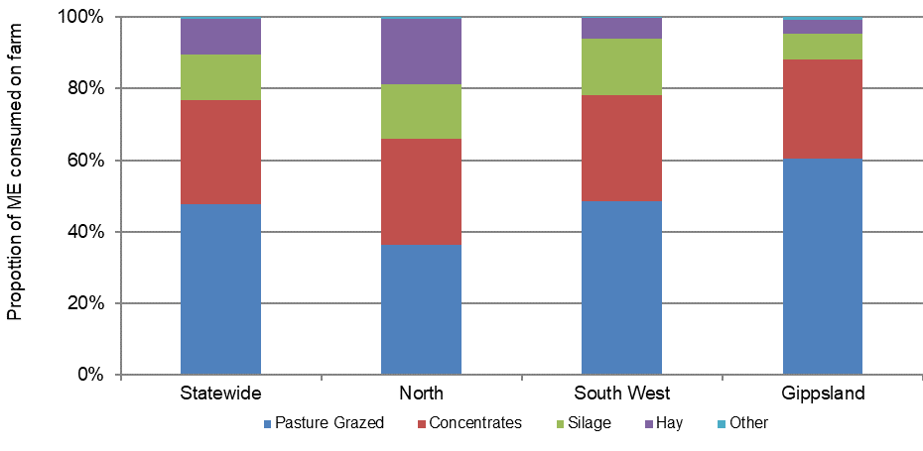

FIGURE 8. ESTIMATED TONNES OF HOMEGROWN FEED REMOVED
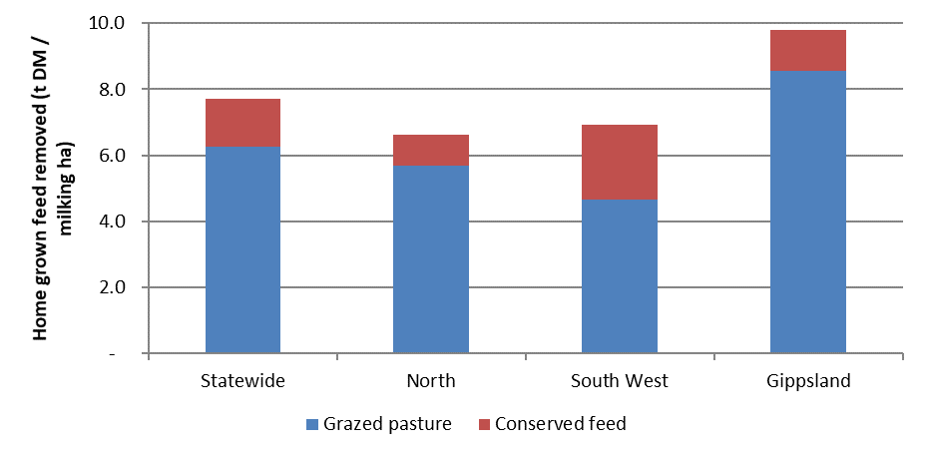

Fertiliser application

The application of nutrients decreased on average in 2019-20 compared to the previous year. The South West increased their use of macro nutrients while DFMP farms in Gippsland and the North decreased their use (Figure 9).
South West farms capitalised on the consistent rainfall and applied additional fertiliser in 2019-20. This assisted pasture growth and silage yields. The total amount of NPKS increased from 238 kg/ha to 273 kg/ha in 2019-20.
In the North, farms applied less fertiliser with the business decision to shift away from homegrown feed due to the high prices of allocation water and low allocations of high reliability water shares (HRWS). On average, fertiliser use decreased from 182 kg/ha to 132 kg/ha in 2019-20.
In Gippsland, fertiliser use of NPKS decreased from 303 kg/ha in 2018-19 to 287 kg/ha in 2019-20. Farms applied less fertiliser due to the challenging seasonal conditions of low rainfall, particularly those from central and east Gippsland in drought for the first half of the 2019-20 season. The low allocations in the MID also contributed to the lower fertiliser rates applied in 2019-20.
Pasture growth and fertiliser application strategies will be influenced by water availability, pasture species, soil type, pasture management, seasonal variation in response rates to fertilisers, amount of (and nutrient composition of) imported feeds, variations in long-term fertiliser strategies among other factors. This level of detail is not captured as part of this project.
Appendix Table 2 provides further information on nutrient application for participant farms in each region.

FIGURE 9. NUTRIENT APPLICATION
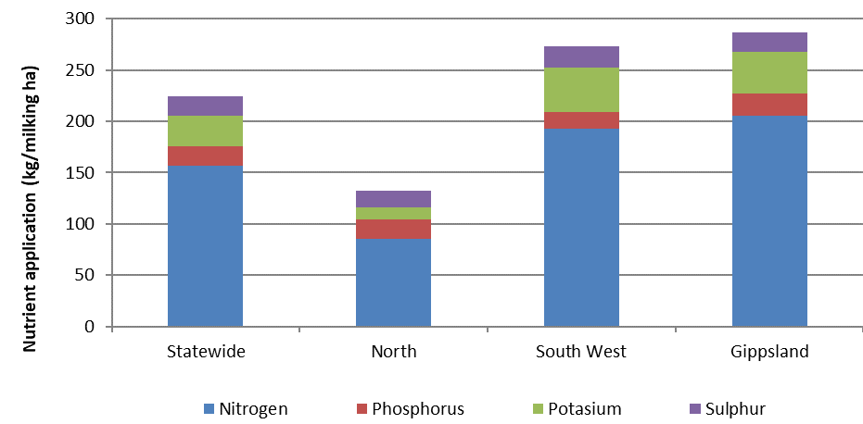

Milk solids sold

All three regions sold the greatest amount of milk during the spring period (Figure 10), however each region had its own unique milk production distribution as similar to previous years.
The monthly milk solids sold in the North shows a double peak occurring in spring and autumn. Spring sales accounted for 30% of the milk solids sold, while autumn accounted for 25% notably occurring in May.
The South West had an extended winter to spring milk production peak period, where approximately 59% of milk was produced between July and December 2019. The lowest producing months were January through to March accounting for 18% of the milk solids sold, before a rise heading into winter.
In Gippsland, there was a distinct seasonal supply in spring when milk solid sales accounted for 32% of the yearly supply compared to 28% in summer, 23% in autumn and 17% in winter. As farms in this region have a high proportion of grazed pasture in the diet, the milk production patterns followed a tradition of producing milk when there is normally a greater abundance of homegrown feed.
Calving pattern
The calving pattern for all regions is shown in Figure 11.
The North farms had peak calving in two distinct times; August 2019 and March 2020. This pattern matches the milk supply curve shown in Figure 10.
The South West farms were characterised by autumn calving where the greatest number of calves were born in April 2020.
Gippsland had a dominant winter calving period, with over 35% calves born in August 2020. The calving pattern matched the peak milk production which occurred three months later in spring.

FIGURE 10. MONTHLY DISTRIBUTION OF MILK SOLD
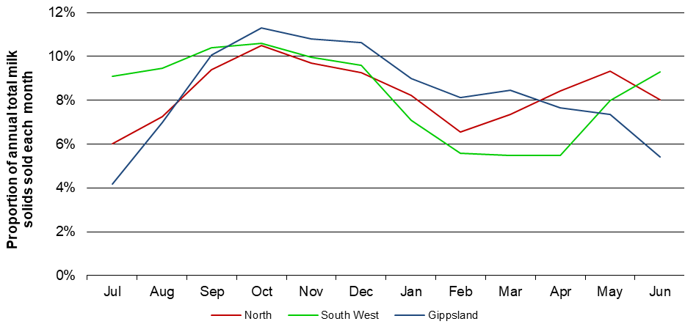

FIGURE 11. MONTHLY DISTRIBUTION OF CALVING
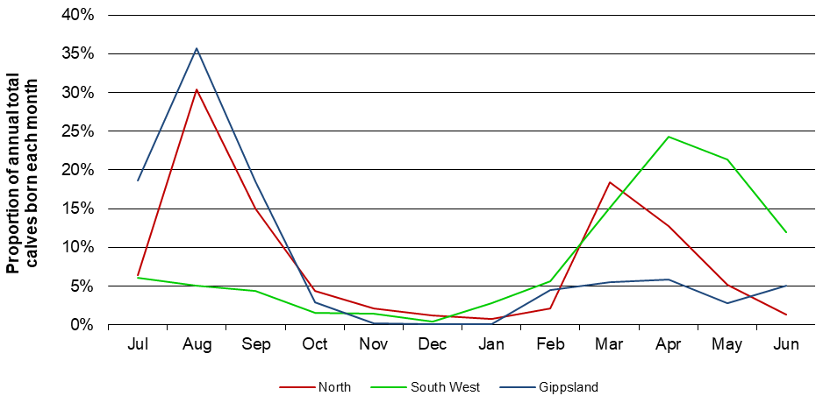

Part Two: The North

Seasonal conditions
The 2019-20 season was characterised by contrasting conditions - ‘tough spring and brilliant autumn’. Low rainfall and high water prices from August to December 2019 were followed by milder temperatures in January-February 2020 and high rainfall events in autumn. The opening allocations of HRWS in the Murray and Goulburn/ Loddon systems were 2 per cent, increasing to final allocations of 66% and 80%, respectively.

Rainfall across surveyed farms in the North for the 2019-20 season was patchy, totalling 456 mm, or 96% of the long-term average of 474 mm (Figure 12). Except for close to average rainfall in July 2019, the next five months were dry (Figure 3) and soil profiles were not full heading into spring. Spring rainfall on participating farms was 41% of long-term average with poor pasture growth and farmers had to secure high-priced fodder and concentrates. Low winter and spring rainfall across northern Victoria led to a higher percentage of crops intended for grain production being cut for hay or silage. The high quality of cereal fodder assisted dairy farmers who were able to maintain or improve milk production over the summer and autumn.
January 2020 saw conditions improve with cooler than average temperatures and a slight improvement in rainfall. Summer rainfall was 81% of long-term average. The much-awaited autumn break eventuated in late April and almost doubled the long-term average for this month’s rainfall. There was good pasture growth as a result of mild conditions. Of the annual rainfall of 456mm (96% of long-term average), 26% fell in April. This left farmers with fodder and water to carry over into the 2020-21 year.
The top performing farms received 8% more rain than the average although this was still 5% lower than the long-term average of 519mm for these farms.
Dry and hot conditions since 2018-19 meant there was less water in the storages resulting in an opening allocation of HRWS in the Murray and Goulburn/Loddon systems of 2%. By November 2019, HRWS allocations were 48% in the Murray and 61% in the Goulburn and Loddon systems. At the end of the season HRWS allocation reached 66% in the Murray system and 80% in the Goulburn and Loddon systems.
The price of water for irrigation is influenced by allocation announcements and rainfall events. The prices of allocation water reached a high level in 2019-20 prompting many farmers to evaluate the most cost-effective feed sources. Published data on water trading showed median monthly price of allocation water steadily rose through the season, peaking in November before falling to levels closer to the long-term average by the end of the financial year.
In July 2019 the price was $610/ML in Zone 1A (Greater Goulburn) and Zone 6 (Vic Murray Dartmouth to Barmah Choke), and $618/ML in Zone 7 (Barmah to South Australian Border).
The highest monthly median prices of allocation water were recorded in November 2019: $650/ML in trading Zone 1A and $939/ML in Zone 7, and $640/ML in January 2020 in Zone 6. By June 2020, the monthly median prices were $190/ML (Zone 1A), $200/ML in Zone 6 and $200/ML (Zone 7), prices not seen since June 2018.
The median price of allocation water for the whole year (2019-20) in Zone 1A and Zone 6 was $550/ML, and $625/ML in Zone 7. These prices were similar (in nominal terms) to the prices between 2006 and 2008, recorded at the height of the millennium drought.
There was a difference in the price of water in the Murray system above the Barmah Choke (Zone 6) compared to below the choke (Zone 7). There was a price differential between the Goulburn and Murray systems. Participant farms were therefore faced with different allocation water prices depending on the location of their properties.
Many DFMP farmers opted not to purchase water for irrigation due to the high price. A few sold some of their allocation water to manage their cashflow or purchase fodder. Farmers who purchased feed early in the season (at high prices) shifted to hand-feeding cows once pasture dried out. There was also a lack of agistment, and where available, was expensive. Agistment became more readily available in autumn 2020. Water budgeted by some farmers for use later in the season was not required because of the good autumn rain and was carried over to 2020-21.

_____________________
Seven new farms (NO0078, NO0079, NO0080, NO0081, NO0082, NO0084 and NO0085) joined the DFMP and two returned in 2019-20 (NO0027 and NO0035).
The top 25% are shown as the darker bars in all graphs as ranked by ROTA.

FIGURE 12. ANNUAL RAINFALL AND LONG-TERM AVERAGE RAINFALL – NORTH
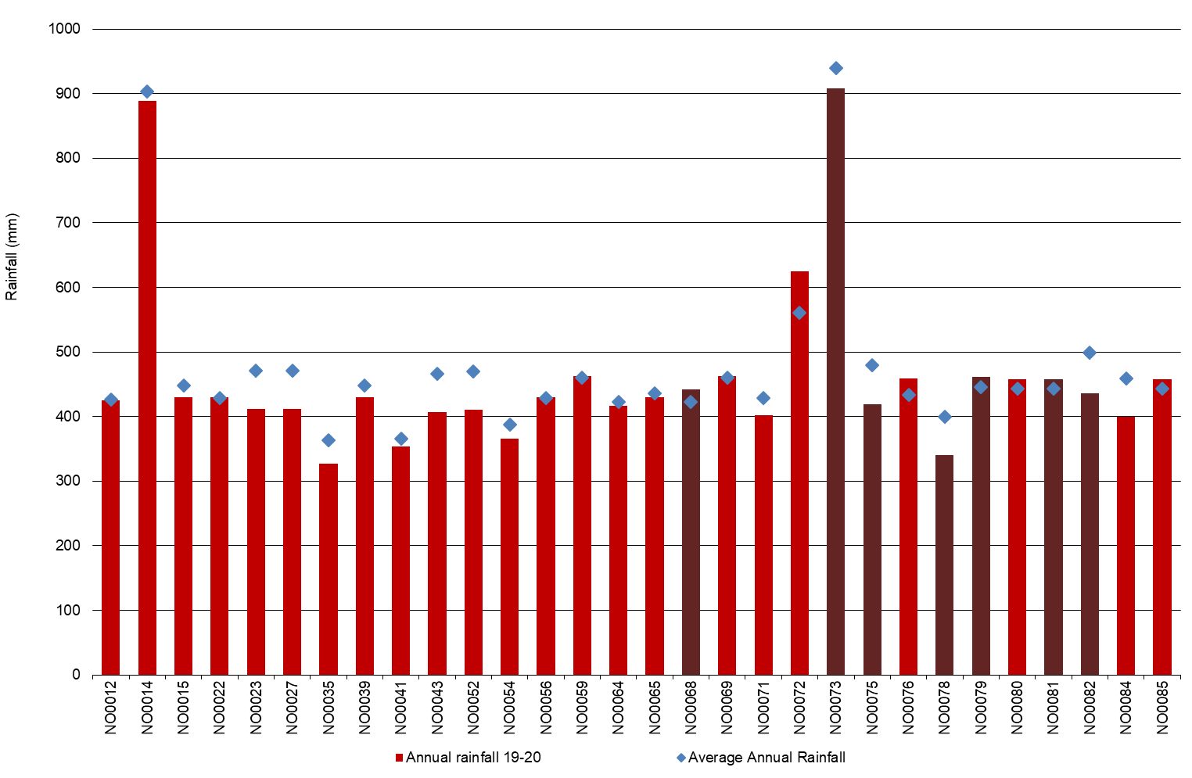

Whole Farm Analysis
The overall performance of participant farms did not reflect the continued difficult conditions from 2018-19 through to the first half of the season. Average EBIT was $1.22/kg MS, an improvement from last year (-$0.45/kg MS, the lowest in the 14-year history of the project). Grain and fodder prices were high in spring and eased with new season crops. Higher milk price (16% increase) combined with good management decisions helped reduce variable costs (7% decrease) to finish the season in a better financial position.

Key whole farm physical parameters for the North are presented below in Table 4. The Q1 – Q3 range shows the band in which the middle 50% of farms sit for each parameter.
The number of milking cows per farm rose by 5% and there was a 12% increase in the average usable area. This reduced the stocking rate to 1.5 cows/ha, slightly lower than the 1.6 cows/ha registered in the last two years.
The average homegrown feed as percentage of ME consumed was much lower at 50% compared to 60% in 2018-19 (Table 4). This result shows the tough conditions for growing pasture and the reliance on purchased feed to get through the season.
The average water use (rainfall and irrigation) for the North farms was 762 mm/ha (14% lower than in 2018-19) producing 0.8 t DM/100mm/ha of homegrown feed.
The top 25% of participants in the North had a higher proportion of homegrown feed as percentage of ME consumed at 57% compared to the regional average, but lower than the top performing farms last year (68%). The higher percentage of homegrown feed used by the top 25% was reﬂected in the total water use for these farms (826 mm/usable ha), which was 8% higher than the average of all participant farms in the North. They produced 20% more homegrown feed (1 t DM/100mm/ha) compared to the average (0.8 t DM/100mm/ha). They had a lower water use efficiency of 3.9 t DM/ML of irrigation water compared to 4.1 t DM/ML for the average.

TABLE 4. FARM PHYSICAL DATA – NORTH
Farm physical parameters | North average | Q1 to Q3 range | Top 25% average
Annual rainfall 19-20 (mm) | 459 | 411 - 457 | 495
Herd size | 418 | 252 - 496 | 477
Total water use efficiency (t DM/100mm/ha) | 0.8 | 0.7 - 1.0 | 1.0
Total usable area (hectares) | 304 | 168 - 339 | 301
Milking cows per usable hectares | 1.5 | 1.1 - 1.8 | 1.6
Milk solids sold (kg MS /cow) | 566 | 529 - 614 | 564
Milk solids sold (kg MS /ha) | 867 | 594 - 1,093 | 860
Home grown feed as % of ME consumed | 50% | 42% - 58% | 57%
Labour efficiency (cows / FTE) | 103 | 86 - 113 | 121
Labour efficiency (kg MS / FTE) | 57,272 | 49,924 - 63,341 | 65,768

Milk solids sold

On average, DFMP farms in the North sold more milk solids than in 2018-19, on per farm, per cow and per hectare bases. They sold an average of 566 kg MS/cow and 867 kg MS/ha (Figure 13), increases of 8% and 5%, respectively, year-on-year.
On average, total milk solids increased by 13% to 242,000 kg MS/farm from 214,000 kg MS/farm in the previous year, partly due to the change of farms in the sample. For farms that participated in both years, the average increase was 7% (or 15,200 kg MS/farm) between years. Of these 21 farms, 16 farms sold more milk than they did the previous year, with an average increase of 21,800 kg MS/farm, equivalent to 10% increase per farm.
Almost a third of the milk solids sold (30%) occurred in spring, with the greatest amount of milk solids sold in October 2018 with 24,300 kg MS/farm (Figure 10). While most milk was sold in September through to December 2019, there was another slight peak in May 2020, same pattern as in the 2018-19 season.
The top performing farms sold slightly less milk per cow and per hectare than the average. Compared to the top 25% last year, they sold more milk per cow (6% higher) and per hectare (15% higher) bases.
Figure 13 illustrates that the quantity of milk solids sold is not the only characteristic contributing to good performance.

FIGURE 13. MILK SOLIDS SOLD – NORTH
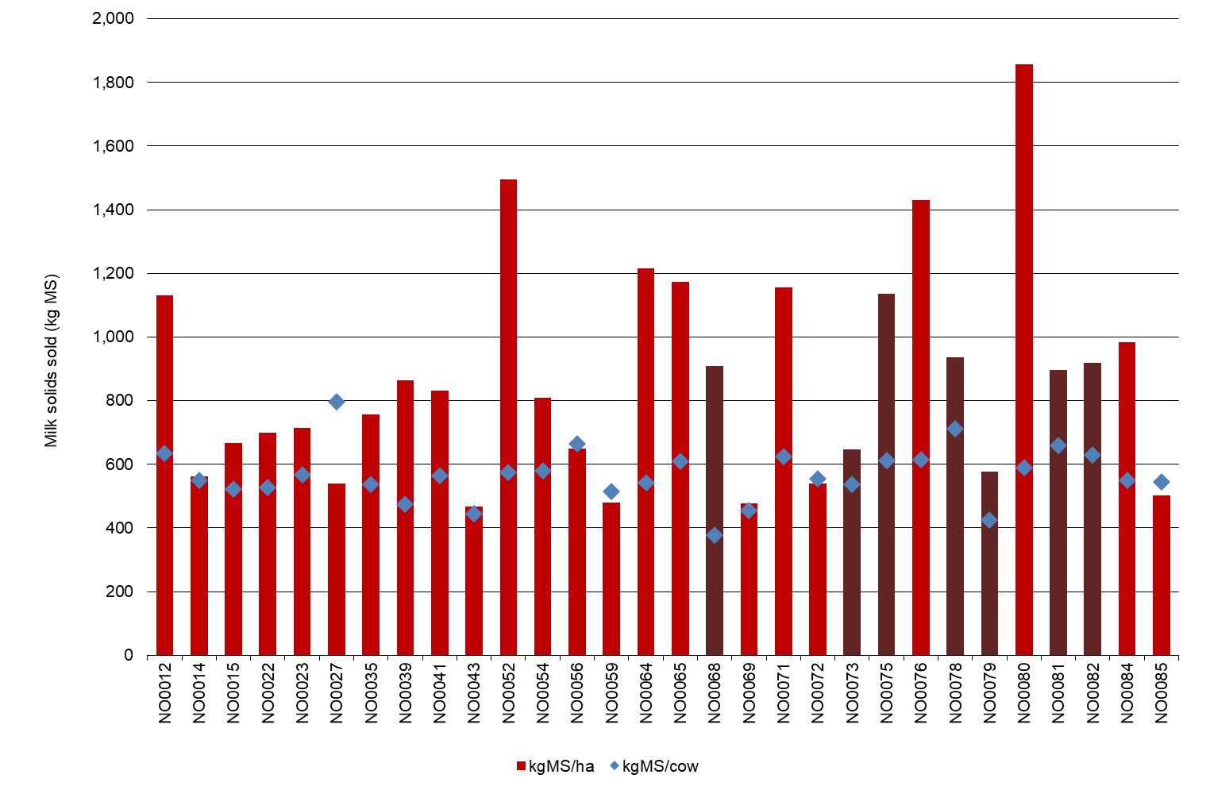
Gross farm income

For farms in the North on a per kg MS basis, milk income contributed 91%, livestock trading 8% and other income 1% to the gross farm income of $8.01/kg MS (Table 5).
Figure 14 shows a wide variation in milk price received per kg MS. On average milk price increased to $7.31/kg MS, up 16% from $6.28/kg MS in 2018-19. It was the highest price in nominal terms since the start of the project in 2006-07. When the effects of inﬂation are removed, milk prices were highest in 2007-08 ($8.58/kg MS) and in 2013-14 ($7.53/kg MS).
Farms that were in the top 25% received an average milk price of $7.18/kg MS compared to the top group’s $6.48/kg MS last year.
Similar to previous years, many participant farmers raised their newborn calves to take advantage of improved cattle prices and also to manage their cashﬂows.

FIGURE 14. GROSS FARM INCOME – NORTH
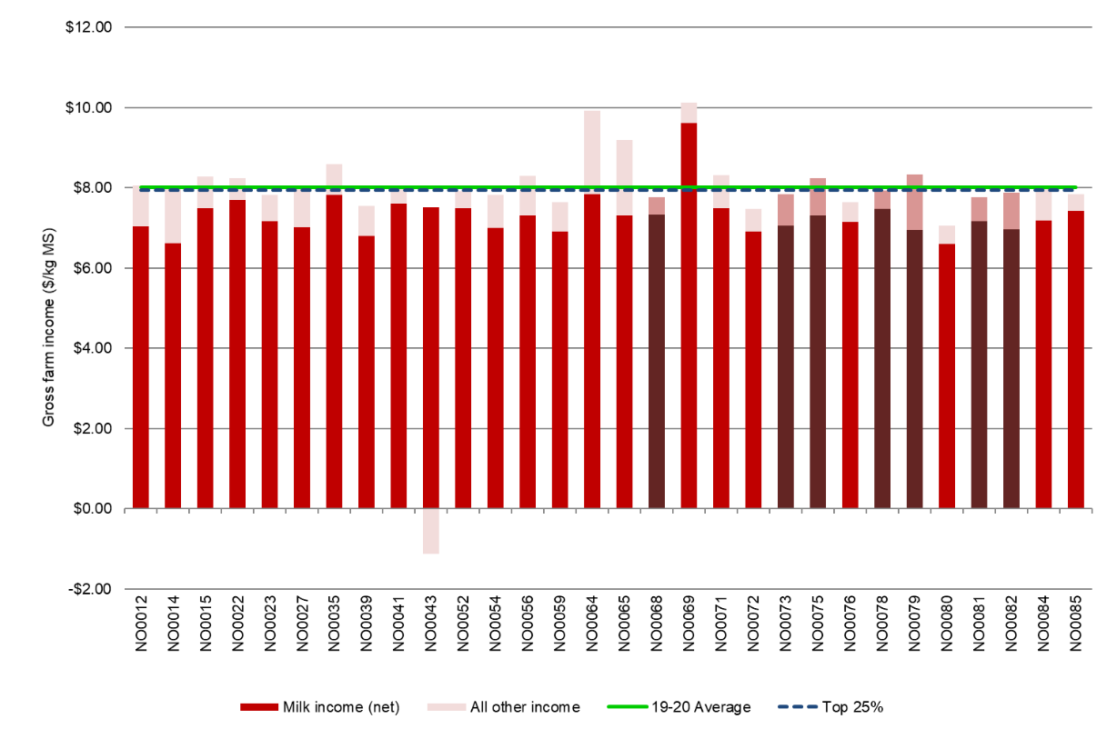

Variable costs

Participant farms in the North spent an average of $4.61/kg MS on variable costs, 7% lower than in 2018-19 (Figure 15). Feed costs were the major variable cost for farms in the North, accounting for 60% of total costs (similar to last year).
Herd and shed costs were similar to 2018-19 at $0.33/kg MS and $0.20/kg MS, respectively.
Feed costs decreased by 7% to $4.08/kg MS from $4.40/kg MS in 2018-19 with half of the participant farms spending between $3.64/kg MS and $4.52/kg MS. The DFMP farms reduced their fertiliser and water use due to the low spring 2019 rainfall and relatively high price for allocation water in the first half of 2019-20. These decisions lowered their overall feed costs, despite the farms increasing the quantity of purchased fodder and concentrates.
Purchased feed and agistment accounted for 44% of feed costs in 2019-20, increasing from 37% in 2018-19. The cost of purchased feed this year was $3.00/kg MS, an increase of 12% from last year due to substantial increase in quantity rather than price. The average purchased feed per cow was 4 t DM/cow, compared to 2.7 t DM/cow last year. The quantity of all purchased supplements fed per cow on usable area increased: concentrate by 6%; silage almost tripled, and hay by two-thirds; while, the price of all purchased feed (concentrate, hay, silage and other feed) decreased. The average price of purchased feed decreased 12%, from $453/t DM to $397/t DM year-on-year.
Irrigation costs were on average $0.50/kg MS and accounted for 7% of total costs in 2019-20, down from 10% of total cost ($0.79/kg MS) in the previous year. The lower cost was due to lower water use; a few farmers chose not to purchase allocation water due to the high price.
The purchase of allocation water (total of all North farms) decreased by 1,272 ML (24% reduction) compared to 2018-19 while sales increased by 149 ML (24% higher) year-on-year. Some farms had higher ‘other irrigation cost per ML applied’ because of the fixed costs associated with owning water shares spread over low water use. For the same 21 farms participating in both years, the average irrigation costs were 42% lower at $0.47/kg MS in 2019-20 compared to $0.82/kg MS in 2018-19.
On average, many also managed to improve their feed and water inventory position. Where a negative change in inventory occurred, such as -$0.09/kg MS for the average feed inventory in the North indicates that fodder reserves increased and is therefore counted as a decrease in feed costs. Some farmers carried-over their water to 2020-21 on the back of good autumn rainfall, with an average of -$0.11 water inventory change, compared to $0.17/kg MS last year. Those farmers who chose to conserve feed last year to manage the risk of higher feed costs in 2019-20 utilised the reserves carried into the season. Of the 30 North sample farms, 12 farms had built both feed and water reserves by the end of the financial year.
The top 25% farms spent $3.96/kg MS on variable costs in 2019-20, 14% lower than the average of North farms and slightly higher (5%) than last year’s top performing farms. Generally, they spent similar amounts on herd and homegrown feed costs and less on shed costs and purchased feed than the average of all participant farms. Compared to the North average, they had higher feed inventory change and lower water inventory change.
Figure 15 shows the breakdown of total farm costs as variable and overhead costs per kg MS. A breakdown of the costs for individual farms can be found in Appendix Tables B4 and B5. The price of purchased feed is shown in Appendix Table B3.

FIGURE 15. VARIABLE AND OVERHEAD COSTS – NORTH
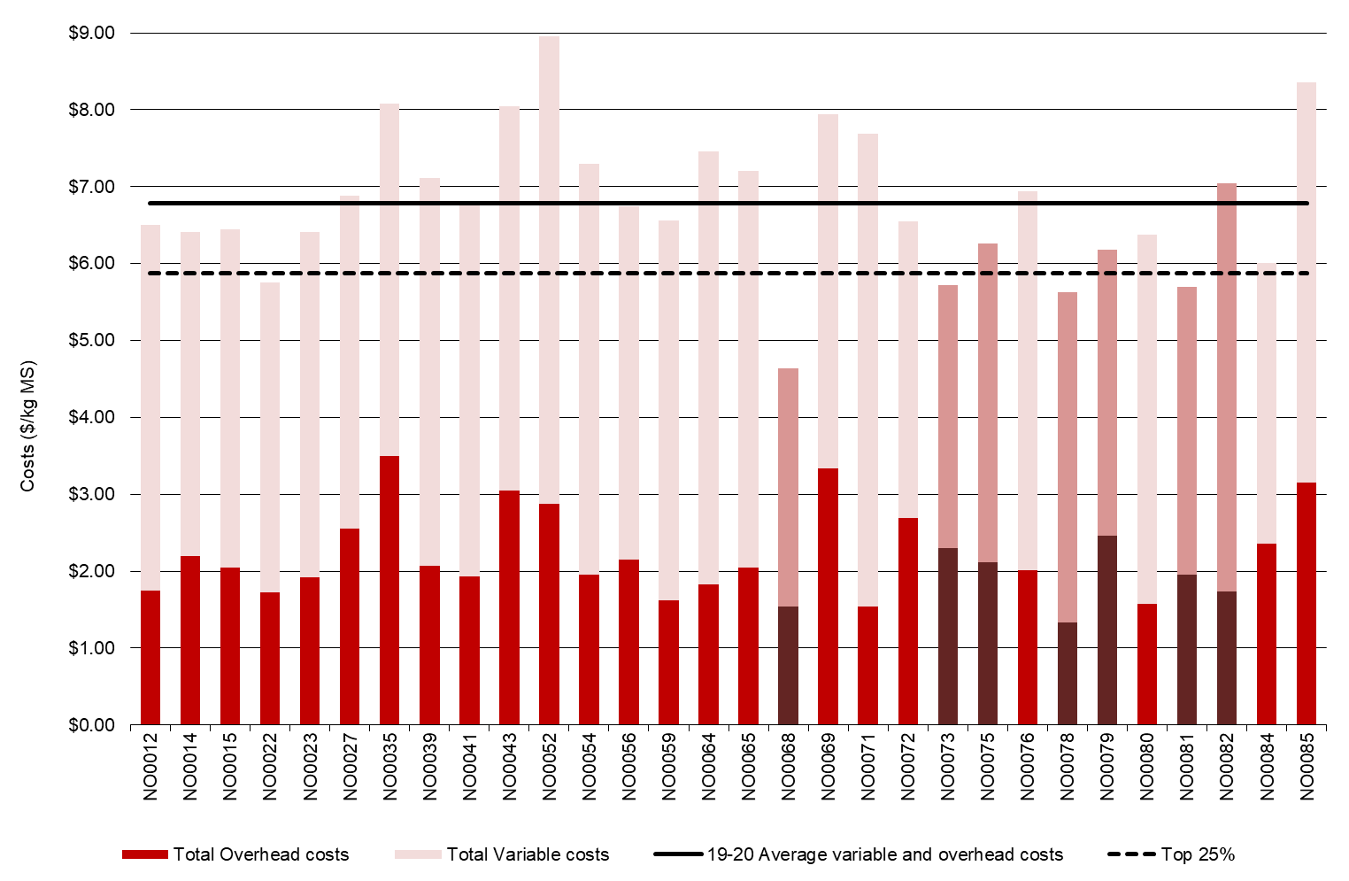

Overhead costs

Average overhead costs accounted for 32% of total costs. In 2019-20 overhead costs were 6% lower at $2.18/kg MS than last year’s $2.31/kg MS. Decreases in many cash overhead cost items were offset by increases in ‘other overhead’ costs. Employed labour cost remained static at $0.60/kg MS.
Repairs and maintenance decreased on per farm and per kg MS bases as another option to lessen operating costs. On average, repairs and maintenance was lower by 8% to $0.31/kg MS, compared to $0.34/kg MS last year and from $82,300/farm to $78,900/farm this year. The same 21 farms between years also decreased this cost by 8% on per kg MS basis and by 10% per farm basis.
Non-cash overhead costs (depreciation and imputed labour) decreased by 9% compared to 2018-19.
The top performing farms spent less on overhead costs than the average due mainly to their lower labour cost (employed and imputed labour). Their imputed and employed labour costs were 24% and 5% less than the average, respectively as supported by their higher labour efficiency on a per cow and kg MS bases (Table 4).

TABLE 5. AVERAGE FARM FINANCIAL PERFORMANCE – NORTH
 | North average | Q1 to Q3 range | Top 25% average
 | $/kg MS | $/kg MS | $/kg MS
INCOME
Milk income (net) | $7.31 | $7.00 - $7.49 | $7.18
Livestock trading profit | $0.61 | $0.46 - $0.81 | $0.71
Other farm income | $0.10 | $0.00 - $0.09 | $0.06
Gross farm income | $8.01 | $7.78 - $8.27 | $7.95
VARIABLE COSTS
Herd cost | $0.33 | $0.25 - $0.40 | $0.27
Shed cost | $0.20 | $0.16 - $0.24 | $0.19
Home grown feed cost | $1.29 | $0.98 - $1.50 | $1.30
Purchased feed and agistment | $3.00 | $2.59 - $3.47 | $2.47
Feed inventory change | -$0.09 | -$0.21 - $0.07 | -$0.23
Water inventory change | -$0.11 | -$0.23 - $0.00 | -$0.04
Total feed costs | $4.08 | $3.64 - $4.52 | $3.50
Total variable costs | $4.61 | $4.16 - $5.03 | $3.96
GROSS MARGIN | $3.40 | $2.64 - $4.00 | $3.98
OVERHEAD COSTS
Employed labour | $0.60 | $0.34 - $0.82 | $0.57
Repairs and maintenance | $0.31 | $0.22 - $0.39 | $0.29
All other overheads | $0.29 | $0.19 - $0.36 | $0.26
Imputed labour | $0.77 | $0.43 - $0.93 | $0.58
Depreciation | $0.20 | $0.14 - $0.26 | $0.21
Total overhead costs | $2.18 | $1.77 - $2.44 | $1.92
Variable and overhead costs | $6.79 | $4.82 - $5.74 | $5.88
EBIT | $1.22 | $0.68 - $1.94 | $2.07

Cost of production

Cost of production gives an indication of the cost of producing a kilogram of milk solids. It is calculated as variable plus overhead costs and accounts for changes in fodder and livestock inventory.
Table 6 shows the cost of production with inventory change was $6.86/kg MS, 7% lower than in 2018-19. The Q1 to Q3 range in 2018-19 was wider ($6.43/kg MS to $8.18/kg MS) compared to 2019-20 ($6.18/kg MS to $7.26/kg MS).
The top performing group had a 17% lower cost of production with inventory change ($5.72/kg MS) than the average of North farms. All categories contributed to their lower cost of production than the average of all participant farms.

TABLE 6. COST OF PRODUCTION – NORTH
Farm costs | North average  $/kg MS | Q1 to Q3 range  $/kg MS | Top 25% average  $/kg MS
Cash cost of production | $6.02 | $5.50 - $6.62 | $5.35
Cost of production (excl inventory changes) | $7.00 | $6.39 - $7.36 | $6.15
INVENTORY CHANGE
+/- feed and water inventory changes | -$0.21 | -$0.48 - $0.13 | -$0.27
+/- livestock inventory changes minus purchases | $0.07 | -$0.17 - $0.23 | -$0.16
Cost of production (incl inventory changes) | $6.86 | $6.18 - $7.26 | $5.72

Earnings before interest and tax

Average EBIT increased substantially, from -$0.45/kg MS last year to $1.22/kg MS this year, with middle half of the farms fell within $0.68/kg MS and $1.94/kg MS range (Figure 16). Managing costs and better milk price were the drivers of the improved profitability of farms. For the same 21 farms, EBIT also improved, from -$0.32/kg MS to $1.22/kg MS year-on-year.
Almost all farms posted positive EBIT (27 out of 30 farms, 90% of farms), compared to 40% in 2018-19 and 80% in 2017-18.
The EBIT of $2.07/kg MS for the top 25% was substantially higher than the average of all participant farms and last year’s top performers ($1.33/kg MS). The main driver of improved performance of farmers in the North was their effectiveness and efficiency in managing their costs than having higher producing cows and receiving high price. Compared to the average of all North farms, the top 25% of farms received a 2% lower milk price and had similar milk solids sold per cow and per hectare. Their costs of running the business, however, were lower; 16% less variable cost and 13% less overhead costs. Their lower overhead costs were reflective of their better labour efficiency.

FIGURE 16. EBIT – NORTH
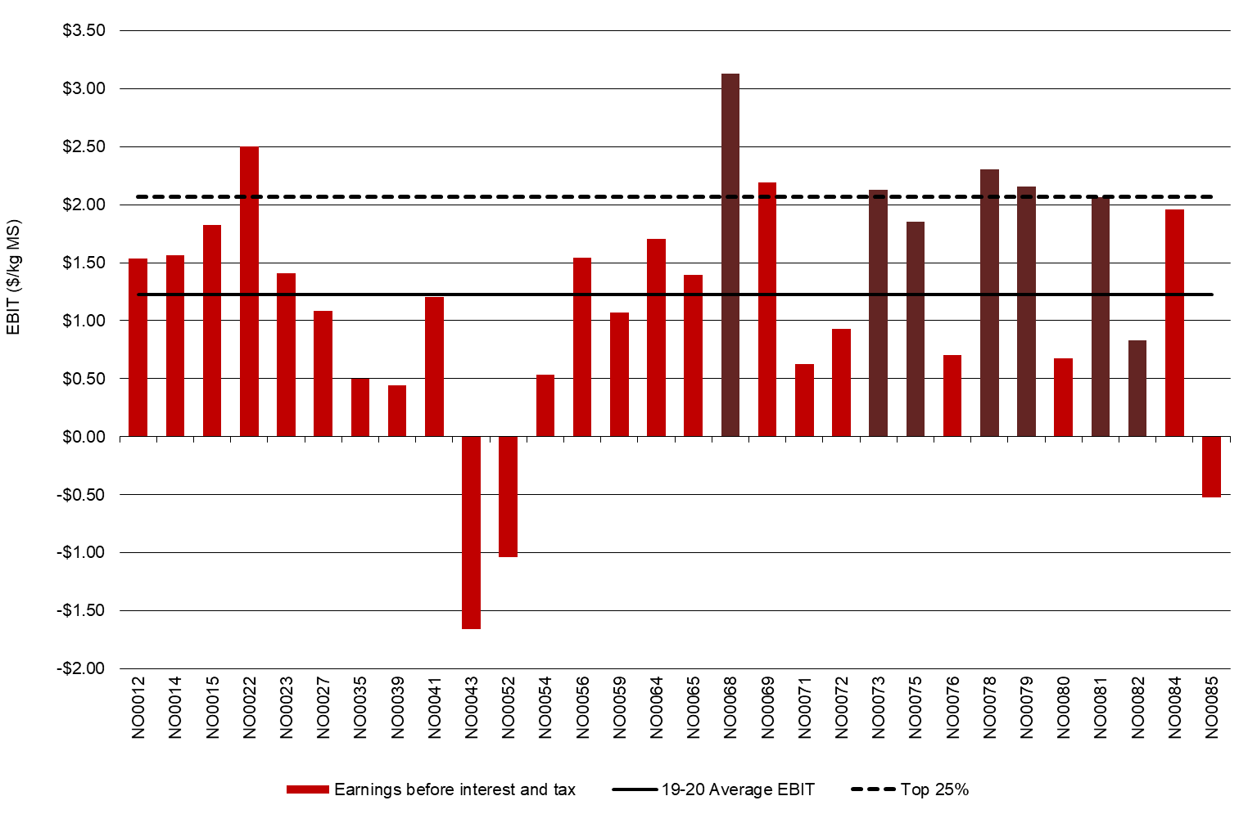

Return on total assets and equity

Average ROTA for North participants was 4.1% in 2019-20, an improvement from last year’s -1.7% (Figure 17). The 21 farms that participated in both years posted ROTA of 3.6%, up from -1.2% in 2018-19. Farmers adapted to the challenging seasonal conditions, high water prices and high feed costs in spring.
The average value of total assets was about $7 million in 2019-20, an increase of 7% from the previous year ($6.5 million). Water assets contributed 31% to the total farm assets, similar to the proportion in 2018-19.
On average, holders of HRWS (owned water) had the value of their water increase by 15% in 2019-20 as compared with the previous year. This was partly due to a change in the sample as well as the higher valuation of water because the average water holding decreased. Owned HRWS per farm was 610 ML, 12% lower than the 694ML recorded in 2018-19. Owned low reliability water shares (LRWS) per farm also decreased from 304 ML to 282 ML during the same period.
Four farmers in the North dataset purchased an average of 70 ML of HRWS; of these four farmers, two also purchased LRWS.
For the 19 participant farms in both years with water holding, the value of water assets rose by 10% from a combined effects of higher valuation and increased volume. Their HRWS increased by 6% to 757 ML and LRWS increased by 15% to 343 ML in 2019-20, as compared with 2018-19.
The average ROTA of the top performing farms was 7.7% compared to the top group’s average of 3.7% in 2018-19.
Return on equity reflects the various capital structures of businesses in the North. The average ROE this year was 3.7%, much higher than last year’s -7.4% (Figure 18).
Majority of the farms (83%) posted positive ROE compared to only 32% in 2018-19. Two-thirds of farms (20 of 30 farms) had recorded a ROE higher than their ROTA, compared to two of 25 farms last year. A higher ROE than ROTA indicates that the return on the additional asset was worth more than the cost of financing it.
The top performing group had an average of 9.8% compared to the top group’s ROE of 3.8% in 2018-19 and similar to their ROE of 10% in 2017-18.

FIGURE 17. ROTA – NORTH
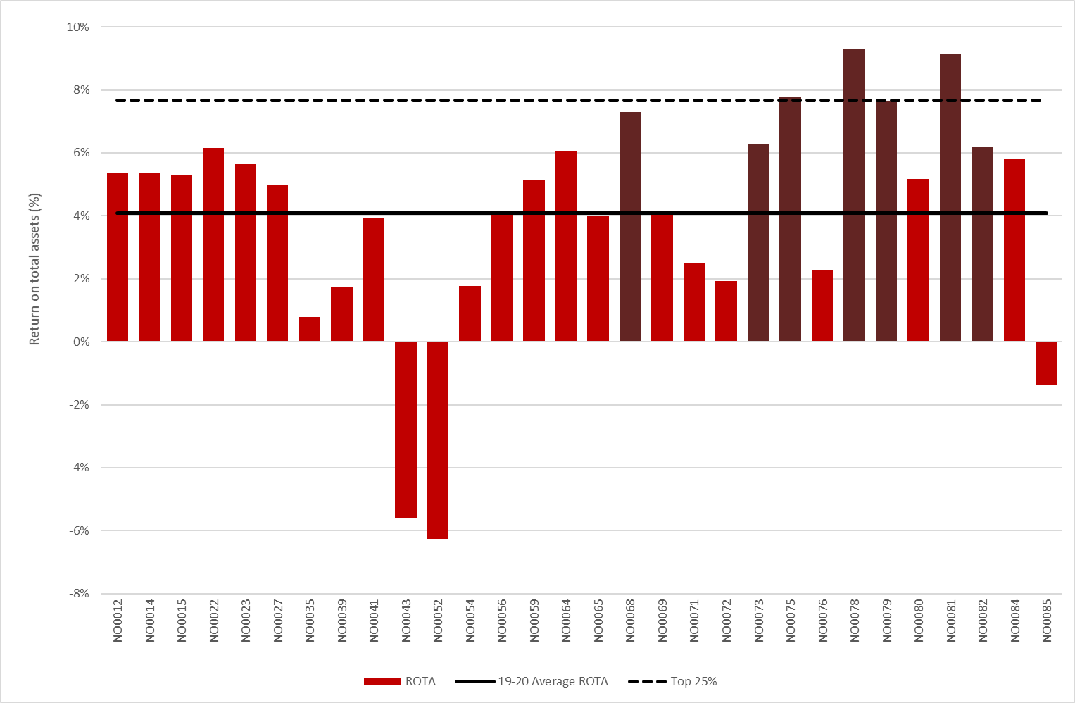
FIGURE 18. ROE – NORTH
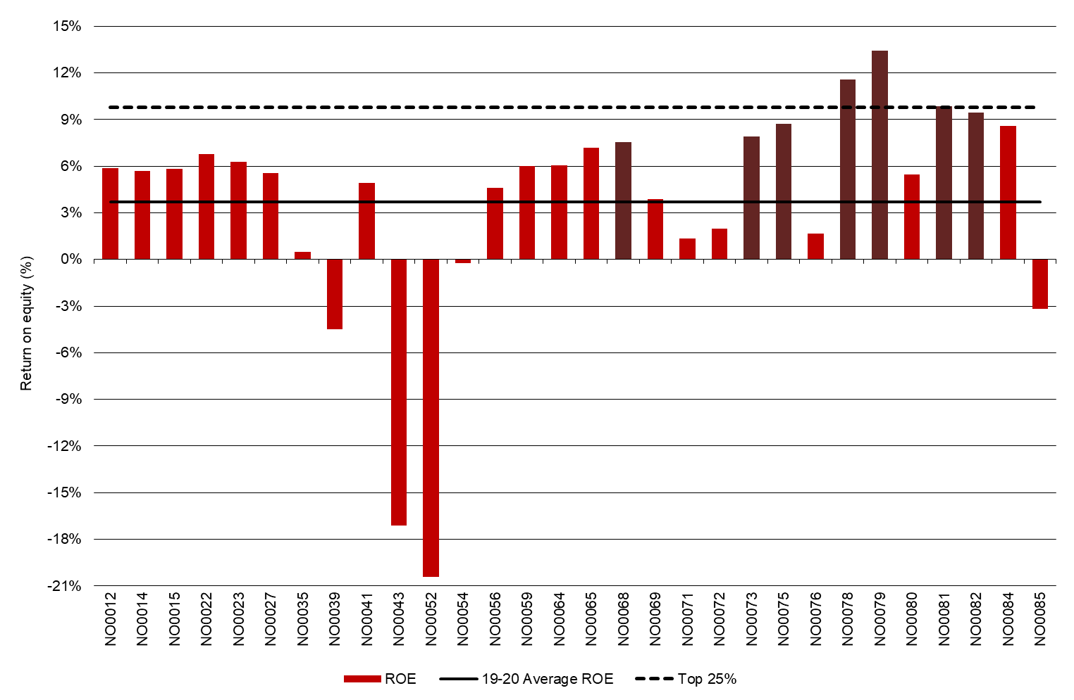

Feed consumption and fertiliser
Farms in the North used a wide range of feeding systems. Directly grazed pasture accounted for an average of 36% of total ME with a range of 5% to 66%. The average fertiliser use on the milking area was 132 kg/ha (compared to 182 kg/ha in 2018-19).

Feed consumption

The relative contribution of each feed type to the ME consumed on each farm is shown in Figure 19. The broad range of sources of ME used on individual farms is evident.
On average, North farms sourced 36% of their ME from directly grazed pasture, continuing what has been a downward trend from 44% in 2018-19 and 46% in 2017-18. Four of the 30 farms had less than 20% of diet from directly grazed pasture, of which three farms were participants in 2018-19 and 2019-20. Grazed pasture supplied 50% or more of ME consumed on five of the 30 farms, compared to seven of 25 farms in 2017-18 and 2018-19. This result indicates that farms were changing their feeding system to adapt to seasonal conditions and their operating environment.
Of the remaining ME consumed, 30% were concentrate, 18% hay, 15% silage and a small proportion of ‘other feed’, on average.
Purchased feed fed on milking area increased to 4 t DM/cow up from 2.7 t DM/cow last year, reflecting some farmers’ strategy to purchase fodder instead of focusing on irrigation and to a degree, a change in the farmer sample. The 21 farms in both years also increased their purchased feed to 3.8 t DM/cow from 2.8 t DM/cow year-on-year.
The top performing farms obtained an average of 42% of ME consumed from grazed pasture, less than the 51% recorded in 2018-19 and 54% in 2017-18 for top 25% of farms.

FIGURE 19. SOURCES OF WHOLE FARM METABOLISABLE ENERGY – NORTH
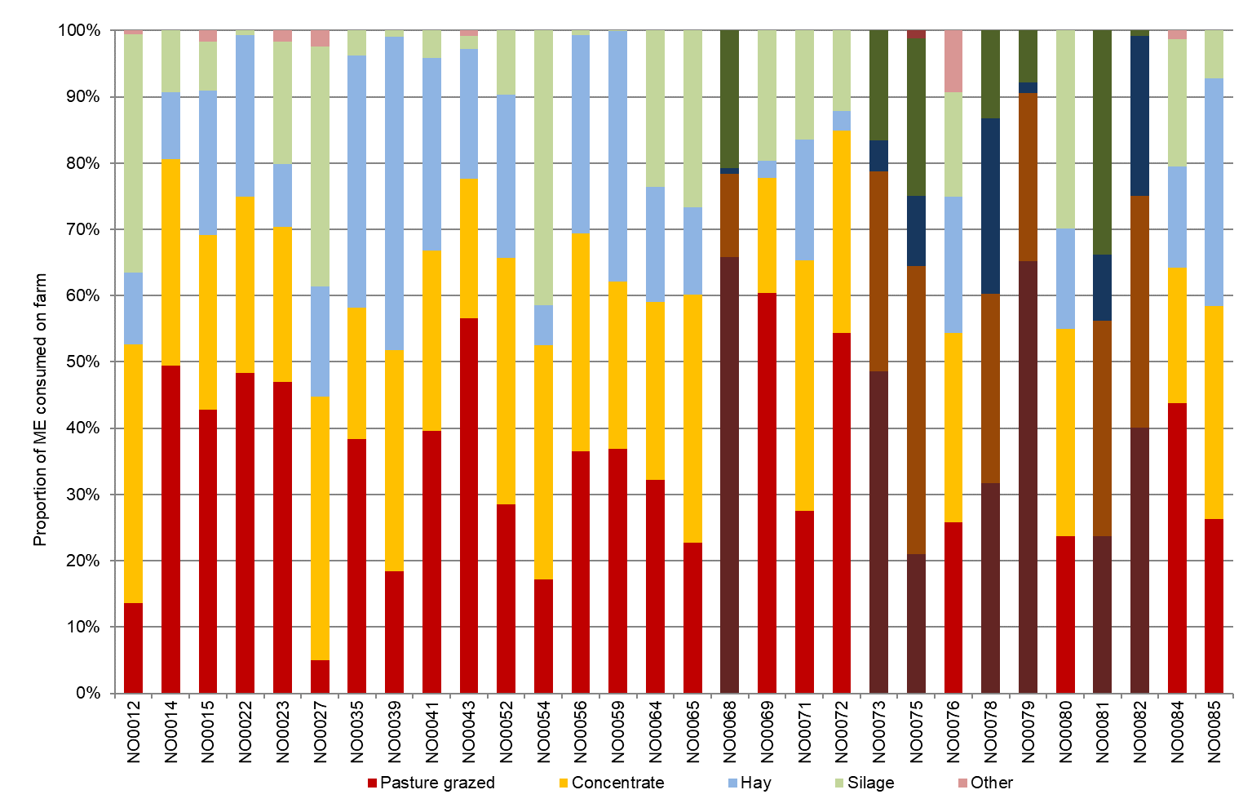

Figure 20 shows the estimated homegrown feed consumed per milking hectare for farms in the North.
Although the North experienced challenging seasonal conditions and high water prices in the first half of the season average homegrown feed on usable area was 5.7 t DM/ha, 20% lower than last year.
On the milking area, homegrown feed was slightly higher at 6.6 t DM/ha, of which 5.7 t DM/ha was grazed pasture. Many farmers (73%) were able to conserve feed on the milking area, with the North’s average of 0.9 t DM/ha compared to last year’s 1.6 t DM/ha.
The top 25% of farms were also able to conserve feed on the milking area at higher quantity (1.4 t DM/ha) than the average. Their grazed pasture consumption was also higher, at 6.4 t DM/ha, but much lower than the top performers last year (8.4 t DM/ha).

FIGURE 20. ESTIMATED TONNES OF HOMEGROWN FEED REMOVED – NORTH
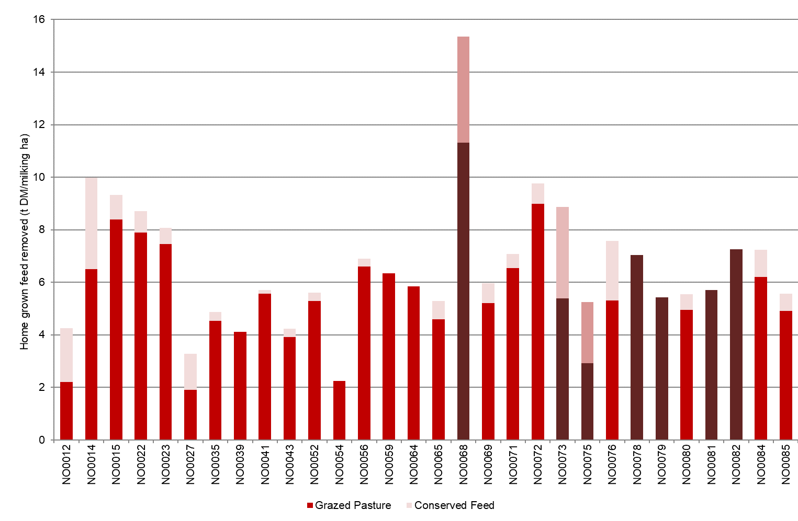
Fertiliser application

Majority of farms (27 of 30 farms or 90%) in the North dataset applied fertiliser to their crops and pasture (Figure 21) on the milking area.
The average fertiliser application was 132 kg/ha, continuing a decreasing trend since 2017-18. Nitrogen and phosphorus were the commonly applied nutrients. Application of all nutrients decreased from last year, with large reduction in potassium and nitrogen (39% and 31% lower, respectively). This was consistent with the reduction in the quantity of grazed pasture. The same 21 farms in 2018-19 and 2019-20 datasets had applied 189 kg/ha and 146 kg/ha, respectively.
The top 25% had similar fertiliser application as the average but with a substantial decrease from 216 kg/ha last year to 135 kg/ha this year.
The values for Figure 20 and 21 can be found in Appendix Table B2.

FIGURE 21. NUTRIENT APPLICATION – NORTH
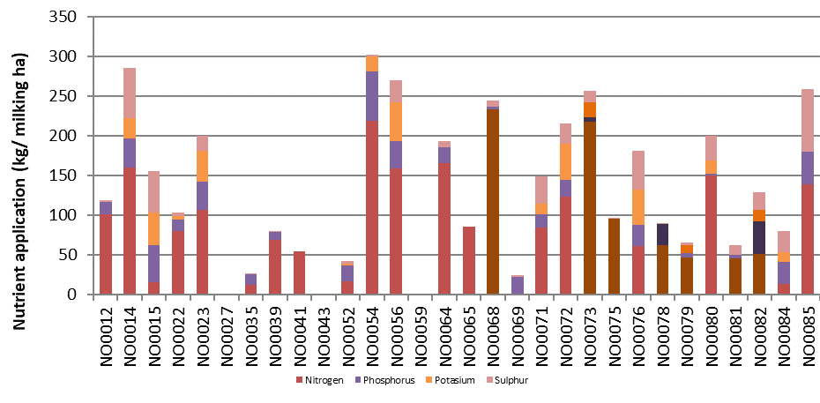

Part Three: The South West

Seasonal conditions
The 2019-20 seasonal conditions in the South West supported good crop and pasture growth. While farmers entered the season with a wet winter, it then became drier before rainfall arrived in late spring. Dairy farmers capitalised on the conditions and harvested above average pasture and silage yields. A mild summer and consistent rainfall events throughout autumn provided good pasture cover and growth heading into winter.

On average, participating farms in the South West received 92% of their long-term average annual rainfall in 2019-20 (Figure 22). The timing of the rainfall (Figure 3) shows the season started with a wet winter, followed by a drier spring before late rain arrived in October and November 2019. Consistent rainfall was received through the first half of 2020 with decent rainfall occurring in May 2020.
The late rains in October and November 2019 allowed farmers to take advantage of good spring conditions and build a feed buffer for the rest of the season. Many farmers were able to capitalise on the good spring conditions to harvest above average pasture yields. Fodder conservation remained similar to the previous year on average (at 2.2 t DM/ha) and farmers were able to increase their silage and hay reserves.
Summer in the region was relatively mild, with fewer extreme heat events which saw pasture growth extend longer than in previous years. As a result, many farmers held onto conserved feed and purchased less fodder; 12 farmers relied on the purchased fodder market in 2019-20, as compared with 20 farms in 2018-19.
In southern parts of the region, good autumn rains have set the area up for good pasture yields through to winter, with many farms having excellent pasture cover well into June. In the northern parts of the region, a later autumn break has combined with good rainfall and a milder winter to have good pasture yields heading into winter 2020.
Some DFMP farmers applied additional fertiliser to capitalise on rainfall events which resulted in producing more fodder than they had anticipated.

FIGURE 22. ANNUAL RAINFALL AND LONG-TERM AVERAGE RAINFALL – SOUTH WEST
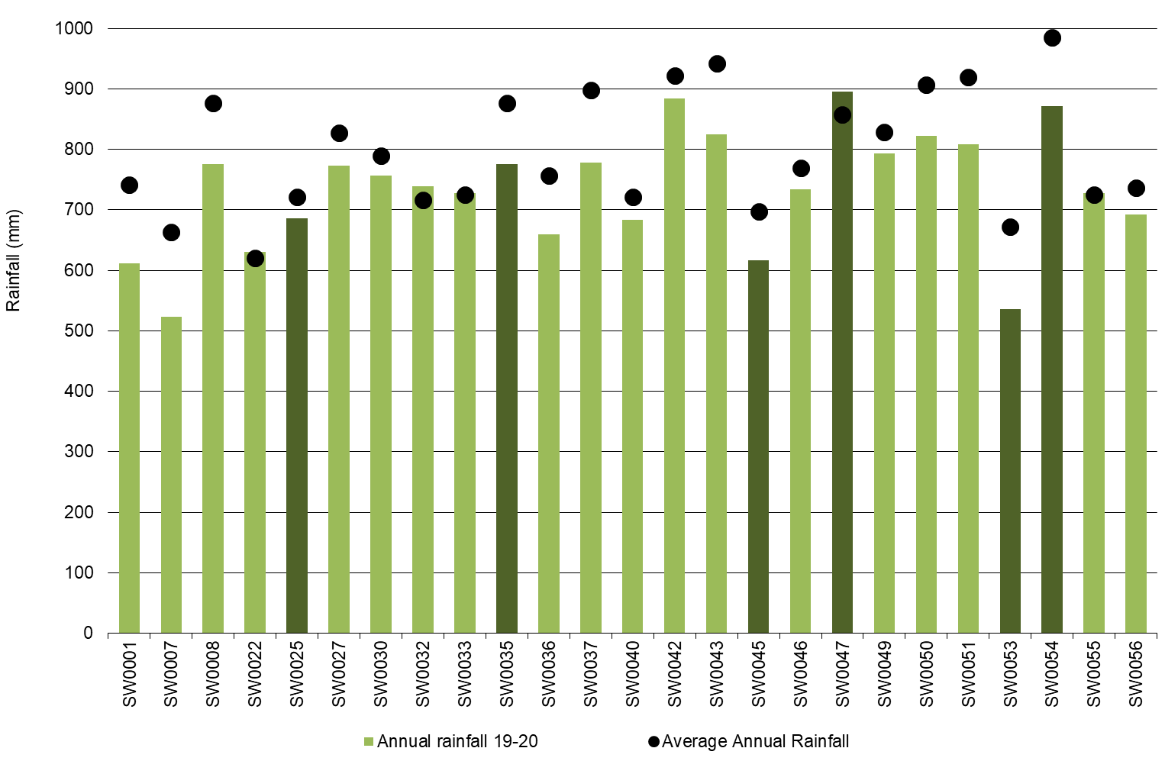

Whole Farm Analysis
Improved operating conditions enabled all South West DFMP farms to achieve positive EBIT and ROTA in 2019-20. Farmers were able to lower their feed costs by building feed inventory reserves and reduce their reliance on purchased fodder. This combined with an improved milk price enabled the economic performance to lift compared to the previous year and return to the long-term average for the region.

Key whole farm physical parameters for the South West are presented below in Table 7. The Q1 – Q3 range shows the band in which the middle 50% of farms sit for each parameter.
On average farms maintained their herd size at 369 milking cows. Some farmers attempted to build flexibility in their business by keeping carryover cows for longer than usual to take advantage of the improved seasonal conditions. Other farms responded to the strong milk price signals and slowly rebuilt their herds after a period of heavy culling in response to drier conditions. Other farms in the sample were considering their next business stage and kept herd sizes the same or decreased. Land area remained similar to the previous year at 333 usable hectares, keeping the milking cows per hectare stable at 1.1.
Farms in the top 25% (ranked according to ROTA) were characteristic of higher milk production measured per cow and per hectare, and higher labour efficiency, based on cows/FTE and kg MS/FTE.

TABLE 7. FARM PHYSICAL DATA – SOUTH WEST
Farm physical parameters | South West average | Q1 to Q3 range | Top 25% average
Annual rainfall 19-20 (mm) | 733 | 684 - 794 | 730
Herd size | 369 | 200 - 520 | 423
Total water use efficiency (t DM/100mm/ha) | 0.8 | 0.7 - 1.0 | 1.0
Total usable area (hectares) | 333 | 175 - 434 | 363
Milking cows per usable hectare | 1.1 | 1.0 - 1.2 | 1.2
Milk solids sold (kg MS /cow) | 516 | 461 - 558 | 562
Milk solids sold (kg MS /ha) | 577 | 495 - 649 | 681
Home grown feed as % of ME consumed | 68% | 63% - 72% | 68%
Labour efficiency (cows / FTE) | 99 | 88 - 114 | 106
Labour efficiency (kg MS / FTE) | 50,658 | 45,584 - 58,034 | 59,648

Milk solids sold

On average, South West DFMP farms increased their milk solids sold on a total, per cow and per ha metrics. An increase in the average milk solids sold was supported by larger herd sizes and favourable seasonal conditions that supported good pasture growth. Total sales of milk solids returned to levels seen two years ago at 197,000 kg MS per farm, increasing 5% from 187,000 kg MS per farm 2018-19.
On a per hectare and per cow bases, milk production increased by 5% and 4%, respectively. Milk production per cow increased to 516 kg MS/cow, up from 492 kg MS/cow the previous year. Of the 21 farms participating between years, 16 farms (or 76%) increased their milk production on a per cow basis (Figure 23). Milk production per hectare also increased to 577 kg MS/ha, up from 553 kg MS/ha in 2018-19.
The months with the highest milk solids sold in the South West were September and October 2019 (Figure 10). There is a shoulder period on either side of these months with approximately 60% of milk solids sold occurring between July 2019 and December 2019.
The top performing group sold more milk per cow and per ha than the average, and more than the top performing group last year for both metrics.

FIGURE 23. MILK SOLIDS SOLD – SOUTH WEST
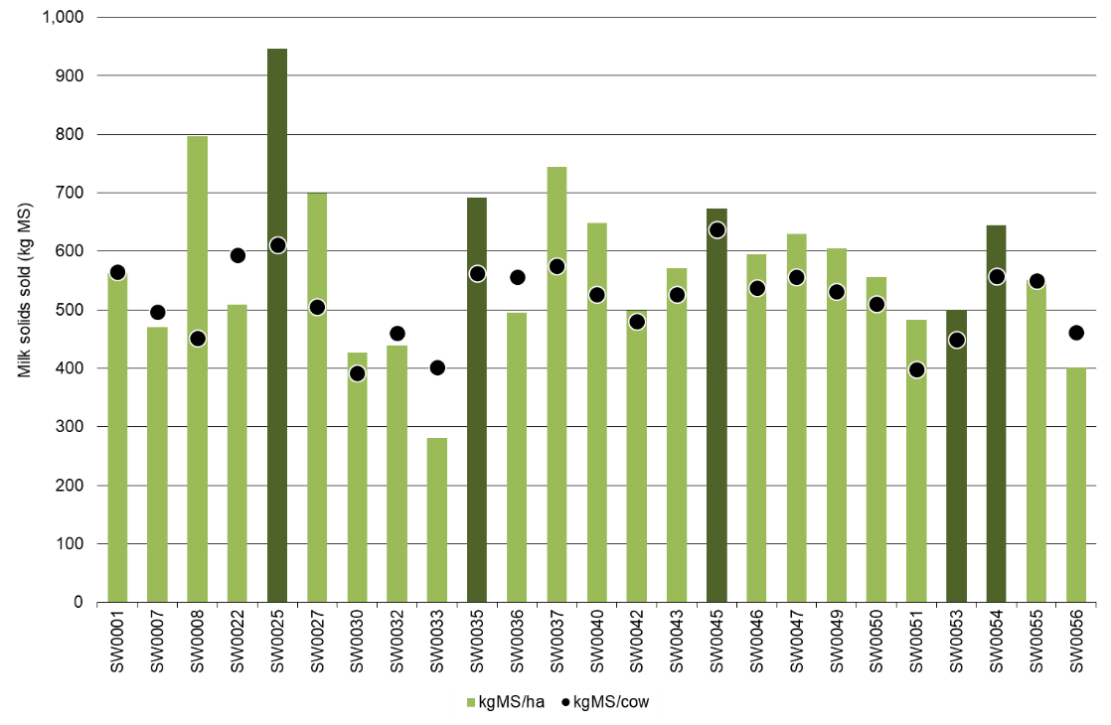

Gross farm income

Gross farm income for South West participants comprised of milk income at $7.16/kg MS, livestock trading at $0.74/kg MS and other farm income at $0.07/kg MS in 2019-20.
On average, gross farm income increased 14% in 2019-20 for South West farms to $7.98/kg MS, mostly due to a $1/kg MS increase (or 16% increase) in the milk price. Figure 24 and Table 8 shows most participants received a milk price in the range of $6.96/kg MS to $7.35/kg MS, as measured by Q1 to Q3.
Farms that were in the top 25% in the South West received an average milk price of $7.32/kg MS, compared with $6.44/kg MS recorded for the top 25% group in 2018-19.

FIGURE 24. GROSS FARM INCOME – SOUTH WEST
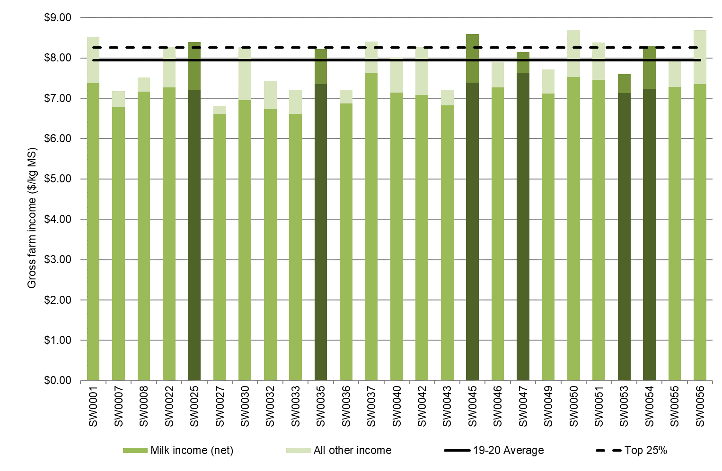

Variable costs

Variable costs decreased on per kg MS in 2019-20, from $3.74/kg MS in 2018-19 to $3.52/kg MS. On a total dollar basis, variable costs remained near identical at $722,000 per farm. As milk production increased the costs on a per kg MS basis declined.
The main component of variable costs were feed costs which accounted for 48% of variable and overhead costs this year. Last year, feed costs accounted for 51% of total costs. Feed costs decreased by 8% to $2.95/kg MS from $3.20/kg MS recorded the previous year. This was a result of feed inventory gains and lower purchased feed costs while homegrown feed costs were higher.
The main reason for the lower feed costs was the building of feed inventory reserves. Changes to feed inventory are considered feed costs and as such, negative inventory changes of -0.22/kg MS mean a reduction in feed cost. This was an improvement from -$0.02/kg MS in 2018-19. Of the 25 farms in the sample, 19 were able to build their fodder reserves.
The homegrown feed cost categories that contributed most to the increase were fertiliser costs. This increased by 15% to $0.58/kg MS as farmers applied greater quantities of fertiliser in 2019-20 than the previous year taking advantage of the consistent rainfall events. They were rewarded with pasture grazed increasing by 0.4 t DM/ha to 4.7 t DM/ha and conserved fodder totals remaining stable at 2.2 t DM/ha on the milking area. The other homegrown categories of hay and silage making, pasture improvement and fuel remained similar at $0.22/kg MS, $0.24/kg MS and $0.14/kg MS, respectively.
Purchased feed costs reduced on average for South West farms. As farmers capitalised on the favourable seasonal conditions, they were able to reduce their reliance on purchased fodder through greater pasture availability. The amount of fodder fed decreased from 2.5 t DM/cow to 1.9 t DM/cow in 2019-20, on average. For those farmers who purchased silage and hay the prices decreased to $151/t DM $269/t DM).
The concentrate costs decreased on per kg MS basis from $1.85/kg MS in 2018-19 to $1.78/kg MS in 2019-20. The price of concentrates decreased, from $512/t DM in 2018-19 to $491/t DM in 2019-20, while the average feeding levels across the same farms remained the same at 1.8 t DM/cow. Even though more farmers fed additional concentrates per cow (13 of the same 21 participating farms fed more in 2019-20 than the previous year), not all farms responded to the strong milk price signals and some decreased their concentrate feeding levels.
Herd and shed costs were $0.57/kg MS in 2019-20 compared to $0.54/kg MS last year.

FIGURE 25. VARIABLE AND OVERHEAD COSTS – SOUTH WEST
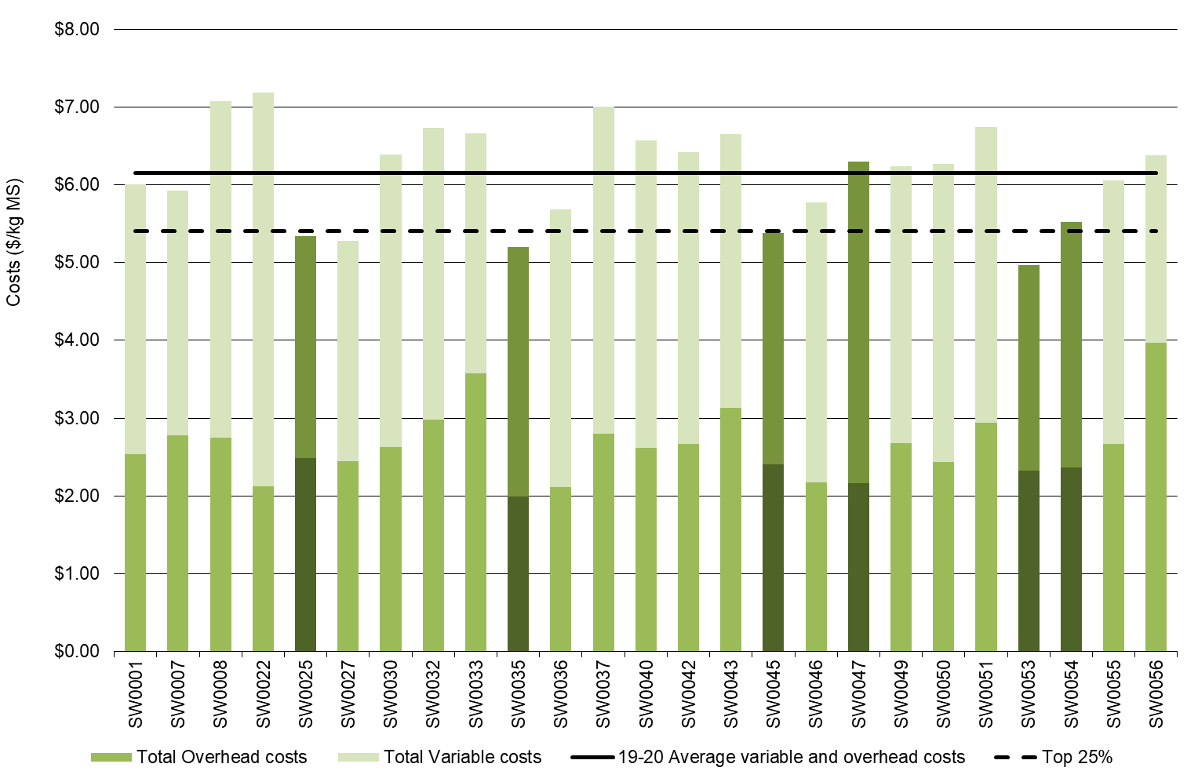

Overhead costs

Overhead costs increased by 3% in 2019-20, up to $2.63/kg MS. Farmers increased their expenditure on cash overhead costs, with many undertaking delayed repairs and maintenance, while non-cash overheads remained similar. With the improved operating conditions and strong milk price, farmers used their cash flow to make repairs which had been deferred in recent years, such as upgrading tracks, laneways and irrigation infrastructure. Total labour costs remained the same at $1.51/kg MS. While farmers spent $0.05/kg MS more on employed labour than in 2018-19, their imputed labour decreased by the same amount.
Farms in the top 25% had lower overhead costs, compared to the average. The average overhead costs for the top 25% was $2.29/kg MS in 2019-20, slightly higher than $2.25/kg for the top 25% group in 2018-19.
Figure 25 shows the breakdown of total farm costs as variable and overhead costs per kg MS. The breakdown of individual farm costs can be found in Appendix Tables C4 and C5.

TABLE 8. AVERAGE FARM FINANCIAL PERFORMANCE – SOUTH WEST
 | South West average  $/kg MS | Q1 to Q3 range  $/kg MS | Top 25% average  $/kg MS
INCOME
Milk income (net) | $7.16 | $6.96 - $7.35 | $7.32
Livestock trading profit | $0.74 | $0.44 - $1.05 | $0.89
Other farm income | $0.07 | $0.00 - $0.11 | $0.10
Gross farm income | $7.98 | $7.52 - $8.40 | $8.32
VARIABLE COSTS
Herd cost | $0.31 | $0.19 - $0.34 | $0.28
Shed cost | $0.26 | $0.21 - $0.28 | $0.22
Home grown feed cost | $1.21 | $1.05 - $1.41 | $1.08
Purchased feed and agistment | $1.97 | $1.70 - $2.22 | $1.80
Feed inventory change | -$0.22 | -$0.31 - -$0.09 | -$0.22
Water inventory change | $0.00 | $0.00 - $0.00 | $0.00
Total feed costs | $2.95 | $2.58 - $3.23 | $2.66
Total variable costs | $3.52 | $3.15 - $3.80 | $3.16
GROSS MARGIN | $4.46 | $4.03 - $4.95 | $5.16
OVERHEAD COSTS
Employed labour | $0.60 | $0.18 - $0.90 | $0.59
Repairs and maintenance | $0.47 | $0.29 - $0.61 | $0.48
All other overheads | $0.31 | $0.23 - $0.38 | $0.24
Imputed labour | $0.92 | $0.44 - $1.21 | $0.67
Depreciation | $0.34 | $0.22 - $0.44 | $0.31
Total overhead costs | $2.63 | $2.37 - $2.77 | $2.29
Variable and overhead costs | $6.15 | $5.73 - $6.50 | $5.45
EBIT | $1.83 | $1.40 - $2.51 | $2.87

Cost of production

Cost of production gives an indication of the cost of producing a kg MS. It is calculated as variable plus overhead costs and accounts for changes in fodder, water and livestock inventory.
The cost of production with inventory change was $6.35/kg MS in 2019-20, slightly above the $6.25/kg MS recorded in 2018-19. There was a wide range in costs with most farms spending between $5.98/kg MS and $6.69/kg MS as shown by the Q1 to Q3 range in Table 9.
Where a negative change in inventory occurred, such as
-$0.22/kg MS for the average feed and water inventory of the South West, it indicates that fodder reserves increased and is therefore counted as a decrease in the cost of production. Two-thirds of the South West sample (19 of the 25 farms) increased their fodder reserves in 2019-20.

TABLE 9. COST OF PRODUCTION – SOUTH WEST
Farm costs | South West average  $/kg MS | Q1 to Q3 range  $/kg MS | Top 25% average  $/kg MS
Cash cost of production | $5.12 | $4.39 - $5.81 | $4.69
Cost of production (excl inventory changes) | $6.37 | $6.02 - $6.78 | $5.67
INVENTORY CHANGE
+/- feed and water inventory changes | -$0.22 | -$0.31 - -$0.09 | -$0.22
+/- livestock inventory changes minus purchases | $0.20 | -$0.01 - $0.28 | $0.16
Cost of production (incl inventory changes) | $6.35 | $5.98 - $6.69 | $5.62

Earnings before interest and tax

The South West recorded a strong EBIT performance at $1.83/kg MS in 2019-20 with all farms posting positive returns (Figure 26). The average EBIT increased by more than $1/kg MS from the $0.71/kg MS recorded in 2018-19. While the milk price improved by $1/kg MS, total costs (variable and overhead costs) decreased. The higher milk production yields and re-stocked fodder inventories helped South West participants see their highest returns since 2013-14.
The top performing group recorded an EBIT of $2.87/kg MS, up from $1.93/kg MS the previous year. The top 25% recorded a higher milk price and demonstrated more efficient milk production with higher milk solids sold at lower costs, compared to the average.

FIGURE 26. EBIT - SOUTH WEST
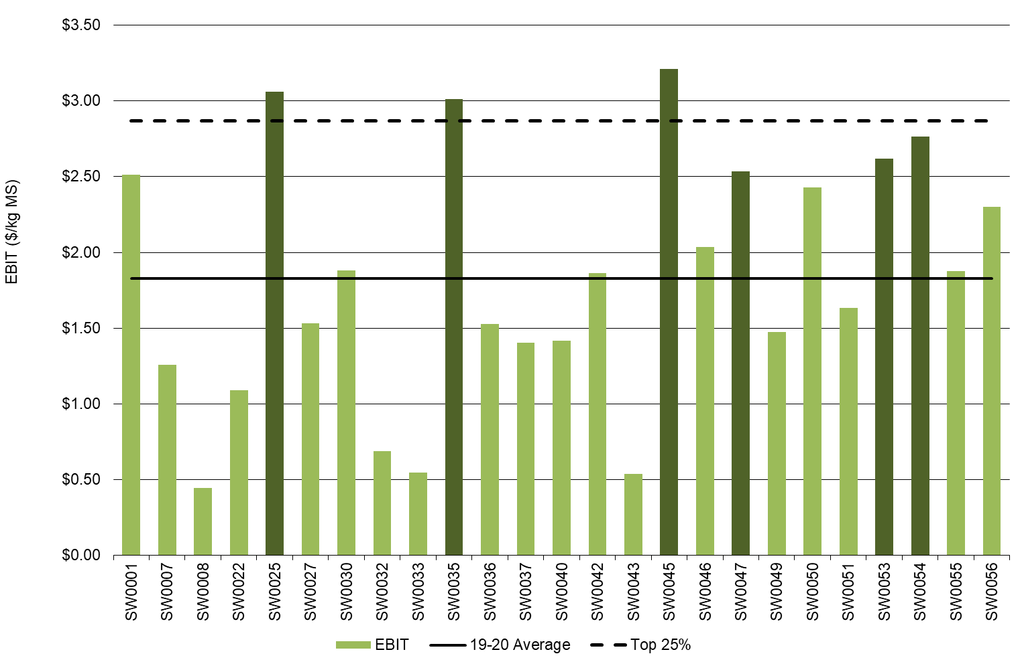

Return on total assets and equity

In 2019-20, the returns from the total assets under management was 5.8%, up from a ROTA of 2.3% recorded the previous year (Figure 27). The top performing group also experienced higher returns in 2019-20 at 9.8% compared to the top 25% group the previous year at 6.6%.
All but one farm posted a positive ROE indicating that their farm business is worth more at the end of the year than a year ago (Figure 28). The top performing group averaged 21.7% for ROE in 2019-20.
The rate of return on the owner’s capital invested in the business was 9.6%, almost doubled the ROTA for the average. There were 19 farms who achieved a ROE higher than their ROTA indicated that the return on the additional assets was worth more than the cost of accessing it. These farmers have been able to grow their business.
Average equity was $3.48 million or 68% while net farm income was $1.29/kg MS in 2019-20.
Figures 27 and 28 were calculated excluding capital appreciation.

FIGURE 27. ROTA - SOUTH WEST
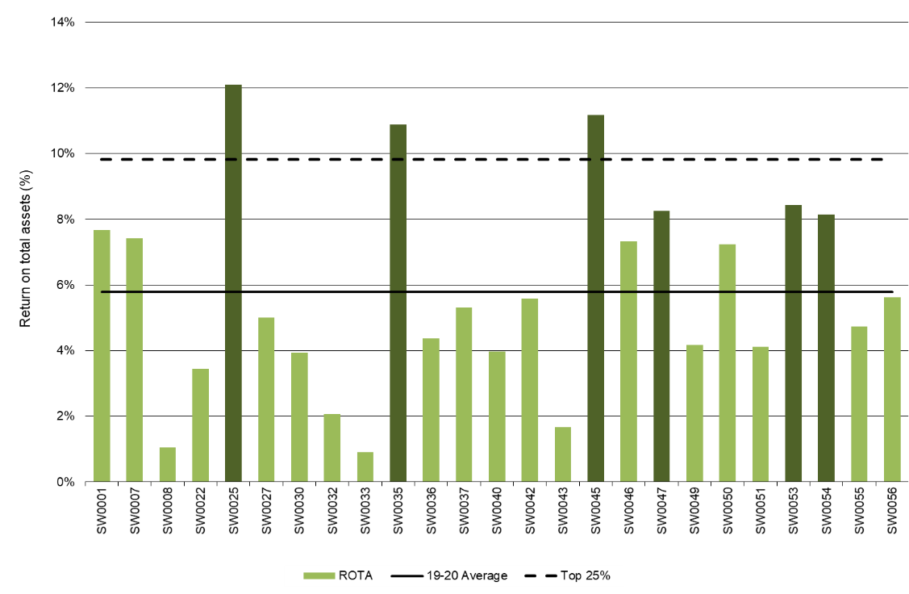
FIGURE 28. ROE - SOUTH WEST
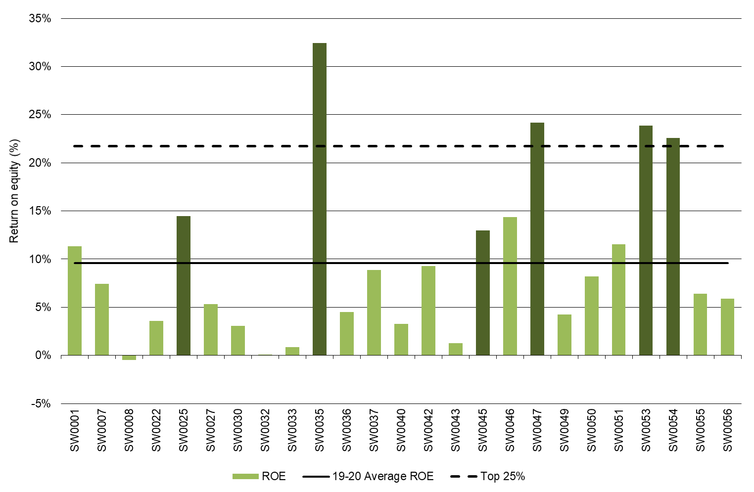

Feed consumption and fertiliser
South West farms grazed more pasture on the milking area in 2019-20 compared to the previous year, thereby reducing the amount of silage fed per cow. Higher rates of fertiliser were applied as farmers capitalised on consistent rainfall events.

Feed consumption

On average, grazed pasture constituted 49% of the ME consumed on South West farms in 2019-20 (Figure 29). This was an increase from 45% in 2018-19. The improved pasture growing conditions enabled farmers to grow, harvest and consume greater quantities of pasture and crops this year.
Concentrates were the most used supplement again this year, accounting for 30% of the diet. The proportion of concentrates in the diet increased from 28% in 2018-19 as the concentrate feeding levels increased by 0.1 t DM/cow to 1.8 t DM/cow on average. Of the same 21 participating farms between years, 13 farms increased the concentrates fed per cow whereas all 21 farms decreased their overall use of supplements. The total supplements fed decreased from 3.7 t DM/cow to 3.4 t DM/cow in 2019-20, due to the decreased levels of silage fed.
The silage fed per cow decreased from 1.9 t DM/cow in 2018-29 to 1.2 t DM/cow in 2019-20. The proportion of the diet sourced from silage also decreased 4 percentage points, down to 16%. On average, all silage fed was homegrown.
The proportion of hay in the diet remained stable at 6% between years. While, hay feeding levels also remained stable at 0.6 t DM/cow, more hay was homegrown than purchased when compared to 2018-19.

FIGURE 29. SOURCES OF WHOLE FARM METABOLISABLE ENERGY – SOUTH WEST
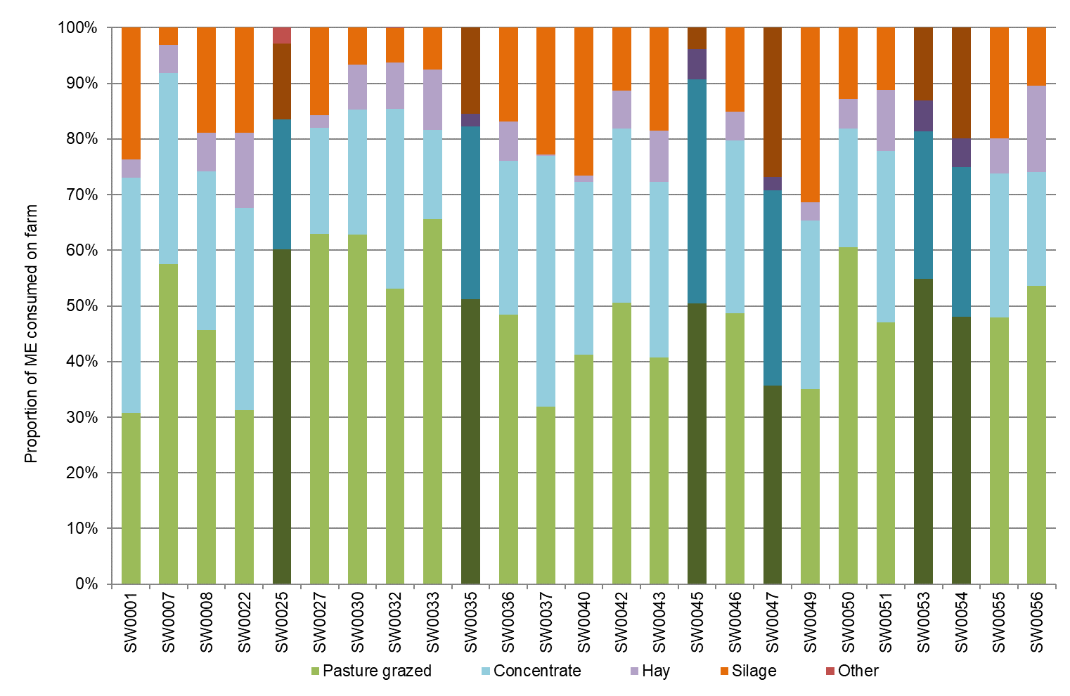

Homegrown feed removed on the milking area increased by 0.4 t DM/ha in 2019-20, up to 6.9 t DM/ha (Figure 30). The increase was utilised as extra pasture grazed while the amount of conserved feed remained the same between years at 2.2 t DM/ha. Grazed pasture increased from 4.3 t DM/ha to 4.7 t DM/ha in 2019-20 thereby reducing the reliance on supplementary feeding.
Farms in the top performing group had greater pasture consumption compared to the average. When compared with the top performing group last year, grazed pasture increased while conserved feed decreased. Grazed pasture was 5.6 t DM/ha in 2019-20, up from 4.8 t DM/ha for the top performing group in 2018-19. Conserved feed was 1.7 t DM/ha in 2019-20, down from 3.4 t DM/ha in 2018-19.

FIGURE 30. ESTIMATED TONNES OF HOMEGROWN FEED REMOVED – SOUTH WEST
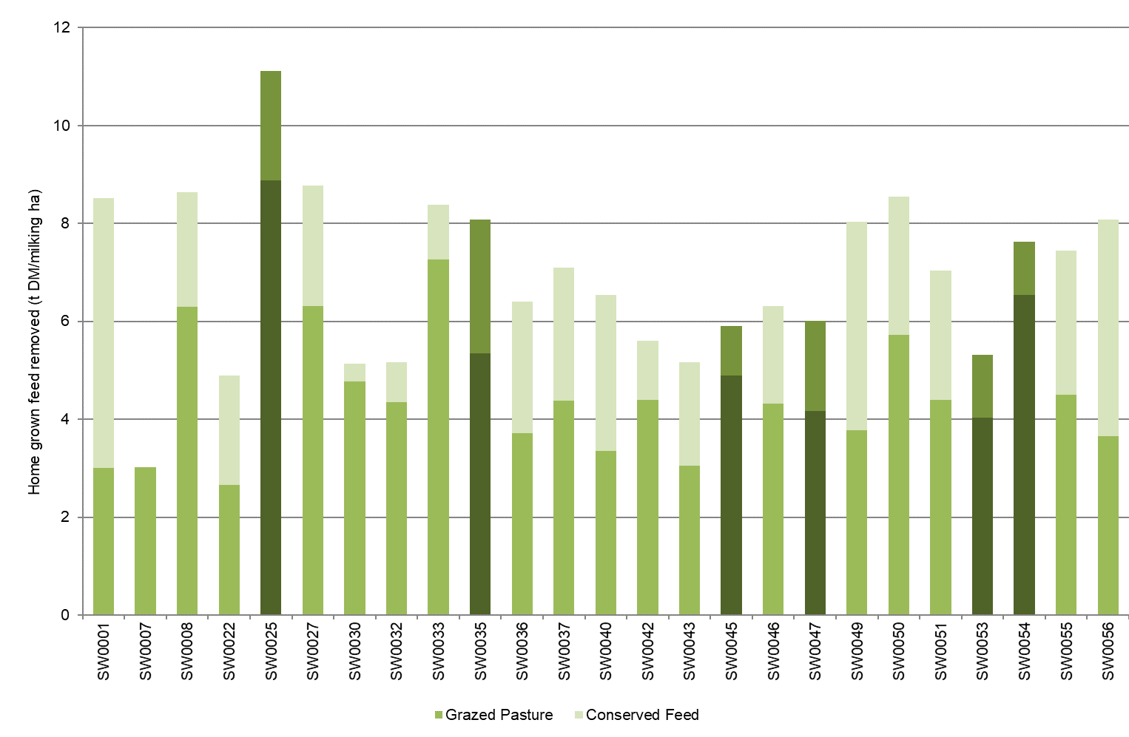
Fertiliser application

Fertiliser application on the milking area increased in 2019-20 with the total nutrients applied increasing from 239 kg/ha in 2018-19 to 273 kg/ha in 2019-20. This was comprised of nitrogen (193 kg N/ha), phosphorus (16 kg P/ha), potassium (43 kg K/ha) and sulphur (21 kg S/ha) as shown in Figure 31. The individual values related to Figure 31 can be found in Appendix Table C2.

FIGURE 31. NUTRIENT APPLICATION – SOUTH WEST
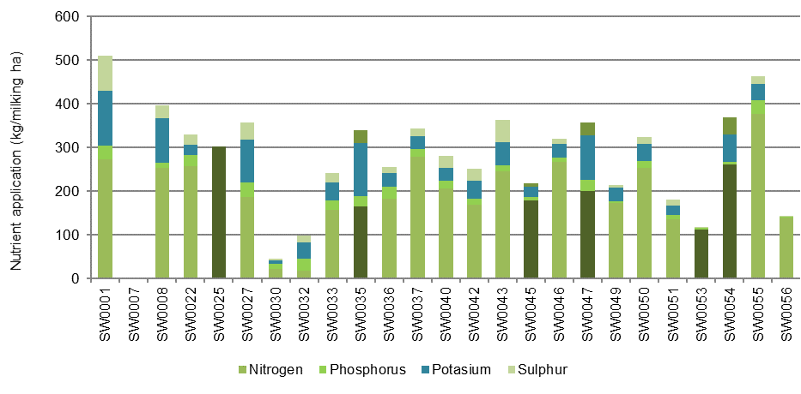

Part Four: Gippsland

Seasonal conditions
The seasonal conditions in Gippsland started out as very challenging in 2019-20. Eastern areas of the region remained in drought and the irrigation area opened with low water allocations. Conversely it was considerably wetter in south and west Gippsland for the same period. Conditions improved considerably from January to be one of the best growing seasons for many years with multiple fodder conservation opportunities and good pasture availability.

The average rainfall across participating farms in Gippsland was 944 mm, about 108% of the long-term average (Figure 32). Erratic and large rainfall events throughout the year provided many challenges. July, October, December and March 2020 had well below long-term rainfall with well above long-term rainfall in January, February, April and May 2020.
The Gippsland participants again had mixed fortunes regarding seasonal conditions experienced throughout the year. In south and west Gippsland, winter and early spring were similar to 2018-19, having average rainfall and milder conditions. This allowed the conservation of silage in October 2019, being a little drier than average. Good rains in November 2019 enabled some second cut silage and/or hay to be made and summer crops to get a good start.
December 2019 through to mid-January 2020 was hotter and drier right across Gippsland, but then rain arrived in mid-January 2020 through to February 2020 which allowed farms to make early autumn silage. The rain then continued from April to June 2020 with many farms experiencing higher than normal soil moisture heading into winter.
Central and east Gippsland experienced significantly different conditions. The Macalister Irrigation District (MID) had an opening allocation of 70% HRWS (as at 16th July 2019) including water made available from the Thomson Dam drought reserve. Irrigators ended the season having a 100% allocation of HRWS (as at 10th September 2019) and 100% allocation of Low Reliability Water Share (LRWS) (but this wasn’t until 21st April). For the second year running there was no declaration of spill from Lake Glenmaggie.
East Gippsland also recorded below average to very much below average soil moisture through winter and early spring to make any silage. Rain arrived in November which helped with summer crops and some late hay. The rainfall events in mid-January 2020 helped to quell the fires in east Gippsland, and also marked a turnaround in conditions for the dairying regions of central Gippsland. Continued rain in April, May and June 2020 has seen Lake Glenmaggie fill to 79% by the end of June 2020 and helped reduce irrigation water use for many. This turnaround in conditions for central and east Gippsland has seen improved confidence for the first time in three to four years.

FIGURE 32. ANNUAL RAINFALL AND LONG-TERM AVERAGE RAINFALL – GIPPSLAND
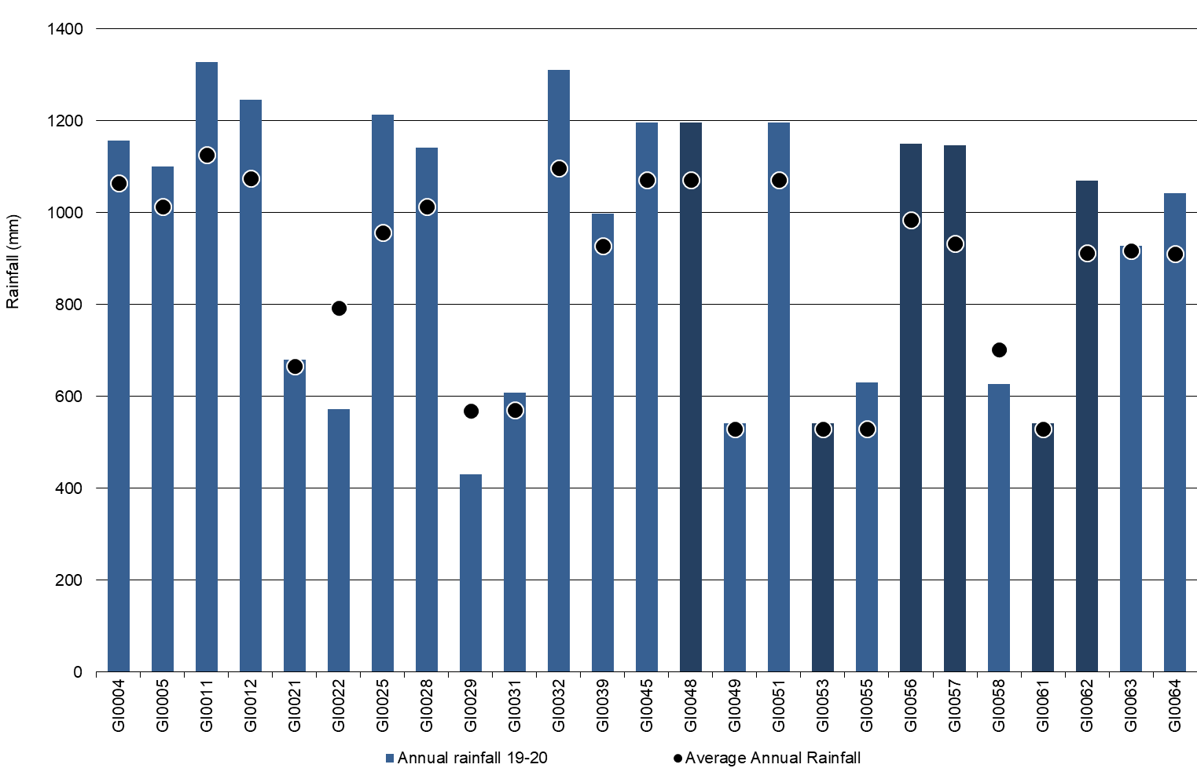

Whole Farm Analysis
Despite challenging operating conditions in Gippsland for the first six months of 2019-20, average EBIT increased to $2.07/kg MS, a three-fold improvement from $0.51/kg MS in 2018-19. This was supported by the improved growing conditions which allowed harvesting of excess fodder, a greater reliance on homegrown forage and a cost reduction for imported feeds.

Key whole farm physical parameters for Gippsland are presented below in Table 10. The Q1 – Q3 range shows the band in which the middle 50% of farms sit for each parameter.
Despite the challenging operating conditions in Gippsland for the first six months of the financial year, herd size and stocking rate were maintained, and greater feed production led to an improvement in per cow and per hectare milk production performance.
In 2019-20, the greater pasture availability and lower priced purchased feeds had a positive influence on farm performance and also enabled farmers to maintain a similar average herd size at 310, compared to last year at 307 cows. Stocking rate was stable at 1.9 cows/ha as was usable area at 187 ha.
The amount of homegrown feed as a % of ME consumed increased to 68% of the cows’ diet, from 66% last year, as result of the improved seasonal conditions in the second half of 2019-20.
Labour efficiency per cow remained relatively similar at 121 cows /FTE compared to 119 cows/FTE last year. Since per cow production increased, so too did labour efficiency at 58,000 kg MS/FTE, up from 54,700 kg MS/FTE in 2018-19.
The top 25% of farms in Gippsland had similar physical characteristics to the region average for rainfall, water use and labour efficiency. There were noticeable differences for herd size, stocking rate, production per cow and per hectare and estimated grazed pasture per hectare.
The top performers appeared to have utilised their physical resources to similar advantage to that of the average for the region with the key performance differences being in homegrown feed utilisation and cost control as discussed further in this chapter.

TABLE 10. FARM PHYSICAL DATA – GIPPSLAND
Farm physical parameters | Gippsland average | Q1 to Q3 range | Top 25% average
Annual rainfall 19-20 (mm) | 944 | 627 - 1,197 | 942
Herd size | 310 | 248 - 348 | 344
Total water use efficiency (t DM/100mm/ha) | 0.8 | 0.7 - 0.9 | 0.9
Total usable area (hectares) | 187 | 106 - 201 | 184
Milking cows per usable hectare | 1.9 | 1.4 - 2.3 | 2.2
Milk solids sold (kg MS /cow) | 486 | 432 - 534 | 509
Milk solids sold (kg MS /ha) | 925 | 646 - 1,120 | 1,058
Home grown feed as % of ME consumed | 68% | 63% - 73% | 71%
Labour efficiency (cows / FTE) | 121 | 99 - 132 | 141
Labour efficiency (kg MS / FTE) | 58,145 | 49,120 - 64,247 | 69,760

Milk solids sold

Gippsland farms improved per cow and per hectare milk solids sold in 2019-20. Figure 33 shows the range in milk solids sold per cow and per hectare for Gippsland farms during this season, with the average at 151,000 kg MS/farm (3% improvement on last year).
Milk solids sold per cow increased 4% from 468 kg MS/cow to 486 kg MS/cow in 2019-20. There was also a 4% increase in milk solids sold per ha to 925 kg MS/ha from 888 kg MS/ha recorded in 2018-19.
The top 25% recorded a higher milk solid sold per cow (509 kg MS/cow in 2019-20) compared to the average of all participants and the top 25% group last year (489 kg MS/cow in 2018-19). However, sales increased considerably by 10% from 959 kg MS/ha in 2018-19 to 1,058 kg MS/ha in 2019-20, which was driven by a similar 10% increase in stocking rate this season to 2.2 cows/milking ha.
The improved milk sales was mostly a result of improved water availability from both rainfall and irrigation which enabled greater quantities of homegrown feed to be removed in 2019-20 than the previous year.

FIGURE 33. MILK SOLIDS SOLD – GIPPSLAND
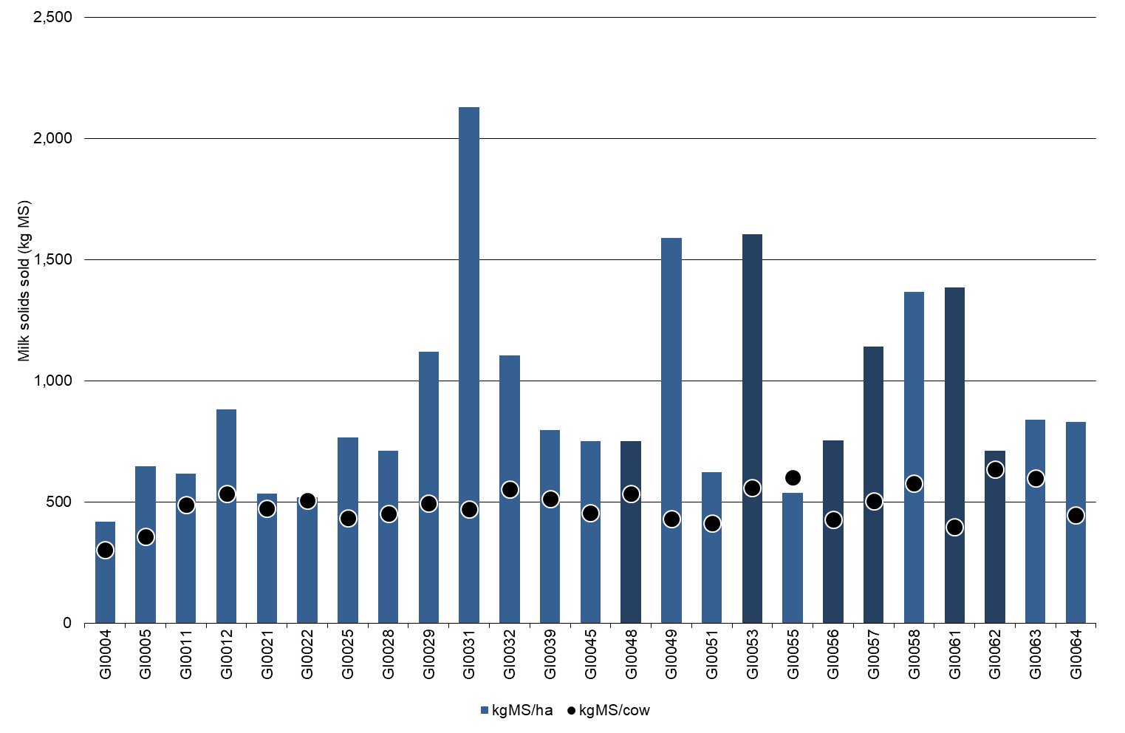
Gross farm income

Gross farm income improved considerably in 2019-20. An increase of 17% in gross farm income to $7.59/kg MS was seen compared to $6.47/kg MS in 2018-19. The variation in gross farm income was $6.54/kg MS to $8.60/kg MS. The top 25% received a slightly higher gross farm income than the average at $7.69/kg MS.
It was a positive year for improvements in both milk income and livestock trading profit on average for Gippsland participants. Average milk price increased by 16% to $6.95/kg MS and livestock trading profit increased by 32% to $0.61/kg MS. The range of milk prices received was between $6.36/kg MS and $7.69/kg MS compared to range in 2018-19 between $5.57/kg MS and $6.34/kg MS
The top 25% participants received an average milk price of $7.11/kg MS, an improvement of 19% from last year with a range of between $6.74/kg MS and $7.69/kg MS.
There was a large proportion of farms in the Gippsland sample that changed milk processors during the year. This was either to find a payment system that better suited their milk supply pattern or look to companies that were offering a higher payment for their milk. In the top 25% and the average of the sample, milk income accounted for 92% of gross farm income.
Livestock trading profit for the top 25% improved substantially by 85% and contributed $0.55/kg MS to gross farm income compared to last year at $0.30/kg MS. This was still 10% less than the livestock trading profit received by the average of Gippsland participants.
The remaining other income contributed $0.02/kg MS and $0.03/kg MS to gross farm income for the average and top 25%, respectively.

FIGURE 34. GROSS FARM INCOME – GIPPSLAND
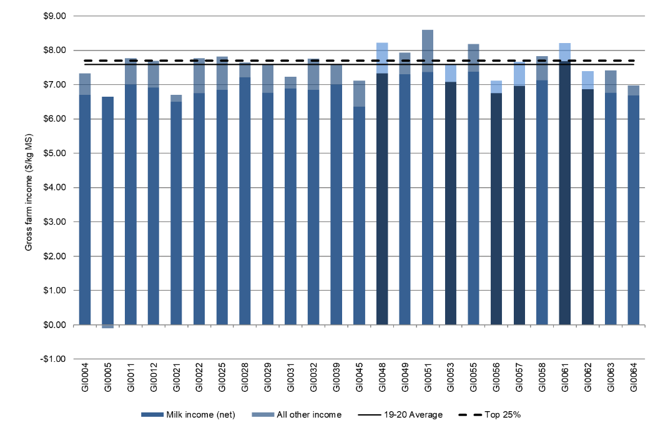

Variable costs

Variable costs in 2019-20 reduced by 12% in Gippsland to $3.36/kg MS from $3.81/kg MS in 2018-19. The top 25% performers decreased their variable costs by 11% to $2.95/kg MS from $3.33/kg MS last year. This year’s variable costs ranged between $1.62/kg MS and $4.95/kg MS. The separation of variable and overhead costs per kg MS is shown in Figure 35.
The greatest reduction, although a smaller portion of variable costs, was seen in herd costs. There was a 31% decrease in calf rearing costs this season to $0.05/kg MS, with an overall reduction by 3% in herd costs.
Shed costs increased by 5% this year to $0.22/kg MS, with the cost of dairy supplies increasing by 22% to $0.09/kg MS.
As with previous years, feed costs contributed the largest portion to variable costs, contributing 84% of variable costs (but only 51% of overall variable plus overhead costs).
In 2019-20, feed costs averaged $2.81/kg MS, a 13% decline from $3.27/kg MS last year. One of the greatest contributors to the reduction in feed costs was a $0.13/kg MS decrease in grain or concentrate costs to $1.65/kg MS. Fodder purchases also decreased, reducing by $0.12/kg MS to $0.22/kg MS in 2019-20. The greater quantities of pasture grazed and conserved feed helped to lower these purchased feed costs. On average, farmers fed 4% less purchased feed per milker and the prices of concentrates, silage and fodder decreased between years The ME sourced from homegrown feed increased to 68% from 66% last year shows a reduced reliance on purchased fodder in 2019-20.
The top 25% also experienced a 12% decline in grain and concentrate feeding, with a similar 11% decline in variable costs to $2.95/kg MS.
The second largest variable cost was fertiliser at $0.57/kg MS, 6% higher than in 2018-19 at $0.54/kg MS. The elevated fertiliser price per tonne this year can account for the increase in this cost category rather than an increase in quantity applied.
Due to the improved growing conditions later in the season fodder inventory increased on average, up to -$0.22/kg MS from -$0.15/kg MS in 2018-19. There was more conserved feed on 19 of the 25 participants farms at the end of the year than at the start.
Overhead costs
In Gippsland, total overhead costs in 2019-20 ranged between $1.50/kg MS and $3.65/kg MS, similar to last year. Average overhead costs remained unchanged at $2.16/kg MS. Imputed or family labour was the greatest cost on average at $0.82/kg MS. There was a slight reduction of overhead costs for both the average and top 25% which appeared to be offset by a similar sized increase in employed labour ($0.59/kg MS on average in 2019-20). Figure 35 illustrates the overhead costs per kg MS
Overhead costs for the top 25% remained similar to that of last year at $1.65/kg MS. The top 25% were lower in all overhead cost categories per kg MS compared to the average. The slightly larger herd size, better labour efficiency and mix of imputed and paid labour enabled a better ability to spread costs this year.
A breakdown of overheads costs can be found in Appendix Tables D5.

FIGURE 35. VARIABLE AND OVERHEAD COSTS – GIPPSLAND
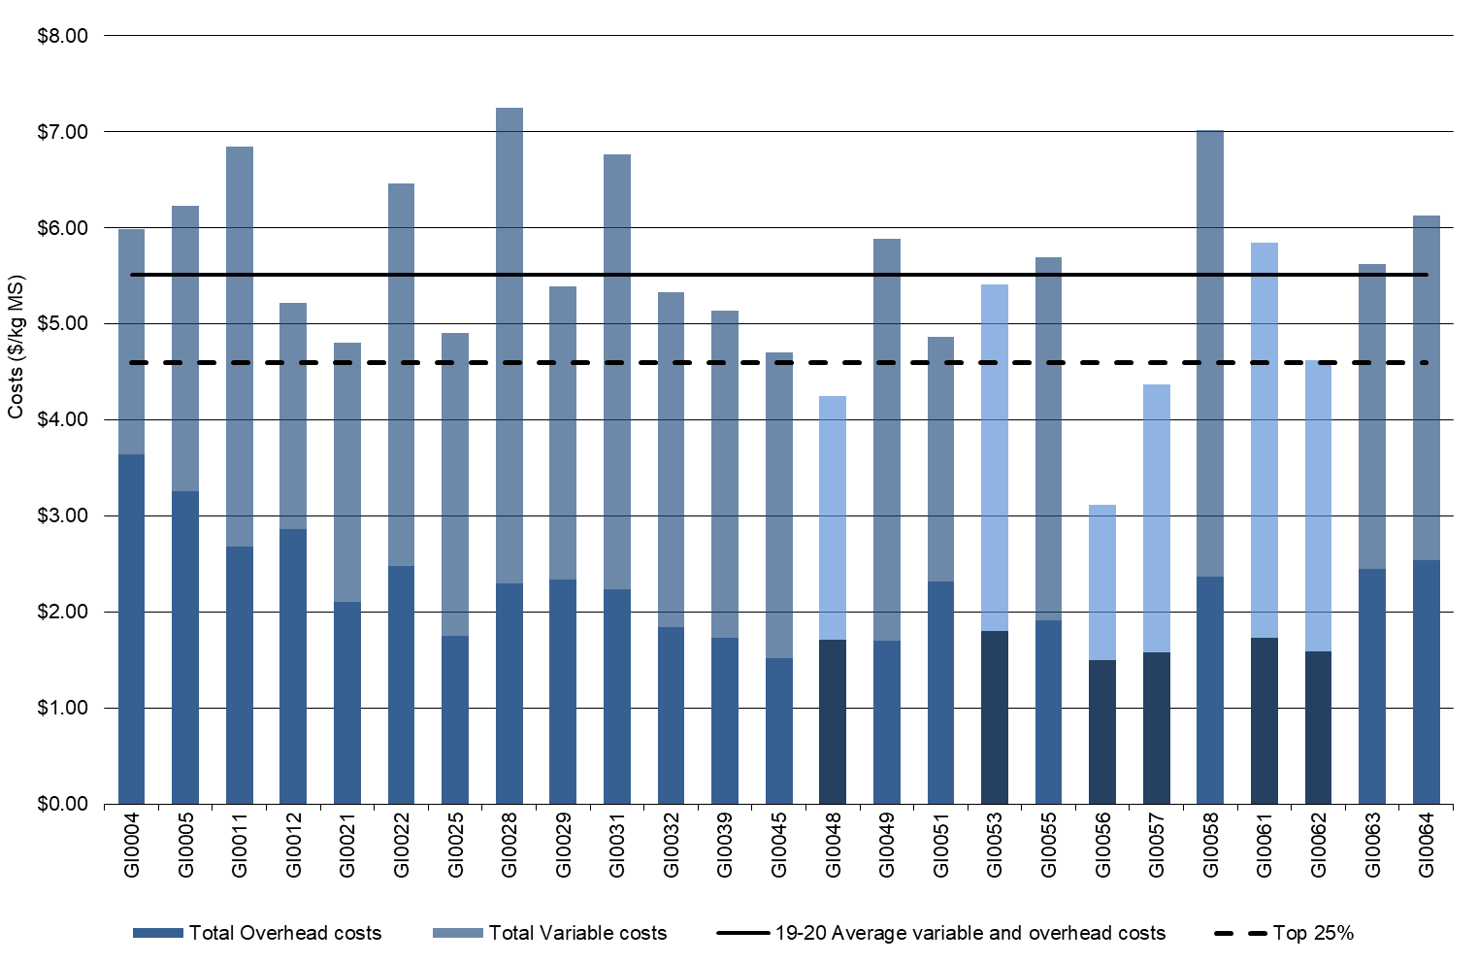

TABLE 11. AVERAGE FARM FINANCIAL PERFORMANCE – GIPPSLAND
 | Gippsland average  $/kg MS | Q1 to Q3 range  $/kg MS | Top 25% average  $/kg MS
INCOME
Milk income (net) | $6.95 | $6.75 - $7.12 | $7.11
Livestock trading profit | $0.61 | $0.39 - $0.77 | $0.55
Other farm income | $0.03 | $0.00 - $0.01 | $0.03
Gross farm income | $7.59 | $7.33 - $7.82 | $7.69
VARIABLE COSTS
Herd cost | $0.32 | $0.22 - $0.43 | $0.27
Shed cost | $0.22 | $0.18 - $0.25 | $0.17
Home grown feed cost | $1.06 | $0.75 - $1.32 | $1.04
Purchased feed and agistment | $1.98 | $1.64 - $2.35 | $1.87
Feed inventory change | -$0.22 | -$0.43 - -$0.01 | -$0.39
Water inventory change | -$0.01 | $0.00 - $0.00 | $0.00
Total feed costs | $2.81 | $2.42 - $3.31 | $2.51
Total variable costs | $3.36 | $2.78 - $3.98 | $2.95
GROSS MARGIN | $4.23 | $3.74 - $4.67 | $4.75
OVERHEAD COSTS
Employed labour | $0.59 | $0.19 - $1.02 | $0.50
Repairs and maintenance | $0.30 | $0.23 - $0.37 | $0.28
All other overheads | $0.28 | $0.21 - $0.31 | $0.19
Imputed labour | $0.82 | $0.34 - $1.03 | $0.57
Depreciation | $0.17 | $0.09 - $0.23 | $0.11
Total overhead costs | $2.16 | $1.73 - $2.45 | $1.65
Variable and overhead costs | $5.51 | $5.41 - $6.41 | $4.60
EBIT | $2.07 | $1.31 - $2.49 | $3.09

Cost of production

Cost of production gives an indication of the unit cost of one kg MS sold as well as the cost to maintain the livestock at current numbers. It is calculated as variable plus overhead costs and accounts for changes in fodder, water and livestock inventory.
Table 12 shows that the average cost of production with inventory change has decreased from $6.07/kg MS last year, to $5.44/kg MS this year, back to a similar level seen in 2017-18. The top 25% of farms had a lower cost of production at $4.42/kg MS, down from $5.08/kg MS in 2018-19.
Feed inventory increased again this year to -$0.22/kg MS. The top 25% had greater reserves on-hand at the end of the year as reflected by an inventory change of -$0.39/kg MS. A negative inventory value indicates that fodder reserves increased and is counted as a decrease to the cost of production.
A buoyant livestock market lifted prices received for livestock sales and further improved the cost of production position of both the average and top 25% of the sample to -$0.08/kg MS and -$0.19/kg MS respectively.

TABLE 12. COST OF PRODUCTION – GIPPSLAND
Farm costs | Gippsland average  $/kg MS | Q1 to Q3 range  $/kg MS | Top 25% average  $/kg MS
Cash cost of production | $4.74 | $4.17 - $5.24 | $4.31
Cost of production (excl inventory changes) | $5.74 | $5.35 - $6.37 | $4.99
INVENTORY CHANGE
+/- feed and water inventory changes | -$0.22 | -$0.43 - -$0.01 | -$0.39
+/- livestock inventory changes minus purchases | -$0.08 | -$0.23 - -$0.01 | -$0.19
Cost of production (incl inventory changes) | $5.44 | $4.70 - $6.09 | $4.42

Earnings before interest and tax

On average, the EBIT on Gippsland farms in 2019-20 increased to $2.07/kg MS, a three-fold improvement from $0.51/kg MS in 2018-19. An improved milk price combined with lower costs to result in a positive EBIT across all DFMP Gippsland farms in 2019-20.
The top 25% had an average EBIT of $3.09/kg MS, a 58% increase on $1.36/kg MS the previous year for the top 25% group. All farms in the top 25% recorded an EBIT above the average.
Historically, a high EBIT has been achieved on the irrigated farms in the sample, however due to low water availability at the start of the season this may not have been fully realised in 2019-20. This year the majority of high EBIT farms were characterised by higher milk prices and lower costs. However, one of the top 25% farms received one of the lowest milk prices. With high per cow production and a strong focus on cost control their performance was in the top quartile. One of the highest milk prices received had high costs due to poor seasonal conditions and was not in the top 25% group this year.
Farms located in the MID recorded an average EBIT of $1.94/kg MS. These farms received a higher than average milk price of $7.18/kg MS which was partially offset with higher than average variable costs of $3.89/kg MS, although overhead costs were lower than the average at $1.95/kg MS. The higher cost structure (variable costs divided by variable plus overhead costs) of 67% on irrigated farms compared to the average of 61% meant that irrigated farms had to perform exceptionally well to be in the top 25% this year.
Dryland farms in south and west Gippsland dominated the top 25% this year as rainfall (although erratic) promoted early pasture growth and consequent fodder conservation to assist variable cost control early in the season.

FIGURE 36. EBIT – GIPPSLAND
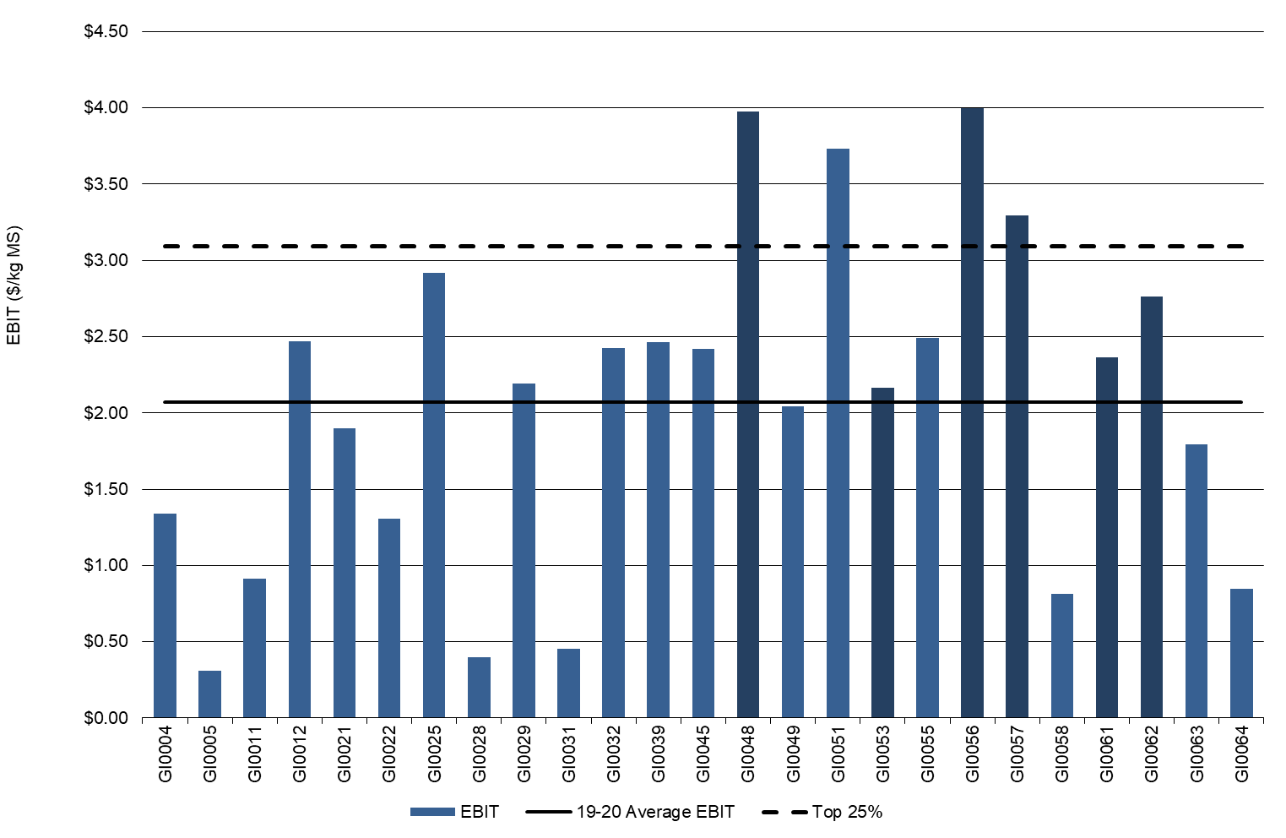

Return on total assets and equity

The second highest ROTA of 6.6% in the 14-year history for the project was achieved in 2019-20.
All Gippsland participants had a positive ROTA in 2019-20, a considerable improvement from last year when only 17 of the 25 farms (70%) returned a positive result. The range for all Gippsland participants in 2019-20 was 0.9% and 15.1%.
The top 25% recorded an average ROTA of 11.5% compared to 4.7% last year, with a range of between 10% and 15% as shown in Figure 37.
In 2019-20, there were 21 of the 25 (84%) Gippsland participants who generated a positive ROE (Figure 38), a vast improvement on the previous three seasons. Average ROE was 12.4%, increasing markedly from -2.3% last year, with a range of -3.1% to 59% in 2019-20.
Interest and lease costs for 2019-20 reduced to $0.65/kg MS from $0.69/kg MS last year. The top 25% increased their interest and lease charges to $0.53/kg MS and resulted in an average ROE of 23%. Average capital values are provided in Appendix D6.
FIGURE 37. ROTA – GIPPSLAND
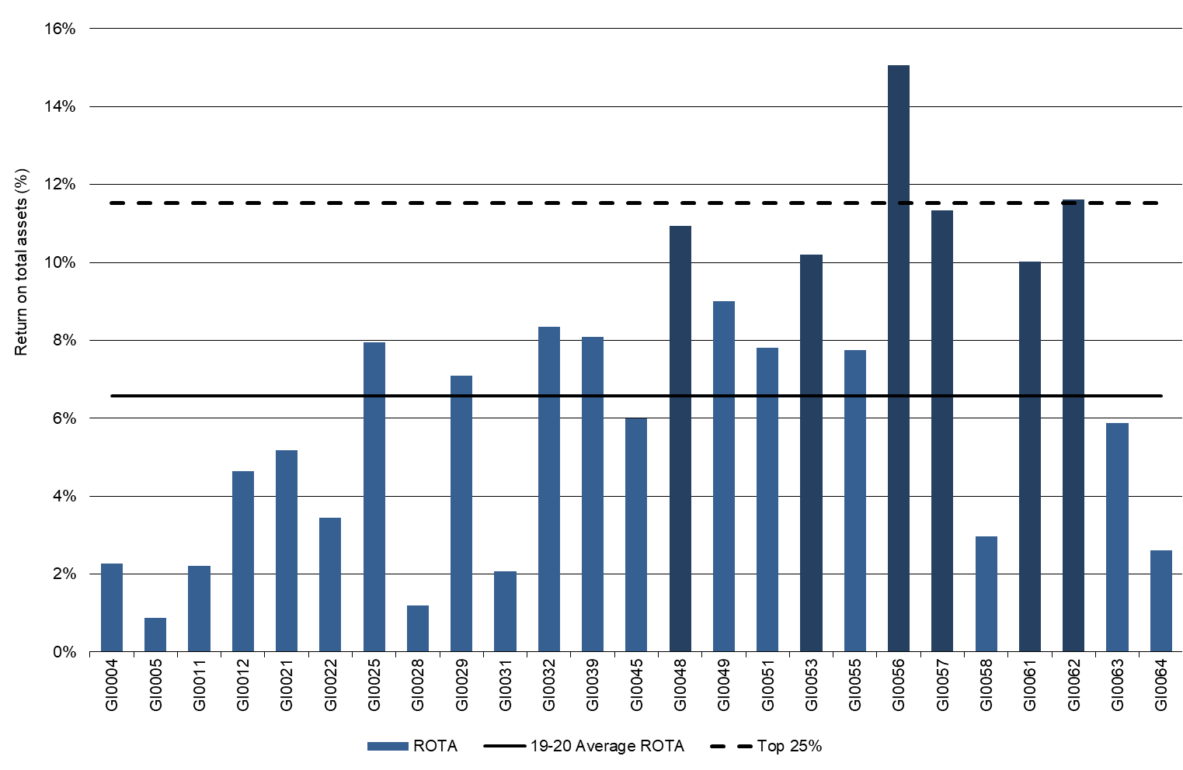
FIGURE 38. ROE – GIPPSLAND
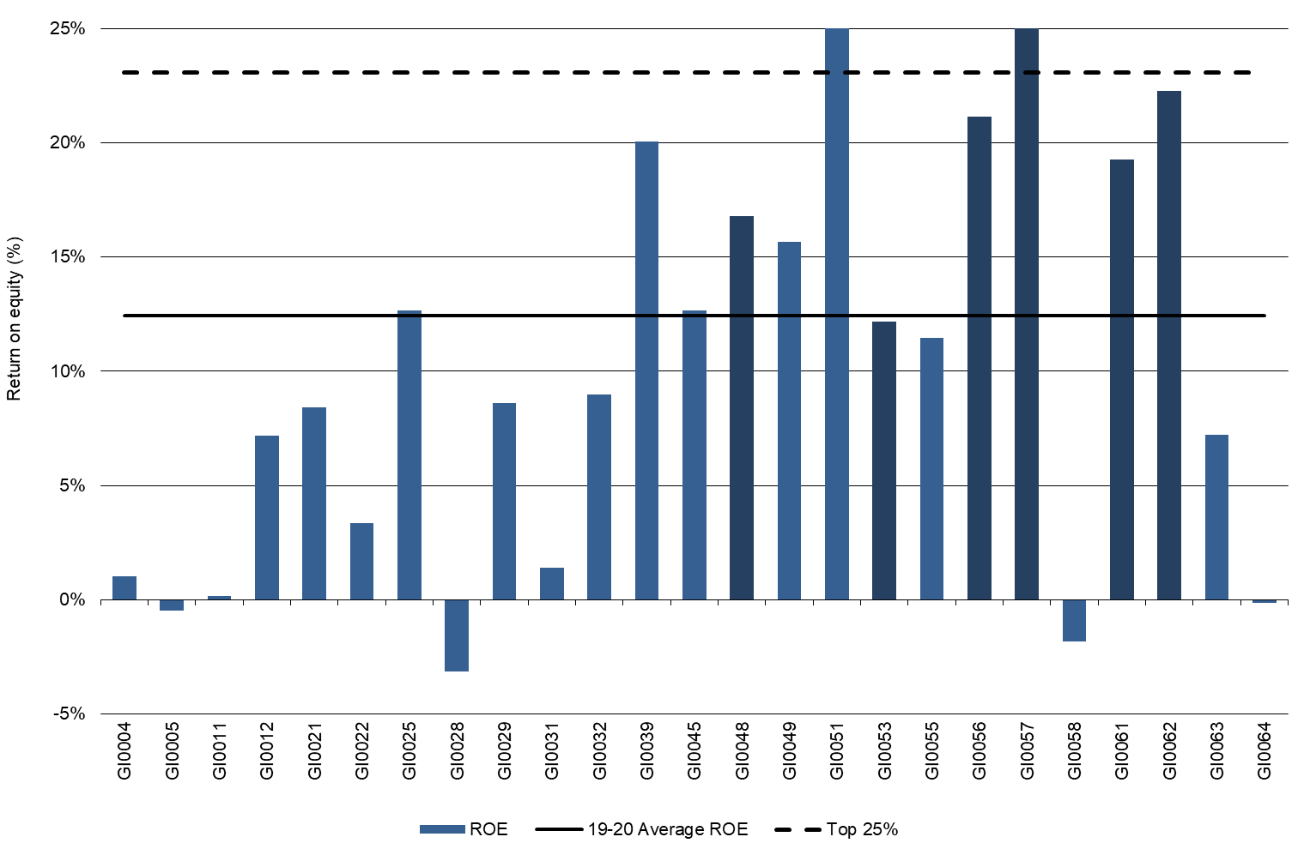
The axis in Figure 38 has been modified to allow for better presentation of all Gippsland farms in the project. Two farms (GI0051 and GI0057) had much higher ROE than the rest of the dataset, which the axis did not allow to be represented to the full extent. Appendix Table D1 presents this measure for all participant farms.

Feed consumption and fertiliser
Rainfall events determined feed availability in Gippsland in 2019-20. All but three of the 25 farms sourced at least 50% of their ME requirements from grazed pasture. Total pasture harvested on the milking area by direct grazing and conservation rose to 9.8 t DM/ha on average and for the top performers reached 12 t DM/ha.

In 2019-20, there was an increase in the proportion of homegrown feed as a percentage of ME consumed from 66% to 68% on the milking area. Feed was predominantly more available between January and June rather than the first six months of the financial year.
On average 32% of the ME consumed by the herd was imported, with 29% imported ME for the top 25%. This indicates a greater reliance on homegrown pasture and forage for the higher performers.
Pasture harvested directly on the milking area by grazing animals averaged 8.6 t DM/ha and conservation achieved a further 1.2 t DM/ha harvested. The top 25% increased their directly grazed pasture by 30% to 10.4 t DM/ha and decreased the pasture conserved by 6% to 1.6 t DM/ha.
On the usable area the outcome was similar with a 4% overall increase on average for directly grazed pasture to 7.2 t DM/ha and 1.5 t DM/ha for conserved feed.
The top 25% substantially increased the directly grazed portion of the diet on the usable area by 25% more this year at 8.6 t DM/ha but decreased conserved fodder by 15% to 1.5 t DM/ha. This resulted in a 17% increase in total pasture removed by direct grazing and conservation to 10.2 t DM/ha on the usable area for the top performers.
On a per cow basis Gippsland farms fed less purchased feed per milker, declining 4% from last year to 1.9 t DM/cow. Average concentrate price was $500/t DM which was a minor decrease from $518/t DM last year. The top 25% had similar percentage declines and fed 1.8 t DM/cow of purchased feed and paid $494/t DM for concentrates fed.
Average purchased feed price was similar for the average and top 25% groups at $463/t DM and $461/t DM respectively. The average cost of silage reduced to an average of $262/t DM, a decline of 28%, and hay reduced by 11% to an average cost of $303/t DM.
Figure 39 shows the composition of ME consumed from different sources for each farm.
The estimated tonnes of dry matter of homegrown feed consumed per milking hectare is given in Figure 40. Homegrown feed can be grazed pasture (shown by the dark blue bars) or conserved fodder (light blue bars). A description of the method used to calculate ME sources and feed consumption is given in Appendix E.

FIGURE 39. SOURCES OF WHOLE FARM METABOLISABLE ENERGY – GIPPSLAND
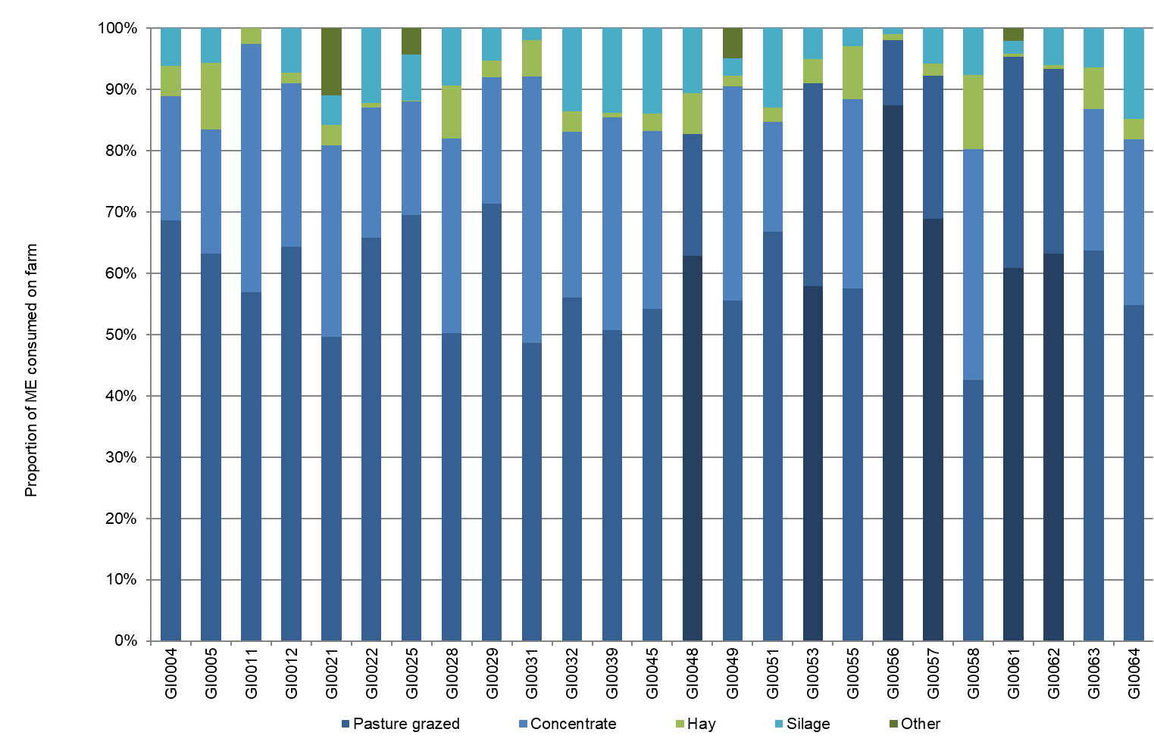

FIGURE 40. ESTIMATED TONNES OF HOMEGROWN FEED REMOVED – GIPPSLAND
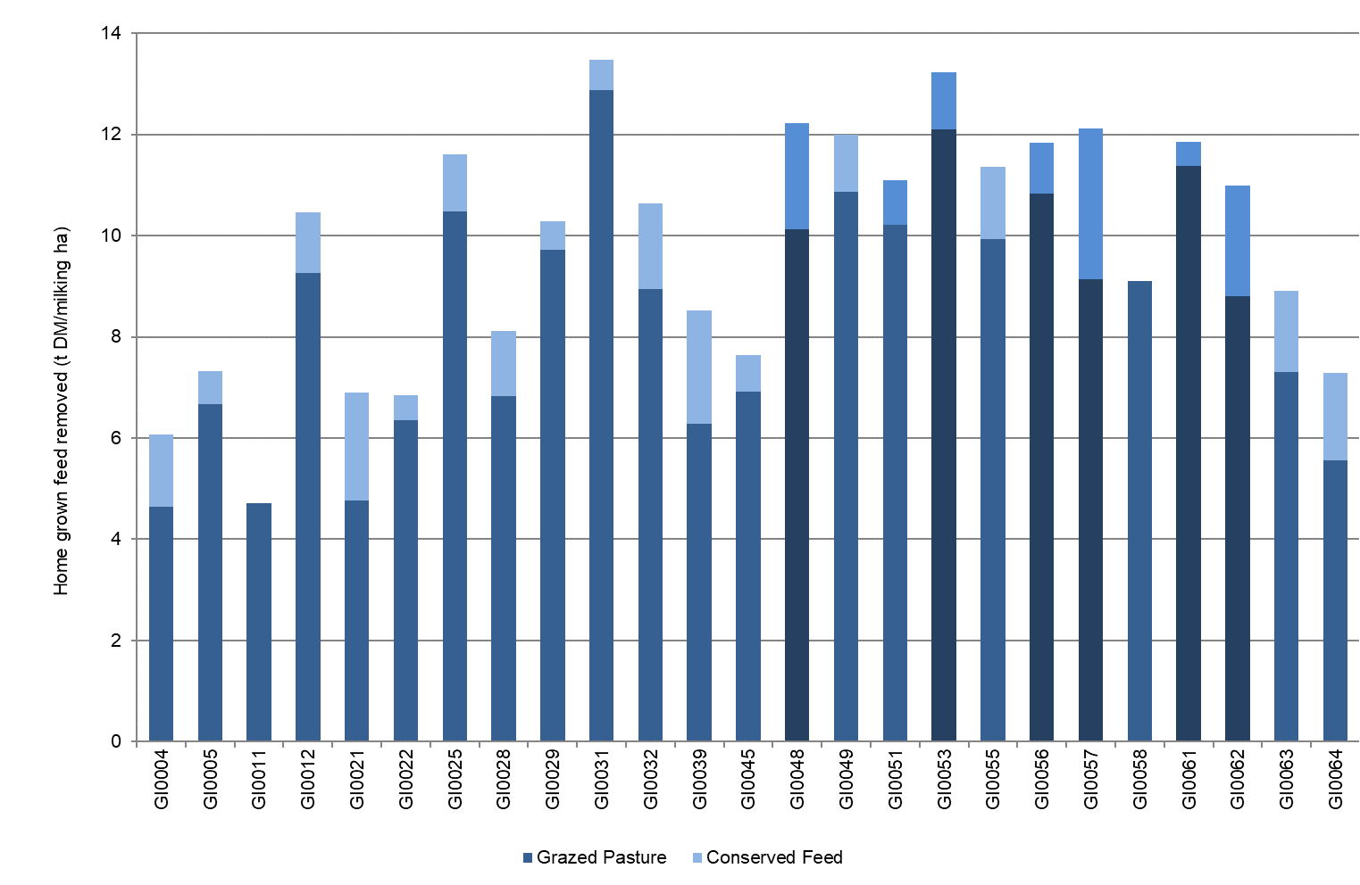
Fertiliser application

Erratic rainfall events strongly determined the timing and quantity of fertiliser applied in Gippsland in 2019-20.
On average there was a decrease in the amount of nutrients applied per milking hectare. Having less water available in many parts of the region from July to December 2019 reduced pasture growth and hence nutrient application, despite an overall increase in pasture grown and consumed this year.
The overall decrease was seen across most macro nutrients. Nitrogen use decreased by 6% to 205 kg N/ha, potassium by 4% to 40 kg K/ha and 13% of sulphur to 19 kg S/ha. Phosphorus use was unchanged at 22kg P/ha. This reflected the more targeted use of blends and strategic application of nutrients this year.
The top 25%, despite increasing their pasture harvested as direct grazed and conserved feed, did not change their nitrogen use this year, reported as 279 kg N/ha. Phosphorus application increased significantly by 70% to 26 kg P/ha, a 5% reduction in potassium use at 39 kg K/ha and significant reduction in sulphur use of 27% to 15 kg S/ha. Again, the strong swing to blends and strategic application was reflected in the sample and timing of application was noticeably different this year, as a result of available soil moisture.
The values for Figures 40 and 41 can be found in Appendix Table D2.

FIGURE 41. NUTRIENT APPLICATION – GIPPSLAND
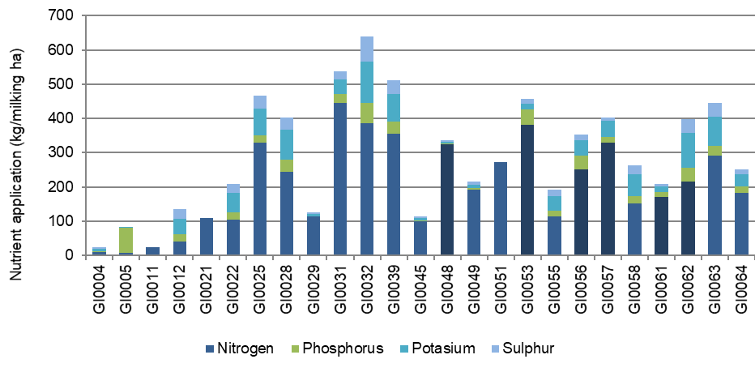

Part Five: Business Confidence Survey

Expectations for business profit
The most positive region heading into 2020-21 were farmers in the North. Over 60% of the North respondents expect their farm business returns to increase in the coming year, noting the string of difficult years for farms in this region. Most Gippsland respondents were also expecting their returns to increase while in the South West most farms were expecting profits to remain stable next year.

The 2019-20 survey was developed to consider different aspects of farming, from climate outlook to expectations about market conditions for dairy products bought and sold. While expectations of the coming year were generally positive regarding the seasonal outlook, there were slight regional differences.
Across the state, 43% of respondents were optimistic about business profit for the coming season. In the North, two-thirds of respondents were expecting their farm returns to improve in the coming year. This sentiment was summarised by a North participant who commented they were ‘confident for a good season with good milk price and seasonal conditions being good at this point’.
Most of the South West respondents were expecting similar returns to the previous year whereas expectations in Gippsland were mixed (Figure 42).

FIGURE 42. EXPECTED CHANGE TO FARM BUSINESS PROFIT IN 2020-21
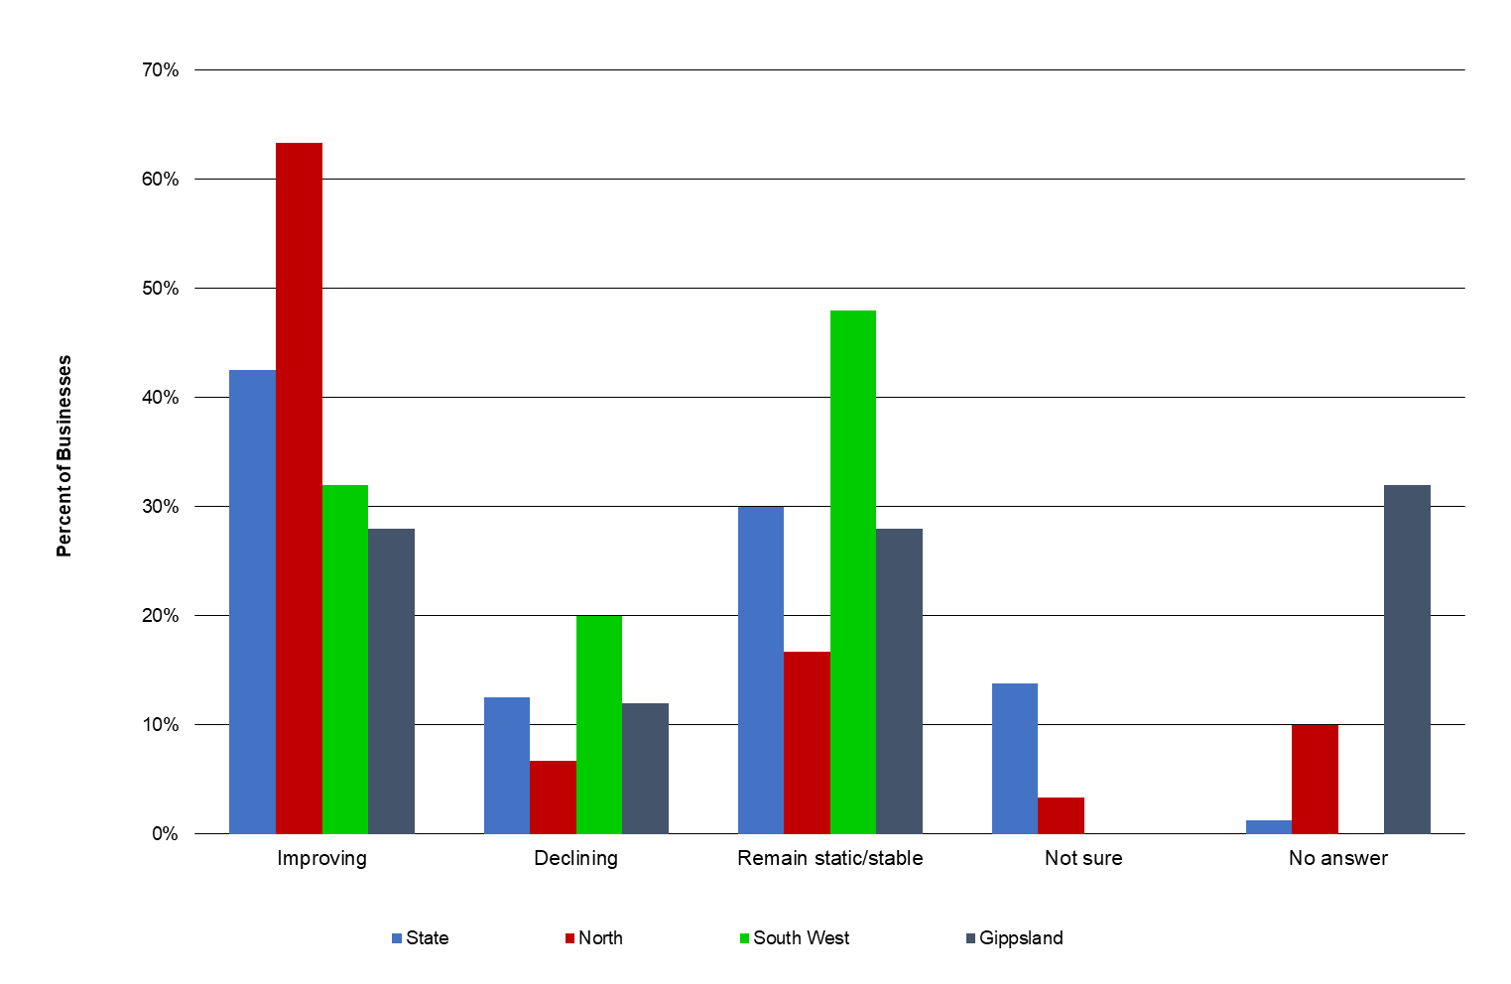
Price and production expectations - milk
On the back of the highest milk prices recorded in the history of project (in nominal terms), the majority of participants in Gippsland and the South West were expecting milk price to fall in the coming year (Figure 43).
Farmers in the North are expecting milk prices in 2020-21 to remain comparable with the previous year. Farms in this region recorded the highest price for their milk in 2019-20 and of all the regions they also had the greatest diversity in the choice of milk processors.
Most respondents are expecting their milk production to increase (43%) with the highest percentage recorded by those in Gippsland. There were similar responses by North and South West participants for increasing production at 48%, with production remaining stable at 41% and 36% respectively. There were 11% of responses indicating they will reduce their milk production in the coming year for those in the North; the lowest of all the regions.

FIGURE 43. PRODUCER EXPECTATIONS OF MILK PRICES AND PRODUCTION IN 2020-21
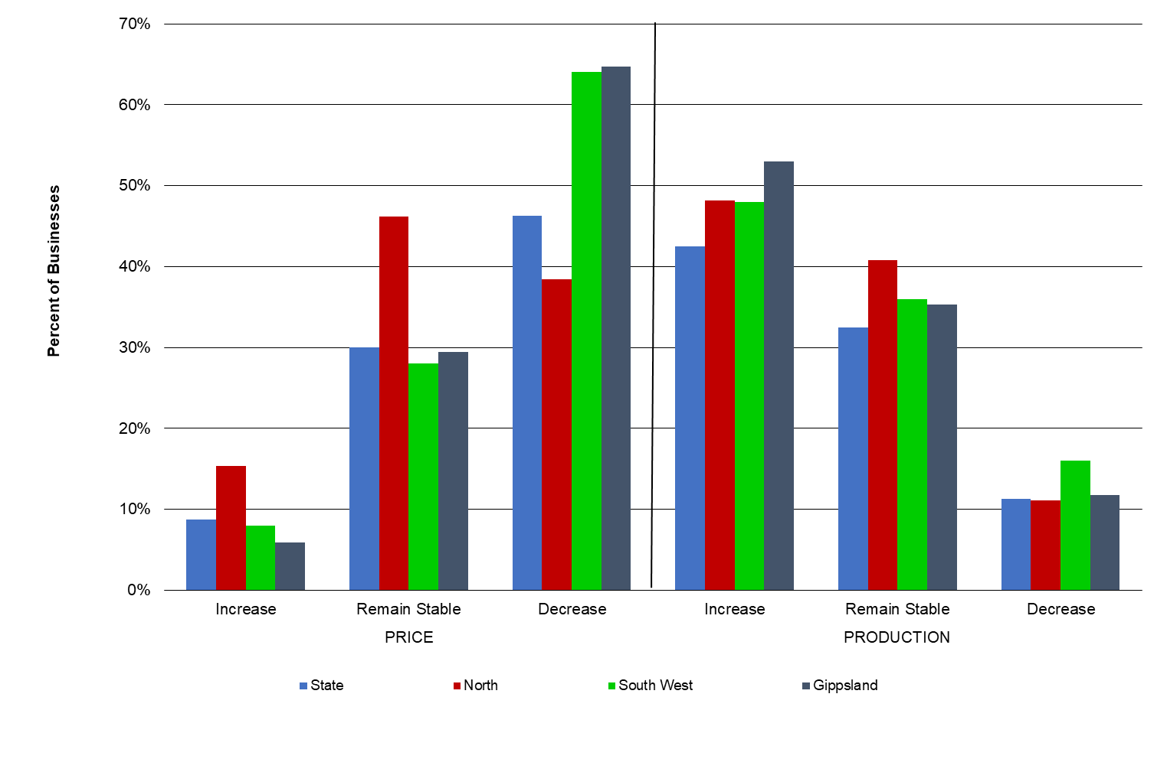
Production expectations - fodder

The expectations for fodder production in 2020-21 were positive with almost half of the respondents (47%) expecting an increase (Figure 44). Almost all respondents in the North are expecting their fodder production to increase on the back of good autumn and winter conditions and rainfall over the irrigation catchments.
Whilst most of Gippsland farms are expecting fodder production to increase, there was a relatively even spread across responses for increasing, remaining stable and decreasing (41%, 35% and 24%, respectively).
The expectation for fodder production in the South West was mostly for remaining stable with 58% of respondents.
Many participants were concerned about seasonal variability in the coming year. This was highlighted by some of the participants who commented that managing ‘wet winters will be critical to this farm’ and ‘climate is a major concern’.

FIGURE 44. PRODUCER EXPECTATIONS OF FODDER PRODUCTION IN 2020-21
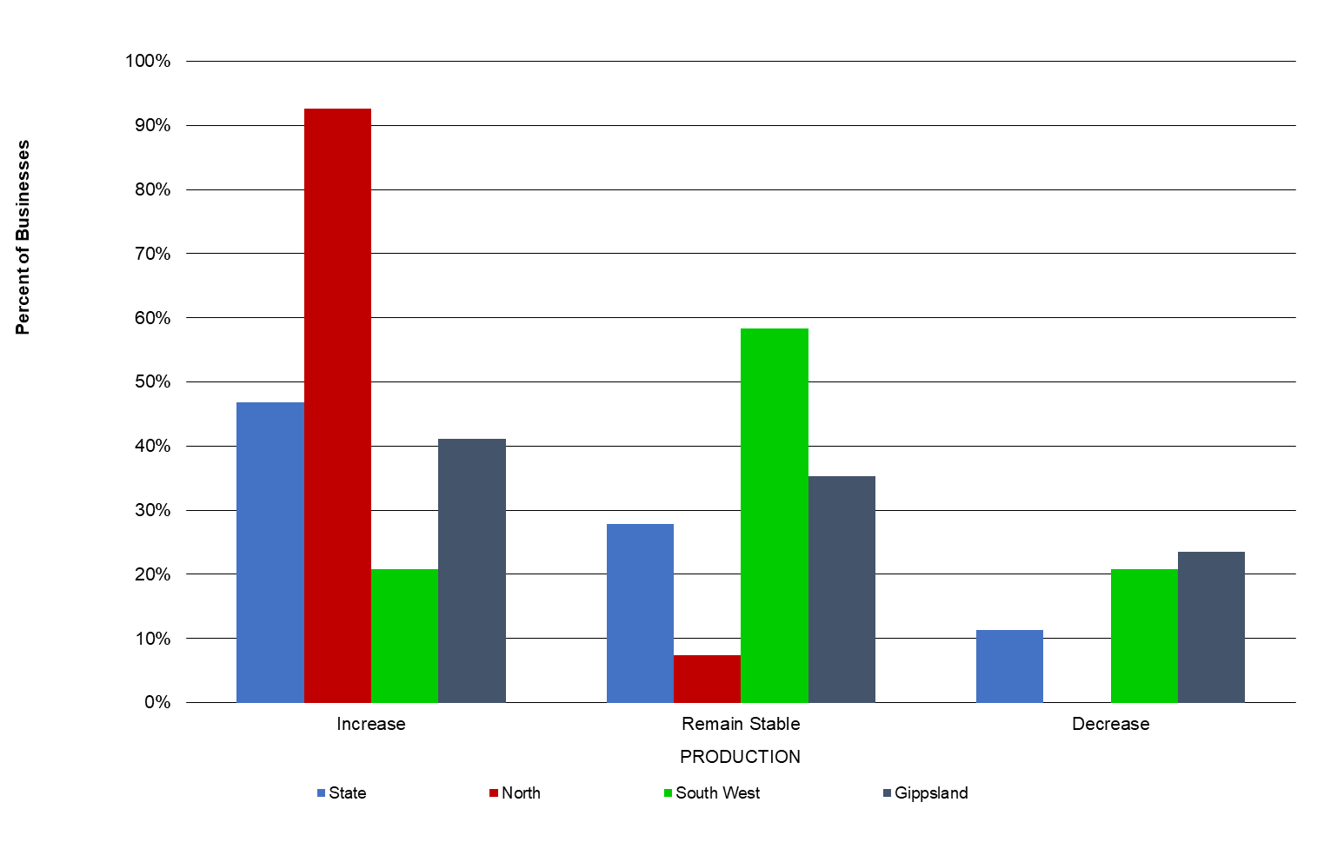

Cost expectations

Purchased feed is the cost category that was recorded as most likely to decrease in 2020-21 (Figure 45). The improved seasonal conditions have decreased demand for fodder in 2019-20, placing downward pressure on fodder prices. All other costs were expected to remain stable for most of the respondents.
For the coming 2020-21 year, those farms with irrigation had mixed expectations for irrigation costs, with 29% of respondents expecting costs to remain stable, 23% expecting a decrease while 15% expect an increase. The survey was conducted in July 2020 and the median prices of allocation water were $230/ML in Zone 1A Greater Goulburn, $240/ML in Zone 6 Dartmouth to Barmah Choke and $350/ML in Zone 7 VIC Murray - Barmah to South Australia border.

FIGURE 45. PRODUCER EXPECTATIONS OF COSTS FOR THE DAIRY INDUSTRY IN 2020-21
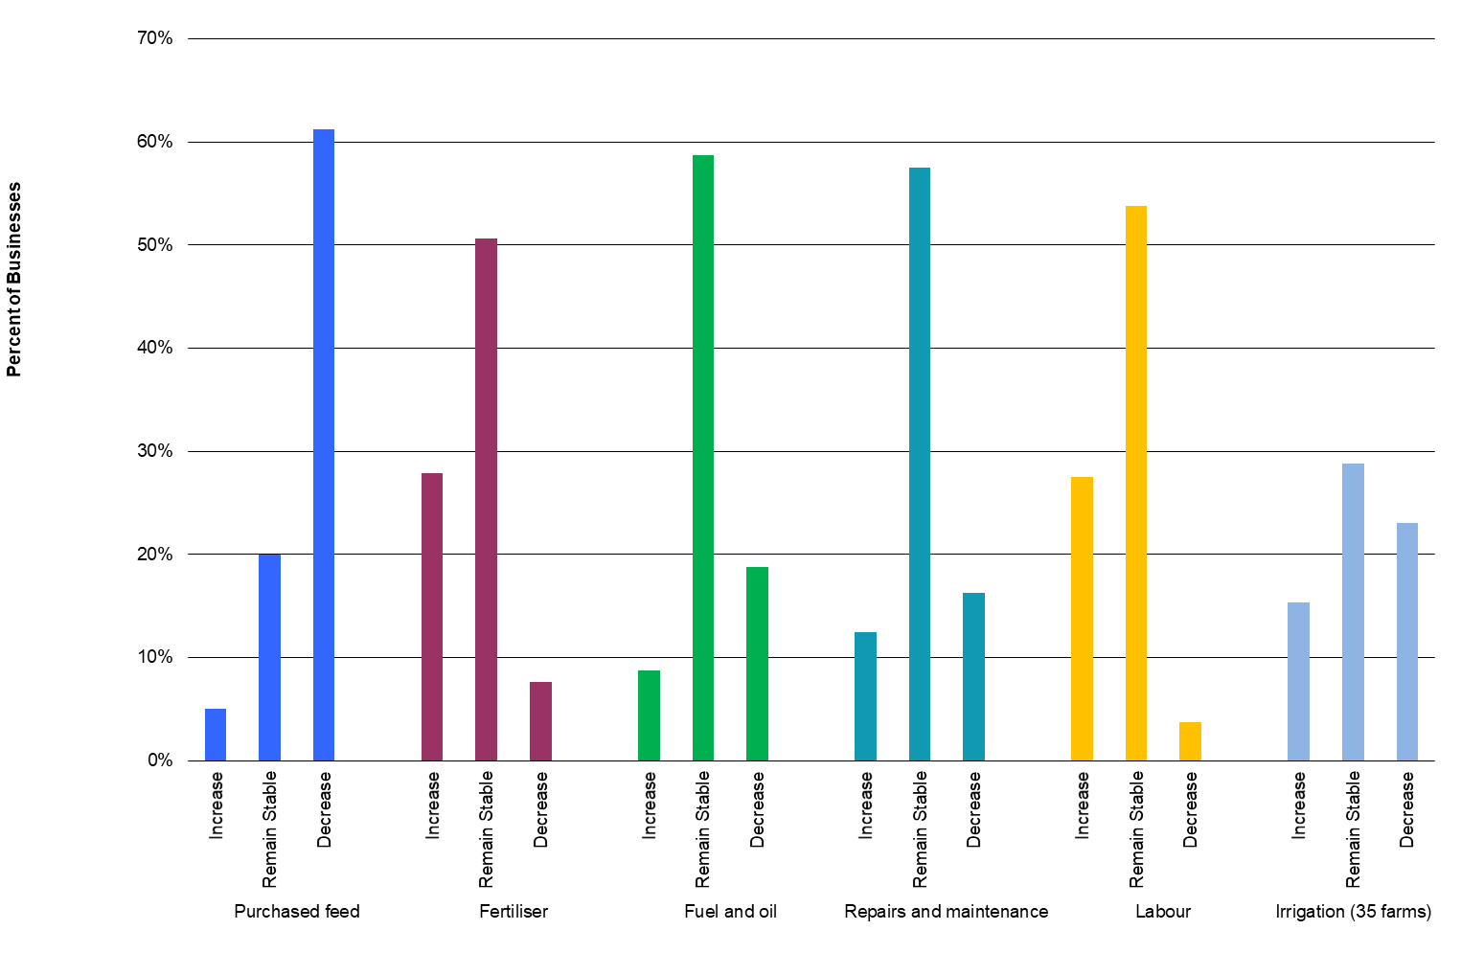

Comments from participants

In 2019-20, the coronavirus (COVID-19) pandemic was front-of-mind for participants with many commenting that they were uncertain of the full impact it would have on their farm business. Some of the short-term impacts of concern for respondents were the availability of farming supplies such as semen, machinery parts and cleaning products for the dairy. Longer-term issues of farmers’ concern were impacts on the milk price emanating from global markets, domestic food retail markets, the hospitality industry and a further cost-price squeeze between input prices and milk price impacted by coronavirus (COVID-19).
Participants were also concerned about transitioning their farm (such as to organic) or succession planning (such as ceasing milking and handing to the next generation). Farmers commented that they were evaluating their next steps on land ownership and one farm had prioritised this as their employees had left. Participation in the project is useful for some farms as highlighted by a farmer that it’s ‘good to track progress of the farm with others over time and especially so with changing to the new organic system’.
Different farmers commented that bushfires or other unforeseen events, policy developments regarding emissions and regulatory impacts were issues to manage and adapt to.

Issues of importance to dairy businesses - the next 12 months

Participant farmers were asked to rank issues based on the level of importance to their business for the upcoming season. The participants were asked to rank these issues from 1 to 7, with (1) being most important and (7) being least important. The results are shown in Figures 46 and 47.
The most important issue in the coming 12 months were input costs, with 18% of respondents ranking this as number 1. Participants shared their expectations for costs of purchased feed, fertiliser, fuel and oil, repairs and maintenance and labour (Figure 45).
Climate/seasonal conditions was the second most important issue, as reported in 2018-19. This was followed by milk price and pasture/fodder with 15% of responses, respectively.
There were regional differences between the top two concerns. In the North, most farmers were concerned about climate/ seasonal conditions (18%), followed by input costs. Whereas Gippsland respondents were more concerned about input costs ahead of climate/seasonal conditions. Respondents in the South West were equally concerned with milk price and input costs.
The respondents did not identify any other issues critical to their business.
FIGURE 46. MAJOR ISSUES FOR INDIVIDUAL BUSINESSES – 12-MONTH OUTLOOK
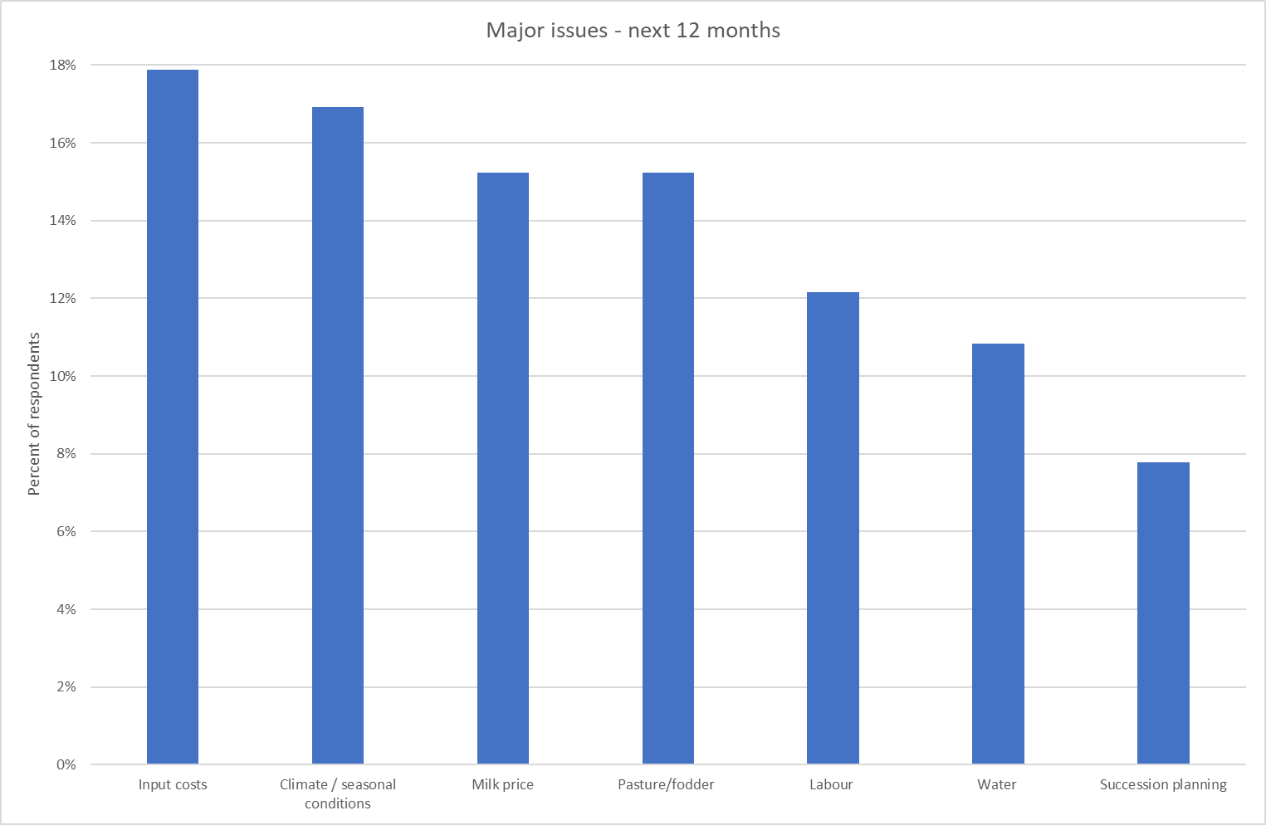
Issues of importance to dairy businesses- the next five years

In the medium term (five years), milk price was the most important issue followed closely by input costs and climate/seasonal conditions (Figure 47). This ranking was consistent at the state and regional level, with all regions ranking the issues in the same order. The uncertainty of the coronavirus (COVID-19) impacts on export markets and milk price was highlighted by farms in the short and medium terms.
FIGURE 47. MAJOR ISSUES FOR INDIVIDUAL BUSINESSES – 5-YEAR OUTLOOK
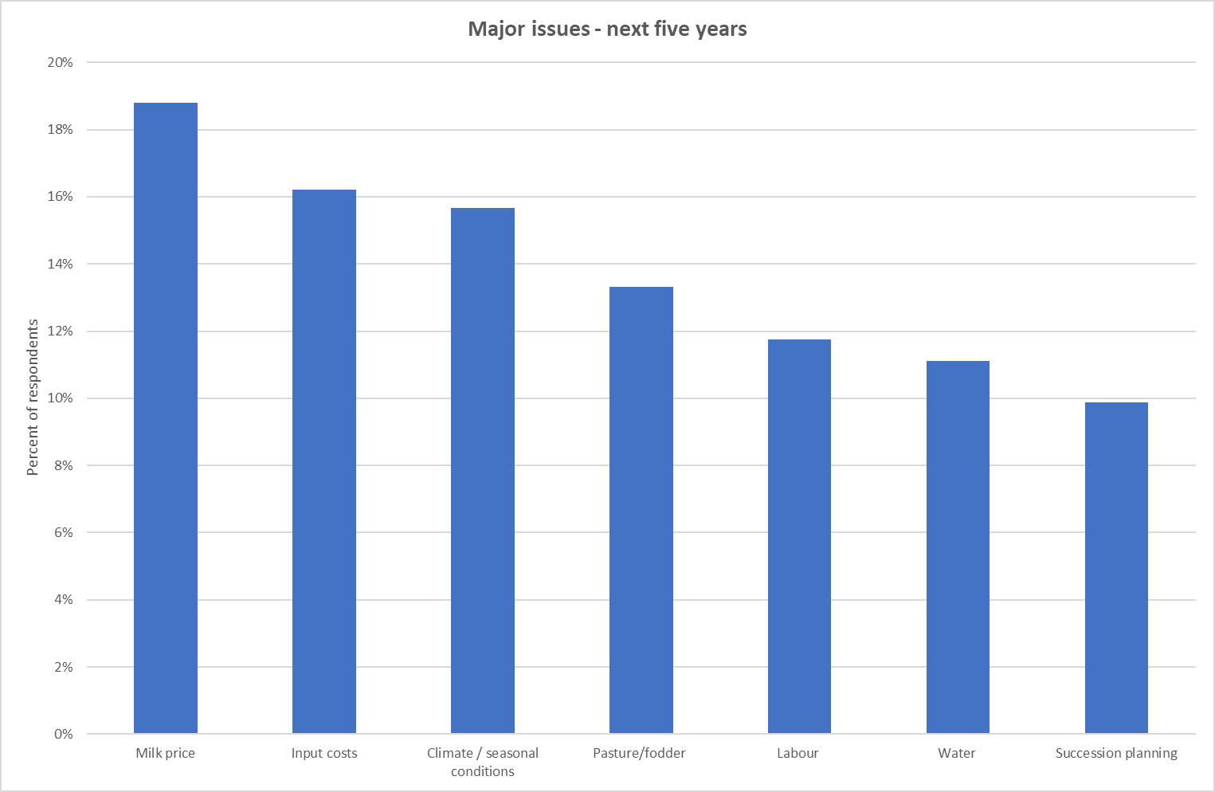

Part Six: Greenhouse Gas Emissions

2019-20 Greenhouse gas emissions
In 2019-20, the average estimated greenhouse gas emission intensity was 13.6 tonnes of carbon dioxide equivalents per tonne of milk solids sold (t CO₂-e/t MS). The greatest contributors to total farm emissions was (enteric) methane from ruminant digestion at 56% and pre-farm emissions sources at 14% (such as carbon dioxide from purchased feed and fertiliser).

In 2019-20, the average estimated greenhouse gas (GHG) emission intensity was 13.6 tonnes, as measured by tonnes of carbon dioxide equivalents per tonne of milk solids sold (t CO₂-e/t MS), a reduction of 7% from last year’s reported 14.5 t CO₂-e/t MS. The increase in production efficiency was achieved by producing more milk solids from a similar set of resources which was coupled with a reduction in fertiliser use due to the poor seasonal conditions for the first six months of the financial year across most of the state. Additional reductions have occurred with declining electricity use from conventional sources (grid) with an increased uptake of solar generated power. Total GHG emissions, however, increased slightly from the previous year at 2,742 t CO₂-e/t MS per farm, mainly due to increased herd size.
In 2019-20, estimated greenhouse gas emissions intensity ranged from 10.3 t CO₂-e/t MS to 17.1 t CO₂-e/t MS. The distribution of different emissions for 2019-20 is shown in Figure 48.
Methane was identified as the main GHG emitted from dairy farms, accounting for 8.8 t CO₂-e/t MS, 65% of all emissions. Of the methane gas, those produced from ruminant digestion (enteric CH₄) was the major source of emissions from all farms in this report, with an average of 56% of total emissions (7.5 CO₂-e/t MS). Methane from effluent ponds accounted for 9% of total emissions (1.2 CO₂-e/t MS) on average across the state in 2019-20.
The second main GHG emission was carbon dioxide (CO₂) produced primarily from fossil fuel consumption (electricity and fuel). Carbon dioxide accounted for 3.1 t CO₂-e/t MS, 23% of emissions in 2019-20. Greenhouse gases emitted during the manufacturing of fertilisers and during the production of purchased fodder, grain and concentrates are also included in this amount. Pre-farm gate sources accounted for 14% (1.9 CO₂-e/t MS) of the carbon dioxide emissions and 9% (1.2 CO₂-e/t MS) was from on-farm energy sources.
The third main greenhouse gas was nitrous oxide (N₂O) with an estimated emission of 1.7 t CO₂-e/t MS, 12% of all emissions. Nitrous oxide was produced from wastes (dung and urine), applied fertiliser and effluent ponds. Nitrous oxide emissions from fertiliser accounted for 2% of total emissions, effluent ponds accounted for 1% and excreta accounted for 4% of total emissions. Nitrous oxide from indirect emissions accounted for 5% of total emissions. Reduced fertiliser application due to the poor season also supported the reduction of N₂O emission this year.
The top 25% of farms in the state had higher total farm emission (2,861 t CO₂-e/farm) than the state average (2,742 t CO₂-e/ farm). However, taking account of their higher milk production per farm than the average, resulted in their slightly lower emissions per kg MS sold (13.1 t CO₂-e/t MS). This demonstrates how possible efficiency gains and economies of scale can result in a lower GHG emission profile.
The GHG estimation presented here does not include any carbon sequestration activities that may be accumulated in farm trees or soils. Further information on the Australian National Greenhouse Gas inventory can be found at the Department of the industry, Science, Energy and Resources website at https://www.industry.gov.au/strategies-for-the-future/australias-climate-change-strategies/tracking-and-reporting-greenhouse-gas-emissions

FIGURE 48. ESTIMATED 2019-20 AVERAGE GREENHOUSE GAS EMISSIONS (CO₂ EQUIVALENT)
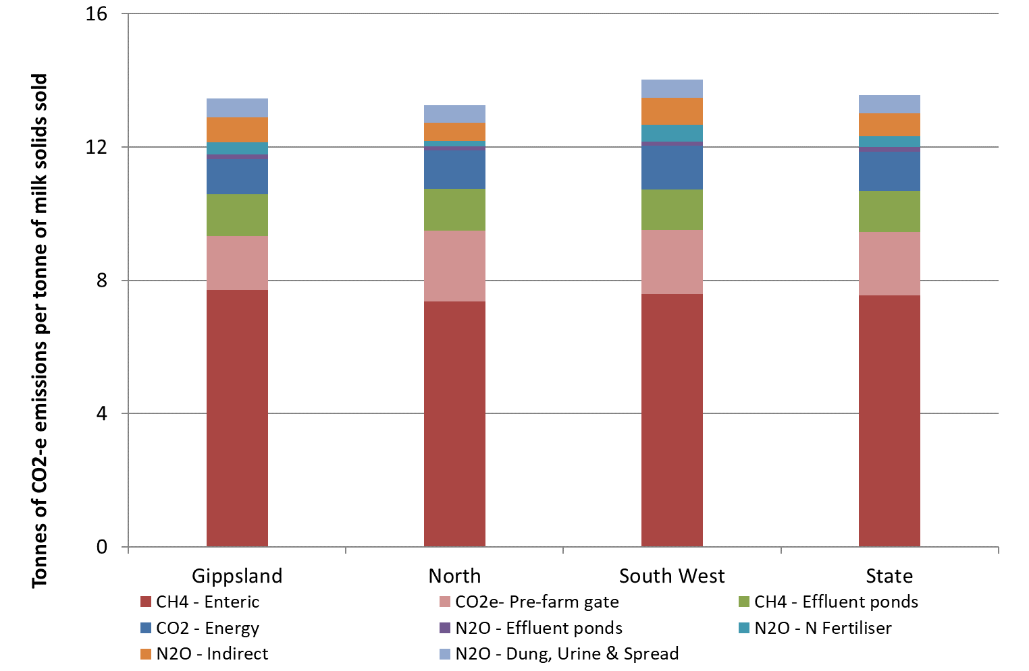

Part Seven: Historical analysis

Historical analysis
While nearly all DFMP farms experienced positive profits in 2019-20, with consistent performance reported across the regions, many farms have not fully recovered from the recent years of challenging conditions and lower performance.
The North

In 2019-20, the profit performance of farms in the North was the highest since 2013-14 (Figure 49). The improved milk price, seasonal and business conditions in the second half of 2019-20 helped farms post an average EBIT of $323,000 and net farm income of $221,000. Farms increased their cash flow and built their water and feed inventories however, many farms will require consecutive years of positive performance to recoup the negative performance recorded in recent years.
The previous four years (between 2015-16 and 2018-19) were characterised by low returns. There were periods with too much rain (first six-months of 2016-17), too little rain (2015-16, 2017-18 and 2018-19) and times of record high price of inputs and fluctuations in milk price. The milk price step-downs in April 2016 added financial stress to the challenges of the competitive water trading market and less than full seasonal determinations. Farmers have relied on equity or increased their debt to manage the fluctuations in profits. Having some level of debt enables farms to grow their wealth at a faster rate than without debt. However, the reverse is also true, when a farm has debt their ROE will fall away at a quicker rate than the decrease in ROTA (2015-16 and 2018-19) (Figure 50).
Prior to 2019-20, the highest returns for farms in the North occurred in 2013-14. In this year, farmers received 100% seasonal determinations enabling farms to apply water early in the season to offset lower than average spring rainfall. This was an improvement on the challenges experienced during 2012-13 corresponding with lower milk prices and high costs.
Earlier in the project’s history, farmers in the North were challenged with the millennium drought (2002-2009), low water allocations (43% in 2007-08; 35% in 2008-09) and high allocation water price. The annual median prices in the main water trading zones were between $260/ML and $400/ML between 2007 and 2009 ($340/ML and $520/ML when the effects of inflation are removed). This was followed by the global financial crisis (GFC) in 2008-09 causing mid-season milk price step downs. In 2009-10, farms were still recovering from the effects of the GFC and lingering drought.
Interest and lease costs remained relatively steady across all years except for decreases seen in the last two years.
Average ROTA was 4.1% in 2019-20, above the long-term average of 3.6% while ROE was 3.7% and higher than the long-term average of 1.5%.

FIGURE 49. FARM PROFITABILITY (REAL $) BETWEEN 2006-07 AND 2019-20 – NORTH
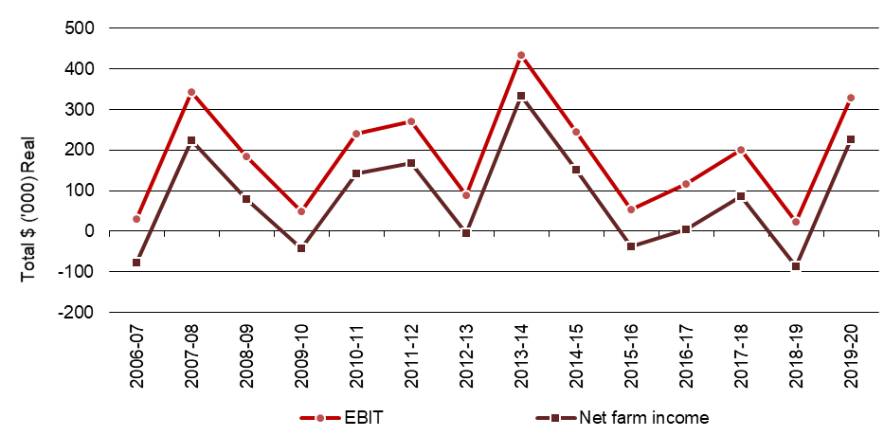
FIGURE 50. WHOLE FARM PERFORMANCE BETWEEN 2006-07 AND 2019-20 – NORTH
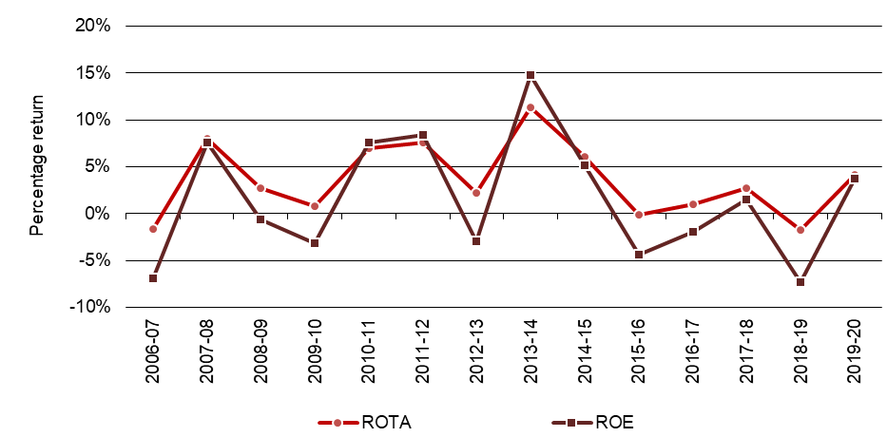
The South West

Farm profit in the South West improved for the third consecutive year in 2019-20 and was the highest since 2013-14 (Figure 51). All farms recorded positive EBIT performance in 2019-20 and of the 21 participating farms between years, 19 of these farms recorded higher profits than the previous year. The improved profit performance has helped farms build their net worth and most have increased the amount they have repaid on their liabilities than the previous year. Interest and lease costs have generally followed a downward trend since the highs seen in 2011-12 ($220,000) to $110,000 in 2019-20. When the same farms are considered, they have reduced their borrowings since 2017-18. Figure 54 shows average EBIT rose to $382,000 in 2019-20 and was the third highest recorded in the project. Net farm income was $273,000.
Figure 52 shows the largest fall in ROE in 2012-13. In this year, farmers experienced their most challenging year since the drought of 2006-07, relying on equity or further borrowings to manage the conditions. Spring rainfall was below average for a second consecutive year; the first time this had occurred since the 1981-82 drought while the remaining nine months between October 2012 and June 2013 was decile one rainfall for most of the region. Milk price also decreased, and farmers depleted their fodder reserves and purchased additional supplementary feed.
The following year, in 2013-14 was a year of recovery for farms in the South West. Improved seasonal conditions and reduced reliance on the purchased fodder market helped farms record performance among the highest for the project in this region. In the following two years, (2014-15 and 2015-16), seasonal conditions were drier than the long-term average providing challenges for South West farms. A welcome improvement to seasonal conditions and milk price led to better performance in 2016-17. The next two years (2017-18 and 2018-19) farm returns were similar before improving in 2019-20.
Average ROTA was 5.8% in 2019-20, above the long-term average of 4%. A return to positive performance for ROE, saw the average ROE in the South West increase to 9.6% in 2019-20 and was above the long-term average of 2.5% (Figure 55).

FIGURE 51. FARM PROFITABILITY (REAL $) BETWEEN 2006-07 AND 2019-20 – SOUTH WEST
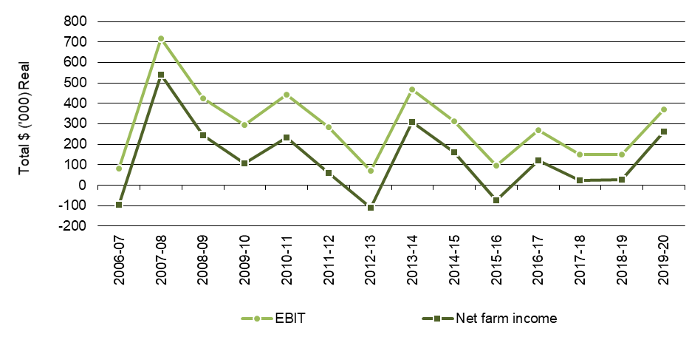

FIGURE 52. WHOLE FARM PERFORMANCE BETWEEN 2006-07 AND 2019-20 – SOUTH WEST
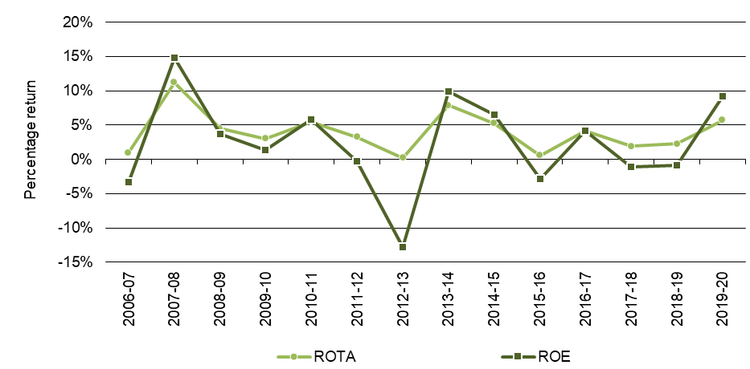

Gippsland

Gippsland farm performance varied across the geographical location of farms. In recent years, farms in east Gippsland have experienced four consecutive years of dry seasonal conditions. The challenging conditions have compromised homegrown feed production and increased their reliance on supplementary feed; which reached record high price in 2018-19. The farms located in the MID reliant on irrigation allocations and spill from Lake Glenmaggie have not always been received, increasing their reliance on purchased feed. Farms in south and west Gippsland have experienced more consistent rainfall despite being too wet at times.
Over the longer term, farm returns have generally followed a three-year cycle where the influences on profit have aligned and the strong returns were achieved in the third year (2007-08, 2010-11, 2013-14 and 2019-20).
The low performance recorded in 2012-13 was on the back of south and west Gippsland experiencing their most challenging year since 2006-07. Following an earlier wet 12-month period, in 2012-13 Gippsland experienced drier than average conditions. Farms drew heavily on their long-term fodder reserves and those in the MID strategically stopped irrigating some areas to maximise water use efficiency on more productive pastures. More recently, farmers drew on the fodder reserves in 2018-19 particularly those in east Gippsland and the MID. They supplemented the herd’s diet with purchased fodder at elevated prices. Then, in 2019-20, Gippsland farm profit improved from the previous year and was the second highest recorded in the history of the project (Figure 53). While there was wide variation in performance across the Gippsland DFMP farms, all farms returned positive EBIT performance in 2019-20. On average, farm EBIT rose to $337,000 in 2019-20 while net farm income was $238,000. Average interest and lease costs remained steady at $99,000.
On average, Gippsland ROTA increased to 6.6% which was above the long-term average of 3.8%. Average ROE posed a positive performance of 12.4%, well above the long-term average of 3.6%. (Figure 54).

FIGURE 53. FARM PROFITABILITY (REAL $) BETWEEN 2006-07 AND 2019-20 – GIPPSLAND
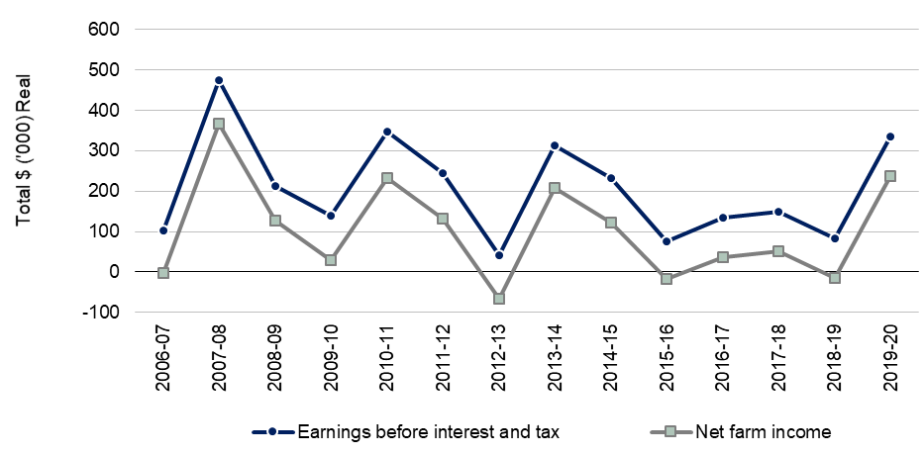

FIGURE 54. WHOLE FARM PERFORMANCE BETWEEN 2006-07 AND 2019-20 – GIPPSLAND
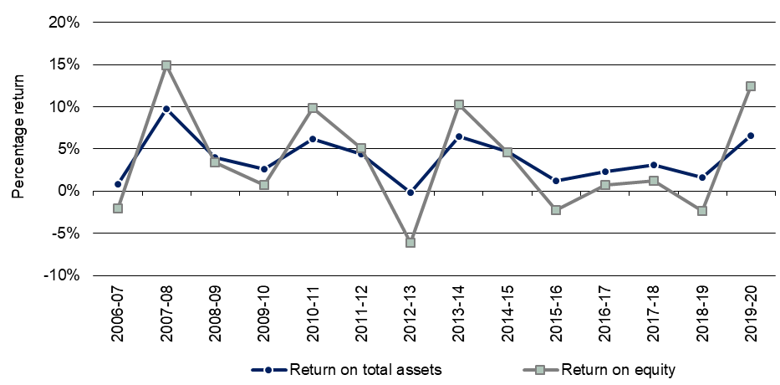

Appendices

Appendix A: Statewide summary tables
Table A1
Main financial indicators - Statewide
 | Milk income (net)  ($/ kg MS) | All other farm income  ($/ kg MS) | Gross farm income  ($/ kg MS) | Total variable costs  ($/ kg MS) | Total overhead costs  ($/ kg MS) | Cost structure (variable costs / total costs) (%) | Earnings Before Interest & Tax  ($/ kg MS) | Return on total assets (%) | Interest & lease charges  ($/ kg MS) | Debt servicing ratio  (% of income) | Net farm income (  $/ kg MS) | Return on equity  (%)
Average | $7.15 | $0.72 | $7.87 | $3.88 | $2.31 | 62% | $1.68 | 5.4% | $0.54 | 6.8% | $1.14 | 8.3%
Top 25% | $7.20 | $0.78 | $7.98 | $3.28 | $1.92 | 63% | $2.78 | 9.8% | $0.60 | 7.4% | $2.18 | 20.8%

Table A2
Physical information - Statewide
 | Total usable area  (ha) | Milking area (ha) | Total water use efficiency (t DM/100mm) | Number of milking cows (cows) | Milking cows per usable area (cows/ha) | Milk sold  (kg MS/ cow) | Milk sold  (kg MS/ ha) | Fat  (%) | Protein  (%)
Average | 277 | 161 | 0.8 | 369 | 1.5 | 525 | 794 | 4.3% | 3.5%
Top 25% | 259 | 159 | 0.9 | 387 | 1.8 | 538 | 914 | 4.3% | 3.5%

Table A2
Physical information - Statewide (continued)
 | Estimated grazed pasture**  (t DM/ ha) | Estimated conserved feed**  (t DM/ ha) | Home grown feed as % of ME consumed  (% of ME) | Nitrogen application** (kg/ ha) | Phosphorous application** (kg/ ha) | Potassium application** (kg/ ha) | Sulphur application** (kg/ ha) | Labour efficiency (cows/ FTE) | Labour efficiency (kg MS/ FTE)
Average | 6.3 | 1.4 | 61% | 156.6 | 18.7 | 30.6 | 18.7 | 107 | 55,478
Top 25% | 7.9 | 1.5 | 66% | 231.6 | 18.6 | 41.7 | 18.7 | 126 | 66,491
**on milking area

Table A3
Purchased feed - Statewide
 | Purchased feed per milker**  (t DM/ cow) | Concentrate price  ($/ t DM) | Silage price  ($/ t DM) | Hay price  ($/ t DM) | Other feed price  ($/ t DM) | Average purchased feed price  ($/ t DM) | Purchased feed as % of ME consumed  (% of ME)
Average | 2.7 | $495 | $249 | $300 | $345 | $439 | 39%
Top 25% | 2.3 | $478 |  |  |  | $446 | 34%
** All purchased feed including concentrates, hay, silage and other feed fed on the usable area to all classes of livestock divided by the number of cows
Calculation of average price of silage, hay and other feed excludes zero values

Table A4
Variable costs - Statewide
 | AI and herd test  ($/ kg MS) | Animal health ($/ kg MS) | Calf rearing ($/ kg MS) | Shed power  ($/ kg MS) | Dairy supplies ($/ kg MS) | Total herd and shed costs  ($/ kg MS) | Fertiliser  ($/ kg MS) | Irrigation **  ($/ kg MS) | Hay and silage making  ($/ kg MS)
Average | $0.13 | $0.14 | $0.05 | $0.13 | $0.09 | $0.54 | $0.45 | $0.36 | $0.20
Top 25% | $0.13 | $0.12 | $0.05 | $0.11 | $0.09 | $0.49 | $0.56 | $0.23 | $0.25
** Calculation of average cost of irrigation excludes zero values

Table A4
Variable costs - Statewide (continued)
 | Fuel and oil  ($/ kg MS) | Pasture improvement/ cropping  ($/ kg MS) | Other feed costs  ($/ kg MS) | Fodder purchases  ($/ kg MS) | Grain/ concentrates/ other  ($/ kg MS) | Agistment costs ($/ kg MS) | Feed and water inventory change  ($/ kg MS) | Total feed costs ($/ kg MS) | Total variable costs  ($/ kg MS)
Average | $0.10 | $0.20 | $0.02 | $0.57 | $1.70 | $0.07 | -$0.22 | $3.33 | $3.88
Top 25% | $0.08 | $0.13 | $0.02 | $0.27 | $1.61 | $0.07 | -$0.33 | $2.79 | $3.28

Table A5
Overhead costs - Statewide
 | Rates ($/ kg MS) | Farm Insurance ($/ kg MS) | Motor vehicle expenses ($/ kg MS) | Repairs and maintenance ($/ kg MS) | Other overheads ($/ kg MS) | Employed labour ($/ kg MS) | Total cash overheads ($/ kg MS) | Depreciation ($/ kg MS) | Imputed labour cost ($/ kg MS) | Total overheads ($/ kg MS)
Average | $0.05 | $0.08 | $0.03 | $0.36 | $0.13 | $0.59 | $1.24 | $0.24 | $0.83 | $2.31
Top 25% | $0.04 | $0.06 | $0.02 | $0.34 | $0.12 | $0.53 | $1.11 | $0.21 | $0.61 | $1.92

Table A6
Capital structure - Statewide
 | Farm assets* Land value ($/ha) | Farm assets* Land value ($/cow) | Farm assets* Permanent water value ($/ha) | Farm assets* Permanent water value ($/cow) | Other farm assets (per usable hectare) Plant and equipment ($/ha) | Other farm assets (per usable hectare) Livestock ($/ha) | Other farm assets (per usable hectare) Hay and grain ($/ha) | Other farm assets (per usable hectare) Other assets ($/ha) | Total assets ($/ha)
Average | $11,498 | $8,327 | $7,399 | $4,404 | $1,226 | $3,320 | $332 | $585 | $20,580
Top 25% | $11,053 | $6,617 | $2,546 | $1,276 | $1,293 | $3,676 | $356 | $473 | $19,397
*Calculation of average values of land, water asset and equity excludes zero values.

Table A6
Capital structure - Statewide (continued)
 | Liabilities per usable hectare ($/ha) | Liabilities per milking cow ($/cow) | Equity per usable hectare ($/ha) | Average equity (%)
Average | $6,497 | $4,511 | $14,083 | 67%
Top 25% | $7,066 | $4,030 | $12,331 | 65%

Table A7
Historical data - Statewide
Main financial indicators
Year | Income  Milk income (net) Nominal ($/kg MS) | Income  Milk income (net) Real  ($/kg MS) | Income  Gross farm income Nominal ($/kg MS) | Income  Gross farm income Real  ($/kg MS) | Variable costs  Herd costs Nominal ($/kg MS) | Variable costs  Herd costs Real  ($/kg MS) | Variable costs  Shed costs Nominal ($/kg MS) | Variable costs  Shed costs Real  ($/kg MS) | Variable costs  Feed costs Nominal ($/kg MS) | Variable costs  Feed costs Real  ($/kg MS) | Total variable costs Nominal ($/kg MS) | Total variable costs  Real  ($/kg MS)
2006-07 | $4.46 | $6.15 | $5.23 | $7.20 | $0.21 | $0.29 | $0.15 | $0.20 | $2.83 | $3.90 | $3.23 | $4.45
2007-08 | $6.57 | $8.63 | $7.80 | $10.25 | $0.24 | $0.31 | $0.14 | $0.19 | $3.39 | $4.45 | $3.79 | $4.98
2008-09 | $5.35 | $6.74 | $6.08 | $7.66 | $0.23 | $0.29 | $0.15 | $0.19 | $2.85 | $3.60 | $3.23 | $4.07
2009-10 | $4.46 | $5.45 | $5.17 | $6.31 | $0.22 | $0.27 | $0.16 | $0.19 | $2.20 | $2.69 | $2.58 | $3.15
2010-11 | $5.64 | $6.69 | $6.47 | $7.68 | $0.26 | $0.31 | $0.18 | $0.22 | $2.27 | $2.69 | $2.71 | $3.22
2011-12 | $5.52 | $6.43 | $5.97 | $6.96 | $0.26 | $0.30 | $0.19 | $0.22 | $2.33 | $2.71 | $2.78 | $3.23
2012-13 | $4.90 | $5.55 | $5.25 | $5.95 | $0.27 | $0.31 | $0.22 | $0.25 | $2.59 | $2.93 | $3.08 | $3.49
2013-14 | $6.79 | $7.49 | $7.44 | $8.21 | $0.28 | $0.30 | $0.22 | $0.24 | $2.90 | $3.20 | $3.39 | $3.74
2014-15 | $6.04 | $6.52 | $6.61 | $7.13 | $0.29 | $0.31 | $0.20 | $0.21 | $2.90 | $3.13 | $3.39 | $3.66
2015-16 | $5.40 | $5.75 | $5.90 | $6.29 | $0.28 | $0.30 | $0.19 | $0.20 | $3.15 | $3.36 | $3.62 | $3.86
2016-17 | $5.07 | $5.30 | $5.80 | $6.06 | $0.29 | $0.30 | $0.20 | $0.21 | $2.40 | $2.51 | $2.89 | $3.02
2017-18 | $5.81 | $5.95 | $6.41 | $6.57 | $0.31 | $0.32 | $0.22 | $0.22 | $2.93 | $3.01 | $3.46 | $3.55
2018-19 | $6.13 | $6.21 | $6.76 | $6.85 | $0.32 | $0.32 | $0.23 | $0.23 | $3.62 | $3.67 | $4.17 | $4.22
2019-20 | $7.15 | $7.15 | $7.87 | $7.87 | $0.32 | $0.32 | $0.23 | $0.23 | $3.33 | $3.33 | $3.88 | $3.88
Average |  | $6.43 |  | $7.21 |  | $0.30 |  | $0.21 |  | $3.23 |  | $3.75
Notes: 'Real' dollar values are the nominal values converted to 2019-20 dollar equivalents by the consumer price index (CPI) to allow for inflation
From 2016-17 Gross farm income does not include feed inventory changes and changes to the value of carry-over water. These are included in feed costs.

Table A7
Historical data - Statewide
Main financial indicators (continued)
Year | Overhead costs  Cash overhead costs Nominal ($/kg MS) | Overhead costs  Cash overhead costs Real  ($/kg MS) | Overhead costs  Non-cash overhead costs Nominal  ($/kg MS) | Overhead costs  Non-cash overhead costs Real  ($/kg MS) | Overhead costs  Total overhead costs Nominal ($/kg MS) | Overhead costs  Total overhead costs Real ($/kg MS)
2006-07 | $0.77 | $1.06 | $1.17 | $1.61 | $1.94 | $2.67
2007-08 | $0.84 | $1.11 | $0.88 | $1.16 | $1.62 | $2.14
2008-09 | $0.82 | $1.03 | $0.88 | $1.11 | $1.70 | $2.14
2009-10 | $0.84 | $1.03 | $1.05 | $1.28 | $1.89 | $2.30
2010-11 | $1.00 | $1.19 | $1.02 | $1.21 | $2.02 | $2.40
2011-12 | $0.99 | $1.15 | $1.07 | $1.24 | $2.06 | $2.39
2012-13 | $0.99 | $1.12 | $1.09 | $1.23 | $2.08 | $2.36
2013-14 | $1.05 | $1.16 | $0.97 | $1.07 | $2.03 | $2.24
2014-15 | $1.08 | $1.16 | $0.90 | $0.97 | $1.97 | $2.13
2015-16 | $1.07 | $1.14 | $1.03 | $1.10 | $2.10 | $2.23
2016-17 | $1.09 | $1.14 | $1.06 | $1.11 | $2.16 | $2.25
2017-18 | $1.18 | $1.21 | $1.11 | $1.14 | $2.29 | $2.35
2018-19 | $1.22 | $1.23 | $1.12 | $1.14 | $2.34 | $2.37
2019-20 | $1.24 | $1.24 | $1.07 | $1.07 | $2.31 | $2.31
Average |  | $1.14 |  | $1.17 |  | $2.31

Table A7
Historical data - Statewide
Main financial indicators (continued)
Year | Profit  Earnings before interest and tax  Nominal ($/kg MS) | Profit  Earnings before interest and tax  Real  ($/kg MS) | Profit  Interest & lease charges  Nominal  ($/kg MS) | Profit  Interest & lease charges  Real  ($/kg MS) | Profit  Net farm income  Nominal  ($/kg MS) | Profit  Net farm income  Real  ($/kg MS) | Profit  Return on total assets  % | Profit  Return on equity  %
2006-07 | $0.06 | $0.08 | $0.58 | $0.80 | -$0.52 | -$0.72 | 0.1% | -4.1%
2007-08 | $2.39 | $3.14 | $0.63 | $0.83 | $1.75 | $2.30 | 9.8% | 12.4%
2008-09 | $1.08 | $1.36 | $0.59 | $0.74 | $0.49 | $0.62 | 3.8% | 2.2%
2009-10 | $0.65 | $0.79 | $0.68 | $0.83 | -$0.03 | -$0.03 | 2.2% | -0.3%
2010-11 | $1.73 | $2.06 | $0.76 | $0.90 | $0.98 | $1.16 | 6.2% | 7.8%
2011-12 | $1.14 | $1.33 | $0.71 | $0.83 | $0.43 | $0.50 | 5.0% | 4.4%
2012-13 | $0.09 | $0.11 | $0.70 | $0.79 | -$0.60 | -$0.68 | 0.7% | -7.3%
2013-14 | $2.02 | $2.23 | $0.65 | $0.71 | $1.38 | $1.52 | 8.5% | 11.6%
2014-15 | $1.25 | $1.34 | $0.60 | $0.65 | $0.64 | $0.69 | 5.3% | 5.2%
2015-16 | $0.18 | $0.19 | $0.59 | $0.63 | -$0.41 | -$0.44 | 0.6% | -3.2%
2016-17 | $0.75 | $0.79 | $0.63 | $0.66 | $0.12 | $0.13 | 2.5% | 1.0%
2017-18 | $0.66 | $0.68 | $0.61 | $0.63 | $0.05 | $0.05 | 2.5% | 0.4%
2018-19 | $0.25 | $0.26 | $0.64 | $0.65 | -$0.39 | -$0.39 | 0.7% | -3.5%
2019-20 | $1.68 | $1.68 | $0.54 | $0.54 | $1.14 | $1.14 | 5.4% | 8.3%
Average |  | $1.14 |  | $0.73 |  | $0.42 | 3.8% | 2.5%

Table A8
Historical data - Statewide
Average farm physical information
Year | Total usable area (ha) | Milking area (ha) | Total water use efficiency  (t DM/100mm/ha) | Number of milking cows (cows) | Milking cows per usable area (cows/ha) | Milk sold (kg MS/ cow) | Milk sold (kg MS/ ha)
2006-07 | 271 | 268 | 0.8 | 345 | 1.4 | 447 | 636
2007-08 | 265 | 250 | 0.8 | 332 | 1.3 | 489 | 612
2008-09 | 256 | 237 | 0.8 | 330 | 1.5 | 498 | 741
2009-10 | 232 | 219 | 0.8 | 307 | 1.5 | 496 | 752
2010-11 | 236 | 227 | 0.7 | 305 | 1.4 | 493 | 719
2011-12 | 237 | 160 | 0.7 | 328 | 1.6 | 508 | 800
2012-13 | 232 | 154 | 0.8 | 323 | 1.6 | 495 | 781
2013-14 | 242 | 157 | 0.8 | 335 | 1.6 | 498 | 810
2014-15 | 248 | 160 | 0.9 | 350 | 1.6 | 514 | 845
2015-16 | 252 | 162 | 0.7 | 345 | 1.6 | 511 | 818
2016-17 | 268 | 166 | 0.7 | 342 | 1.5 | 503 | 748
2017-18 | 264 | 166 | 0.7 | 352 | 1.5 | 503 | 752
2018-19 | 261 | 162 | 0.9 | 357 | 1.6 | 495 | 757
2019-20 | 277 | 161 | 0.8 | 369 | 1.5 | 525 | 794
Average | 253 | 189 | 0.8 | 337 | 1.5 | 498 | 755

Table A8
Historical data - Statewide
Average farm physical information (continued)
Year | Estimated grazed pasture* (t DM/ ha) | Estimated conserved feed* (t DM/ ha) | Home grown feed as % of ME consumed (% of ME) | Concentrate price Nominal ($/T DM) | Concentrate price  Real  ($/ T DM)
2006-07 | 4.9 | 1.0 | 60% | $329 | $453
2007-08 | 4.8 | 1.0 | 64% | $425 | $559
2008-09 | 5.6 | 0.9 | 62% | $375 | $473
2009-10 | 6.2 | 0.8 | 66% | $273 | $333
2010-11 | 5.8 | 1.9 | 65% | $301 | $357
2011-12 | 6.2 | 1.0 | 57% | $296 | $345
2012-13 | 6.2 | 1.2 | 58% | $336 | $381
2013-14 | 6.6 | 1.4 | 62% | $388 | $428
2014-15 | 6.5 | 1.2 | 59% | $405 | $437
2015-16 | 5.8 | 1.2 | 53% | $402 | $428
2016-17 | 6.5 | 1.6 | 65% | $335 | $350
2017-18 | 6.1 | 1.5 | 62% | $373 | $383
2018-19 | 6.4 | 1.7 | 65% | $514 | $527
2019-20 | 6.3 | 1.4 | 61% | $495 | $495
Average | 6.0 | 1.3 | 61% |  | $425
* From 2006-07 to 2010-11 estimated grazed pasture and conserved feed was calculated per usable hectare
From 2011-12 estimated grazed pasture and conserved feed was calculated per hectare of milking area

Appendix B: North summary tables

Table B1
Main financial indicators - North
Farm number | Milk income (net)  ($/ kg MS) | All other farm income  ($/ kg MS) | Gross farm income  ($/ kg MS) | Total variable costs  ($/ kg MS) | Total overhead costs  ($/ kg MS) | Cost structure (variable costs / total costs) (%) | Earnings Before Interest & Tax  ($/ kg MS) | Return on total assets  (%) | Interest & lease charges  ($/ kg MS) | Debt servicing ratio  (% of income) | Net farm income  ($/ kg MS) | Return on equity  (%)
NO0012 | $7.03 | $1.01 | $8.04 | $4.76 | $1.75 | 73% | $1.54 | 5.4% | $0.04 | 0.6% | $1.49 | 5.9%
NO0014 | $6.62 | $1.36 | $7.98 | $4.21 | $2.20 | 66% | $1.56 | 5.4% | $0.48 | 6.1% | $1.08 | 5.7%
NO0015 | $7.50 | $0.77 | $8.27 | $4.40 | $2.05 | 68% | $1.83 | 5.3% | $0.56 | 6.8% | $1.27 | 5.8%
NO0022 | $7.69 | $0.57 | $8.25 | $4.03 | $1.73 | 70% | $2.50 | 6.1% | $0.16 | 1.9% | $2.34 | 6.8%
NO0023 | $7.17 | $0.65 | $7.82 | $4.48 | $1.93 | 70% | $1.41 | 5.6% | $0.33 | 4.3% | $1.07 | 6.3%
NO0027 | $7.01 | $0.95 | $7.96 | $4.32 | $2.56 | 63% | $1.09 | 5.0% | $0.47 | 5.9% | $0.62 | 5.6%
NO0035 | $7.83 | $0.76 | $8.59 | $4.58 | $3.50 | 57% | $0.50 | 0.8% | $0.20 | 2.3% | $0.30 | 0.5%
NO0039 | $6.80 | $0.75 | $7.55 | $5.03 | $2.07 | 71% | $0.44 | 1.8% | $0.98 | 13.0% | -$0.54 | -4.5%
NO0041 | $7.60 | $0.39 | $8.00 | $4.86 | $1.93 | 72% | $1.21 | 3.9% | $0.58 | 7.2% | $0.63 | 4.9%
NO0043 | $7.51 | -$1.12 | $6.39 | $5.01 | $3.04 | 62% | -$1.66 | -5.6% | $0.79 | 12.4% | -$2.46 | -17.1%
NO0052 | $7.49 | $0.43 | $7.92 | $6.08 | $2.88 | 68% | -$1.04 | -6.3% | $0.59 | 7.4% | -$1.63 | -20.4%
NO0054 | $7.00 | $0.83 | $7.83 | $5.34 | $1.96 | 73% | $0.53 | 1.8% | $0.57 | 7.3% | -$0.04 | -0.2%
NO0056 | $7.32 | $0.97 | $8.29 | $4.60 | $2.15 | 68% | $1.54 | 4.1% | $0.80 | 9.6% | $0.75 | 4.6%
NO0059 | $6.91 | $0.73 | $7.63 | $4.94 | $1.62 | 75% | $1.07 | 5.2% | $0.64 | 8.3% | $0.44 | 6.0%
NO0064 | $7.85 | $1.31 | $9.16 | $5.63 | $1.83 | 75% | $1.71 | 6.1% | $0.50 | 5.4% | $1.21 | 6.0%
NO0065 | $7.32 | $1.28 | $8.60 | $5.15 | $2.05 | 72% | $1.40 | 4.0% | $0.91 | 10.6% | $0.48 | 7.2%
NO0068 | $7.34 | $0.43 | $7.76 | $3.10 | $1.54 | 67% | $3.13 | 7.3% | $0.02 | 0.3% | $3.11 | 7.5%
NO0069 | $9.61 | $0.52 | $10.13 | $4.60 | $3.34 | 58% | $2.19 | 4.2% | $0.66 | 6.5% | $1.53 | 3.9%
NO0071 | $7.49 | $0.83 | $8.32 | $6.15 | $1.54 | 80% | $0.63 | 2.5% | $0.41 | 5.0% | $0.21 | 1.4%
NO0072 | $6.91 | $0.56 | $7.48 | $3.85 | $2.69 | 59% | $0.93 | 1.9% | $0.01 | 0.1% | $0.92 | 2.0%
NO0073 | $7.05 | $0.80 | $7.85 | $3.42 | $2.29 | 60% | $2.13 | 6.3% | $0.34 | 4.3% | $1.79 | 7.9%
NO0075 | $7.31 | $0.81 | $8.11 | $4.14 | $2.12 | 66% | $1.85 | 7.8% | $0.27 | 3.3% | $1.59 | 8.7%
NO0076 | $7.14 | $0.50 | $7.64 | $4.93 | $2.01 | 71% | $0.70 | 2.3% | $0.26 | 3.4% | $0.44 | 1.7%
NO0078 | $7.48 | $0.45 | $7.93 | $4.30 | $1.33 | 76% | $2.30 | 9.3% | $0.77 | 9.6% | $1.54 | 11.6%
NO0079 | $6.94 | $1.39 | $8.33 | $3.72 | $2.46 | 60% | $2.15 | 7.6% | $0.66 | 8.0% | $1.49 | 13.4%
NO0080 | $6.60 | $0.45 | $7.05 | $4.81 | $1.57 | 75% | $0.67 | 5.2% | $0.23 | 3.2% | $0.45 | 5.5%
NO0081 | $7.17 | $0.60 | $7.77 | $3.75 | $1.95 | 66% | $2.07 | 9.1% | $0.06 | 0.7% | $2.01 | 9.9%
NO0082 | $6.97 | $0.90 | $7.87 | $5.31 | $1.73 | 75% | $0.83 | 6.2% | $0.32 | 4.0% | $0.51 | 9.4%
NO0084 | $7.18 | $0.78 | $7.97 | $3.64 | $2.36 | 61% | $1.96 | 5.8% | $0.57 | 7.1% | $1.39 | 8.6%
NO0085 | $7.42 | $0.42 | $7.84 | $5.21 | $3.15 | 62% | -$0.52 | -1.4% | $0.31 | 4.0% | -$0.83 | -3.2%
Average | $7.31 | $0.70 | $8.01 | $4.61 | $2.18 | 68% | $1.22 | 4.1% | $0.45 | 5.6% | $0.77 | 3.7%
Top 25%* | $7.18 | $0.77 | $7.95 | $3.96 | $1.92 | 67% | $2.07 | 7.7% | $0.35 | 4.3% | $1.72 | 9.8%
* Top 25% are bold and italicised

Table B2
Physical information - North
Farm number | Total usable area (ha) | Milking area (ha) | Total water use efficiency (t DM/100mm) | Number of milking cows (cows) | Milking cows per usable area (cows/ha) | Milk sold  (kg MS/ cow) | Milk sold  (kg MS/ ha) | Fat  (%) | Protein  (%)
NO0012 | 472 | 372 | 0.7 | 840 | 1.8 | 635 | 1,130 | 4.2% | 3.5%
NO0014 | 496 | 320 | 0.7 | 507 | 1.0 | 550 | 563 | 3.6% | 3.3%
NO0015 | 247 | 92 | 0.8 | 315 | 1.3 | 523 | 666 | 4.6% | 3.6%
NO0022 | 226 | 105 | 0.9 | 300 | 1.3 | 527 | 699 | 4.7% | 3.6%
NO0023 | 342 | 155 | 0.9 | 430 | 1.3 | 568 | 714 | 4.4% | 3.6%
NO0027 | 1170 | 220 | 1.0 | 793 | 0.7 | 795 | 539 | 4.3% | 3.4%
NO0035 | 109 | 66 | 0.5 | 153 | 1.4 | 538 | 755 | 4.2% | 3.4%
NO0039 | 170 | 70 | 0.7 | 310 | 1.8 | 474 | 865 | 4.6% | 3.7%
NO0041 | 217 | 153 | 0.9 | 320 | 1.5 | 564 | 832 | 4.3% | 3.5%
NO0043 | 144 | 144 | 0.8 | 151 | 1.0 | 446 | 467 | 4.3% | 3.5%
NO0052 | 46 | 44 | 1.0 | 120 | 2.6 | 573 | 1,495 | 4.1% | 3.4%
NO0054 | 1131 | 310 | 1.0 | 1,579 | 1.4 | 580 | 809 | 3.8% | 3.3%
NO0056 | 264 | 90 | 0.7 | 258 | 1.0 | 665 | 650 | 4.0% | 3.3%
NO0059 | 311 | 75 | 0.5 | 290 | 0.9 | 514 | 479 | 4.4% | 3.4%
NO0064 | 289 | 254 | 0.7 | 650 | 2.2 | 541 | 1,216 | 5.0% | 3.8%
NO0065 | 218 | 108 | 1.0 | 419 | 1.9 | 610 | 1,173 | 4.1% | 3.5%
NO0068 | 353 | 277 | 1.5 | 852 | 2.4 | 376 | 908 | 4.6% | 3.7%
NO0069 | 162 | 100 | 0.7 | 170 | 1.0 | 456 | 478 | 4.9% | 3.8%
NO0071 | 173 | 80 | 0.9 | 320 | 1.8 | 625 | 1,157 | 4.1% | 3.3%
NO0072 | 195 | 57 | 0.8 | 190 | 1.0 | 553 | 539 | 4.3% | 3.6%
NO0073 | 389 | 230 | 0.6 | 470 | 1.2 | 536 | 648 | 3.8% | 3.3%
NO0075 | 280 | 190 | 0.8 | 520 | 1.9 | 611 | 1,135 | 4.4% | 3.7%
NO0076 | 142 | 96 | 0.7 | 330 | 2.3 | 614 | 1,430 | 5.3% | 3.9%
NO0078 | 269 | 100 | 1.1 | 354 | 1.3 | 711 | 936 | 4.1% | 3.4%
NO0079 | 118 | 118 | 0.9 | 160 | 1.4 | 425 | 576 | 4.5% | 3.6%
NO0080 | 80 | 80 | 0.7 | 250 | 3.1 | 590 | 1,857 | 4.5% | 3.6%
NO0081 | 368 | 80 | 1.1 | 500 | 1.4 | 660 | 898 | 4.1% | 3.4%
NO0082 | 331 | 180 | 1.0 | 483 | 1.5 | 630 | 920 | 4.0% | 3.4%
NO0084 | 168 | 120 | 0.9 | 300 | 1.8 | 550 | 983 | 4.5% | 3.5%
NO0085 | 238 | 78 | 0.5 | 220 | 0.9 | 544 | 502 | 4.6% | 3.6%
Average | 304 | 145 | 0.8 | 418 | 1.5 | 566 | 867 | 4.3% | 3.5%
Top 25%* | 301 | 168 | 1.0 | 477 | 1.6 | 564 | 860 | 4.2% | 3.5%

Table B2
Physical information - North (continued)
Farm number | Estimated grazed pasture**  (t DM/ ha) | Estimated conserved feed**  (t DM/ ha) | Home grown feed as % of ME consumed  (% of ME) | Nitrogen application** (kg/ ha) | Phosphorous application** (kg/ ha) | Potassium application** (kg/ ha) | Sulphur application** (kg/ ha) | Labour efficiency (cows/ FTE) | Labour efficiency  (kg MS/ FTE)
NO0012 | 2.2 | 2.1 | 46% | 101.1 | 16.1 | 0.0 | 1.3 | 129 | 82,160
NO0014 | 6.5 | 3.5 | 59% | 160.1 | 36.8 | 25.3 | 63.7 | 85 | 46,586
NO0015 | 8.4 | 0.9 | 57% | 15.2 | 47.2 | 41.5 | 52.2 | 110 | 57,442
NO0022 | 7.9 | 0.8 | 59% | 79.8 | 14.5 | 4.6 | 4.7 | 124 | 65,118
NO0023 | 7.5 | 0.6 | 53% | 106.9 | 35.0 | 39.0 | 19.0 | 113 | 64,065
NO0027 | 1.9 | 1.4 | 42% | 0.0 | 0.0 | 0.0 | 0.0 | 65 | 51,534
NO0035 | 4.5 | 0.3 | 44% | 12.3 | 13.6 | 0.0 | 1.1 | 67 | 35,796
NO0039 | 4.1 | 0.0 | 31% | 68.8 | 10.0 | 0.0 | 0.8 | 106 | 50,451
NO0041 | 5.6 | 0.1 | 42% | 54.1 | 0.0 | 0.0 | 0.0 | 105 | 59,401
NO0043 | 3.9 | 0.3 | 59% | 0.0 | 0.0 | 0.0 | 0.0 | 119 | 53,166
NO0052 | 5.3 | 0.3 | 31% | 16.4 | 20.0 | 3.0 | 2.5 | 64 | 36,542
NO0054 | 2.2 | 0.0 | 57% | 219.4 | 61.6 | 19.7 | 1.6 | 100 | 58,191
NO0056 | 6.6 | 0.3 | 56% | 158.5 | 34.6 | 49.4 | 27.4 | 92 | 60,911
NO0059 | 6.3 | 0.0 | 38% | 0.0 | 0.0 | 0.0 | 0.0 | 113 | 57,955
NO0064 | 5.8 | 0.0 | 32% | 165.4 | 19.8 | 0.0 | 8.6 | 138 | 74,839
NO0065 | 4.6 | 0.7 | 45% | 85.2 | 0.0 | 0.0 | 0.0 | 88 | 54,019
NO0068 | 11.3 | 4.0 | 90% | 233.4 | 3.7 | 0.0 | 7.0 | 203 | 76,268
NO0069 | 5.2 | 0.8 | 73% | 0.0 | 22.6 | 0.0 | 2.0 | 82 | 37,169
NO0071 | 6.5 | 0.5 | 45% | 84.5 | 17.1 | 12.6 | 34.3 | 116 | 72,504
NO0072 | 9.0 | 0.8 | 67% | 123.4 | 20.7 | 46.0 | 25.7 | 68 | 37,555
NO0073 | 5.4 | 3.5 | 65% | 218.1 | 5.4 | 18.5 | 14.5 | 106 | 56,805
NO0075 | 2.9 | 2.3 | 38% | 95.4 | 0.0 | 0.0 | 1.7 | 93 | 56,920
NO0076 | 5.3 | 2.3 | 35% | 61.2 | 26.2 | 44.6 | 49.3 | 86 | 52,579
NO0078 | 7.0 | 0.0 | 45% | 62.8 | 25.8 | 0.0 | 2.1 | 136 | 96,794
NO0079 | 5.4 | 0.0 | 65% | 47.1 | 4.7 | 9.9 | 3.9 | 111 | 47,319
NO0080 | 5.0 | 0.6 | 25% | 149.6 | 2.9 | 16.4 | 31.1 | 106 | 62,497
NO0081 | 5.7 | 0.0 | 51% | 46.0 | 4.4 | 0.0 | 12.2 | 95 | 62,727
NO0082 | 7.2 | 0.0 | 46% | 51.4 | 40.6 | 15.2 | 22.4 | 101 | 63,546
NO0084 | 6.2 | 1.0 | 53% | 12.9 | 28.5 | 12.5 | 26.2 | 90 | 49,749
NO0085 | 4.9 | 0.7 | 46% | 138.9 | 41.4 | 0.0 | 78.6 | 69 | 37,539
Average | 5.7 | 0.9 | 50% | 85.6 | 18.4 | 11.9 | 16.5 | 103 | 57,272
Top 25%* | 6.4 | 1.4 | 57% | 107.7 | 12.1 | 6.2 | 9.1 | 121 | 65,768
**on milking area

Table B3
Purchased feed - North
Farm number | Purchased feed per milker**  (t DM/ cow) | Concentrate price  ($/ t DM) | Silage price  ($/ t DM) | Hay price  ($/ t DM) | Other feed price ($/ t DM) | Average purchased feed price  ($/ t DM) | Purchased feed as % of ME consumed (% of ME)
NO0012 | 3.9 | $447 | $250 | $271 | $233 | $351 | 54%
NO0014 | 3.1 | $513 |  | $314 |  | $420 | 41%
NO0015 | 3.1 | $377 |  | $328 | $379 | $354 | 43%
NO0022 | 3.2 | $594 |  | $329 |  | $451 | 41%
NO0023 | 4.4 | $404 | $266 | $310 | $401 | $340 | 47%
NO0027 | 6.3 | $442 | $282 | $119 | $238 | $298 | 58%
NO0035 | 4.4 | $365 |  | $310 |  | $323 | 56%
NO0039 | 4.6 | $354 |  | $341 |  | $346 | 69%
NO0041 | 5.5 | $547 | $291 | $309 |  | $386 | 58%
NO0043 | 3.4 | $578 |  | $318 | $470 | $421 | 41%
NO0052 | 5.6 | $565 | $335 | $229 |  | $394 | 69%
NO0054 | 3.2 | $521 | $157 | $300 |  | $443 | 43%
NO0056 | 3.8 | $506 |  | $283 |  | $402 | 44%
NO0059 | 5.0 | $609 |  | $356 |  | $432 | 62%
NO0064 | 5.4 | $451 | $309 | $362 |  | $368 | 68%
NO0065 | 4.6 | $495 | $295 | $363 |  | $426 | 55%
NO0068 | 0.5 | $344 | $250 | $166 |  | $329 | 10%
NO0069 | 2.0 | $804 | $460 | $471 |  | $602 | 27%
NO0071 | 4.8 | $536 |  | $328 |  | $448 | 55%
NO0072 | 2.3 | $491 |  | $290 |  | $469 | 33%
NO0073 | 2.2 | $412 |  | $331 |  | $397 | 35%
NO0075 | 4.2 | $406 | $270 | $345 | $376 | $371 | 62%
NO0076 | 4.9 | $485 | $190 | $337 | $397 | $375 | 65%
NO0078 | 5.1 | $449 |  | $360 |  | $394 | 55%
NO0079 | 2.1 | $533 | $344 | $308 |  | $422 | 35%
NO0080 | 5.3 | $512 | $282 | $297 |  | $348 | 75%
NO0081 | 4.0 | $493 | $229 | $350 |  | $398 | 49%
NO0082 | 4.7 | $545 | $369 | $372 |  | $465 | 54%
NO0084 | 3.5 | $533 | $223 | $273 | $390 | $337 | 47%
NO0085 | 3.7 | $499 | $202 | $299 |  | $405 | 54%
Average | 4.0 | $494 | $278 | $312 | $360 | $397 | 50%
Top 25%* | 3.3 | $455 |  |  |  | $397 | 43%
** All purchased feed including concentrates, hay, silage and other feed fed on the usable area to all classes of livestock divided by the number of cows
Calculation of average price of silage, hay and other feed excludes zero values

Table B4
Variable costs - North
Farm number | AI and herd test ($/ kg MS) | Animal health ($/ kg MS) | Calf rearing  ($/ kg MS) | Shed power  ($/ kg MS) | Dairy supplies ($/ kg MS) | Total herd and shed costs  ($/ kg MS) | Fertiliser  ($/ kg MS) | Irrigation **  ($/ kg MS) | Hay and silage making  ($/ kg MS)
NO0012 | $0.21 | $0.12 | $0.05 | $0.10 | $0.16 | $0.64 | $0.18 | $0.15 | $0.18
NO0014 | $0.12 | $0.17 | $0.04 | $0.12 | $0.14 | $0.59 | $0.56 | $0.01 | $0.03
NO0015 | $0.13 | $0.14 | $0.03 | $0.14 | $0.07 | $0.50 | $0.36 | $1.54 | $0.26
NO0022 | $0.11 | $0.15 | $0.01 | $0.18 | $0.05 | $0.50 | $0.19 | $0.36 | $0.12
NO0023 | $0.20 | $0.13 | $0.02 | $0.16 | $0.06 | $0.57 | $0.47 | $0.27 | $0.10
NO0027 | $0.12 | $0.28 | $0.00 | $0.14 | $0.09 | $0.63 | $0.25 | $0.15 | $0.54
NO0035 | $0.20 | $0.24 | $0.01 | $0.12 | $0.03 | $0.59 | $0.17 | $0.94 | $0.11
NO0039 | $0.12 | $0.13 | $0.03 | $0.15 | $0.07 | $0.49 | $0.14 | $0.44 | $0.01
NO0041 | $0.12 | $0.16 | $0.03 | $0.09 | $0.03 | $0.43 | $0.09 | $0.47 | $0.05
NO0043 | $0.13 | $0.06 | $0.00 | $0.15 | $0.24 | $0.59 | $0.00 | $0.43 | $0.02
NO0052 | $0.16 | $0.19 | $0.02 | $0.15 | $0.10 | $0.63 | $0.14 | $0.32 | $0.04
NO0054 | $0.27 | $0.25 | $0.02 | $0.09 | $0.03 | $0.66 | $0.47 | $0.18 | $0.52
NO0056 | $0.22 | $0.20 | $0.01 | $0.12 | $0.06 | $0.62 | $0.32 | $0.48 | $0.15
NO0059 | $0.09 | $0.02 | $0.01 | $0.13 | $0.07 | $0.32 | $0.00 | $0.23 | $0.05
NO0064 | $0.11 | $0.16 | $0.03 | $0.09 | $0.08 | $0.47 | $0.20 | $1.23 | $0.13
NO0065 | $0.15 | $0.27 | $0.05 | $0.08 | $0.08 | $0.62 | $0.17 | $0.32 | $0.41
NO0068 | $0.10 | $0.15 | $0.08 | $0.16 | $0.07 | $0.56 | $0.46 | $0.47 | $0.23
NO0069 | $0.05 | $0.15 | $0.09 | $0.16 | $0.10 | $0.55 | $0.21 | $0.84 | $0.33
NO0071 | $0.20 | $0.16 | $0.03 | $0.13 | $0.06 | $0.58 | $0.38 | $0.64 | $0.34
NO0072 | $0.11 | $0.26 | $0.09 | $0.10 | $0.07 | $0.64 | $0.45 | $0.16 | $0.50
NO0073 | $0.12 | $0.15 | $0.24 | $0.13 | $0.12 | $0.75 | $0.44 | $0.14 | $0.21
NO0075 | $0.15 | $0.07 | $0.04 | $0.08 | $0.06 | $0.41 | $0.28 | $0.34 | $0.27
NO0076 | $0.09 | $0.25 | $0.06 | $0.09 | $0.07 | $0.56 | $0.19 | $0.92 | $0.17
NO0078 | $0.07 | $0.15 | $0.00 | $0.07 | $0.06 | $0.35 | $0.15 | $0.92 | $0.04
NO0079 | $0.00 | $0.12 | $0.10 | $0.21 | $0.05 | $0.48 | $0.17 | $0.45 | $0.00
NO0080 | $0.07 | $0.05 | $0.01 | $0.07 | $0.12 | $0.32 | $0.10 | $0.79 | $0.04
NO0081 | $0.05 | $0.09 | $0.00 | $0.10 | $0.10 | $0.33 | $0.22 | $0.29 | $0.58
NO0082 | $0.13 | $0.11 | $0.01 | $0.08 | $0.05 | $0.37 | $0.29 | $0.73 | $0.16
NO0084 | $0.05 | $0.14 | $0.01 | $0.08 | $0.05 | $0.34 | $0.27 | $0.44 | $0.14
NO0085 | $0.17 | $0.26 | $0.14 | $0.12 | $0.14 | $0.82 | $0.31 | $0.50 | $0.31
Average | $0.13 | $0.16 | $0.04 | $0.12 | $0.08 | $0.53 | $0.25 | $0.50 | $0.20
Top 25%* | $0.09 | $0.12 | $0.07 | $0.12 | $0.07 | $0.46 | $0.29 | $0.48 | $0.21
** Calculation of average cost of irrigation excludes zero values
Table B4
Variable costs - North (continued)
Farm number | Fuel and oil  ($/ kg MS) | Pasture improvement/ cropping  ($/ kg MS) | Other feed costs  ($/ kg MS) | Fodder purchases  ($/ kg MS) | Grain/ concentrates/ other  ($/ kg MS) | Agistment costs  ($/ kg MS) | Feed and water inventory change  ($/ kg MS) | Total feed costs  ($/ kg MS) | Total variable costs  ($/ kg MS)
NO0012 | $0.12 | $0.17 | $0.03 | $0.97 | $1.70 | $0.38 | $0.24 | $4.12 | $4.76
NO0014 | $0.21 | $0.00 | $0.00 | $1.08 | $2.03 | $0.00 | -$0.30 | $3.62 | $4.21
NO0015 | $0.14 | $0.27 | $0.02 | $0.93 | $1.25 | $0.00 | -$0.88 | $3.89 | $4.40
NO0022 | $0.05 | $0.24 | $0.00 | $1.21 | $1.86 | $0.02 | -$0.51 | $3.53 | $4.03
NO0023 | $0.12 | $0.28 | $0.00 | $1.16 | $1.29 | $0.04 | $0.18 | $3.92 | $4.48
NO0027 | $0.12 | $0.44 | $0.00 | $0.65 | $2.04 | $0.00 | -$0.49 | $3.69 | $4.32
NO0035 | $0.08 | $0.12 | $0.00 | $2.09 | $0.81 | $0.09 | -$0.42 | $3.99 | $4.58
NO0039 | $0.06 | $0.41 | $0.00 | $2.05 | $1.31 | $0.17 | -$0.03 | $4.55 | $5.03
NO0041 | $0.08 | $0.20 | $0.00 | $2.16 | $1.87 | $0.06 | -$0.54 | $4.44 | $4.86
NO0043 | $0.12 | $0.18 | $0.00 | $1.43 | $1.80 | $0.00 | $0.43 | $4.42 | $5.01
NO0052 | $0.06 | $0.20 | $0.00 | $1.31 | $2.32 | $0.86 | $0.19 | $5.45 | $6.08
NO0054 | $0.09 | $0.26 | $0.00 | $0.40 | $2.08 | $0.26 | $0.42 | $4.68 | $5.34
NO0056 | $0.10 | $0.22 | $0.00 | $0.83 | $1.71 | $0.00 | $0.15 | $3.98 | $4.60
NO0059 | $0.04 | $0.27 | $0.00 | $2.43 | $1.79 | $0.00 | -$0.19 | $4.62 | $4.94
NO0064 | $0.09 | $0.13 | $0.00 | $2.39 | $1.32 | $0.02 | -$0.36 | $5.16 | $5.63
NO0065 | $0.10 | $0.30 | $0.00 | $1.16 | $1.98 | $0.03 | $0.06 | $4.53 | $5.15
NO0068 | $0.14 | $0.44 | $0.00 | $0.04 | $0.50 | $0.06 | $0.20 | $2.54 | $3.10
NO0069 | $0.16 | $0.16 | $0.02 | $1.50 | $1.82 | $0.00 | -$1.00 | $4.05 | $4.60
NO0071 | $0.04 | $0.60 | $0.00 | $1.10 | $2.45 | $0.24 | -$0.22 | $5.57 | $6.15
NO0072 | $0.05 | $0.32 | $0.00 | $0.13 | $1.73 | $0.00 | -$0.12 | $3.22 | $3.85
NO0073 | $0.10 | $0.20 | $0.05 | $0.26 | $1.38 | $0.00 | -$0.10 | $2.67 | $3.42
NO0075 | $0.08 | $0.22 | $0.01 | $0.63 | $1.80 | $0.20 | -$0.11 | $3.73 | $4.14
NO0076 | $0.08 | $0.14 | $0.00 | $1.31 | $1.79 | $0.00 | -$0.24 | $4.37 | $4.93
NO0078 | $0.09 | $0.11 | $0.00 | $1.72 | $1.35 | $0.00 | -$0.44 | $3.95 | $4.30
NO0079 | $0.13 | $0.15 | $0.00 | $1.15 | $1.74 | $0.07 | -$0.63 | $3.23 | $3.72
NO0080 | $0.05 | $0.08 | $0.00 | $2.38 | $1.51 | $0.16 | -$0.61 | $4.49 | $4.81
NO0081 | $0.03 | $0.17 | $0.03 | $1.01 | $1.70 | $0.08 | -$0.68 | $3.42 | $3.75
NO0082 | $0.02 | $0.35 | $0.05 | $1.28 | $2.19 | $0.00 | -$0.13 | $4.94 | $5.31
NO0084 | $0.13 | $0.15 | $0.00 | $1.26 | $1.24 | $0.06 | -$0.39 | $3.30 | $3.64
NO0085 | $0.09 | $0.29 | $0.00 | $0.86 | $1.66 | $0.06 | $0.31 | $4.39 | $5.21
Average | $0.09 | $0.24 | $0.01 | $1.23 | $1.67 | $0.10 | -$0.21 | $4.08 | $4.61
Top 25%* | $0.08 | $0.23 | $0.02 | $0.87 | $1.52 | $0.06 | -$0.27 | $3.50 | $3.96

Table B5
Overhead costs - North
Farm number | Rates  ($/ kg MS) | Farm Insurance ($/ kg MS) | Motor vehicle expenses ($/ kg MS) | Repairs and maintenance ($/ kg MS) | Other overheads ($/ kg MS) | Employed labour ($/ kg MS) | Total cash overheads ($/ kg MS) | Depreciation ($/ kg MS) | Imputed labour cost ($/ kg MS) | Total overheads ($/ kg MS)
NO0012 | $0.03 | $0.01 | $0.01 | $0.32 | $0.11 | $1.03 | $1.51 | $0.22 | $0.02 | $1.75
NO0014 | $0.03 | $0.09 | $0.02 | $0.19 | $0.04 | $0.61 | $0.98 | $0.37 | $0.85 | $2.20
NO0015 | $0.07 | $0.09 | $0.02 | $0.29 | $0.19 | $0.49 | $1.13 | $0.12 | $0.79 | $2.05
NO0022 | $0.07 | $0.06 | $0.01 | $0.31 | $0.11 | $0.49 | $1.05 | $0.07 | $0.61 | $1.73
NO0023 | $0.05 | $0.06 | $0.02 | $0.33 | $0.14 | $0.32 | $0.93 | $0.19 | $0.80 | $1.93
NO0027 | $0.04 | $0.05 | $0.01 | $0.47 | $0.12 | $1.31 | $2.00 | $0.30 | $0.26 | $2.56
NO0035 | $0.07 | $0.14 | $0.02 | $0.38 | $0.17 | $1.12 | $1.90 | $0.39 | $1.21 | $3.50
NO0039 | $0.03 | $0.07 | $0.01 | $0.19 | $0.09 | $0.05 | $0.44 | $0.17 | $1.46 | $2.07
NO0041 | $0.03 | $0.04 | $0.01 | $0.22 | $0.12 | $0.71 | $1.13 | $0.22 | $0.59 | $1.93
NO0043 | $0.09 | $0.15 | $0.07 | $0.68 | $0.36 | $0.28 | $1.64 | $0.29 | $1.12 | $3.04
NO0052 | $0.04 | $0.13 | $0.04 | $0.24 | $0.18 | $0.13 | $0.76 | $0.15 | $1.97 | $2.88
NO0054 | $0.02 | $0.01 | $0.01 | $0.42 | $0.17 | $1.21 | $1.84 | $0.12 | $0.00 | $1.96
NO0056 | $0.07 | $0.07 | $0.03 | $0.36 | $0.19 | $0.33 | $1.05 | $0.17 | $0.93 | $2.15
NO0059 | $0.04 | $0.04 | $0.03 | $0.17 | $0.10 | $0.45 | $0.83 | $0.18 | $0.61 | $1.62
NO0064 | $0.03 | $0.07 | $0.01 | $0.44 | $0.12 | $0.63 | $1.29 | $0.14 | $0.39 | $1.83
NO0065 | $0.05 | $0.04 | $0.03 | $0.26 | $0.06 | $0.95 | $1.39 | $0.29 | $0.38 | $2.05
NO0068 | $0.03 | $0.02 | $0.01 | $0.23 | $0.04 | $0.68 | $1.03 | $0.12 | $0.38 | $1.54
NO0069 | $0.12 | $0.18 | $0.05 | $0.39 | $0.26 | $0.15 | $1.14 | $0.30 | $1.90 | $3.34
NO0071 | $0.01 | $0.04 | $0.05 | $0.18 | $0.06 | $0.38 | $0.72 | $0.13 | $0.69 | $1.54
NO0072 | $0.09 | $0.07 | $0.00 | $0.23 | $0.13 | $1.25 | $1.78 | $0.18 | $0.73 | $2.69
NO0073 | $0.07 | $0.11 | $0.01 | $0.48 | $0.21 | $0.76 | $1.64 | $0.24 | $0.41 | $2.29
NO0075 | $0.04 | $0.04 | $0.00 | $0.33 | $0.16 | $0.75 | $1.32 | $0.28 | $0.52 | $2.12
NO0076 | $0.04 | $0.07 | $0.01 | $0.19 | $0.06 | $0.51 | $0.89 | $0.22 | $0.91 | $2.01
NO0078 | $0.05 | $0.06 | $0.01 | $0.24 | $0.03 | $0.22 | $0.60 | $0.24 | $0.49 | $1.33
NO0079 | $0.04 | $0.03 | $0.06 | $0.33 | $0.22 | $0.19 | $0.87 | $0.23 | $1.37 | $2.46
NO0080 | $0.03 | $0.02 | $0.02 | $0.18 | $0.13 | $0.36 | $0.74 | $0.09 | $0.73 | $1.57
NO0081 | $0.03 | $0.07 | $0.00 | $0.21 | $0.26 | $0.48 | $1.06 | $0.27 | $0.63 | $1.95
NO0082 | $0.02 | $0.03 | $0.05 | $0.24 | $0.09 | $0.90 | $1.32 | $0.13 | $0.28 | $1.73
NO0084 | $0.06 | $0.09 | $0.08 | $0.50 | $0.11 | $0.84 | $1.68 | $0.13 | $0.55 | $2.36
NO0085 | $0.08 | $0.07 | $0.01 | $0.41 | $0.40 | $0.37 | $1.34 | $0.18 | $1.64 | $3.15
Average | $0.05 | $0.07 | $0.02 | $0.31 | $0.15 | $0.60 | $1.20 | $0.20 | $0.77 | $2.18
Top 25%* | $0.04 | $0.05 | $0.02 | $0.29 | $0.14 | $0.57 | $1.12 | $0.21 | $0.58 | $1.92
*Calculation of average values of land, water asset and equity excludes zero values.

Table B6
Capital structure - North
 | Farm assets* Land value ($/ha) | Farm assets* Land value ($/cow) | Farm assets* Permanent water value ($/ha) | Farm assets* Permanent water value ($/cow) | Other farm assets (per usable hectare) Plant and equipment ($/ha) | Other farm assets (per usable hectare) Livestock ($/ha) | Other farm assets (per usable hectare) Hay and grain ($/ha) | Other farm assets (per usable hectare) Other assets ($/ha) | Total assets ($/ha)
Average | $8,842 | $6,434 | $9,029 | $5,713 | $1,235 | $3,357 | $415 | $601 | $22,858
Top 25%* | $9,492 | $6,506 | $7,360 | $4,159 | $1,124 | $3,328 | $459 | $771 | $22,534

Table B6
Capital structure - North (continued)
 | Liabilities per usable hectare ($/ha) | Liabilities per milking cow ($/cow) | Equity per usable hectare ($/ha) | Average equity (%)
Average | $6,181 | $4,265 | $16,676 | 68%
Top 25%* | $6,132 | $4,360 | $16,403 | 67%

Table B7
Historical data - North
Main financial indicators
Year | Income  Milk income (net) Nominal ($/kg MS) | Income  Milk income (net) Real  ($/kg MS) | Income  Gross farm income Nominal ($/kg MS) | Income  Gross farm income Real  ($/kg MS) | Variable costs  Herd costs Nominal ($/kg MS) | Variable costs  Herd costs Real  ($/kg MS) | Variable costs  Shed costs Nominal ($/kg MS) | Variable costs  Shed costs Real  ($/kg MS) | Variable costs  Feed costs Nominal ($/kg MS) | Variable costs  Feed costs Real  ($/kg MS) | Total variable costs Nominal ($/kg MS) | Total variable costs  Real  ($/kg MS)
2006-07 | $4.64 | $6.39 | $5.48 | $7.55 | $0.21 | $0.29 | $0.17 | $0.23 | $3.60 | $4.96 | $4.03 | $5.55
2007-08 | $6.53 | $8.58 | $7.86 | $10.33 | $0.23 | $0.30 | $0.15 | $0.19 | $4.37 | $5.75 | $4.70 | $6.17
2008-09 | $5.32 | $6.70 | $6.06 | $7.63 | $0.21 | $0.26 | $0.13 | $0.17 | $3.47 | $4.37 | $3.81 | $4.80
2009-10 | $4.46 | $5.44 | $5.19 | $6.34 | $0.23 | $0.28 | $0.15 | $0.18 | $2.71 | $3.31 | $3.09 | $3.78
2010-11 | $5.69 | $6.76 | $6.74 | $7.99 | $0.31 | $0.37 | $0.19 | $0.22 | $2.66 | $3.16 | $3.16 | $3.75
2011-12 | $5.64 | $6.57 | $6.06 | $7.06 | $0.26 | $0.30 | $0.18 | $0.21 | $2.52 | $2.93 | $2.95 | $3.44
2012-13 | $5.05 | $5.72 | $5.53 | $6.27 | $0.25 | $0.29 | $0.24 | $0.27 | $2.85 | $3.22 | $3.34 | $3.78
2013-14 | $6.83 | $7.53 | $7.46 | $8.23 | $0.27 | $0.30 | $0.21 | $0.23 | $3.13 | $3.46 | $3.61 | $3.98
2014-15 | $6.09 | $6.56 | $6.62 | $7.14 | $0.30 | $0.32 | $0.19 | $0.21 | $3.20 | $3.45 | $3.69 | $3.97
2015-16 | $5.46 | $5.82 | $5.98 | $6.37 | $0.30 | $0.32 | $0.18 | $0.19 | $3.59 | $3.82 | $4.06 | $4.33
2016-17 | $5.13 | $5.36 | $5.92 | $6.19 | $0.34 | $0.36 | $0.20 | $0.21 | $2.87 | $3.00 | $3.41 | $3.57
2017-18 | $5.87 | $6.02 | $6.55 | $6.71 | $0.34 | $0.35 | $0.20 | $0.21 | $3.21 | $3.29 | $3.75 | $3.85
2018-19 | $6.28 | $6.36 | $6.81 | $6.90 | $0.32 | $0.32 | $0.23 | $0.23 | $4.40 | $4.46 | $4.95 | $5.02
2019-20 | $7.31 | $7.31 | $8.01 | $8.01 | $0.32 | $0.32 | $0.23 | $0.23 | $4.08 | $4.08 | $4.61 | $4.61
Average |  | $6.51 |  | $7.34 |  | $0.31 |  | $0.21 |  | $3.80 |  | $4.33
Notes: 'Real' dollar values are the nominal values converted to 2019-20 dollar equivalents by the consumer price index (CPI) to allow for inflation
From 2016-17 Gross farm income does not include feed inventory changes and changes to the value of carry-over water. These are included in feed costs.

Table B7
Historical data - North
Main financial indicators (continued)
Year | Overhead costs  Cash overhead costs Nominal ($/kg MS) | Overhead costs  Cash overhead costs Real ($/kg MS) | Overhead costs  Non-cash overhead costs  Nominal ($/kg MS) | Overhead costs  Non-cash overhead costs  Real ($/kg MS) | Overhead costs  Total overhead costs Nominal ($/kg MS) | Overhead costs  Total overhead costs Real ($/kg MS)
2006-07 | $0.82 | $1.13 | $1.10 | $1.52 | $1.92 | $2.65
2007-08 | $0.78 | $1.03 | $0.90 | $1.18 | $1.57 | $2.07
2008-09 | $0.74 | $0.93 | $0.82 | $1.04 | $1.56 | $1.97
2009-10 | $0.82 | $1.00 | $1.01 | $1.24 | $1.83 | $2.24
2010-11 | $1.01 | $1.20 | $1.05 | $1.24 | $2.06 | $2.45
2011-12 | $0.90 | $1.05 | $0.85 | $0.99 | $1.75 | $2.04
2012-13 | $0.94 | $1.07 | $0.87 | $0.98 | $1.81 | $2.05
2013-14 | $0.99 | $1.09 | $0.85 | $0.93 | $1.83 | $2.02
2014-15 | $1.03 | $1.11 | $0.81 | $0.88 | $1.84 | $1.99
2015-16 | $1.02 | $1.08 | $0.87 | $0.93 | $1.89 | $2.01
2016-17 | $1.13 | $1.18 | $1.01 | $1.06 | $2.14 | $2.23
2017-18 | $1.13 | $1.16 | $1.01 | $1.04 | $2.14 | $2.19
2018-19 | $1.23 | $1.24 | $1.08 | $1.09 | $2.31 | $2.34
2019-20 | $1.20 | $1.20 | $0.98 | $0.98 | $2.18 | $2.18
Average |  | $1.11 |  | $1.08 |  | $2.17

Table B7
Historical data - North
Main financial indicators (continued)
Year | Profit  Earnings before interest and tax  Nominal ($/kg MS) | Profit  Earnings before interest and tax  Real ($/kg MS) | Profit  Interest & lease charges  Nominal ($/kg MS) | Profit  Interest & lease charges  Real ($/kg MS) | Profit  Net farm income  Nominal ($/kg MS) | Profit  Net farm income  Real ($/kg MS) | Profit  Return on total assets  % | Profit  Return on equity  %
2006-07 | -$0.47 | -$0.65 | $0.57 | $0.78 | -$1.04 | -$1.43 | -1.6% | -6.9%
2007-08 | $1.59 | $2.09 | $0.55 | $0.72 | $1.04 | $1.37 | 7.9% | 7.6%
2008-09 | $0.59 | $0.74 | $0.54 | $0.68 | $0.05 | $0.06 | 2.7% | -0.7%
2009-10 | $0.20 | $0.25 | $0.51 | $0.63 | -$0.31 | -$0.38 | 0.8% | -3.1%
2010-11 | $1.52 | $1.80 | $0.65 | $0.77 | $0.87 | $1.03 | 7.0% | 7.6%
2011-12 | $1.36 | $1.58 | $0.57 | $0.67 | $0.78 | $0.91 | 7.6% | 8.4%
2012-13 | $0.39 | $0.44 | $0.58 | $0.66 | -$0.19 | -$0.22 | 2.2% | -2.9%
2013-14 | $2.02 | $2.23 | $0.56 | $0.61 | $1.46 | $1.61 | 11.3% | 14.7%
2014-15 | $1.10 | $1.18 | $0.50 | $0.54 | $0.59 | $0.64 | 6.1% | 4.9%
2015-16 | $0.03 | $0.03 | $0.46 | $0.49 | -$0.43 | -$0.46 | -0.1% | -4.4%
2016-17 | $0.37 | $0.39 | $0.59 | $0.61 | -$0.22 | -$0.23 | 1.0% | -2.0%
2017-18 | $0.65 | $0.67 | $0.55 | $0.56 | $0.10 | $0.11 | 2.5% | 1.2%
2018-19 | -$0.45 | -$0.46 | $0.56 | $0.57 | -$1.01 | -$1.03 | -1.7% | -7.4%
2019-20 | $1.22 | $1.22 | $0.45 | $0.45 | $0.77 | $0.77 | 4.1% | 3.7%
Average |  | $0.82 |  | $0.62 |  | $0.20 | 3.6% | 1.5%

Table B8
Historical data - North
Average farm physical information
Year | Total usable area (ha) | Milking area (ha) | Total water use efficiency (t DM/100mm/ha) | Number of milking cows (cows) | Milking cows per usable area (cows/ha) | Milk sold (kg MS/ cow) | Milk sold (kg MS/ ha)
2006-07 | 336 | 331 | 0.7 | 365 | 1.4 | 430 | 636
2007-08 | 294 | 258 | 0.8 | 321 | 1.1 | 511 | 559
2008-09 | 245 | 195 | 0.8 | 322 | 1.6 | 500 | 784
2009-10 | 216 | 195 | 0.7 | 282 | 1.6 | 515 | 806
2010-11 | 196 | 171 | 0.7 | 261 | 1.5 | 495 | 762
2011-12 | 193 | 128 | 0.7 | 304 | 1.9 | 516 | 957
2012-13 | 193 | 123 | 0.8 | 300 | 1.8 | 518 | 961
2013-14 | 210 | 130 | 0.8 | 332 | 1.9 | 522 | 995
2014-15 | 222 | 135 | 0.9 | 356 | 1.9 | 537 | 1020
2015-16 | 234 | 142 | 0.7 | 367 | 1.9 | 527 | 992
2016-17 | 274 | 152 | 0.7 | 370 | 1.7 | 499 | 827
2017-18 | 269 | 149 | 0.7 | 383 | 1.6 | 535 | 838
2018-19 | 271 | 149 | 0.9 | 399 | 1.6 | 524 | 829
2019-20 | 304 | 145 | 0.8 | 418 | 1.5 | 566 | 867
Average | 247 | 172 | 0.8 | 341 | 1.6 | 514 | 845

Table B8
Historical data - North
Average farm physical information (continued)
Year | Estimated grazed pasture* (t DM/ ha) | Estimated conserved feed* (t DM/ ha) | Home grown feed as % of ME consumed (% of ME) | Concentrate price Nominal ($/t DM) | Concentrate price  Real  ($/ t DM)
2006-07 | 4.3 | 0.5 | 48% | $316 | $435
2007-08 | 3.1 | 0.7 | 47% | $398 | $523
2008-09 | 4.3 | 0.7 | 46% | $347 | $437
2009-10 | 5.0 | 0.6 | 51% | $256 | $313
2010-11 | 5.1 | 2.6 | 58% | $286 | $339
2011-12 | 7.1 | 1.1 | 53% | $267 | $311
2012-13 | 8.1 | 1.4 | 55% | $311 | $352
2013-14 | 7.6 | 1.6 | 57% | $366 | $404
2014-15 | 7.6 | 1.2 | 54% | $387 | $417
2015-16 | 7.1 | 1.1 | 50% | $389 | $414
2016-17 | 6.8 | 1.1 | 58% | $311 | $325
2017-18 | 7.0 | 1.4 | 59% | $352 | $361
2018-19 | 7.1 | 1.6 | 60% | $513 | $519
2019-20 | 5.7 | 0.9 | 50% | $494 | $494
Average | 6.1 | 1.2 | 53% |  | $403
* From 2006-07 to 2010-11 estimated grazed pasture and conserved feed was calculated per usable hectare
From 2011-12 estimated grazed pasture and conserved feed was calculated per hectare of milking area

Appendix C: South West summary tables

Table C1
Main financial indicators - South West
Farm number | Milk income (net)  ($/ kg MS) | All other farm income  ($/ kg MS) | Gross farm income  ($/ kg MS) | Total variable costs  ($/ kg MS) | Total overhead costs  ($/ kg MS) | Cost structure (variable costs / total costs) (%) | Earnings Before Interest & Tax  ($/ kg MS) | Return on total assets  (%) | Interest & lease charges  ($/ kg MS) | Debt servicing ratio  (% of income) | Net farm income  ($/ kg MS) | Return on equity  (%)
SW0001 | $7.37 | $1.14 | $8.52 | $3.47 | $2.54 | 58% | $2.51 | 7.7% | $0.48 | 5.6% | $2.03 | 11.3%
SW0007 | $6.78 | $0.40 | $7.18 | $3.15 | $2.77 | 53% | $1.26 | 7.4% | $0.00 | 0.0% | $1.26 | 7.4%
SW0008 | $7.17 | $0.35 | $7.52 | $4.33 | $2.75 | 61% | $0.44 | 1.1% | $0.57 | 7.6% | -$0.12 | -0.5%
SW0022 | $7.27 | $1.01 | $8.28 | $5.06 | $2.13 | 70% | $1.09 | 3.5% | $0.27 | 3.2% | $0.82 | 3.6%
SW0025 | $7.20 | $1.19 | $8.40 | $2.85 | $2.49 | 53% | $3.06 | 12.1% | $0.27 | 3.2% | $2.79 | 14.5%
SW0027 | $6.62 | $0.19 | $6.81 | $2.83 | $2.45 | 54% | $1.53 | 5.0% | $0.22 | 3.2% | $1.31 | 5.3%
SW0030 | $6.96 | $1.31 | $8.27 | $3.76 | $2.63 | 59% | $1.88 | 3.9% | $1.26 | 15.3% | $0.62 | 3.1%
SW0032 | $6.73 | $0.69 | $7.42 | $3.75 | $2.98 | 56% | $0.69 | 2.1% | $0.67 | 9.1% | $0.01 | 0.1%
SW0033 | $6.61 | $0.59 | $7.21 | $3.09 | $3.57 | 46% | $0.55 | 0.9% | $0.01 | 0.2% | $0.53 | 0.9%
SW0035 | $7.35 | $0.86 | $8.21 | $3.21 | $1.99 | 62% | $3.01 | 10.9% | $1.16 | 14.2% | $1.85 | 32.4%
SW0036 | $6.87 | $0.34 | $7.21 | $3.57 | $2.12 | 63% | $1.53 | 4.4% | $0.33 | 4.5% | $1.20 | 4.5%
SW0037 | $7.63 | $0.77 | $8.40 | $4.20 | $2.80 | 60% | $1.40 | 5.3% | $0.39 | 4.6% | $1.02 | 8.9%
SW0040 | $7.14 | $0.85 | $7.99 | $3.96 | $2.62 | 60% | $1.42 | 4.0% | $0.91 | 11.3% | $0.51 | 3.3%
SW0042 | $7.09 | $1.19 | $8.28 | $3.75 | $2.67 | 58% | $1.86 | 5.6% | $0.52 | 6.3% | $1.34 | 9.3%
SW0043 | $6.83 | $0.36 | $7.19 | $3.52 | $3.13 | 53% | $0.54 | 1.7% | $0.25 | 3.5% | $0.29 | 1.3%
SW0045 | $7.39 | $1.20 | $8.60 | $2.98 | $2.40 | 55% | $3.21 | 11.2% | $0.11 | 1.3% | $3.10 | 13.0%
SW0046 | $7.28 | $0.53 | $7.81 | $3.59 | $2.18 | 62% | $2.03 | 7.3% | $0.48 | 6.1% | $1.56 | 14.4%
SW0047 | $7.63 | $1.21 | $8.84 | $4.14 | $2.17 | 66% | $2.54 | 8.2% | $0.94 | 10.6% | $1.59 | 24.2%
SW0049 | $7.12 | $0.59 | $7.71 | $3.56 | $2.67 | 57% | $1.47 | 4.2% | $0.53 | 6.9% | $0.94 | 4.2%
SW0050 | $7.53 | $1.16 | $8.70 | $3.83 | $2.44 | 61% | $2.43 | 7.2% | $0.50 | 5.7% | $1.93 | 8.2%
SW0051 | $7.46 | $0.91 | $8.38 | $3.80 | $2.94 | 56% | $1.64 | 4.1% | $1.00 | 11.9% | $0.64 | 11.5%
SW0053 | $7.13 | $0.45 | $7.59 | $2.64 | $2.33 | 53% | $2.62 | 8.4% | $0.77 | 10.2% | $1.85 | 23.8%
SW0054 | $7.23 | $1.05 | $8.29 | $3.15 | $2.37 | 57% | $2.77 | 8.1% | $0.84 | 10.1% | $1.93 | 22.6%
SW0055 | $7.29 | $0.65 | $7.93 | $3.38 | $2.67 | 56% | $1.88 | 4.7% | $0.93 | 11.7% | $0.95 | 6.4%
SW0056 | $7.35 | $1.33 | $8.68 | $2.42 | $3.96 | 38% | $2.30 | 5.6% | $0.05 | 0.6% | $2.24 | 5.9%
Average | $7.16 | $0.81 | $7.98 | $3.52 | $2.63 | 57% | $1.83 | 5.8% | $0.54 | 6.7% | $1.29 | 9.6%
Top 25%* | $7.32 | $1.00 | $8.32 | $3.16 | $2.29 | 58% | $2.87 | 9.8% | $0.68 | 8.3% | $2.18 | 21.7%
* Top 25% are bold and italicised

Table C2
Physical information - South West
Farm number | Total usable area (ha) | Milking area (ha) | Total water use efficiency (t DM/100mm) | Number of milking cows (cows) | Milking cows per usable area (cows/ha) | Milk sold  (kg MS/ cow) | Milk sold  (kg MS/ ha) | Fat  (%) | Protein  (%)
SW0001 | 523 | 250 | 1.0 | 520 | 1.0 | 565 | 562 | 3.7% | 3.4%
SW0007 | 116 | 116 | 0.6 | 110 | 0.9 | 496 | 470 | 5.3% | 4.0%
SW0008 | 372 | 246 | 0.9 | 655 | 1.8 | 452 | 797 | 3.8% | 3.3%
SW0022 | 759 | 410 | 0.8 | 650 | 0.9 | 594 | 508 | 4.1% | 3.5%
SW0025 | 239 | 164 | 1.3 | 370 | 1.5 | 611 | 946 | 4.0% | 3.4%
SW0027 | 125 | 99 | 1.0 | 173 | 1.4 | 505 | 699 | 5.3% | 3.9%
SW0030 | 294 | 200 | 0.7 | 320 | 1.1 | 392 | 427 | 4.5% | 3.7%
SW0032 | 204 | 130 | 0.5 | 195 | 1.0 | 460 | 440 | 5.2% | 3.9%
SW0033 | 146 | 56 | 0.6 | 102 | 0.7 | 402 | 281 | 4.6% | 3.7%
SW0035 | 175 | 135 | 1.0 | 215 | 1.2 | 563 | 691 | 3.8% | 3.3%
SW0036 | 333 | 220 | 0.9 | 296 | 0.9 | 557 | 495 | 4.5% | 3.5%
SW0037 | 431 | 252 | 0.8 | 558 | 1.3 | 575 | 744 | 3.5% | 3.4%
SW0040 | 316 | 240 | 1.0 | 390 | 1.2 | 526 | 649 | 3.9% | 3.4%
SW0042 | 212 | 157 | 0.6 | 220 | 1.0 | 480 | 499 | 4.1% | 3.4%
SW0043 | 129 | 86 | 0.8 | 140 | 1.1 | 526 | 571 | 4.5% | 3.6%
SW0045 | 643 | 505 | 1.1 | 680 | 1.1 | 637 | 673 | 3.9% | 3.5%
SW0046 | 434 | 290 | 0.9 | 480 | 1.1 | 538 | 595 | 4.3% | 3.5%
SW0047 | 596 | 305 | 0.6 | 675 | 1.1 | 556 | 630 | 4.2% | 3.6%
SW0049 | 443 | 305 | 0.7 | 505 | 1.1 | 531 | 605 | 4.4% | 3.5%
SW0050 | 280 | 200 | 1.0 | 305 | 1.1 | 510 | 556 | 4.1% | 3.3%
SW0051 | 165 | 120 | 0.9 | 200 | 1.2 | 399 | 483 | 4.0% | 3.3%
SW0053 | 302 | 240 | 1.0 | 336 | 1.1 | 450 | 500 | 4.0% | 3.4%
SW0054 | 225 | 110 | 0.8 | 260 | 1.2 | 558 | 645 | 4.5% | 3.6%
SW0055 | 757 | 469 | 0.9 | 760 | 1.0 | 550 | 552 | 4.2% | 3.5%
SW0056 | 118 | 80 | 0.9 | 103 | 0.9 | 461 | 402 | 3.9% | 3.2%
Average | 333 | 215 | 0.8 | 369 | 1.1 | 516 | 577 | 4.2% | 3.5%
Top 25%* | 363 | 243 | 1.0 | 423 | 1.2 | 562 | 681 | 4.0% | 3.5%

Table C2
Physical information - South West (continued)
Farm number | Estimated grazed pasture**  (t DM/ ha) | Estimated conserved feed**  (t DM/ ha) | Home grown feed as % of ME consumed  (% of ME) | Nitrogen application** (kg/ ha) | Phosphorous application** (kg/ ha) | Potassium application** (kg/ ha) | Sulphur application** (kg/ ha) | Labour efficiency (cows/ FTE) | Labour efficiency  (kg MS/ FTE)
SW0001 | 3.0 | 5.5 | 58% | 273.7 | 30.7 | 125.0 | 80.4 | 103 | 58,261
SW0007 | 3.0 | 0.0 | 58% | 0.0 | 0.0 | 0.0 | 0.0 | 52 | 25,954
SW0008 | 6.3 | 2.3 | 59% | 254.4 | 10.8 | 102.4 | 29.9 | 135 | 61,003
SW0022 | 2.7 | 2.2 | 57% | 257.1 | 26.1 | 24.2 | 22.0 | 104 | 61,938
SW0025 | 8.9 | 2.2 | 71% | 302.9 | 0.0 | 0.0 | 0.0 | 87 | 53,104
SW0027 | 6.3 | 2.5 | 81% | 186.9 | 34.1 | 97.1 | 39.5 | 101 | 50,925
SW0030 | 4.8 | 0.4 | 69% | 22.5 | 11.3 | 7.5 | 5.0 | 138 | 54,057
SW0032 | 4.4 | 0.8 | 63% | 18.3 | 28.1 | 36.9 | 16.4 | 91 | 41,829
SW0033 | 7.3 | 1.1 | 84% | 157.1 | 22.9 | 40.0 | 22.1 | 78 | 31,511
SW0035 | 5.4 | 2.7 | 69% | 164.8 | 24.4 | 121.4 | 30.3 | 114 | 64,335
SW0036 | 3.7 | 2.7 | 72% | 184.1 | 26.6 | 30.7 | 15.0 | 88 | 49,133
SW0037 | 4.4 | 2.7 | 55% | 278.6 | 18.4 | 29.2 | 17.4 | 88 | 50,487
SW0040 | 3.3 | 3.2 | 69% | 206.1 | 19.0 | 29.3 | 26.7 | 91 | 48,076
SW0042 | 4.4 | 1.2 | 64% | 168.5 | 15.4 | 40.1 | 28.3 | 88 | 42,276
SW0043 | 3.0 | 2.1 | 65% | 245.9 | 14.0 | 53.1 | 50.3 | 63 | 32,951
SW0045 | 4.9 | 1.0 | 60% | 178.9 | 7.3 | 24.6 | 7.2 | 119 | 76,097
SW0046 | 4.3 | 2.0 | 69% | 267.3 | 9.7 | 31.4 | 12.1 | 128 | 69,075
SW0047 | 4.2 | 1.8 | 65% | 201.0 | 24.5 | 103.4 | 29.0 | 96 | 53,412
SW0049 | 3.8 | 4.3 | 68% | 172.8 | 4.9 | 30.8 | 6.3 | 102 | 54,341
SW0050 | 5.7 | 2.8 | 78% | 254.6 | 14.9 | 38.8 | 16.0 | 98 | 50,188
SW0051 | 4.4 | 2.6 | 69% | 136.1 | 10.8 | 20.4 | 13.4 | 129 | 51,311
SW0053 | 4.0 | 1.3 | 71% | 112.3 | 3.3 | 0.0 | 0.3 | 118 | 52,905
SW0054 | 6.5 | 1.1 | 72% | 262.0 | 4.8 | 62.7 | 40.2 | 104 | 58,034
SW0055 | 4.5 | 2.9 | 74% | 378.2 | 29.8 | 38.5 | 17.5 | 83 | 45,584
SW0056 | 3.7 | 4.4 | 80% | 139.1 | 2.5 | 0.0 | 0.2 | 64 | 29,673
Average | 4.7 | 2.2 | 68% | 192.9 | 15.8 | 43.5 | 21.0 | 99 | 50,658
Top 25%* | 5.6 | 1.7 | 68% | 203.6 | 10.7 | 52.0 | 17.8 | 106 | 59,648
**on milking area

Table C3
Purchased feed - South West
Farm number | Purchased feed per milker**  (t DM/ cow) | Concentrate price  ($/ t DM) | Silage price  ($/ t DM) | Hay price  ($/ t DM) | Other feed price ($/ t DM) | Average purchased feed price  ($/ t DM) | Purchased feed as % of ME consumed (% of ME)
SW0001 | 2.9 | $446 |  | $151 |  | $442 | 42%
SW0007 | 2.3 | $546 | $238 | $314 |  | $474 | 42%
SW0008 | 2.8 | $482 | $150 | $232 |  | $381 | 41%
SW0022 | 3.8 | $501 |  | $374 |  | $464 | 43%
SW0025 | 2.1 | $511 | $118 |  |  | $445 | 29%
SW0027 | 1.1 | $532 |  |  |  | $532 | 19%
SW0030 | 2.2 | $456 |  | $270 |  | $391 | 31%
SW0032 | 2.4 | $509 |  | $296 |  | $466 | 37%
SW0033 | 0.9 | $484 |  |  |  | $484 | 16%
SW0035 | 2.1 | $479 |  |  |  | $479 | 31%
SW0036 | 1.8 | $529 |  |  |  | $529 | 28%
SW0037 | 3.0 | $468 |  |  |  | $468 | 45%
SW0040 | 2.1 | $525 |  | $381 |  | $522 | 31%
SW0042 | 2.5 | $502 |  | $217 |  | $402 | 36%
SW0043 | 2.2 | $537 |  | $435 |  | $523 | 35%
SW0045 | 3.0 | $462 |  |  |  | $462 | 40%
SW0046 | 2.0 | $450 |  |  |  | $450 | 31%
SW0047 | 2.3 | $430 |  |  |  | $430 | 35%
SW0049 | 1.9 | $512 |  | $243 |  | $476 | 32%
SW0050 | 1.5 | $509 |  |  |  | $509 | 22%
SW0051 | 1.7 | $490 |  |  |  | $490 | 31%
SW0053 | 1.7 | $445 |  | $172 |  | $388 | 29%
SW0054 | 1.9 | $467 | $100 |  |  | $445 | 28%
SW0055 | 1.8 | $484 |  | $147 |  | $454 | 26%
SW0056 | 1.2 | $506 |  | $269 |  | $506 | 20%
Average | 2.1 | $491 | $151 | $269 |  | $464 | 32%
Top 25%* | 2.2 | $466 |  |  |  | $441 | 32%
** All purchased feed including concentrates, hay, silage and other feed fed on the usable area to all classes of livestock divided by the number of cows
Calculation of average price of silage, hay and other feed excludes zero values

Table C4
Variable costs - South West
Farm number | AI and herd test ($/ kg MS) | Animal health ($/ kg MS) | Calf rearing  ($/ kg MS) | Shed power  ($/ kg MS) | Dairy supplies ($/ kg MS) | Total herd and shed costs  ($/ kg MS) | Fertiliser  ($/ kg MS) | Irrigation **  ($/ kg MS) | Hay and silage making  ($/ kg MS)
SW0001 | $0.11 | $0.10 | $0.07 | $0.13 | $0.11 | $0.52 | $0.56 | $0.02 | $0.34
SW0007 | $0.13 | $0.13 | $0.02 | $0.13 | $0.06 | $0.47 | $0.00 | $0.00 | $0.00
SW0008 | $0.09 | $0.08 | $0.09 | $0.12 | $0.06 | $0.44 | $0.63 | $0.20 | $0.20
SW0022 | $0.16 | $0.12 | $0.27 | $0.10 | $0.18 | $0.83 | $0.63 | $0.00 | $0.19
SW0025 | $0.10 | $0.08 | $0.14 | $0.11 | $0.07 | $0.49 | $0.44 | $0.01 | $0.10
SW0027 | $0.08 | $0.08 | $0.00 | $0.10 | $0.19 | $0.45 | $0.68 | $0.00 | $0.30
SW0030 | $0.06 | $0.07 | $0.04 | $0.19 | $0.10 | $0.47 | $0.46 | $0.00 | $0.03
SW0032 | $0.14 | $0.08 | $0.14 | $0.12 | $0.08 | $0.56 | $0.31 | $0.00 | $0.14
SW0033 | $0.09 | $0.08 | $0.00 | $0.13 | $0.22 | $0.51 | $0.60 | $0.00 | $0.27
SW0035 | $0.11 | $0.07 | $0.01 | $0.12 | $0.09 | $0.40 | $0.77 | $0.00 | $0.29
SW0036 | $0.07 | $0.12 | $0.03 | $0.14 | $0.11 | $0.47 | $0.79 | $0.05 | $0.38
SW0037 | $0.18 | $0.16 | $0.03 | $0.13 | $0.14 | $0.64 | $0.71 | $0.08 | $0.18
SW0040 | $0.24 | $0.14 | $0.15 | $0.16 | $0.11 | $0.80 | $0.57 | $0.00 | $0.07
SW0042 | $0.05 | $0.13 | $0.00 | $0.12 | $0.14 | $0.44 | $0.69 | $0.00 | $0.12
SW0043 | $0.05 | $0.11 | $0.01 | $0.18 | $0.14 | $0.48 | $0.73 | $0.00 | $0.09
SW0045 | $0.09 | $0.08 | $0.10 | $0.10 | $0.16 | $0.53 | $0.57 | $0.00 | $0.23
SW0046 | $0.13 | $0.17 | $0.01 | $0.17 | $0.11 | $0.59 | $0.70 | $0.00 | $0.45
SW0047 | $0.19 | $0.12 | $0.00 | $0.14 | $0.06 | $0.51 | $0.57 | $0.01 | $0.54
SW0049 | $0.14 | $0.03 | $0.07 | $0.10 | $0.07 | $0.40 | $0.45 | $0.25 | $0.15
SW0050 | $0.15 | $0.15 | $0.04 | $0.16 | $0.11 | $0.60 | $0.91 | $0.00 | $0.45
SW0051 | $0.16 | $0.19 | $0.15 | $0.27 | $0.10 | $0.86 | $0.60 | $0.00 | $0.39
SW0053 | $0.22 | $0.09 | $0.00 | $0.11 | $0.12 | $0.54 | $0.26 | $0.07 | $0.08
SW0054 | $0.12 | $0.16 | $0.00 | $0.15 | $0.11 | $0.54 | $0.75 | $0.00 | $0.10
SW0055 | $0.22 | $0.43 | $0.05 | $0.17 | $0.08 | $0.96 | $0.48 | $0.13 | $0.29
SW0056 | $0.17 | $0.03 | $0.00 | $0.33 | $0.10 | $0.63 | $0.65 | $0.00 | $0.09
Average | $0.13 | $0.12 | $0.06 | $0.15 | $0.11 | $0.57 | $0.58 | $0.09 | $0.22
Top 25%* | $0.14 | $0.10 | $0.04 | $0.12 | $0.10 | $0.50 | $0.56 | $0.03 | $0.22
** Calculation of average cost of irrigation excludes zero values

Table C4
Variable costs - South West (continued)
Farm number | Fuel and oil  ($/ kg MS) | Pasture improvement/ cropping  ($/ kg MS) | Other feed costs  ($/ kg MS) | Fodder purchases  ($/ kg MS) | Grain/ concentrates/ other  ($/ kg MS) | Agistment costs  ($/ kg MS) | Feed and water inventory change  ($/ kg MS) | Total feed costs  ($/ kg MS) | Total variable costs  ($/ kg MS)
SW0001 | $0.14 | $0.23 | $0.01 | $0.00 | $2.26 | $0.00 | -$0.62 | $2.95 | $3.47
SW0007 | $0.07 | $0.00 | $0.00 | $0.44 | $1.85 | $0.41 | -$0.09 | $2.68 | $3.15
SW0008 | $0.24 | $0.44 | $0.00 | $0.38 | $1.77 | $0.00 | $0.04 | $3.89 | $4.33
SW0022 | $0.16 | $0.19 | $0.00 | $0.61 | $2.39 | $0.00 | $0.05 | $4.23 | $5.06
SW0025 | $0.16 | $0.08 | $0.00 | $0.28 | $1.36 | $0.06 | -$0.12 | $2.36 | $2.85
SW0027 | $0.04 | $0.40 | $0.00 | $0.00 | $1.08 | $0.00 | -$0.11 | $2.38 | $2.83
SW0030 | $0.17 | $0.39 | $0.00 | $0.50 | $1.55 | $0.00 | $0.19 | $3.29 | $3.76
SW0032 | $0.08 | $0.04 | $0.01 | $0.31 | $2.21 | $0.00 | $0.10 | $3.20 | $3.75
SW0033 | $0.14 | $0.47 | $0.00 | $0.00 | $1.09 | $0.00 | $0.02 | $2.58 | $3.09
SW0035 | $0.10 | $0.17 | $0.02 | $0.00 | $1.77 | $0.00 | -$0.31 | $2.81 | $3.21
SW0036 | $0.13 | $0.38 | $0.00 | $0.00 | $1.73 | $0.00 | -$0.35 | $3.10 | $3.57
SW0037 | $0.18 | $0.20 | $0.04 | $0.00 | $2.41 | $0.00 | -$0.24 | $3.56 | $4.20
SW0040 | $0.17 | $0.32 | $0.18 | $0.04 | $2.01 | $0.00 | -$0.21 | $3.15 | $3.96
SW0042 | $0.13 | $0.11 | $0.02 | $0.33 | $2.10 | $0.04 | -$0.22 | $3.31 | $3.75
SW0043 | $0.12 | $0.20 | $0.00 | $0.25 | $1.90 | $0.00 | -$0.26 | $3.04 | $3.52
SW0045 | $0.14 | $0.02 | $0.00 | $0.00 | $2.18 | $0.00 | -$0.70 | $2.45 | $2.98
SW0046 | $0.10 | $0.11 | $0.06 | $0.00 | $1.69 | $0.00 | -$0.11 | $3.00 | $3.59
SW0047 | $0.11 | $0.27 | $0.00 | $0.00 | $1.91 | $0.00 | $0.22 | $3.62 | $4.14
SW0049 | $0.16 | $0.18 | $0.00 | $0.13 | $1.72 | $0.23 | -$0.11 | $3.16 | $3.56
SW0050 | $0.14 | $0.78 | $0.01 | $0.00 | $1.43 | $0.00 | -$0.48 | $3.23 | $3.83
SW0051 | $0.23 | $0.26 | $0.00 | $0.00 | $2.10 | $0.00 | -$0.64 | $2.94 | $3.80
SW0053 | $0.09 | $0.10 | $0.02 | $0.16 | $1.52 | $0.00 | -$0.20 | $2.09 | $2.64
SW0054 | $0.19 | $0.24 | $0.00 | $0.02 | $1.51 | $0.00 | -$0.19 | $2.61 | $3.15
SW0055 | $0.07 | $0.06 | $0.03 | $0.05 | $1.58 | $0.00 | -$0.26 | $2.43 | $3.38
SW0056 | $0.23 | $0.37 | $0.00 | $0.00 | $1.43 | $0.00 | -$0.97 | $1.79 | $2.42
Average | $0.14 | $0.24 | $0.02 | $0.14 | $1.78 | $0.03 | -$0.22 | $2.95 | $3.52
Top 25%* | $0.13 | $0.15 | $0.01 | $0.08 | $1.71 | $0.01 | -$0.22 | $2.66 | $3.16

Table C5
Overhead costs - South West
Farm number | Rates  ($/ kg MS) | Farm Insurance ($/ kg MS) | Motor vehicle expenses ($/ kg MS) | Repairs and maintenance ($/ kg MS) | Other overheads ($/ kg MS) | Employed labour ($/ kg MS) | Total cash overheads ($/ kg MS) | Depreciation ($/ kg MS) | Imputed labour cost ($/ kg MS) | Total overheads ($/ kg MS)
SW0001 | $0.04 | $0.08 | $0.02 | $0.53 | $0.08 | $0.95 | $1.70 | $0.44 | $0.40 | $2.54
SW0007 | $0.06 | $0.09 | $0.01 | $0.80 | $0.11 | $1.49 | $2.56 | $0.07 | $0.14 | $2.77
SW0008 | $0.03 | $0.08 | $0.03 | $0.84 | $0.15 | $0.65 | $1.78 | $0.43 | $0.54 | $2.75
SW0022 | $0.05 | $0.04 | $0.02 | $0.29 | $0.11 | $0.56 | $1.08 | $0.37 | $0.68 | $2.13
SW0025 | $0.05 | $0.05 | $0.07 | $0.61 | $0.09 | $0.76 | $1.62 | $0.35 | $0.52 | $2.49
SW0027 | $0.06 | $0.08 | $0.12 | $0.25 | $0.14 | $0.08 | $0.73 | $0.31 | $1.41 | $2.45
SW0030 | $0.13 | $0.03 | $0.07 | $0.25 | $0.18 | $0.18 | $0.83 | $0.60 | $1.21 | $2.63
SW0032 | $0.05 | $0.07 | $0.05 | $0.68 | $0.21 | $0.31 | $1.37 | $0.15 | $1.46 | $2.98
SW0033 | $0.10 | $0.19 | $0.09 | $0.21 | $0.18 | $0.00 | $0.76 | $0.37 | $2.44 | $3.57
SW0035 | $0.00 | $0.05 | $0.02 | $0.49 | $0.11 | $0.11 | $0.78 | $0.12 | $1.10 | $1.99
SW0036 | $0.06 | $0.08 | $0.04 | $0.24 | $0.09 | $0.72 | $1.23 | $0.38 | $0.50 | $2.12
SW0037 | $0.06 | $0.11 | $0.01 | $0.71 | $0.06 | $1.08 | $2.04 | $0.39 | $0.38 | $2.80
SW0040 | $0.10 | $0.14 | $0.03 | $0.22 | $0.26 | $0.98 | $1.73 | $0.26 | $0.62 | $2.62
SW0042 | $0.06 | $0.05 | $0.04 | $0.48 | $0.07 | $0.90 | $1.59 | $0.20 | $0.87 | $2.67
SW0043 | $0.05 | $0.14 | $0.08 | $0.09 | $0.14 | $0.07 | $0.57 | $0.28 | $2.28 | $3.13
SW0045 | $0.04 | $0.06 | $0.01 | $0.56 | $0.09 | $0.69 | $1.44 | $0.53 | $0.44 | $2.40
SW0046 | $0.03 | $0.10 | $0.02 | $0.61 | $0.08 | $0.45 | $1.29 | $0.45 | $0.43 | $2.18
SW0047 | $0.04 | $0.11 | $0.01 | $0.40 | $0.13 | $0.96 | $1.65 | $0.19 | $0.32 | $2.17
SW0049 | $0.04 | $0.09 | $0.02 | $0.52 | $0.22 | $0.68 | $1.56 | $0.40 | $0.72 | $2.67
SW0050 | $0.08 | $0.11 | $0.03 | $0.57 | $0.10 | $0.62 | $1.52 | $0.23 | $0.69 | $2.44
SW0051 | $0.00 | $0.16 | $0.02 | $0.68 | $0.14 | $0.17 | $1.16 | $0.49 | $1.29 | $2.94
SW0053 | $0.02 | $0.05 | $0.05 | $0.51 | $0.07 | $0.57 | $1.28 | $0.22 | $0.82 | $2.33
SW0054 | $0.07 | $0.09 | $0.04 | $0.32 | $0.12 | $0.43 | $1.08 | $0.44 | $0.85 | $2.37
SW0055 | $0.05 | $0.10 | $0.01 | $0.57 | $0.06 | $1.49 | $2.27 | $0.21 | $0.19 | $2.67
SW0056 | $0.08 | $0.14 | $0.08 | $0.33 | $0.13 | $0.00 | $0.77 | $0.61 | $2.59 | $3.96
Average | $0.05 | $0.09 | $0.04 | $0.47 | $0.13 | $0.60 | $1.38 | $0.34 | $0.92 | $2.63
Top 25%* | $0.04 | $0.07 | $0.03 | $0.48 | $0.10 | $0.59 | $1.31 | $0.31 | $0.67 | $2.29
*Calculation of average values of land, water asset and equity excludes zero values.

Table C6
Capital structure - South West
 | Farm assets* Land value ($/ha) | Farm assets* Land value ($/cow) | Farm assets* Permanent water value ($/ha) | Farm assets* Permanent water value ($/cow) | Other farm assets (per usable hectare) Plant and equipment ($/ha) | Other farm assets (per usable hectare) Livestock ($/ha) | Other farm assets (per usable hectare) Hay and grain ($/ha) | Other farm assets (per usable hectare) Other assets ($/ha) | Total assets ($/ha)
Average | $11,042 | $10,064 | $1,547 | $1,316 | $1,260 | $2,621 | $275 | $438 | $15,708
Top 25%* | $8,767 | $7,168 |  |  | $1,418 | $2,802 | $177 | $311 | $13,490

Table C6
Capital structure - South West (continued)
 | Liabilities per usable hectare ($/ha) | Liabilities per milking cow ($/cow) | Equity per usable hectare ($/ha) | Average equity (%)
Average | $5,163 | $4,485 | $10,545 | 68%
Top 25%* | $4,870 | $4,078 | $8,621 | 64%

Table C7
Historical data - South West
Main financial indicators
Year | Income  Milk income (net) Nominal ($/kg MS) | Income  Milk income (net) Real  ($/kg MS) | Income  Gross farm income Nominal ($/kg MS) | Income  Gross farm income Real  ($/kg MS) | Variable costs  Herd costs Nominal ($/kg MS) | Variable costs  Herd costs Real  ($/kg MS) | Variable costs  Shed costs Nominal ($/kg MS) | Variable costs  Shed costs Real  ($/kg MS) | Variable costs  Feed costs Nominal ($/kg MS) | Variable costs  Feed costs Real  ($/kg MS) | Total variable costs Nominal ($/kg MS) | Total variable costs  Real  ($/kg MS)
2006-07 | $4.31 | $5.93 | $5.05 | $6.96 | $0.19 | $0.26 | $0.13 | $0.18 | $2.61 | $3.60 | $2.97 | $4.09
2007-08 | $6.56 | $8.62 | $7.91 | $10.39 | $0.21 | $0.28 | $0.14 | $0.19 | $2.95 | $3.88 | $3.32 | $4.37
2008-09 | $5.40 | $6.80 | $6.13 | $7.72 | $0.22 | $0.27 | $0.15 | $0.20 | $2.55 | $3.22 | $2.93 | $3.69
2009-10 | $4.55 | $5.56 | $5.23 | $6.39 | $0.21 | $0.25 | $0.16 | $0.20 | $2.00 | $2.44 | $2.37 | $2.89
2010-11 | $5.62 | $6.67 | $6.34 | $7.53 | $0.21 | $0.25 | $0.18 | $0.21 | $2.10 | $2.49 | $2.48 | $2.95
2011-12 | $5.56 | $6.47 | $5.97 | $6.96 | $0.23 | $0.27 | $0.21 | $0.25 | $2.35 | $2.74 | $2.79 | $3.25
2012-13 | $4.90 | $5.56 | $5.24 | $5.94 | $0.24 | $0.28 | $0.21 | $0.24 | $2.60 | $2.95 | $3.06 | $3.47
2013-14 | $6.91 | $7.62 | $7.54 | $8.32 | $0.25 | $0.28 | $0.23 | $0.25 | $2.90 | $3.19 | $3.37 | $3.72
2014-15 | $6.16 | $6.64 | $6.70 | $7.23 | $0.25 | $0.27 | $0.20 | $0.22 | $2.88 | $3.11 | $3.34 | $3.61
2015-16 | $5.47 | $5.82 | $5.95 | $6.33 | $0.24 | $0.26 | $0.19 | $0.20 | $3.14 | $3.34 | $3.57 | $3.80
2016-17 | $5.25 | $5.49 | $5.98 | $6.25 | $0.25 | $0.26 | $0.20 | $0.21 | $2.14 | $2.23 | $2.59 | $2.71
2017-18 | $5.80 | $5.95 | $6.42 | $6.58 | $0.29 | $0.30 | $0.24 | $0.24 | $2.90 | $2.97 | $3.43 | $3.51
2018-19 | $6.15 | $6.23 | $6.99 | $7.08 | $0.32 | $0.32 | $0.23 | $0.23 | $3.20 | $3.24 | $3.74 | $3.78
2019-20 | $7.16 | $7.16 | $7.98 | $7.98 | $0.32 | $0.32 | $0.23 | $0.23 | $2.95 | $2.95 | $3.52 | $3.52
Average |  | $6.47 |  | $7.26 |  | $0.28 |  | $0.22 |  | $3.02 |  | $3.53
Notes: 'Real' dollar values are the nominal values converted to 2019-20 dollar equivalents by the consumer price index (CPI) to allow for inflation
From 2016-17 Gross farm income does not include feed inventory changes and changes to the value of carry-over water. These are included in feed costs.

Table C7
Historical data - South West
Main financial indicators (continued)
Year | Overhead costs  Cash overhead costs Nominal ($/kg MS) | Overhead costs  Cash overhead costs Real ($/kg MS) | Overhead costs  Non-cash overhead costs  Nominal ($/kg MS) | Overhead costs  Non-cash overhead costs  Real ($/kg MS) | Overhead costs  Total overhead costs Nominal ($/kg MS) | Overhead costs  Total overhead costs Real ($/kg MS)
2006-07 | $0.79 | $1.09 | $0.99 | $1.36 | $1.78 | $2.45
2007-08 | $0.95 | $1.25 | $0.84 | $1.11 | $1.69 | $2.23
2008-09 | $0.92 | $1.16 | $0.89 | $1.12 | $1.81 | $2.28
2009-10 | $0.89 | $1.09 | $1.03 | $1.26 | $1.92 | $2.35
2010-11 | $1.06 | $1.26 | $1.08 | $1.29 | $2.14 | $2.54
2011-12 | $1.11 | $1.29 | $1.29 | $1.51 | $2.40 | $2.80
2012-13 | $0.95 | $1.07 | $1.20 | $1.36 | $2.15 | $2.44
2013-14 | $1.14 | $1.26 | $1.00 | $1.11 | $2.14 | $2.37
2014-15 | $1.15 | $1.24 | $0.92 | $1.00 | $2.08 | $2.24
2015-16 | $1.10 | $1.17 | $1.10 | $1.17 | $2.19 | $2.33
2016-17 | $1.11 | $1.16 | $1.12 | $1.17 | $2.23 | $2.33
2017-18 | $1.30 | $1.33 | $1.22 | $1.25 | $2.51 | $2.58
2018-19 | $1.28 | $1.30 | $1.27 | $1.29 | $2.55 | $2.59
2019-20 | $1.38 | $1.38 | $1.26 | $1.26 | $2.63 | $2.63
Average |  | $1.22 |  | $1.23 |  | $2.44

Table C7
Historical data - South West
Main financial indicators (continued)
Year | Profit  Earnings before interest and tax  Nominal ($/kg MS) | Profit  Earnings before interest and tax  Real ($/kg MS) | Profit  Interest & lease charges  Nominal ($/kg MS) | Profit  Interest & lease charges  Real ($/kg MS) | Profit  Net farm income  Nominal ($/kg MS) | Profit  Net farm income  Real ($/kg MS) | Profit  Return on total assets  % | Profit  Return on equity  %
2006-07 | $0.30 | $0.42 | $0.59 | $0.82 | -$0.29 | -$0.40 | 1.0% | -3.3%
2007-08 | $2.89 | $3.80 | $0.72 | $0.95 | $2.17 | $2.85 | 11.2% | 14.8%
2008-09 | $1.32 | $1.67 | $0.69 | $0.87 | $0.63 | $0.80 | 4.5% | 3.7%
2009-10 | $0.91 | $1.11 | $0.80 | $0.98 | $0.10 | $0.12 | 3.0% | 1.3%
2010-11 | $1.71 | $2.03 | $0.95 | $1.12 | $0.77 | $0.91 | 5.5% | 5.8%
2011-12 | $0.78 | $0.91 | $0.90 | $1.04 | -$0.12 | -$0.14 | 3.3% | -0.2%
2012-13 | $0.03 | $0.03 | $0.78 | $0.88 | -$0.75 | -$0.85 | 0.2% | -12.7%
2013-14 | $2.03 | $2.23 | $0.69 | $0.77 | $1.33 | $1.47 | 7.9% | 9.9%
2014-15 | $1.28 | $1.38 | $0.62 | $0.67 | $0.66 | $0.71 | 5.2% | 6.2%
2015-16 | $0.18 | $0.20 | $0.68 | $0.72 | -$0.49 | -$0.52 | 0.6% | -2.8%
2016-17 | $1.16 | $1.21 | $0.63 | $0.66 | $0.53 | $0.55 | 4.2% | 4.3%
2017-18 | $0.48 | $0.49 | $0.60 | $0.61 | -$0.12 | -$0.12 | 1.9% | -1.1%
2018-19 | $0.71 | $0.71 | $0.67 | $0.68 | $0.03 | $0.03 | 2.3% | -0.8%
2019-20 | $1.83 | $1.83 | $0.54 | $0.54 | $1.29 | $1.29 | 5.8% | 9.6%
Average |  | $1.29 |  | $0.81 |  | $0.48 | 4.0% | 2.5%

Table C8
Historical data - South West
Average farm physical information
Year | Total usable area (ha) | Milking area (ha) | Total water use efficiency  (t DM/100mm/ha) | Number of milking cows (cows) | Milking cows per usable area (cows/ha) | Milk sold  (kg MS/ cow) | Milk sold  (kg MS/ ha)
2006-07 | 286 | 285 | 0.8 | 386 | 1.4 | 500 | 688
2007-08 | 320 | 317 | 0.8 | 387 | 1.2 | 489 | 591
2008-09 | 330 | 328 | 0.8 | 384 | 1.3 | 510 | 649
2009-10 | 302 | 298 | 0.8 | 366 | 1.3 | 503 | 665
2010-11 | 322 | 319 | 0.7 | 369 | 1.2 | 491 | 585
2011-12 | 327 | 225 | 0.7 | 387 | 1.2 | 507 | 605
2012-13 | 308 | 205 | 0.8 | 369 | 1.2 | 506 | 601
2013-14 | 330 | 214 | 0.8 | 390 | 1.2 | 503 | 600
2014-15 | 333 | 223 | 0.9 | 389 | 1.2 | 525 | 627
2015-16 | 320 | 222 | 0.7 | 378 | 1.2 | 523 | 625
2016-17 | 326 | 224 | 0.7 | 368 | 1.1 | 525 | 595
2017-18 | 333 | 225 | 0.6 | 378 | 1.1 | 502 | 569
2018-19 | 325 | 215 | 0.8 | 364 | 1.1 | 492 | 553
2019-20 | 333 | 215 | 0.8 | 369 | 1.1 | 516 | 577
Average | 321 | 251 | 0.8 | 377 | 1.2 | 507 | 609

Table C8
Historical data - South West
Average farm physical information (continued)
Year | Estimated grazed pasture* (t DM/ ha) | Estimated conserved feed*  (t DM/ ha) | Home grown feed as % of ME consumed (% of ME) | Concentrate price Nominal ($/t DM) | Concentrate price  Real  ($/ t DM)
2006-07 | 4.8 | 1.1 | 61% | $332 | $457
2007-08 | 5.1 | 1.3 | 71% | $425 | $559
2008-09 | 5.3 | 1.2 | 68% | $390 | $491
2009-10 | 6.0 | 1.0 | 71% | $287 | $350
2010-11 | 5.1 | 1.6 | 67% | $302 | $358
2011-12 | 4.2 | 1.0 | 55% | $309 | $360
2012-13 | 4.0 | 1.5 | 58% | $342 | $387
2013-14 | 4.6 | 1.5 | 62% | $395 | $436
2014-15 | 4.5 | 1.2 | 59% | $408 | $440
2015-16 | 3.4 | 1.5 | 51% | $400 | $426
2016-17 | 4.8 | 2.2 | 67% | $345 | $361
2017-18 | 3.9 | 1.9 | 62% | $377 | $387
2018-19 | 4.3 | 2.2 | 68% | $512 | $519
2019-20 | 4.7 | 2.2 | 68% | $491 | $491
Average | 4.6 | 1.5 | 63% |  | $430
* From 2006-07 to 2010-11 estimated grazed pasture and conserved feed was calculated per usable hectare
From 2011-12 estimated grazed pasture and conserved feed was calculated per hectare of milking area

Appendix D: Gippsland summary tables

Table D1
Main financial indicators - Gippsland
Farm number | Milk income (net)  ($/ kg MS) | All other farm income  ($/ kg MS) | Gross farm income  ($/ kg MS) | Total variable costs  ($/ kg MS) | Total overhead costs  ($/ kg MS) | Cost structure (variable costs / total costs) (%) | Earnings Before Interest & Tax  ($/ kg MS) | Return on total assets  (%) | Interest & lease charges  ($/ kg MS) | Debt servicing ratio  (% of income) | Net farm income  ($/ kg MS) | Return on equity  (%)
GI0004 | $6.70 | $0.63 | $7.33 | $2.34 | $3.65 | 39% | $1.34 | 2.3% | $0.94 | 12.9% | $0.40 | 1.0%
GI0005 | $6.65 | -$0.11 | $6.54 | $2.98 | $3.25 | 48% | $0.31 | 0.9% | $0.44 | 6.7% | -$0.13 | -0.5%
GI0011 | $7.00 | $0.77 | $7.76 | $4.16 | $2.69 | 61% | $0.91 | 2.2% | $0.89 | 11.4% | $0.03 | 0.1%
GI0012 | $6.92 | $0.77 | $7.69 | $2.36 | $2.86 | 45% | $2.47 | 4.6% | $0.37 | 4.8% | $2.10 | 7.2%
GI0021 | $6.50 | $0.20 | $6.70 | $2.69 | $2.11 | 56% | $1.90 | 5.2% | $1.08 | 16.1% | $0.82 | 8.4%
GI0022 | $6.75 | $1.02 | $7.77 | $3.98 | $2.48 | 62% | $1.31 | 3.5% | $0.53 | 6.8% | $0.78 | 3.3%
GI0025 | $6.84 | $0.98 | $7.82 | $3.15 | $1.75 | 64% | $2.92 | 7.9% | $0.66 | 8.5% | $2.26 | 12.7%
GI0028 | $7.21 | $0.44 | $7.65 | $4.95 | $2.30 | 68% | $0.40 | 1.2% | $0.86 | 11.2% | -$0.46 | -3.1%
GI0029 | $6.77 | $0.81 | $7.58 | $3.05 | $2.34 | 57% | $2.19 | 7.1% | $0.35 | 4.6% | $1.84 | 8.6%
GI0031 | $6.89 | $0.34 | $7.23 | $4.53 | $2.24 | 67% | $0.46 | 2.1% | $0.20 | 2.8% | $0.25 | 1.4%
GI0032 | $6.86 | $0.90 | $7.76 | $3.49 | $1.85 | 65% | $2.42 | 8.3% | $0.12 | 1.5% | $2.30 | 9.0%
GI0039 | $7.00 | $0.60 | $7.60 | $3.40 | $1.74 | 66% | $2.47 | 8.1% | $0.82 | 10.7% | $1.65 | 20.1%
GI0045 | $6.36 | $0.76 | $7.12 | $3.18 | $1.52 | 68% | $2.42 | 6.0% | $0.76 | 10.7% | $1.66 | 12.7%
GI0048 | $7.33 | $0.89 | $8.22 | $2.54 | $1.71 | 60% | $3.97 | 10.9% | $0.35 | 4.2% | $3.63 | 16.8%
GI0049 | $7.31 | $0.62 | $7.93 | $4.19 | $1.70 | 71% | $2.04 | 9.0% | $0.51 | 6.5% | $1.53 | 15.6%
GI0051 | $7.36 | $1.23 | $8.60 | $2.54 | $2.32 | 52% | $3.73 | 7.8% | $1.48 | 17.2% | $2.25 | 59.0%
GI0053 | $7.08 | $0.50 | $7.57 | $3.60 | $1.81 | 67% | $2.16 | 10.2% | $0.32 | 4.3% | $1.84 | 12.2%
GI0055 | $7.38 | $0.81 | $8.19 | $3.78 | $1.92 | 66% | $2.49 | 7.7% | $0.84 | 10.3% | $1.65 | 11.4%
GI0056 | $6.74 | $0.37 | $7.12 | $1.62 | $1.50 | 52% | $4.00 | 15.1% | $0.27 | 3.8% | $3.73 | 21.1%
GI0057 | $6.96 | $0.70 | $7.66 | $2.78 | $1.58 | 64% | $3.29 | 11.3% | $0.68 | 8.9% | $2.61 | 46.7%
GI0058 | $7.12 | $0.71 | $7.83 | $4.65 | $2.36 | 66% | $0.81 | 3.0% | $0.95 | 12.1% | -$0.13 | -1.8%
GI0061 | $7.69 | $0.52 | $8.21 | $4.11 | $1.73 | 70% | $2.36 | 10.0% | $0.99 | 12.1% | $1.37 | 19.2%
GI0062 | $6.87 | $0.52 | $7.39 | $3.04 | $1.59 | 66% | $2.76 | 11.6% | $0.58 | 7.9% | $2.18 | 22.3%
GI0063 | $6.77 | $0.65 | $7.41 | $3.17 | $2.45 | 56% | $1.79 | 5.9% | $0.29 | 3.9% | $1.50 | 7.2%
GI0064 | $6.69 | $0.29 | $6.98 | $3.59 | $2.54 | 59% | $0.85 | 2.6% | $0.87 | 12.4% | -$0.02 | -0.1%
Average | $6.95 | $0.64 | $7.59 | $3.36 | $2.16 | 61% | $2.07 | 6.6% | $0.65 | 8.5% | $1.43 | 12.4%
Top 25%* | $7.11 | $0.58 | $7.69 | $2.95 | $1.65 | 63% | $3.09 | 11.5% | $0.53 | 6.9% | $2.56 | 23.0%
* Top 25% are bold and italicised

Table D2
Physical information - Gippsland
Farm number | Total usable area (ha) | Milking area (ha) | Total water use efficiency (t DM/100mm) | Number of milking cows (cows) | Milking cows per usable area (cows/ha) | Milk sold  (kg MS/ cow) | Milk sold  (kg MS/ ha) | Fat  (%) | Protein  (%)
GI0004 | 143 | 135 | 0.5 | 198 | 1.4 | 301 | 417 | 4.6% | 3.6%
GI0005 | 91 | 84 | 0.6 | 165 | 1.8 | 356 | 646 | 4.1% | 3.2%
GI0011 | 89 | 75 | 0.3 | 112 | 1.3 | 489 | 615 | 3.8% | 3.4%
GI0012 | 97 | 70 | 0.7 | 160 | 1.6 | 534 | 881 | 3.8% | 3.4%
GI0021 | 337 | 188 | 0.8 | 380 | 1.1 | 473 | 533 | 5.1% | 4.0%
GI0022 | 423 | 280 | 1.3 | 435 | 1.0 | 505 | 519 | 4.2% | 3.4%
GI0025 | 189 | 102 | 0.8 | 335 | 1.8 | 432 | 767 | 4.6% | 3.4%
GI0028 | 168 | 104 | 0.6 | 265 | 1.6 | 450 | 710 | 3.9% | 3.6%
GI0029 | 106 | 103 | 1.1 | 240 | 2.3 | 494 | 1,120 | 4.5% | 3.4%
GI0031 | 73 | 73 | 0.9 | 330 | 4.5 | 471 | 2,128 | 4.1% | 3.6%
GI0032 | 160 | 120 | 0.9 | 320 | 2.0 | 552 | 1,105 | 4.3% | 3.4%
GI0039 | 193 | 120 | 0.8 | 300 | 1.6 | 512 | 796 | 3.9% | 3.6%
GI0045 | 267 | 165 | 0.7 | 440 | 1.6 | 455 | 750 | 5.1% | 3.9%
GI0048 | 342 | 180 | 0.7 | 480 | 1.4 | 534 | 750 | 4.1% | 3.5%
GI0049 | 72 | 72 | 1.2 | 265 | 3.7 | 432 | 1,589 | 4.5% | 3.6%
GI0051 | 358 | 162 | 0.8 | 540 | 1.5 | 413 | 624 | 4.2% | 3.3%
GI0053 | 111 | 92 | 1.2 | 320 | 2.9 | 557 | 1,606 | 4.4% | 3.5%
GI0055 | 296 | 100 | 0.6 | 265 | 0.9 | 601 | 538 | 4.5% | 3.6%
GI0056 | 189 | 130 | 0.8 | 333 | 1.8 | 428 | 754 | 5.4% | 4.0%
GI0057 | 174 | 174 | 1.1 | 395 | 2.3 | 503 | 1,141 | 4.5% | 3.6%
GI0058 | 147 | 100 | 0.9 | 348 | 2.4 | 577 | 1,366 | 4.0% | 3.4%
GI0061 | 89 | 89 | 1.0 | 310 | 3.5 | 398 | 1,386 | 4.5% | 3.7%
GI0062 | 201 | 105 | 0.6 | 225 | 1.1 | 636 | 710 | 4.1% | 3.4%
GI0063 | 177 | 130 | 0.8 | 248 | 1.4 | 600 | 840 | 4.6% | 3.6%
GI0064 | 178 | 155 | 0.7 | 330 | 1.9 | 446 | 829 | 4.9% | 4.0%
Average | 187 | 124 | 0.8 | 310 | 1.9 | 486 | 925 | 4.4% | 3.6%
Top 25%* | 184 | 128 | 0.9 | 344 | 2.2 | 509 | 1,058 | 4.5% | 3.6%

Table D2
Physical information - Gippsland (continued)
Farm number | Estimated grazed pasture**  (t DM/ ha) | Estimated conserved feed**  (t DM/ ha) | Home grown feed as % of ME consumed  (% of ME) | Nitrogen application** (kg/ ha) | Phosphorous application** (kg/ ha) | Potassium application** (kg/ ha) | Sulphur application** (kg/ ha) | Labour efficiency (cows/ FTE) | Labour efficiency  (kg MS/ FTE)
GI0004 | 4.6 | 1.4 | 77% | 8.9 | 3.0 | 7.7 | 3.6 | 99 | 29,677
GI0005 | 6.7 | 0.7 | 69% | 6.0 | 73.6 | 4.2 | 0.0 | 87 | 30,827
GI0011 | 4.7 | 0.0 | 58% | 24.5 | 0.0 | 0.0 | 0.0 | 93 | 45,364
GI0012 | 9.3 | 1.2 | 72% | 39.4 | 23.1 | 44.5 | 28.7 | 73 | 39,222
GI0021 | 4.8 | 2.1 | 57% | 109.9 | 0.0 | 0.0 | 0.0 | 109 | 51,336
GI0022 | 6.4 | 0.5 | 80% | 103.6 | 20.8 | 57.8 | 26.4 | 119 | 60,284
GI0025 | 10.5 | 1.1 | 76% | 329.4 | 21.6 | 76.5 | 39.2 | 148 | 63,797
GI0028 | 6.8 | 1.3 | 66% | 242.8 | 36.2 | 86.8 | 36.1 | 104 | 46,881
GI0029 | 9.7 | 0.6 | 77% | 112.6 | 1.9 | 6.8 | 2.9 | 103 | 50,822
GI0031 | 12.9 | 0.6 | 51% | 445.4 | 24.6 | 43.4 | 24.2 | 132 | 62,148
GI0032 | 8.9 | 1.7 | 73% | 385.2 | 59.5 | 122.2 | 71.3 | 158 | 87,479
GI0039 | 6.3 | 2.2 | 65% | 356.0 | 34.0 | 81.8 | 39.1 | 124 | 63,583
GI0045 | 6.9 | 0.7 | 71% | 99.1 | 2.3 | 6.8 | 4.7 | 168 | 76,636
GI0048 | 10.1 | 2.1 | 70% | 325.3 | 1.7 | 3.3 | 4.7 | 115 | 61,220
GI0049 | 10.9 | 1.1 | 59% | 192.1 | 5.1 | 8.2 | 9.6 | 160 | 68,931
GI0051 | 10.2 | 0.9 | 82% | 271.6 | 0.0 | 0.0 | 0.0 | 129 | 53,148
GI0053 | 12.1 | 1.1 | 63% | 381.3 | 44.1 | 17.9 | 14.4 | 118 | 65,510
GI0055 | 9.9 | 1.4 | 61% | 112.9 | 18.4 | 40.3 | 19.1 | 93 | 55,584
GI0056 | 10.8 | 1.0 | 89% | 250.0 | 40.8 | 45.4 | 16.2 | 221 | 94,429
GI0057 | 9.1 | 3.0 | 73% | 330.1 | 14.9 | 48.2 | 8.3 | 115 | 57,723
GI0058 | 9.1 | 0.0 | 43% | 152.2 | 20.0 | 65.0 | 25.0 | 106 | 60,968
GI0061 | 11.4 | 0.5 | 63% | 169.3 | 14.6 | 16.2 | 8.4 | 161 | 64,247
GI0062 | 8.8 | 2.2 | 66% | 214.8 | 41.3 | 102.0 | 40.0 | 119 | 75,427
GI0063 | 7.3 | 1.6 | 71% | 291.2 | 29.5 | 83.0 | 42.0 | 82 | 49,120
GI0064 | 5.6 | 1.7 | 70% | 181.7 | 18.6 | 35.4 | 14.5 | 88 | 39,272
Average | 8.6 | 1.2 | 68% | 205.4 | 22.0 | 40.1 | 19.1 | 121 | 58,145
Top 25%* | 10.4 | 1.6 | 71% | 278.5 | 26.2 | 38.8 | 15.3 | 141 | 69,760
**on milking area

Table D3
Purchased feed - Gippsland
Farm number | Purchased feed per milker**  (t DM/ cow) | Concentrate price  ($/ t DM) | Silage price  ($/ t DM) | Hay price  ($/ t DM) | Other feed price ($/ t DM) | Average purchased feed price  ($/ t DM) | Purchased feed as % of ME consumed (% of ME)
GI0004 | 1.1 | $535 |  | $64 |  | $464 | 23%
GI0005 | 1.8 | $552 | $241 | $194 |  | $376 | 31%
GI0011 | 2.3 | $553 |  | $94 |  | $522 | 42%
GI0012 | 1.7 | $459 | $140 | $106 |  | $423 | 28%
GI0021 | 2.3 | $459 |  |  | $48 | $359 | 43%
GI0022 | 1.5 | $470 |  | $327 |  | $465 | 20%
GI0025 | 1.4 | $450 | $300 | $265 | $190 | $384 | 24%
GI0028 | 2.1 | $549 |  | $365 |  | $539 | 34%
GI0029 | 1.3 | $522 |  | $383 |  | $506 | 23%
GI0031 | 2.6 | $432 |  | $418 |  | $450 | 49%
GI0032 | 1.9 | $545 |  | $338 |  | $538 | 27%
GI0039 | 2.2 | $381 |  | $145 | $716 | $383 | 35%
GI0045 | 1.6 | $504 |  |  |  | $504 | 29%
GI0048 | 2.2 | $416 | $216 | $418 |  | $330 | 30%
GI0049 | 2.1 | $582 |  | $294 | $311 | $534 | 41%
GI0051 | 1.0 | $497 |  |  |  | $497 | 18%
GI0053 | 2.2 | $519 |  | $348 |  | $491 | 37%
GI0055 | 2.7 | $552 | $300 | $326 |  | $487 | 39%
GI0056 | 0.5 | $434 |  |  |  | $434 | 11%
GI0057 | 1.5 | $533 | $320 | $300 |  | $485 | 27%
GI0058 | 4.4 | $460 | $328 | $463 |  | $431 | 57%
GI0061 | 1.8 | $545 |  | $560 | $339 | $526 | 37%
GI0062 | 2.5 | $520 | $320 |  |  | $501 | 34%
GI0063 | 2.0 | $513 |  | $388 |  | $479 | 29%
GI0064 | 1.5 | $528 | $197 | $256 |  | $463 | 30%
Average | 1.9 | $500 | $262 | $303 | $321 | $463 | 32%
Top 25%* | 1.8 | $494 |  |  |  | $461 | 29%
** All purchased feed including concentrates, hay, silage and other feed fed on the usable area to all classes of livestock divided by the number of cows
Calculation of average price of silage, hay and other feed excludes zero values

Table D4
Variable costs - Gippsland
Farm number | AI and herd test ($/ kg MS) | Animal health ($/ kg MS) | Calf rearing  ($/ kg MS) | Shed power  ($/ kg MS) | Dairy supplies ($/ kg MS) | Total herd and shed costs  ($/ kg MS) | Fertiliser  ($/ kg MS) | Irrigation **  ($/ kg MS) | Hay and silage making  ($/ kg MS)
GI0004 | $0.00 | $0.06 | $0.03 | $0.17 | $0.12 | $0.37 | $0.26 | $0.00 | $0.09
GI0005 | $0.08 | $0.08 | $0.01 | $0.17 | $0.11 | $0.45 | $0.50 | $0.00 | $0.00
GI0011 | $0.08 | $0.02 | $0.01 | $0.21 | $0.16 | $0.49 | $0.57 | $0.00 | $0.00
GI0012 | $0.08 | $0.11 | $0.02 | $0.11 | $0.07 | $0.39 | $0.47 | $0.00 | $0.08
GI0021 | $0.10 | $0.09 | $0.01 | $0.21 | $0.22 | $0.63 | $0.30 | $0.00 | $0.23
GI0022 | $0.21 | $0.27 | $0.02 | $0.16 | $0.02 | $0.68 | $0.93 | $0.04 | $0.52
GI0025 | $0.00 | $0.25 | $0.02 | $0.09 | $0.15 | $0.51 | $1.05 | $0.01 | $0.42
GI0028 | $0.20 | $0.18 | $0.09 | $0.12 | $0.13 | $0.71 | $1.22 | $0.00 | $0.28
GI0029 | $0.11 | $0.14 | $0.03 | $0.12 | $0.09 | $0.49 | $0.22 | $0.42 | $0.05
GI0031 | $0.19 | $0.31 | $0.03 | $0.06 | $0.11 | $0.71 | $0.42 | $0.36 | $0.02
GI0032 | $0.18 | $0.10 | $0.26 | $0.09 | $0.04 | $0.68 | $0.74 | $0.00 | $0.12
GI0039 | $0.12 | $0.13 | $0.03 | $0.15 | $0.09 | $0.52 | $0.86 | $0.00 | $0.38
GI0045 | $0.14 | $0.24 | $0.06 | $0.09 | $0.14 | $0.67 | $0.20 | $0.00 | $0.33
GI0048 | $0.09 | $0.10 | $0.03 | $0.14 | $0.04 | $0.39 | $0.59 | $0.00 | $0.22
GI0049 | $0.26 | $0.14 | $0.03 | $0.21 | $0.13 | $0.77 | $0.24 | $0.24 | $0.10
GI0051 | $0.21 | $0.20 | $0.08 | $0.09 | $0.01 | $0.60 | $0.65 | $0.00 | $0.65
GI0053 | $0.17 | $0.11 | $0.03 | $0.09 | $0.12 | $0.52 | $0.36 | $0.22 | $0.08
GI0055 | $0.12 | $0.14 | $0.15 | $0.05 | $0.06 | $0.52 | $0.48 | $0.26 | $0.05
GI0056 | $0.14 | $0.13 | $0.03 | $0.09 | $0.10 | $0.50 | $0.65 | $0.00 | $0.13
GI0057 | $0.06 | $0.16 | $0.01 | $0.09 | $0.05 | $0.37 | $0.74 | $0.00 | $0.28
GI0058 | $0.16 | $0.08 | $0.03 | $0.16 | $0.07 | $0.51 | $0.25 | $0.28 | $0.00
GI0061 | $0.23 | $0.11 | $0.05 | $0.12 | $0.10 | $0.61 | $0.37 | $0.29 | $0.06
GI0062 | $0.05 | $0.06 | $0.03 | $0.07 | $0.04 | $0.25 | $0.85 | $0.15 | $0.31
GI0063 | $0.12 | $0.27 | $0.03 | $0.13 | $0.04 | $0.60 | $0.74 | $0.01 | $0.27
GI0064 | $0.18 | $0.13 | $0.05 | $0.15 | $0.12 | $0.63 | $0.51 | $0.00 | $0.16
Average | $0.13 | $0.14 | $0.05 | $0.13 | $0.09 | $0.54 | $0.57 | $0.21 | $0.19
Top 25%* | $0.12 | $0.11 | $0.03 | $0.10 | $0.07 | $0.44 | $0.59 | $0.22 | $0.18
** Calculation of average cost of irrigation excludes zero values

Table D4
Variable costs - Gippsland (continued)
Farm number | Fuel and oil  ($/ kg MS) | Pasture improvement/ cropping  ($/ kg MS) | Other feed costs  ($/ kg MS) | Fodder purchases  ($/ kg MS) | Grain/ concentrates/ other  ($/ kg MS) | Agistment costs  ($/ kg MS) | Feed and water inventory change  ($/ kg MS) | Total feed costs  ($/ kg MS) | Total variable costs  ($/ kg MS)
GI0004 | $0.13 | $0.24 | $0.00 | $0.04 | $1.66 | $0.00 | -$0.44 | $1.97 | $2.34
GI0005 | $0.07 | $0.00 | $0.00 | $0.56 | $1.53 | $0.00 | -$0.14 | $2.53 | $2.98
GI0011 | $0.12 | $0.01 | $0.14 | $0.03 | $2.45 | $0.20 | $0.15 | $3.67 | $4.16
GI0012 | $0.06 | $0.02 | $0.08 | $0.05 | $1.41 | $0.00 | -$0.19 | $1.97 | $2.36
GI0021 | $0.11 | $0.12 | $0.00 | $0.00 | $1.74 | $0.00 | -$0.43 | $2.06 | $2.69
GI0022 | $0.22 | $0.37 | $0.00 | $0.04 | $1.33 | $0.00 | -$0.14 | $3.31 | $3.98
GI0025 | $0.09 | $0.14 | $0.09 | $0.12 | $1.22 | $0.00 | -$0.49 | $2.64 | $3.15
GI0028 | $0.10 | $0.15 | $0.02 | $0.08 | $2.29 | $0.00 | $0.09 | $4.24 | $4.95
GI0029 | $0.08 | $0.09 | $0.00 | $0.11 | $1.16 | $0.28 | $0.15 | $2.56 | $3.05
GI0031 | $0.07 | $0.08 | $0.00 | $0.42 | $2.08 | $0.38 | $0.00 | $3.82 | $4.53
GI0032 | $0.07 | $0.07 | $0.00 | $0.04 | $1.78 | $0.00 | -$0.01 | $2.81 | $3.49
GI0039 | $0.05 | $0.12 | $0.00 | $0.03 | $1.69 | $0.00 | -$0.24 | $2.89 | $3.40
GI0045 | $0.06 | $0.13 | $0.04 | $0.00 | $1.73 | $0.00 | $0.02 | $2.51 | $3.18
GI0048 | $0.07 | $0.03 | $0.12 | $0.65 | $0.99 | $0.00 | -$0.52 | $2.15 | $2.54
GI0049 | $0.05 | $0.06 | $0.02 | $0.09 | $2.45 | $0.23 | -$0.04 | $3.42 | $4.19
GI0051 | $0.13 | $0.17 | $0.00 | $0.00 | $1.19 | $0.00 | -$0.86 | $1.95 | $2.54
GI0053 | $0.03 | $0.09 | $0.04 | $0.24 | $1.78 | $0.29 | -$0.05 | $3.08 | $3.60
GI0055 | $0.11 | $0.42 | $0.00 | $0.39 | $1.82 | $0.00 | -$0.26 | $3.26 | $3.78
GI0056 | $0.03 | $0.06 | $0.01 | $0.00 | $0.57 | $0.00 | -$0.33 | $1.12 | $1.62
GI0057 | $0.05 | $0.15 | $0.00 | $0.21 | $1.26 | $0.39 | -$0.67 | $2.42 | $2.78
GI0058 | $0.09 | $0.17 | $0.00 | $1.58 | $2.04 | $0.03 | -$0.28 | $4.14 | $4.65
GI0061 | $0.03 | $0.17 | $0.00 | $0.06 | $2.39 | $0.19 | -$0.05 | $3.51 | $4.11
GI0062 | $0.04 | $0.17 | $0.14 | $0.11 | $1.74 | $0.00 | -$0.73 | $2.79 | $3.04
GI0063 | $0.05 | $0.04 | $0.00 | $0.36 | $1.27 | $0.00 | -$0.17 | $2.58 | $3.17
GI0064 | $0.08 | $0.17 | $0.01 | $0.20 | $1.58 | $0.16 | $0.10 | $2.96 | $3.59
Average | $0.08 | $0.13 | $0.03 | $0.22 | $1.65 | $0.09 | -$0.22 | $2.81 | $3.36
Top 25%* | $0.04 | $0.11 | $0.05 | $0.21 | $1.46 | $0.15 | -$0.39 | $2.51 | $2.95

Table D5
Overhead costs - Gippsland
Farm number | Rates  ($/ kg MS) | Farm Insurance ($/ kg MS) | Motor vehicle expenses ($/ kg MS) | Repairs and maintenance ($/ kg MS) | Other overheads ($/ kg MS) | Employed labour ($/ kg MS) | Total cash overheads ($/ kg MS) | Depreciation ($/ kg MS) | Imputed labour cost ($/ kg MS) | Total overheads ($/ kg MS)
GI0004 | $0.12 | $0.20 | $0.04 | $0.36 | $0.19 | $0.20 | $1.11 | $0.23 | $2.31 | $3.65
GI0005 | $0.13 | $0.12 | $0.15 | $0.17 | $0.07 | $0.00 | $0.65 | $0.12 | $2.49 | $3.25
GI0011 | $0.05 | $0.07 | $0.04 | $0.36 | $0.13 | $0.19 | $0.83 | $0.32 | $1.53 | $2.69
GI0012 | $0.11 | $0.06 | $0.02 | $0.41 | $0.16 | $0.43 | $1.20 | $0.22 | $1.44 | $2.86
GI0021 | $0.10 | $0.13 | $0.04 | $0.17 | $0.14 | $0.95 | $1.52 | $0.25 | $0.34 | $2.11
GI0022 | $0.06 | $0.07 | $0.08 | $0.38 | $0.12 | $1.44 | $2.15 | $0.20 | $0.13 | $2.48
GI0025 | $0.03 | $0.07 | $0.00 | $0.21 | $0.10 | $0.13 | $0.55 | $0.16 | $1.05 | $1.75
GI0028 | $0.09 | $0.07 | $0.03 | $0.28 | $0.13 | $0.81 | $1.41 | $0.13 | $0.76 | $2.30
GI0029 | $0.06 | $0.05 | $0.03 | $0.37 | $0.05 | $0.72 | $1.28 | $0.09 | $0.97 | $2.34
GI0031 | $0.03 | $0.06 | $0.00 | $0.34 | $0.16 | $1.43 | $2.02 | $0.22 | $0.00 | $2.24
GI0032 | $0.06 | $0.02 | $0.05 | $0.48 | $0.05 | $0.01 | $0.66 | $0.31 | $0.87 | $1.85
GI0039 | $0.05 | $0.04 | $0.08 | $0.15 | $0.11 | $0.39 | $0.81 | $0.14 | $0.78 | $1.74
GI0045 | $0.06 | $0.04 | $0.00 | $0.25 | $0.12 | $0.14 | $0.60 | $0.08 | $0.84 | $1.52
GI0048 | $0.04 | $0.05 | $0.02 | $0.23 | $0.04 | $0.41 | $0.80 | $0.10 | $0.81 | $1.71
GI0049 | $0.03 | $0.12 | $0.00 | $0.24 | $0.14 | $1.07 | $1.61 | $0.09 | $0.00 | $1.70
GI0051 | $0.04 | $0.08 | $0.01 | $0.38 | $0.30 | $1.02 | $1.84 | $0.13 | $0.34 | $2.32
GI0053 | $0.03 | $0.04 | $0.01 | $0.38 | $0.19 | $0.37 | $1.01 | $0.09 | $0.70 | $1.81
GI0055 | $0.05 | $0.06 | $0.03 | $0.09 | $0.07 | $0.50 | $0.80 | $0.25 | $0.87 | $1.92
GI0056 | $0.05 | $0.05 | $0.02 | $0.31 | $0.03 | $0.00 | $0.46 | $0.23 | $0.81 | $1.50
GI0057 | $0.00 | $0.02 | $0.00 | $0.16 | $0.07 | $1.10 | $1.34 | $0.07 | $0.17 | $1.58
GI0058 | $0.00 | $0.05 | $0.01 | $0.34 | $0.18 | $1.11 | $1.68 | $0.45 | $0.23 | $2.36
GI0061 | $0.03 | $0.08 | $0.00 | $0.37 | $0.12 | $1.05 | $1.66 | $0.07 | $0.00 | $1.73
GI0062 | $0.03 | $0.03 | $0.01 | $0.24 | $0.17 | $0.07 | $0.55 | $0.09 | $0.95 | $1.59
GI0063 | $0.07 | $0.06 | $0.05 | $0.50 | $0.12 | $0.50 | $1.30 | $0.12 | $1.03 | $2.45
GI0064 | $0.04 | $0.11 | $0.00 | $0.34 | $0.13 | $0.64 | $1.25 | $0.16 | $1.12 | $2.54
Average | $0.06 | $0.07 | $0.03 | $0.30 | $0.12 | $0.59 | $1.16 | $0.17 | $0.82 | $2.16
Top 25%* | $0.03 | $0.04 | $0.01 | $0.28 | $0.10 | $0.50 | $0.97 | $0.11 | $0.57 | $1.65
*Calculation of average values of land, water asset and equity excludes zero values.
Table D6
Capital structure - Gippsland
 | Farm assets* Land value ($/ha) | Farm assets* Land value ($/cow) | Farm assets* Permanent water value ($/ha) | Farm assets* Permanent water value ($/cow) | Other farm assets (per usable hectare) Plant and equipment ($/ha) | Other farm assets (per usable hectare) Livestock ($/ha) | Other farm assets (per usable hectare) Hay and grain ($/ha) | Other farm assets (per usable hectare) Other assets ($/ha) | Total assets ($/ha)
Average | $15,294 | $8,885 | $5,178 | $1,974 | $1,180 | $3,973 | $286 | $673 | $22,720
Top 25%* | $11,234 | $5,851 | $0 | $0 | $915 | $4,254 | $309 | $346 | $19,895

Table D6
Capital structure - Gippsland (continued)
 | Liabilities per usable hectare ($/ha) | Liabilities per milking cow ($/cow) | Equity per usable hectare ($/ha) | Average equity (%)
Average | $8,211 | $4,653 | $14,509 | 63%
Top 25%* | $7,061 | $3,188 | $12,834 | 71%

Table D7
Historical data - Gippsland
Main financial indicators
Year | Income  Milk income (net) Nominal ($/kg MS) | Income  Milk income (net) Real  ($/kg MS) | Income  Gross farm income Nominal ($/kg MS) | Income  Gross farm income Real  ($/kg MS) | Variable costs  Herd costs Nominal ($/kg MS) | Variable costs  Herd costs Real  ($/kg MS) | Variable costs  Shed costs Nominal ($/kg MS) | Variable costs  Shed costs Real  ($/kg MS) | Variable costs  Feed costs Nominal ($/kg MS) | Variable costs  Feed costs Real  ($/kg MS) | Total variable costs Nominal ($/kg MS) | Total variable costs  Real  ($/kg MS)
2006-07 | $4.46 | $6.15 | $5.16 | $7.11 | $0.23 | $0.31 | $0.15 | $0.20 | $2.31 | $3.19 | $2.72 | $3.75
2007-08 | $6.62 | $8.71 | $7.58 | $9.97 | $0.27 | $0.36 | $0.13 | $0.17 | $2.80 | $3.68 | $3.30 | $4.33
2008-09 | $5.32 | $6.71 | $6.05 | $7.63 | $0.25 | $0.32 | $0.15 | $0.19 | $2.61 | $3.28 | $3.01 | $3.80
2009-10 | $4.38 | $5.35 | $5.07 | $6.19 | $0.22 | $0.27 | $0.17 | $0.20 | $1.95 | $2.38 | $2.33 | $2.84
2010-11 | $5.59 | $6.63 | $6.34 | $7.52 | $0.28 | $0.33 | $0.19 | $0.22 | $2.06 | $2.44 | $2.52 | $2.99
2011-12 | $5.37 | $6.25 | $5.89 | $6.86 | $0.29 | $0.33 | $0.18 | $0.22 | $2.12 | $2.47 | $2.59 | $3.01
2012-13 | $4.75 | $5.38 | $4.99 | $5.65 | $0.31 | $0.35 | $0.22 | $0.25 | $2.31 | $2.62 | $2.85 | $3.22
2013-14 | $6.62 | $7.31 | $7.33 | $8.08 | $0.31 | $0.34 | $0.21 | $0.23 | $2.67 | $2.95 | $3.19 | $3.52
2014-15 | $5.88 | $6.35 | $6.51 | $7.02 | $0.32 | $0.34 | $0.20 | $0.22 | $2.63 | $2.83 | $3.15 | $3.39
2015-16 | $5.28 | $5.62 | $5.79 | $6.16 | $0.30 | $0.32 | $0.20 | $0.21 | $2.73 | $2.91 | $3.24 | $3.44
2016-17 | $4.84 | $5.05 | $5.50 | $5.75 | $0.27 | $0.28 | $0.20 | $0.21 | $2.21 | $2.31 | $2.68 | $2.80
2017-18 | $5.74 | $5.89 | $6.26 | $6.42 | $0.31 | $0.32 | $0.21 | $0.22 | $2.69 | $2.76 | $3.21 | $3.29
2018-19 | $5.97 | $6.05 | $6.47 | $6.56 | $0.32 | $0.32 | $0.23 | $0.23 | $3.27 | $3.31 | $3.81 | $3.86
2019-20 | $6.95 | $6.95 | $7.59 | $7.59 | $0.32 | $0.32 | $0.23 | $0.23 | $2.81 | $2.81 | $3.36 | $3.36
Average |  | $6.31 |  | $7.04 |  | $0.32 |  | $0.21 |  | $2.85 |  | $3.40
Notes: 'Real' dollar values are the nominal values converted to 2019-20 dollar equivalents by the consumer price index (CPI) to allow for inflation
From 2016-17 Gross farm income does not include feed inventory changes and changes to the value of carry-over water. These are included in feed costs.

Table D7
Historical data - Gippsland
Main financial indicators (continued)
Year | Overhead costs  Cash overhead costs Nominal ($/kg MS) | Overhead costs  Cash overhead costs Real ($/kg MS) | Overhead costs  Non-cash overhead costs  Nominal ($/kg MS) | Overhead costs  Non-cash overhead costs  Real ($/kg MS) | Overhead costs  Total overhead costs Nominal ($/kg MS) | Overhead costs  Total overhead costs Real ($/kg MS)
2006-07 | $0.69 | $0.95 | $1.44 | $1.98 | $2.13 | $2.93
2007-08 | $0.80 | $1.05 | $0.90 | $1.18 | $1.59 | $2.09
2008-09 | $0.78 | $0.99 | $0.93 | $1.17 | $1.71 | $2.16
2009-10 | $0.80 | $0.98 | $1.09 | $1.33 | $1.90 | $2.31
2010-11 | $0.93 | $1.11 | $0.93 | $1.10 | $1.86 | $2.21
2011-12 | $0.95 | $1.11 | $1.05 | $1.23 | $2.01 | $2.34
2012-13 | $1.09 | $1.23 | $1.19 | $1.35 | $2.28 | $2.58
2013-14 | $1.04 | $1.15 | $1.07 | $1.18 | $2.11 | $2.33
2014-15 | $1.05 | $1.13 | $0.96 | $1.03 | $2.00 | $2.16
2015-16 | $1.09 | $1.16 | $1.13 | $1.20 | $2.22 | $2.36
2016-17 | $1.03 | $1.08 | $1.07 | $1.11 | $2.10 | $2.19
2017-18 | $1.11 | $1.14 | $1.10 | $1.13 | $2.21 | $2.27
2018-19 | $1.14 | $1.16 | $1.01 | $1.02 | $2.15 | $2.18
2019-20 | $1.16 | $1.16 | $0.99 | $0.99 | $2.16 | $2.16
Average |  | $1.10 |  | $1.21 |  | $2.30

Table D7
Historical data - Gippsland
Main financial indicators (continued)
Year | Profit  Earnings before interest and tax  Nominal ($/kg MS) | Profit  Earnings before interest and tax  Real ($/kg MS) | Profit  Interest & lease charges  Nominal ($/kg MS) | Profit  Interest & lease charges  Real ($/kg MS) | Profit  Net farm income  Nominal ($/kg MS) | Profit  Net farm income  Real ($/kg MS) | Profit  Return on total assets  % | Profit  Return on equity  %
2006-07 | $0.31 | $0.43 | $0.57 | $0.78 | -$0.26 | -$0.36 | 0.8% | -2.1%
2007-08 | $2.69 | $3.54 | $0.61 | $0.80 | $2.08 | $2.74 | 9.7% | 14.9%
2008-09 | $1.28 | $1.61 | $0.51 | $0.65 | $0.76 | $0.96 | 4.0% | 3.4%
2009-10 | $0.80 | $0.97 | $0.70 | $0.85 | $0.10 | $0.12 | 2.6% | 0.7%
2010-11 | $1.96 | $2.33 | $0.67 | $0.79 | $1.29 | $1.53 | 6.1% | 9.9%
2011-12 | $1.30 | $1.51 | $0.65 | $0.76 | $0.64 | $0.75 | 4.4% | 5.1%
2012-13 | -$0.14 | -$0.15 | $0.73 | $0.82 | -$0.86 | -$0.98 | -0.2% | -6.2%
2013-14 | $2.03 | $2.23 | $0.69 | $0.76 | $1.34 | $1.48 | 6.4% | 10.2%
2014-15 | $1.36 | $1.47 | $0.68 | $0.73 | $0.68 | $0.73 | 4.7% | 4.6%
2015-16 | $0.33 | $0.36 | $0.64 | $0.68 | -$0.30 | -$0.32 | 1.3% | -2.3%
2016-17 | $0.73 | $0.76 | $0.68 | $0.71 | $0.05 | $0.05 | 2.3% | 0.7%
2017-18 | $0.84 | $0.87 | $0.69 | $0.71 | $0.15 | $0.15 | 3.0% | 1.0%
2018-19 | $0.51 | $0.52 | $0.69 | $0.70 | -$0.18 | -$0.19 | 1.7% | -2.3%
2019-20 | $2.07 | $2.07 | $0.65 | $0.65 | $1.43 | $1.43 | 6.6% | 12.4%
Average |  | $1.32 |  | $0.74 |  | $0.58 | 3.8% | 3.6%

Table D8
Historical data - Gippsland
Average farm physical information
Year | Total usable area (ha) | Milking area (ha) | Total water use efficiency  (t DM/100mm/ha) | Number of milking cows (cows) | Milking cows per usable area (cows/ha) | Milk sold  (kg MS/ cow) | Milk sold  (kg MS/ ha)
2006-07 | 191 | 187 | 0.8 | 282 | 1.4 | 405 | 579
2007-08 | 181 | 174 | 0.9 | 289 | 1.6 | 464 | 741
2008-09 | 182 | 172 | 0.9 | 276 | 1.6 | 483 | 803
2009-10 | 172 | 160 | 0.8 | 268 | 1.7 | 472 | 792
2010-11 | 190 | 187 | 0.8 | 285 | 1.6 | 494 | 811
2011-12 | 189 | 126 | 0.6 | 291 | 1.7 | 501 | 843
2012-13 | 194 | 134 | 0.8 | 299 | 1.7 | 462 | 781
2013-14 | 186 | 126 | 0.8 | 284 | 1.8 | 468 | 835
2014-15 | 189 | 123 | 0.9 | 304 | 1.8 | 479 | 890
2015-16 | 201 | 122 | 0.7 | 291 | 1.7 | 482 | 836
2016-17 | 203 | 122 | 0.8 | 290 | 1.7 | 486 | 823
2017-18 | 189 | 124 | 0.9 | 294 | 1.8 | 471 | 849
2018-19 | 186 | 123 | 1.0 | 307 | 1.9 | 468 | 888
2019-20 | 187 | 124 | 0.8 | 310 | 1.9 | 486 | 925
Average | 189 | 143 | 0.8 | 291 | 1.7 | 473 | 814

Table D8
Historical data - Gippsland
Average farm physical information (continued)
Year | Estimated grazed pasture* (t DM/ ha) | Estimated conserved feed*  (t DM/ ha) | Home grown feed as % of ME consumed (% of ME) | Concentrate price Nominal ($/t DM) | Concentrate price  Real  ($/ t DM)
2006-07 | 5.6 | 1.2 | 71% | $339 | $467
2007-08 | 7.2 | 1.1 | 74% | $451 | $593
2008-09 | 7.2 | 0.8 | 71% | $385 | $485
2009-10 | 7.6 | 0.9 | 73% | $273 | $333
2010-11 | 7.1 | 1.7 | 69% | $315 | $374
2011-12 | 7.4 | 0.9 | 62% | $311 | $362
2012-13 | 6.9 | 0.6 | 62% | $356 | $403
2013-14 | 7.6 | 1.0 | 68% | $403 | $445
2014-15 | 7.4 | 1.1 | 66% | $419 | $452
2015-16 | 6.9 | 1.0 | 59% | $418 | $445
2016-17 | 7.8 | 1.4 | 70% | $350 | $366
2017-18 | 7.4 | 1.2 | 66% | $391 | $401
2018-19 | 7.9 | 1.1 | 66% | $518 | $525
2019-20 | 8.6 | 1.2 | 68% | $500 | $500
Average | 7.3 | 1.1 | 67% |  | $439
* From 2006-07 to 2010-11 estimated grazed pasture and conserved feed was calculated per usable hectare
From 2011-12 estimated grazed pasture and conserved feed was calculated per hectare of milking area

Appendix E: Glossary of terms, abbreviations and standard value

Glossary of terms

All other farm income
Income to the farm from all sources except milk. Includes livestock trading profit, dividends, interest payments received, and rent from farm cottages.
Allocation
Water that is actually available to use or trade in any given year, including new allocations and carryover. The water that is actually in the dam in any given year is allocated against water shares. Previously known as temporary water.

Allocation trade
The transfer of a volume of allocation water between a seller and buyer. Water is traded within a current irrigation season. Previously this was known as trading of temporary water entitlement and some irrigators still use this term.

Appreciation
An increase in the value of an asset in the market place.
often only applicable to land value.
Asset
Anything managed by the farm, whether it is owned or not. Assets include owned land and buildings, leased land, plant and machinery, fixtures and fittings, trading stock, farm investments (i.e. Farm Management Deposits), debtors, and cash.
Cash overheads
All fixed costs that have a cash cost to the business. Includes all overhead costs except imputed labour costs and depreciation.
Cost of production
The cost of producing the main product of the business; milk. Usually expressed in terms of the main enterprise output i.e. dollars per kg MS. It is reported at the following levels;
- Cash cost of production; variable costs plus cash overhead costs
- Cost of production excluding inventory changes; variable costs plus cash and non-cash overhead costs
- Cost of production including inventory changes; variable costs plus cash and non-cash overhead costs, accounting for feed inventory change and livestock inventory change minus livestock purchases
Cost structure
Variable costs as a percentage of total costs, where total costs equal variable costs plus overhead costs.
Debt servicing ratio
interest and lease costs as a percentage of gross farm income.
Depreciation
Decrease in value over time of capital asset, usually as a result of using the asset. Depreciation is a non-cash cost of the business but reduces the book value of the asset and is therefore a cost.
Earnings before interest & tax (EBIT)
Gross income minus total variable and total overhead costs.
Employed labour cost
Cash cost of any paid employee, including on-costs such as superannuation and WorkCover.
Equity
Total assets minus total liabilities. Equal to the total value of capital invested in the farm business by the owner/ operator(s).
Equity %
Total equity as a percentage of the total assets owned.
The proportion of the total assets owned by the business.
Feed costs
Cost of fertiliser, irrigation (including effluent), hay and silage making, fuel and oil, pasture improvement, fodder purchases, grain/concentrates, agistment and lease costs associated with any of the above costs, and feed inventory change.
Feed inventory change
An estimate of the feed on hand at the start and end of the financial year to capture feed used in the production of milk and livestock.
Finance costs
See interest and lease costs.
Full time equivalent (FTE)
Standardised labour unit. Equal to 2,400 hours a year.
Calculated as 48 hours a week for 50 weeks a year.
Grazed pasture
Calculated using the back-calculation approach. Grazed pasture is calculated as the difference between total metabolisable energy required by livestock over the year and amount of metabolisable energy available from other sources (hay, silage, grain and concentrates).
Total metabolisable energy required by livestock is a factor of age, weight, growth rate, pregnancy and lactation requirements, walking distance to shed, terrain and number of animals.
Total metabolisable energy available is the sum of metabolisable energy from all feed sources except pasture, calculated as (weight (kg) x dry matter content (DM %) x metabolisable energy (MJ/ kg DM)).
Gross farm income
Farm income including milk sales, livestock trading and other income such as income from grants and rebates.
Gross margin
Gross farm income minus total variable costs.
Herd costs
Cost of artificial insemination (AI) and herd tests, animal health and calf rearing.
Imputed
An estimated amount introduced into economic management analysis to allow reasonable comparisons between years and between other businesses.
Imputed labour cost
An allocated allowance for the cost of owner/operator, family and sharefarmer time in the business.
Interest and lease costs
Total interest plus total lease costs paid.
Labour cost
Cost of the labour resource on farm. Includes both imputed and employed labour costs.
Labour efficiency
FTEs per cow and per kg MS. Measures productivity of the total labour resources in the business.
Labour resource
Any person who works in the business, be they the owner, family, sharefarmer or employed on a permanent, part time or contract basis.
Liability
Money owed to someone else, e.g. family or a financial institute such as a bank.
Livestock trading profit
An estimate of the annual contribution to gross farm income by accounting for the changes in the number and value of livestock during the year. It is calculated as the trading income from sales minus purchases, plus changes in the value and number of livestock on hand at the start and end of the year, and accounting for births and deaths. An increase in livestock trading indicates there was an appreciation of livestock or an increase in livestock numbers over the year.
Milk income
income from the sale of milk. This is net of compulsory levies and charges.
Milking area
Total usable area minus out-blocks or run-off areas.
Net farm income
Earnings before interest and tax (EBIT) minus interest and lease costs. The amount of profit available for capital investment, loan principal repayments and tax.
Nominal terms
Dollar values or interest rates that include an inflation component.
Number of milkers
Total number of cows milked for at least three months.
Other income
Income to the farm from other farm owned assets and farm business related external sources. Includes milk factory dividends, interest payments received, and rent from farm cottages.
Overhead costs
All fixed costs incurred by the farm business that do not vary with the level of production. These include cash overhead costs such as employed labour and noncash costs such as imputed owner-operator labour, family labour and depreciation of plant and equipment. It excludes interest, lease costs, capital expenditure, principal repayments, drawings and tax.
Real terms
Dollar values or interest rates that have no inflation component.
Return on equity (ROE)
Net farm income divided by the value of total equity.
Return on total assets (ROTA)
Earnings before interest and tax divided by the value of total assets under management, including owned and leased land.
Shed costs
Cost of shed power and dairy supplies such as filter socks, rubberware, vacuum pump oil etc.
Top 25%
Regional or State average for the top 25% of farms ranked by return on total assets; can also be referred to as the top group, top performers within a region or the state.
Total income
See gross farm income.
Total usable area
Total hectares managed minus the area of land which is of little or no value for livestock production eg house and shed area.
Total water use efficiency
Home grown feed consumed or harvested per 100 mm water applied (rainfall and irrigation) to the usable hectares on the farm.
Variable costs
All costs that vary with the size of production in the enterprise e.g. herd, shed and feed costs (including feed inventory change).
Water inventory change
An estimate of the irrigation water on hand at the start and end of the financial year to capture water used in the production of pasture and crops.

AI | Artificial insemination
CH₄ | Methane
CO₂ | Carbon dioxide
CO₂-e | Carbon dioxide equivalent
CoP | Cost of production
DFMP | Dairy Farm Monitor Project
DM | Dry matter of feed stuffs
DJPR | Department of Jobs, Precincts and Resources, Victoria
EBIT | Earnings before interest and tax
FTE | Full time equivalent
GWP | Global Warming Potential.
ha  hd | Hectare(s)  Head
HRWS | High Reliability Water Shares
kg | Kilograms
LRWS | Low Reliability Water Shares.
ME | Metabolisable energy (MJ/kg DM)
MJ  ML | Megajoules of energy  Megalitres
mm | Millimetres. 1 mm is equivalent to 4 points or
 | 1/25th of an inch of rainfall
MS | Milk solids (protein and fat)
N₂O | Nitrous oxide
Q1 | First quartile, i.e. the value of which one quarter, or 25%, of data in that range is less than the average
Q3 | Third quartile, i.e. the value of which one quarter, or 25%, of data in that range is greater than the average
ROTA | Return on total assets
ROE | Return on equity
t | Tonne = 1,000 kg
Top 25% | Regional or State average for the top 25% of farms ranked by return on total
 | assets; can also be referred to as the top group, top performers within a region or the state

List of abbreviations
Imputed owner/operator and family labour
In 2019-20, the imputed owner/operator and family labour rate was $32/hr based on a full time equivalent (FTE) working 48 hours/week for 50 weeks of the year. This increased from $30.33/hr in 2018-19.

Standard values
Irrigation values
The 2019-20 standard opening values used to estimate the inventory values of irrigation water in the North were:
Category | HRWS  ($/ML) ¹ | LRWS  ($/ML) ² | Allocation  ($/ML) ³
Zone 1A Greater Goulburn | $4,335 | $401 | $474
Zone 2 -Broken | $1,955 | $154 | $498
Zone 3 Lower Goulburn | $4,104 | $549 | $453
Zone 6 Dartmouth to Barmah Choke | $4,829 | $542 | $459
Zone 6B Lower Broken Creek | $5,970 | $547 | $532
Zone 7 Barmah Choke Vic to South Australian border | $5,615 | $654 | $600
Zone 9 King and Ovens | $1,113 | no LRWS | $81
Groundwater (permanent) | $1,832/ML
Weighted average of all trades in each trading zone: (1) $1,000/ML except Zone 9 ($500/ML) and above; (2) $100/ML and above; (3) $50/ML and above
Closing values were the weighted average of opening values and the farm’s purchases and sales, if applicable
Groundwater: Weighted average of transactions $500/ML and above in northern Victoria.
Source: waterregister.com.au

Livestock values
The standard vales used to estimate the inventory values of livestock were:
Category | Opening value ($/hd) | Closing value ($/hd)
Mature cows | $1,600 | $1,600
2-year old heifers | $1,200 | $1,600
1-year old heifers | $600 | $1,200
19-20 calves |  | $600
Mature bulls | $2,400 | $2,400

Profit map adapted from Queensland Dairy Accounting Scheme - 2010 with permission from Ray Murphy, Department of Employment, Economic Development and Innovation, Queensland.
Victorian Food and Fibre Export Performance report 2018-19
Malcolm, L.R., Makeham, J.P. and Wright, V. (2005), The Farming Game, Agricultural Management and Marketing, Cambridge University Press, New York. p180.
There were four new farms in the 2019-20 sample: SW0053, SW0054, SW0055 and SW0056. The top 25% are shown as the darker bars in all graphs as ranked by ROTA.
There were two new farms for the Gippsland region in 2019-20; GI0063 and GI0064. *Top 25% - The top 25% are shown as the darker bars in all graphs as ranked by ROTA.
* Only includes responses from irrigators
Dollar values are adjusted to allow comparison between years, however, some farms have not participated each year and care is needed when comparing performance across years.

