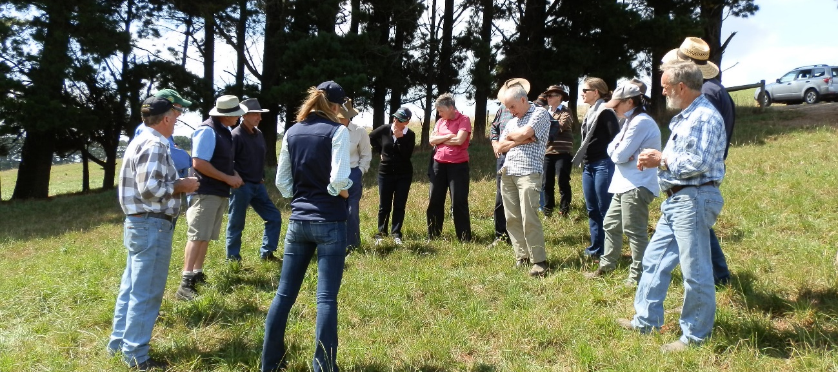
Picture: West Gippsland BetterBeef group discussing pasture options with Graham’s Seeds agronomists 2015
Group – BetterBeef West Gippsland
Coordinator – Fiona Baker
- Based in West Gippsland, established in 2011
- Currently 15 businesses
Enterprise mix
- A mix of both breeders and traders
Measuring, monitoring and using data
The West Gippsland BetterBeef group formed in 2011, with many of the members having completed a three-year BeefCheque course the previous year. In the early years, many of the sessions were focused on building on the information gained through BeefCheque. More recently, the sessions have been focused on problem solving an issue relevant to the host farm, with group members acting as consultants.
Some sessions have involved crunching numbers for the host farm – using feed budgets to help make recommendations. Often in February or March a ‘start of winter pasture target’ budget is worked through, so group members know the size of the feed wedge they need to grow over the autumn period. We then discuss the management options that might be needed in that particular year, to hit the target and how to monitor whether they are on target to achieve the growth they need.
During one session, members used this ‘start of winter’ feed budgeting approach to determine how many stock the property could comfortably carry through winter. This assisted with autumn stock purchasing decisions, and the amount of urea that might need to be purchased to boost growth through the winter.
On another property a summer budget was used during late spring to determine whether there would be enough feed to see stock through to the ideal sale date. This was used to make decisions on whether they would need to sell stock early or buy-in feed, allowing the farmer to compare the potential financial returns of each scenario.

Feeding to meet target weights
On one farm the group compared two lots of silage that had been cut and baled on the property 11 days apart. The silage was to be fed to cattle that were soon to go to slaughter at a target weight by a set date.
When using the feed analysis figures for the two different lots of silage, it was calculated that the early cut silage would allow the cattle to grow at just under 1 kgLW/day. The later cut silage only allowed for growth of about 0.5 kgLW/day. This later cut silage, if fed to the steers, could have left them vulnerable to dark cutting as well as missing their target weight. By crunching the numbers before feeding, the decision could be made to feed the early cut silage to the steers for slaughter and the later cut silage to a younger mob of steers on the property.
Many group members have made changes to their pasture bases over the years. There are some in the group that like to have a go and will trial new varieties of grasses or look for pasture species that will provide a better feed profile across the year to better match stock needs.
An “out of group” trip resulted in a visit to Merlewood Angus who use fodder crops to fill feed gaps. The group got to quiz the owners and farm manager on the use of chicory, lucerne and outback oats that are more novel feeds in the area. It was interesting to see how they used them in their beef breeding business and how well the forage crops grew on the heavier soil types.
The value in the West Gippsland BetterBeef group is in the support they provide each other. This support comes from questioning each other’s management practices, providing suggestions for alternative ways of achieving the farm goals, or simply providing the host farm with the confidence to know they are on the right track.
Using data from the host farm, whether it be in the areas of soil fertility, pasture species and management, feed quality and stock requirements, marketing of stock and looking at breed advantages not only improves the management on the host farms but has resounding flow-on effects across the group. It is often the small steps that add up over time that get results.
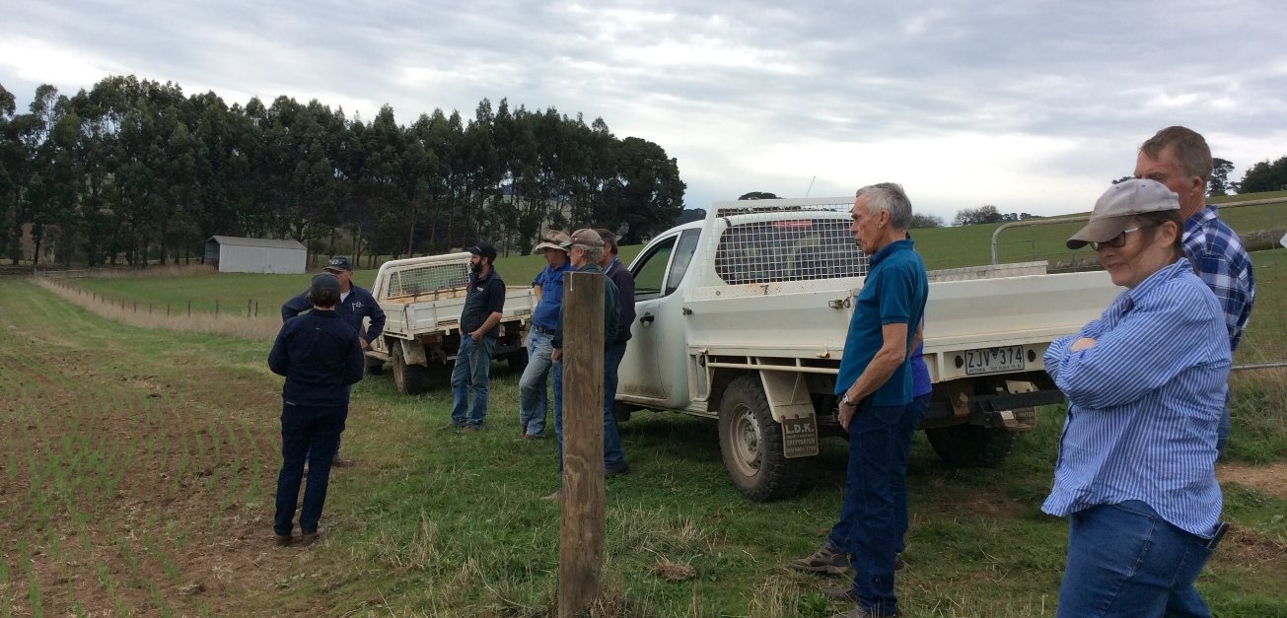Picture: West Gippsland BetterBeef group visiting Merlewood Angus to explore the use of fodder crops (outback oats in the photo) in their production systems 2018

