Antibiotic Use in Pigs: Stop, Think, Choose wisely
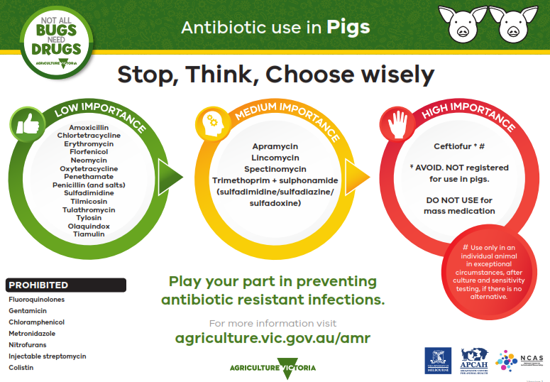
The information provided sets out the prioritisation of antibiotics for use by veterinarians as per Antibacterial Importance Ratings developed by the Australian Government with expert advice from the Australian Strategic and Technical Advisory Group (ASTAG). The antibiotics are displayed in circles corresponding to the colours of a traffic light; green, orange and red.
LOW IMPORTANCE (in a green circle)
Amoxicillin
Chlortetracycline
Erythromycin
Florfenicol
Neomycin
Oxytetracycline
Penethamate
Penicillin (and salts)
Sulfadimidine
Tilmicosin
Tulathromycin
Tylosin
Olaquindox
Tiamulin
MEDIUM IMPORTANCE (in an orange circle)
Apramycin
Lincomycin
Spectinomycin
Trimethoprim + sulphonamide (sulfadimidine/sulfadiazine/sulfadoxine)
HIGH IMPORTANCE (in a red circle)
Ceftiofur (Avoid. Not registered for use in pigs. Use only in an individual animal in exceptional circumstances, after culture and sensitivity testing, if there is no alternative).
PROHIBITED
Fluoroquinolones
Gentamicin
Chloramphenicol
Metronidazole
Nitrofurans
Injectable streptomycin
Colistin
Play your part in preventing antibiotic resistant infections
For more information visit the Antimicrobial resistant infections webpage of the Agriculture Victoria website at agriculture.vic.gov.au/amr
Developed and designed by Agriculture Victoria, the University of Melbourne, the Asia-Pacific Centre for Animal Health and the National Centre for Antimicrobial Stewardship.

