European wool carder bee

Anthidium manicatum
In January 2019, Agriculture Victoria received an unconfirmed report of a European wool carder bee (Anthidium manicatum) in Maffra, Victoria. In March 2020 further bees were collected in Sale, approximately 17 km away and identification of the species confirmed. Wool carder bee has been assessed as unlikely to have any significant impacts and not to be feasible to eradicate from Australia. No further action is planned in relation to this bee.

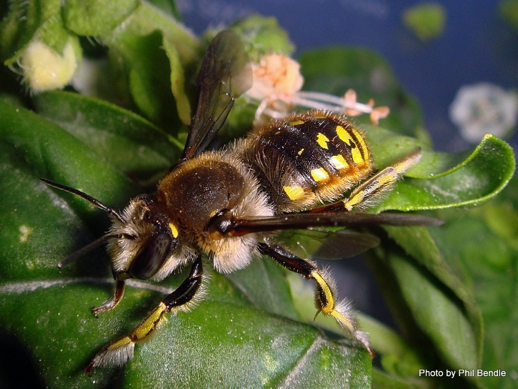
About European wool carder bee

European wool carder bee (courtesy of Phil Bendle)
European wool carder bee is a species of solitary bee that is native to parts of Europe, Asia, and Africa and present as an introduced species in North and South America, and New Zealand. It is named after the female’s behaviour of scraping or ‘carding’ hair from leaves, which they roll into little balls to line their nests.
Part of the Megachilidae family, European wool carder bee is not related to the European honey bee (Apis mellifera) commonly found in Australia.

Identifying European wool carder bee
The European wool carder bee is black with yellow spots and is covered with yellow-grey hairs. Its face and abdomen are covered in yellow spots and it has striking yellow markings on its back. The bee has a wingspan of approximately 20 mm and body length of 11 - 13 mm for females, and 14 -17 mm for males.
Female bees have a retractable sting. Male bees do not have stings as stings in Hymenoptera are modified ovipositors, however males of this species have five sharp spikes on their abdomens that they use to defend floral resources (their territories) from other males.
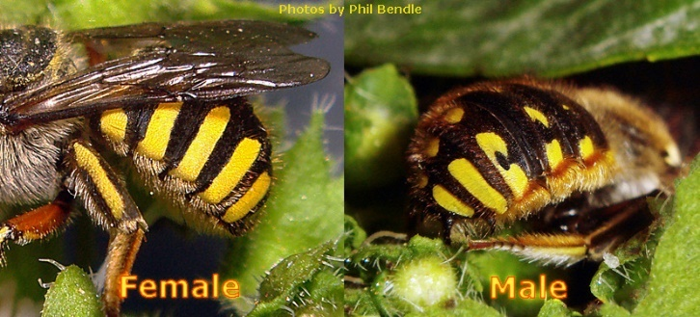
Both males and females will hover near flowers. Although this bee forages in a variety of plant species, it prefers purple or blue flowers such as cat nip, lavender, rosemary and lambs ear. This bee builds its nests in existing holes in timber, masonry, soil, wood piles, buildings or plant stems.

Abdomen of female and male bee showing yellow markings (courtesy of Phil Bendle)

What is THE likely impact IF DETECTED?
According to a New Zealand study, the European wool carder bee has not had any significant environmental impacts on New Zealand’s flora and fauna. Although males are aggressive, they seldom attacked native bees or pollinators outside of their territory.
The European wool carder bee does not present a threat to commercial/hobby beekeeping because it is a solitary bee that does not swarm or attack hives. Instead, it prefers to forage and build nests in cracks and crevices.
European wool carder bee does not sting or otherwise attack humans, livestock or pets and does not damage infrastructure.
Although European wool carder bee has so far only been found in Victoria, a related Megachilidae bee was found in Brisbane in 2000, the meter-box bee (Afranthidium repititum). The meter-box bee has since been found in Melbourne (2015) and South Australia (2016). Despite its rapid spread, it has not had any significant impact on agriculture or native bee populations, and it is expected that this will also be the case for the European wool carder bee.
The National Biosecurity Management Consultative Committee (NBMCC) considered the European wool carder bee after the Sale detection and agreed that it is not nationally significant, as defined by the National Environmental Biosecurity Response Agreement. This is because the available evidence suggests that European wool carder bee is unlikely to have significant impacts on the environment, human health, social amenity, infrastructure and business activity.
The NBMCC also agreed that European wool carder bee is not technically feasible or cost beneficial to eradicate from Australia. This is because it is a solitary bee that nests in existing cracks and cavities of a variety of natural and artificial substrates, making it difficult to detect and treat. Tracing and containment activities are also difficult due to its ability to move by flight and by hitchhiking within the cavities of a wide range of materials.
The NBMCC will recommend these outcomes to the National Biosecurity Management Group (NBMG).

What to do if you think you have found European wool carder bee

There is no need to report European wool carder bee if you are confident of its identity. If you are unsure or have found any other unusual pest or disease, secure it and report it to the Exotic Plant Pest Hotline on 1800 084 881.

Alternatively, email photos of the suspected pest, along with your contact details and the pest's location to plant.protection@ecodev.vic.gov.au.

