Using stock containment areas during a flood
Case study – The Ipsen family, Wareek - Central Victoria

A Central Victorian family has shown just how versatile stock containment areas (SCAs) can be – in rain, hail or shine.
The SCAs displayed their all-weather capacity during flooding in September 2016.
When heavy rains were forecast, Matthew Ipsen, who farms with his parents, Robert and Barbara, at Wareek, near Maryborough, immediately moved ewes and lambs from the farm’s creek flats into stock containment.
Farm information:
Producer: Robert, Barbara and Matthew Ipsen
Location: Wareek (near Maryborough)
Property size: 1060 ha
Annual Rainfall: 500 mm
Soils: Sandy-Clay
Enterprise: Cereal cropping; self-replacing Merino ewe flock
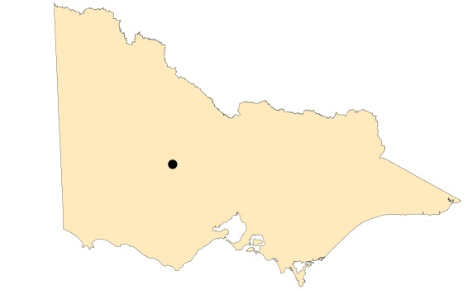
Map of Victoria identifying Wareek in Central Victoria.

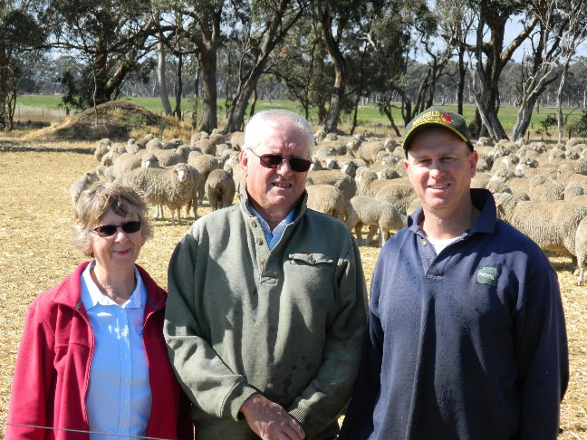
Photo: the Ipsen family.
Bet Bet Creek, which runs through the farm, often floods quickly after such rains, rising and falling within 36 hours.
The family has five SCAs, four of which were built in 2007 during the Millennium Drought and the fifth early in 2016, with assistance from the Victorian Government’s Stock Containment Area program.
Located near the stock yards, the areas were home to the family’s 2,000 breeding ewes for six months in 2015. The yards are also used during shearing and at other times during the year.
During the 2016 floods they provided a safe haven for sheep while their paddocks went under water.
“Basically it is somewhere to lock the sheep up when it is flooding . We either put them into containment or up on high ground in other paddocks. It is ideal because you have water and feed there,” said Matthew.
With good laneways on the property, Matthew said it only takes a few minutes to move the ewes and lambs into the yards. He did this before the rains as a precaution and while the first rains did not end in flooding, he knew the sheep were safe and well.
They were not so lucky when the second big rain was forecast – and arrived – causing flooding on the farm. The sheep, meanwhile were safely held, high and dry in the stock containment areas.
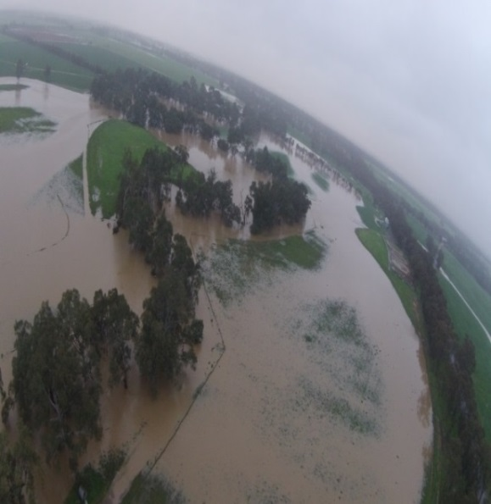
“When you lose fencing you have got somewhere secure to put them.”
Matthew said the SCAs were also used successfully in the 2011 floods and helped to reduce the health issues in the following weeks and months.
“We didn’t have foot trouble and they also helped to reduce the worm burden that season,” he said.
With capacity for 2,500 sheep in five SCAs, Matthew and Robert see the areas as a vital piece of farm infrastructure in drought, flood and even fire.
“We are constantly using them. Their versatility is amazing and I don’t think enough people realise what they could have,” Matthew said.
Robert agreed. “The flooding event was one that lent itself to putting stock in the yards. It is a tool there to be used and not just in drought,” Robert said.
In designing, constructing and using the stock containment areas, Matthew and Robert have some good experience and advice.
Photo: the Ipsen farm in flood with the SCAs visible on the right.

SITE SELECTION
Matthew said it was important to select a suitable site on higher ground with stable soil. The Ipsen’s reinforced the soil in their yards with 1,000 cubic metres of blue metal to further stabilize it and prevent erosion. They also chose a location that was adjacent to some existing trees to provide shade. With the Bet Bet Creek nearby, Matthew and Robert were keen to ensure that nutrients did not run off into the creek. The SCA was set a minimum distance of 200 metres from the creek and the Ipsen’s always try to maintain good groundcover in the paddock below the yards to filter the runoff from the SCAs.
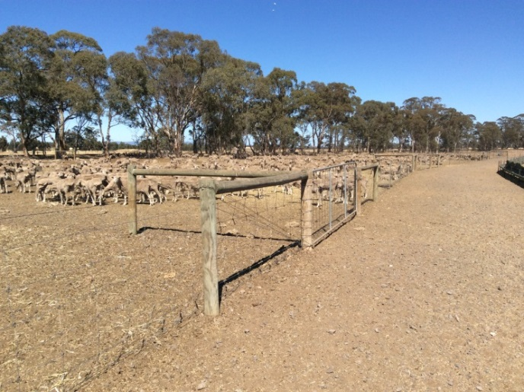
Proximity to other infrastructure is also important when choosing a site and the Ipsen’s SCAs are located adjacent to the existing shearing shed and sheep yards. They have often used the SCAs during other activities including shearing.
WATER
The Ipsen’s farm has a reliable bore close to the SCAs, with another bore on a nearby property connected to the same pipeline. Their Airwell pump provides water directly to the troughs in the yards and they can change the direction it pulls from if they need to get water from the alternative bore. Mathew said they are planning to install a tank nearby to gravity feed the troughs so that they don’t have to rely on the pump in case of power failure. Concrete water troughs with a 600 litre capacity are used and are cleaned out regularly.
The water is regularly tested for its salt content to make sure it is suitable for drinking.
Photo: SCAs and adjacent feeding laneway.
DESIGN AND FEEDING
Each SCA is about 50 x 50 metres in size and is designed to hold 500 sheep. The Ipsen’s built four containment yards with an adjacent laneway that runs the full length of the yards. A feed trough running the full length of the laneway was constructed using shade cloth and wire. Matthew says this has been an effective way of feeding grain as he simply drives alongside the ‘trough’ with the grain feeder, dispensing a pre-calculated and measured amount of feed. He then opens the gate to one SCA and the sheep come out to feed while Matthew undertakes some other tasks.
When they have eaten, the sheep walk themselves back into their yard, and a short while later Matthew comes back and repeats the process with another yard. This process repeats for the other two yards in the afternoon.
During containment Matthew calculates the feed ration based on the animals daily nutritional requirements for each class of sheep. Grain is provided on the first two days of a three-day rotation, with hay and straw provided on the third day.
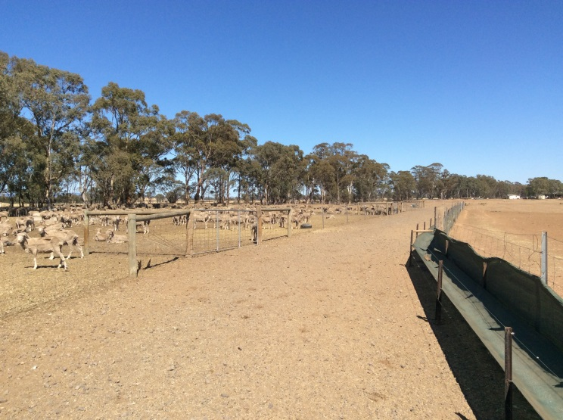
Figure 1: The Ipsen’s SCA design with the feeding laneway running full length of the four SCAs
Photo: The feeding laneway and grain trough.
DISEASE MANAGEMENT
“People should be aware that containment yards can also increase the risk of the spread of disease. With any intensive livestock system, the risk of spreading an infection or disease increases due to the close proximity of the animals,” Matthew said.
“It is mentally challenging when you come and check on the stock and find a dead animal. This is on top of a poor season and having to feed out for months on end.
“The commitment of feeding sheep every day for sometimes up to six months can be daunting and exhausting.
“The key to managing disease and infection is getting it diagnosed early,” Matthew said.
The Ipsen’s use their containment yards most years to allow their pastures to recover and build up a feed wedge prior to lambing in August. “It is such an important part of our system now but we are learning all the time,” Matthew said.

FURTHER INFORMATION
For further information or to obtain a copy of the relevant Drought Feeding Guide visit agriculture.vic.gov.au/dryseasons contact your local Agriculture Victoria Extension Officer or call the Customer Service Centre on 136 186.

Accessibility
If you would like to receive this publication in an accessible format, please telephone Agriculture Victoria on 136 186 or email drought.support@agriculture.vic.gov.au

This document is also available in (HTML and/or PDF and/or Word) format at agriculture.vic.gov.au

Disclaimer
Republished by Agriculture Victoria 2020.
This publication may be of assistance to you but the State of Victoria and its employees do not guarantee that the publication is without flaw of any kind or is wholly appropriate for your particular purposes and therefore disclaims all liability for any error, loss or other consequence which may arise from you relying on any information in this publication.

