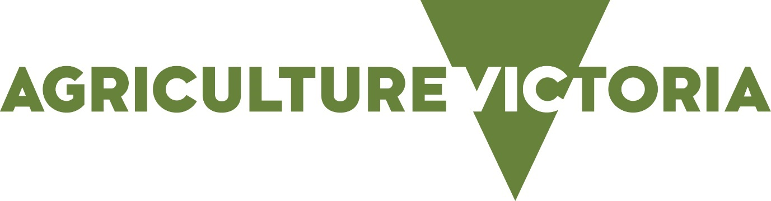

Legal requirement for the retail supply of 1080 and PAPP products
This information note summarises the legal requirements for retailers supplying sodium fluoroacetate (1080) and 4-aminopropiophenone (PAPP) pest animal control products.
1080 and PAPP products are Schedule 7 poisons and are classified as Restricted Chemical Products (RCPs).
Because of this the supply of these products is subject to strict legal requirements.
Product | Supply types | Premises accreditation required | Employee accreditation required | Licence required
1080 and PAPP shelf stable  (i.e., dried manufactured meat baits, dry oat baits and liquid capsules [for use in a canid pest ejector]) | Retail | Agsafe accreditation | Agsafe agvet chemical supplier course; and  Agsafe 1080 and PAPP course. | N/A
1080 perishable (short-life or fresh)  (i.e., fresh meat baits). | Retail | Agsafe accreditation | Agsafe agvet chemical supplier course; and  Agsafe 1080 and PAPP course. | N/A
1080 perishable (short-life or fresh)  (i.e., fresh meat baits). | Manufacture and supply by retail | Agsafe accreditation | Agsafe agvet chemical supplier course; and  Agsafe 1080 and PAPP course. | Department of Health (DH) licence to ‘manufacture and sell or supply 1080 perishable baits’

ACCREDITATION AND LICENSING
The objective of accreditation and licensing is to ensure premises and their employees appropriately store, handle and supply 1080 and PAPP products.

WHO CAN BE SUPPLIED?
It is illegal to supply any 1080 or PAPP product to persons under the age of 18 years as they are Schedule 7 poisons.
As 1080 and PAPP products are RCPs, they must only be supplied to persons who are authorised to use the product. In Victoria, an authorised person is:
- a person who holds a valid Agricultural Chemical User Permit (ACUP) with 1080 & PAPP endorsement;

- a person operating under a valid Commercial Operator Licence (COL) with vermin destroyer endorsement, and has completed the 1080 & PAPP user training; (The 1080 & PAPP user training is the course Minimising risks in the use of 1080 pest animal bait products. This course trains participants in the safe, legal and effective use of 1080 and PAPP products.)

- a person who holds a valid DH Pest Control Licence (PCL) authorising the use of pesticides formulated for the control of pest animals and has completed 1080 & PAPP user training; (The 1080 & PAPP user training is the course Minimising risks in the use of 1080 pest animal bait products. This course trains participants in the safe, legal and effective use of 1080 and PAPP products.) or

- a person who holds a valid pilot licence (Chemical Rating) (PCRL) and has completed 1080 & PAPP user training (The 1080 & PAPP user training is the course Minimising risks in the use of 1080 pest animal bait products. This course trains participants in the safe, legal and effective use of 1080 and PAPP products).
Suppliers should sight the person’s proof of authorisation at the point of sale. For COL, PCL and PCRL holders this means sighting their licence as well as the 1080 & PAPP user training certificate, as completion of this training is not marked on the licence.
It is illegal to supply 1080 or PAPP products to any person who is not authorised.
This includes persons picking up products on behalf of another person to use.
An agent is a person who obtains or collects product on behalf of the bait user (i.e., family, employees baiting coordinators). The agent must be an authorised person to be supplied product, even though they may not be the end user.
Suppliers must refuse to supply products to a person if they cannot present proof of authorisation.
With the exception of a PCRL, licences issued by other State and Territory governments are not valid in Victoria. Suppliers must only provide products to persons who hold valid Victorian authorisation and have competed the 1080 & PAPP user training (The 1080 & PAPP user training is the course Minimising risks in the use of 1080 pest animal bait products. This course trains participants in the safe, legal and effective use of 1080 and PAPP products).
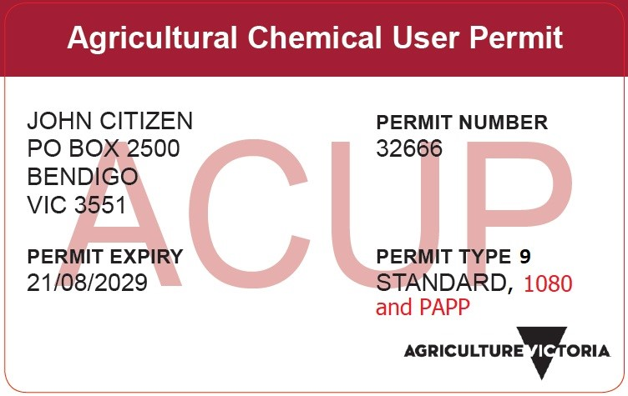

WHAT RECORDS MUST BE KEPT?
It is a legal requirement for suppliers to make and keep prescribed records for the supply of all Schedule 7 poisons, which includes 1080 and PAPP products.
The prescribed records must set out the following details:
- The date of supply.
- The name and address of the person (not an account name) to whom the product was supplied to:
– The person who collected/obtained the product from the store; and
– The person who will use the product, if different from above (i.e. if the product was collected by an agent).
- The name of the poison or full trade name of the product supplied.
- The quantity of the product supplied.
The prescribed records must be kept for a minimum of three years and must be made and kept for all instances of supply, including cash or non-account purchases.
Recording the authorisation details of the person is not a legal requirement but it can demonstrate that their authorisation was sighted and checked prior to supply.
Agriculture Victoria has templates available which may assist suppliers in meeting their record keeping requirements.

STORAGE
1080 and PAPP products must not be stored in any manner that allows physical access by any person unless they are an:
- Agsafe accredited employee; or
- Authorised person who is under the supervision of an employee/s.

FURTHER INFORMATION

Agriculture Victoria
The use of 1080 and PAPP products is regulated and monitored by Agriculture Victoria. Agriculture Victoria is also responsible for licensing authorised persons. Supply record keeping templates are available from Agriculture Victoria.

Enquires can be directed to:
- The Agriculture Victoria Customer Contact Centre on 1300 502 656.
- Agriculture Victoria

Department of Health (DH)
Contact DH Drugs and Poisons Regulation for information on the licences required to manufacture and sell or supply 1080 or PAPP pest animal products by wholesale or retail.
DH does not license the supply of 1080 or PAPP pest animal products by retail to end users (only wholesale).
Legislation administered by DH covers the requirements for record keeping, storage and age restrictions on the supply of Schedule 7 poisons such as 1080 and PAPP products.
Information on DH controls on the supply of Schedule 7 poisons can be found via:
- Drugs and Poisons Regulation phone 1300 364 545.
- dpcs@health.vic.gov.au

Agsafe
Agsafe provides accreditation and training for the safe and responsible storage, distribution, use and disposal of agriculture and veterinary chemical products.
Accreditation validates that premises are compliant with Commonwealth, State and Territory regulations for the transport, storage and handling of agriculture and veterinary chemical products.
Agsafe training ensures that people who store, handle, transport or provide advice on agricultural and veterinary chemicals have a good understanding of managing the risks of these products in their workplace.
For information on Agsafe 1080 and PAPP accreditation and training, telephone 02 6206 6888.

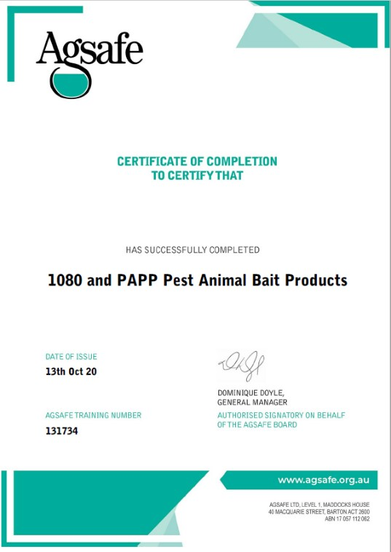
Australian Pesticides and Veterinary Medicines Authority (APVMA)
The Australian Pesticides and Veterinary Medicines Authority (APVMA) regulate the supply of agricultural and veterinary chemical products. The APVMA’s Register of chemical products available for supply and use in Australia is available at www.apvma.gov.au

