Shaping Victoria’s Biosecurity Future Workshop
Bringing together individuals from industry, government and community
‘What was said’ Report
June 2021
Contents
1. Introduction 3
Workshop purpose 3
Workshop participation 4
Attendance 5
2. Workshop overview 7
3. Opening plenary 9
Keynote speakers and Q&A 11
4. Theme 1 – Strengthening partnerships and engagement 16
Characteristics of good partnerships and engagement 17
Core principles 20
5. Theme 2 - Modernising legislation and enhancing regulatory practice 25
Characteristics of good legislation 25
Tailwinds and Roadblocks 28
Actions 32
6. Theme 3 – Improving preparedness for biosecurity emergencies 40
Outcomes and actions 40
Outcomes within two years 41
Outcomes within five years 47
Outcomes within ten years 53
7. Theme 4 – Enhancing information sharing and surveillance 56
Collective connections to information sharing and surveillance 56
Good information sharing 61
Good surveillance 65
The game changers 69
Information sharing 69
Surveillance 75
8. Closing plenary 79
9. Workshop feedback 85

Introduction
The Shaping Victoria’s Biosecurity Future Workshop is part of Agriculture Victoria’s efforts to strengthen Victoria’s biosecurity system.
The workshop brought together a diverse mix of individuals from industry, community, and all levels of government. People participating came from across Australia and from various sectors including agriculture, land management, environmental protection, and biosecurity regulation, among others.

Workshop purpose
The purpose of the workshop was to:
- Develop a shared understanding of the challenges facing the biosecurity system
- Explore opportunities to strengthen the system
- Identify how we can work together to achieve these improvements.
The workshop was held over two days, 17 and 18 June and incorporated six individual sessions.
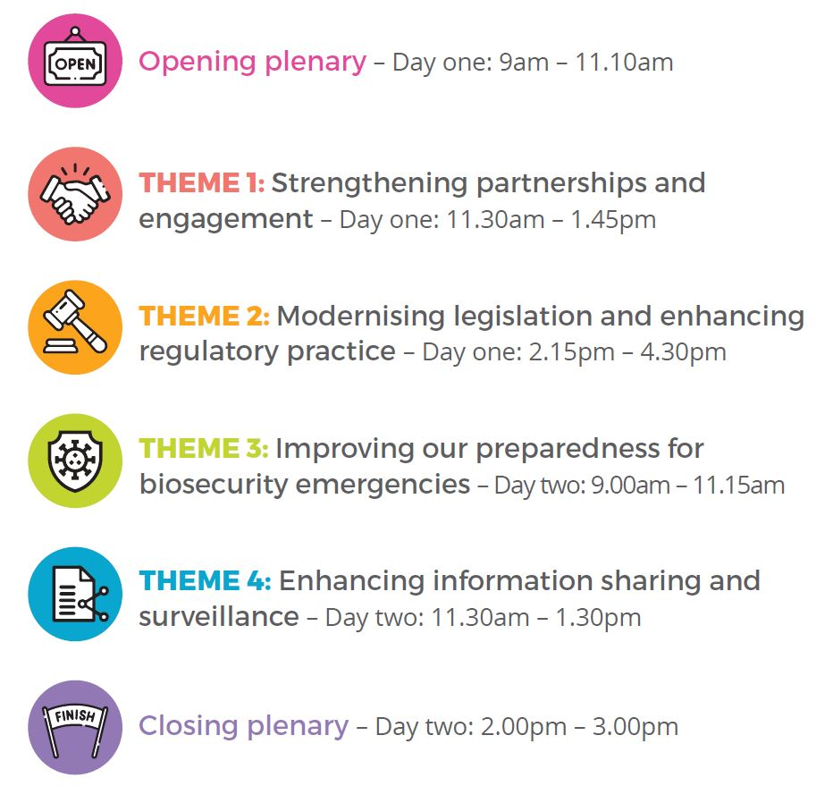
Day one
- Opening Plenary – 9am – 11.10am
- Theme one: Strengthening partnerships and engagement - 11.30am – 1.45pm
- Theme two: Modernising legislation and enhancing regulatory practice – 2.15pm – 4.30pm
Day two
- Theme three: Improving our preparedness for biosecurity emergencies – 9.00am – 11.15am
- Theme four: Enhancing information sharing and surveillance – 11.30am – 1.30pm
- Closing plenary – 2.00pm – 3.00pm

Workshop participation
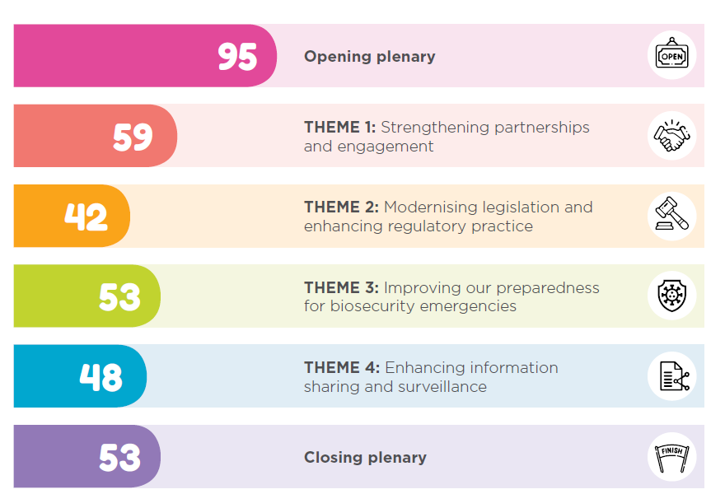
(Description of the workshop participation infographic)
Opening Plenary – 95
Theme 1: Strengthening Partnerships and Engagement – 59
Theme 2: Modernising Legislation and Enhancing Regulatory Practice – 42
Theme 3: Improving our Preparedness for Biosecurity Emergencies – 53
Theme 4: Enhancing Information Sharing and Surveillance – 48
Closing Plenary – 2.00pm – 3.00pm – 53
The Strengthening Victoria’s Biosecurity System Project Team and the Agriculture Victoria leadership team and staff participated in the workshops through opening each session and participating in the discussions alongside the participants.
MosaicLab designed and facilitated the workshops with a team consisting of Nicole Hunter, Lyndal Mackintosh, Jessica Connor-Kennedy, Naomi Oosting and Noa Levin.
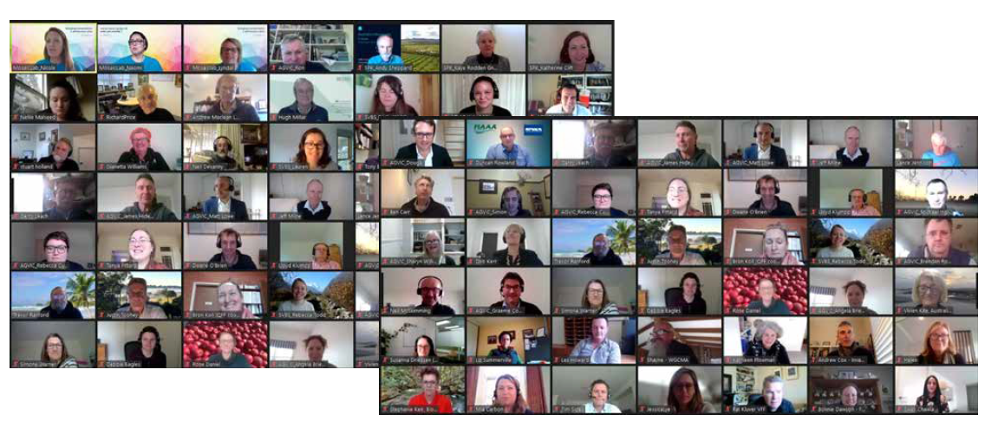
Photo from the Opening Plenary – 17 June 2021

Attendance
The following organisations were represented across the 2 days:
ACT Government
Agribusiness Yarra Valley
Agriculture Victoria
Animal Health Australia
Apple and Pear Australia Limited
AusMeat
AuSPICA
Australian Alpaca Association
Australian Chicken Meat Federation
Australian Dairy Farmers, Advisor
Australian Livestock & Property Agents Association
Australian Livestock Saleyards Association
Australian Pork Limited
Australian Veterinary Association (Victorian Division)
Australian Wool Innovation
Centre for Invasive Species Solutions
Citrus Australia
Colac Regional Saleyards
Coles Group
CSIRO Australian Centre for Disease Preparedness
Department of Agriculture and Fisheries, Queensland
Department of Agriculture, Water and the Environment
Department of Environment, Land, Water and Planning
Department of Health
Department of Primary Industries and Regional Development WA
Diamond Valley Pork
East Gippsland Shire Council
Environment Protection Authority Victoria
Equestrian Victoria
First People of the Millewa-Mallee Aboriginal Corporation
Food & Fibre Gippsland
Grain Producers Australia
Grains Research and Development Corporation
Gunpork
Invasive Species Council
JW & JA de Hennin
LT's Egg Farm
Landcare Victoria Inc.
Livestock & Rural Transporters Association of Victoria Inc
Moorabool Shire
Municipal Association of Victoria
NSW Department of Primary Industries
Nursery & Garden Industry Victoria
Plant Health Australia
Port of Melbourne Operations
PrimeSafe
Private - SVBS PCB member | Chair, National Fruit Fly Council
Racing Victoria
AusMeat
RJH Maranoa (livestock producer)
Stock Feed Manufacturers' Council of Australia
Summerfruit Australia Ltd
SVBS Project Control Board independent members
Vic Catchments
Victorian Apiarists Association
Victorian Farmers Federation
Victorian Farmers' Markets Association
Victorian Fisheries Authority
Victorian Forest Products Association
Victorian Rabbit Action Network
Victorian Serrated Tussock Working Party
Wimmera Catchment Management Authority

Workshop overview
The workshop was facilitated over Zoom in six different parts, across the 2 days. Below is an overview of the 2 day agenda.
Opening Plenary | Acknowledgement of Country  Welcome  - The Hon. Mary-Anne Thomas, Minister for Agriculture  - Matt Lowe, Chief Executive, Agriculture Victoria  Participant Connection  Keynote Speakers and Q&A  - Andy Sheppard, CSIRO  - Katherine Clift, Executive Director Biosecurity Services, Agriculture Victoria  - Kaye Rodden, Victorian Rabbit Action Network
Theme 1  Strengthening partnerships and engagement | Welcome  - Dougal Purcell, Executive Director Agriculture Services and Regions, Agriculture Victoria, Agriculture Victoria  Introductory video and key message  Goals and aspirations of good partnerships and Engagement  Core principles  Our role to strengthen partnerships and engagement
Theme 2  Modernising legislation and enhancing regulatory practice | Welcome  - Sally Fensling, Executive Director Animal Welfare Victoria and Agriculture Regulatory Policy, Agriculture Victoria  Introductory video and characteristics of good legislation  Tailwinds and roadblocks  Priority actions
Theme 3  Improving preparedness for biosecurity emergencies | Welcome  - Graeme Cooke, Chief Veterinary Officer, Agriculture Victoria  What does preparedness look like and Introductory video  Preparedness outcomes  Actions to support our outcomes
Theme 4  Enhancing information sharing and surveillance | Welcome  - Rosa Crnov, Chief Plant Health Officer, Agriculture Victoria  Introductory video and connection to information sharing and surveillance  Goals and aspirations  The game changers that will make a difference
Closing plenary | Welcome  Thank you and words from the host – Matt Lowe, Chief Executive, Agriculture Victoria  Reflections from participants  Next steps  Close

Opening plenary
The Shaping Victoria’s Biosecurity Future Workshop opened with a welcome from the Honourable Mary-Anne Thomas, Minister for Agriculture and Matt Lowe, Chief Executive Officer, Agriculture Victoria.
There were over 90 people attending the opening plenary and the online format provided opportunity for people to participate far and wide from across Australia.
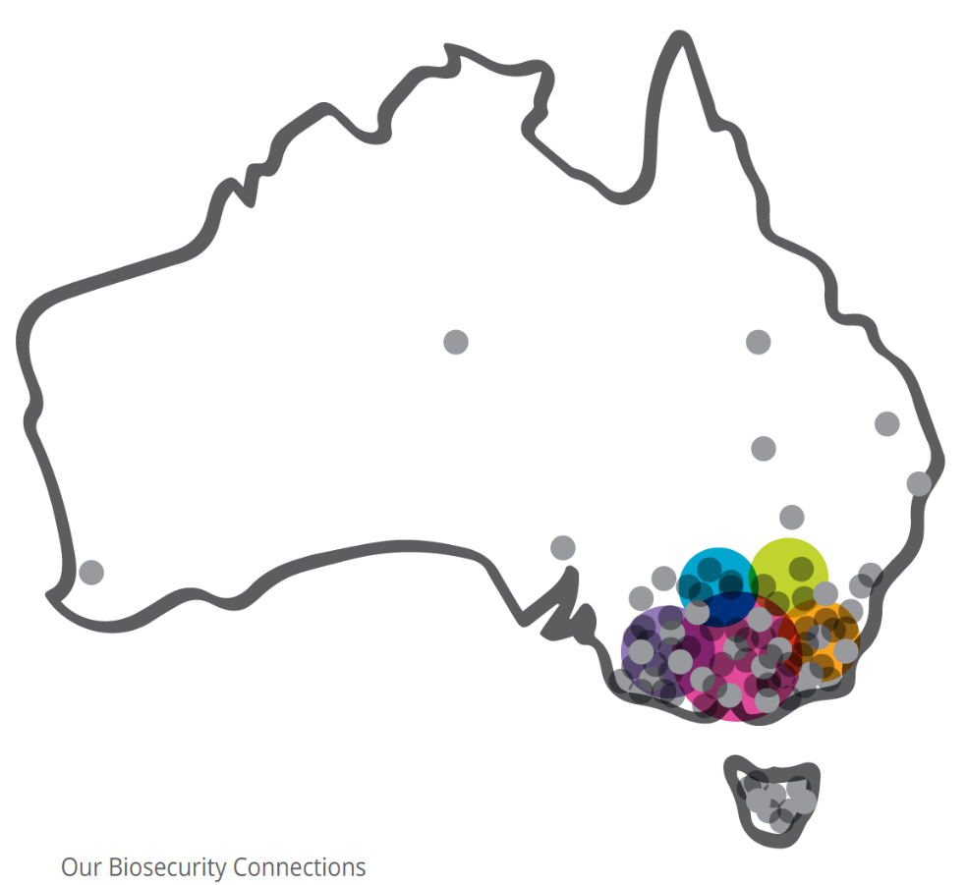

The participants were asked one hope they would like to see in Victoria’s biosecurity future. The responses have been grouped into similar themes that demonstrate the interests and hopes of the participants.
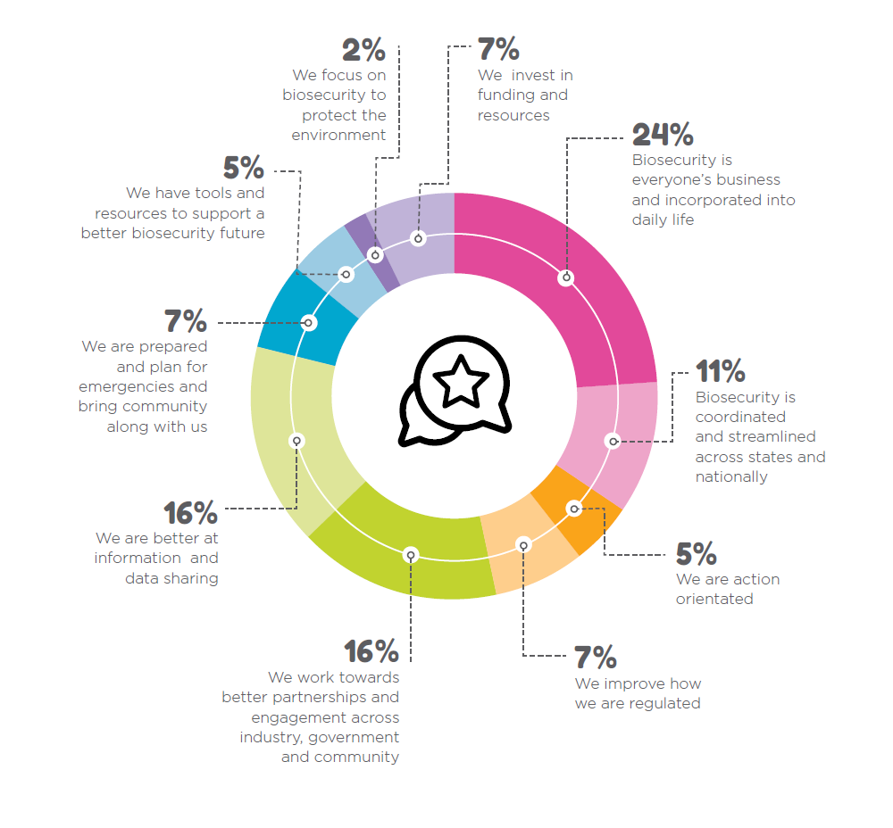
(Infographic description - Data in the above graphic is captured below)
Themes - one hope for Victoria’s biosecurity future | Percentage of participants
- Biosecurity is everyone's business and incorporated into daily life | 24 per cent
- Biosecurity is coordinated and streamlined across states and nationally | 11 per cent
- We are action orientated | 5 per cent
- We improve how we are regulated | 7 per cent
- We work towards better partnerships and engagement across industry, government and community | 16 per cent
- We are better at information and data sharing | 16 per cent
- We are prepared and plan for emergencies and bring community along with us | 7 per cent
- We have tools and resources to support a better biosecurity future | 5 per cent
- We focus on biosecurity to protect the environment | 2 per cent
- We invest in funding and resources | 7 per cent

Keynote speakers and Q&A
A series of keynote speakers were invited to the opening to set the scene from a national, state and regional perspective. Each speaker was followed by small group discussions on insights and questions for each of the speakers.
Insights - Dr. Andy Sheppard - Senior Principal Research Scientist, CSIRO
Insights that received seven likes:
- A clear definition and understanding of shared responsibility.
Insights that received four likes:
- We need to get commitment beyond election cycles?
- We need standardised language and concepts across all states.
- Scaling up the current system is just not good enough- we need transformational change.
- Is the biggest challenge the disharmonised approach of states.
Insights that received three likes:
- The division between States & Commonwealth.
Insights that received two likes:
- What are the mechanisms for cost recovery for growers with shared responsibility.
- We need real preparedness.
- Shared responsibility is more than engagement - it requires a discussion of rights and responsibilities (inclusive governance).
- Response and recovery (BAU) vs prevention and early detection (transformative).
- Not working in 10yrs, we can see the cracks now.
- Need to be able to have a national approach - national consistency.
- Biosecurity dedicated resources such as a levy at a national levy in industry is necessary.
Insights that received one like:
- There is a social responsibility aspect - it’s not just commercial.
- The multi-dimensional nature of the challenge is hard to get your head around.
- Shared responsibility - its problematic and tricky.
- Potential to use data and analytics to inform the system.
- Our current animal tracing system was fit-for-purpose at the time but no longer is. Plant tracing systems are less advanced. We need to look to technology and innovation to have fit-for-purpose tracing systems for tomorrow.
- Need for transformation (not simply scaling what we are already doing).
- Keeping small/hobby industry engaged and up to date with incoming and changing legislation.
- How to we learn from COVID to approach biosecurity new ways to manage the risk.
- Great to have robust risk-based biosecurity at the border however, industry needs to understand that this will result in increases in production costs as feed ingredients are banned from importation as they can't meet the protocols.
- Environment is a really important part of the biosecurity system.
- Better engagement and understanding by broader population could have a big impact on biosecurity outcomes - if people know what to do, and why, they are likely to get on board.
Insights that received no likes:
- You are only as good as your weakest link - so how can you get states all online to deliver considering they do not apply resources now.
- Who is going to pay for the extra biosecurity costs incurred by producers in the push to make industry more responsible for national biosecurity? Will consumers pay more for produce to achieve this? Why should the producer take another pay cut? Who funds peri-urban biosecurity? How do we capture the residential contribution to funding biosecurity in backyard production?
- We have to stop talking.
- We have come together on major issues successfully in the past, but it is the smaller ongoing issues that are the greater threat.
- There needs to be a focus and surge of investment - but the states are not doing this as they do not resource it - but they will reap the economic effects from biosecurity incidents.
- The need for greater national prospective outside of a crisis.
- States must get properly funded.
- Relationship building a key to preparedness to enabled shared and collective input (data).
- Maybe a lack of social awareness of good biosecurity practice.
- It is states who deliver this and they are just not resourced or funded to do this - and time is running out.
Insights – Katherine Clift, Executive Director Biosecurity Services, Agriculture Victoria
Insights that received 7 likes:
- We can't have preparedness with short term funding. We need real long term investment into science and people building careers in biosecurity and diagnostics, in order to have actual preparedness. Enough short term plans and glossy documents and buzz words for media articles.
Insights that received four likes:
- It's nice to hear the importance of community collaboration.
Insights that received two likes:
- The concept of biosecurity is huge, is the broad range of topics making it difficult to maintain the engagement and support. Everything from pest control feral and native animals, agriculture pests and diseases that impact general public. How do we make the topic less overwhelming for those trying to become engaged.
- States are not harmonised for action.
- Everyone needs to be involved in biosecurity - how to get everyone involved.
Insights that received one like:
- We hope the legacy of the Delivery Leadership Group (DLG) can be carried forward.
- Biggest container imports to Australia.
- How we engage smaller producers, hobby farmers, lifestyle block owners, general public. Industry generally has a good understanding of biosecurity but are put at risk by those outside of industry who are part of the biosecurity system but don't fully understand their responsibilities and how what they do can affect industry and the environment.
- Need to engage parts of the industry who are not currently being reached to push forward successful programs.
- The key challenge is engaging the broader community in biosecurity - and the language used will be important.
- Very similar issues across Australia and huge potential for joining up and sharing insights.
Insights that received no likes:
- Things are too fragmented - there needs to not be a call to action, but a plan for action that gets delivered.
- There needs to be action and resourcing now - the gaps have to be filled.
- COVID has demonstrated the ability for the broader community to understand personal action/sacrifice for greater community good, we need to build on that understanding to support shared responsibility for broader biosecurity issues.
- Action needed now!
- Is it possible to design a coherent system that encompasses biosecurity risks extending from COVID to Feral Deer to Gorse to animal diseases? I think perhaps not.
- Because of trade and tourism, Victoria is shown as the most vulnerable area for the introduction of an animal Emergency Animal Disease incursion. It's therefore really important for Victoria to lead the way in maximising preparedness.
- Moving in the right direction.
- Appetite from those working on biosecurity for major change.
- We can’t lose what we have achieved. We need to build on it.
Dr. Kaye Rodden, Secretary and Board Member, Victorian Rabbit Action Network
Insights that received three likes:
- Community engagement is essential. Victorian Farmers Federation has (or did have) dedicated Biosecurity Officers, which is a model copied from the now-closed National Livestock Biosecurity Network. This methodology was a success in engaging communities and should be revitalised, but with adequate funding this time!
Insights that received two likes:
- Community wants to be part of solution not just be considered as the cause.
- Community task forces can be very good source of early detection capability.
- Government needs to support community members to be effective first responders to biosecurity events and issues.
Insights that received one like:
- It seems as if key to success was the support, investment and trust by Government in the Victorian Rabbit Action Network, removing the limitations of bureaucracy, improved response times, results led to results.
- A Landcare model that works for urban/peri-urban is needed.
- Kaye touched on the 'ferals' that come out of the sky – the new invaders. This has big potential to a greater community focus.
- CMAs play a major role in bring people together to develop regional priorities and carry out integrated on-ground action.
- Need to map and understand real world action, real world solutions rather than just mapping the problem. Support the implementation of technical knowledge for local area needs.
- Do you focus on the landscape with the community or the issue(s)?
Insights that received no likes:
- What’s the common variable between rabbits and biosecurity - is it people? Is it relationships?
- Is there an equivalent approach that can be applied within industry?
- Is long term stuff required - a biosecurity cultural change.
- The enthusiasm and willingness of those involved to make these groups happen.
- How citizen scientists can play a crucial role.
- Can this be landscaped based not just pest based.
- Living with established species - devolving power.
- Great energy and support for collaborations.
- Risk prioritisation and allocation of responsibilities (devolved) to sustainable groups - community and others for collaborative responses. Need to be backed up with good science and technology. Return on the investment (by all) must be justified. Big risk issues can then focus on the national borders.
- It would be interesting to know how much more engaged a farmer involved in a rabbit control program would be in other biosecurity issues. If supported further, could provide an efficient way to engage across more biosecurity issues.
- There are a wide range of views on risk!

Theme 1 – Strengthening partnerships and engagement
The purpose of the theme 1 workshop was to explore opportunities to strengthen partnerships and engagement, and to identify goals, principles and values that should drive our future work around partnerships and engagement. The workshop commenced with a welcome from Dougal Purcell, Executive Director, Agriculture Services and Regions.
Participants watched a short video about strengthening partnerships and engagement featuring:
- Tony Baker - Executive Officer, Vic Catchments
- Gerry Leach - farmer and Chair, Victorian Rabbit Action Network
- Angela Atkinson - Industry Development Officer, Strawberries Vic/SA
- Patrick Kluver - Senior Project Specialist, Victorian Farmers Federation
The key messages participants took away from the video are as follows:
- At any particular point in time, understanding where community is at, so can be compassionate and engage with them in a meaningful manner.
- Bottom up approach as well as the old top down approach
- Co-funding models can be a good reflection on the strength of partnerships (e.g. livestock duties).
- Community engagement.
- Devolve the decision making to a more local level.
- Different engagement for different stakeholders/land managers.
- Diseases and pests that create market access issues are much harder to hand over to community groups. Finding a way to find a middle ground is critical.
- Empower government to devolve responsibility.
- Empower the community.
- Get councils involved-they are the industry group representing the wider community.
- Government has a role in supporting, coordinating and conducting gap analysis across community groups.
- Have to be able to talk face to face to get the message across.
- Importance of knowing land managers and engaging with them effectively.
- Importance of working together, especially empowering involvement and decisions at local level.
- It's about the people as much as the problem.
- Need to support existing networks to achieve more across the biosecurity continuum.
- Need to understand the touch points for messaging-networks.
- Recognise the strengths of each of the partners-who is best placed to take responsibility?
- The need to have everyone in the room for harmonisation.
- Try to involve everybody.
- Understanding each other’s circumstances.
- Use the existing networks.
- Using social science to understand the value chains, knowledge, attitudes and practices to better understand biosecurity responsibilities.
- Utilise COVID, an on-off opportunity while the community is biosecurity aware.
- We need to close the gap with those that are not engaged. Through relationship becomes insight and then action. It takes time to build relationships.
- What happens when the risks are in one area (urban areas) and the benefits in another area/industry?

Characteristics of good partnerships and engagement
Participants were then asked to discuss the characteristics of good partnerships and engagement. The responses have been lightly grouped into similar themes where it has made sense. It also captured where people have liked or supported another participants response.
Openness and trust
Likes | Responses
3 | Trust and two way approach.
3 | Honesty, trust, openness, clarity of purpose, communication.
2 | All stakeholders communicating well based on trust and open relationships. Developing a common understanding of risk and values; pressures and impacts; and understanding what our common objectives are.
2 | Trust and understanding between partners.
Mutual respect and common understanding
Likes | Responses
4 | Respect of each other’s strengths.
2 | Shared responsibility-moving beyond the buzz words - what in it for us? Being clear on who’s responsible for what? Using social science.
1 | Desire of genuine meaningful partnerships based on shared understanding of all participants.
1 | Community and government recognise importance of each to deliver outcomes that benefit all.
1 | Mutual respect is critical to good partnerships.
0 | Shared common understanding from all parties.
0 | Common objectives.
0 | Recognising the importance of relationships and respecting these.
Commitment to partnerships across time and crises
Likes | Responses
6 | Focus on long terms relationships and networks to support the implementation of effective biosecurity-recognise that industry/community is well placed to bring consistency over time.
9 | Respect and trust. Commitment from all parties all the time not just during a crisis.
3 | Developing networks during peace and war time - being clear transparent, based on two way communication.
0 | A good partnership has short medium and long term goals and resources.
0 | Build trust among the rural community through a long-term commitment to building networks of biosecurity experts across Australia.
0 | True partnerships including decision making.
Working closely and effectively with Government
Likes | Responses
3 | Industry and government can help each other-in some cases government needs to let go of owning the situation.
2 | Bringing together of cross commodity groups-makes it easier for industry groups to determine priorities across groups and then be able to take those priorities to government. This then needs to be linked back to sustainable funding across industry and government.
0 | Community and government recognise that neither body can solve a common problem alone.
0 | Industry and government present a common front in engaging with the broader community.
0 | Challenge of government instigating partnership needs to be recognised.
0 | Clarity between partners includes within and between government departments.
0 | A risk adverse government, concerned with devolving roles to industry can hold back the progress of a partnership.
Other (individual responses)
Likes | Responses
3 | Design needs to be 'fit for purpose and adaptable' that reflects the need for local - industry and geographic approaches. Important because of the complexity and diversity of agriculture in Victoria. Adding value to existing networks is much more effective than trying to start from scratch. People are already engaged and invested in these networks.
3 | Use established structures-the community fabric, networks and connections that exist. System will be stronger if leverage these.
2 | Frameworks that empower/enable bottom/local up approaches.
2 | Engage at the right level at the right time for the right reasons.
1 | Needs positive messaging.
1 | Processes, communications and engagement in place prior to events so trust is there and people know how to react, next steps.
0 | Relevant to the maturity and needs of the stakeholders.
0 | Well-informed people, meaningful engagement that is practical and hands on.
0 | Impactful and with effect.
0 | Need everybody to understand the reasons why enforcement is done.
0 | Using compliance pyramid effectively and proportionately. Understanding that engagement and education is vital for the vast majority but this must be supported by enforcement for the recalcitrant.
0 | Concrete commitment - concrete actions to facilitate rapid and genuine change.
0 | Locally embedded co-ordinators or facilitators.
0 | Early interaction that involves community in a region and grows together.
0 | Regionally specific and focused on inclusion of all stakeholders.
0 | Communication is the cornerstone to strong partnerships.

Core principles
Based on these characteristics, participants identified key elements that could make up the core principles that drive good partnerships and engagement.
Likes | Responses
5 | Trust, trust, trust.
4 | Connections built on understanding of other peoples or groups why (purpose).
4 | Integrity.
3 | Common objectives.
3 | Courage to share power.
3 | Inclusion.
3 | Frank, honest and regular two-way communication.
3 | Respect.
2 | Action and follow through.
2 | Clear communication.
2 | Respect - there is difference of opinion, but we all have something valuable to bring.
2 | Understanding each other.
1 | Clear objectives for the partnership.
1 | Embracing change.
1 | Courage.
1 | Making sure we are on the same page with the same information - equity.
1 | Openness and honesty to create a shared understanding.
1 | Development of achievable shared goals, ACTION against those goals, and regular monitoring and progress against the actions.
0 | Partnerships will acknowledge and celebrate their wins.
0 | Putting aside differences.
0 | Shared objectives.
0 | Durability.
0 | Resilience.
0 | Resourcing the priorities (time, money, support).

The final activity of the workshop asked participants to select a particular perspective (e.g. government, stakeholder, farmer, etc), and consider their role moving forward to strengthen partnerships and engagement.
Industry
Perspective | What you see as your role going forward... | Comments
Industry Representative. | Provide a conduit between industry, community and government, provide up to date information about industry practice and maintain Government understanding of the sector. | Industry/Government relationships have to be based on a high level of integrity and trust, open conversations and long term outcomes.
Industry has a role to facilitate government working with business groups to achieve agreed outcomes. | (no response given) | (no response given)
Government
Perspective | What you see as your role going forward...
State Government. | Collective engagement across all areas of biosecurity.
State Government - creating opportunity for the 'two-way' engagement. | (no response given)
Victorian Chief Veterinary Officer. | (no response given)
Commonwealth Government. | The role of the Commonwealth could be better communicated at a local level. Partnerships require that all parties understand what each part of the partnership are responsible for and have control of. Creates shared responsibilities.
Other
Perspective | What you see as your role going forward...
Community capacity and capability building. | Ensuring that community is invited into the conversation.
West Gippsland Catchment Management Authority (WGCMA)-able to utilise long standing, established, trusted networks, community and industry to facilitate regional engagement / information sharing between government / community / industry. | (no response given)
Provide tools and support adoption. | (no response given)
Advocate. | (no response given)
Regulator of some intensive animal industries. | (no response given)
Industry/community/government-figuring out the best way we can work together. | (no response given)
Apiculture (bee's)-public engagement across the sector (peri-urban) industry and government. | (no response given)
Leaders’ community led action groups. | Continue to be advocates to both the government to support the program as well as the community to continue their involvement in the programs  Deliver agreed outcomes by empowering the community  Build on relationship with Ag Vic to have better understanding of each other’s roles.
Research, Development, Extension, Adoption and Commercialisation (RDE&A) investment. | (no response given)
Apiculture (bee's). | (no response given)
Food safety regulator. | (no response given)
Farmer/advocacy - bringing farmer experience and expertise to the table. | (no response given)
Catchment Management Authorities-continue to form as many relationships and partnerships. | (no response given)
Regional coordinator for area wide management. | linking stakeholders to information.
State farming organisations. | To seek common biosecurity goals and to lead industry towards them.
Environmental sector. | I can bring those in my network to support the goals of the biosecurity system.
Environmental regulator. | (no response given)
Critical friend. | Promoting collaboration.
Championing all the tools in the toolbox. | Ensuring government understands pre-existing community infrastructure.

Theme 2 - Modernising legislation and enhancing regulatory practice
The Theme 2 workshop focused on exploring opportunities to modernise legislation and policy. The objectives of the session were to investigate what aspects of the existing legislation create pain and what aspects create gain. Participants were asked to consider different dilemmas relating to legislation and regulatory frameworks and to prioritise a set of actions for the future. The workshop commenced with a welcome from Sally Fensling, Executive Director, Animal Welfare Victoria and Agricultural Regulatory Policy.

Characteristics of good legislation
Participants watched a short video about legislation and regulatory practice featuring:
- Brendon Tatham - CEO, PrimeSafe
- Craig Tabener - CEO, Nursery and Gardening Industry Victoria
- Susanna Driesson - General Manager Emergency Preparedness and Response, Plant Health Australia
Participants were asked to identify characteristics of good legislation.
Flexibility
- Flexible, outcome based, proactive, fit for purpose.
- Flexible and going from nudging to a firm "no".
- Flexible and adaptive.
- Flexible and easy to update as the regulatory and biosecurity environment changes.
- Flexibility to recognise differences within different systems and with different operators
- Flexible to account for risk.
Clarity and simplicity
- Plain English and easy to understand.
- Plain English, easy to understand.
- Simple and transparent.
Consistency
- Clear lines of responsibility that can survive restructures of government e.g. Department of Health, Agriculture and Environment all have biosecurity powers and responsibilities.
- Provides for a consistent client experience across all areas of biosecurity.
- Harmonised between states and territories-avoids inefficiencies and makes it easier to develop national programs.
- Consistency between state and national legislation (and within state) allows good policy to be developed.
- Cohesive between organisations (i.e. Federal and State consistency and cooperation).
Inclusive of the practical industry experience
- Designed by practical users and not just by legislative thinkers.
- Ground up design.
- Good legislation considers farmers livelihoods and helps protect.
- Being aware of the impact that legislation has on the livelihoods of farmers.
- Industry built - practical and operational.
Collaborative and recognises existing systems
- Coregulation and recognition of systems already in effect, such as tools used by industry.
- Recognise industry programs that adopt biosecurity standards (e.g. Quality Assurance programs) and reduce regulatory burden on participants.
- Designed around co-delivery model.
- Build in the collaborative model and consultative mechanisms into the legislation.
Other
- Good legislation is a tool not an end; most good biosecurity does not depend on it.
- Give confidence that a fair and just investigation will follow a report and action will occur.
- Remove the fear of reporting.
- Meaningful and implementable/ risk based and prioritised application - no point in having grand ideas if they are not applied by those responsible - government or community or industry.
- Using market access and a lever to comply.
- Legislation that empowers people to be proactive and enables improvement.
- Doesn't create absurdities and is actually able to be implemented effectively by inspectors and authorised officers.
- The right regulator.
- Risk proportionate.
- Outcomes orientated with clear purpose.
- Support offered before penalty.
- Supporting and enabling.
- Clarity of purpose and principles.
- Harmonisation as best we can - really important to industry.
- Third party recognition and assurance.
- Firm and reasonable (due to externality impacts), can't over-regulate but must have legislation in place for people who don't do the right thing.
- Preventative.
- Preventative approach.

Tailwinds and roadblocks
Participants were asked to list tailwinds and roadblocks that they face in biosecurity legislation and regulatory practice at the moment.
Tailwinds: Things that help us along/push us forward
Tailwinds | Similar grouped ideas
Draw on the experience of other jurisdictions | - Stand on the shoulders of others-other jurisdictions.  - A number of states and territories have already done this leg reform so we can draw on their best practice.  - Standing on the shoulders of others.  - Victoria is the last state to develop one biosecurity act-opportunity to use other learnings.  - Leverage on the learnings of other states.
Business good will and incentives for greater biosecurity protection | - Drive from industry for greater biosecurity protection.  - Business incentives to do the right thing- increased market access, community engagement, trust.  - Industry good will-63 percent would report.
COVID has raised awareness of the importance of this legislation | - Recent events (COVID) have helped to raise the importance of legislation when people aren't doing the right thing.  - Increased of biosecurity through the COVID experience and community understanding and acceptance.  - Community Understanding of Biosecurity.  COVID has helped people see the need for strong Biosecurity practices.  - Currently political will and funding with COVID creating opportunities.
Senior People and decision makers committed to reform | - Senior people and decision makers to commit to reform-'climate' is right for Victoria given the recent responses.  - Interest and support from Minister.  - Political willingness to change.  - Mandate in agriculture strategy and investment of Victorian Government to reform the legislation.

Tailwinds: More things that help us along/push us forward
- Access to data (e.g. From QA programs) to inform consumers, community
- Community connections
- Recognition among all players of the importance of biosecurity
- Playing on success: recent incursion of hitchhiker pests (brown marmorated stink bug, Khapra), good coordination between states and industry
- There is a push for improved technology use that it can be utilised in legislation
- Resource it right so that people don't get burnt out-it’s a big reform
- Biosecurity laws that focus on risk should lower biosecurity risks
- Advances in traceability and auditability as a result of COVID
- Making sure the legislation encourages, prioritises interventions that are preventative
- The need-legislation is out of date and all agree it needs to modernise (and harmonise with other jurisdictions)
- Collaboration across industry and government including politicians
- Environmental Protection Agency "General Duty of Care" statement
- Power of supply chain
- Harnessing the power in the supply chain to drive better biosecurity (e.g. supermarket) in a recognised regulatory framework to give it integrity
- Education and engagement in communities

Roadblocks: Things that hold us back/get in the way
Roadblocks | Similar grouped ideas
Legislation does not support a cooperative model of enforcement | - Current legislation doesn’t support co-regulation and ability to recognise / leverage industry assurance systems.
Cost of biosecurity and its sustainability | - Recognising the expense/costs of change and impact on business-changes on many fronts either from legislation or industry.
Lack of cross-agency cooperation | - Looking at it by sector (plant, animal, invasive) not to look at it the broader system and other outcomes (cultural, and environmental).
Neglecting the cultural and change elements that are the legislative change | - The will to make it happen-by improving decision-making, planning and engagement (at all levels of government).  - Sustaining the momentum for the time of period (10 years) that might be required to develop and implement legislation.  - Understanding drivers that contribute to non-compliant behaviours; need to take people on the journey and convince the need for change.
The challenges of state based legislation, national and intra-state | - Agriculture Victoria doesn't have sole responsibility for all biosecurity-related Acts, so unclear how we will obtain single Act.  - Lack of harmonisation in legislation between states.  - Different regulations between states and Federal government.  - Moving States between States can be complex - state borders can be roadblocks.
Too many acts! Diverse Ministerial responsibilities creating complexity. | - Too many acts that cover Biosecurity legislation.

Roadblocks: More things that hold us back/get in the way
- Expertise to develop new legislation (stakeholder engagement, understanding the law, complexities of the system.
- Federation (commonwealth) problem.
- Legislation doesn’t currently empower broader community involvement in responding to and managing biosecurity.
- Drivers for change need to be clearly communicated to diverse personnel industry community etc.
- Outdated framing of the role of legislation (i.e.. The need to regulate everything) rather than co-regulate it with industry and community.
- In relation to emergency animal diseases, people can benefit from compensation arrangements even where they haven’t met their obligations– legislation distorts incentives.
- Need for Caution to preserve current strong powers in existing biosecurity legislation-hard to get in new legislation.
- Cross Jurisdiction risks.
- Legislative change moving at a glacial pace.
- Different risks and different equities of the system, what is the auditing process. Balancing supply chain and equity.
- How to draw a line around biosecurity - it’s so broad.
- Legislation doesn’t support the ability to respond to biosecurity incursions in residential or non-agricultural settings.
- Human behaviour to ignore risk and divest responsibility.

Actions
Participants were finally asked to identify specific actions that would improve legislation and regulatory practice.
Leverage learnings from industry, other jurisdictions and COVID
Action | Description of the action | Who should deliver this action? | How might these activities be funded? | Votes
Leverage learnings from other jurisdictions | Analysis of common issues across other jurisdictions; learnings from what worked well and what they might have done differently; speaking to stakeholders in those jurisdictions regarding their experience. | Agriculture Victoria; supported by other jurisdictions and stakeholders | Government | 5
Leverage industry tools and resources | Use tools and resources from industry (where appropriate) to avoid duplication. | (no response given) | (no response given) | 4
Liaise and engage with states with new legislation to look at lessons learnt | (no response given) | (no response given) | (no response given) | 3
Training and education of regulatory requirements leveraged off of COVID | As discussed within the discussions today, COVID has brought biosecurity into the public domain and the general public have a greater understanding of biosecurity because of COVID. Agriculture Victoria should leverage off this to further education particularly in the peri urban environment. | Agriculture Victoria in collaboration with industry sector | (no response given) | 1

Develop a plan
Action | Description of the action | Who should deliver this action? | How might these activities be funded? | Votes
Clear and transparent engagement plan on how we will engage industry, community and governments (who have already changed) for harmonising biosecurity legislation | There is opportunity to look at learnings from other jurisdictions, but also opportunity to look at legislative reform outside biosecurity that may provide valuable insights.  Better define the roles and responsibilities (from the backyard producer; farmer, government-across the biosecurity continuum). | (no response given) | (no response given) | 9
Develop a clear project plan that is resourced (including consultation-which is resource heavy) overseen by co-operative governance structures (community, industry, government) | Needs to acknowledge the in-kind contribution of community in this process (on incentives). | (no response given) | (no response given) | 8
Undertake a structured project to engage with New South Wales and Queensland to assess the strengths, weaknesses, issues and benefits of their new biosecurity acts | (no response given) | (no response given) | (no response given) | 6
Develop a biosecurity Strategy to map out our intentions over the forward agenda-future state that we're working towards | (no response given) | (no response given) | (no response given) | 5
Road mapping of linking legislation and jurisdictions responsibility | Identify what’s working well, where's the gaps and what needs to change for clarity. | Agriculture Victoria | Government | 3
Plan upfront for implementation | Scope project through to implementation, not just development of the legislation. | Agriculture Victoria | (no response given) | 3
Focus on developing a comms plan to support the initiative and identify stakeholders who are keen to engage | (no response given) | (no response given) | (no response given) | 1
Producing effective communications
Action | Description of the action | Who should deliver this action? | How might these activities be funded? | Votes
Communications and engagement plan | Give people a good idea of how the communications plan will look and what the engagement points will be. Could learn from Queensland and New South Wales for this is done well there. Steady stream of information at all stages. | (no response given) | (no response given) | 3
Thinking about getting the messages to the end user | New Zealand pitch example-12-year-old could understand the legislation; needs to be communicated in a way that the lay person can understand what is required. So many documents, requirements, legislative instruments. Understand the different demographics, where should we be doing the communication based on those demographics. | Make use of the industry and community groups-networks that already exist, greater reliance on eyes and ears in place. | (no response given) | 2
Drive a national conversation (e.g. National Biosecurity Committee) | Drive a national conversation around the need to define the key success criteria for biosecurity legislation to promote consistent (if not harmonised) legislative tool kits in each jurisdiction. | Biosecurity Victoria; supported by Agriculture Victoria, industry and National Biosecurity Committee | Industry  Government | 1
Collaboration
Action | Description of the action | Who should deliver this action? | How might these activities be funded? | Votes
Identify all areas of Victorian Government that are affected by the legislation change-work together | (no response given) | (no response given) | (no response given) | 8
Working groups across both government agencies and with stakeholders to facilitate co-development approach | (no response given) | (no response given) | (no response given) | 7
Identify the commonalities that exist across different state legislative frameworks and gain an understanding of how this could apply in the Victorian context (also New Zealand framework) | (no response given) | (no response given) | (no response given) | 7
Collaboration with industry & the public from the outset | To design from a customer perspective you need to hear from your customer first. | Agriculture Victoria action, supported by key influencers including peak industry bodies, other governments and recognised farmers | Government | 6
Clear bi-partisan commitment and statement of intent on what we want to achieve for biosecurity legislation | (no response given) | (no response given) | (no response given) | 2
Other
Action | Description of the action | Who should deliver this action? | How might these activities be funded? | Votes
Ability to deal with compliance and enforcement needs sufficient  flexibility to address different levels of culpability and harm (matched with  appropriate powers and obligations) | (no response given) | (no response given) | (no response given) | 4
Ministerial commitments-recognising multiple portfolio responsibilities and potential regulatory overlap | (no response given) | (no response given) | (no response given) | 3
Through consultation, determine the governance needs of the biosecurity system and how this can be reflected in legislation | (no response given) | (no response given) | (no response given) | 3
Translating good intent into action: getting started | Virtual meetings with key stakeholders. | Agriculture Victoria is currently leading. Desire in the sector to be more involved. | Government | 2
Intra Agriculture Victoria engagement-policy – legislation-regulation | intra agency engagement in development of legislation, need to ensure intent and practice translate and exchange of bottom-up and top-down insights, break down silos. | Agriculture Victoria | Government | 1
Explore 3rd party assurance and accreditation | Understand what already exists and how the legislation could support it. | (no response given) | (no response given) | 1
Design legislation to provide tools but to not be too prescriptive | Could look at other jurisdictions use of legislation to determine the outcome based approach used. | Those participating in legislative development | Government | 1
Cohesive end to end legislative/ regulatory process | Currently the processes do not interact. Need to think about how people work within legislative requirements to reduce regulatory burden. | Agriculture Victoria  Industry | (no response given) | 1
Industry and stakeholder engagement | Gain an understanding of issues and requirements. Get people on board with objectives and their roles and responsibilities in helping to make it happen. | Agriculture Victoria to facilitate.  Industry and other stakeholders to support. | (no response given) | 1
Reviewing ideas around digital technology | Opportunities for recognising and promoting technology (blockchain, internet of things, sensors etc). Don't want the legislation to limit. | (no response given) | (no response given) | 0
Industry to identify opportunities | Industry could proactively consider what role they could play in future system; common issues; opportunities to tackle problems; propose what they see is required in the legislation. | Industry, perhaps driven by peak bodies; supported by government | (no response given) | 0
Set up a variety of working groups to gain insights and collaborate on next steps and implementation | (no response given) | (no response given) | (no response given) | 0

Theme 3 – Improving preparedness for biosecurity emergencies
The Theme 3 workshop focused on improving preparedness for biosecurity emergencies. The objectives of the session were to explore opportunities to better prepare for biosecurity emergencies. Participants were asked to think about the outcomes they would like to achieve in 2, 5 and 10 years’ time and the actions that will help them get there.
The workshop commenced with a welcome from Graeme Cook, Chief Veterinary Officer. The scene was further set for a discussion with participants and a supporting video on preparedness featuring:
- Graeme Cook - Chief Veterinary Officer, Agriculture Victoria
- Debbie Eagles - Deputy Director, Australian Centre for Disease Preparedness
- Brian Ahmed - Managing Director, LTs Egg Farm and Victorian Farmers Federation Egg Committee President
- Danyel Cucinnota - Business Development Manager, LTs Egg Farm and Vice President Victorian Farmers Federation

Outcomes and actions
Each outcome included a section where participants were able to capture the intent of the outcome; what will help achieve the outcome; and actions. Participants were also provided the opportunity to like specific outcomes. All responses are captured below and grouped across similar themes where relevant.

Outcomes within two years

Gaps and opportunities
Outcome: Identify preparedness gaps and build capacity to fill them
Likes received: 2
Outcome: Become more proactive rather than reactive
The outcome intent - what does it hope to achieve?
- Preventing problems getting out of control and escalating.
What will help achieve this outcome?
- More collaboration with other groups/countries/states/broader community.
Action 1: Better forecasting and modelling of events. Introduction of better technology to assist.
Action 2: Education of the broader community to understand how important biosecurity is and the part they play in it.
Action 3: Clarity in roles and responsibilities in advance of events. Determining in advance where funding comes from.
Likes received: 1
Outcome: Explaining the impact of system failure to the broader community
Likes received: 1
Outcome: Better understanding of emerging risks
Likes received: 1
Outcome: Exercises - openly public
Action 1: Identify gaps and opportunities to help in being better prepared through workshops /simulation.
Likes received: 0
Outcome: Identify high-risk gap areas – what others are there, and how to best communicate and bring them on board (analysis)
Action 1: Analyse the high risk gap areas.
Action 2: Communicate to the identified groups and focus on the gaps (5 years).
Likes received: 0

Capability and capacity
Outcome: Uplift in resourcing, capability and capacity of Government to be ready for response and recovery
The outcome intent - what does it hope to achieve?
- Dedicated people to be tasked rather than drawn off to other Emergency Management responses. People work with people not 'Department' and we need continuity to build trust. Not just 'more' people necessarily but the right people with the right training over the short and medium term and sustained over the long term.
What will help achieve this outcome?
- Have a 'helpdesk' to triage and connect government, industry and community. Needs to be a partnership.
Action 1: Gap analysis to be done and then enacted across industry and government-clear knowledge transfer and succession planning. The gaps should be identified regularly with good debriefs and follow up - not file it away.
Action 2: Clear understanding of roles and responsibilities and updated response plans. Clear understanding of needs and capabilities for a response scenario–consider exercises that go deep and are held regularly. This might include a plan that identifies how resources are mobilised including the practical contribution from industry.
Action 3: Development of an app that easily updates and tells people what needs to be done-a system that is ready to go and supports businesses.
Likes received: 1
Comments:
- Operational capability that can be scaled up, including surge capacity.
- Understanding how national cost sharing supports a response.
- Industry mobilisation of intelligence.
- Deeper numbers of people to respond across industry to work with government
- AUSVET and AUSPLANT.
- Relationships are key - invest time in maintenance of relationships and who does what.
Outcome: Know the capability and capacity we need to manage a significant pest or disease event-develop scenarios for each sector and use these to assess current and future state
Likes received: 1
Outcome: Mapped out gaps and capacity and capability including overseas resources that could be accessed
Likes received: 1
Outcome: Broaden out training to respond to an emergency response e.g. use of SES leading to more community involvement
Likes received: 0
Outcome: Good processes for exercises and ensuring succession planning-so that knowledge is retained and built on over time.
The outcome intent - what does it hope to achieve?
- Information / knowledge is retained in the system / organisation. Partnerships are maintained.
What will help achieve this outcome?
- More regular links and contact on this issue, so that it's front of mind.
Likes received: 0

Quality and access to data
Outcome: Data sharing with industry Quality Assurance schemes etc that will support understanding of biosecurity risks and help early identification of any risks
Likes received: 0
Outcome: Improve reporting and overcome data privacy issues - so Agriculture Victoria can have all the information in hand involvement
Likes received: 0

Collaborating across industry, government and the community
Outcome: Established networks across all the different sectors to ensure information is flowing and learning
Likes received: 0
Outcome: More collaboration between states
Likes received: 0
Outcome: Good planning on the roles and responsibilities of groups
The outcome intent - what does it hope to achieve?
- People understanding what they should do, where they can go for info, overall coordination. Drives people to keep plans up to date.
Action 1: Bring people together regularly to work through issues and keep it front of mind.
Action 2: Get biosecurity on the agenda to livestock agent/saleyard groups-at their regular workshops-good opportunity to get people along to talk about updating plans.
Action 3: Finalise a long term timetable for planning exercises. Including joint training initiatives between government, community and industry.
Likes received: 0
Outcome: Break down silos that exist within the department to share info and leverage their expertise across teams not just during emergency but also during business as usual
Likes received: 0
Outcome: Stronger collaboration between government, industry and the public
Likes received: 0

Other
Outcome: Communicating and making public information about the biosecurity risks that are of concern to Australia and what people need to know about these
Likes received: 0
Outcome: Awareness of the arrangements across sectors and supply chains
Likes received: 0
Outcome: Better approaches for working in urban/peri urban environments as these are where the risks will arrive
The outcome intent - what does it hope to achieve?
- Urban/peri urban landowners to be better informed and engaged in biosecurity impacts, and better understand what their role is and how they prevent and respond (technical understanding).
What will help achieve this outcome?
- Better understanding of these environments and their drivers.
Action 1: Social research to understand the drivers. Leverage retailers to share information and hard to reach groups like peri-urban and lifestyle farmers.
Action 2: Improved engagement with local government to consider biosecurity into local laws and planning-what is Local Government responsibility in biosecurity?
Action 3: Engagement networks across community and local government.
Likes received: 1
Outcome: Establish sustainable funding
The outcome intent - what does it hope to achieve?
- Biosecure and resilient business communities and industries understanding and accepting your role in the biosecurity continuum to deliver practice change.
What will help achieve this outcome?
- Capacity and capability to understand what needs to be done
- Starts on a property
- Incentives and disincentives (for not participating).
- Demonstrate value proposition at all levels.
- Biosecure and resilient business communities and industries.
- Not just $$$, but also capability capacity, time. General community acceptance of biosecurity that will underpin sustainable biosecurity.
- As a consumer biosecurity value it is invisible - how do we create value proposition for the consumer
- Industry-Quality Assurance-ISO based approach.
- How to do this in peri-urban landholders?
- Biosecurity built into the cost of business-throughout the supply chain.
Action 1: Set of principles, strong narrative and value proposition particularly for environment peri-urban and urban areas.
Action 2: Sustainable Biosecurity Roadmap (e.g. CSIRO PHA AHA CISS 2030) and costing estimates.
Action 3: Discrete roadmap for sustainable investment.
Likes received: 1
Outcome: Leverage SES/CFA for their networks to prepare, respond and share information about biosecurity
Action 1: Bring biosecurity into the Emergency Management Victoria /emergency response approaches using volunteers and volunteer organisations at the local level. Involve them in training and education and empower them for information sharing.
Likes received: 1
Outcome: 100 per cent of farms and allied businesses e.g. contractors etc with biosecurity plans in place and integrated into on farm activities
Likes received: 1
Outcome: Property Identification Codes (PIC) across all producers and refine PIC operational process
Action 1: Have producers be required to update PICs every five years.
Likes received: 1
Outcome: Determine world's best practice on managing different issues
Likes received: 0
Outcome: National tree survey is adopted by more fruit industries
Likes received: 0
Outcome: Improved business systems to manage outbreaks
Likes received: 0
Outcome: Understanding from centre of government what must be a priority as part of protecting a major industry
Likes received: 0

Outcomes within five years

Preparation of biosecurity plans
Outcome: Regional preparedness plans
The outcome intent - what does it hope to achieve?
- Early detection, rapid response, involvement and ownership of issues/solutions.
What will help achieve this outcome?
- Paid regional co-ordinators to integrate groups in community.
Likes received: 3
Outcome: All industry sectors have biosecurity plans imbedded at individual producer level. Quality Assurance based and preferably audited/ auditable
The outcome intent - what does it hope to achieve?
- That biosecurity preparedness and plans become business as usual so are routinely practised and embedded in normal practice.
What will help achieve this outcome?
- Collaboration, engagement and networks across government, industry and community; government could incentivise biosecurity planning e.g. in legislation supporting biosecurity 'duty' or 'obligation', fast track those producers who have an on-farm plan. Should include government obligation regarding public assets, like land.
Action 1: Rebuild a strong, collaborative mechanism similar to the previous Livestock Biosecurity Network but with government funding and engagement included (like with the Plant Health Australia model). The Victorian Farmers Federation model is an example of what works; this could be expanded nationally with encouragement from the Victorian Government.
Action 2: Review existing on-farm plans for consistency and fit-for-purpose and, where relevant, incorporation into existing Quality Assurance programs as a well-designed and easily adopted module (i.e. avoiding duplication).
Action 3: Undertake a process for raising awareness about the plans and the resources available to encourage uptake.
Likes received: 2
Outcome: Fill gaps in industry biosecurity plans, build capacity, practice scenarios and improve
The outcome intent - what does it hope to achieve?
- Industry has a mindset that operations are biosecure compartment. Everyone has a mindset that they can support biosecurity practice. (Behavioural and cultural change).
What will help achieve this outcome?
- Duties on managers to implement biosecurity plans. Encourage local level engagement to support the development of biosecurity plans.
- Incentivise individuals to develop their own plans.
- Look at other jurisdictions use of incentives/duties in regulations and legislation.
Action 1: Engage with industry to help to better understand their role and ability to manage biosecurity risks.
Action 2: Conducting practice/scenarios (to demonstrate risk). To build effective preparedness-joint industry/government with facilitation and assistance from government. Plant industries follow model (for exercises/scenarios) established in from livestock management.
Action 3: Incentive-based regulatory control on use of biosecurity plans.
Likes received: 2
Outcome: Community biosecurity plans
The outcome intent - what does it hope to achieve?
- We have informed community groups who are educated, who know what to do and can respond to a biosecurity emergency. They feel a part of the solution and valued. Community groups are connected to other players involved in a biosecurity response such as government and industry.
What will help achieve this outcome?
- Know the risks-use language they can understand, having risks translated into other languages, know risks of importing and sending materials interstate and overseas.
Action 1: Groups are empowered to report-use language that there is no harm in reporting, know they play a role in surveillance and they know what to look out for and who to report to.
Action 2: Educated about process - have templates to create a biosecurity plan, training and being networked (role for government in this).
Action 3: Funding-establish how this can be properly funded (whether local government or other solutions to support group biosecurity planning and involvement).
Likes received: 1
Comments:
- Not just individual farm or home plans.
- Hope to achieve having the community feeling included and part of it all.
- Community biosecurity plans are focused at a local level (regions, suburbs, towns-so plans can be tailored to their risk and threat priorities).
- Funding - community/industry want government funding for these types of activities.
Outcome: The environment sector - government is the steward and owner - all natural environment 'estates ' should have a biosecurity plan with obligations placed on users (who can be asked to pay)
Likes received: 0
Outcome: Technology in place to support good planning
The outcome intent - what does it hope to achieve?
- Up to date, real time information to support planning and response in an emergency.
What will help achieve this outcome?
- Cross-sectoral support.
Action 1: An app that stores plans, contacts, and is updated regularly.
Likes received: 0

Existing programs and processes
Outcome: Leveraging what the teams have done so far and use for various things - like maturing both plant/animal space to same level, improving citizen science etc.
Likes received: 0
Outcome: Build capacity, knowledge transfer (many diagnosticians are in an older age group! and very few young diagnosticians and taxonomists are being trained-the latter not offered in Aust. Universities) - increased capacity, sabbaticals of young and mid-career scientist in countries where the major biotic threats are from.
Likes received: 0

Research infrastructure and systems
Outcome: Create a national plant diagnostic centre for Emergency Plant Pests-i.e. an Australian Centre for Disease Control equivalent for plant pests
The outcome intent - what does it hope to achieve?
- Fund a reference laboratory network or system not one big lab. Build on existing DX capability in state plant labs - ID pest or class of pest and where capability should be built.
Likes received: 0
Outcome: Better transfer of diagnostic capability and capacity to state laboratories (from Australian Centre for Disease Control)-i.e. extend Laboratories Emergency Animal Disease Diagnosis and Response (LEADDR) Network
The outcome intent - what does it hope to achieve?
- Enhanced surge capacity for emergency pests and diseases.
Action 1: Better funding for LEADDR.
Likes received: 0

Residential and peri urban
Outcome: Every urban area is aware of their biosecurity responsibility and focused on community. Working with hobby/backyard/residential/peri-urban stakeholders to build biosecurity awareness and responsibilities
The outcome intent - what does it hope to achieve?
- Better surveillance, early response-potentially one of the greatest risks and also potentially one of the greatest assets (they are highly engaged and politically powerful).
What will help achieve this outcome?
- Local Government could ask households if they have trees, animals etc. that pose specific biosecurity risks (i.e. fruit trees, chickens, pigs etc.) then help engage them in citizen science surveillance etc.).
- Understanding their incentive (very passionate) and their networks and through different mediums (i.e. looking at the OneHealth).
- Potential to explore using youth mechanisms to build the message-engaging the youth.
- Leverage Local Government networks as mechanisms (such as garbage trucks), i.e. Fruit Fly campaign. Develop a grant/funding to support Local Government.
- Introduce year ten science program and grade five.
- Acknowledging the history of programs that were established, and how we can learn from them (i.e. weed spotters).
- Environmental Protection Agency (EPA) pilot program - where EPA are embedded into local council to influence their practice.
Action 1: Reviewing current and past programs, new ideas (i.e. Facebook) to look to re-establish engagement with this sector so they are advocating the biosecurity message.
Action 2: We have established an engaged network, using citizen science.
Action 3: Influencing the school curriculum/local government/meter readers/posties-training on biosecurity.
Likes received: 2
Outcome: Backyard/residential biosecurity awareness and responsibilities
The outcome intent - what does it hope to achieve?
- Better surveillance, early response.
What will help achieve this outcome?
- LGA's could ask households if they have trees, animals etc. that pose specific biosecurity risks (i.e. fruit trees, chickens, pigs etc) then help engage them in citizen science surveillance etc.)..
Likes received: 2

Other
Outcome: Plant traceability
The outcome intent - what does it hope to achieve?
- Improve traceability.
Likes received: 4
Outcome: Strengthen and harmonise cross-jurisdiction/border capability and preparedness
The outcome intent - what does it hope to achieve?
- Overcome the inherent 'federated' diversity, important to inter-state and export trade-build capacity to draw on where it's available and need (e.g. the national power grid).
What will help achieve this outcome?
- Start with neighbouring states technology.
Action 1: Shared information systems within a national incident response framework (applicable across all sectors but assumes a PIC database).
Action 2: Quality Control and Assurance mechanism for on-farm biosecurity plans and training/education. Inter-jurisdictional simulation exercise for emergencies to analyse and help preparedness. Involving industry in terms of inter-jurisdictional biosecurity preparedness-in short term, find problem areas via surveys and try to fix the known issues. Long term, use industry as enablers in setting high standards for biosecurity instead of disablers or being neutral.
Action 3: Improve data sharing.
Likes received: 1
Outcome: Building an all hazards approaches across all sectors (environment, farming, community) and particular supply chains
The outcome intent - what does it hope to achieve?
- Ensuring that there is access to specific skills and capabilities required.
Likes received: 1
Outcome: Greater than 50 percent of identified gaps now addressed
Likes received: 1
Outcome: General biosecurity duty in legislation supported
The outcome intent - what does it hope to achieve?
- This can be done by guidance, Community of Practice etc. to help people support their understanding.
Likes received: 0
Outcome: Preparedness needs to focus earlier on how we need to build recovery (in the planning phase)
Likes received: 0

Outcomes within ten years

Funding opportunities
Outcome: Funding sustainable long term projects and action
The outcome intent - what does it hope to achieve?
- End point consumer awareness and accountability for actions.
Action 1: National funding stream (national biosecurity levy) and national management system be developed. The existing Emergency Animal Disease levy legislation (national) is set at zero but can be amended to allow for biosecurity funding and be lifted for $0.
Likes received: 3
Outcome: Sustained funding model that ensures risk creators (importers) are also funding biosecurity
The outcome intent - what does it hope to achieve?
- Hypothecated funding through a levy on all container imports to support quarantine, surveillance, management and response to biosecurity threats.
What will help achieve this outcome?
- Legislation (currently no incentive for the importers to do the right thing, no personal commitment of protecting the country from new risks).
Action 1: Engage with the importers-identify what are the potential incentives for them to manage biosecurity risks (good business marketing by being accredited as doing the right thing as an importer-our business followers’ good practices to protect to Vic/Aus).
Action 2: Development of a range of mechanisms that regulates the import requirements.
Action 3: Engage with broader community to increase awareness of growing biosecurity risks associated with imports. Clear language.
Likes received: 2

Embedding biosecurity
Outcome: Biosecurity is embedded in the community as is the need for health and education
Likes received: 1
Outcome: Leverage citizen science initiatives and making them Business Aa Usual
Likes received: 0

Other
Outcome: Every landholder or group of landowners or community responsibility has a biosecurity plan
Likes received: 2
Outcome: Data sharing is the norm-a culture of data sharing-across all tiers of government, industry and community groups-agreed systems, policies and process are in place.
Likes received: 2
Outcome: Drills and exercises to mobilise groups to prepare and respond to a biosecurity emergency
Action 1: Working with community groups to run drills.
Action 2: Bringing together all parties involved in a biosecurity response-government, industry, community-doing it at different levels of a response (local, regional, state). Focus on involving the groups we have worked with (in first two years identifying gaps and who needs info and plans) and five year plan to get community group biosecurity plans and group level plans.
Action 3: Putting the plans into action/helping people be prepared and mobilised through practice and action.
Likes received: 1
Outcome: Commonwealth and State/Territory legislation supports consistent outcomes
The outcome intent - what does it hope to achieve?
- Easier daily operations and interactions for cross-border communities and industries.
- Removing inconsistencies will avoid issues such as reporting and compensation.
What will help achieve this outcome?
- Similar basis for the legislation. National framework designed to deliver.
Likes received: 1
Outcome: Set the barriers to stop any potential butterfly effect caused by a small trigger
Likes received: 1
Outcome: Full traceability for all relevant commodities (and harmony across these systems)
Likes received: 1
Outcome: Integration of animal, plant, environmental biosecurity systems
The outcome intent - what does it hope to achieve?
- Holistic approach to mitigating risk across the biosecurity spectrum-aligns to an 'all-hazards' approach.
Likes received: 0

Theme 4 – Enhancing information sharing and surveillance
The Theme 4 workshop, the final in the series, focused on opportunities to enhance information sharing and surveillance. Participants were asked to reflect on how they could better use their collective capability in surveillance and data collection across the system, the principles and values that should drive work in the area, and potential goals for the future.

Collective connections to information sharing and surveillance
The workshop commenced with a welcome from Rosa Crnov, Chief Plant Health Officer. The scene was further set for a discussion with participants and a supporting video on information sharing and surveillance featuring:
- Andrew Cox - CEO, Invasive Species Council
- Rosa Crnov - Chief Plant Officer, Agriculture Victoria
- Angela Atkinson - Industry Development Officer, Strawberries Vic/SA
- Jeff Milne - National Citrus Surveillance Coordinator, Citrus Australia
Initially, participants were asked to share their current connection to information sharing and/or surveillance.
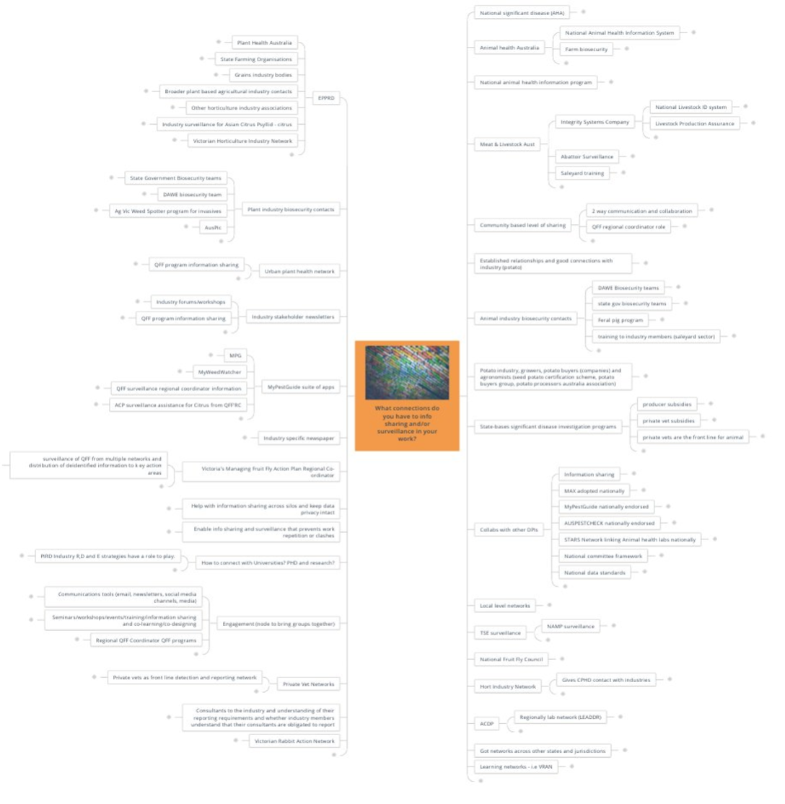
(Description of the network infographic that asks participants ‘What connections do you have to information sharing and/or surveillance in your work? – responses captured in the table below)
Responses
Two way communication and collaboration
Abattoir Surveillance
ACDP
ACP surveillance assistance for Citrus from QFF'RC
Ag Vic Weed Spotter program for invasives
Animal health Australia
Animal industry biosecurity contacts
AUSPESTCHECK nationally endorsed
AusPic
Broader plant based agricultural industry contacts
Collabs with other DPIs
Communications tools (email, newsletters, social media channels, media)
Community based level of sharing
Consultants to the industry and understanding of their reporting requirements and whether industry members understand that their consultants are obligated to report
DAWE biosecurity team
DAWE Biosecurity teams
Enable info sharing and surveillance that prevents work repetition or clashes
Engagement (node to bring groups together)
EPPRD
Established relationships and good connections with industry (potato)
Farm biosecurity
Feral pig program
Gives CPHO contact with industries
Got networks across other states and jurisdictions
Grains industry bodies
Help with information sharing across silos and keep data privacy intact
Horticulture Industry Network
How to connect with universities? PHD and research?
Industry forums/workshops
Industry specific newspaper
Industry stakeholder newsletters
Industry surveillance for Asian Citrus Psyllid - citrus
Information sharing
Integrity Systems Company
Learning networks - i.e VRAN
Livestock Production Assurance
Local level networks
MAX adopted nationally
Meat & Livestock Aust
MPG
MyPestGuide nationally endorsed
MyPestGuide suite of apps
MyWeedWatcher
NAMP surveillance
National animal health information program
National Animal Health Information System
National committee framework
National data standards
National Fruit Fly Council
National Livestock ID system
National significant disease (AHA)
Other horticulture industry associations
PIRD Industry R,D and E strategies have a role to play.
Plant Health Australia
Plant industry biosecurity contacts
Potato industry, growers, potato buyers (companies) and agronomists (seed potato certification scheme, potato buyers group, potato processors Australia association)
Private Vet Networks
private vet subsidies
private vets are the front line for animal
Private vets as front line detection and reporting network
producer subsidies
QFF program information sharing
QFF program information sharing
QFF regional coordinator role
QFF surveillance regional coordinator information
Regional QFF Coordinator QFF programs
Regionally lab network (LEADDR)
Saleyard training
Seminars/workshops/events/training/information sharing and co-learning/co-designing
STARS Network linking Animal health labs nationally
State Farming Organisations
state gov biosecurity teams
State Government Biosecurity teams
State-bases significant disease investigation programs
surveillance of QFF from multiple networks and distribution of deidentified information to key action areas
training to industry members (saleyard sector)
TSE surveillance
Urban plant health network
Victoria's Managing Fruit Fly Action Plan Regional Co-ordinator
Victorian Horticulture Industry Network
Victorian Rabbit Action Network

Good information sharing
Participants were asked to consider the elements of good information sharing.
Cross-jurisdictional
Likes | Response
3 | Seamless dataset, nationally.
2 | Have data that common platform and common standards.
2 | The surveillance system should join up across jurisdictions.
1 | Across borders and jurisdictions-there is harmonisation.
1 | National data standards allow information sharing between diverse systems.
1 | Good cross linkages.
0 | Data agreements between organisations.
0 | Cross industry inputs.
0 | Regional coordination.
0 | Process and agreements to share timely information between industry and government - also needs to be agreed in peacetime about what level is appropriate.
0 | Good information has a well-designed system/good architecture-that others can easily access-that considers the end-users needs and outcomes.
Respectful of privacy
Likes | Response
1 | Respect privacy issues
1 | Accessibility for all users, allowing for privacy
1 | Privacy
Systems are user friendly and fit for purpose
Likes | Response
2 | Tailored structures fit for purpose.
1 | Good information sharing is underpinned by user friendly systems which are not time consuming, and all people can use it.
1 | Up to date.
0 | Design.
0 | Automated where possible e.g. Systems that can trap insects like trapyou and rapidaim.
0 | Fit for use.
0 | Continuity over time, network maintenance, etc.
Consistent data
Likes | Response
1 | Importance of consistent property ID codes.
1 | Centrally co-ordinated.
1 | Information collected can be standardised.
0 | Remove inconsistency and make it uniform- for info sharing and for surveillance.  Comment- Isotopic model/risk assessment
0 | Accessible and single point
Data collected is useful
Likes | Response
3 | Ask first-what is the outcome you want from this data-before you start collecting.
1 | Evidence that allows good decisions.
0 | Good information sharing depends on good data analysis to turn shared data into information and intelligence. Much of this collated information can be shared back with data providers.
0 | Should gather intelligence.
0 | Intended use of data.
0 | Information that is utilised.
0 | The capacity and capability to share the data, once it is collected.
Other
Likes | Response
3 | Timely information.
2 | Actionable.
1 | Strong partnerships with community to support info sharing.
1 | Needs to be a shared model. Industry shares information and in return receives workable data to inform better decision making.
1 | Clean data.
1 | Quality / accuracy.
1 | Good information sharing allows us to make better decisions.
0 | Having scientific grounding is important to know where to place traps.
0 | Hobby farm surveillance by satellite-know what you don't know.
0 | Data that learns from data.
0 | Learn what is happening via internet information.
0 | Satellite surveillance.
0 | Good communication and relationships with trading partners/clear systems and processes for surveillance and reporting.
0 | Keep politics out of it.
0 | Pilot data sharing to improve proactive information.
0 | Sharing information between commodities.
0 | Should be input to exercises.
0 | Includes varied and verified data sets.
0 | Open and transparent data sharing with no unintended consequences.
0 | Data quality must be comparable.
0 | A feedback loop - so that ppl providing the information can see how it is being used.
0 | Trusted and competent.
0 | Representation of the situation.
0 | Regular and scheduled.
0 | Provides benchmarking.
0 | Two way sharing of information is essential for 'good' information sharing. Sounds obvious but often is one-way.

Good surveillance
Participants were asked to consider the elements of good surveillance.
Use of intelligence
Likes | Response | Comments
2 | A Constant conversation-not data going into a hole. | (no comments made)
2 | Surveillance is about intelligence-where to focus effort. | (no comments made)
1 | Use of intelligence including looking for trends. | Using surveillance at container import through to container transport and then to end destination and good receiver.
0 | Good surveillance relies on turning data into intelligence. Data analytics is an investment opportunity for Agriculture Victoria. | (no comments made)
0 | Google type intelligence. | (no comments made)
0 | Information-$1, good intelligence $111! | (no comments made)
0 | A system that takes good data and turns it into useful intelligence. | (no comments made)
Consistency
Likes | Response
2 | Consistency across states.
0 | Understood definitions (e.g. area of freedom).
0 | More uniform surveillance is good surveillance.
Systems are user friendly and fit for purpose
Likes | Response
1 | Fit for purpose.
1 | Useable access to information.
1 | Analysis and plain language interpretation of the data to improve sharing and increase likelihood of it supporting outcomes.
0 | Needs to meet need of who we're trying to sell the need to.
0 | Used for notification.
0 | User friendly and not time consuming-best when it is part of BAU.
Fit for purpose data collection
Likes | Response
2 | Good surveillance planning is reliant on what data is available / discoverable.
1 | On-ground collecting of data-making it locally relevant so that people can see the value of collecting.
1 | Receiving quality-see any absence of evidence.
1 | Availability from other sources.
1 | Too many points of contact / methods of accessing the available data.
0 | Screening social media for 'chatter' has been an effective way of monitoring from ASF in Timor and PNG, even in small remote communities (they all have iphones with Facebook!)
0 | Local councils/posties/meter readers etc have great potential for being strong advocates for surveillance (as well as reporters).
0 | Timely information that is properly recorded with full details on when/where.
0 | Validating data that's sent by citizen science.
0 | Using citizen scientists to help sending in data.

Understanding that surveillance is a public good / important
Likes | Response
0 | More public understanding of the need for data sharing as a public good.
0 | Good surveillance is engaging the broader community which are co-designed with community on topics both parties identify as important. It is resourced to support good analytics.
0 | Data is a public good.
0 | Good surveillance is Business as Usual for every human in Australia.
Use of technology/existing data
Likes | Response
1 | Widespread use of apps for identification and reporting of diseases, pests and weeds.
0 | Ensuring policy and legislative framework keeps up with technology.
0 | Using technology in addition to people.
0 | Make use of existing of biodiversity apps/public data sets to scan for early detection and use to better inform surveillance strategies.
0 | Integration and cross-referencing of the many apps that collect data at an industry level.
0 | Uses resources already in place-for e.g. fruitfly surveillance system data.
Other
Likes | Response
2 | Affordable surveillance programs. It must be cost-effective-which is relative to the benefit in addition to being affordable.
2 | Strong partnerships within and across communities and informal agronimer networks.
1 | Need to ensure varied information sources can be integrated.
1 | Scientifically validated.
0 | Getting remote traps accepted-either by trading partners (domestic and international) and businesses or between jurisdictions.
0 | Understanding of data classification.
0 | Good surveillance for early detection is continuous, and builds on the everyday observations of people in the environments or contexts in which they work or live or enjoy.
0 | Needs a data trust.
0 | Engagement from all players and have systems in place for data sharing and use the existing data.
0 | Frameworks exists for industry data sets.
0 | Proactive information to business.
0 | Good and adequate response, with loop back to who submitted the data.
0 | Triggers on risk profiles.
0 | Regular interface between livestock producers and vets.
0 | Leading indicators to alert of risks.
0 | Track information lifecycle.
0 | All producers are involved and have buy-in to surveillance programs.
0 | Need to know the post farm gate movements.
0 | We are sharing policies, processes and standard operating procedures.
0 | Widespread producer engagement.
0 | Timely reporting.
0 | View information against demographics.
0 | Statistics.

The game changers
Participants were asked to identify their top ideas to improve information sharing and surveillance.

Information sharing
Consistency
Likes | Idea | Description
5 | Establish data standards - ideally nationally. | Breakdown the fragmentation of the system between government (State and Federal) and industry,  community.
3 | Better cross-sectoral information sharing. | There have been attempts to develop national data surveillance standards-single standard that can  import data from across sectors.
1 | Preparation and standardisation of communications/engagement processes so that situational information only needs to be added rather than new documents prepared. | (no description)
1 | Build network(s) that incorporate all regional groups, including local governments, with an interest in information sharing and design an overarching body if desired. | (no description)
0 | National architecture infrastructure and system to collect and use the data. | Currently piecemeal.  Clarity about what's in the formal/top tier vs the informal sources.  How to verify and privacy from informal sources?
Education
Likes | Idea | Comments
3 | Education and clear understanding of what, where and when information can be shared. | (no comments made)
1 | To build biosecurity education into the structure of industry as part of information sharing. | Use education as a way of engagement, and also increasing awareness. Industry and university must be geared towards the needs of Agriculture Victoria.
1 | Educate the organisation on what can and can't be shared in terms of data privacy and security. | (no comments made)
Empowering the community
Likes | Idea | Description | Comments
4 | Stop referring to the general public/ potential detectors as ‘community’. It's important to get specific about the types of stakeholders well placed to share info and monitor, and tailor engagement activities to suit. Industry and government are community too. | (no description) | (no comments made)
2 | Making it as easy as possible for community to report biosecurity observations. | Using established social platforms, practices and systems to find information e.g. Facebook, inaturalists.  Need a gateway to take information from existing systems - can machine learning be used to extract information.  Using metadata including location points from the existing information.  Don't need to be hung up on data quantity when it is more important to focus on quality. | Links to using data to inform surveillance or as a type of surveillance.
0 | Community-as well as industry and government-are inspired and empowered to share information. It is a social norm to share regulatory duty. | (no description) | (no comments made)
Other
Likes | Idea | Description | Comments
7 | Cease overuse of "privacy" as a means of dodging data sharing ... investigate existing barriers and opportunities to improve data sharing. | (no description) | (no comments made)
4 | Ensuring industry is involved in emergency responses exercises across all sectors and all stakeholders. | (no description) | (no comments made)
3 | Memorandum of Understanding with government to support information sharing and allows recognition of data e.g. as per South Australian Government and potato industry. | (no description) | (no comments made)
3 | Build communities of practice in biosecurity-regionally based. | Bring local knowledge together with invested stakeholders owning the learning and actions. | For example, Victorian Rabbit Action Network run community leadership three day training course, enabling them to go back to their communities to lead.  They form learning networks, and the learning networks are connected (supports information sharing and consistent data collection).  This is a platform for building upon and linking to the 'bigger' system-enhancing/capturing local knowledge about applying that to building practices and behaviours in how people act and adopt biosecurity habits.
1 | Creation of an environment of trust. |  | (no comments made)
1 | Both macro and micro awareness and engagement investment. | Larger generic Agriculture Victoria advertising and engagement pieces delivered and supported at a local level by community leaders -reward and renumerate volunteers that are operational at a local level, fund them to be there consistently. | Advertising Campaign (at macro level) target general public with basic biosecurity habits, behaviours and reporting methods e.g. clean boots, clean tools and equipment (prune cutters plant to plant), hygiene when moving place to place.  Tailored messages (at micro level) with information, action, biosecurity risks/threats at the local level.
1 | Leveraging existing data and improve information sharing between silos. | (no description) | (no comments made)
1 | Incorporate data sharing as a key objective in the Intergovernmental Agreement on Biosecurity. | Need to improve quality of data and then improve interface.  Need to ensure data is accurate, reliable and repeatable, along with being able to verify as easily as possible.  We are swimming in data but we don't know what that means-Need to establish clarity (Important to realise and acknowledge it).  Needs to be broader than intergovernmental-communities and industry. | (no comments made)
1 | Equal partnership between government-industry-community. | True partnership, inclusive collaboration, part of the 'solution' not the 'problem'.  Cross over into surveillance.  Many sources of data held across many stakeholders, shared / agreement about form/format of data (linked to national data standards). | (no comments made)
0 | Manageable steps we can take to improve data capabilities across we can do and build an appetite for change in our leaders to change legislation. | (no description) | (no comments made)
0 | Need to understand the regulatory framework before you use it. | (no description) | (no comments made)

Surveillance
Use of technology
Likes | Idea | Description
4 | Investigate new technologies (e.g. drones, satellites, electronic livestock collars) for improving surveillance for disease and weed incursions, and utilise risk modelling for predicting incursions and/or spread. | Look at applying artificial intelligence that can search key words and terms across various platforms; it can bring attention to potential new and emerging risks.
1 | Use of technology-existing and emergent. | In COVID context Victoria Police didn't believe roadblocks was the best use of their expertise and resource, as compared to QR codes to track movement.  What is being used / worked upon in other place (NASA, Defence etc) that could be interesting or adapted?
0 | Utilising the latest, relevant technology to democratise surveillance which also uses (image recognition and other emerging technologies). | (no description)
Leverage existing systems/data
Likes | Idea | Description | Comments
2 | Recognition of community and industry data and the value for surveillance and use for market access. | (no description) | (no comments made)
1 | Make use of local assets and community groups that already have interest and skill set or existing data sets - support and encourage use of a platform for data collation. | Make a national link of this information for use by trusted sources. | Harness those groups where people are already looking (interest groups such as the Bird Watchers who are looking at birds in their garden for recreation, support them to be aware of biosecurity risks and threats; gardening groups who are already vigilant about plants in their garden or local park; retailers who are selling stock that could have little hitchhikers).  Other potential groups to leverage: Lions Clubs (a group of community minded people who want to hitch to a cause); Heirloom seed collectors group; etc.
 | Increase utilisation of Peak Industry Councils and state/territory farming organisations to design and implement policies for their respective research and development corporations and governments that, when applied, lead to improved surveillance. | (no description) | (no comments made)
 | Work with existing networks, Victoria Police. | (no description) | (no comments made)
Other
Likes | Idea | Description | Comments
3 | Fund surveillance at all levels and appoint regional collation. | (no description) | Burnout and attrition in volunteer groups is an issue-or reliance on one or two people who are on multiple committees and groups.
4 | Agree to compensate first farm that reports an exotic pest or disease no matter what to remove the disincentives to reporting. | (no description) | (no comments made)
3 | Explore the link between surveillance, intelligence and policy development in the biosecurity space. | (no description) | There must be cohesion in all the areas, be it legislative, regulatory, engagement, data etc.
3 | Get smart about mining and analysing publicly available data. | (no description) | (no comments made)
2 | Data and information needs to become intelligence. | Can be done in a simplistic or sophisticated manner.  Mitigate against the perception that reported information (through government data systems) will lead to the person being investigated/ prosecuted-change language to give more confidence to the reportee. | (no comments made)
1 | Better cross-sectoral collaboration and support (e.g. a single community engagement app). | (no description) | (no comments made)
1 | Requirements for industry participants to do training and participate in surveillance activities as part of codes of practice/property registration requirements. | (no description) | (no comments made)
1 | Explore use of satellite capabilities to share data across the supply chain. | (no description) | (no comments made)
0 | Any future surveillance programs needed to be grounded in industry experience-those at the cold face. | (no description) | (no comments made)
0 | Clarity of roles and expectation setting in terms of benefits of surveillance. | (no description) | (no comments made)
0 | National architecture infrastructure and system to collect and use the data. | Cross -over with info sharing - inextricably linked.  Trust-Mindful of 'uniforms' intimidating parts of the community who fear consequences (whether real of not).  Requires genuine partnership to be part of the solution.  Find common / shared / aligned interests to motivate people to action. | (no comments made)
0 | Creating greater awareness of biosecurity as a public good and giving the community a bigger role in it. | (no description) | (no comments made)
0 | Teach others how to get the best use data and make use of it (ensuring that it is accessible). | (no description) | (no comments made)

Closing plenary
In the closing plenary of the event, participants responded to three prompts to capture their reflections. They were:
Head: One thing I have learnt over the two days
Heart: One thing that has inspired me
Hands: My first action to continue building and improving Victoria's biosecurity is...
Head
One thing I have learnt over the 2 days:
Necessity for collaboration
- Government needs to be properly organised to get this done.
- The level of joint commitment.
- Need to influence and work together nationally.
- We are all in this together, common interests.
- There is a desire from everyone that they want to work together in biosecurity - we just need to do it.
- Relationships are key - we don't need to re-create the wheel.
Power of community action
- Victoria's community led initiatives.
- Community engagement has been central to the discussions, particularly in Day one; citizen science being a fundamental component.
- The community wants the change to occur.
- The power of community led action.
Learnings from COVID
- COVID has changed many people’s minds-make the most of it now.
- It is important that we do not lose what has been learnt during biosecurity emergencies including the COVID pandemic.
Passion for action
- Time for action.
- That Agriculture Victoria is serious about getting an outcome.
- Agriculture in Australia wants to get it done!
- Hunger for change, and for Victoria to show strong leadership on the national stage.
- That Strengthening Victoria’s Biosecurity Future (SVBF) is more than a slogan or spin - it has substance and support from high levels in the department.
- We're on the same page about the importance of biosecurity and that there are a lot of key people in groups from community and industry and government looking to take action and forward this work.
- Support for strong regulatory action for non-compliance.
Need for effective communication strategies
- The importance of data and information sharing in promoting positive biosecurity.
- Importance of language and how these impacts on people e.g. surveillance, community.
- How much communication is needed to manage biosecurity.
- The need for open and transparent sharing of information. Whether that is data or messaging.
Other
- The Gaps are well understood - obvious in fact.
- This area has been underinvested.
- The intelligence in the group and leveraging knowledge.
- We have untapped opportunity to tap into publicly available data sets - we need verification, but let's take advantage of it and build systems to manage it.
- Value of benchmarking and peer review across and within activities, sectors.
- There are different levels of understanding of biosecurity actions in place.
- Biosecurity is economy and society wide.
- Discussion about urban and peri urban risk and surveillance needs has noticeably increased.
- Urban and peri-urban biosecurity is a really important emerging area.
- We are going in the right direction with the Yarra Valley Queensland Fruit Fly awareness and engagement project by involving all the stakeholders and having emergency management plans that focus on preparedness and building relationships in communities.
- That broad understanding of the bigger picture of biosecurity, it can be a little boxed because of the complexity and technical nature of so many issues in the space.
- Biosecurity is important to many different sectors.
- Lord Baden Powell started the Scout movement.
- There are a lot of great professionals involved on biosecurity.
Heart
One thing that has inspired me:
Passion for biosecurity
- Agriculture Victoria is serious about this issue.
- The desire to get the gaps filled-don’t let that down.
- Strengths-based approach to biosecurity-willingness for positive action.
- Camaraderie, willingness to engage in long-term planning, shared responsibility being taken seriously.
- The power and passion of community groups when Government supports their activities.
- The passion to be harnessed.
- Motivating and enthusiasm is contagious able to build and add on people's ideas.
- There are so many passionate people in this space.
- The enormous level of commitment to make things better.
- Range of participants and willingness to learn from each other.
- Openness and goodwill from across the sector to work towards a common goal - the greater good.
- We all want to make the biosecurity system work better and are prepared to make it happen.
- Our collective passion of biosecurity.
- Everyone wants to talk about legislation.
- There is a will to make a difference. So much enthusiasm.
- People's desires of improve the Biosecurity system.
- The enthusiasm of partners to get involved and help make improvements.
Collective knowledge
- The diversity of and value in collective "smarts".
- Role of citizen science in supporting government and industry responsibility.
- Provides support, cross pollination and opportunity to talk to others with a common interest.
- Hearing from so many people across the system about what matters, where the gaps are and what we can do to move forward together.
- So many players in this space, amazing the number of people and the diversity of interests, opportunities to connect.
- The amount of knowledge available across all the experts.
Other
- Quote from early session: "Not helpful to think of biosecurity as a tax on the industry".
- Lots of aspirational thoughts. We may not "achieve" it all, but let’s not drop the ball, we can eat the elephant a bit at a time.
- Desire to think inventively and modernise - doing it differently.
- There has been NO finger pointing. Everyone realises that we are in this together.
- The potential - just get on with it.
- Potential for new technologies.
- The fact that this forum has been held is an indication of intent to engage.
- Positivity and inclusiveness that has been generated, ability of everyone to contribute whether it is at local, regional or national level.
- The potential and goodwill for us all to get together and make a real difference.
- Partnerships built from the bottom up.
Hands
My first action to continue building and improving Victoria's biosecurity is:
Continue the conversation
- Read the report back the continued engagement.
- Continue to look for creative ways of enriching our understanding of information that is available and useful.
- Start the conversation with people who use and are affected by biosecurity – understand where biosecurity is headed and what we need for the future.
- Continue the conversation.
- Continue the conversations from today into other forums to progress biosecurity goals.
- I will continue ramp up the awareness of biosecurity in my community.
Share learnings with network
- Read report, and take it back to my network/peers.
- Will say to my network that Victorian’s biosecurity participants really want change and the government seems ready to support this.
- Share the outcomes, documents and discussions from this forum more widely with our networks.
- Share the outcomes.
- Working with my members on reinforcing their role in the biosecurity continuum.
- Share information around emergency and procedure information with producers.
- Take what we have heard into the departments work going forward and make the most of the connections that have been made as part of this forum.
- Reminding everyone that biosecurity is part of what we do, it’s in our DNA.
Work with producers
- As a producer working together 'with' per-urban/lifestyle farmers.
- Shared workspace with other biosecurity professionals and aim for more emersion with other orgs. Put yourself in their shoes.
- Identify existing producer networks and how we can share information with them.
- Understand producer needs.
Other
- Ensure Agriculture Victoria and Industry delivers on its promises.
- Push for more resources and focus on this area.
- Make this a priority until things get sorted.
- Think more about preparedness and the gaps that need thinking through.
- Have an EXERCISE - improve and understand-then another.
- Push Strengthening Victoria’s Biosecurity Future to keep it going.
- Needs a business intelligence based approach-where to focus the effort and scarce resources.
- Investigate how Landcare can contribute to the 4M eyes idea.
- Review the data/information and look at how we take the next steps for meaningful engagement.
- Work with Peak Industry Councils on policy development and implementation.
- Agriculture Victoria to support more opportunities for people to engage.
- To brief the Australian Veterinary Association on the Strengthening Victoria’s Biosecurity Future program and seek to enhance engagement with Agriculture Victoria /Chief Veterinary Officer team on enhancing whole of vet profession collaboration.
- Work with producers more when developing strategies and projects.
- Face to face for next forum, maybe even hold it sooner than 12 months.
- Putting in place a mechanism to support better industry/government/community information sharing.
- Be an intelligent critic/friend to Strengthening Victoria’s Biosecurity Future.
- Make time to try to get this done.
- Strengthening Victoria’s Biosecurity Future will be presented to the national plant health committee in the coming weeks to help forward the agenda.
- Look at better opportunities for community engagement and education.
- Communication around Smart Surveillance Data - we can generate quality surveillance data cheaper.

Workshop feedback
At the conclusion of each workshop, participants were asked to complete a short survey to provide feedback on their experience. The feedback from each workshop has been compiled and is presented here by question. Note that some participants will have filled out the survey more than once if they attended multiple workshops.
Participants who completed the survey were from the following organisations:
- Department of Jobs, Precincts and Regions
- Vic Catchments
- PrimeSafe
- Agribusiness Yarra Valley
- Agriculture Victoria
- Invasive Species Council
- Grains industry representative
- Victorian Farmers Federation
- Animal Health Australia
- Australian Livestock Saleyards Association
- Environmental Protection Authority Victoria
- Victorian Apiarist Association Inc. Beekeeping Industry
- Apple and Pear Australia Ltd.
- Victorian Rabbit Action Network.

Question 1: Overall, how would you rate your satisfaction with this event?
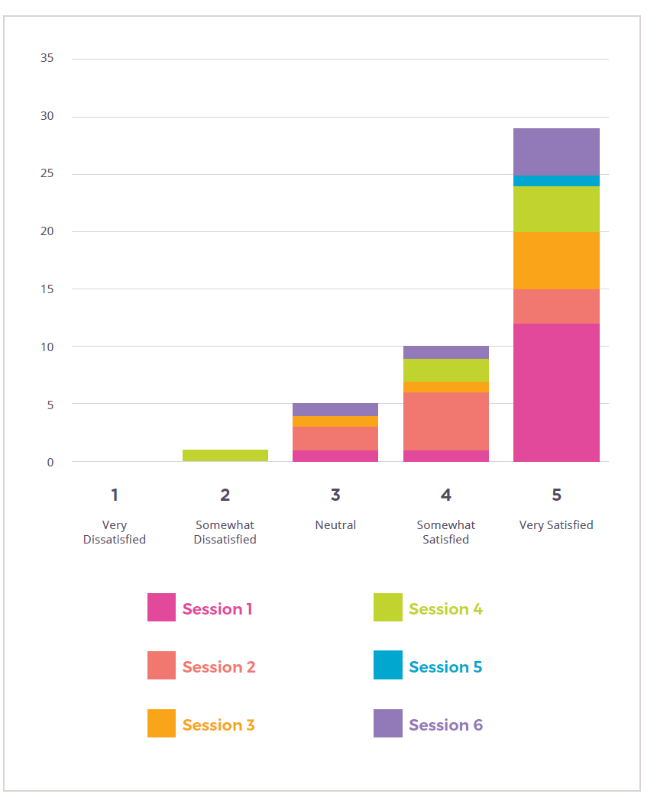
(Description of the data shown in the above graph for Question 1)
Session 1
- 11 very satisfied
- 1 somewhat satisfied
- 1 neutral
Session 2
- 3 very satisfied
- 5 somewhat satisfied
- 1 neutral
Session 3
- 5 very satisfied
- 1 somewhat satisfied
- 1 neutral
Session 4
- 4 very satisfied
- 1 somewhat satisfied
- 1 somewhat dissatisfied
Session 5
- 1 very satisfied
Session 6
- 4 very satisfied
- 1 somewhat satisfied
- 1 neutral
Question 1 - Comments
Session 1
- Insufficient time for discussion.
- Very easy. Good conversations
- A lot of good information and the little discussion groups help get to know other attendees and their point of view
- Engaging way to get thinking about the topic
- Great mix of presenters and participants in chat groups
- The program was engaging and great for participation.
- Lots of great conversations had.
- Small group work and interactive nature was excellent.
- Facilitators are doing an exceptional job
- Good mix of presentation styles
- Very engaging, breakout rooms are great way to generate discussion 👍
- I like the format of keynote and breakout short and sharp, but would be great if there was a facilitator in each breakout to get good value out of these
- I thought it was fantastic how the team welcomed people as they arrived into the room, I really like the 'cameras on' approach and consistently encouraging people to switch on (means people have to be 'present'), great guidance on using the technology, a good variety of speakers, and I really enjoyed the small-group discussions (for gaining insights and making connections with people).
- Well run, great conversations, good speakers, small group engagement
- Very engaging, breakout rooms are great way to generate discussion 👍
Session 2
- It was very smooth. It will need a lot of ongoing conversation on this topic.
- Respectful exploration of the issues and a way forward
- lost link to comments pages (comments could/should be able to apply to more than 1 session)
- too fast and session not long enough
- common aspirations of participants about the need for regional extension practice to support biosecurity
Session 3
- Short small sessions good - it will be in the interpretation that a final judgement can be made. The Mosaic team were good.
- Well run, great conversation and engaged participants
- Good open exploration
- Really well structured process and timing for good conversations.
- interesting discussions, breakout rooms worked well. Session length was just right
- Lots of useful insights from a range of stakeholders about how the biosecurity legislative framework affects them.
- Very good and respectful discussions.
Session 4
- Let’s see how some very good ideas and needs get translated to action
- Well facilitated and effective participation using online system
- There were other biosecurity meetings in play this morning that prevented the attendance at this meeting, and this was also the case yesterday for some
- Everyone involved was very inclusive in discussing their industry issues around biosecurity and how similar thoughts issues were to ours.
- The organisers were patronising and basic in their approach. There were no real aims identified and no real outcomes identified either. The whole event felt it was a tick box so that government can make the statement they ‘consulted industry’.
Session 5
- A really great format with engaging facilitators; So great to see so many participants willing and able to give time to this and share their ideas and expertise.
Session 6
- Was useful but as I wasn't able to attend all the sessions, I felt I had missed some of the previous conversations from the day.
- Really enjoyed hearing people's inspirations and priorities for next actions
- Great to hear from Matt Lowe and his primary action as Community Engagement to reach out to community and industry!
- The inclusive nature of the forum ... respect and trust was built

Question 2: How would you rate your understanding of Victoria’s biosecurity system as a whole following this workshop?
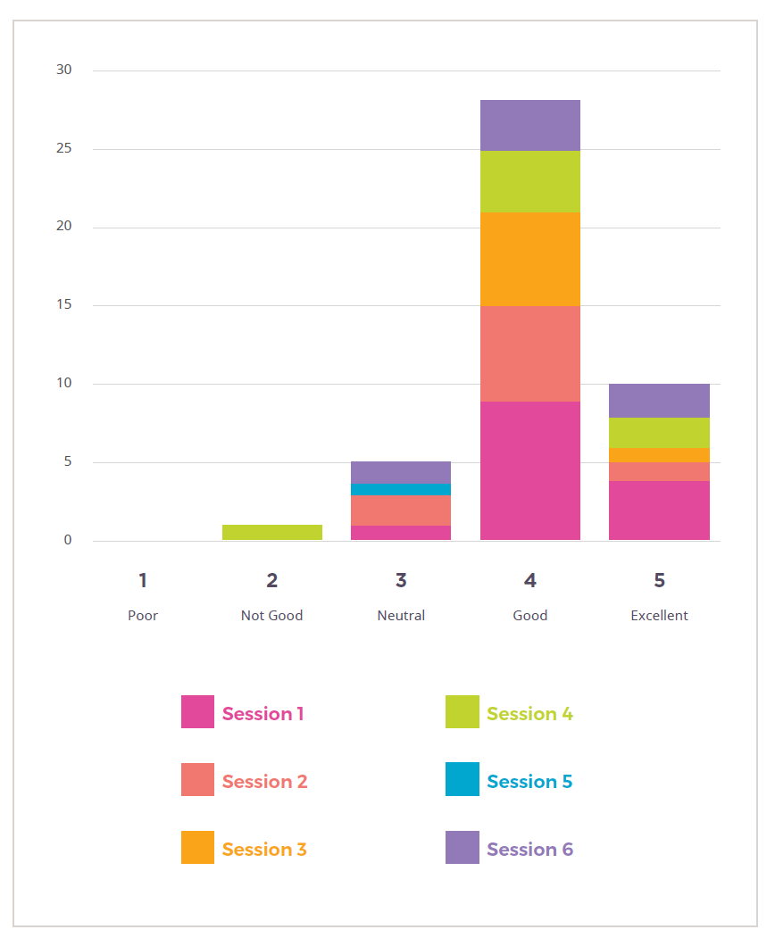
(Description of the data in the above graph for Question 2)
Session 1
- 4 excellent
- 9 good
- 1 neutral
Session 2
- 1 excellent
- 7 good
- 2 neutral
Session 3
- 1 excellent
- 6 good
Session 4
- 2 excellent
- 4 good
- 1 not good
Session 5
- 1 neutral
Session 6
- 2 excellent
- 3 good
- 1 neutral

Question 3: What was your key take away from the event?
Session 1
- Drivers of change for Victoria
- More collaboration
- More funding is needed and more public participation is needed
- Community is key
- Evident that we need more boots on the ground and regional coordinator roles to support multi industry agricultural regions
- The importance of community engagement. I think we have government and industry engagement sorted, but need to improve community engagement
- Deeper engagement is needed
- Need to work with common purpose to engage collective actions examples include Landcare, VRAN, CPMGs - industry is interested in following this model
- Good scene setting and relationship building
- Community wants to be part of the solution not just considered as the cause of the issue
- "It’s not helpful to think of Biosecurity as some type of tax on industry"
- Doing 'more of the same' for biosecurity is not going to be enough, in the future, to maintain the level of protection and assurance we have now
- So much to do, can be done, needs to be supported, real world action
- Community wants to be part of the solution not just considered as the cause of the issue.
Session 2
- Connection, trust and honesty are key to strong partnerships and good engagement
- Historical roles should be challenged
- Relationships based on integrity, trust and respect are key to shared responsibility actually working
- Trust and collaboration
- Need to scope 'Biosecurity' better
- Agriculture Victoria doesn't want to be the knowledge pinnacle, the call out is for community members to step up, but they are lacking the time and resources to do so, and there is still a gap not properly identified or solved yet
- I think there is a genuine mood for change which is good, let's do it.
Session 3
- Things need to be done-not continually talked about
- Importance of governance of the project involving industry/community
- Lots of opportunities-but also hesitancy around legislation
- More needs to be done around how government engages on this topic
- Victoria is very motivated to do a great job of modernising their legislation
- That biosecurity is relevant and important in settings other than agriculture
- Genuine commitment to lead a reform style agenda.
Session 4
- There are clear gaps and needs that must be fulfilled
- That there are significant opportunities for Government and peak bodies to work with industry to improve their preparedness
- That there is a big push for industry and community to be invested and responsible for biosecurity, but the resources and funding may not be there to collate and communicate data to influence management actions at a regional level. We need to stop asking the same people in each region or industry to donate time and resources, we need an employed service provider to do the heavy lifting (work and knowledge gathering and teaching) in communities and assist the volunteers to participate
- That we are all in the same boat as industries and need to share ideas and work together to solve issues
- There will be nothing done to improve biosecurity in Australia, especially in agriculture.
Session 5
- The value of local networks, and importance of inter-jurisdictional collaboration. The need for more resources to facilitate biosecurity actions.
Session 6
- Connections with interested partners
- We need to understand what we mean by 'community' in the context of biosecurity and how we inform and empower communities to be contributors to the biosecurity system
- Networking with other biosecurity professionals
- That we are all working together...
- There is a lot of work to do in a complex arena with limited funding and a crucial need to have engagement with industry, stakeholders and the broader community.

Question 4: How much opportunity did you have to contribute to the workshop session discussions?
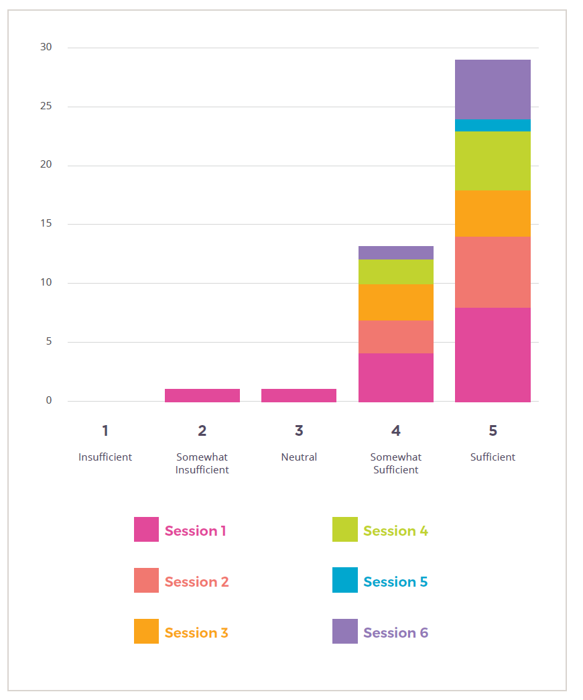
(Description of the data in the above graph for Question 4)
Session 1
- 8 sufficient
- 5 somewhat sufficient
- 1 neutral
Session 2
- 7 sufficient
- 3 somewhat sufficient
Session 3
- 4 sufficient
- 3 somewhat sufficient
Session 4
- 5 sufficient
- 2 somewhat sufficient
Session 5
- 1 sufficient
Session 6
- 5 sufficient
- 1 somewhat sufficient

Question 5: The workshop was an engaging learning experience
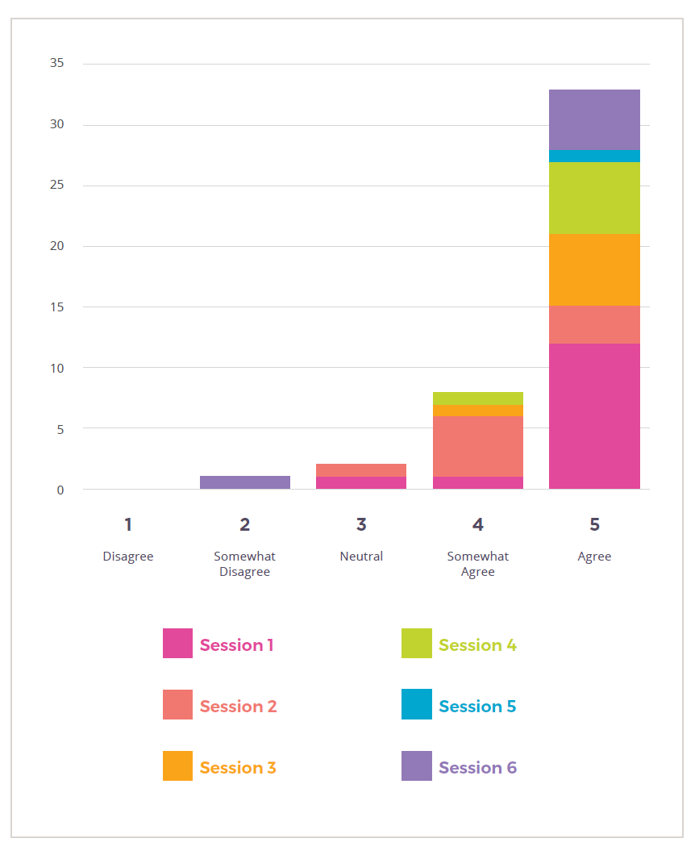
(Description of the data in the above graph for Question 5)
Session 1
- 12 agree
- 1 somewhat agree
- 1 neutral
Session 2
- 3 agree
- 6 somewhat agree
- 1 neutral
Session 3
- 6 agree
- 1 somewhat agree
Session 4
- 6 agree
- 1 somewhat agree
Session 5
- 1 agree
Session 6
- 5 agree
- 1 somewhat agree

Question 6: If we were to run a similar event, is there anything that you would like to see changed/added to it? (e.g. in terms of content, design, timing, layout, etc.)
Session 1
- More time for group discussions and more pointed questions.
- Perhaps slightly more time for discussion
- No it ran better than all other zoom meetings I have previously been involved in
- No
- Smaller regional action groups
- I think the program at the opening plenary was great
- No
- Maybe a little shorter opening from government representatives
- Don’t make all these questions mandatory!!
- No well run
- Facilitated workshops, intros for each participant in small groups
- Always want just a little more time in those small group discussions - first few minutes are always taken up with getting over everyone's mutual awkwardness.
- Potentially enforce some training on EPPRD etc legislative frameworks prior to attending
- No well run.
Session 2
- Good tools - better than sticky bits of paper
- Don't do it over lunch
- It would have been good to have a leader in each breakout group to help people stay on track, share time in chat rooms and ask each participant to contribute
- Also, the ability to see the questions with lead time (i.e. Sent at the start of the week) to allow better preparation of responses. Some group map instructions were unfamiliar or unclear
- Great format considering face to face would also have been good COVID allowable.
Session 3
- Perhaps a way of seeing what were the most popular response types, i.e. more resourcing, more trust needed etc
- More time for conversations!
- All good thanks
- N/A
- No, everything was good. The mosaic team did a great job facilitating
- Same as always, just a little more time in those small group discussions - this is often where the most interesting and surprising insights emerge
- Maybe a little more discussion time
Session 4
- Despite everyone who is part of the workshop being interested in biosecurity it is worrying how many do not understand the broader policy and legislative frameworks that are impacting our effectiveness in this space. E.g. limited knowledge and assumptions regarding strength of quarantine and surveillance regulations (i.e. didn’t know not every container inspected) limited knowledge of EPPRD and other industry systems.
- The time intervals given today where much more appropriate and much appreciated
- Perhaps some guidance in how to write outcomes, actions etc.
- A clear calendar with regards to other biosecurity related events
- No I think it was well run with plenty of opportunity to have input
- Have clear aims and outcomes and what the whole point of the event is.
Session 5
- No comments
Session 6
- The sessions were really well thought through and designed, made the most of the digital environment
- A little more time to chat! !LOL
- The role of first nations people... Given their emerging role in caring for our land and its security
- All participants should have been required to complete the EADRA, EPPRD familiarisation training to ensure they understood emergency response processes, there is a real need to broaden participants understanding of the regulatory frameworks and limitations impacting biosecurity and to gain an understanding of the bigger picture, a few too many had little understanding beyond their personal box.

Question 7: Is there anything else that you would like to share about your experience?
Session 1
- Some more examples of teams’ work worked through.
- Thanks
- I appreciate that my role and my region have a best practice model of community and regional action in area wide management of a pest, and there should be more of this in more communities across more biosecurity issues - pulling people together.
Session 2
- No further comments.
Session 3
- That we need to keep the conversation continuing ... and include more and different people in the mix of contributors.
Session 4
- No comments.
Session 5
- There needs to be a road map of actions after this - not a suspended set of needs and gaps that are not dealt with. Thanks
- N/A
- No
- No other comments
- Great opportunity to learn and share knowledge and expertise.
Session 6
- Thanks for the opportunity-good luck
- Well facilitated
- Biosecurity really does mean different things to different people
- Great to meet so many people from different sectors of the biosecurity community - can we have a list of names, roles and contact details to continue future discussions?
- Well done.

Please note:
While every effort has been made to transcribe participants comments accurately, a small number may not have been included in this summary due to the legibility of the content. Please contact Lyndal Mackintosh lyndal@moscaiclab.com.au for any suggested additions.
This report has been prepared by MosaicLab on behalf of and for the exclusive use of Agriculture Victoria. The sole purpose of this report is to provide a summary of participant input provided during the 2 day workshop on the 17 and 18 June 2021.
This report has been prepared in accordance with the scope of services set out by Agriculture Victoria. In preparing this report, MosaicLab has relied upon the information provided by the participants at the workshop. Agriculture Victoria can choose to share and distribute this report as they see fit. MosaicLab accepts no liability or responsibility whatsoever for or in respect of any use of or reliance upon this report by any third party.
MosaicLab is a Victorian-based consultancy that specialises in community and stakeholder engagement, facilitation, negotiation, strategic planning and coaching.

