Legal requirements for the supply of 1080 or PAPP Community baiting programs
This information note provides coordinators of community baiting programs with guidance on the legal requirements for the supply and use of 1080 (sodium fluoroacetate) or PAPP (4-aminopropiophenone) pest animal bait products in Victoria.

What role do coordinators play?
Baiting coordinators organise a group of landholders to simultaneously conduct a baiting program. Participants may be part of a community group, Landcare program or neighbouring landholders.
Coordinators perform a crucial role in the safe and effective use of 1080 and PAPP products in communities. They are often viewed as experts by their local communities, and as a result are often expected to have a more thorough understanding of the legal requirements than the general public.
Coordinators will often be tasked with arranging a bait order for landholders with a supplier. Coordinators must ensure that all landholders involved in the program are authorised to be supplied with and to use bait products and should request proof of this authorisation from participants.
Coordinators should also make sure all participating landholders hold a copy of the Directions for the use of 1080 and PAPP pest animal bait products in Victoria (the Directions for Use) and discuss the requirements with them.

The directions for use
The “Directions for the use of 1080 and PAPP pest animal bait products in Victoria” (the Directions for Use) is a document prepared by Agriculture Victoria which sets out how to meet the minimum legal standard required when using 1080 or PAPP bait products in Victoria. It outlines legal responsibilities related to supply, storage, use and disposal of these products that are in addition to those set out on the product labels.
By complying with the Directions for Use, people will not only meet their legal obligations, but also minimise risks posed to themselves, their neighbours and non-target species.
The Directions for Use specifies requirements for:
- Completing a pre-use risk assessment.
- Transporting and storing product appropriately.
- Notifying neighbours and displaying signage to communicate baiting activities.
- Managing risks to non-target animals.
- Following distance restrictions.
- Laying bait correctly.
- Agent and product user record keeping.
- Disposing of used and unused product, carcasses, and containers.
Coordinators must remind participating landowners that they (the bait users) are responsible for ensuring people comply with the Directions for Use.
A copy of the “Directions for Use of 1080 and PAPP Pest Animal Bait Products in Victoria” is available at agriculture.vic.gov.au/baiting

Who can be supplied baits?
1080 and PAPP products are classified by the Australian Pesticides and Veterinary Medicines Authority (APVMA) as Restricted Chemical Products (RCPs). This means they can only be supplied to ‘authorised persons’, and it is illegal for 1080 or PAPP products to be in the possession of any person who is not authorised.
In Victoria, an authorised person is over the age of 18 years and:
- holds a valid Agricultural Chemical User Permit (ACUP) with ‘1080 and PAPP’ endorsement; or
- operates under a valid Commercial Operator Licence (COL) with vermin destroyer endorsement, and has completed the 1080 and PAPP user training∗; or
- holds a valid Victorian Department of Health Pest Control Licence (PCL) authorising the use of pesticides formulated for the control of pest animals and has completed 1080 and PAPP user training*; or
- holds a valid Pilot (Chemical Rating) Licence (PCRL) and has completed 1080 and PAPP user training*.
Apart from a PCRL, licences issued by other State and Territory governments are not valid in Victoria. Bait products must only be supplied to persons who hold valid Victorian authorisation and have completed the 1080 and PAPP user training*.
At the point of supply, a person must present their authorisation for the retailer to sight and check. For COL, PCL and PCRL holders this means producing their licence as well as their 1080 and PAPP user training certificate, as completion of this training is not stated on the licence.
Sometimes a person collects bait products on behalf of the bait user. This includes baiting coordinators and Landcare representatives. This person is called an agent.
An agent must be authorised to be supplied the product, even though they may not be the end user.
* 1080 and PAPP user training is the course accredited by the Victorian Registration and Qualifications Authority titled ‘Course in Minimising risks in the Use of 1080 baits for vertebrate pest control (VIC222275) and previous equivalents.
This course trains participants in the safe, legal, and effective use of 1080 and PAPP products.
Retailers and agents must not supply products to a person if they do not have proof of authorisation.

Wholesale vs retail supply
The legal requirements for supplying 1080 or PAPP products by wholesale or retail are different.
Wholesaling is the supply of product to a retailer, who then supplies the product to the end user. A licence from the Department of Health (DH) is required to supply 1080 or PAPP by wholesale, and wholesalers can only supply to retailers that are Agsafe 1080 and PAPP accredited.
Retailing is the supply of product to the end user and not for on-supply. Retailers must be Agsafe 1080 and PAPP accredited.
A bait coordinator should only obtain baits from a licensed retail supplier.
A list of Agsafe 1080 and PAPP accredited retailers can be found on the Agsafe website.

Manufacturing of fresh 1080 baits
A licence is also required from DH to manufacture ‘fresh’ (perishable) 1080 products. Some manufacturers will be licensed for wholesale supply only, and others for both wholesale and retail supply. A list of licensed manufacturers can be found on the DH website.
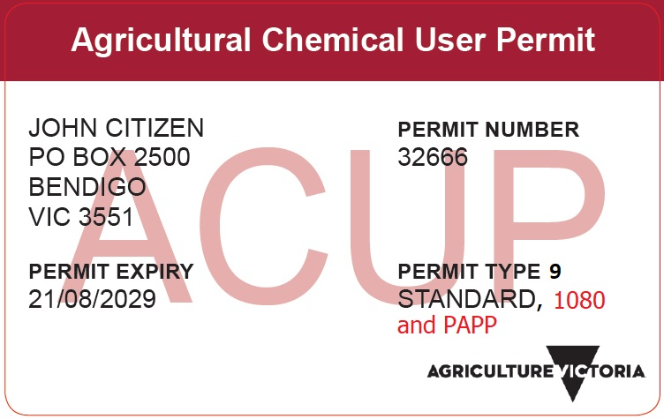
Image: A 1080 and PAPP endorsed ACUP.

Supply for a baiting program
Coordinators must not put themselves in the position of the ‘retailer’ unless they are appropriately licensed or accredited. This can occur unintentionally when bait products are being collected and paid for by different parties. For example, if a coordinator purchases bait product and then invoices the landholders for those products, they are deemed as having ‘retailed’ the baits.
The following examples are considered lawful supply from an accredited retailer/licensed manufacturer:
Where the landholder is responsible for paying for the product:
- Each landholder obtains the baits from the supplier and is directly invoiced; or
- Agent obtains the baits from the supplier, and the supplier invoices the landholders.
Where the community group is paying for the product:
- Each landholder obtains the baits from the supplier and the community group is invoiced for the full amount; or
- Agent obtains the product from the supplier, and the supplier invoices the community group for the full amount.
Supplying bait products to an unauthorised person is illegal and poses significant risk to people, non-target animals and the environment.

Supply record keeping

Retailers
If a 1080 or PAPP product is collected by an agent, the retailer is required to record the full name and address of both the agent and end user.
Agents need to ensure they have these details for participating landholders at the time of collection.
Retailers are required to make other records when selling 1080 or PAPP bait products. Further information on the requirements can be found in the Agriculture Victoria information note titled ‘Legal requirements for the retail supply of 1080 and PAPP products’, available on the Agriculture Victoria website.

Agents
Authorised persons acting as an agent must make a record that includes the following information:
- full name and address of the agent and authorised user/s; and
- authorisation type (i.e. ACUP), number and expiry date held by the agent and authorised user/s; and
- 1080 or PAPP product name, total quantity purchased, and quantity provided to each authorised user.

The agent must sign and date this record and keep it for two years. A record keeping template, “Agent 1080 and PAPP bait purchase record” is available on the Agriculture Victoria website at www.agriculture.vic.gov.au/baiting

Neighbour notification
1080 and PAPP users participating in a coordinated community baiting program with their neighbours may meet their notification requirements by co-signing an acknowledgement notification form. This must be completed at least 72 hours in advance of using 1080 or PAPP bait products. A copy of the “Community baiting program notification and acknowledgement form” is available at www.agriculture.vic.gov.au/baiting

Further information
More information on 1080 and PAPP bait products, including the Directions for Use and record keeping templates can be found on the Agriculture Victoria website at: www.agriculture.vic.gov.au/baiting
More information on the Victorian Department of Health 1080 manufacturing licence holders can be found on the Department of Health website at: www2.health.vic.gov.au/public-health/drugs-and-poisons/1080-poison-manufacture-and-supply-licence
More information on the Victorian Department of Health Pest Control Licence (PCL) can be found on the Department of Health website at: www2.health.vic.gov.au/public-health/environmental-health/pesticide-use-and-pest-control

If you would like to receive this publication in an accessible format please call 1300 502 656
ISBN 978-1-76090-454-8 (Print)

