BestWool/BestLamb – Group Profile
Western Plains Network Group – March 2022

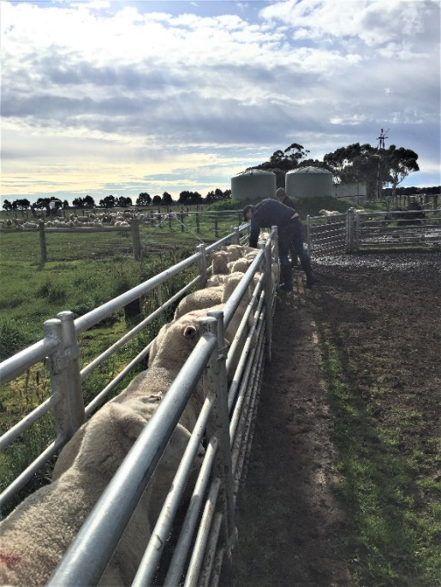

Figure 1. Condition scoring ewes prior to entering
lambing paddocks for mob size trial.

Group – Western Plains, 18 members.
BWBL Coordinator – Andrew Kennedy
Agriculture Victoria Coordinator – Cathy Mulligan
Location – Camperdown region
Enterprises – prime lamb, wool production and mixed beef cattle.

The Western Plains BestWool/BestLamb (BW/BL) group have recently finished a three-year on-farm Producer Demonstration Site project in Victoria's south west which looked at the factors impacting lamb survival.

The project looked at ewe condition and feed on offer throughout pregnancy, as well as mob size and shelter at lambing, and how each of these factors influenced lamb survival rates.

Results from the demonstration align with lamb survival research* (Improving lamb survival by optimising lambing density 2019 and Lifetime Ewe Management 2005) and have given the group the confidence to make changes on their own farms. Results showed ewes lambing in smaller mobs had higher survival rates compared with ewes lambing in larger mobs. Shelter also had an influence and ewes lambing in more sheltered paddocks had higher lamb survival rates compared to less shelter. The ewe condition trial conducted in the first two years demonstrated that condition had an impact on lamb survival in multiple bearing ewes.

The mob-size trial was conducted on one host property for three years with twin-bearing ewes split into smaller mobs (averaging 45 ewes) and larger mobs (averaging 113 ewes). Lamb survival ranged from 86 – 90 per cent in the smaller mobs, compared to 82 – 83 per cent in the larger mobs. Lamb marking rates ranged from 172 – 180 per cent in the smaller mobs and 147 – 165 per cent in the larger mobs. In the final year of the project, a second property measured a seven per cent increase in lamb survival in the smaller mob of 64 ewes (77 per cent lamb survival) compared to the larger mob of 100 ewes (70 per cent survival). This equated to 15 per cent more lambs marked in the smaller mob (155 per cent), than the larger mob (140 per cent).

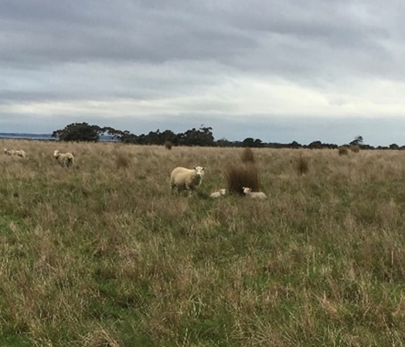

Figure 2. Newborn twin lambs in the shelter trial.

The 2021 shelter trial involved two mobs of 63 and 64 twin–bearing ewes lambing down in a higher shelter paddock and a lower shelter paddock. The higher sheltered paddock had more tussocks and was surrounded on all sides by shelterbelts, whilst the other paddock had less tussocks and shelterbelts. The paddocks were a similar size, with similar levels of feed. The trial achieved a 24 per cent increased marking rate (164 per cent compared to 140 per cent) and 10 per cent increased lamb survival (82 per cent compared to 70 per cent) in the more sheltered paddock.

The influence of body condition on lamb survival was trialled in 2019 and 2020 and showed that ewes in lower condition at lambing produced fewer lambs than ewes in higher condition. Two mobs of 80 ewes scanned in lamb with twins were drafted off with an average condition score of 2.8 (lower condition treatment) and 3.5 (higher condition treatment). In 2020, the higher condition ewes produced 147 lambs compared to 101 lambs from the lower condition ewes. Marking rates were 184 per cent and 126 per cent and lamb survival rates were 92 per cent and 63 per cent respectively, resulting in a 29 per cent increase in lamb survival for the higher condition mob. A similar trial in 2019 on the same property also resulted in increased marking and lamb survival rates in the higher condition mob, although not as large as the 2020 results. The 2019 results showed six per cent higher lamb survival and 12 per cent increase at marking in the higher condition mob.

As well as participating in and observing the results of each trial, group members gained skills and experience through group condition scoring activities. Paddock walks assessing feed on offer were part of the lambing paddock preparation, and temporary electric fencing was demonstrated to divide paddocks to allow for smaller lambing mobs. A lamb autopsy workshop was planned as a group activity in 2021, however due to gathering restrictions the workshop was alternatively delivered as an online webinar. Although the benefits of a practical session where not fully achieved, members reported it was a useful refresher for the coming lambing season. One-on-one sessions were also conducted to help members explore and identify areas that may help improve lamb survival or ewe reproductive performance.

In years two and three the demonstration was disrupted due to restrictions on group gatherings but despite this, the Western Plains BWBL group all agreed they had learnt new knowledge and skills around management of twin–bearing ewes leading to greater lamb survival. Members are currently implementing or planning to implement changes to their existing practices around ewe mob size and paddock size, managing condition and feed on offer for pregnant ewes, and better use of shelter for twin–bearing ewes.

The demonstration has shown there are welfare and economic gains to be made by influencing shelter, mob size and condition score of twin–bearing ewes. Economic analysis is currently underway to estimate the cost:benefit for adopting these practices.

A final report on the demonstration Increasing Lamb Survival Producer Demonstration will be available on the MLA and Agriculture Victoria website in the future.

For more information email BWBL Coordinator Andrew Kennedy at andrew@thriveagriservices.com.au or Bindi Hunter, Project Leader – Farming Systems Demonstrations, Agriculture Victoria at bindi.hunter@agriculture.vic.gov.au

This Producer Demonstration Site project was funded by Agriculture Victoria and Meat and Livestock Australia (MLA).

*Improving lamb survival by optimising lambing density MLA and Australian Wool Innovation (AWI) co-funded research led by the Department of Economic Development, Jobs, Transport and Resources (DEDJTR), 2019. Lifetime Ewe Management (LTEM) research conducted by AWI, 2005.

Accessibility
If you would like to receive this publication in an accessible format, contact Agriculture Victoria on beef.sheepnetworks@agriculture.vic.gov.au
This document is also available in PDF and Word format at http://agriculture.vic.gov.au/on-farm-demos

Disclaimer
This publication may be of assistance to you but the State of Victoria and its employees do not guarantee that the publication is without flaw of any kind or is wholly appropriate for your particular purposes and therefore disclaims all liability for any error, loss or other consequence which may arise from you relying on any information in this publication.
Issued March 2022

