BestWool/BestLamb – Group Profile

Boort Group demonstration: Using drones on farm to monitor sheep welfare – April 2022

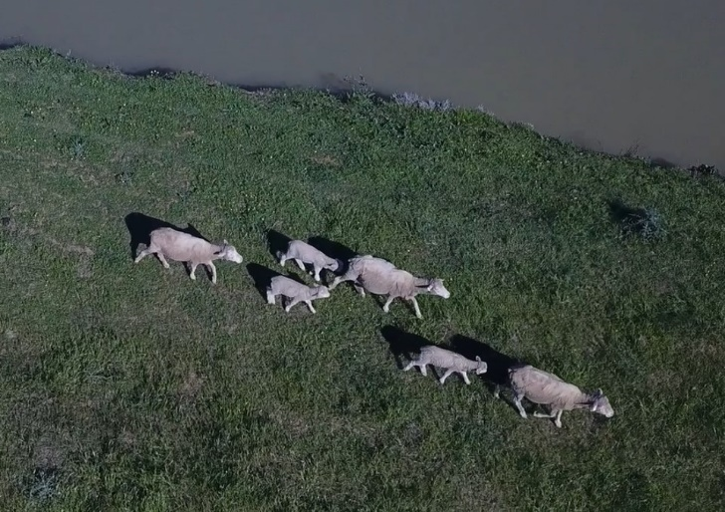
Figure 1:Drone in flight, checking ewe and lamb welfare

Group – Boort BestWool/BestLamb
BWBL and demonstration coordinator – Erica Schelfhorst
Enterprises – prime lamb, wool production and mixed farming and cropping.

The Boort BestWool/BestLamb group have recently finished a three-year on-farm trial investigating the usefulness of drones to monitor lambing ewes and for other farming operations. The on-farm demonstration was set up in early 2019, with funding from Meat and Livestock Australia (MLA) and Agriculture Victoria.
The group chose to investigate the practicality and usefulness of a drone to monitor sheep welfare at lambing and at other critical times in the year to see if the technology reduced time and labour costs normally associated with these tasks.
Drones are being used more frequently in agriculture, mainly for monitoring crops and pastures, with some large ones used to spot spray. There was little available information about their use for checking livestock and which drone might best suit the needs of the farmers or how to use one around sheep. Drone suppliers were relied upon to recommend and supply the most appropriate drone for the task of monitoring sheep welfare.
Seven producers from the Boort group were directly involved in the trial with lambing occurring from autumn through to spring. This allowed the drones to be moved from one property to the next according to the lambing schedule. To enable the sheep to become accustomed to the drone, the plan was to present it to the flock before lambing, however that was not always achievable given time-critical farm activities. The farmers immediately removed the drone from a lambing paddock if they thought that it was negatively impacting ewe and lamb behaviour.
A GoPro drone followed by the addition of two DJI drones, a Phantom Pro and Mavic Pro were used during the demonstration. These are all off-the-shelf commercial sub 2 kg drones.
Video footage from the drones clearly showed the sheep’s response to the drone at different heights and speeds. It was observed that sheep stayed calm when the drone was traveling slowly or hovering above 30 m. The sheep flight response was triggered when the drone was at a lower height or was travelling at speed at any height, which the farmers believed was due to the sound of the drone. Ewes and lambs were observed to stay calm with the drone at lower heights (10 - 15 m) if approached slowly.
The drone cameras used in this trial unfortunately lacked the ability to zoom, which was particularly necessary if the drone was above 20 m. Hence the drone needed to be lowered closer to ground-level for items to be clearly seen, which was more likely to trigger the sheep’s flight response. Newer drones now have cameras that can zoom which may have negated the need to lower the drone.

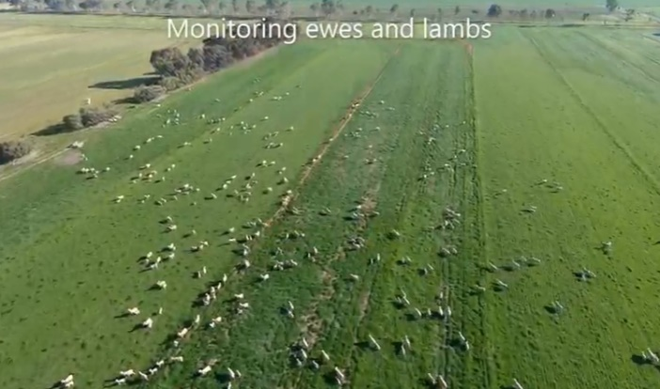
Figure 2: Sheep captured from a drone while grazing
View the drone in action
As well as participating in and observing the results from each farm, group members gained skills and experience in the use of drones on their own farm. One farmer said, 'It was a good chance to use a drone to see what it's like before committing to buying one, especially when you're not sure that it will work for you in your setting. And a drone is not something that you use everyday or can easily try'.
The demonstration also looked at whether drones could enable more frequent sheep welfare checks and offered any labour savings. Newer drones like the DJI drones can travel up to 5 km from the operator, although it is a Civil Aviation Safety Authority (CASA) requirement that the operator must always have 'visual line-of-sight'. The visual line-of-sight was reached in some of the lambing paddocks. In one example, the drone could no longer be seen past 1 km, yet the far boundary of the paddock was over 1.6 km from the operator. This may not be an issue in areas where paddocks are smaller.
The drone battery life of about 8 - 15 minutes also impacted flight duration, particularly if it was windy and or when the drone needed to be flown slowly so that the sheep remained calm. The battery life and lack of visual line-of-sight across some paddocks made multiple welfare monitoring checks difficult.
An economic analysis is currently underway to estimate the cost:benefit of using a drone to monitor the welfare of lambing ewes versus normal practice.
The usefulness of a drone to undertake other activities during other times of the year was also trialled. One farmer found the drone very useful for checking irrigation channels and monitoring how far the irrigation water had moved through a paddock. Others used the drone to check pastures, fences, water troughs and dams. These activities were mostly undertaken quickly and effectively using the drone.
As well as participating in and observing the results from each farm, group members gained skills and experience in the use of drones on their own farm. One farmer said, 'It was a good chance to use a drone to see what it's like before committing to buying one, especially when you're not sure that it will work for you in your setting. And a drone is not something View the drone in action that you use everyday or can easily try'.
The demonstration has shown that the drones used in this trial can be used to undertake some tasks on-farm quickly and effectively such as trough checks. It can be used to check ewe and lamb welfare at lambing but in this trial the lack of zoom ability on the camera, battery life and losing visual line-of-sight in some of the large lambing paddocks did impact on its overall usefulness to perform this task.
Finally and importantly, there is a need to consider the CASA (Civil Aviation Safety Authority) regulations if looking to purchase a drone. Flying over your own land has safety and record-keeping requirements for presentation to CASA if so requested. Visit the CASA website for more information.
A final report on the demonstration Using drones on-farm to monitor sheep welfare will be available on the MLA and Agriculture Victoria website in the future.

For more information contact Erica Schelfhorst, Boort BWBL group coordinator on email.
Accessibility
format, contact Agriculture Victoria on beef.sheepnetworks@agriculture.vic.gov.au
This document is also available in PDF and Word format at http://agriculture.vic.gov.au/on-farm-demos
Disclaimer
This publication may be of assistance to you but the State of Victoria and its employees do not guarantee that the publication is without flaw of any kind or is wholly appropriate for your particular purposes and therefore disclaims all liability for any error, loss or other consequence which may arise from you relying on any information in this publication.
Issued March 2022

