Report marine pests

Protect our marine environment.

Look out for marine pests on:

vessels

submerged structures

wharves and equipment

If you see something unusual, report it.

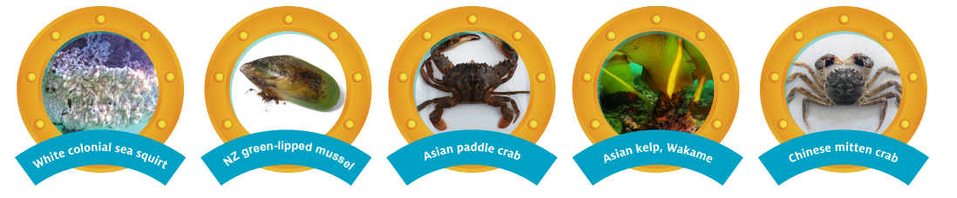

Go to vic.gov.au/marine-pests to learn more.

