Dairy Farm Monitor Project

South West Victoria Performance

Dairying in South West Victoria
Approximately 941 dairy farm businesses in South West Victoria produced 1.85 billion litres of milk in 2022-23, accounting for 36% of Victorian milk production output and 23% of Australia's milk production.

Physical farm characteristics
Greater pasture availability due to good seasonal grazing conditions lifted the amount of homegrown feed in the diet and reduced the requirement for supplements. Milk production and cows milked remained comparable on average.
1% | Stable | 2%
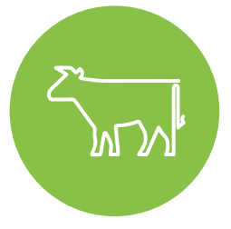
Average herd size  385 cows | Milk solids sold  526 kg MS/cow | Homegrown feed  64% of metabolisable energy consumed

In 2022-23, all participants (25 of the 25) recorded a positive return on total assets

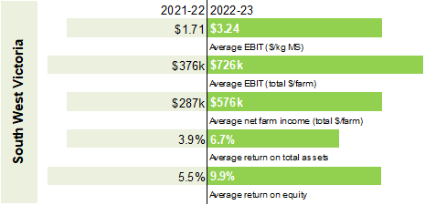

Future expectations 2023-24
Four-in-five farmers expect business returns to decline or stabilise

In 2022-23 farm profitability has been influenced by:
33% increase in average milk price to $9.81/kg MS
9% in herd and shed costs to $0.70/kg MS
17% in total feed costs to $4.08/kg MS
6% in overhead costs to $3.07/kg MS.
124% of long-term average rainfall saw wet conditions and reduced conserved feed
0.3 t DM/cow decrease in average supplements fed (total 3.7 t DM/cow)
Highest total costs (variable and overhead) in 17 years of DFM.

Return on total assets and milk price

Concerns as reported by farm businesses:
Input Costs  19% | Climate  18% | Pasture/fodder  17%

