Horticulture Business Fitness Checklist
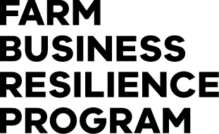
Contents
Farm Business Resilience Program 2
Partners 2
Farm Business Resilience Program 3
Farm Fitness Checklist 3
Where are you and your farm at now? 3
Now, where, how? 3
How to use this checklist 3
Our People 5
Things we can do 7
Our Farm 8
Things we can do 10
Our Business 11
Things we can do 12
Our Landscape 13
Things we can do 14
Our Risks 15
Things we can do 17
SWOT Analysis 18
Internal Factors 18
Strengths 18
Weaknesses 18
External Factors 18
Opportunities 18
Threats 18
Your Farm Business Plan 19

Farm Business Resilience Program

Partners
This Farm Fitness Checklist has been developed by Dairy Australia in collaboration with the NSW Department of Primary Industries and Agriculture Victoria. It will be used to support the roll out of the Farm Business Resilience Program, a key initiative of the Australian Government’s Future Drought Fund.
The checklist is designed to assist all Australian farmers to be more prepared and better planned, ultimately making them more resilient and able to meet challenges and grasp opportunities.
Dairy Australia would like to acknowledge the support of the Gardiner Dairy Foundation and DairyNZ.
The Gardiner Dairy Foundation has supported the development and roll out of the Our Farm, Our Plan program to all dairy farmers, reinforcing the value of the dairy industry working together.
DairyNZ kindly gave permission to Dairy Australia to adapt their Farm Fitness Checklist for use in the Our Farm, Our Plan program, another example of Trans-Tasman collaboration providing benefit to Australasian dairy farmers.

Farm Business Resilience Program

Farm Fitness Checklist

Where are you and your farm at now?
A fit and healthy farm business provides the platform needed to achieve your goals (business and personal), and be profitable and resilient in the long term.
How well do you and your partners know your farm and your business, and its fitness for the future? Use this checklist to assess where you’re at now and to help identify opportunities for improvement. It also suggests where to go to get the information, resources and support you need to make it happen.

Now, where, how?
Completing the checklist will give you a good sense about where you and your business are at now. This is an important step in the planning process, followed by clearly identifying your ‘where and how’ and, preferably, getting it down on paper.

How to use this checklist
Each section of this checklist is designed to prompt your thinking about different aspects of your farm business. It’s a ‘self-assessment’ and there are no right or wrong answers. Your job is to identify areas that might be a priority for you by ticking the box that best describes where you are at for each question.
Yes, we’ve nailed it | Ok, but we could do better | No, and we should do something about it | No, and it’s not relevant to us
P | P | P | P

Try scanning through the checklist before you start ticking so that you have an idea of what’s included. The aim is to identify and focus on a small number of areas that will move you forward significantly.
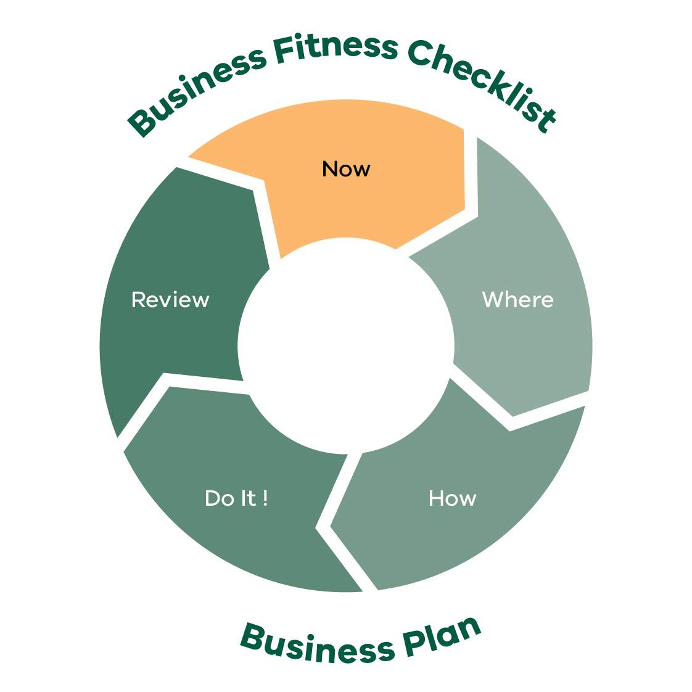
Business Fitness Checklist Business Plan
- Now
- Where
- How
- Dot It!
- Review
This process will help you to focus on what’s achievable — none of us can do everything at once.
After completing each section think about how you’ve rated yourself and list some goals and actions that you reckon will make the biggest difference in improving what you do.

Our People
(Please place x in relevant cell)
Planning for us:
Questions | Yes, we’ve nailed it | Ok, but we could do better | No, and we should do something about it | No, and it’s not relevant to us
We know what we want our life to look like in 5 years’ time
We are considering our retirement needs and what it will take to get there
We have enough time to spend with family and friends
Most days we are happy to go to work and find it fulfilling
We have a healthy lifestyle and have an annual health check
We manage our fatigue levels and appropriately manage safety for all
We know who our neighbours are, and we help them in times of need
We are involved in local groups and activities that strengthen the local community

Planning for the team:
Questions | Yes, we’ve nailed it | Ok, but we could do better | No, and we should do something about it | No, and it’s not relevant to us
We have a plan to develop our skills (e.g. communication, people management, financial, safety)
We are/aware/compliant with our legal obligations when employing staff either directly or through an Approved Employer Labour Hire Service provider
We have a documented labour requirement plan for the business
We have adequate numbers of staff for all tasks to be effective, avoid staff fatigue and staff dissatisfaction
We invest in professional development for all members of our business
Our staff are adequately trained for the roles they perform including appropriate licences (e.g. ChemCert, heavy vehicle and forklift licenses)
Our team understands our business purpose and their role in achieving that purpose
We have regular team meetings to discuss plans, progress and opportunities for improvement
We ensure that our staff are trained in Safe Work Practice requirements for our business
We have a safety plan in place for staff working remote or alone
We provide awareness and access to Mental Health Support programs for ourselves and our staff
Planning for our visitors/contractors:
Our employees/contractors have been inducted and the inductions are documented
We have a visitor sign-in log
We have an emergency management plan in place
Our contractors are appropriately licensed
and legally compliant
We make sure all staff, visitors and contractors are aware of our site biosecurity requirements

Things we can do
Think about the ratings you’ve given yourself above. What areas do you want to focus on? Can you see opportunities? Write some goals and actions down here.

Things to think about (goals/ actions) | Who is responsible | Priority level | Timeframe

Notes

Our Farm
(Please place x in relevant cell)
Questions | Yes, we’ve nailed it | Ok, but we could do better | No, and we should do something about it | No, and it’s not relevant to us
Farm accommodation for us and Employee accommodation is suitable and compliant (PALM)
We have a plan to improve our farm infrastructure to meet future needs
We have and use a documented quality assurance system (e.g. Freshcare, HARPS)
Our fertiliser and chemical storage capacity is sufficient and meets requirements
We understand our crop water needs and have sufficient water available for the season
We have a water use plan for drought conditions
Farm fencing is adequate for our needs
All our staff are appropriately trained and licensed for the tasks they complete (e.g. drivers license type, ChemCert, ACUP)
We plan our crops and/or variety prioritisation based on performance and/or market signals
We have a replant/rework program for our farm
We have a regular Soil testing program in place and use it to help manage our soil and plant health
We use a soil moisture monitoring system to better understand and manage our water
We, as much as possible, take a pro-active rather than reactive approach to running our business but remain flexible

Things we can do
Think about the ratings you’ve given yourself above. What areas do you want to focus on? Can you see opportunities? Write some goals and actions down here.

Things to think about (goals/ actions) | Who is responsible | Priority level | Timeframe

Notes

Our Business
(Please place x in relevant cell)
Questions | Yes, we’ve nailed it | Ok, but we could do better | No, and we should do something about it | No, and it’s not relevant to us
We have a written business plan and a list of sustainable goals that we are working towards
We feel we are in control of our business
We have measures and targets for our farm production
We are aware of our financial performance measured by profitability, sustainability and net worth over time
We know our cash flow position and ability to pay bills on time
We have a good handle of our costs of production and profit-making commodity price targets
We develop an annual plan and budget and update it throughout the year
We look at other businesses for ways we can improve what we do
We have a documented succession plan which is regularly reviewed and discussed with family members
We have a good relationship with our accountant, our bank and other service providers
We have off farm income streams (e.g. rental income, day job, contracting)
We understand the likely effects of a changing climate on our farm business and have plans (short/long) to adapt accordingly
We are aware of our energy usage and emissions output and have plans in place to reduce them

Things we can do
Think about the ratings you’ve given yourself above. What areas do you want to focus on? Can you see opportunities? Write some goals and actions down here.

Things to think about (goals/ actions) | Who is responsible | Priority level | Timeframe

Notes

Our Landscape
(Please place x in relevant cell)
Questions | Yes, we’ve  nailed it | Ok, but we could do better | No, and we should do something about it | No, and it’s not relevant to us
We have a Whole Farm Plan and map identifying environmental risks (e.g. waterways, wells, bridges, culverts, infrastructure, erosion areas, steep slopes)
We apply AgriChem responsibly and fully understand the spray set up and environmental conditions required to avoid drift, run off and off target damage
We are on track to leave and improved natural resource base for the next generation
Our farm management strategies optimise soil water retention
We monitor our soil health and our management strategies enhance our soil capability (e.g. ground cover preservation, reduced tillage)
We understand our soils and what is needed to manage any constraints
We strategically use and plant trees for multiple purposes (e.g. windbreaks, erosion control, salinity, timber capturing carbon and/or biodiversity)
Our community works together to improve/enhance the local landscape
We are aware of and manage fire/flood risks

Things we can do
Think about the ratings you’ve given yourself above. What areas do you want to focus on? Can you see opportunities? Write some goals and actions down here.

Things to think about (goals/ actions) | Who is responsible | Priority level | Timeframe

Notes

Our Risks
Questions | Yes, we’ve nailed it | Ok, but we could do better | No, and we should do something about it | No, and it’s not relevant to us
Our business is robust and can withstand various ‘shocks’ (e.g. commodity price drops, interest rate fluctuations, drought, floods, staff vacancies)
In the event of these shocks, we have recovery plans and know where to access support information
We have an appropriate business structure in place (e.g. sole trader, partnership, company or trust)
We have effective insurance coverage (e.g. farm and life insurance)
We have identified the major risks associated with our business and have risk mitigation strategies in place
We have access to finance that allows us to invest in development work or opportunities when they arise
We have identified and documented the hazards on farm which are effectively managed to keep ourselves, our team and our visitors safe
We have a plan for managing the farm and crops during extreme weather (e.g. droughts, fire, floods, storms)
We have a biosecurity plan in place and use it
We are effectively managing chemical resistance for pests and weeds and use IPDM
Our team has health and safety front of mind, the safety risks are identified and systems are in place to isolate or minimise these
We use short- and long-term seasonal forecasts to make informed decisions and adapt our management practices and business plans

Things we can do
Think about the ratings you’ve given yourself above. What areas do you want to focus on? Can you see opportunities? Write some goals and actions down here.

Things to think about (goals/ actions) | Who is responsible | Priority level | Timeframe

Notes

SWOT Analysis
Considering your business Strengths, Weaknesses, Opportunities and Threats (SWOT) after completing Checklist questions can assist with your next move and priorities.

Internal Factors

Strengths
“Build on…”

Weaknesses
“Correct or avoid…”

External Factors

Opportunities
“Take advantage of…”

Threats
“Mitigate…”

Developing strategies will help you achieve your goals and objectives. Use your strengths to take advantage of opportunities, and work to mitigate your weaknesses and minimize threats. Remember that creating a SWOT plan is an ongoing process. You should continually assess your Strengths, Weaknesses, Opportunities and Threats, and adjust your plan accordingly to stay ahead of the curve.
Questions | Strategies to build on
Ways to build on strengths
Ways to take advantage of opportunities
Ways to reduce the effects of weaknesses
Ways to reduce the effects of threats

Your Farm Business Plan
Putting your goals and actions on in a plan will help you to focus on the things that matter the most. It means you have taken the plans in your head and put them on paper, which also means you get the full picture of the things you’d like to achieve next in one place.
This gives all of the decision makers in your business the chance to see the plan and to make sure you’re all on the same page.
Importantly it allows you to:
be confident that you have a shared view of what’s next
communicate your plan with other people, either inside or outside your business
refer back to your plans and track your progress and achievements.
You can find the Farm Business Plan template and other resources on the Farm Business Resilience Program webpage: agriculture.vic.gov.au/FBRP
Notes

The Farm Business Resilience Program is supporting farmers to build stronger, more productive agricultural businesses.
Visit: agriculture.vic.gov.au/FBRP
The Farm Business Resilience Program is jointly funded through the Australian Government’s Future Drought Fund and the Victorian Government’s Future Agriculture Skills Capacity Fund.

