Livestock Farm Monitor Project

Victoria │ Annual Report

2022-23

Further information regarding the Livestock Farm Monitor Project (LFMP) may be obtained from:
Sam Henty
Agriculture Victoria
195-229 Lyttleton Terrace, Bendigo, Victoria, 3550
sam.henty@agriculture.vic.gov.au
Authorised and published by the Victorian Government, Department of Energy, Environment and Climate Action (DEECA) 2023. © The State of Victoria Department of Energy, Environment and Climate Action 2023.
This publication is copyright. No part may be reproduced by any process except in accordance with the provisions of the Copyright Act 1968.
For more information contact the Agriculture Victoria Customer Service Centre on 136 186.

Disclaimer
This publication may be of assistance to you, but the State of Victoria and its employees do not guarantee that the publication is without flaw of any kind or is wholly appropriate for your particular purposes and therefore disclaims all liability for any error, loss or other consequence which may arise from you relying on any information in this publication.
Accessibility
If you would like to receive this publication in an accessible format, such as large print or audio, please telephone 136 186.
Deaf, hearing impaired or speech impaired? Call us via the National Relay Service on 133 677 or visit www. relayservice.com.au
This document is also available on the Agriculture Victoria website.

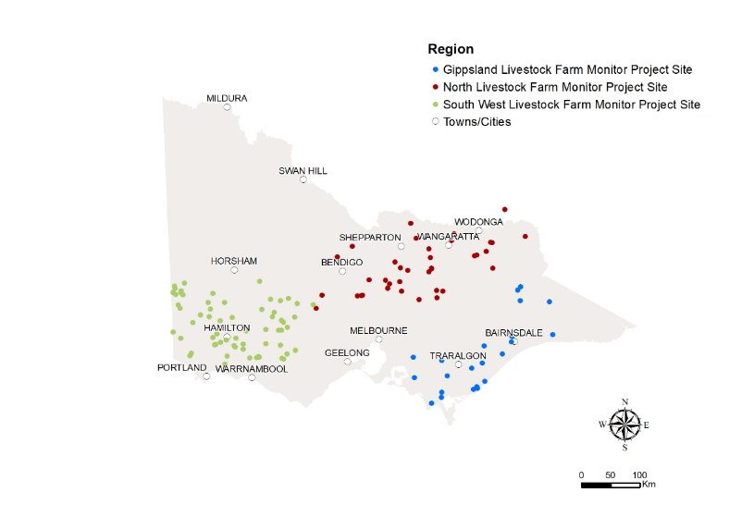In 2022-23, the Livestock Farm Monitor Project (LFMP) provided 124 Victorian sheep, beef and mixed farming, including cropping, farmers with detailed financial and production performance information. Agriculture Victoria collated the individual business performance information of all surveyed farms to provide insights in this report.
The LFMP is Agriculture Victoria’s primary source of farm-level information for sheep and beef production practices, resource use, and economic data.
The results of this annual survey provide farm-level data to inform Agriculture Victoria’s decisions that impact at a farm level, and to inform the direction of future policy design, research themes and service delivery programs.

Farmers who participate in the project increase their understanding of their farm business, which builds resilience and improves their ability to adapt to change.
Results published in this report are not statistically representative of an industry or a region.
Agriculture Victoria staff are grateful for the cooperation of the farmers who contributed their data to this project.
This report has been funded by Agriculture Victoria.

State summary
Key points
- The decline in red meat and wool prices lowered farm incomes across the state in 2022-23.
- Variable and overhead costs remained high but at similar levels to 2021-22.
- High fertiliser prices and very wet conditions led to a reduction in phosphorus application rates to the lowest levels recorded in a decade.
- Supplementary feeding rates and expenditure increased as a result of wet conditions, water logged paddocks and challenging pasture management conditions.
- More than 60% of farms in each region purchased new machinery during 2022-23.
- Higher interest rates and lower incomes meant total interest costs made up 7% of farm income, more than double recorded in 2021-22.
- Larger farms were able to reduce their costs by spreading overhead costs over more output and tended to have a higher return on assets than smaller farms.

State summary
 | G | G | N | N | SW | SW
Financial parameter bars: | 10-yr average | 2022-23 | 10-yr average | 2022-23 | 10-yr average | 2022-23
Gross farm income ($/ha) | $1,147 | $1,160 | $844 | $961 | $1,184 | $1,227
Variable costs ($/ha) | $430 | $446 | $310 | $380 | $453 | $581
Overhead costs ($/ha) | $512 | $575 | $356 | $400 | $343 | $360
Earnings before interest and Tax (EBIT) ($/ha) | $205 | $138 | $178 | $181 | $387 | $286
Return on assets (%) | 1.6% | 0.6% | 1.9% | 0.8% | 3.7% | 1.5%
Return on equity (%) | 1.4% | -0.4% | 1.6% | 1.3% | 4.7% | 1.4%
 | G | G | N | N | SW | SW
Physical parameter bars: | 10-yr average | 2022-23 | 10-yr average | 2022-23 | 10-yr average | 2022-23
Effective area (ha) | 750 | 637 | 896 | 822 | 1,216 | 1,658
Stocking rate (DSE/ha) | 16.7 | 17.5 | 10.5 | 12.1 | 15.4 | 15.7
Sheep (head) | 2,682 | 1,458 | 3,352 | 2,840 | 6,996 | 9,641
Cattle (head) | 540 | 680 | 377 | 411 | 297 | 414

Business profit and returns
Farm profit declined across the state in 2022-23. Gippsland and South West farm business profits decreased to below the respective regional 10-year averages, with the South West recording the lowest result since 2015-16 (Figure 1). Northern Victoria profits remained above the 10-year average earnings before interest and tax (EBIT). Gross farm income decreased significantly in each region but remained above the 10-year averages, while variable and overhead costs remained at similar levels to 2021-22 and above the 10-year averages.
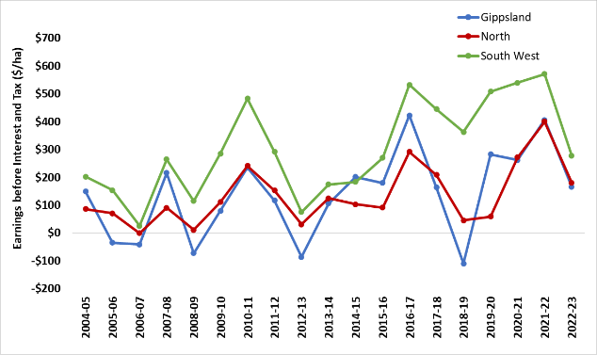
Figure 1. Regional profitability over time
In 2022-23, average return on assets (RoA) was below the 10-year average in all regions. Surveyed farms located in South West Victoria recorded the highest 2022-23 average RoA for the state (1.5%). Regardless of the average, each region had participant farms that recorded high returns and negative returns (Appendix B1, C1, D1).
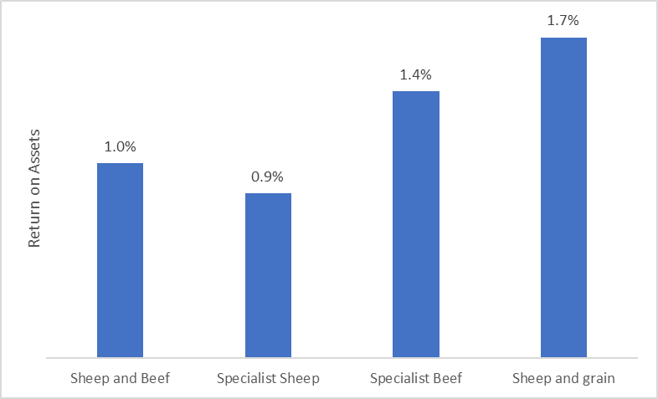
Figure 2. 2022-23 return on assets for each business type
When the dataset was separated into farm business types (see glossary for definitions), sheep and grain, and specialist beef businesses had the highest annual returns (Figure 2). Businesses specialising in sheep had the lowest average return on assets in 2022-23. This result was because specialist sheep businesses recorded the lowest average gross farm income ($975/ha) of all the business types (Table 1). Specialist beef businesses recorded the highest average farm income but also recorded the highest average operating (variable plus overhead) costs.
Business type | Gross farm income | Total variable costs | Total overhead costs | Earnings before interest and tax | Return on Assets
 | $/ha | $/ha | $/ha | $/ha | %
Sheep and beef | 1,057 | 468 | 357 | 232 | 1.0%
Specialist sheep | 975 | 494 | 337 | 144 | 0.9%
Specialist beef | 1,359 | 493 | 568 | 298 | 1.4%
Sheep and grain | 1,264 | 573 | 366 | 325 | 1.7%
Table 1. Average performance measures for each business type for the 2022-23 LFMP dataset.

Scale
When the LFMP dataset was separated by business scale based on total cash income, there were farms with good returns across all farm sizes. Figure 3 shows larger farms tended to have a higher average return on assets than smaller farms. Surveyed farms with cash income less than $478,000 had the lowest average RoA.
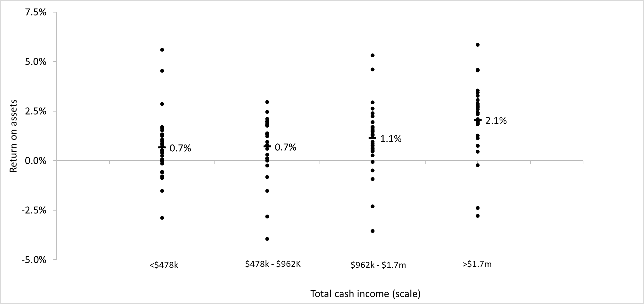
Figure 3. 2022–23 farm scale as defined by total cash income and return on assets
Figure 4 shows the major sources of scale economies in Victorian sheep and cattle production were in overhead costs. When specialist beef and specialist sheep businesses were separated by scale based on total dry sheep equivalent (DSE), there were significant differences among each of the size group overhead costs, but less differences for variable costs. This result highlights that larger farms can reduce their costs through scale by spreading overhead costs over more output.
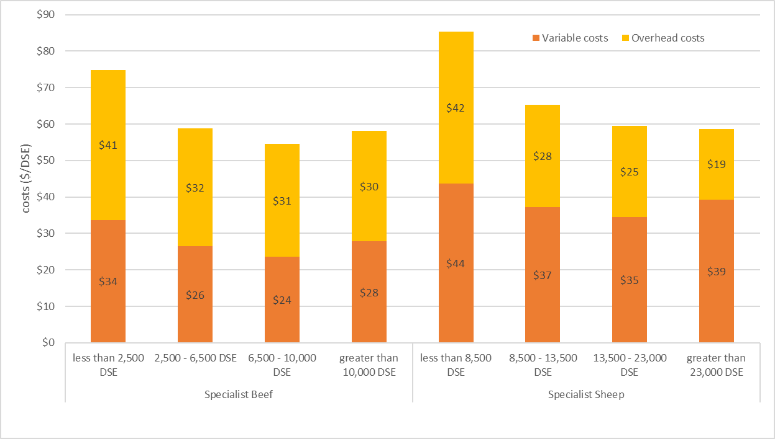
Figure 4. Variable and overhead costs ($/DSE) for specialist beef and specialist sheep businesses when separated by scale based on total DSE

Capital expenditure
The most popular capital expense was new machinery. More than 60% of farm businesses in each region purchased new machinery during 2022-23 (Figure 5). Many factors influence the decision to invest in machinery such as changes to farming practices, farm scale expansion, labour skills and availability, family and lifestyle needs and the importance placed on machinery relative to other aspects of the business. Farm machinery has allowed many producers to increase productivity and efficiency. However, higher machinery investment and debt, and costs have the potential to erode farm profits.
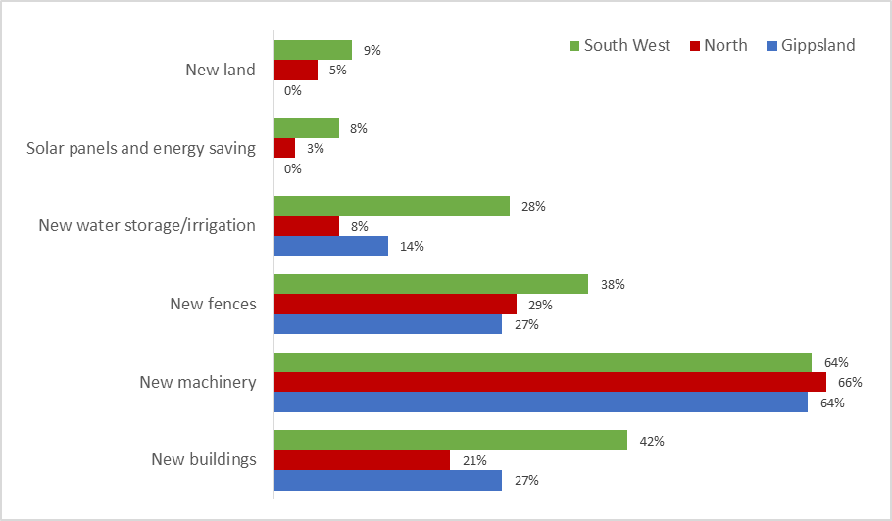
Figure 5. The proportion of farms in each region that made capital additions

Debt
Over half of South West Victorian farms increased their debt during 2022-23 (Figure 6). This was mostly for capital improvements as managers chose to invest in land, machinery and other on-farm improvements. This contrasted with Gippsland where only 18% of farms increased debt but 40% reduced debt throughout 2022-23.
Debt was part of the business structures for many of the surveyed farms. The use of debt increases the obligatory costs of farm businesses as principal and interest repayments must be paid in good and poor years. For this reason, farm management strategies employed throughout the year can be influenced by the level of debt held by the business.
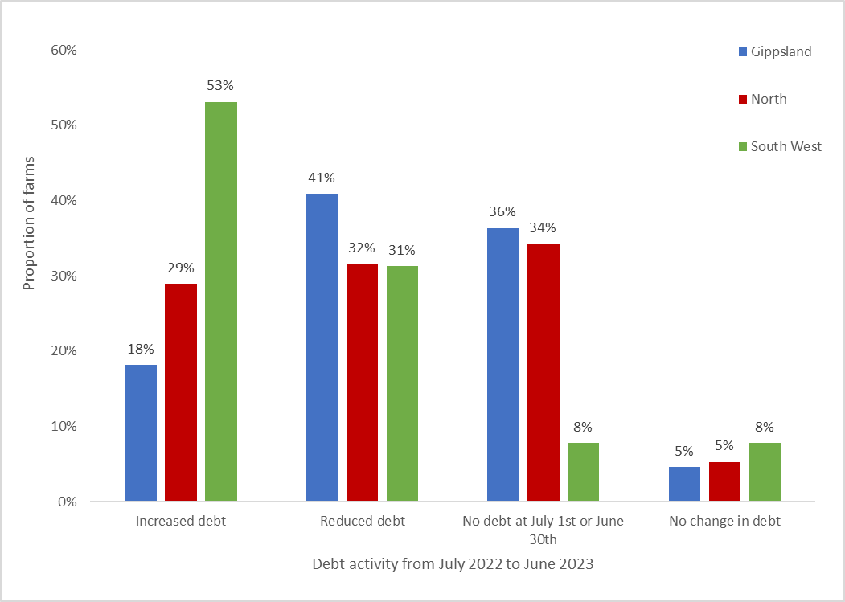
Figure 6. Debt activity from 1 July 2022 to 30 June 2023

Debt servicing
Servicing debt consists of making interest payments and repaying principal. The proportion of farm cash income spent on interest expenses (interest expense ratio) is useful to determine the capacity of a farm business to service debt. 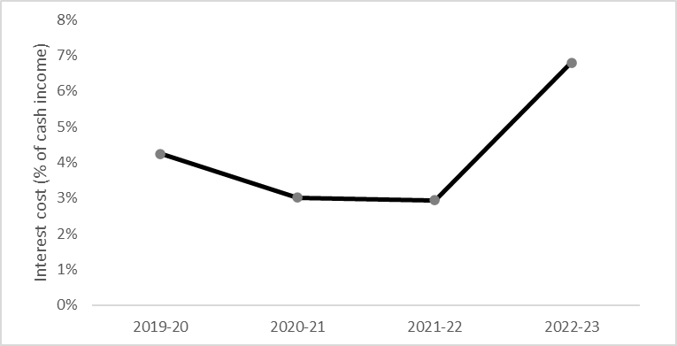
Figure 7. The proportion of farm cash income spent on interest payments from 2019-20 to 2022-23.
In 2022-23 the average interest expense ratio for LFMP participants was 7% (Figure 7). The large increase in interest expense ratio was caused by an increase in borrowing, falling incomes and rising interest rates in 2022-23.

Comparing enterprise performance based on lambing and calving season
A commonly asked question is “how does the timing of lambing and calving effect enterprise performance?”. This section looks at the characteristics of beef, wool sheep and prime lamb enterprises lambing and calving across the winter, spring and autumn seasons. Table 2 shows selected performance measures for 2022-23 LFMP enterprises separated by season of lambing and calving.
Calving/ lambing season | Enterprise | Stocking rate | Supp feeding rate | Average sale weight | Price received
 |  | DSE/ha | ME fed/DSE | kg LWT/hd | $/kg LWT
Winter | Beef | 16.3 | 277 | 436 | 4.6
Spring | Beef | 17.7 | 297 | 471 | 4.3
Autumn | Beef | 15.2 | 362 | 500 | 4.4
 |  |  |  |  | $/kg CWT
Winter | Prime lamb | 14.9 | 331 | 49 | 7.2
Spring | Prime lamb | 15.0 | 422 | 50 | 7.8
Autumn | Prime lamb | 9.3 | 476 | 56 | 7.6
 |  |  |  |  | $/kg greasy
Winter | Wool sheep | 12.3 | 189 | 46 | 11.3
Spring | Wool sheep | 16.2 | 250 | 50 | 14.2
Autumn | Wool sheep | 10.3 | 207 | 51 | 10.4
Table 2. Various measures in 2022-23 for enterprises across winter, spring and autumn lambing and calving.

Stocking rate
All autumn calving or lambing enterprises had the lowest average stocking rates. Whereas spring enterprises had the highest stocking rates. Autumn enterprises tended to be in locations where average annual rainfall and carrying capacity were lower than spring and winter enterprises.

Sales and price
There were minimal differences in prices received for beef or lamb across the seasons but for wool there was a large range. This could be the influence of time of lambing on the time of shearing and therefore time of sale, with sales later in the year more exposed to downward price trends experienced across 2022-23. All autumn enterprises had the heaviest average stock sale weights and winter enterprises had the lightest sale weights.

Supplementary feeding
Autumn beef and prime lamb enterprises had the highest reliance on supplementary feed. Their supplementary feeding rates were the highest. Winter enterprises had the least reliance on supplementary feed recording the lowest average supplementary feeding rates across all enterprises.

Comparing risk and gross margins of enterprises
Average gross margins were calculated for each enterprise for each season over the last 4 years. The criteria used to compare the enterprises were the size of gross margin (return) and the variability in gross margin (risk).
Risk was measured by the standard deviation in gross margin across the time period 2019-20 to 2022-23. Gross margins that fall toward the right-hand side of Figure 8 are considered ‘riskier’ than those indicated by points toward the left-hand side.
Autumn and winter calving beef enterprises had the highest average gross margins but were also among the riskiest enterprises. All sheep enterprises were less risky than the beef enterprises except for autumn prime lamb which had the most risk of all enterprises. Prime lamb winter and spring lambing enterprises were the highest gross margins of the sheep enterprises. Both had similar gross margins and risks. Wool sheep spring enterprises had almost half the risk and 40% higher gross margin than wool sheep winter enterprises.
This analysis shows the relationship between risk and return for the different enterprises and different seasons. Enterprises with higher gross margins tended to have higher risk.
Managing the volatility of an enterprise over time is a characteristic of good farm managers. They will choose a seasonal enterprise so the risk-return mix suits their business location, goals and objectives.
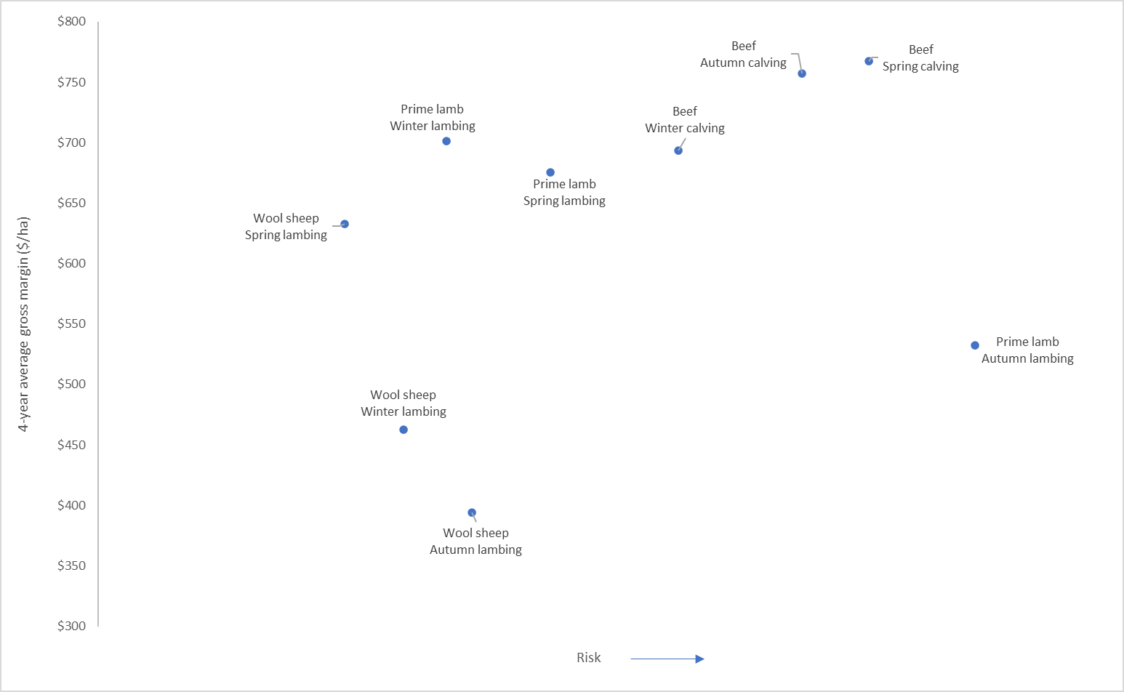
Figure 8. Return versus risk: Average and standard deviation of gross margins from wool sheep, prime lamb and beef enterprises reproducing across different seasons (2019-20 to 2022-23).

Gippsland

Price received
***Infographic 1**
Beef ($/kg LWT)
***Infographic 2**
Lamb ($/kg CWT)
***Infographic 3**
Fine wool ($/kg greasy)
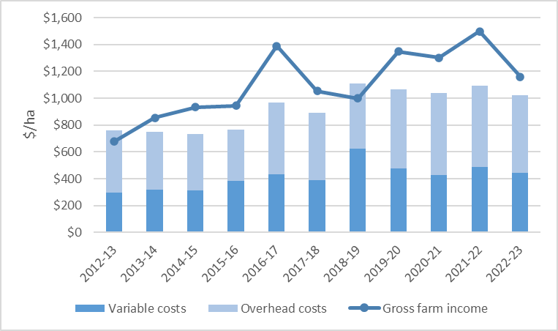
Figure 9. Gippsland average income and costs (2012-13 to 2022-23)
Beef was the dominant enterprise of the Gippsland region (Appendix D3) and many participant farms were exposed to the falling beef prices in 2022-23. As a result, regional average gross farm income decreased by 23% (Figure 9). Gippsland farmers cut expenditure in 2022-23 resulting in small annual decreases in both regional average variable and overhead costs (Figure 9).

Fertiliser
***Infographic 4**
Superphosphate ($/t)
***Infographic 5**
Lime ($/t)

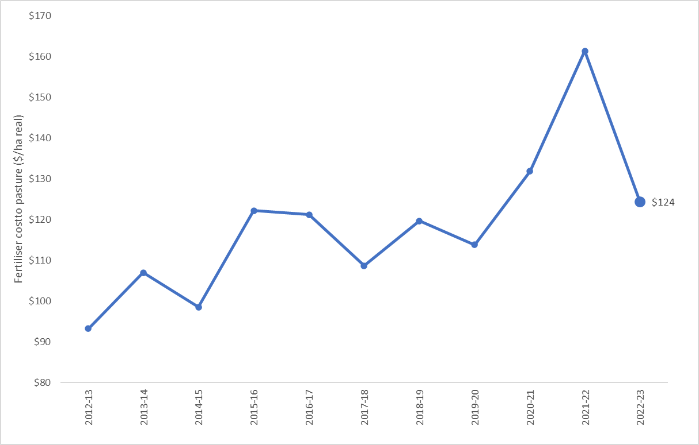
Figure 10. Average cost of fertiliser applied to pasture
Gippsland was subject to the significant unit price increase of all fertilisers experienced across the state in 2022-23. Additional freight costs to the region meant Gippsland farmers paid more per unit of fertiliser than their Northern and South West Victoria counterparts (Appendix F1).
Gippsland farmers responded to high fertiliser prices and very wet conditions with a 26% annual reduction in average phosphorus application rates. In 2022-23, it was the third consecutive year of cuts to phosphorus application rates and was the lowest average rate recorded in 10 years (Figure 11). No fertiliser was applied on 9% of Gippsland participant farms. Despite the reduced application rates fertiliser was the largest cost item on Gippsland farms in 2022-23, on average making up 16% of total cash operating costs.
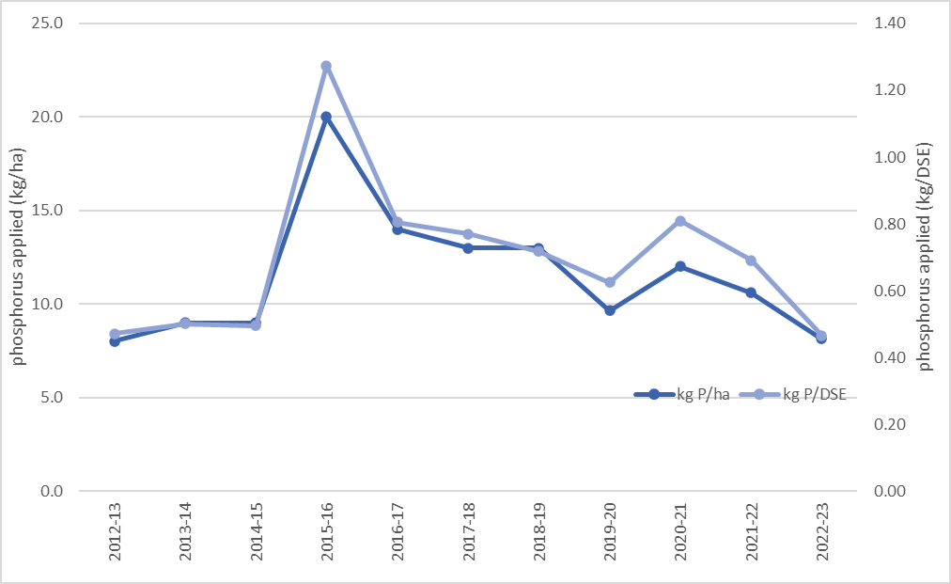
Figure 11. Average phosphorus application rates kg/ha (left hand axis) and kg/DSE (right hand axis) from 2012-13 to 2022-23.

Gross margins
Infographic 6: Beef gross margin ($/ha)
Infographic 7: Prime Lamb gross margin ($/ha)
Infographic 8: Wool Sheep gross margin ($/ha)
Beef gross margins on Gippsland participant farms decreased from the highs of 2021-22 and were 13% below the three-year average in 2022-23.

Calving and lambing pattern
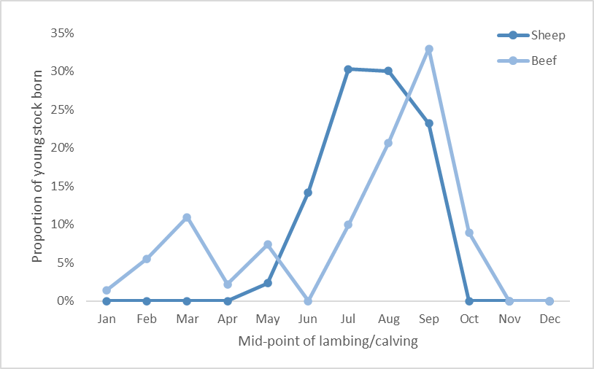
Figure 12. 2022-23 calving and lambing pattern
July and August were the peak months for lambing in sheep enterprises, while September was the peak month for calving in beef enterprises. Consequently, late winter and spring 2022 represented the times of highest feed demand. On average Gippsland farms received 125% of their long-term average spring rainfall (Appendix D2) which left some soils saturated, particularly in south and west Gippsland. Wet conditions provided a challenge to harvest pasture for conservation thereby reducing the quantities of fodder harvested from the previous year. As a result, hay and silage making costs decreased compared to the previous year.
Wet conditions meant supplementary feeding rates and expenditure increased across all enterprises in 2022–23. Beef enterprises were most reliant on supplementary feed (241 ME fed per DSE). Homegrown hay was the most common form of supplementary feed fed to beef enterprises in Gippsland.

Capital structure
***Infographic 9**
Farmland value ($/ha)
Gippsland farmland values continued to rise resulting in Gippsland farms managing the highest value of total assets per hectare of the LFMP regions ($20,448/ha). Increases in land values offset the increase in debt levels leading to an average annual addition to farmers wealth (equity) of $1,124/ha.

Return on assets
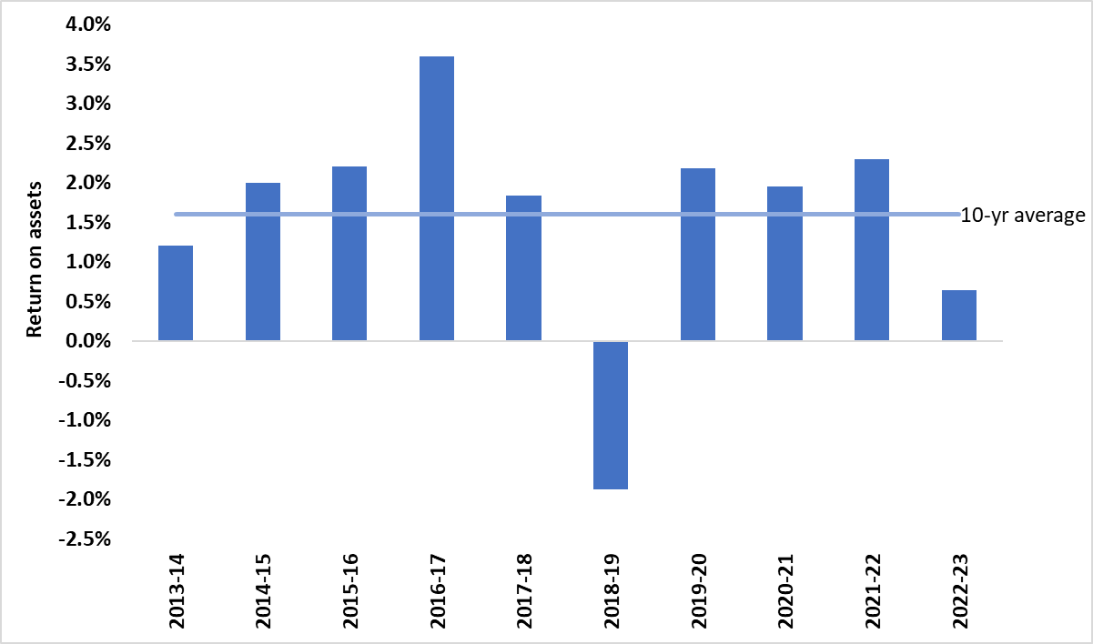
Figure 13. Gippsland return on assets
Decreases in farm profits coupled with the increase in the value of total assets managed meant that RoA for Gippsland farms were more than half the 10-year average and was the second lowest recorded in the last decade (Figure 13).

Gippsland regional summary
- Beef sales were 73% of cash income for LFMP farms in Gippsland
- Beef prices dropped by an average of 21% from 2021-22 levels
- Lowest average gross farm income since 2018-19 combined with high and rising variable costs to reduce farm margins Second lowest return on assets in the last 10 years
- Average annual increase in equity (net worth) of $1,124/ha.

Regional summary |  | G
 | 3-yr average | 2022-23
Enterprise income
Beef income ($/ha) | 1326 | 1,205
Prime lamb income ($/ha) | 921 | 861
Wool sheep income ($/ha) | 724 | 602
Variable costs
Beef variable costs ($/ha) | 533 | 514
Prime lamb variable costs ($/ha) | 397 | 431
Wool sheep variable costs ($/ha) | 303 | 329
Production
Beef sold (kg lwt/ha) | 329 | 305
Lamb sold (kg cwt/ha) | 94 | 109
Wool sheep wool cut (kg Gr./ha) | 38 | 38
Labour
Labour use (FTE/farm) | 1.9 | 1.9
Labour use efficiency (ha/FTE) | 310 | 321
Labour use efficiency (DSE/FTE) | 4,933 | 5,272
Nutrient application
Nitrogen applied to pasture (kg/ha) | 13 | 15
Phosphorus applied to pasture (kg/ha) | 11 | 8
Potassium applied to pasture (kg/ha) | 12 | 13
Sulphur applied to pasture (kg/ha) | 10 | 8
Top 5 costs (Proportion of total cash operating costs)
Pasture fertiliser costs (%) |  | 16%
Livestock selling costs (%) |  | 8%
Animal health (%) |  | 7%
Wages for permanent staff (%) |  | 6%
Rates (%) |  | 6%

Northern Victoria

Price received
***Infographic 10**
Beef ($/kg LWT)
***Infographic 11 **
Lamb ($/kg CWT)
***Infographic 12**
Fine wool ($/kg greasy)
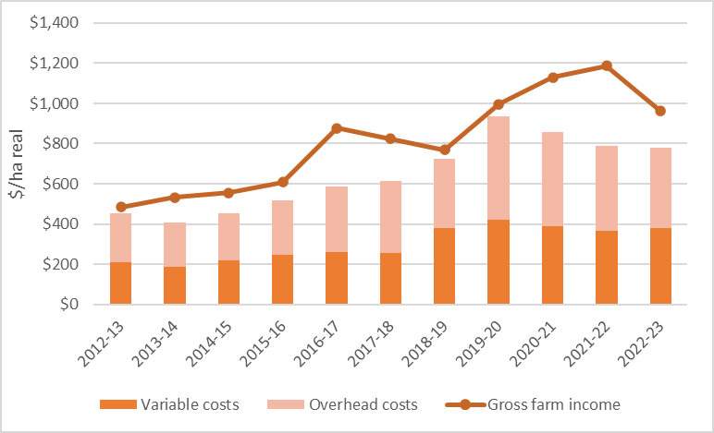
Figure 14. Northern average income and costs (2012-13 to 2022-23)
Cattle (29%) and sheep sales (17%) were the major components of farm cash income in Northern Victoria (Appendix C5). A combination of declining beef, lamb and mutton prices, sales quantities and very wet conditions resulted in a 19% annual decrease in gross farm income in Northern Victoria (Figure 14). Regional average variable and overhead costs remained at similar levels recorded in 2021-22. Gross farm income, variable costs and overhead costs all remained above the regional 10-year average.

Fertiliser
***Infographic 13**
Superphosphate ($/t)
***Infographic 14**
Lime ($/t)
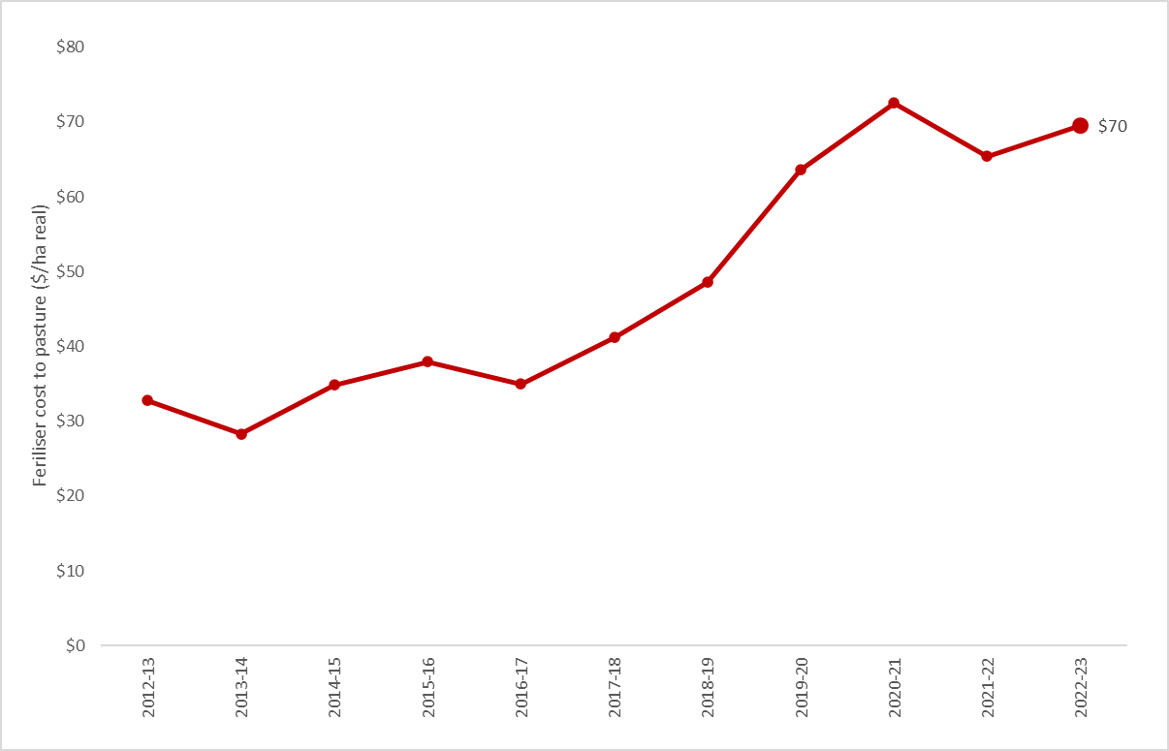
Figure 15. Average cost of fertiliser applied to pasture
Fertiliser application rates remained similar to 2021-22 but the price of most fertilisers increased, resulting in an increase of average expenditure on pasture fertiliser in 2022-23 (Figure 15). There was also an increase in the number of farms applying fertiliser. No fertiliser was applied on 11% of northern Victorian farms in 2022-23, a decrease from 19% in 2021-22.
Phosphorus application rates reduced by 5% in 2022-23 (Figure 16) but phosphorus remained the most commonly applied nutrient on Northern farms. Phosphorus application rates decreased for the third consecutive year in 2022-23 and the lowest rates (kg P/DSE) recorded since 2012-13 (Figure 16). For some farmers the wet conditions experienced throughout the year made fertiliser application to paddocks very difficult and application rates were lower as a result. Farm managers also decreased phosphorus application to help offset the higher fertiliser prices. Despite the reduced application rates, fertiliser was the largest cost item on Northern farms in 2022-23, on average making up 10% of total cash operating costs.
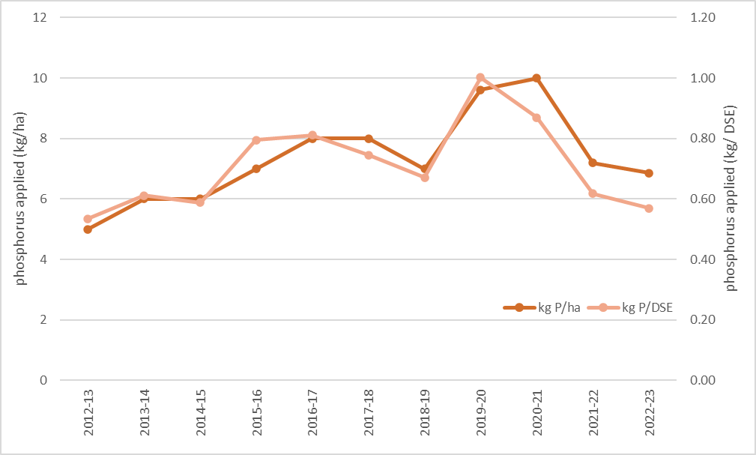
Figure 16. Average phosphorus application rates kg/ha (left hand axis) and kg/DSE (right hand axis) from 2012-13 to 2022-23.

Gross margins
***Infographic 15**
Beef gross margin ($/ha)
***Infographic 16**
Prime lamb gross margin ($/ha)
***Infographic 17**
Wool sheep gross margin ($/ha)
Falling commodity prices and incomes across all enterprises meant gross margins recorded by Northern farms were below the 3-year average for each of the livestock enterprises.

Calving and lambing pattern

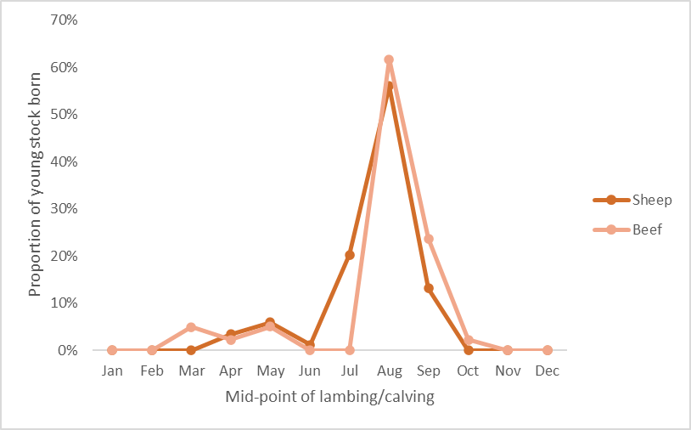
Figure 17. 2022-23 calving and lambing
Northern Victoria was characterised by tight time frames for lambing and calving, with 85% of all calving occurring in August and September and 75% of lambing occurring in July and August (Figure 17).
The wet conditions were exemplified by all Northern participants receiving higher than average annual rainfall in 2022-23. Over half of the farms received more than 250% of the long-term average spring rainfall (Appendix C2).

Capital structure
***Infographic 18**
Farmland value ($/ha)
The average amount of farm debt owed increased by 15% to $1,023/ha in 2022-23 (Appendix A6). However, the increase in farm debt was offset by the continued rise in the average total farm assets and resulted in equity remaining high (92%) with the average increase in farmers' wealth (equity) of $1,450/ha. Increases in farmland values across Northern Victoria was the major influence on the increases in farm assets and therefore to farmers net worth.
Return on assets

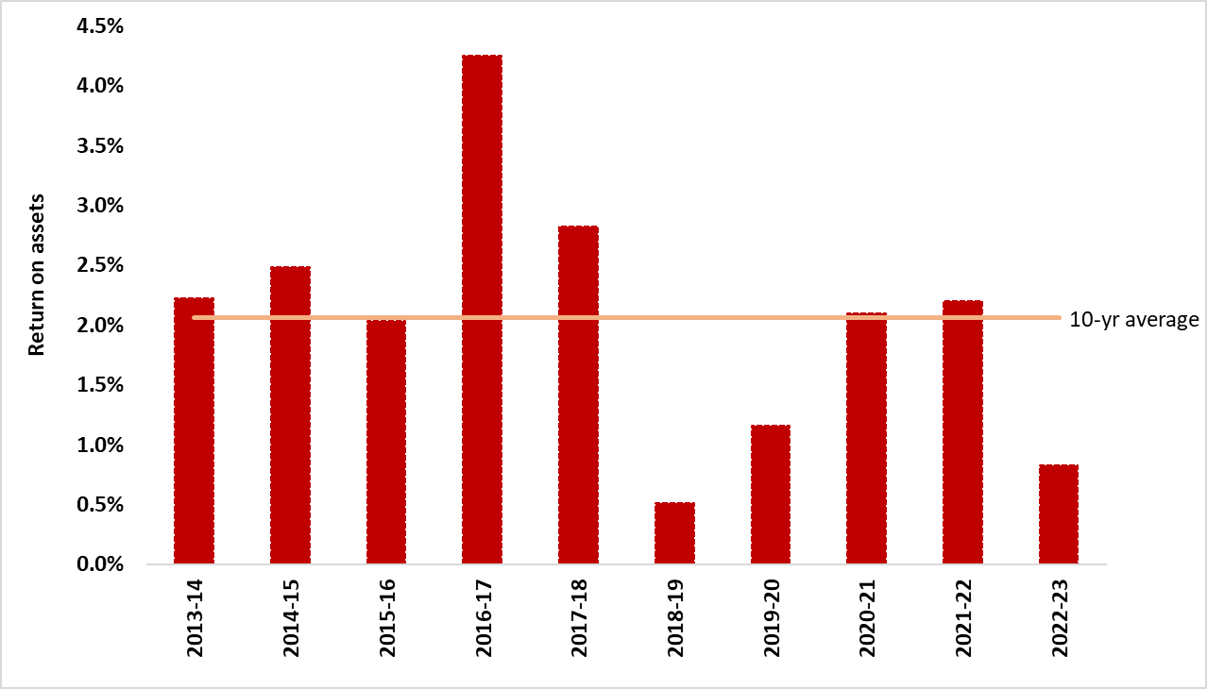
Figure 18. Northern return on assets
In 2022-23, Northern return on assets fell below the 10-year average to 0.8% (Figure 18). The main factor contributing to the decrease in return on assets was the declining commodity prices and farm incomes. However, the continued increase in asset values also influenced the lower returns as less profit was made from more valuable assets.

Northern Victoria regional summary
- Majority of farms received more than 250% of the long-term average spring rainfall
- Declining beef, lamb and mutton prices resulted in a 19% annual decrease in gross farm income
- All enterprise gross margins were below the 3-year average
- Return on assets fell to 0.8%, and was below the 10-year average
- Average annual increase in equity (net worth) of $1,450/ha.

Regional summary |  | N
 | 3-yr average | 2022-23
Enterprise income
Beef income ($/ha) | 1,084 | 1,019
Prime lamb income ($/ha) | 964 | 877
Wool sheep income ($/ha) | 848 | 743
Variable costs
Beef variable costs ($/ha) | 377 | 398
Prime lamb variable costs ($/ha) | 467 | 458
Wool sheep variable costs ($/ha) | 317 | 322
Production
Beef sold (kg lwt/ha) | 270 | 274
Lamb sold (kg cwt/ha) | 146 | 118
Wool sheep wool cut (kg Gr./ha) | 37 | 38
Labour
Labour use (FTE/farm) | 2.0 | 2.1
Labour use efficiency (ha/FTE) | 424 | 427
Labour use efficiency (DSE/FTE) | 4,786 | 4,677
Nutrient application
Nitrogen applied to pasture (kg/ha) | 6 | 6
Phosphorus applied to pasture (kg/ha) | 10 | 7
Potassium applied to pasture (kg/ha) | 3 | 4
Sulphur applied to pasture (kg/ha) | 8 | 6
Top 5 costs (Proportion of total cash operating costs)
Pasture fertiliser costs (%) |  | 10%
Livestock selling costs (%) |  | 8%
Animal health (%) |  | 7%
Wages for permanent staff (%) |  | 6%
Rates (%) |  | 6%

South West Victoria

Price received
***Infographic 19**
Beef ($/kg LWT)
***Infographic 20**
Lamb ($/kg CWT)
***Infographic 21**
Fine wool ($/kg greasy)
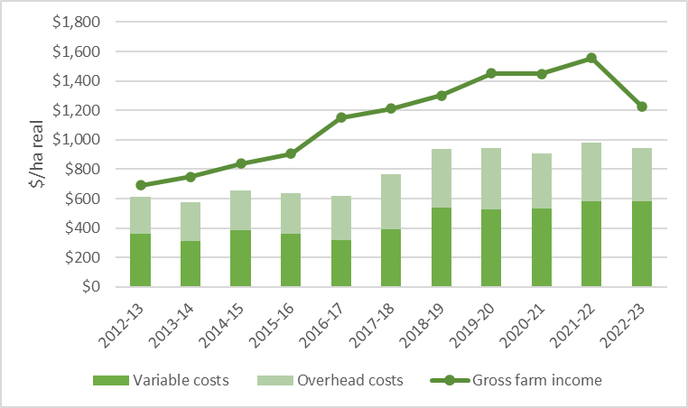
Figure 19. South West average income and costs (2012-13 to 2022-23)
In 2022-23, the South West experienced the first decrease in average gross farm income in a decade (Figure 19). South West gross farm income decreased by 20% but remained above the regional 10-year average. Sheep enterprises were the dominant businesses in the South West. Sheep (42%) and wool sales (20%) made up the majority of total farm income (Appendix B5). In 2022–23, prices for all red meat and wool decreased below each respective 3-year average price. Regional variable costs remained at the same levels recorded in 2021-22 and the second highest recorded in the past decade.

Fertiliser
***Infographic 22**
Superphosphate ($/t)
***Infographic 23**
Lime ($/t)
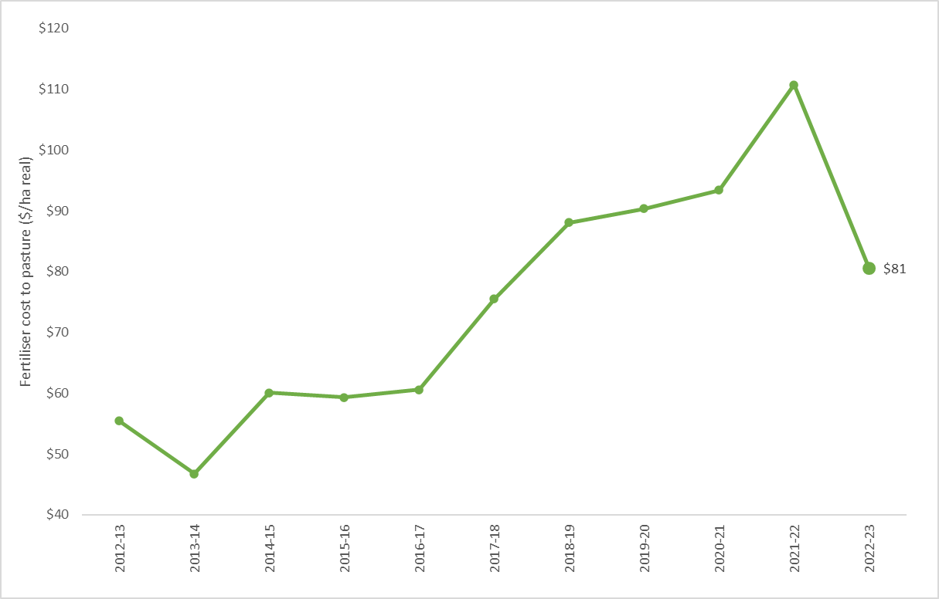
Figure 20. Average cost of pasture fertiliser (2012-13 to 2022-23)
In 2022-23, there was a sharp annual decline in the average expenditure on pasture fertiliser (Figure 20,). South West farmers decreased application rates of nitrogen, phosphorus, potassium and sulphur to well below the regional 3-year average. Application rates were decreased in response to a combination of high, and rising, fertiliser prices (Appendix F1) and very wet conditions. Even with the reduction in fertiliser application, pasture fertiliser costs were the largest cost item on South West farms, on average making up 10% of total cash operating costs. There was also a rise in farms not applying any fertiliser. No fertiliser was applied on 9% of South West farms in 2022-23 (Appendix B3), an increase from 2% of farms in 2021-22.
Phosphorus was the most commonly applied nutrient on South West farms. Phosphorus application rates were reduced by 30% from 2021-22 levels and for the fourth consecutive year (Figure 21). In 2022-23 the lowest average phosphorus application rates were recorded since 2013-14. Despite the reduced application rates, South West phosphorus application rates were higher than other regions in the state. 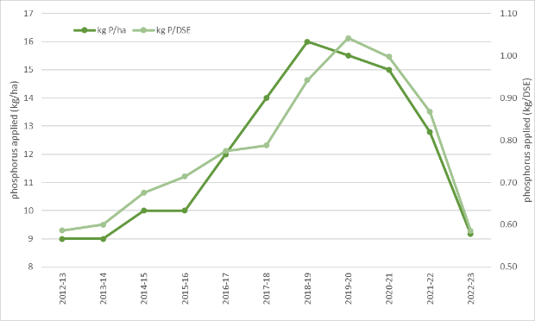
Figure 21. Average phosphorus application rates kg/ha (left hand axis) and kg/DSE (right hand axis) from 2012–13 to 2022–23.

Gross margins
***Infographic 24**
Beef gross margin ($/ha)
***Infographic 25**
Prime lamb gross margin ($/ha)
***Infographic 26**
Wool sheep gross margin ($/ha)
Decreased enterprise income coupled with no change to variable costs meant all livestock gross margins decreased in 2022-23. Lamb prices and wool prices dropped further than beef prices and consequently, prime lamb and wool sheep gross margins fell 28% below the 3-year average.

Calving and lambing pattern
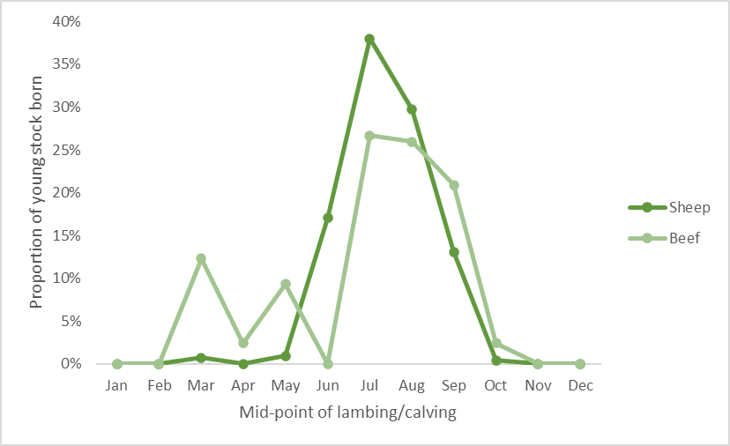
Figure 22.
Figure 22. South West 2022–23 calving and lambing pattern
In the South West, most (85%) lambing in wool sheep and prime lamb enterprises occurred during the winter months. Beef enterprises had a larger spread of calving dates with approximately 50% of calving occurring in winter, 25% in spring and 25% in autumn. South West participants received an average of 130% of annual rainfall and 200% of spring rainfall (Appendix B2).
Supplementary feeding rates and expenditure increased as a result of wet conditions, water-logged paddocks and difficult operating conditions. Prime lamb enterprises were the most reliant on supplementary feed (356 ME fed per DSE) followed by wool sheep (268 ME per DSE). Grain and concentrates were the most common form of supplement fed to prime lamb and wool sheep enterprises in the South West.

Capital structure
***Infographic 27**
Farmland value ($/ha)
Farmland values continued to rise across South West Victoria. The subsequent increase in the value of total farm assets offset the 24% increase in debt levels and resulted in an average annual addition to farmers’ wealth (equity) of $787/ha.

Return on assets
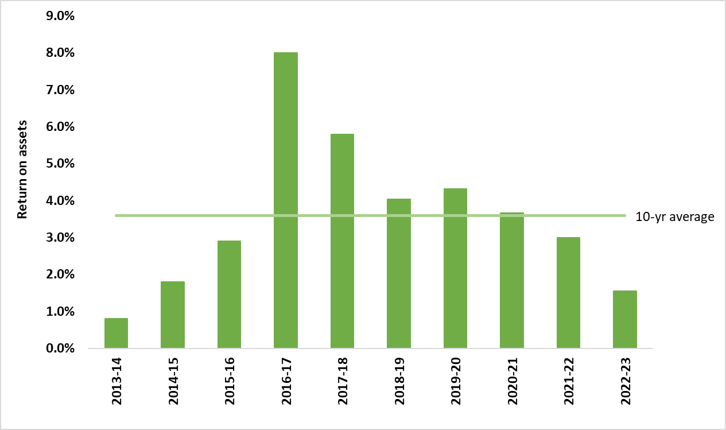
Figure 23. South West return on assets
Average EBIT on South West farms halved in 2022-23, from the record highs of 2021-22. Lower profit was made using more valuable assets resulting in the return on assets declining for the third consecutive year to 1.5%, the lowest returns recorded since 2013-14 and well below the 10-year regional average (Figure 23).

South West Victoria regional summary
- Gross farm income decreased for the first time in 10 years
- Second highest regional variable costs in 18 years
- Prime lamb and wool sheep gross margins fell 28% and was below the 3-year average
- Phosphorus application rates to pasture reduced by 30% from 2021-22 levels and for the fourth consecutive year
- Earnings before interest and tax (EBIT) halved from the record highs of 2021-22.
- Average annual increase in equity (net worth) by $787/ha.

Regional summary |  | SW
 | 3-yr average | 2022-23
Enterprise income
Beef income ($/ha) | 1,396 | 1,175
Prime lamb income ($/ha) | 1,356 | 1,168
Wool sheep income ($/ha) | 1,081 | 915
Variable costs
Beef variable costs ($/ha) | 497 | 506
Prime lamb variable costs ($/ha) | 597 | 623
Wool sheep variable costs ($/ha) | 529 | 519
Production
Beef sold (kg lwt/ha) | 580 | 455
Lamb sold (kg cwt/ha) | 120 | 121
Wool sheep wool cut (kg Gr./ha) | 48 | 48
Labour
Labour use (FTE/farm) | 3.5 | 3.8
Labour use efficiency (ha/FTE) | 421 | 425
Labour use efficiency (DSE/FTE) | 6,245 | 5,870
Nutrient application
Nitrogen applied to pasture (kg/ha) | 8 | 4
Phosphorus applied to pasture (kg/ha) | 12 | 9
Potassium applied to pasture (kg/ha) | 13 | 5
Sulphur applied to pasture (kg/ha) | 12 | 8
Top 5 costs (Proportion of total cash operating costs)
Pasture fertiliser costs (%) |  | 10%
Contract shearing and crutching (%) |  | 10%
Purchased supplementary grain and pellets (%) |  | 9%
Animal health (%) |  | 8%
Wages for permanent staff (%) |  | 6%

Glossary
Appreciation
An increase in the value of an asset in the marketplace. Often only applicable to land value.
Asset
Anything managed by the farm, whether it is owned or not. Assets include owned land and buildings, leased land, plant and machinery, fixtures and fittings, trading stock, farm investments (i.e., Farm Management Deposits), debtors and cash.
Average
The sum of a collection of numbers divided by the count of numbers in the collection.

Business type
Specialist sheep
Businesses with more than 85% of DSE coming from sheep and less than 30% income coming from grain and cropping.
Specialist beef
Businesses with more than 85% of DSE coming from beef and less than 30% income coming from grain and cropping.
Sheep and beef
Businesses with less than 85% of DSE coming from beef, less than 85% DSE coming from sheep and less than 30% income coming from grain.
Sheep and grain
Businesses with more than 30% of income coming from grain and cropping sales and greater than zero sheep DSE.

Cash Income
The sum of all cash income related to the operation of the farm/enterprise. Does not include.

Cash overheads
All fixed costs have a cash cost to the business. Includes all overhead costs except imputed labour costs and depreciation.
Casual labour
A casual employee is an employee engaged casually and paid by the hour. Casual loading is paid instead of annual leave, a notice of termination, redundancy benefits and other attributes of permanent labour.
Contract labour
A contractor controls the work to be done and how it is to be performed. They can employ their own staff and can subcontract or delegate.
Concentrate
Category of feed that includes grains, oilseeds, and pellets.
Depreciation
Decrease in value over time of capital asset, usually as a result of using the asset. Depreciation is a non-cash cost of the business but reduces the book value of the asset and is therefore a cost.
Dry sheep equivalent (DSE)
The standard unit used to compare the metabolisble energy (ME) requirements of different classes of stock for feed budgeting purposes.
Earnings before interest and tax (EBIT)
Also known as ‘Operating Profit’ or ‘Profit’ is the return on all the capital used in the business before accounting for finance costs. Calculated as gross farm income minus total variable and total overhead costs.
Effective area
Total hectares managed minus the area of land which is of little or no value for livestock or crop production.
Enterprise income
The total income received from an enterprise before any expenses are paid. Includes cash all receipts relevant to that enterprise and the value of changes in inventory relevant to that enterprise.

Equity
Total assets minus total liabilities. Equal to the total value of capital invested in the farm business by the owner/operator(s).
Equity %
Total equity as a percentage of the total assets owned.
The proportion of the total assets owned by the business.
Feed inventory change
An estimate of the quantity and value of grain, hay and silage on hand at the start and end of the financial year.
Full time equivalent (FTE)
Standardised labour unit. Equal to 1,920 hours a year.
Calculated as 48 hours a week for 40 weeks a year.
Grazed area
Pasture area plus an estimate of annual cropping area grazed. If a farm has multiple livestock enterprises, the grazed area is apportioned based on the total annual ME demand of each enterprise.
Grazed pasture utilised
Calculated using the back-calculation approach. Grazed feed is calculated as the difference between the total metabolisable energy required by livestock over the year and the amount of metabolisable energy consumed from other sources (hay, silage, grain, and concentrates).
The total metabolisable energy required by livestock is a factor of age, weight, growth rate, pregnancy and lactation requirements and the number of animals.
Gross farm income
The total income received from a farm. Includes all cash receipts and the value of changes in stock, feed, and wool inventory.
Gross margin
Enterprise income minus enterprise variable costs.
Imputed
An estimated amount is introduced into economic management analysis to allow reasonable comparisons between years and between other businesses.
Interest and lease costs
Total interest plus total lease costs paid. Also known as ‘finance costs’.
Liability
Money owed to someone else, e.g., family or a financial institution.
Livestock trading profit
An estimate of the annual contribution to gross farm income by accounting for the changes in the number and value of livestock during the year. It is calculated as the trading income from sales minus purchases, plus changes in the value and number of livestock on hand at the start and end of the year, and accounting for births and deaths. An increase in livestock trading indicates there was an appreciation in the value of livestock per head or an increase in livestock numbers over the year.
Metabolisable energy (ME)
The energy available for use by the animal. It is the energy used for maintenance of body systems, activity, milk production, pregnancy and weight gain. Metabolisable is net of energy lost in the form of urine and methane gas released by rumen and hind-gut microbes.
Net farm income
Earnings before interest and tax (EBIT) minus interest and lease costs. The amount of profit available for capital investment, loan principal repayments and tax.
Nominal terms
Dollar values that have no inflation component.
Livestock costs
All expenses relating to assisting with herd and flock management. Includes animal health costs and shearing contractors.
Livestock marketing costs
All costs associated with buying and selling livestock including freight and cartage.
Operating costs
Overhead and variable costs, i.e., the costs associated with the annual operation of the farm.
Overhead costs
All fixed costs incurred by the farm business that do not vary with the level of production. These include cash overhead costs such as permanent labour and noncash costs such as owner-operator labour, family labour and depreciation of plant and equipment. It excludes interest, lease costs, capital expenditure, principal repayments, drawings, and tax.
Owner/Operator labour
Staff members (such as family) that take income from business drawings rather than wages. The operators’ labour and management are an input to make a profit and so these must be costed and deducted to estimate the true profit and return to the capital in the business.
Pasture costs
All costs associated with growing pasture including fertiliser, seed and chemicals.
Permanent labour
Farm staff who have an ongoing expectation of work, generally work standard or set hours, are entitled to paid leave and notice of termination.
Profit (s)
See Earnings before interest and tax (EBIT).
Real terms
Dollar values that include an inflation component.
Return on equity (ROE)
Net farm income divided by the value of total equity.
Return on assets (ROA)
Earnings before interest and tax divided by the value of total assets under management, including owned and leased land.
Standard deviation
The standard deviation is a measure of how widely values are dispersed from the average value.

Variable costs
Variable costs (sometimes called direct costs) vary directly as the output of an enterprise varies.

List of abbreviations
CWT | Carcass weight
DEECA | Department of Energy, Environment and Climate Action, Victoria
DSE | Dry sheep equivalent
EBIT | Earnings before interest and tax
GM | Gross margin
ha | Hectare(s)
kg | Kilograms
Kg Gr. or  Gr. kg | Kilograms of greasy wool
LFMP | Livestock Farm Monitor Project
LWT | Live weight
ME or  MJ ME | Megajoules of Metabolisable energy
ML | Megalitre
mm | Millimetres
NFI | Net Farm Income
ROA | Return on Assets
ROE | Return on Equity
t | Tonne = 1,000 kg
tDM | Dry matter of feed stuffs measured in tonnes
yrs | Years old

References
Kay RD, Edwards WM, Duffy PA 'Farm Management' (Mcgraw-Hill Companies)
Malcolm B, Makeham J, Wright V 'The Farming Game - Agricultural Management and Marketing.' (Cambridge University Press: Melbourne)

